第三届“认证杯”数学中国
数学建模国际赛
承 诺 书

我们仔细阅读了第三届“认证杯”数学中国数学建模国际赛的竞赛规则。
我们完全明白，在竞赛开始后参赛队员不能以任何方式（包括电话、电子邮件、网上咨询等）与队外的任何人（包括指导教师）研究、讨论与赛题有关的问题。
我们知道，抄袭别人的成果是违反竞赛规则的, 如果引用别人的成果或其他公开的资料（包括网上查到的资料），必须按照规定的参考文献的表述方式在正文引用处和参考文献中明确列出。
我们郑重承诺，严格遵守竞赛规则，以保证竞赛的公正、公平性。如有违反竞赛规则的行为，我们将受到严肃处理。
我们允许数学中国网站(www.madio.net)公布论文，以供网友之间学习交流，数学中国网站以非商业目的的论文交流不需要提前取得我们的同意。
我们的参赛队号为：1517
我们选择的题目是： C题
参赛队员 (签名)
队员1：

队员2：

队员3：

参赛队教练员 (签名)：

第三届“认证杯”数学中国
数学建模国际赛
编 号 专 用 页

参赛队伍的参赛队号：（请各个参赛队提前填写好）：

1517

竞赛统一编号（由竞赛组委会送至评委团前编号）：

竞赛评阅编号（由竞赛评委团评阅前进行编号）：

TITLE
Abstract:
Since December 2013，Ebola outbreak in west Africa again，and this year’s disease was the most serious Ebola serious, which arouse the global attention. For task one，considering that among the countries where outbreak Ebola disease, Nigeria has the most serious problem. So we choose Nigeria as our object, establish differential equation and take the initial value to calculate, expecting rate of change in the number of Ebola infections for the country from 2006 to 2025, in the absence of any additional drugs. Clearly giving the inspecting time， we can get the change of the number of healthy people and the patients. And estimate the cost of US to deal with the crisis. For task2，we consider the drugs, so on the foundation of the differential equation, we make some improvements, taking the infection as a changing factor over time. Also we solve the differential equation, get the changing of the healthy people and the patients. Then we take the company’s benefit into consideration. According to the patients and the spending of company, we calculate the earnings, which account for 10% in the investment. And considering that the company has investment from the government and the organization in addition to the medical market, we decide to develop drugs during this time period in the area. Then change the time to put the drugs into the market on the timeline. Use the first model during the former period and the second model for the latter period, calculating the earnings of the medical company, and estimate the deadline and output of drug development process. For task3 and task4, in order to develop a “reward” policy for pharmaceutical companies to support drug R & D work and establish cooperation，we establish the comprehensive evaluation model，making evaluations for the big company in comprehensive power and scientific study , drugs development and cooperation. Allocating the investment from public-health benefits and US Budget, and select some enterprises to establish cooperation.

Key words:
Ebola develop drugs differential equation comprehensive evaluation model yield

Contents
1. Introduction...................................................................................................................................................5
1.1 The source of Ebola............. .............................................................................................................5
1.2 Cure this disease............. ....................................................................................................................5
1.3 Pharmaceutical company’s decision............. ............................................................................5
1.4 Other Tropical disease......................................................................................................................5
1.5 Get the drugs effectively..................................................................................................................5
2. The Description of Problem............................................................................................................................................................6
2.1 Approximate the expected rate of change in the number of Ebola infection........6
2.2 Determine whether any new disease need to develop drugs..........................................6
2.3 Develop a “reward” policy for pharmaceutical companies............................................6
2.4 How to select some enterprises to establish cooperation? .............................................6
3. Models..............................................................................................................................................................6
3.1 Model one ...............................................................................................................................................6
3.1.1 Symbols and Definitions.......................................................................................................6
3.1.2 Assumptions................................................................................................................................7
3.1.3 The Foundation of Model.....................................................................................................7
3.1.4 Analysis of the Result..............................................................................................................8
3.1.5 The cost of US to deal with the crisis............................................................................9
3.1.6 Strength and Weakness.........................................................................................................9
3.2 Model two..............................................................................................................................................10
3.2.1 Extra Symbols..........................................................................................................................10
3.2.2 Additional Assumptions......................................................................................................10
3.2.3 The Foundation of Model...................................................................................................10
3.2.4 Analysis of the Result...........................................................................................................12
3.2.5 Strength and Weakness........................................................................................................14
3.3 Model three........................................................................................................................................15
3.3.1 Determine the evaluation objects...................................................................................15
3.3.2 Establish evaluation index system................................................................................15.
3.3.3 Determine the weight coefficient..................................................................................16
3.3.4 The dimensionless of evaluation index..............................................................。...... 16
3.4 Task four..............................................................................................................................................17
4. Conclusions..................................................................................................................................................18
5.Future…….......................................................................................................................................................19
5. References.....................................................................................................................................................20
6. Appendix.......................................................................................................................................................20
Programs and codes.....................................................................................................................................20
I. Introduction
1.1 The source of Ebola
The deadly hemorrhagic fever Ebola was first discovered in 1976, and it has haunted the public imagination for twenty years, Since December 2013, an ongoing outbreak of Ebola in West Africa has infected at least 567 people in Guinea, Sierra Leone and Liberia, including 350 who died, according to the World Health Organization.
1.2 Cure this disease
People with Ebola are treated with only general therapies meant to support the ill patient. They might be given fluids (Ebola patients are frequently dehydrated), or treatments aimed at maintaining blood pressure and oxygen levels, and treating infections if they develop, according to the Centers for Disease Control and Prevention.
1.3 Pharmaceutical company’s decision
They naturally assess the potential market for a drug candidate. That means that they have an incentive to target diseases that affect wealthier people (above all, people in the developed world), who can afford to pay a lot. They have an incentive to make drugs that many people will take. And they have an incentive to make drugs that people will take regularly for a long time—drugs like statins.
1.4 Other Tropical disease
Then, there’s what the World Health Organization calls “neglected tropical diseases,” such as Chagas disease and dengue; they affect more than a billion people and kill as many as half a million a year. One study found that of the more than fifteen hundred drugs that came to market between 1975 and 2004 just ten were targeted at these maladies. And when a disease’s victims are both poor and not very numerous that’s a double whammy.
1.5 Get the drugs effectively
The key is to reward companies for creating substantial public-health benefits. And the simplest way to do this would be to offer prizes for new drugs. The drug company would get paid, and would avoid all the expenses of trying to push a new product (which you don’t want with a last-resort antibiotic, anyway). Society would get a new drug, and public-health officials would be able to control how it was promoted and used.

II. The Description of the Problem
2.1 task one
Choose the country you believe to be most critical in terms of Ebola in Africa. Build a model to approximate the expected rate of change in the number of Ebola infections for the country from 2006 to 2025, in the absence of any additional drugs. Fully explain your model and the assumptions that underlie your model. In addition, estimate the cost of US to deal with the crisis.
2.2 task two
Build a mathematical model to determine whether any new disease need to develop drugs during this time period in the area. If so, estimate the deadline and output of drug development process.
2.3 task three
Develop a “reward” policy for pharmaceutical companies to support drug R & D work. The approach that you develop should make use of public-health benefits and US Budget.
2.4 task four
Joint drug research conducted by multiple companies can effectively lower costs and risk. How to select some enterprises to establish cooperation is a thorny issue. Your team can help the government to make a choice?
III. Models
3.1 Basic Model
Searching for the data, we know that there were 400 people infected by Ebola in 2006, and the total population in Nigeria is about 4.3 million. Comparing with other countries where there were Ebola cases, Nigeria’s problem was the most serious, so we choose Nigeria to be most critical in terms of Ebola in Africa，and establish differential equation model，studying the expected rate of change in the number of Ebola infections for the country from 2006 to 2025。
3.1.1 Terms, Definitions and Symbols
- s(t) : The proportion of susceptible in total number
- i(t) : The proportion of infective in total number
- : The people infected by one person every year
- : The proportion of patient in the initial time
- r(t) :The proportion of dead people in total number
- N : The total number in the inspecting area
- :the proportion of dead people in patient every year
3.1.2 Assumptions
- Because our inspecting time was during 2006 to 2025，during this period, the population change in Nigeria，the inspecting time is short, so we ignore the birth and dead。
- During the disease spread period, we divide the people into susceptible people, infective and dead people, and the total number N stay constant.
- Assuming the susceptible infected by Ebola virus, and there wasn’t any drugs and surgery, once the susceptible infected, they would die.
- Because the patient infected by Ebola virus has a short living time, assuming in one cycle, which is one year, the effective contact of average population for every patient is in one year. When patient effectively contact with susceptible, the susceptible would be infected.
- Because the inspecting time is a little short, assuming the proportion of the dead in patients every year stay constant.

3.1.3 The Foundation of Model
According to the assumption，every person can infect s(t) susceptible into patient, because the total number of patient is Ni(t),every year there areNi(t)s(t) susceptible infected，so Nis is the increasing rate of number of patients Ni，the rate of dead for each year is ，so：
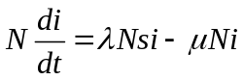 （1）
Because the reduction of susceptible equals to the susceptible infected every year，so：
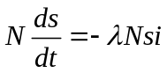 （2）

And also
s(t)+i(t)+r(t)=1 （3）
the proportion of patient in the initial time（t=0）is ，the proportion of susceptible is
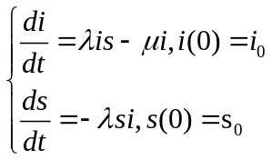 （4）
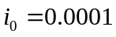,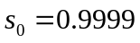
After the analysis ,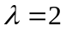，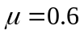
According to the equation（3）,we get the result as follows：
Year | 2006 | 2007 | 2008 | 2009 | 2010 | 2011 | 2012 | 2013 | 2014 | 2015
infective rate | 0.0001 | 0.0004 | 0.0015 | 0.0061 | 0.0239 | 0.0842 | 0.2189 | 0.3318 | 0.3113 | 0.2259
susceptible rate | 0.9999 | 0.9995 | 0.9979 | 0.9913 | 0.9656 | 0.8762 | 0.6536 | 0.3699 | 0.1912 | 0.1156
Year | 2016 | 2017 | 2018 | 2019 | 2020 | 2021 | 2022 | 2023 | 2024 | 2025
infective rate | 0.1502 | 0.0948 | 0.0584 | 0.0354 | 0.0214 | 0.0129 | 0.0077 | 0.0046 | 0.0028 | 0.0017
susceptible rate | 0.0794 | 0.0623 | 0.0536 | 0.0489 | 0.0462 | 0.0447 | 0.0438 | 0.0433 | 0.043 | 0.0428
Form 1
The figure of i(t) and s(t) are as follows:
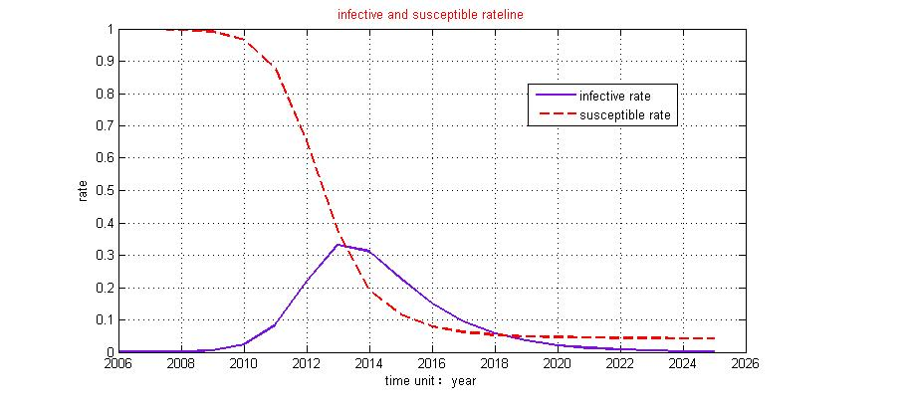
Figure 1

3.1.4 Analysis of the Result
According to the result，Nigeria is infected by Ebola virus, in the initial time ,which is 2006, there were 400 people infected, almost accounting for 0.1% of the total population. When there weren’t drugs to cure the disease, the illness seriously deteriorated.
The change of the susceptible as the dotted line in figure1shows, the number constantly decrease, and finally it maintain a constant at lower than10%, the reason is because the susceptible infected by the patient, the number will constantly decrease.
At last, when all the patient die, the susceptible will no longer be infected, the susceptible will maintain constant at a quite small number.
From 2006 to 2025, the change of the number of the patient as the solid line in figure 1shows, the number increase at first, then it decreases. The reason is that the patient will infect the susceptible, resulting in the increasing of the number of the patient. On the other hand, the patient will die, so the number will decrease again. From 2006 to 2013, because there are many susceptible and less patients, the susceptible infected increase, and the patients who die have a small number. Which means, the rate of the increasing number patients is greater than the decreasing number of the patients, so the number of patients increase? From 2013 to 2025, the proportion of the susceptible decrease and the number of patients increase, during this period, the rate of the people dying is greater than the susceptible infected, so the number of patients decrease.
Around 2013, the number of patients is of the most number, at this time , the rate of susceptible infected is the biggest, so among the change of the number of the susceptible, around the middle of 2013, the curve of the susceptible is of the steepest, which means, the number is the fastest declined.
3.1.5 The cost of US to deal with the crisis
If the US wants to deal with the crisis，it has to work in several ways，and spend much cost. The cost of US to deal with the crisis mainly from direct investment、drug R & D work、send medical personnel and military controlling. In the absence of any additional drugs，in the peak period of infection，the number of patient account for the 33.18% of the total number in Nigeria，which means 1.42 million people. The problems are quite serious. According to the previous Infectious disease management and the current investment for Ebola, estimating that American need to investment at least 10 million dollars if the US wants to deal with the crisis and send 8000 doctors and 3000 soldiers. American military establish hospitals in the disease area，Coordinate transportation equipment and people. Considering that African countries also have relatively serious problem, so the US has to pay more. And also the risk of the Ebola virus and its international health crisis, not only the US will deal with the crisis, and also WHO, the European Union and the world bank and other countries have to deal with the crisis by investing and doing some relative work.
3.1.6 Strength and Weakness
- Strength: In despite of this, the model has proved that the infection rate and the proportion of healthy people are changing as the change of time. With application of differential equation model under the model assumption situation, more accurate conclusions are drawn. Moreover, we have drawn some useful conclusions that, without the human drug intervention，the spread of the disease will be quite fast, around 2014, it will reach 30%. And people will not be isolated because of the illness.
- Weakness: This model just applies to the simple spread，if it applies to our lives, it’s more suitable for wild animals, when there is infectious disease, there will be isolation and medical cure, that’s what we need to improve.
3.2 Model two
3.2.1 Extra Symbols
Signs and definitions indicated above are still valid. Here are some extra signs and definitions.
- P : the price of each drugs
- B: the amount of drug everyone need everyone per unit time
- W: the yield of the Pharmaceutical company
- 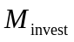: the investment that one Pharmaceutical company need to develop one kind of drugs
3.2.2 Additional Assumptions
  - Assuming that one person need 3 doses of medicine when being cured.
  - Every doses of medicine’s cost is 1000 dollars
  - Every doses of medicine’s price is 1300 dollars
  - Assuming that one kind of medicine’s investment is =6.02 hundred million
  - Dead or cured people won’t infect others or be infected.
  - Suppose drug production can be entirely sold.
3.2.3 The Foundation of Model
In the model 1, we don’t use any drugs, so the number of infected people doesn’t get controlled. With time goes by，all the susceptible would be infected. In the second question, considering the factor of human, so we need to cure the infected people and physically isolation in order to prevent the further spread. So after using the drugs, every patient in the unit time: the effective contact people would decrease; we analyze the number of infected people recent years and conclude the relationship of effective contact people and time t:
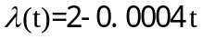
The same way we consider the proportion of patients in the initial time（t=0）is ，the proportion of susceptible is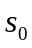，taking the into the following equation，using the mat lab to solve the differential equation i(t)：
How do we decide whether we need to develop new drugs to deal with the new disease in this place during this period? So mainly decided by American pharmaceutical company, whether it can get enough income after invest the drug development and the income is higher than investing other industry. So we define a annual return for a pharmaceutical company 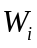，iNBC is the cost of the drugs，in which iNPC stands for the cost of the drugs and 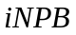 stands for the sales income of drugs.
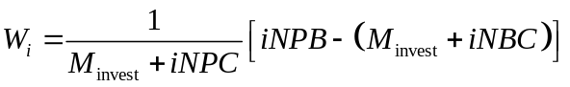
Further simplify we can get:

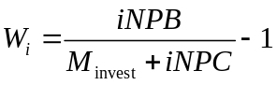
The invention of new drugs is a huge system engineering，it needs to spend a lot of money. According to the information from PMA：the research and development costs of screening one new drugs is around 2.5-3.5 hundred million dollars. The average research cost of one new drug is about =6．02 hundred million dollars，after the calculation, if the yield is greater than zero, that means the Pharmaceutical companies is profitable; if it’s less than zero, it means the Pharmaceutical companies are losing money.
But if the company is at the time when drugs firstly enter the market, aparting from the cost, the company is profitable every year, but it is likely not to receive the cost. However, with time goes by, the net profit has accumulated to a certain amount, they can be profitable.
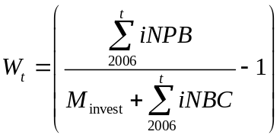
In which i is about the function of time，here we adopt the discrete value that after using drugs i to calculate.

3.2.4 Analysis of the Result
From the model analysis we get the numerical result as follows. By the above-mentioned can be obtained, the infection rate of Ebola virus obviously slow down, after using the drugs, we also significantly curb the its spread.

Year | 2006 | 2007 | 2008 | 2009 | 2010 | 2011 | 2012 | 2013 | 2014 | 2015
infective rate | 0.0001 | 0.0002 | 0.0003 | 0.0006 | 0.001 | 0.0018 | 0.0033 | 0.0059 | 0.0105 | 0.0184
susceptible rate | 0.9999 | 0.9998 | 0.9995 | 0.999 | 0.9981 | 0.9964 | 0.9935 | 0.9882 | 0.9788 | 0.9625
Year | 2016 | 2017 | 2018 | 2019 | 2020 | 2021 | 2022 | 2023 | 2024 | 2025
infective rate | 0.0313 | 0.0512 | 0.0784 | 0.1019 | 0.1363 | 0.1503 | 0.148 | 0.1326 | 0.1106 | 0.0876
susceptible rate | 0.9349 | 0.8906 | 0.8249 | 0.7375 | 0.6364 | 0.5356 | 0.4477 | 0.3785 | 0.3274 | 0.291

Form 2
From this figure, we can see the infection rate i(t)（the blue line in the figure）and the healthy people’s rate(the red line in the figure) is trending as the change of the time. Compare with the above analysis, the drugs are getting in, and human factor’ intervention have huge impact on the infectious disease, so it reflect the need for the investment of the medical industry. 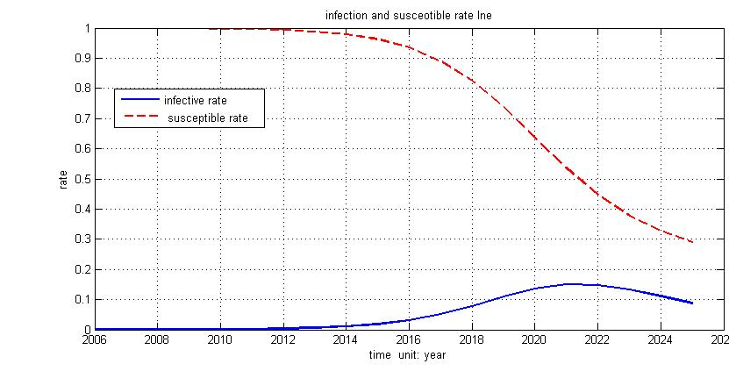
Figure 2
How to think about whether it needs to develop a new drug or not, for a developing company, the first thing come to mind is:：Can they earn money in an appropriate deadline? Apply the result from the model 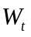(the sum of the yield of the company during the period). If a company is in an early stage of drug development work when seeing a crisis is about to outbreak, seizing the opportunity to get the drugs into the market when the crisis is actually happening， so the company invest 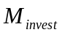=6.02 hundred million，besides the cost of the unit dose of the drug P, they will get more time to earn money. The longer the time is, the better the benefit of the investment is.
As the figure 3 shows, the red line stands for that , from 2006 , when the disease start to outbreak ,the pharmaceutical company started to put in drugs in Liberia which has 4.3 million people. It started to profit when get into the market, so it constantly profit in this place during this period until 2015, and the sum of the yield（）will reach about 25%, after that, the infected people will be less gradually. The yield of the sales tends to a stable value. At this time, the pharmaceutical company has get the cost and profit. Although it will spend huge funding and manpower, the return is huge.
So we consider in this area from2006-2025, there needs to develop the new drugs, then when is the latest do the pharmaceutical companies put the drugs into the society and still profit? We choose several years’ data to simulate the experiment:
Set the drug delivery in 2015 as example，before 2015, the infection of Ebola in Liberia is natural infection, and there is no drug treatment. So according to the model one we get the discrete value of infection rate 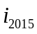 and the value of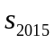: 0.2259 and 0.1156. Taking this data into the second question which consider the drugs get into the infectious area, with the medical intervention, the initial value get the changing rule of the infection rate as the change of time (the dotted red line in the figure) .Because the Ebola infectious people will die without the drug treatment, so the Pharmaceutical companies may lose part of the customer. With time goes by, there will be less infected people, so the profit will be less. From the figure, we can clearly see the drugs which be put into production in 2015, during this period the latest yield is zero. So we can estimate the deadline is 2015.
Besides, we also choose one particular year 2020, during this period, putting the drugs into production again, also from the figure 3 , we can see that there are still people who get infected, so they still have profit. But the investments are more than its income，it’s in a loss state, which is about -18%. So the time is not appropriate, then we can estimate the deadline is around 2015.
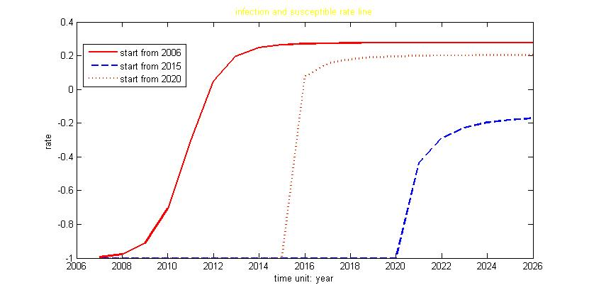
Figure 3
So investing at the deadline, Drugs in the annual sales will present the trend as the figure shows 。So during the 2006-2015, because there are no drugs sales, so the company has no production. From 2015, because Nigeria at that time has a serious problem, so the drugs will be popular and have a high sale. With the drugs constantly curing and the people die, so there will be less people infected and the productions and sales will be less.
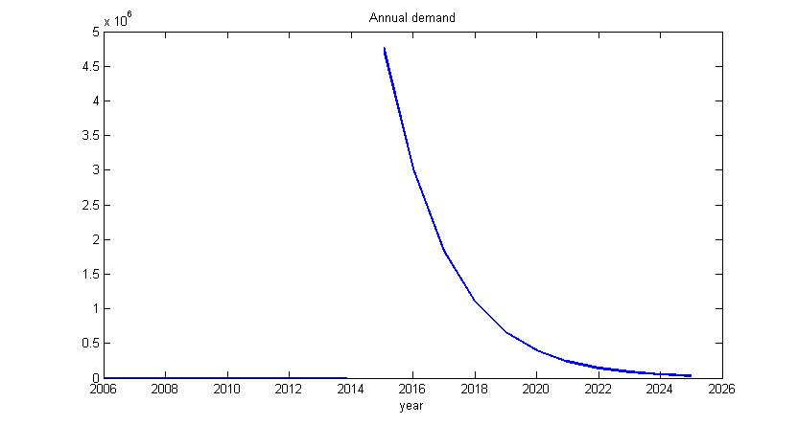
Figure 4
3.2.5 Strength and Weakness
- Strength: The Model two considers that the drugs get into the Nigeria and the infectious people, and then draw the conclusion of the infection rate as the change of time. At the mean time, we define a yield function to evaluate whether the company needs to invest the drugs or not. It makes the company have the data foundation when making the decision and it provide a way of thinking for us. The result seems to declare that this model is more reasonable than the Model one and much more effective than the existing design.
- Weakness: The model just considers Liberia as background and don’t think of others, and the mean time, we don’t consider the income of other countries when the drugs get into the countries. And these don’t exist in actual situations, the countries can infect each other，and after the development of the drugs, when they get the money back, the actual situation in every country will be more sophisticated than the modeling analysis. This has doomed to limit the applications of it.
3.3. model three
Treatment of Ebola infections disease drug development is a high risk, time-consuming long project, the cost is about 600 million dollars. The time is long, drug synthesis is difficult；Besides, Innovative drug research and development are more and more difficult，facing such situation, Incentive policy mainly focus on medicine for Ebola infections and encourages enterprises to research and development，and provide pharmaceutical companies with drugs for the treatment of Ebola infections, and invest in R&D work. This investment comes from public-health benefits and US Budget, and establishes a comprehensive evaluation model of capital allocation.
3.3.1. Determine the evaluation objects
The evaluated object is the object researched in the comprehensive evaluation model. In this problem, the object is The overall strength of the research of the drug companies, we choose the stronger, typical medical company such as Pfizer、Abbott、Johnson、AstraZeneca、lily.
3.3.2 Establish evaluation index system
Evaluation index is the essential factor to reflect the evaluated object’s running states. Problems generally consists of a number of indicators，Each indicators from different sides characterization system has some characteristics of the size of a measure. Abiding by the principles of selecting evaluation index system：System, science, comparability, measurability and independence. So in this problem, the evaluation index we choose are: number of employees 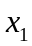、Number of production bases 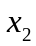、Number of research and development institutions 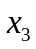，so the evaluation index vector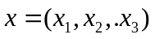。They respectively stand for cooperation ability, medicine, and scientific research ability and production capacity of the company. Access to information obtained:

company name | The number of employees | Production base | Research and development institutions
Pfizer | 77000 | 56 | 260
Abbott | 65000 | 55 | 194
Johnson&Johnson | 11500 | 55 | 194
Astrazeneca | 55000 | 31 | 11
lilly | 31285 | 30 | 30

3.3.3 Determine the weight coefficient
Every comprehensive evaluation problem has its respective evaluation purpose, for each evaluation purpose，among the relative importance of each index is different.The relative importance between evaluation index weight coefficient can be used to depict the size of the。After the analysis we get the :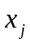corresponding weight 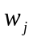，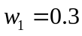，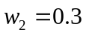，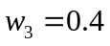.
3.3.4 The dimensionless of evaluation index
Between the actual index,,…,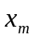，there are existing different orders of magnitude and unit，Make commensurability between these indexes, this creates problems for the comprehensive evaluation，Especially for the establishment of the comprehensive evaluation index and production irrationality. Now there are n groups of index of statistics 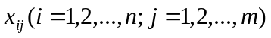，making The dimensionless processing：
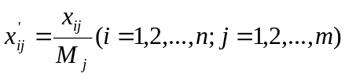
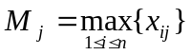. So 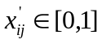 is the Dimensionless index of statistics。
After numerical dimensionless:
company name | The number of  employees | Production base | Research and development  institutions
Pfizer | 1 | 1 | 1
Abbott | 0.844155844 | 0.982142857 | 0.746153846
Johnson&Johnson | 0.149350649 | 0.982142857 | 0.746153846
Astrazeneca | 0.714285714 | 0.553571429 | 0.042307692
lilly | 0.406298701 | 0.535714286 | 0.115384615
Now known n set of dimensionless index 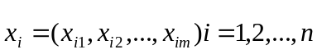，and the corresponding weight vector were determined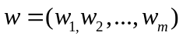. In order to evaluating with comprehensive evaluation object analysis，We should choose appropriate mathematical method to construct the comprehensive evaluation function:
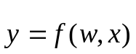
Calculate the comprehensive evaluation index function value 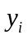（i=1,2,…,n）, then analyze and interpret of the value of the size of the again. We adopt linear function:
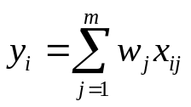
As the comprehensive evaluation model， comprehensively evaluate the evaluation objects。Company, the higher score the company get, the stronger the company is，which need to accept the funding.
Caculation result:
Pfizer(1)>Abbott(0.846351)>Johnson&Johnson(0.63791)>Astrazeneca(0.39728)>lilly(0.328758)
Known from the results,Pfizer as the strongest pharmaceutical companies, the big share should be given to it，next is Abbott and Johnson.

3.4 Task four
As we know that joint drug research conducted by multiple companies can effectively lower costs and risk. But how to make these big company to play a greater benefit，So every company is to make the most powerful part and the most powerful part of the joint of another company. From the task 3 we know that Pfizer is the strongest among the five company listed. But it’s not the most effective. So we should take some methods to calculate the department of each company and decide which is the most efficient. The most efficient of the company and make this a few together to develop new drugs against Ebola virus. The solution plan are as follows: 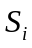stands for company's operating income for one year， 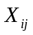stands for the company i’s the first j normalized values，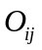 stands for the first i company’s The first unit of output value of the j item（the bigger the is, more efficient the department of the company is）efficiency value definition is as follows:
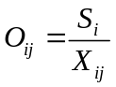

The value of are as follows:
company name | Efficiency of employees | Efficiency of Production base | Efficiency of Research and development institutions
Pfizer | 225.7 | 225.7 | 225.7
Abbott | 48.09538462 | 41.33818182 | 54.41237115
Johnon&Johnson | 800.1304367 | 121.6727273 | 160.1546392
Astrazeneca | 219.8000001 | 283.612903 | 3710.909118
lilly | 250.5545791 | 190.0266666 | 882.2666696
Form 4
We can clearly see from the form , although Pfizer is the comprehensively strongest，but the production is not so much, which mean the department’s efficiency is low. Abbott’s output in every department is not so high. Johnon&Johnson in a limited employee’s number，Get higher efficiency value, it reaches：800.1304367。Astrazeneca did a good job in the construction aspect of production base, Production base can gain higher returns: 3710.909118. While lilly is pretty good In the development of testing，the efficiency value reaches:882.2666696。So we choose Johnon&Johnson，Astrazeneca，lilly in the latest listed company, which are the most powerful in developing the drugs. They can use least government investment to get the most return.
Because we just search for 5 companies’ data, and 3 evaluation standard, if we can get more data and evaluation standard in other companies, when calculating the efficiency , it can be more rational, and the model will be trending to realistic.
IV. Conclusions
- In Task 1，we choose Nigeria as our object, establish differential equation model, approximate the expected rate of change in the number of Ebola infections for the country from 2006 to 2025, in the absence of any additional drugs. Clearly giving the change of the healthy people and the patient as the change of time during the inspecting time. And estimate the cost of US to deal with the crisis.
- In Task2，we determine whether any new disease need to develop drugs during this time period in the area. Mainly considering the benefit of the Pharmaceutical companies. We modify in the question 1, make it be a changing value. And also remove the differential equation; we get the infection rate as the change of time. Then change the time when put the drugs into the market, The first model in the former period，The second plan in the latter period. Then calculate the earnings，we get that around 2015 the earning is zero, and according to this , we get the drugs production in 2015.
- In Task3 and Task4，in order to develop a “reward” policy for pharmaceutical companies to support drug R & D work and establish cooperation，we establish the comprehensive evaluation model, in the giving typical big medical company, evaluate its comprehensive power scientific study, drugs development and cooperation capabilities. So the allocation come from public-health benefits and US Budget and select some enterprises to establish cooperation.
V Future
5.1 Another model
5.1.1 The defects of the model ：in the differential equation model in the first question, we set every person who infected others . However, with time goes by, the seriousness of the disease gradually become stronger, so the people's attention for Ebola increase ，then is sophisticated function which will change with time.
5.1.2 The improvements of model 1：in the question we still use The spread of infectious disease model in the differential equation, but for , we use Regression analysis method to determine. Search from 2006 to 2012, the infection rate in every year，using nonlinear regression analysis fitting the best .
5.1.3 In task3, because of the data channel is unitary，data volume is not big enough. We just use 5 company’s data, in the ， in the actual case , we should take full advantage of the medical company to reduce the risk. Besides, there is medical company’s index which we can use to make a comprehensive evaluation of Pharmaceutical companies.

VI. References

[1] Zhang Fa, Li Lu, Xuan Hui-yu . Survey of transmission models of infectious diseases. System s Engineering-Theory & Practice. Vol.31 , No .9 SePt.2011.
[2] Liming-jing ,Zhang zhen-ji. Applications of Matlab in Mathematical Model of the Economy. China traffic Forum . Vol.3 , No .7 Nove.2013.
[3] Cao Zhi-dong,Zeng Da-jun,Zheng Xiao-long. Characteristics of SARS popular with law of spatio-temporalpropagation. China Science: Earth Science. The sixth period Vol.40.2011.
[4] Mark Boroush. Federal R&D Funding, by Budget Function: Fiscal Years 2013–15.National Science Foundation. Detailed Statistical Tables | NSF 15-306 | November 2014.
[5] Wang Ling. drugs USA 2010 best sales of the American medical reform policy in the rankings.2012.

VII. Appendix
Programs and codes
model one:
function y=ill(t,x)
a=2,b=0.6;
y=[a*x(1)*x(2)-b*x(1),-a*x(1)*x(2)]';

ts=2006:2025;
x0=[0.000093,0.999907];
options=odeset('reltol',0.01,'abstol',0.01)
[t,x]=ode45('ill',ts,x0,options);[t,x]
y(:,1)=x(:,1)
y(:,2)=x(:,2)
plot(t,x(:,1),t,x(:,2)),grid,pause

answer
y=
0.0001 0.9999
0.0004 0.9995
0.0015 0.9979
0.0061 0.9913
0.0239 0.9656
0.0842 0.8762
0.2189 0.6536
0.3318 0.3699
0.3113 0.1912
0.2259 0.1156
0.1502 0.0794
0.0948 0.0623
0.0584 0.0536
0.0354 0.0489
0.0214 0.0462
0.0129 0.0447
0.0077 0.0438
0.0046 0.0433
0.0028 0.0430
0.0017 0.0428

model two:
first problem
function y=ill(t,x)
a=2-0.0004*t,b=0.6;
y=[a*x(1)*x(2)-b*x(1),-a*x(1)*x(2)]';

ts=2006:2025;
x0=[0.000093,0.999907];
[t,x]=ode45('ill',ts,x0);[t,x]
y(:,1)=x(:,1)
y(:,2)=x(:,2)
plot(t,x(:,1),t,x(:,2)),grid,pause
plot(x(:,2),x(:,1)),grid

answer
y =

0.0001 0.9999
0.0002 0.9998
0.0003 0.9995
0.0006 0.9990
0.0010 0.9981
0.0018 0.9964
0.0033 0.9935
0.0059 0.9882
0.0105 0.9788
0.0184 0.9625
0.0313 0.9349
0.0512 0.8906
0.0784 0.8249
0.1095 0.7375
0.1363 0.6364
0.1503 0.5356
0.1480 0.4477
0.1326 0.3785
0.1106 0.3274
0.0876 0.2910
second problem
for i=1:20
w(i)=0;
s(i)=0;
k(i)=0;
t(i)=2006+i;
end
m=[ 0.0001 0.0002 0.0003 0.0006 0.001 0.0018 0.0033 0.0059 0.0105 0.0184 0.0313 0.0512 0.0784 0.1095 0.1363 0.1503 0.148 0.1326 0.1106 0.0876 ];
for i=1:20
for j=1:i

k(i)=k(i)+m(j)*4300000*100*5;
s(i)=s(i)+m(j)*4300000*5*50;

end
w(i)=k(i)/(600000000+s(i))-1;
end
plot(t,w)
w =
Columns 1 through 10
-0.9996 -0.9989 -0.9979 -0.9957 -0.9921 -0.9858 -0.9742 -0.9538 -0.9185 -0.8597
Columns 11 through 20
-0.7676 -0.6350 -0.4666 -0.2821 -0.1086 0.0354 0.1448 0.2236 0.2791 0.3177

m20=[0 0 0 0 0 0 0 0 0 0 0 0 0 0 0.0214 0.0124 0.0072 0.0042 0.0024 0.0014
];
m15=[0 0 0 0 0 0 0 0 0 0.2259 0.1402 0.0854 0.0514 0.0308 0.0184 0.011 0.0065 0.0039 0.0023 0.0014
];
m06=[0.0001 0.0004 0.0015 0.0061 0.0239 0.0842 0.2189 0.3318 0.3113 0.2259 0.1502 0.0948 0.0584 0.0354 0.0214 0.0129 0.0077 0.0046 0.0028 0.0017
];
for i=1:20
w(i)=0;
s(i)=0;
k(i)=0;
t(i)=2006+i;
end

for i=1:20
for j=1:i

k(i)=k(i)+m06(j)*4300000*1300*5;
s(i)=s(i)+m06(j)*4300000*5*1000;

end
w06(i)=k(i)/(600000000+s(i))-1;
end
for i=1:20
w(i)=0;
s(i)=0;
k(i)=0;
t(i)=2006+i;
end
for i=1:20
for j=1:i

k(i)=k(i)+m15(j)*4300000*1300*3;
s(i)=s(i)+m15(j)*4300000*3*1000;

end
w15(i)=k(i)/(600000000+s(i))-1;
end
for i=1:20
w(i)=0;
s(i)=0;
k(i)=0;
t(i)=2006+i;
end

for i=1:20
for j=1:i

k(i)=k(i)+m20(j)*4300000*1300*5;
s(i)=s(i)+m20(j)*4300000*5*1000;

end
w20(i)=k(i)/(600000000+s(i))-1;
end
plot(t,w06,'r'),hold on
plot(t,w20,'b'),hold on
plot(t,w15)

