# 

# Artificial intelligence version 1.1

Members of project:

Guolin Yang, Dexter Shepherd, Josh Hassett, Morgan Pile

Paper by:

Dexter Shepherd and Guolin Yang

# Planning and Design

## Task

Chat bot able to reply appropriately to the user’s message using existing data, the system will be controlled by voice command and will be able to reply appropriately within the scope of the conversation.

Include commands so it can be taught and will learn from the conversation.

## Requirement

To be able to learn new replies for messages it doesn’t know and to store it so it is able to use it for later. The system will need to find key words in a sentence and have replies in sad files, happy files, etc.…

## User Interface

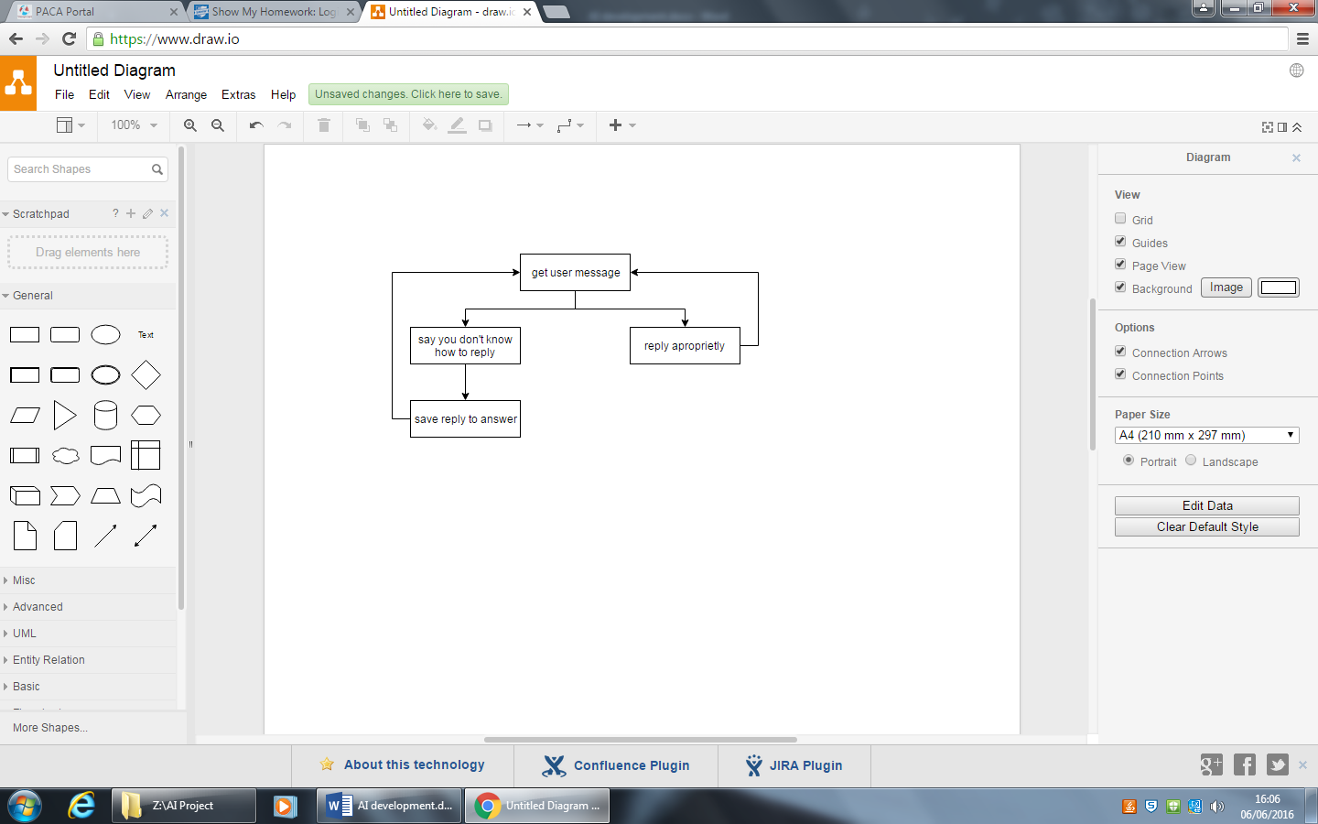

## Success Criteria

When a conversation is held during a long period of time with little or, preferably, no bugs.

## Test plan

|  |  |  |
| --- | --- | --- |
| Test Number | Test | Expected result |
| 1 | Will it run | yes |
| 2 | Will it end | yes |
| 3 | Will it remember new replies | yes |
| 4 | Does voice control work | Prints the words |
| 5 | Does it give different to the same scenario | yes |
| 6 | Does it save to the SD | The system will work, but to check it will be in the SD file. |
| 7 | Does it learn new replies | Yes, it will output “I do not know how to respond to that. Please help” |
| 8 | Does it output the through wav files | It says according to what you say |
| 9 | Does the system output the words in the data? | yes |
| 10 | Does the system display the message on the lcd screen? | yes |

## Variable Plan

Too many variables to put here

## Hardware

Arduino Mega (main memory board)

Arduino Uno x 3 (lcd, audio board, led eye)

Speakers

SD Cards and holders

Wires

Microphone

## Flowchart

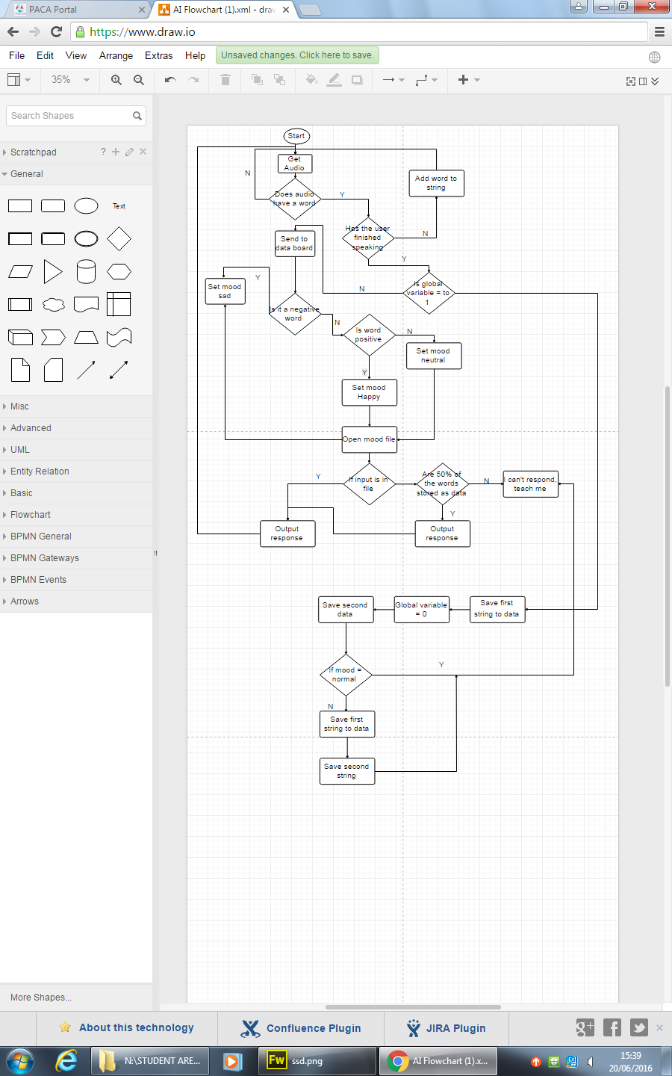

## Pseudocode

Board 1 – Audio

Get audio

If (audio noise < 5)

{

String ignore;

Add noise to ignore

}

Else

{

If (audio > 5)

{

Count 2 seconds after noise has stopped

Open file

Check if noise included similar frequencies

If (true)

{

Send found word main board through i2c communication.

}

}

Send / word main board through i2c communication.

reset

}

Board 2 main board

Function main ()

{

If receive event through i2c

{

If wire read == /

{

Check ()

}

Else

{

Word string + wire read

}

}

}

Function check ()

{

Loop

{

If word contains anything in sad vocab file

{

File = open sad file

}

Else if word contains anything in happy vocab file

{

File = open happy file

}

Else

{

File = open main file

}

Check through file to see if word string is inside

If true

{

Get known response

Send response through i2c communication to board 3

break

}

If over half the words are found in sentence

{

Find response

Send response through i2c communication to board 3

}

Else

{

}

}

}

Board 3 – sound board

Loop

{

Look for data through i2c communication.

C = read

String += c

If data is done

{

String += “.wav”

File open string

Send read data to .wav file

String = “”

}

}

Board 4 – led eye

Loop

{  
Look for data through i2c communication.

C = read

String += c

If string = “sad”

{

}

Else if string = “happy”

{

}

Else if string = “angry”

{

}

Else

{

}

}

Function Happy

{  
eye =

{0,0,0,0,0,0,0,0},

{0,0,0,0,0,0,0,0},

{0,0,0,0,0,0,0,0},

{0,0,0,0,0,0,0,0},

{0,0,0,0,0,0,0,0},

{0,0,0,0,0,0,0,0},

{0,0,0,0,0,0,0,0},

{0,0,0,0,0,0,0,0},

{0,0,0,0,0,0,0,0},

}

Function Sad

{

eye =

{0,0,0,0,0,0,0,0},

{0,0,0,0,0,0,0,0},

{0,0,0,0,0,0,0,0},

{0,0,0,0,0,0,0,0},

{0,0,0,0,0,0,0,0},

{0,0,0,0,0,0,0,0},

{0,0,0,0,0,0,0,0},

{0,0,0,0,0,0,0,0},

{0,0,0,0,0,0,0,0},

}

Function Angry

{

eye =

{0,0,0,0,0,0,0,0},

{0,0,0,0,0,0,0,0},

{0,0,0,0,0,0,0,0},

{0,0,0,0,0,0,0,0},

{0,0,0,0,0,0,0,0},

{0,0,0,0,0,0,0,0},

{0,0,0,0,0,0,0,0},

{0,0,0,0,0,0,0,0},

{0,0,0,0,0,0,0,0},

}

Function None

{

eye =  
{0,0,0,0,0,0,0,0},

{0,0,0,0,0,0,0,0},

{0,0,0,0,0,0,0,0},

{0,0,0,0,0,0,0,0},

{0,0,0,0,0,0,0,0},

{0,0,0,0,0,0,0,0},

{0,0,0,0,0,0,0,0},

{0,0,0,0,0,0,0,0},

{0,0,0,0,0,0,0,0},

}

Coded Solution

# 

# Development

## Development diary

|  |  |  |
| --- | --- | --- |
| Date | What I worked on | What happened / What testing |
| 06/06/16 | We decided on the task and requirements of the code. came up with user interface, and started the test plan. |  |
| 20/06/16 | We did concept art and worked on board one and two of the pseudocode. |  |
| 22/06/16 | We worked on more of the pseudocode, it is now finished apart from the eye designs transferred. We also designed the graphics of the eye led matrix. |  |
| 18/07/2016 | It is difficult to keep up with the amount of entries. Every Monday and Wednesday we meet and progress. Early versions of interfacing with hardware such as sound input and output.  The biggest challenge has been the audio input; we need the code to understand over a million words through sorting out the volume.  Instead we decided to search for sounds and letters. This would be beneficial as we don’t have to record as much. |  |
| 05/08/2016 | Building on the last entry, we have been developing the project more and more. Right now we have added emotion data files, added audio output, added the led eye and made it change depending on the mood.  The AI obviously requires further development within its brain but it is doing what we wanted it to do in V1.1.  We are currently working on the voice command code; this has already been slightly developed, so far it will recognise letters and find in its data the nearest sounding one.  The aim is to develop phonemes within its data so we can gather a word, then with this word it will look in a dictionary and find the nearest word (like an auto correct) before sending it over to the main board.  Within this time, we have made it so that the AI and audio output is on one board, we also increased data, storage and RAM on the AI by using a higher p board such as the Mega.  We are working on a C++ version of the AI to include on a website about our project and to allow users of the internet to use our AI and help it learn. This also creates publicity and trust in our AI and future company.  This leads to the point that when we finish v1.1 we will be making a website and hopefully hosting it on our school’s server, if not we will all have to put a bit each in to buy one. |  |
| 22/08/16 | The AI has been finished, the voice code all works with the main code with the built in text to speech. |  |
| 03/09/016 | The AI has a certain file format on the SD card. This format contains its memory for different emotions, tally files to count the amount of commands and a words pad where you can add in phrases which the system uses to find different words within each sentence. The system recognises words better as sentences.  The system has instead used the main board to host the voice recognition and audio output shield. | It is advised to spell words how they sound in a dyslexic manor so the system can get the correct phonemes to register your voice to words. |

# Testing

## Test results

|  |  |  |  |
| --- | --- | --- | --- |
| Test number | Test | Pass/fail | Comment |
| 1 | Will it run | pass |  |
| 2 | Will it end | pass | The system restarts each time, it ends when the power is taken out… as designed. |
| 3 | Will it remember new replies | pass | It saves to the SD card |
| 4 | Does voice control work | pass |  |
| 5 | Does it give different to the same scenario |  |  |
| 6 | Does it save to the SD | pass |  |
| 7 | Does it learn new replies | pass | The system will save and reply it next time. |
| 8 | Does it output the through wav files | - - - | The system does not use this idea anymore. It uses text to speech to speak to a user. |
| 9 | Does the system output the words in the data? | Pass | The system uses text to speech and uses the outputString variable collected from the data as the response string. |
| 10 | Does the system display the message on the lcd screen? | Pass | The words send through byte by byte to through i2c communication. |

# Future ideas

Include many Arduinos that will connect to each other so they can have conversations. Have a system where the program will remember the last thing it said as a short term memory thing.

Another idea is that it will not only be able to learn how to respond through words but how to respond through physical interaction.

More ideas include object recognition and using its own 3d maps stored like a radar in arrays (X, Y, Z) to locate the object.

More ideas include using potentiometers to get servo input and output it when commanded, instead of the AI just learning verbal response, why can’t it use physical output, and potentially physical input.

Allow the AI to connect through the internet using WIFI shields or cheaper Ethernet shields. When the AI is asked a question it doesn’t know the answer to it will search the internet for an answer, if it cannot find one on the internet it will have to say; “sorry I do not know, maybe try research it when you have some free time”.

# Evaluation

The system works well enough, it is still uneasy and will need a bit of work but for the second versions and first version with audio I/O it works as designed with the exception of the words file.

It would be good if you could add words to the SD by some sort of screen, and digital keyboard; not have to take out the SD and write them into the file.

The system will be improved to use physical input and output instead of be capped off to only use/ learn words. The system currently uses an LCD screen to display your verbal input but it could use this idea of a screen.