Docker

dism.exe /online /enable-feature /featurename:Microsoft-Windows-Subsystem-Linux /all /norestart

2.dism.exe /online /enable-feature /featurename:VirtualMachinePlatform /all /norestart

3.https://aka.ms/wsl2kernel

4.wsl --set-default-version 2

5.wsl --list 6.wsl --list --online

6.wsl --install -d Ubuntu-20.04

<https://drive.google.com/file/d/1Uuxc9PTDHZ_l7zOxBnKfn4XbBnd0iLtK/view?pli=1>

<https://commons.apache.org/proper/commons-math/download_math.cgi>

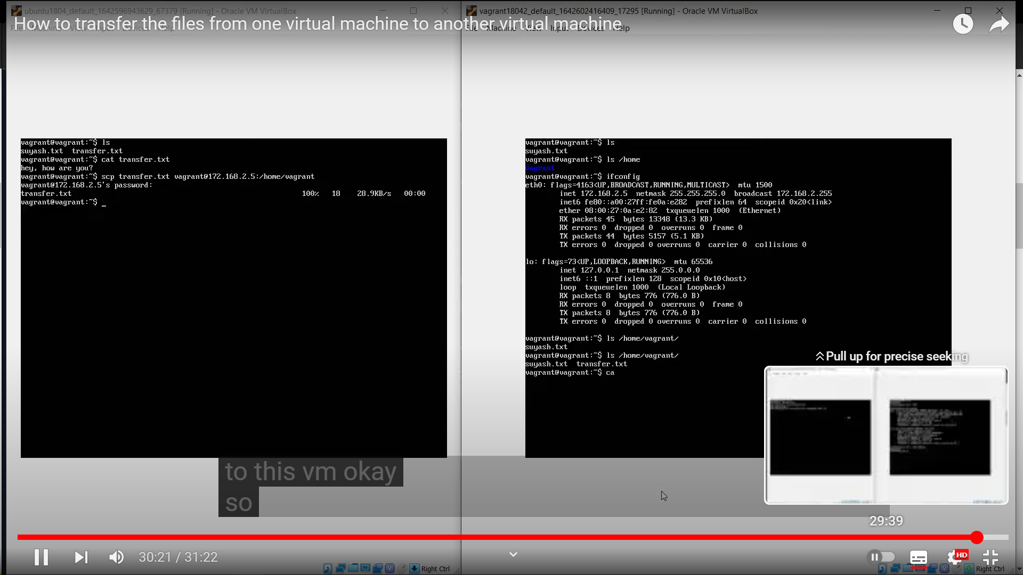

**Exp 3 Procedure:**  
  
Step 1: You have to type "Google cloud platform " in the browser.  
Click on the first link  
Step 2: Inside that web page, click on sign-in (appears on the top right side) with your email ID.  
Step 3: After that, you will see a search icon present there. There you have to type "install gcloud".  
Step 4: You have to click on the first link to install gcloud CLI.  
Step 5: A webpage will appear, scroll down a little bit, and you can see the text "Download and install gcloud CLI". Click on the highlighted text.  
Now, we have to click on that downloaded file, a dialog box will appear.  
Step 6: We have to select all the checkboxes. (Leave the beta commands checkbox).  
After the installation, click finish. Now, the gcloud terminal will get opened automatically.  
Step 7: Inside the terminal, it will ask  2 questions.  
1 question is "Do you want to log in?" Answer "y".  
It will take us to the Chrome Gmail page to sign in for authentication. After signing in, the page will show "You are now authenticated."  
Return to the terminal.  
Step 8: After that, it will ask 2nd question" Do you want to create a project?" Answer "N".  
Till now, we have completed the Installation of GAE.  
Step 9: Now we have to **create 2 files, namely "app. yaml, hello.py"**and save these 2 files in a new folder called app on the desktop.  
Step 10: Open Notepad, type the app. yaml code there, and save it.  
Next for the Python file, open Idle Python and type the hello world code in it  
  
**print ('helloworld');**  
  
Save the python file in the app folder.  
  
Step 11: app.YAML File code: (YAML is a configurable file) (Open Notepad and type the following code there, then save it as "app.yaml" and type as  "all files")   
  
runtime: python27  
api\_version: 1  
threadsafe: false  
  
handlers:  
- url: /  
  script: hello.py  
  
  
Save as: app.Yaml  
Type: all files

**Exp 6: Transfer the files from one VM to another VM**  
  
We used SCP protocol, which helps us to securely transfer the files from one VM to another VM.  
   
Requirements:  
1. Virtual Box   
2. should have 2 Virtual machines  
3. Install ubuntu in these VMs  
  
Notes:   
For the start of the experiment, you have to install virtual box and need to create 2 virtual machine with ubuntu as OS for these two. (for the procedure, refer exp 1)  
after completing these procedures, you should follow the steps from the below attached pdf.

EXP 5   
Procedure:  
CloudSim is a framework used for creating a cloud environment(simulation) (cloudsim3.0.3). This is written using java only.  
  
Requirements  
1. Eclipse ide (2023-9)  
2. CloudSim 3.0.3 (uses the language called Java) -- GitHub >scroll down>second file>.zip file  
3. Common math 3.0.6 Apache common > binaries--> zip file  
  
**Step 1**  
Open chrome. Type download Eclipse, Click on the first link within the page. Click on Eclipse download 2023-9(64-bit)  
After downloading click on the downloaded file  
select " java ide for developers "  
Click on the "installation" button  
After that click on "launch".  
  
  
**Step 2**  
Click on system search. Type system variables. Click on the "edit system variable".  
System variable dialogue box  appears. Below the dialogue box Click on "environmental variables" .  
An dialogue box will appear, in that 2nd box named as system variables >> scroll and search for "path"-- select that. Next click on edit then another dialogue box will open then click on new >>Open file explorer >>local disk C >> Program files >> java>> jdk-21>> bin. ( C:\Program Files\Java\jdk-21\bin) .Copy that path and paste in new box and click ok.  
  
**Step 3**  
Open Eclipse >> click on file >> new >> java project. Now a dialogue box will appear. Give the project name.  
Unselect the "use default location" then, click on browse >> downloads>> cloudsim 3.0.3>>cloudsim 3.0.3 (C:\Users\Dell\Downloads\cloudsim-3.0.3\cloudsim-3.0.3)  
Click on next. There will be a library tab open explorer >> Here, go to file explorer again, then copy the common math3-3.6.1 extracted jar file alone into the extracted  cloudsim-3.0.3 folder >> jar folder >> paste the file there.   
Click "finish"  
  
**Step 4**  
Open Eclipse >> click on the created project >> select cloudsim-3.0.3/example>>org.cloudbus.cloudbus.examples>> CloudSimExample1.java.  
CloudSimExample1.java will get opened, click on "run". A error in workspace dialog box may appear. Click on proceed.  
Then the console will be opened.

[[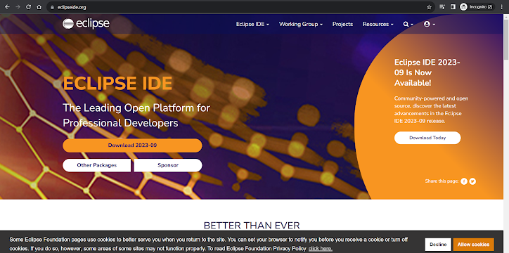](https://drive.google.com/file/d/16iR6_D49lQyjv19qynWpaIyWwfGp_1hC/view?usp=drive_web&authuser=0)](https://drive.google.com/file/d/16iR6_D49lQyjv19qynWpaIyWwfGp_1hC/view?usp=drive_web&authuser=0" \t "_blank)

[1st.png](https://drive.google.com/file/d/16iR6_D49lQyjv19qynWpaIyWwfGp_1hC/view?usp=drive_web&authuser=0" \t "_blank)

[[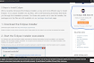](https://drive.google.com/file/d/1eiBj7byd7y7MPUzLIowjILimoZ6p8KR5/view?usp=drive_web&authuser=0)](https://drive.google.com/file/d/1eiBj7byd7y7MPUzLIowjILimoZ6p8KR5/view?usp=drive_web&authuser=0" \o "2nd.png" \t "_blank)

[2nd.png](https://drive.google.com/file/d/1eiBj7byd7y7MPUzLIowjILimoZ6p8KR5/view?usp=drive_web&authuser=0" \o "2nd.png" \t "_blank)

[Image](https://drive.google.com/file/d/1eiBj7byd7y7MPUzLIowjILimoZ6p8KR5/view?usp=drive_web&authuser=0" \o "2nd.png" \t "_blank)

[[](https://drive.google.com/file/d/1aBmIrhz1GL_i6vB504qJxXD8stiL-k59/view?usp=drive_web&authuser=0)](https://drive.google.com/file/d/1aBmIrhz1GL_i6vB504qJxXD8stiL-k59/view?usp=drive_web&authuser=0" \o "3rd.png" \t "_blank)

[3rd.png](https://drive.google.com/file/d/1aBmIrhz1GL_i6vB504qJxXD8stiL-k59/view?usp=drive_web&authuser=0" \o "3rd.png" \t "_blank)

[Image](https://drive.google.com/file/d/1aBmIrhz1GL_i6vB504qJxXD8stiL-k59/view?usp=drive_web&authuser=0" \o "3rd.png" \t "_blank)

[[](https://drive.google.com/file/d/1K6UD8nxLxhkFpy8aRaHC9jXljMR_FirT/view?usp=drive_web&authuser=0)](https://drive.google.com/file/d/1K6UD8nxLxhkFpy8aRaHC9jXljMR_FirT/view?usp=drive_web&authuser=0" \o "4th.png" \t "_blank)

[4th.png](https://drive.google.com/file/d/1K6UD8nxLxhkFpy8aRaHC9jXljMR_FirT/view?usp=drive_web&authuser=0" \o "4th.png" \t "_blank)

[Image](https://drive.google.com/file/d/1K6UD8nxLxhkFpy8aRaHC9jXljMR_FirT/view?usp=drive_web&authuser=0" \o "4th.png" \t "_blank)

[[](https://drive.google.com/file/d/1Yv5qA75hA4X-i-Ad4rGj4C0lX5dA_J63/view?usp=drive_web&authuser=0)](https://drive.google.com/file/d/1Yv5qA75hA4X-i-Ad4rGj4C0lX5dA_J63/view?usp=drive_web&authuser=0" \o "5th.png" \t "_blank)

[5th.png](https://drive.google.com/file/d/1Yv5qA75hA4X-i-Ad4rGj4C0lX5dA_J63/view?usp=drive_web&authuser=0" \o "5th.png" \t "_blank)

[Image](https://drive.google.com/file/d/1Yv5qA75hA4X-i-Ad4rGj4C0lX5dA_J63/view?usp=drive_web&authuser=0" \o "5th.png" \t "_blank)

[[](https://drive.google.com/file/d/1iHmUsbJ2j6Tz9PF2ZtsxgARGyywbedYb/view?usp=drive_web&authuser=0)](https://drive.google.com/file/d/1iHmUsbJ2j6Tz9PF2ZtsxgARGyywbedYb/view?usp=drive_web&authuser=0" \o "6th.png" \t "_blank)

[6th.png](https://drive.google.com/file/d/1iHmUsbJ2j6Tz9PF2ZtsxgARGyywbedYb/view?usp=drive_web&authuser=0" \o "6th.png" \t "_blank)

[Image](https://drive.google.com/file/d/1iHmUsbJ2j6Tz9PF2ZtsxgARGyywbedYb/view?usp=drive_web&authuser=0" \o "6th.png" \t "_blank)

[[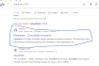](https://drive.google.com/file/d/1zdBgNYmMMeT68rMuu2BTX-XHUqAlb9tP/view?usp=drive_web&authuser=0)](https://drive.google.com/file/d/1zdBgNYmMMeT68rMuu2BTX-XHUqAlb9tP/view?usp=drive_web&authuser=0" \o "7th.png" \t "_blank)

[7th.png](https://drive.google.com/file/d/1zdBgNYmMMeT68rMuu2BTX-XHUqAlb9tP/view?usp=drive_web&authuser=0" \o "7th.png" \t "_blank)

[Image](https://drive.google.com/file/d/1zdBgNYmMMeT68rMuu2BTX-XHUqAlb9tP/view?usp=drive_web&authuser=0" \o "7th.png" \t "_blank)

[[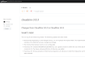](https://drive.google.com/file/d/1__aekabgBA_OakrZArs4CuCLfmN3jRyt/view?usp=drive_web&authuser=0)](https://drive.google.com/file/d/1__aekabgBA_OakrZArs4CuCLfmN3jRyt/view?usp=drive_web&authuser=0" \o "8th.png" \t "_blank)

[8th.png](https://drive.google.com/file/d/1__aekabgBA_OakrZArs4CuCLfmN3jRyt/view?usp=drive_web&authuser=0" \o "8th.png" \t "_blank)

[Image](https://drive.google.com/file/d/1__aekabgBA_OakrZArs4CuCLfmN3jRyt/view?usp=drive_web&authuser=0" \o "8th.png" \t "_blank)

[[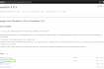](https://drive.google.com/file/d/1unqlK1rqr2xeFca7SI3qVhEKu2eTZZJQ/view?usp=drive_web&authuser=0)](https://drive.google.com/file/d/1unqlK1rqr2xeFca7SI3qVhEKu2eTZZJQ/view?usp=drive_web&authuser=0" \o "9th.png" \t "_blank)

[9th.png](https://drive.google.com/file/d/1unqlK1rqr2xeFca7SI3qVhEKu2eTZZJQ/view?usp=drive_web&authuser=0" \o "9th.png" \t "_blank)

[Image](https://drive.google.com/file/d/1unqlK1rqr2xeFca7SI3qVhEKu2eTZZJQ/view?usp=drive_web&authuser=0" \o "9th.png" \t "_blank)

[[](https://drive.google.com/file/d/1GS3azFJcOXRHOu2U233bCR59Xa8R3oCV/view?usp=drive_web&authuser=0)](https://drive.google.com/file/d/1GS3azFJcOXRHOu2U233bCR59Xa8R3oCV/view?usp=drive_web&authuser=0" \o "10th.png" \t "_blank)

[10th.png](https://drive.google.com/file/d/1GS3azFJcOXRHOu2U233bCR59Xa8R3oCV/view?usp=drive_web&authuser=0" \o "10th.png" \t "_blank)

[Image](https://drive.google.com/file/d/1GS3azFJcOXRHOu2U233bCR59Xa8R3oCV/view?usp=drive_web&authuser=0" \o "10th.png" \t "_blank)

[[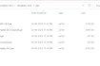](https://drive.google.com/file/d/1ljl-4dO2IEl8TrC57kAyI-D1RNjXVXz7/view?usp=drive_web&authuser=0)](https://drive.google.com/file/d/1ljl-4dO2IEl8TrC57kAyI-D1RNjXVXz7/view?usp=drive_web&authuser=0" \o "copy paste the jar file.png" \t "_blank)

[copy paste the jar file.png](https://drive.google.com/file/d/1ljl-4dO2IEl8TrC57kAyI-D1RNjXVXz7/view?usp=drive_web&authuser=0" \o "copy paste the jar file.png" \t "_blank)

[Image](https://drive.google.com/file/d/1ljl-4dO2IEl8TrC57kAyI-D1RNjXVXz7/view?usp=drive_web&authuser=0" \o "copy paste the jar file.png" \t "_blank)

[[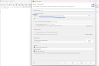](https://drive.google.com/file/d/1PPRRR9monNKly1Xd9xFRml391scF8Ypj/view?usp=drive_web&authuser=0)](https://drive.google.com/file/d/1PPRRR9monNKly1Xd9xFRml391scF8Ypj/view?usp=drive_web&authuser=0" \o "New java project SS.png" \t "_blank)

[New java project SS.png](https://drive.google.com/file/d/1PPRRR9monNKly1Xd9xFRml391scF8Ypj/view?usp=drive_web&authuser=0" \o "New java project SS.png" \t "_blank)

[Image](https://drive.google.com/file/d/1PPRRR9monNKly1Xd9xFRml391scF8Ypj/view?usp=drive_web&authuser=0" \o "New java project SS.png" \t "_blank)

[[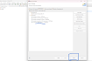](https://drive.google.com/file/d/1RSCBrjpy3_5k1uqVkhP3EuNCQMZtIjB2/view?usp=drive_web&authuser=0)](https://drive.google.com/file/d/1RSCBrjpy3_5k1uqVkhP3EuNCQMZtIjB2/view?usp=drive_web&authuser=0" \o "Java Settings.png" \t "_blank)

[Java Settings.png](https://drive.google.com/file/d/1RSCBrjpy3_5k1uqVkhP3EuNCQMZtIjB2/view?usp=drive_web&authuser=0" \o "Java Settings.png" \t "_blank)

[Image](https://drive.google.com/file/d/1RSCBrjpy3_5k1uqVkhP3EuNCQMZtIjB2/view?usp=drive_web&authuser=0" \o "Java Settings.png" \t "_blank)

[[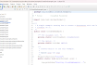](https://drive.google.com/file/d/1opRqvbOwhg8rM4mhcDCzZgu4nimm0_fV/view?usp=drive_web&authuser=0)](https://drive.google.com/file/d/1opRqvbOwhg8rM4mhcDCzZgu4nimm0_fV/view?usp=drive_web&authuser=0" \o "cloudsimexample1.java SS.png" \t "_blank)

[cloudsimexample1.java SS.png](https://drive.google.com/file/d/1opRqvbOwhg8rM4mhcDCzZgu4nimm0_fV/view?usp=drive_web&authuser=0" \o "cloudsimexample1.java SS.png" \t "_blank)

[Image](https://drive.google.com/file/d/1opRqvbOwhg8rM4mhcDCzZgu4nimm0_fV/view?usp=drive_web&authuser=0" \o "cloudsimexample1.java SS.png" \t "_blank)

[[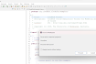](https://drive.google.com/file/d/1qolH0fHVKBgoMPt4eFN9B0ZSAoXcNnMv/view?usp=drive_web&authuser=0)](https://drive.google.com/file/d/1qolH0fHVKBgoMPt4eFN9B0ZSAoXcNnMv/view?usp=drive_web&authuser=0" \o "Errors proceed.png" \t "_blank)

[Errors proceed.png](https://drive.google.com/file/d/1qolH0fHVKBgoMPt4eFN9B0ZSAoXcNnMv/view?usp=drive_web&authuser=0" \o "Errors proceed.png" \t "_blank)

[Image](https://drive.google.com/file/d/1qolH0fHVKBgoMPt4eFN9B0ZSAoXcNnMv/view?usp=drive_web&authuser=0" \o "Errors proceed.png" \t "_blank)

[[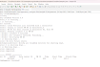](https://drive.google.com/file/d/1Fd9qwR1-KuoflRTBah5LqnZ1_WYvo7b8/view?usp=drive_web&authuser=0)](https://drive.google.com/file/d/1Fd9qwR1-KuoflRTBah5LqnZ1_WYvo7b8/view?usp=drive_web&authuser=0" \o "Output.png" \t "_blank)

[Output.png](https://drive.google.com/file/d/1Fd9qwR1-KuoflRTBah5LqnZ1_WYvo7b8/view?usp=drive_web&authuser=0" \o "Output.png" \t "_blank)

[Image](https://drive.google.com/file/d/1Fd9qwR1-KuoflRTBah5LqnZ1_WYvo7b8/view?usp=drive_web&authuser=0" \o "Output.png" \t "_blank)

Hadoop

Java version 1.8

Hadoop 2.8.0

Configuration files

<https://muhammadbilalyar.github.io/blogs/How-to-install-Hadoop-on-Window-10/>

extract them to c drive folder

right click file manager

system settings-advanced settings-system variables-environemnt varibales-java\_home-path to java-

Hadoop home-path to Hadoop

Set path to java:path to Hadoop:path to java

In Hadoop folder create data folder:subfolders datanode,namenode

Hadoop-etc-coresite.xml add configuration code

Mapred config

Hdfs configure add path datanode,namenode

Yarn site

Haddop.env

<configuration>

<property>

<name>yarn.nodemanager.aux-services</name>

<value>mapreduce\_shuffle</value>

</property>

<property>

<name>yarn.nodemanager.auxservices.mapreduce.shuffle.class</name>

<value>org.apache.hadoop.mapred.ShuffleHandler</value>

</property>

</configuration>

Hadoop configuration files-bin-copy paste to haddop binn

Command prompt -run as admin- hdfs nanenode - format

cd\

cd haddopsbin path

start -all.cnd

4 images appear

Go chrome -localhost 8088

Haddop installed

Netbeans ...file..project.new project .project name.mapteduce client ..word count.java......rightclick mapreduce... properties..libraries..add jar file...click okay

Run..clean main project....build successful...

Open the path jar .. mapreduce client .build..dist...mapreduceclient.jar....copy to c drive....create wordcount.text...wordvount.java

cd/

cd hadoop bin path

Hdfs namenode format

Show with status zero cd ..

cd sbin

Cd start -all.cnd

hadoop dfsadmin -safenode leave

hadoop fs -nkdir /input\_dir

hadoop fs-put wordcount.txtpath /input\_dir

: hadoop dfs -cat /input\_dir

hadoop fs -ls /input\_dir

hadoop dfs -cat /input\_dir/wordcount.txt

hadoop jar C:/MapReduceClient.jar wordcount /input\_dir /output\_dir

hadoop dfs -cat /output\_dir/\*