Hybrid MODWT–ANN Model for Short-Term and Long-Term Electricity Load Forecasting
Abstract
Forecasting electricity demand constantly is essential for operational planning, maintaining system stability and unit commitment. To address the difficulties associated with non-stationary and non-linear load changes, this study presented a hybrid model for short-term and long-term load forecasting (STLF and LTLF). New York Independent System Operator (NYISO) is the dataset used in this study. This dataset comprises meteorological variables such as humidity, temperature, calendar attributes and seasonal indicators, along with hourly load profiles across 12 regions. To decompose load and weather inputs into multi-scale features, the proposed methodology utilizes the Maximal Overlap Discrete Wavelet Transform (MODWT) and Stationary Wavelet Transform (SWT), which are consequently used for day-ahead demand prediction by an Artificial Neural Network (ANN). Comparing our proposed MODWT-ANN and SWT-ANN hybrid approach, SWT-ANN significantly exceeds the standalone ANN model, with the coif1 wavelet family gives the highest accuracy of MAPE = 0.18678, RMSE = 3.5506, and NRMSE = 0.00228 for short-term load forecasting (STLF) and with the db2 wavelet family gives the highest accuracy of MAPE = 1.51416, RMSE = 26.65095, and NRMSE = 0.02721 for long-term load forecasting (LTLF). However, the models limited flexibility to regions with substantially distinct consumption trends and the way it depends on huge, reliable data sets limit its efficiency.
KEYWORDS: Short-term load forecasting (STLF), long-term load forecasting (LTLF), NYISO, ANN (Artificial Neural Network), MODWT (Maximal Overlap Discrete Wavelet Transform), SWT (Stationary Wavelet Transform)
- Introduction
  - Background
Electricity demand for upcoming months, days and hours should be accurately predicted to make sure reliable power generation and distribution. Once upon a time, when electricity was primarily used for public lighting, forecasting demand was slightly easy, while counting the number of light bulbs and multiplying by the power they utilize. But these days, forecasting the energy is much more difficult. Energy is consumed, when the switch is pressed.
Due to climate change, the intensity and frequency of heatwaves are globally increasing [1]. Predicting the demand for the next few hours to some days for the power system defines the Short-Term Electricity-Load Forecasting (STELF). The data that is loaded fluctuates and becomes non-linear, when electricity demand is affected. It is because of some external factors, such as change in weather and the appearance of new electricity consumption scenarios [2]. Multiple factors such as holiday patterns, user behavior and meteorological conditions can affect the power load sequences, which exhibits non-stationarity and difficulty. Insufficient feature representation and mode mixing are some of the challenges faced by Conventional forecasting methods [3].
Forecasting and load scheduling for power grid systems are now subject to stricter restrictions due to the increasing complexity of power systems and the non-linearity of the data being loaded [11]. The three main categories of electric load forecasting methods are machine learning, deep learning, and conventional approaches. The unpredictability of renewable energy sources and sudden shifts in the market are frequently taken into consideration by traditional forecasting models.
In these situations, creating powerful forecasting algorithms capable of accurately predicting both short-term and long-term electricity loads has become critical. The predicting of power demand for the next few weeks is known as short-term load forecasting (STLF), which aids administration departments and power companies in creating and modifying production plans to guarantee the stability and security of the power system. Short-term Load Forecasting (STLF) has mostly been utilized for load demand and production modification, with the goal of delivering optimal utilization plans in the electricity market. Horizons longer than a year are referred to as long-term load forecasting (LTLF) [34]. Long-term load forecasting (LTLF) is essential for modern power systems' efficient operation, long-term planning, and market transactions, as well as for ensuring grid stability, allocating resources efficiently, and cutting operating costs [35].
This work uses MODWT-ANN and SWT-ANN to create a hybrid model for short-term load forecasting (STLF) and long-term load forecasting (LTLF). This study suggests a hybrid approach that combines Artificial Neural Networks (ANN) with Maximal Overlap Discrete Wavelet Transform (MODWT) and Stationary Wavelet Transform (SWT) for short-term and long-term load forecasting due to the improving complexity of modern power systems and the difficulty of traditional forecasting techniques. To improve the precision and resilience of day-ahead demand forecasting, the work employs MODWT-ANN and SWT-ANN. Compared to separate models, this hybridization is anticipated to offer more adaptability to changing load circumstances.
  - Literature Review
A.A.A. El-Ela et al. used updated ANN algorithms for long-term peak load forecasting to assess the Egyptian Central Power System (CPS)'s installed power capacity through 2017. Additionally, a suggested method is used to assess how well wind farms operate, with different proportions of wind farms connected to the CPS up until 2007. Large-scale wind farms can be built in Zafarana on Egypt's Red Sea coast, which has been selected as a suitable location for the implementation of the suggested approach with 3% of the total operational capacity, which has been successfully implemented. In comparison to the linear trend curve, it can be found that the modified ANN technique forecasts peak load demand with more accuracy [24].
D. Ali et al. developed a fuzzy-neuro model based on temperature and humidity to forecast the load in Mubi, Adamawa State, for the next year. The Meteorological Center of the Adamawa State University (MCADSU), Department of Geography donated the temperature (T) and relative humidity (RH) meteorological parameters for the dataset. The historical power usage figures for 2013 and 2014 were submitted by Yola Electric Distribution Company (YEDC), Mubi Business Unit, Adamawa State. The forecasting accuracy is 98.78% with a Mean Absolute Percentage Error (MAPE) of 1.22%. This ensures that fuzzy-neuro is the optimum approach for load forecasting [23].
M.Q. Raza et al. created a new load forecasting model based on feed-forward ANN to anticipate hourly load demand throughout the year. This study uses load records from the Independent System Operator (ISO) New England Regional Transmission Organization (ISO-NE RTO)-controlled power grid. The findings are produced in accordance with the Levenberg–Marquardt (LM), Backpropagation (BP), and Global Particle Swarm Optimization (GPSO) training approaches using a number of ANN load forecasting models. The suggested GPSO training framework produces an overall coefficient of determination (R²) score of 0.9923 and a MAPE of 1.40%. Furthermore, compared to the LM and BP-based methods, the prediction accuracy of the GPSO-based model is higher. In terms of forecast accuracy, computational complexity, and convergence time, it can be demonstrated that the suggested GPSO-based model performs better than the LM and BP approaches [22].
G.-F. Fan et al. presented a novel power load forecasting method called the Phase Space Reconstruction–Back-Stepping (PSR-BSK) model, which combines the PSR algorithm with the BSK regression model. Two power demand datasets from NYISO in the USA and the New South Wales (NSW), Australia location are used for execution. The PSR model is a handy tool for examining the random aspects of non-linear signals. The parameters and hidden information displayed in the high-dimensional dynamical space of the primary system are extracted using the Integral of Correlation (C-C) model. Each power demand data point would be further evaluated using a Recurrence Plot (RP). Following spatial structure assessments, m (the embedded measure in the PSR model), STLF is modeled using BSK regression techniques. The results reveal that, when compared to other forecasting algorithms, the proposed PSR-BSK approach usually receives minimal predicting errors (MAPE < 2.20%, Root Mean Squared Error (RMSE) < 30.0, and Mean Absolute Error (MAE) < 2.30) and has the shortest running time (less than 400 seconds) [21].
To forecast power loads one day ahead of time, S. Fan et al. introduce a new forecasting model that combines Bayesian Clustering by Dynamics (BCD) and Support Vector Regression (SVR), two machine learning algorithms. For the case study, the NYISO's hourly electricity use and the meteorological data collected in Central Park were examined. The comparison between ISO and the proposed Machine Learning Forecast (MLF) for the New York system demonstrates that the MLF has an average MAPE of 1.96% and a MAE of 129.49 MW, whereas the ISO has an average MAPE of 2.79% and an MAE of 175.70 MW. For the Western Farmers Electric Cooperative (WFEC) control point in Oklahoma State, the MLF has an average MAPE of 2.84% and an MAE of 26.23 MW, whereas the Neural Network (NN) approach has an average MAPE of 5.49% and an MAE of 51.17 MW [20].
An SVR method for power demand forecasting that combines Auto Regression (AR) with the Differential Empirical Mode Decomposition (DEMD) technique is described by G.-F. Fan et al. Electric demand data from the New South Wales (NSW), Australia grid and NYISO, USA, are used to compare the forecasting performance of various alternative techniques. A Wilcoxon Signed-Rank Test at the 0.025 and 0.05 critical levels in one-tail tests is used to statistically assess the prediction results between genuine SVR, Autoregressive Integrated Moving Average (ARIMA), Adaptive Fuzzy Cognitive Map (AFCM), PSO–SVR, PSO–BP, Genetic Algorithm–Artificial Neural Network (GA–ANN), Backpropagation Neural Network (BPNN), and DEMD–SVR–AR algorithms. The proposed DEMD–SVR–AR methodology outperforms previous approaches at a threshold level of 0.05, confirming that it can consistently produce forecasts with the highest level of accuracy and interpretability [19].
M. Ghayekhloo et al. present a hybrid approach for forecasting power prices that incorporates a novel time series data mining technique to improve feature selection. The framework uses neural gasoline in conjunction with aggressive mastering to provide greater vector quantization, as well as grouping, preprocessing, and training tiers. Six techniques are used to enable the non-dominant neuron to participate in the selection. The most pertinent group is selected as input to the Bidirectional Recurrent Neural Network (BRNN) using a unique cluster selection strategy based on the persistence method. The suggested clustering yields more accurate results of 16.7%, 28.6%, and 13%. The results show that the Elman Network method, the proposed methodology plus Wavelet Analysis (WA), and the BRNN all performed better than each other. Because hybrid models become more challenging as data increases, the proposed approach may not be suitable, and data flexibility is a major restriction [18].
Using an upgraded deep learning algorithm with Time Series Trend Attention (TSTA) and increased two-layer decomposition, X. Cui et al. present a new ultra-short-term electricity demand forecasting method based on Enhanced Northern Goshawk Optimization (INGO). They forecasted and assessed two datasets to test the forecasting model's performance. Dataset 1 comprises 30-minute forecasts and electrical load data for a state in Australia from 2008 to 2010. The power system firm in northern China assigned data on electricity demand over a 15-minute period to Dataset 2. An Improved Variational Mode Decomposition (IVMD)–Sparse Group Mode Decomposition (SGMD)–INGO–Bidirectional Long Short-Term Memory (BiLSTM)–Trend Pattern Attention (TPA)–Temporal Convolution Network (TCN) load forecasting approach is given in this research. According to the statistics, the INGO performed better in terms of optimization and had smaller error indications than the other models. Finally, due to the limitations of the tools and datasets, daily forecasts throughout the quarter and year were not perceived [17].
S.A. Nabavi et al. used machine learning approaches such as Long Short-Term Memory (LSTM), Discrete Wavelet Transform LSTM (DWTLSTM), Nonlinear Autoregressive Network with Exogenous Inputs (NARX) neural network, and Support Vector Machine (SVM) models to evaluate power usage under usual contexts and over major social events in a variety of geographical settings with different climates, calendars, and civilizations. The electrical load dataset for Iranian case studies is acquired utilizing the German electricity market data platform (SMARD) and the Iranian Grid Management Company (IGMC) online electricity data center. Their results indicate that the DWTLSTM technique has the best accuracy, with MAPE for both short-term and long-term estimations ranging from 0.29% to 3.02% for Germany and 0.59% to 4.2% for Iran [16].
B.L.M. Kamana-Williams et al. offer an agent-based model (ABM) solution to residential electrical load in low-voltage networks. It is designed using high-level census data and may therefore be widely expanded to locations with equivalent data. Sub-models for space heating, water heating, and appliance consumption are employed in MATLAB R2022b to develop the approach. Data from home vessel usage across the country and real power load patterns from low-voltage dispersion transformers in Aotearoa, New Zealand, are used to validate it. The agent-based model depicted effectively anticipates regional household electricity demand using demographic data and general behavior trends. Energy modelers are known to be concerned about the availability and accessibility of high-quality power load data in the nation [15].
A new forecasting approach based on Generalized Additive Models (GAMs) created from interpretable Penalized splines (P-splines) and augmented with autoregressive (AR) post-processing is described by M. Zimmermann and F. Ziel. Load data collected from 24 European states over a span of more than nine years, from 2015 to 2024, is used to test the proposed method. They create an understandable, efficient, and reliable two-stage GAM for Europe in order to estimate mid-term hourly loads. SRWW, SRWA, STL, VanRec, VanDet, VanBas, ARWD, Feedforward Neural Network (FNN), CLIM, CL-ETS, GAM, \AR, \HLD, \Temp, \States, and Day-Ahead Transmission System Operator (DA TSO) models were among the GAM models trained in this work. In every nation covered by the study, recommended GAM models such as GAM, \AR, \HLD, \Temp, \States surpass all benchmark methods except FNN and GAM-type approaches (CLIM, CL-ETS). In terms of calculation time, the FNN is the primary constraint on the GAM techniques [14].
S. Mo et al. introduce a new Multi-Resolution Graph Neural Network (MRGNN) that uses Frequency-enhanced Direct Forecast (FreDF) and a multi-scale patching strategy. They conducted observations on actual urban power load datasets in order to investigate the suggested method. Several time series forecasting techniques, including Gated Recurrent Unit (GRU), Long Short-Term Memory (LSTM), Multilayer Perceptron (MLP), Informer, Pyraformer, and Transformer, are compared in this study. Interestingly, MRGNN outperformed all baseline methods in 92 of the 96 findings. A frequency-enhanced loss function also maps predicted values to actual values in both the frequency and time domains, eliminating label correlation concerns [13].
Q. Yan et al. provide a multi-factor cooperative load forecasting method based on multi-scale feature extraction and feature importance. The data utilized in this work were obtained from publicly accessible real-world data sources, including climatic conditions, electric load, and energy price details for a specific location in New Jersey, USA, from 2023 till 2024, with an hourly recording time. Empirical results show that, when compared to a variety of cutting-edge forecasting techniques such as Multi-channel Convolutional Neural Network (Multi-channel-CNN), LSTM, LSTM-Transformer, Attention-Mechanism Temporal Convolutional Network–Bidirectional LSTM (AM-TCN-BiLSTM), and Multi-Factor Spatio-Temporal Graph Neural Network (MFST-GNN), the proposed method reduces MAE by 28.30%, RMSE by 24.14%, and MAPE by 30.35%, indicating high adaptability, particularly when managing different multivariate coupling relationships. Incomplete data and feature variance are the main real-world issues in this study [12].
In order to anticipate short-term power load, Hongjie Li et al. suggest a CrossInformer method based on dual-layer decomposition and insightfulness. An unevenly collected multivariate time series dataset is used in this investigation. The CrossInformer first selects features using an intelligent optimization strategy, then reduces noise in the load data using an Improved Complete Ensemble Empirical Mode Decomposition with Adaptive Noise–Robust Local Mean Decomposition (ICEEMDAN-RLMD) dual-layer decomposition technique, and then employs the SHapley Additive exPlanations (SHAP) method to improve the model's clarity. With the lowest Mean Squared Error (MSE) of 0.28, MAE of 0.362, RMSE of 48.63, and MAPE of 4.3, CrossInformer outperforms other methods, indicating that it effectively increases prediction accuracy and surpasses cutting-edge time-series forecasting methodologies [11].
Nahid Sultana presents two new hybrid approaches, Bayesian Optimization Algorithm–Long Short-Term Memory (BOA-LSTM) and Bayesian Optimization Algorithm–Nonlinear Autoregressive Network with Exogenous Inputs (BOA-NARX), that use enhanced recurrent neural networks—LSTM and Nonlinear Autoregressive Networks with Exogenous Inputs (NARX)—to implement Bayesian Optimization Algorithms (BOA). Outdoor temperature (°F), hourly electrical load (kilowatt-hour, kWh), wind speed (miles per hour, mph), air pressure (inches, in), and humidity (%) were the five time series that made up the hourly data used in this study. This work employs three common methodologies—Seasonal Heteroskedastic Autoregressive Integrated Moving Average with Exogenous Variables (SHARIMAX), NARX, and LSTM—to produce day-ahead power load prediction strategies for four different seasons. Empirical investigations show that the BOA-LSTM model consistently performs well in all seasons, with coefficient of determination (R²) values over 0.99 and much lower predicting errors [10].
Wavelet Transform Convolution–inverted ProbSparse Transformer (WTC-iPST), a breakthrough deep learning system created exclusively for short-term load forecasting, is presented by Yi Ji et al. The Tetouan electrical load dataset is utilized from the University of California, Irvine (UCI). 52,416 data points were gathered at ten-minute intervals to construct the dataset. Several multistep forecasting algorithms, including PatchTST, iTransformer, Informer, Temporal Convolutional Network (TCN), Transformer, Gated Recurrent Unit (GRU), and Long Short-Term Memory (LSTM), were related to WTC-iPST. According to experimental data, WTC-iPST surpasses state-of-the-art prediction models. It greatly beats the simple iTransformer, with increases of up to 2.96% in coefficient of determination (R²) and reductions of up to 18.09% in MAPE, 16.84% in RMSE, and 17.65% in Relative Root Mean Square Error (RRMSE). WTC-iPST requires a significant number of exceptional historical records for training, and the approach's predictive performance may decline [9].
A hybrid deep learning method called Convolutional Neural Network–Bidirectional Long Short-Term Memory–Autoregressive (CNN-BiLSTM-AR) was employed by H. Mubarak et al. to forecast electricity costs one day in advance. This study made use of a dataset of real electricity prices acquired from the UK's electrical market. Additionally, a dataset about the German electrical market was gathered. The integrated approach successfully integrates an Autoregressive (AR) model, a Bidirectional Long Short-Term Memory (BiLSTM) network, and a Convolutional Neural Network (CNN). Additionally examined is the impact of using hyperparameter optimization methods such as Particle Swarm Optimization (PSO), Genetic Algorithm (GA), and Random Search (RS). The results show that the addition of Hyperparameter Optimization (HPO) methods significantly improves the prediction capabilities of the proposed method, with the PSO-CNN-BiLSTM-AR model achieving the most dramatic reductions in RMSE by 16.7% and MAE values by 23.46% for the German power spot, respectively [8].
A comprehensive and effective solution to the problem of forecasting energy load demand an hour or a day ahead of time is offered by J. Ding, M. Wang, Z. Ping, et al. The NYISO provides weather and load data. To further enhance prediction results, the method employs feature selection and wavelet transformation as crucial pretreatment procedures for Relevance Vector Machine (RVM). RVM has an hour-ahead MAE of 8.46 and a MAPE of 0.74% and a day-ahead MAE of 24.19 and a MAPE of 1.82% when compared to other models such as Support Vector Machine (SVM), ANN, Double Exponential Smoothing (DES), Haar Wavelet Transform (HWT), and Seasonal Autoregressive Integrated Moving Average (SARIMA). A comprehensive experimental comparison shows that the provided RVM-based integrated solution performs better on short-term load forecasting than both traditional time series methods and cutting-edge artificial intelligence systems [7].
Y. Guo et al. introduce a hybrid short-term electric power price prediction system that considers the Wavelet Transform (WT) series' long-term relationships. Forecasting and inspection rely on real-world data from the NYISO and Pennsylvania–New Jersey–Maryland (PJM) markets. The model is divided into four modules: the Seasonal Autoregressive Integrated Moving Average–Long Short-Term Memory (SARIMA-LSTM) hybrid forecasting model, the electricity price series renewal, the electricity price series separation based on WT, and the long-term dependence analysis. The recommended strategy was contrasted with five more state-of-the-art models: Convolutional Neural Network–Long Short-Term Memory (CNN-LSTM), Backpropagation Neural Network (BPNN), SVM, LSTM, and Autoregressive Integrated Moving Average (ARIMA). The recommended approach can increase forecast accuracy by up to 50.98% and stability by up to 68.09% [5].
An intelligible deep-learning neural network (Attention Network, ATTnet), created by H. Yang and K. R. Schell, uses an attention mechanism to provide a comprehensible model pipeline and precise power market price prediction. From the 537 historical market pricing data available on the NYISO official website, eight sources that were both technically and geographically representative were chosen. Regular sampling from the NYISO load subzones was only partially successful in achieving generator variety. The suggested framework, ATTnet, outperforms the most advanced models (Hierarchical Fusion Network, HFnet, Graph Hybrid Transformer Network, GHTnet, and Quantized Convolutional Autoencoder, QCAE) with an average MAE and MAPE decrease of 7.69% and 7.81%, respectively. The suggested approach outperforms the most advanced baseline approaches by 21% in MAE and 22% in MAPE [4].
Y. Xiao et al. describe a Bidirectional Long Short-Term Memory (BiLSTM)-based power load forecasting technique that combines Time Series Generative Adversarial Network (TimeGAN) with a dual attention mechanism. This study performed an experimental analysis utilizing real summer electricity use data from a city in China's Fujian Province between 2021 and 2022. The proposed approach was compared with several popular deep learning frameworks, such as CNN, GRU, TCN, BiLSTM, Transformer, and the hybrid model CNN+BiLSTM+Attention. The findings showed that among single models, BiLSTM performs better than CNN, TCN, and GRU. The three important areas where the proposed method shines are the best forecasting accuracy MAPE minimizations of 18.03% and 33.62% on residential and public service data, respectively), increased interpretability, and improved generalization power. Although it still had some issues simulating the midnight peak of residential load in the heatwave states, the model worked rather well during the daytime peak interval, accurately reproducing the patterns of rapid load rise with rising temperatures [1].
  - Contributions
To address the drawbacks of traditional forecasting techniques in controlling non-linear and non-stationary electricity demand trends, this paper introduces a hybrid load forecasting framework that integrates wavelet-based signal decomposition with Artificial Neural Networks (ANN). The framework improves feature extraction for both short-term and long-term load forecasting applications by combining the Stationary Wavelet Transform (SWT) with the Maximal Overlap Discrete Wavelet Transform (MODWT). ANN models use the multi-scale components of load and meteorological time series to increase prediction accuracy. The framework is authenticated using real-world data from the NYISO, demonstrating best predictive accuracy compared to standalone ANN models. The key contributions of this study are as follows:
- This experiment is executed using the NYISO dataset, which includes hourly load data across 12 regions along with meteorological and calendar-related attributes, ensuring real-world applicability.
- A novel hybrid forecasting framework that integrates MODWT and SWT with ANN is designed to efficiently record the non-linear and non-stationary dynamics of electricity demand data.
- Experimental comparisons describe that the SWT-ANN framework consistently outperforms the baseline ANN model, with the coif1 wavelet family achieving the MAPE of 0.18676 for Short-term load forecasting and db2 wavelet family achieving the MAPE of 1.51416 for Long-term load forecasting.
- Materials
NYISO observes the dependability of the power system and correlates the daily tasks to spread electricity supply. The hourly electric load data with their weather information from the NYISO for 12 different regions are available in this dataset. The hourly power data for 12 different regions are fetched. The weather details that are collected are as follows:
$f_{1}….f_{8}$: Max Temperature of current day and last seven days
$f_{9}….f_{16}$: Min Temperature of current day and last seven days
$f_{17}$: Maximum humidity
$f_{18}$: Minimum humidity
$f_{19}$: Month of the year
$f_{20}$: Season
$f_{21}$: Week number of the year
$f_{22}$: Weekend indicator (1 if weekend, 0 otherwise)
- Methods
The load power data, together with relevant calendar and weather information, are provided by the NYISO dataset. As noted in the prior section, load forecasting considers a total of 22 input features. The proposed method aims to effectively capture both the temporal features of load demand and the influence of weather conditions.
The selected features are preprocessed before being transferred to the Stationary Wavelet Transform (SWT) and Maximal Overlap Discrete Wavelet Transform (MODWT) for signal decomposition. These wavelet transforms allow you to recover both high-frequency (detail) and low-frequency (approximation) subband information by breaking down the original load signal into many frequency components. The multi-resolution characteristics of the load signal are reflected in the 176 wavelet coefficients produced by the decomposition method.
The wavelet coefficients obtained are fed into an Artificial Neural Network (ANN) model to anticipate load. Backpropagation-based feedforward neural networks have three layers: input, hidden, and output. The ANN discovers the nonlinear connection between the electrical load demand and the decomposed wavelet features.
The electrical load is then predicted for the next 24 hours using the trained ANN model. Lastly, the forecasting performance is assessed by comparing the expected load values and the actual load data. Standard error metrics are used to quantify the prediction accuracy, and the error performance is used to confirm the effectiveness of the proposed MODWT-ANN and SWT-ANN models. Fig 1 shows the framework of the Electricity Load Forecasting.
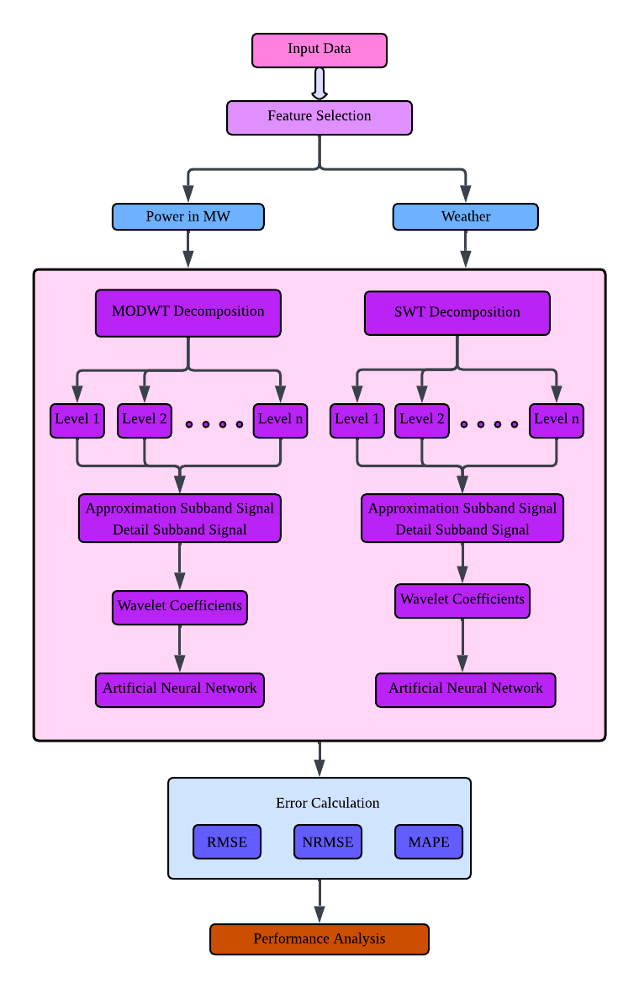
Fig 1. Framework for Electricity Load Forecasting
  - Maximal Overlap Discrete Wavelet Transform (MODWT)
This paper uses a data pre-processing strategy to solve potential difficulties with non-stationarity operations in an SVR model's input data, such as model overfitting. One approach is to divide a time series signal into its corresponding subsignals. However, MODWT is not the same as the original DWT. Although discrete wavelet transformation (DWT) algorithms have been employed in numerous previous investigations, the algorithm's decimation effects still present significant challenges. By combining translation invariance with the efficiency of multi-scale analysis, the maximal overlap discrete wavelet transform (MODWT) demonstrates unique technological advantages [25]. There are different types of Wavelet Families are given in table 2.
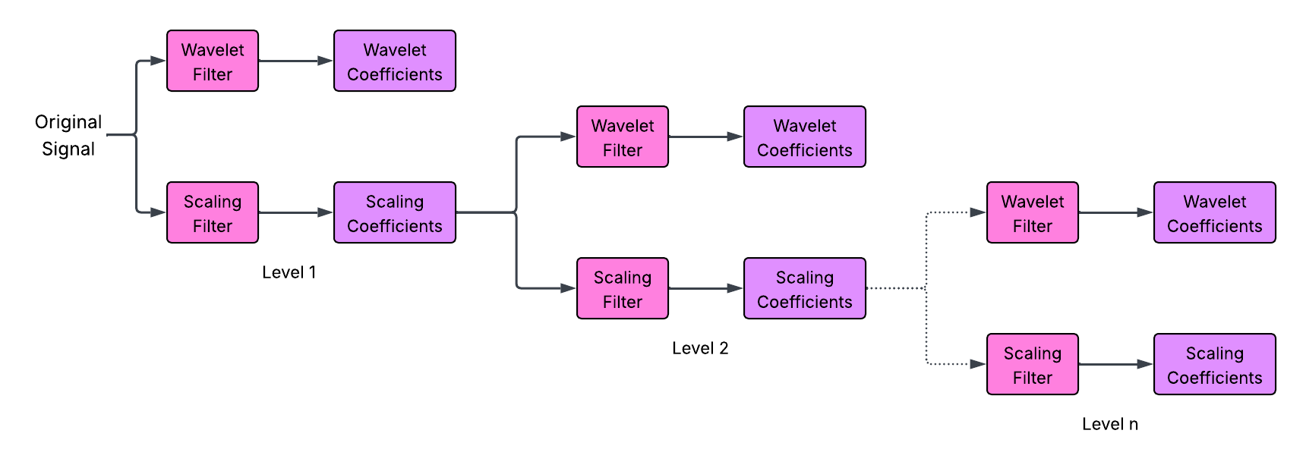
Fig 2. MODWT Decomposition
This research used the maximal overlap discrete wavelet transform (MODWT). MODWT is a non-orthogonal, redundant transform that generates column vectors for a time series $[x]$, in contrast to typical DWT-based models that could add bias because of decimation and the inclusion of future data in model construction. To obtain the first-level wavelet coefficients (detail) and scaling coefficients (approximation), the initial signal $x(n)$ is filtered using a wavelet (high-pass) filter and a scaling (low-pass) filter. The Level 1 scaling coefficients are processed again through the wavelet and scaling filters to produce the Level 2 wavelet and scaling coefficients. Because this procedure is repeated as needed at several levels, the MODWT can record the signal's high-frequency and low-frequency components at each phase without losing any information. Figure 2 shows how the multilevel MODWT decomposition improves the forecasting accuracy and durability of the proposed model. Table 1 lists the wavelet families used for electrical load forecasting.
$W_{k,m}= \sum_{l=0}^{L_{k}-1}{H_{k,l}Y_{m-l mod N}} (1)$
$X_{k,m}=\sum_{l=0}^{L_{k-1}}{J_{k,l}Y_{m-l mod N}}$ (2)
S. No. | Family | Short name | Order N | Examples
1 | Coiflets | coif | N = 1, 2, …., 5 | coif2, coif4
2 | Daubechies | db | N = a positive integer from 2 to 45 | db4, db15
3 | Fejer-Korovkin | fk | 4, 6, 8, 14, 18, 22 | fk4, fk8
4 | Symlets | sym | N = 2, 3, …., 45 | sym2, sym8
Table 1. Wavelet Families
  - Stationary Wavelet Transform (SWT)
Nason and Silverman [36] suggested the stationary wavelet transform (SWT) as a wavelet transform method to address the shift-invariance and non-redundancy problems with the discrete wavelet transform [37]. The original signal is not eliminated by SWT. It modifies the filters at each level by padding zeroes after applying the low-pass or high-pass filters to the data, as opposed to using the downsampling technique. Unlike regular wavelets, the SWT sub-signals from the decomposition have the same length as the original signal, which results in an appealing function (Fig 3).
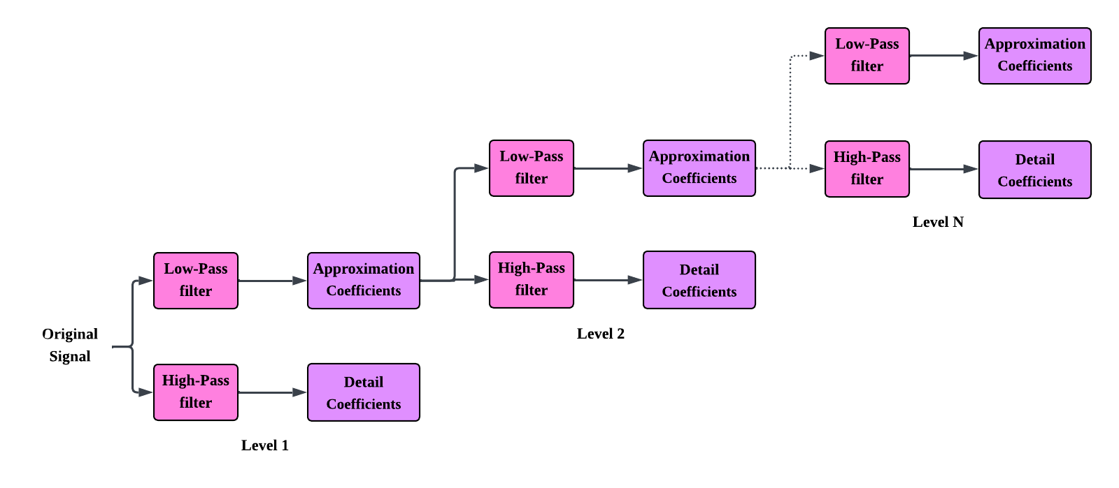
Fig 3. SWT Block Diagram
Let $y(n)$ be the original discrete load signal. At decomposition level $i$, SWT computes the approximation coefficients $B_{i}(n)$ (Eq 3) and detail coefficients $C_{i}(n)$ (Eq 4) as
$$B_{i}\left(n\right)= \sum_{m}{p_{i}\left(m\right)B_{i-1}\left(n-m\right)} (3)$$
$$C_{i}\left(n\right)= \sum_{m}{q_{i}\left(m\right)B_{i-1}\left(n-m\right)} (4)$$
where $p_{i}\left(m\right)$ and $q_{i}\left(m\right)$ represent the level-dependent low-pass and high-pass filters, respectively. These filters are obtained by inserting $2^{i-1}-1$ zeros between filter coefficients of the original wavelet filter (Eq 5). Unlike DWT, no down-sampling is performed, ensuring that
$$length\left(B_{i}\right)=length\left(C_{i}\right)=length\left(y\right) (5)$$
  - Artificial Neural Network (ANN)
The artificial neural network (ANN) was created to solve complicated trend and forecasting issues. The way the brain works is the basis for this algorithm. A neural network consists of three layers. They are the hidden layer, the output layer, and the input layer [26]. The feedforward neural network is the most common and straightforward of the different ANN architectures [27]. ANNs, also known as neural networks (NN) or neural-like networks, are mathematical or computational models used in cognitive science and machine learning to mimic the structure and function of biological neural networks, which are found in animal central nervous systems, particularly the brain [29]. McCulloch and Pitts developed a neural computing architecture and used threshold functions to differentiate the behavioral characteristics of neurons [28]. The ANN is made of three layers: input, hidden, and output. The number of variables that leave each tier is equal to the number of nodes in each layer. The nodes in the input layer correspond to the input parameters [30]. Every artificial neuron, or node, is connected to every other node and has a corresponding threshold and weight [31]. External data is obtained by the input layer, and the outcomes are provided by the output data.
There are a number of hidden layers between the input and output layers. One of a hidden neuron's characteristics is its ability to connect network output with external input in practical ways. Only a few neurons from the layer above are connected to each individual neuron. Fig 4 shows the Multi-layer feed forward network diagram.
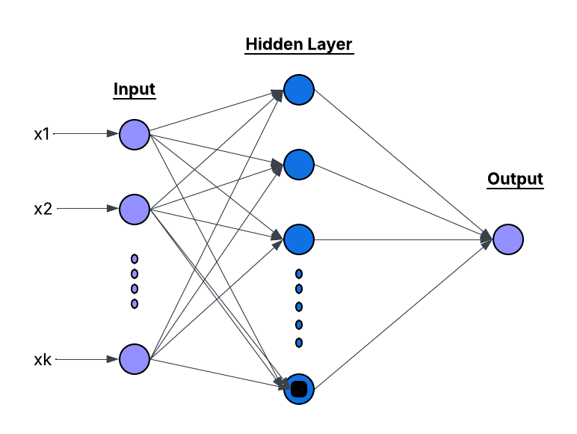
Fig 4. Multi-layer feed forward network
Pooling layers are frequently repeated in deep learning situations. Sub-sampling layers reduce the number of neurons in a layer by connecting a cluster of neurons from one layer to a single neuron from the next layer. Conversely, ANN neurons can be fully coupled if all neurons in one layer are linked to all neurons in the layer above [32]. Because it is made up of neurons, the output layer is responsible for developing and delivering the ultimate output of the layer above it. There is a minimum of one feedback loop in a recurrent neural network. If every neuron transmits its output signal to every other neuron's input, a single layer of neurons can also serve as a recurrent network. The mechanism by which a neuron feeds its output back into its own input is known as self-feedback. The load is the predicted load demand for that hour of the day. It has been noted that human power consumption causes load estimates to change throughout the week and the weekend. This sort of day is thus used as input for the ANN forecast model in order to enhance forecast accuracy.
- Results and Discussion
MATLAB R2018a was used to run the load forecasting simulation using the NYISO dataset. The platform gives an adaptable environment for developing, training, and analysing computationally efficient forecasting models. The output layer of the ANN used a pure-linear transfer function, while the hidden layer used a tangent-sigmoid transfer function. The performance metric, configured as MSE with regularization, was trained. Model accuracy was evaluated using RMSE, NRMSE, and MAPE. Some variations were observed during particular peak demand periods, demonstrating potential for further development. Table 2 describes the hyperparameter description for Deep Learning Models.
Table 2. Hyperparameter description for Deep Learning Models
DL Technique | Hyperparameters | Hyperparameter Search Space | Optimum Values
ANN (Baseline) | Number of hidden neurons | 5 – 30 | 10
 | Activation function | {tansig, logsig, purelin} | tansig
 | Training algorithm | {trainlm, trainscg, traingdx} | trainlm
 | Learning rate | 0.001 – 0.05 | 0.01
 | Number of epochs | 100 – 1000 | 500
 | Performance function | {MSE, RMSE} | RMSE
SWT-ANN (STLF) | Wavelet family | {db2–db45, coif1–coif5, sym2–sym45, fk4–fk22} | coif1
 | SWT decomposition level | 1 – 5 | 3
 | Number of hidden neurons | 5 – 30 | 10
 | Activation function | {tansig, logsig} | tansig
 | Training algorithm | {trainlm, trainscg} | trainlm
SWT-ANN (LTLF) | Wavelet family | {db2–db45, coif1–coif5, sym2–sym45, fk4–fk22} | db2
 | SWT decomposition level | 1 – 5 | 3
 | Number of hidden neurons | 5 – 30 | 10
 | Activation function | {tansig, logsig} | tansig
 | Training algorithm | {trainlm, trainscg} | trainlm
MODWT-ANN (STLF) | Wavelet family | {db2–db45, coif1–coif5, sym2–sym45} | db24
 | MODWT decomposition level | 1 – 6 | 4
 | Number of hidden neurons | 5 – 30 | 10
 | Activation function | {tansig, logsig} | tansig
 | Training algorithm | {trainlm, trainscg} | trainlm
MODWT-ANN (LTLF) | Wavelet family | {db2–db45, coif1–coif5, sym2–sym45} | coif5
 | MODWT decomposition level | 1 – 6 | 4
 | Number of hidden neurons | 5 – 30 | 10
 | Activation function | {tansig, logsig} | tansig
 | Training algorithm | {trainlm, trainscg} | trainlm
Existing research suggests that hybrid and intelligent models enhance electric load forecasting accuracy greatly (Table 4). Early techniques, such as fuzzy-neuro systems and ANN-based models optimized using metaheuristic algorithms, demonstrated astonishing accuracy in long-term load forecasting, with MAPE values as low as 1%. Decomposition-based and optimization-assisted models, such as deep learning architectures, wavelet-integrated neural networks, and SVR hybrids, often outperform traditional statistical techniques like ARIMA for short-term load forecasting. Recent studies using transformer-based models, attention processes, and multi-factor cooperative frameworks have revealed significant decreases in MAE, RMSE, and MAPE. The necessity for precise and effective forecasting frameworks is highlighted by the fact that while more advanced models offer better prediction performance, they frequently need higher processing complexity.
The Artificial Neural Network (ANN) model was configured with carefully selected parameters to provide dependable training and accurate prediction performance. A tangent–sigmoid transfer function was employed in the hidden layers to effectively capture nonlinear interactions within the data, whilst a pure linear transfer function was employed in the output layer to maintain continuity in the predicted values. Mean Absolute Percentage Error (MAPE) was utilized as the primary performance parameter to evaluate the overall forecasting accuracy after the model was trained for 1000 epochs to convergence. These parameter values handled the trade-off between learning efficiency and prediction accuracy.
  - Performance Metrics
The forecasting capacity of the proposed wavelet-based ANN models was evaluated utilizing performance metrics such as mean absolute percentage error (MAPE), normalized root mean square error (NRMSE), and root mean square error (RMSE). Fig 5 shows the comparison of Best Wavelet Performance across Models for Electricity Load Forecasting. In this instance, the predicted and actual load levels are matched by the expected outputs and true observations at the $i^{th}$ time instance. RMSE in Eq.6, NRMSE in Eq.7, and MAPE in Eq.8 can be computed using the following mathematical formulas:
$$RMSE= \sqrt{\frac{\sum_{i=1}^{n}{{({Predicted}_{i}-{Actual}_{i})}^{2}}}{n}} (6)$$
$$NRMSE=\frac{RMSE}{std (A)} (7)$$
$$MAPE=\frac{100}{n}+\sum_{i=1}^{n}{|\frac{{Predicted}_{i}-{Actual}_{i}}{{Actual}_{i}}|} (8)$$
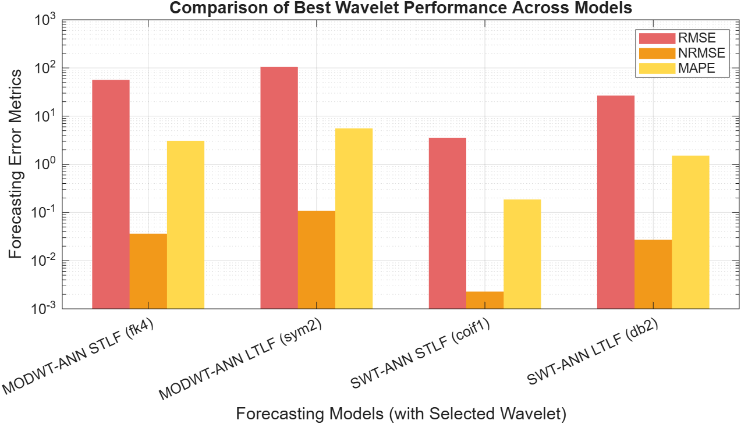
Fig 5. Comparison of Best Wavelet Performance across Models for Electricity Load Forecasting
    - MODWT for Short-term load forecasting
MODWT was utilized to integrate wavelet decomposition with the ANN model to improve forecasting accuracy. By decomposing the load series into multiple frequency components, this hybrid MODWT-ANN approach increased feature extraction for prediction. Among the different wavelet families tested, the fk4 wavelet obtained the lowest MAPE of 3.079528, RMSE of 56.47625, and NRMSE of 0.036285 significantly exceeding standalone ANNs. The hybrid model’s capacity to accurately gather both local variations and total load patterns is demonstrated by the predicted load observing the actual trend. fk4 wavelet family attained a lesser MAPE value of 3.079528. Comparison of actual and predicted load power with MODWT-ANN (STLF) is shown in Fig 6.
For Long-term load forecasting (LTLF) in MODWT, the most effective family was the sym2 wavelet family. To maintain accuracy, it highlights the models ability over extended forecasting horizons with a high degree of agreement between projected and actual values and a MAPE value of 5.583612, RMSE of 105.6133, and NRMSE of 0.107846. The results demonstrated that sym2 decomposition strongly recorded the primary patterns and seasonal differences present in the dataset. sym2 wavelet family attained a lesser MAPE value 5.583612. Comparison of actual load power and predicted load power with MODWT-ANN (LTLF) is shown in Fig 7.
This study improved short-term load forecasting accuracy by combining the Stationary Wavelet Transform (SWT) with a feedforward ANN. To maintain temporal alignment, the load series was zero-padded to a length divisible by 232^323. It was then broken down to level 3 using SWT without downsampling. The resulting wavelet coefficients were immediately used as input features for an ANN with ten hidden neurons to effectively identify both high-frequency fluctuations and low-frequency load patterns. Several wavelet families underwent extensive analysis. The coif1 wavelet outperformed all other wavelets examined, producing the lowest MAPE of 0.18678, an RMSE of 3.550636, and an NRMSE of 0.002281. These findings indicate how successfully the SWT-ANN hybrid model detects short-term load changes, as the forecast load closely matches the actual load profile. Comparison of actual load power and predicted load power with SWT-ANN (STLF) is shown in Fig 8.
In SWT (LTLF), the db2 wavelet outscored all other wavelets studied, with the MAPE of 1.51416, RMSE of 26.65095, and NRMSE of 0.02721. These findings show that the SWT-ANN configuration may be able to precisely represent long-term load behavior. The hybrid model's durability and usefulness for long-term load forecasting applications are demonstrated by how closely the projected load matches the actual long-term load pattern. Comparison of actual load power and predicted load power with SWT-ANN (LTLF) is shown in Fig 9. Table 3 shows the result of wavelets for Electricity Load Forecasting.
Wavelet | MODWT |  |  |  |  |  | SWT
Wavelet | STLF |  |  | LTLF |  |  | STLF |  |  | LTLF
Wavelet | RMSE | NRMSE | MAPE | RMSE | NRMSE | MAPE | RMSE | NRMSE | MAPE | RMSE | NRMSE | MAPE
db2 | 85.76595 | 0.055103 | 4.988128 | 131.7889 | 0.134575 | 5.684972 | 6.40494 | 0.004115 | 0.366505 | 26.65095 | 0.027214 | 1.514161
db3 | 144.9812 | 0.093148 | 8.475029 | 117.0815 | 0.119556 | 6.388797 | 28.90036 | 0.018568 | 1.568611 | 72.18281 | 0.073709 | 4.034223
db4 | 158.3009 | 0.101706 | 9.361026 | 117.3156 | 0.119796 | 6.736072 | 67.74758 | 0.043527 | 3.891373 | 101.1897 | 0.103329 | 5.900045
db5 | 165.1173 | 0.106086 | 9.209246 | 116.2344 | 0.118691 | 6.322268 | 90.22454 | 0.057968 | 5.402965 | 116.9327 | 0.119404 | 6.418326
db6 | 203.0861 | 0.13048 | 11.53316 | 120.2425 | 0.122784 | 6.981891 | 104.1116 | 0.06689 | 6.319093 | 116.0949 | 0.118549 | 6.516663
db7 | 209.8868 | 0.134849 | 11.9802 | 141.2329 | 0.144218 | 8.299941 | 146.6851 | 0.094243 | 8.926842 | 127.6566 | 0.130355 | 7.493562
db8 | 205.7564 | 0.132196 | 11.82544 | 127.9446 | 0.130649 | 6.978624 | 146.8049 | 0.09432 | 8.74368 | 100.8743 | 0.103007 | 5.82229
db9 | 205.1129 | 0.131782 | 11.84002 | 129.7016 | 0.132443 | 7.574007 | 174.1175 | 0.111868 | 10.45776 | 104.6031 | 0.106814 | 5.894026
db10 | 192.3524 | 0.123584 | 10.78394 | 135.0708 | 0.137926 | 7.35221 | 134.9291 | 0.08669 | 8.207382 | 111.7564 | 0.114119 | 6.386451
db11 | 168.5419 | 0.108286 | 9.456091 | 141.6312 | 0.144625 | 8.189129 | 113.6072 | 0.072991 | 6.640283 | 122.5947 | 0.125186 | 7.084306
db12 | 170.9377 | 0.109825 | 9.899201 | 129.5266 | 0.132265 | 7.362467 | 108.6412 | 0.0698 | 6.214035 | 107.5606 | 0.109834 | 6.341269
db13 | 145.5793 | 0.093533 | 8.179227 | 142.6758 | 0.145692 | 7.656179 | 156.5727 | 0.100596 | 9.261884 | 115.472 | 0.117913 | 6.846876
db14 | 123.9036 | 0.079606 | 7.214137 | 136.5846 | 0.139472 | 7.911516 | 155.0295 | 0.099604 | 9.132532 | 129.6816 | 0.132423 | 7.407156
db15 | 112.9187 | 0.072549 | 6.327077 | 146.853 | 0.149957 | 8.533266 | 156.7407 | 0.100704 | 8.866274 | 109.4984 | 0.111813 | 6.412093
db16 | 118.3485 | 0.076037 | 6.844793 | 154.3109 | 0.157573 | 9.047713 | 216.2823 | 0.138958 | 12.60822 | 114.6703 | 0.117094 | 6.736624
db17 | 129.5448 | 0.083231 | 7.48319 | 162.3913 | 0.165824 | 9.159735 | 219.4785 | 0.141012 | 12.91756 | 107.2068 | 0.109473 | 6.126955
db18 | 156.0085 | 0.100233 | 9.22487 | 164.3166 | 0.16779 | 9.392271 | 190.1463 | 0.122166 | 10.78872 | 109.0324 | 0.111337 | 6.033596
db19 | 173.9388 | 0.111753 | 10.07442 | 170.4285 | 0.174031 | 9.926642 | 153.8367 | 0.098838 | 8.809595 | 118.3715 | 0.120874 | 6.792162
db20 | 191.5098 | 0.123042 | 11.38952 | 163.547 | 0.167004 | 9.460527 | 165.9593 | 0.106627 | 9.685634 | 120.75 | 0.123302 | 7.033539
db21 | 206.4273 | 0.132627 | 11.93172 | 173.7103 | 0.177382 | 9.876364 | 140.5354 | 0.090292 | 8.16081 | 128.3851 | 0.131099 | 7.396837
db22 | 211.1811 | 0.135681 | 12.18023 | 174.0452 | 0.177724 | 10.17705 | 137.9401 | 0.088625 | 7.848954 | 134.4624 | 0.137305 | 7.930568
db23 | 209.0194 | 0.134292 | 11.82483 | 178.3189 | 0.182088 | 9.815303 | 148.2762 | 0.095265 | 8.59826 | 139.0157 | 0.141954 | 7.593756
db24 | 216.0874 | 0.138833 | 12.52069 | 163.0349 | 0.166481 | 9.861403 | 175.6257 | 0.112837 | 10.14795 | 152.1862 | 0.155403 | 8.988056
db25 | 225.0883 | 0.144616 | 12.8509 | 175.7389 | 0.179454 | 10.28003 | 188.9743 | 0.121413 | 11.10025 | 125.8982 | 0.12856 | 7.117472
db26 | 212.47 | 0.136509 | 12.24357 | 172.7467 | 0.176398 | 10.03361 | 177.2304 | 0.113868 | 10.62946 | 140.6888 | 0.143663 | 8.306152
db27 | 210.3301 | 0.135134 | 11.72463 | 182.5715 | 0.186431 | 10.58595 | 149.7906 | 0.096238 | 8.782518 | 114.245 | 0.11666 | 6.39273
db28 | 200.9115 | 0.129083 | 11.43167 | 170.5704 | 0.174176 | 10.1253 | 125.0438 | 0.080339 | 7.435429 | 134.4619 | 0.137304 | 8.093796
db29 | 182.4001 | 0.11719 | 10.26329 | 197.4578 | 0.201632 | 11.47568 | 120.2642 | 0.077268 | 7.132154 | 108.8907 | 0.111193 | 6.197073
db30 | 171.8604 | 0.110418 | 9.904579 | 179.7062 | 0.183505 | 10.86515 | 114.3879 | 0.073493 | 6.584215 | 104.9466 | 0.107165 | 5.970164
db31 | 159.5862 | 0.102532 | 9.027973 | 185.8491 | 0.189778 | 11.22723 | 105.7452 | 0.06794 | 5.883676 | 128.0934 | 0.130801 | 7.241889
db32 | 149.0991 | 0.095794 | 8.695346 | 168.1797 | 0.171735 | 10.05353 | 112.366 | 0.072194 | 6.369161 | 109.6137 | 0.111931 | 6.104149
db33 | 147.1814 | 0.094562 | 8.457784 | 184.9043 | 0.188813 | 10.9104 | 125.6222 | 0.080711 | 7.228302 | 103.483 | 0.10567 | 6.039864
db34 | 158.5494 | 0.101866 | 9.20752 | 166.0925 | 0.169603 | 9.778343 | 139.118 | 0.089381 | 8.208692 | 116.516 | 0.118979 | 6.789403
db35 | 166.5729 | 0.107021 | 9.603517 | 182.261 | 0.186114 | 10.89785 | 145.8576 | 0.093711 | 8.684722 | 104.9418 | 0.10716 | 5.779519
db36 | 185.7122 | 0.119318 | 10.89889 | 180.3331 | 0.184145 | 10.23944 | 158.5172 | 0.101845 | 9.297343 | 128.8969 | 0.131622 | 7.681191
db37 | 200.6703 | 0.128928 | 11.74278 | 191.1319 | 0.195172 | 10.98991 | 186.8854 | 0.120071 | 11.20717 | 109.2809 | 0.111591 | 6.17224
db38 | 211.0845 | 0.135619 | 12.36815 | 169.3591 | 0.172939 | 9.581699 | 192.1355 | 0.123444 | 11.5725 | 120.7568 | 0.123309 | 6.690971
db39 | 222.8411 | 0.143172 | 12.84084 | 186.7022 | 0.190649 | 10.95246 | 198.1067 | 0.127281 | 11.84769 | 127.8182 | 0.13052 | 7.068363
db40 | 225.6189 | 0.144957 | 13.06914 | 172.3749 | 0.176019 | 9.663122 | 164.2913 | 0.105555 | 9.535989 | 122.2784 | 0.124863 | 7.17151
db41 | 220.9697 | 0.14197 | 12.69603 | 182.9403 | 0.186807 | 10.94252 | 161.4558 | 0.103733 | 9.254877 | 126.0597 | 0.128724 | 7.26364
db42 | 225.5826 | 0.144934 | 12.98122 | 195.3496 | 0.199479 | 11.16727 | 169.9488 | 0.10919 | 9.51379 | 132.0136 | 0.134804 | 7.79989
db43 | 221.4473 | 0.142277 | 12.62939 | 173.565 | 0.177234 | 9.891143 | 198.9757 | 0.127839 | 11.55609 | 116.3347 | 0.118794 | 6.428919
db44 | 212.0514 | 0.13624 | 12.04882 | 192.8542 | 0.196931 | 10.74854 | 176.4907 | 0.113393 | 9.999113 | 127.4413 | 0.130135 | 7.124155
db45 | 216.9197 | 0.139368 | 12.4318 | 176.1037 | 0.179826 | 10.49872 | 177.6714 | 0.114151 | 10.01275 | 122.6571 | 0.12525 | 6.92275
coif1 | 171.8477 | 0.11041 | 9.259135 | 128.6699 | 0.13139 | 7.252492 | 3.550636 | 0.002281 | 0.186785 | 32.9874 | 0.033685 | 1.618681
coif2 | 156.3667 | 0.100463 | 9.202628 | 161.3847 | 0.164796 | 9.532975 | 26.97141 | 0.017329 | 1.477194 | 70.97987 | 0.07248 | 4.140926
coif3 | 193.0817 | 0.124052 | 11.10093 | 171.6886 | 0.175318 | 10.40754 | 73.0925 | 0.046961 | 4.203226 | 104.76 | 0.106974 | 5.712273
coif4 | 221.6025 | 0.142377 | 12.88567 | 190.2994 | 0.194322 | 11.23382 | 84.48659 | 0.054281 | 5.140507 | 108.9795 | 0.111283 | 6.259026
coif5 | 166.7075 | 0.107107 | 9.510954 | 143.5066 | 0.14654 | 8.402214 | 140.3357 | 0.090164 | 8.691959 | 114.7841 | 0.11721 | 6.447899
sym2 | 85.5881 | 0.054989 | 4.949514 | 105.6133 | 0.107846 | 5.583612 | 6.231042 | 0.004003 | 0.349749 | 39.50158 | 0.040337 | 1.766432
sym3 | 144.7698 | 0.093013 | 8.500123 | 123.5668 | 0.126179 | 6.631667 | 29.5449 | 0.018982 | 1.62981 | 70.01976 | 0.0715 | 3.883869
sym4 | 159.9281 | 0.102752 | 9.304926 | 155.1007 | 0.158379 | 9.403198 | 31.77457 | 0.020415 | 1.836591 | 83.75587 | 0.085526 | 4.646665
sym5 | 216.6002 | 0.139163 | 12.43597 | 159.6869 | 0.163062 | 9.479678 | 17.10995 | 0.010993 | 0.95053 | 61.70658 | 0.063011 | 2.890534
sym6 | 192.1284 | 0.12344 | 11.2588 | 177.5709 | 0.181325 | 10.54774 | 29.25553 | 0.018796 | 1.705208 | 98.99701 | 0.10109 | 4.582716
sym7 | 210.4532 | 0.135213 | 11.70862 | 184.5515 | 0.188453 | 11.58028 | 16.84203 | 0.010821 | 0.911549 | 67.79064 | 0.069224 | 3.909094
sym8 | 210.2004 | 0.135051 | 12.3863 | 160.2538 | 0.163641 | 9.602454 | 27.65396 | 0.017767 | 1.60511 | 78.5888 | 0.08025 | 4.36753
sym9 | 215.3634 | 0.138368 | 12.24288 | 162.2549 | 0.165685 | 9.831693 | 18.87333 | 0.012126 | 1.088735 | 87.73768 | 0.089592 | 4.418301
sym10 | 164.0115 | 0.105375 | 9.102102 | 159.0734 | 0.162436 | 9.488977 | 26.08773 | 0.016761 | 1.513026 | 75.49226 | 0.077088 | 4.299911
sym11 | 197.0124 | 0.126578 | 11.11061 | 169.0891 | 0.172663 | 10.4263 | 13.24923 | 0.008512 | 0.71898 | 124.3037 | 0.126931 | 3.533081
sym12 | 209.4258 | 0.134553 | 12.18306 | 140.5338 | 0.143505 | 8.561597 | 9.629171 | 0.006187 | 0.575529 | 36.30361 | 0.037071 | 2.014764
sym13 | 217.1796 | 0.139535 | 12.40475 | 128.662 | 0.131382 | 7.953096 | 13.02641 | 0.008369 | 0.729534 | 60.61355 | 0.061895 | 2.956929
sym14 | 196.4127 | 0.126192 | 11.02126 | 127.1731 | 0.129861 | 7.794717 | 5.846618 | 0.003756 | 0.31445 | 34.05891 | 0.034779 | 1.853543
sym15 | 174.7039 | 0.112245 | 10.20716 | 122.584 | 0.125175 | 7.42712 | 15.55033 | 0.009991 | 0.841716 | 53.3897 | 0.054518 | 3.022282
sym16 | 225.3755 | 0.144801 | 12.94091 | 146.1242 | 0.149213 | 9.146314 | 5.771014 | 0.003708 | 0.307792 | 35.65276 | 0.036406 | 2.020395
sym17 | 194.6661 | 0.12507 | 11.01122 | 160.1212 | 0.163506 | 10.14403 | 13.14147 | 0.008443 | 0.770568 | 56.39586 | 0.057588 | 3.161619
sym18 | 210.0495 | 0.134954 | 11.98356 | 164.7017 | 0.168183 | 9.691271 | 29.20859 | 0.018766 | 1.738383 | 82.27435 | 0.084014 | 4.425589
sym19 | 177.3926 | 0.113972 | 10.05375 | 165.3177 | 0.168812 | 9.687686 | 18.24348 | 0.011721 | 1.014884 | 63.0346 | 0.064367 | 3.202441
sym20 | 222.4199 | 0.142902 | 12.73391 | 181.6322 | 0.185472 | 10.97341 | 5.980701 | 0.003843 | 0.324008 | 45.29549 | 0.046253 | 2.23641
sym21 | 171.4408 | 0.110148 | 9.584655 | 185.2781 | 0.189195 | 11.13252 | 12.50364 | 0.008033 | 0.732021 | 42.61094 | 0.043512 | 2.4391
sym22 | 175.2665 | 0.112606 | 9.787314 | 187.9018 | 0.191874 | 11.04987 | 7.536872 | 0.004842 | 0.431208 | 230.4489 | 0.23532 | 14.49531
sym23 | 203.5668 | 0.130789 | 11.65923 | 184.3756 | 0.188273 | 10.58785 | 17.76769 | 0.011415 | 1.00149 | 67.55355 | 0.068982 | 3.502344
sym24 | 206.0893 | 0.13241 | 11.60628 | 159.0068 | 0.162368 | 8.937157 | 5.542652 | 0.003561 | 0.292266 | 33.56986 | 0.034279 | 1.875447
sym25 | 175.0225 | 0.11245 | 9.648148 | 152.8614 | 0.156093 | 8.831454 | 11.68304 | 0.007506 | 0.682444 | 70.6809 | 0.072175 | 2.670767
sym26 | 212.8027 | 0.136723 | 12.13738 | 156.1076 | 0.159408 | 8.989017 | 28.24543 | 0.018147 | 1.631654 | 76.7171 | 0.078339 | 4.349239
sym27 | 169.2262 | 0.108725 | 9.46381 | 157.6544 | 0.160987 | 9.142406 | 50.981 | 0.032755 | 3.0971 | 138.8279 | 0.141763 | 8.157344
sym28 | 179.0664 | 0.115048 | 9.806763 | 152.6558 | 0.155883 | 8.810616 | 5.627325 | 0.003615 | 0.297809 | 42.00813 | 0.042896 | 1.953347
sym29 | 219.8354 | 0.141241 | 12.9776 | 180.4259 | 0.18424 | 11.19112 | 11.49261 | 0.007384 | 0.667013 | 63.90529 | 0.065256 | 3.257753
sym30 | 230.1376 | 0.14786 | 13.39242 | 175.3505 | 0.179057 | 10.26877 | 5.704017 | 0.003665 | 0.304009 | 36.55337 | 0.037326 | 1.937746
sym31 | 204.338 | 0.131284 | 11.75607 | 182.0655 | 0.185914 | 10.69401 | 50.06284 | 0.032165 | 2.997308 | 91.56174 | 0.093497 | 5.108771
sym32 | 226.8212 | 0.145729 | 13.23462 | 185.4729 | 0.189394 | 11.23765 | 28.13902 | 0.018079 | 1.618934 | 85.02503 | 0.086822 | 4.78397
sym33 | 228.9676 | 0.147108 | 13.17173 | 193.7539 | 0.19785 | 11.55451 | 11.24557 | 0.007225 | 0.649256 | 75.78182 | 0.077384 | 2.806208
sym34 | 176.5065 | 0.113403 | 9.82466 | 176.0861 | 0.179808 | 10.39249 | 28.27992 | 0.018169 | 1.62919 | 82.27809 | 0.084017 | 4.39559
sym35 | 230.6131 | 0.148166 | 13.36243 | 161.8143 | 0.165235 | 9.226068 | 49.72729 | 0.031949 | 2.971346 | 95.62199 | 0.097643 | 5.491957
sym36 | 230.4413 | 0.148055 | 13.24922 | 168.5726 | 0.172136 | 9.625068 | 28.4479 | 0.018277 | 1.650926 | 82.88258 | 0.084635 | 4.673282
sym37 | 218.1389 | 0.140151 | 12.41205 | 158.081 | 0.161423 | 8.638377 | 14.69363 | 0.00944 | 0.849351 | 67.8471 | 0.069281 | 3.744801
sym38 | 184.8037 | 0.118734 | 10.70558 | 136.9726 | 0.139868 | 7.610617 | 28.35396 | 0.018217 | 1.643537 | 477.2746 | 0.487364 | 32.5129
sym39 | 225.5545 | 0.144916 | 13.03541 | 136.7339 | 0.139624 | 7.536786 | 50.33874 | 0.032342 | 3.037873 | 88.74168 | 0.090618 | 5.081576
sym40 | 222.6853 | 0.143072 | 12.97741 | 136.8261 | 0.139718 | 7.527961 | 5.781173 | 0.003714 | 0.309018 | 48.24903 | 0.049269 | 2.343242
sym41 | 197.3749 | 0.126811 | 11.15768 | 158.2237 | 0.161568 | 8.768026 | 14.6399 | 0.009406 | 0.845228 | 92.19178 | 0.094141 | 2.950209
sym42 | 175.9782 | 0.113064 | 10.01566 | 157.1781 | 0.160501 | 9.09882 | 5.733969 | 0.003684 | 0.305737 | 41.82305 | 0.042707 | 2.366752
sym43 | 213.1516 | 0.136947 | 12.13355 | 174.9005 | 0.178598 | 10.47471 | 48.43782 | 0.031121 | 2.879714 | 106.3718 | 0.10862 | 5.913757
sym44 | 193.0988 | 0.124063 | 11.0949 | 183.8528 | 0.187739 | 10.36218 | 29.14273 | 0.018724 | 1.693325 | 75.41368 | 0.077008 | 4.262064
sym45 | 168.8353 | 0.108474 | 9.623638 | 190.0255 | 0.194042 | 11.536 | 14.34778 | 0.009218 | 0.829327 | 61.34839 | 0.062645 | 3.139838
fk4 | 56.47625 | 0.036285 | 3.079528 | 100.8256 | 0.102957 | 5.982674 | 9.421197 | 0.006053 | 0.506628 | 33.3405 | 0.034045 | 1.988208
fk6 | 131.3697 | 0.084403 | 7.472276 | 113.3297 | 0.115725 | 6.401947 | 35.41101 | 0.022751 | 1.93322 | 113.5324 | 0.115932 | 5.338819
fk8 | 168.3357 | 0.108153 | 9.933927 | 120.1074 | 0.122646 | 6.646429 | 76.86462 | 0.049384 | 4.422736 | 112.2791 | 0.114653 | 6.058515
fk14 | 185.4419 | 0.119144 | 10.82894 | 128.5733 | 0.131291 | 7.0101 | 143.8633 | 0.09243 | 8.605251 | 128.5266 | 0.131244 | 6.825591
fk18 | 202.4175 | 0.13005 | 11.81943 | 123.5996 | 0.126212 | 6.778814 | 125.6184 | 0.080708 | 7.468613 | 112.116 | 0.114486 | 6.137419
fk22 | 194.7739 | 0.12514 | 11.08591 | 122.5444 | 0.125135 | 6.929168 | 135.7717 | 0.087231 | 7.998136 | 114.4431 | 0.116862 | 6.477293
Table 3. Outputs for Electricity Load Forecasting
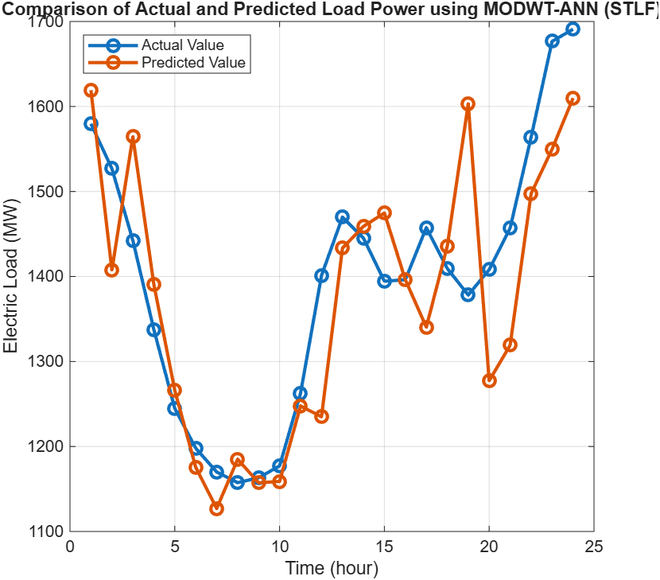
Fig 6. Comparison of Actual and Predicted Load Power using MODWT-ANN (STLF)
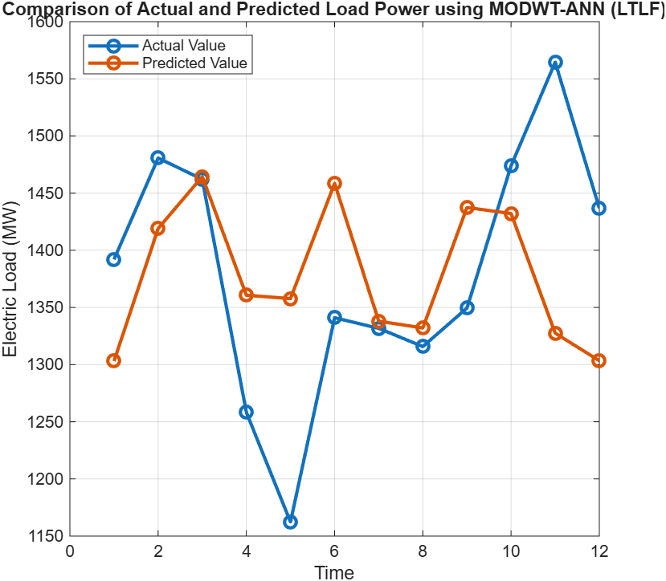
Fig 7. Comparison of Actual and Predicted Load Power using MODWT-ANN (LTLF)
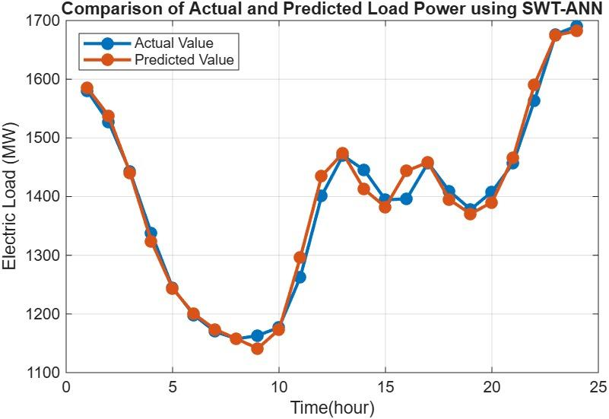
Fig 8. Comparison of Actual and Predicted Load Power using SWT-ANN (STLF)
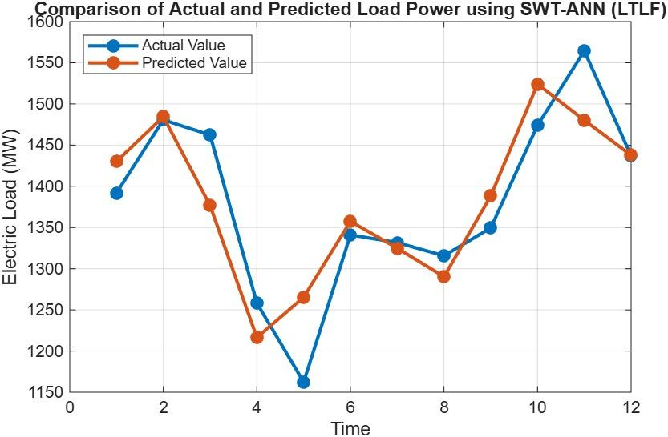
Fig 9. Comparison of Actual and Predicted Load Power using SWT-ANN (LTLF)
  - Comparison with Existing Models
Paper (Author, Year [Ref]) | Model / Approach | Forecast Type | Reported Results / Metrics
D. Ali et al., 2015 [23] | Fuzzy-Neuro | LTLF | Accuracy 98.78%, MAPE 1.22%
M.Q. Raza et al., 2022 [22] | Feed-forward ANN (GPSO training) | Hourly LTLF | R² 0.9923, MAPE 1.40%
G.-F. Fan et al., 2021 [21] | PSR-BSK | STLF | MAPE < 2.20%, RMSE < 30.0, MAE < 2.30, runtime < 400s
S. Fan et al., 2020 [20] | BCD + SVR | STLF | NYISO: MAPE 1.96%, MAE 129.49 MW; WFEC: MAPE 2.84%, MAE 26.23 MW
G.-F. Fan et al., 2019 [19] | DEMD-SVR-AR | STLF | Outperforms ARIMA, PSO-SVR, PSO-BP, GA-ANN, BPNN; threshold significance 0.05
S.A. Nabavi et al., 2016 [16] | DWT-LSTM | STLF & LTLF | Germany MAPE 0.29–3.02%, Iran MAPE 0.59–4.2%
Q. Yan et al., 2025 [12] | Multi-factor Cooperative | STLF | MAE ↓28.30%, RMSE ↓24.14%, MAPE ↓30.35%
Hongjie Li et al., 2025 [11] | CrossInformer (dual-layer decomposition + SHAP) | STLF | MSE 0.28, MAE 0.362, RMSE 48.63, MAPE 4.3%
Nahid Sultana, 2025 [10] | BOA-LSTM & BOA-NARX | Day-ahead STLF | R² > 0.99, very low errors
Yi Ji et al., 2025 [9] | WTC-iPST | STLF | MAPE ↓18.09%, RMSE ↓16.84%, R² ↑2.96% vs iTransformer
H. Mubarak et al., 2024 [8] | CNN-BiLSTM-AR + HPO | Day-ahead STLF | RMSE ↓16.7%, MAE ↓23.46% (German market)
J. Ding et al., 2023 [7] | RVM + Feature selection + WT | Hourly & Day-ahead STLF | Hourly MAE 8.46, MAPE 0.74%; Day-ahead MAE 24.19, MAPE 1.82%
Y. Guo et al., 2023 [5] | SARIMA-LSTM + WT | STLF | Forecast accuracy ↑50.98%, stability ↑68.09%
H. Yang & K.R. Schell, 2024 [4] | ATTnet (Attention DL NN) | Price/STLF | MAE ↓7.69%, MAPE ↓7.81%, outperforms HFnet, GHTnet, QCAE
Y. Xiao et al., 2025 [1] | BiLSTM + TimeGAN + Dual Attention | STLF | MAPE 18.03% (residential), 33.62% (public service)
Our Study, 2026 [This Work] | SWT-ANN | STLF | coif1: RMSE 3.551, NRMSE 0.00228, MAPE 0.1868%
Our Study, 2026 [This Work] | SWT-ANN | LTLF | db2: RMSE 26.65, NRMSE 0.0272, MAPE 1.514%
Our Study, 2026 [This Work] | MODWT-ANN | STLF | fk4: RMSE 56.47625, NRMSE 0.036285, MAPE 3.079528%
Our Study, 2026 [This Work] | MODWT-ANN | LTLF | sym2: RMSE 105.6133, NRMSE 0.107846, MAPE 5.583%
Table 4. Comparison of the proposed techniques with the existing results
By using standalone ANN for load forecasting, there are some issues when there is a lot of fluctuation. By integrating SWT with ANN, forecasting accuracy significantly increased with Coif1 outperforming for short-term load forecasting and db2 for long-term load forecasting. The SWT-ANN framework exceeded several benchmark methods described in the existing research as a reliable and effective technology for short-term and long-term load forecasting.
- Conclusion
This study demonstrates how hybrid wavelet-ANN models improve load forecasting accuracy by efficiently capturing the nonlinear and nonstationary components of electrical load data. For both short- and long-term forecasting horizons, the SWT-ANN hybrid approach performed better than the MODWT-ANN framework.
The enhanced prediction abilities of the SWT-ANN model were consistently demonstrated by lower RMSE, NRMSE, and MAPE values. The SWT framework's coif1 wavelet demonstrated remarkable result in short-term load forecasting with a MAPE of 0.18678, RMSE of 3.5506, and NRMSE of 0.00228, demonstrating the model's capacity to accurately capture high-frequency load changes. The SWT-ANN model with the db2 wavelet produced the lowest error values (MAPE = 1.51416, RMSE = 26.65095, NRMSE = 0.02721) for long-term load forecasting, indicating considerable learning of long-range load trends and seasonal patterns.
Overall, the findings indicate that SWT-ANN is the most effective hybrid method for load forecasting in this investigation. Because of its remarkable accuracy, stability over forecasting horizons, and resilience in handling complex load patterns, it is perfect for real-world applications such as energy management systems, smart grid operation, and long-term planning. These results show the potential of SWT-ANN as a reliable and scalable forecasting framework and provide a strong foundation for future research into complex load forecasting techniques.
REFERENCES
- Yaqiu Xiao, Xinle Hu, Yingshan Lin, Yang Lu, Rui Jing, Yingru Zhao, Interpretable short-term electricity load forecasting considering small sample heatwaves, Applied Energy, Volume 398, 2025, 126417, ISSN 0306-2619, https://doi.org/10.1016/j.apenergy.2025.126417.
- Qi Dong, Rubing Huang, Chenhui Cui, Dave Towey, Ling Zhou, Jinyu Tian, Jianzhou Wang, Short-Term Electricity-Load Forecasting by deep learning: A comprehensive survey, Engineering Applications of Artificial Intelligence, Volume 154, 2025, 110980, ISSN 0952-1976, https://doi.org/10.1016/j.engappai.2025.110980.
- Ningning Hu, Lanmei Cong, Guangyuan Pan, Zhaohui Zhang, Ziyue Han, VTTnet: Multi-component decomposition and feature fusion network for enhanced short-term electricity load forecasting, Electric Power Systems Research, Volume 248, 2025, 111876, ISSN 0378-7796, https://doi.org/10.1016/j.epsr.2025.111876.
- Haolin Yang, Kristen R. Schell, ATTnet: An explainable gated recurrent unit neural network for high frequency electricity price forecasting, International Journal of Electrical Power & Energy Systems, Volume 158, 2024, 109975, ISSN 0142-0615, https://doi.org/10.1016/j.ijepes.2024.109975.
- Yufeng Guo, Yilin Du, Pu Wang, Xueqin Tian, Zhuofan Xu, Fuyuan Yang, Longxiang Chen, Jie Wan, A hybrid forecasting method considering the long-term dependence of day-ahead electricity price series, Electric Power Systems Research, Volume 235, 2024, 110841, ISSN 0378-7796, https://doi.org/10.1016/j.epsr.2024.110841.
- Jing Xu, Yan Wei, Pan Zeng, VMD-based iterative Boruta feature extraction and CNNA-BiLSTM for short-term load forecasting, Electric Power Systems Research, Volume 238, 2025, 111172, ISSN 0378-7796, https://doi.org/10.1016/j.epsr.2024.111172.
- Jia Ding, Maolin Wang, Zuowei Ping, Dongfei Fu, Vassilios S. Vassiliadis, An integrated method based on relevance vector machine for short-term load forecasting, European Journal of Operational Research, Volume 287, Issue 2, 2020, Pages 497-510, ISSN 0377-2217, https://doi.org/10.1016/j.ejor.2020.04.007.
- Hamza Mubarak, Abdallah Abdellatif, Shameem Ahmad, Mohammad Zohurul Islam, S.M. Muyeen, Mohammad Abdul Mannan, Innocent Kamwa, Day-Ahead electricity price forecasting using a CNN-BiLSTM model in conjunction with autoregressive modeling and hyperparameter optimization, International Journal of Electrical Power & Energy Systems, Volume 161, 2024, 110206, ISSN 0142-0615, https://doi.org/10.1016/j.ijepes.2024.110206.
- Yi Ji, Yongyuan Zhu, Siliang Lu, Lixia Yang, Alan Wee-Chung Liew, WTC-iPST: A deep learning framework for short-term electric load forecasting with multi-scale feature extraction, Knowledge-Based Systems, Volume 324, 2025, 113907, ISSN 0950-7051, https://doi.org/10.1016/j.knosys.2025.113907.
- Nahid Sultana, Balancing accuracy and efficiency in multi-step building-level electric load forecasting: Deep learning vs. classical time-series models, Energy and Built Environment, 2025, , ISSN 2666-1233, https://doi.org/10.1016/j.enbenv.2025.05.012.
- Hongjie Li, Yirui Tang, Dayang Liu, A CrossInformer model based on dual-layer decomposition and interpretability for short-term electricity load forecasting, Alexandria Engineering Journal, Volume 129, 2025, Pages 117-127, ISSN 1110-0168, https://doi.org/10.1016/j.aej.2025.05.089.
- Qiao Yan, Wenpeng Cao, Yi Yan, Chengdong Li, Chongyi Tian, Wen Kong, A multi-factor collaborative electricity load forecasting method based on feature importance and multi-scale feature extraction, Energy and AI, Volume 21, 2025, 100579, ISSN 2666-5468, https://doi.org/10.1016/j.egyai.2025.100579.
- Site Mo, Zuhua Yao, Chengteng Yang, Haoxin Wang, Songhai Fan, Rui Liu, Yipeng Mo, MRGNN: Multi-resolution graph neural network for electricity load forecasting, Energy Reports, Volume 13, 2025, Pages 4624-4634, ISSN 2352-4847, https://doi.org/10.1016/j.egyr.2025.03.056.
- Monika Zimmermann, Florian Ziel, Efficient mid-term forecasting of hourly electricity load using generalized additive models, Applied Energy, Volume 388, 2025, 125444, ISSN 0306-2619, https://doi.org/10.1016/j.apenergy.2025.125444.
- Baxter Lorenzo McIntosh Kamana-Williams, Daniel Gnoth, R.J. Hooper, J. Geoffrey Chase, A generalisable agent-based model of residential electricity demand for load forecasting and demand response management, International Journal of Electrical Power & Energy Systems, Volume 168, 2025, 110671, ISSN 0142-0615, https://doi.org/10.1016/j.ijepes.2025.110671.
- Seyed Azad Nabavi, Sahar Mohammadi, Naser Hossein Motlagh, Sasu Tarkoma, Philipp Geyer, Deep learning modeling in electricity load forecasting: Improved accuracy by combining DWT and LSTM, Energy Reports, Volume 12, 2024, Pages 2873-2900, ISSN 2352-4847, https://doi.org/10.1016/j.egyr.2024.08.070.
- Xiwen Cui, Xiaodan Zhang, Dongxiao Niu, A new framework for ultra-short-term electricity load forecasting model using IVMD–SGMD two–layer decomposition and INGO–BiLSTM–TPA–TCN, Applied Soft Computing, Volume 167, Part B, 2024, 112311, ISSN 1568-4946, https://doi.org/10.1016/j.asoc.2024.112311.
- M. Ghayekhloo, R. Azimi, M. Ghofrani, M.B. Menhaj, E. Shekari, A combination approach based on a novel data clustering method and Bayesian recurrent neural network for day-ahead price forecasting of electricity markets, Electric Power Systems Research, Volume 168, 2019, Pages 184-199, ISSN 0378-7796, https://doi.org/10.1016/j.epsr.2018.11.021.
- Guo-Feng Fan, Li-Ling Peng, Wei-Chiang Hong, Fan Sun, Electric load forecasting by the SVR model with differential empirical mode decomposition and auto regression, Neurocomputing, Volume 173, Part 3, 2016, Pages 958-970, ISSN 0925-2312, https://doi.org/10.1016/j.neucom.2015.08.051.
- Shu Fan, Luonan Chen, Wei-Jen Lee, Machine learning based switching model for electricity load forecasting, Energy Conversion and Management, Volume 49, Issue 6, 2008, Pages 1331-1344, ISSN 0196-8904, https://doi.org/10.1016/j.enconman.2008.01.008.
- Guo-Feng Fan, Li-Ling Peng, Wei-Chiang Hong, Short term load forecasting based on phase space reconstruction algorithm and bi-square kernel regression model, Applied Energy, Volume 224, 2018, Pages 13-33, ISSN 0306-2619, https://doi.org/10.1016/j.apenergy.2018.04.075.
- Muhammad Qamar Raza, Mithulananthan Nadarajah, Duong Quoc Hung, Zuhairi Baharudin, An intelligent hybrid short-term load forecasting model for smart power grids, Sustainable Cities and Society, Volume 31, 2017, Pages 264-275, ISSN 2210-6707, https://doi.org/10.1016/j.scs.2016.12.006.
- Danladi Ali, Michael Yohanna, Puwu Markus Ijasini, Musa Bulus Garkida, Application of fuzzy – Neuro to model weather parameter variability impacts on electrical load based on long-term forecasting, Alexandria Engineering Journal, Volume 57, Issue 1, 2018, Pages 223-233, ISSN 1110-0168, https://doi.org/10.1016/j.aej.2016.12.008.
- A.A. Abou El-Ela, A.A. El-Zeftawy, S.M. Allam, G.M. Atta, Long-term load forecasting and economical operation of wind farms for Egyptian electrical network, Electric Power Systems Research, Volume 79, Issue 7, 2009, Pages 1032-1037, ISSN 0378-7796, https://doi.org/10.1016/j.epsr.2009.01.003.
- Sen Xie, Yuyang Hua, Shan Lu, Xin Jin, Multilevel probabilistic wind power forecasting using an adaptive Informer network, Applied Soft Computing, Volume 180, 2025, 113460, ISSN 1568-4946, https://doi.org/10.1016/j.asoc.2025.113460.
- Raniyah Wazirali, Elnaz Yaghoubi, Mohammed Shadi S. Abujazar, Rami Ahmad, Amir Hossein Vakili, State-of-the-art review on energy and load forecasting in microgrids using artificial neural networks, machine learning, and deep learning techniques, Electric Power Systems Research, Volume 225, 2023, 109792, ISSN 0378-7796, https://doi.org/10.1016/j.epsr.2023.109792.
- Oludare Isaac Abiodun, Aman Jantan, Abiodun Esther Omolara, Kemi Victoria Dada, Nachaat AbdElatif Mohamed, Humaira Arshad, State-of-the-art in artificial neural network applications: A survey, Heliyon, Volume 4, Issue 11, 2018, e00938, ISSN 2405-8440, https://doi.org/10.1016/j.heliyon.2018.e00938.
- Warren S. McCulloch, Walter Pitts, A logical calculus of the ideas immanent in nervous activity, Bulletin of Mathematical Biology, Volume 52, Issues 1–2, 1990, Pages 99-115, ISSN 0092-8240, https://doi.org/10.1016/S0092-8240(05)80006-0.
- Zideng Wang, Yan Zhang, Yuyang Leng, Jiabao Lai, Zhenzhen Wang, Weixiong Chen, Multi-objective optimization of 200 kW air centripetal turbine based on artificial neural networks, International Journal of Advanced Nuclear Reactor Design and Technology, Volume 7, Issue 2, 2025, Pages 70-80, ISSN 2468-6050, https://doi.org/10.1016/j.jandt.2025.04.013.
- A.S. Khwaja, A. Anpalagan, M. Naeem, B. Venkatesh, Joint bagged-boosted artificial neural networks: Using ensemble machine learning to improve short-term electricity load forecasting, Electric Power Systems Research, Volume 179, 2020, 106080, ISSN 0378-7796, https://doi.org/10.1016/j.epsr.2019.106080.
- Pedro Chévez, Irene Martini, Applying neural networks for short and long-term hourly electricity consumption forecasting in universities: A simultaneous approach for energy management, Journal of Building Engineering, Volume 97, 2024, 110612, ISSN 2352-7102, https://doi.org/10.1016/j.jobe.2024.110612.
- Giuseppe Aruta, Fabrizio Ascione, Nicola Bianco, Gerardo Maria Mauro, Francesca Villano, Artificial neural networks to forecast building heating/cooling demand and climate resilience based on envelope parameters and new climatic stress indices, Journal of Building Engineering, Volume 108, 2025, 112849, ISSN 2352-7102, https://doi.org/10.1016/j.jobe.2025.112849.
- L. Hernandez et al., "A Survey on Electric Power Demand Forecasting: Future Trends in Smart Grids, Microgrids and Smart Buildings," in IEEE Communications Surveys & Tutorials, vol. 16, no. 3, pp. 1460-1495, Third Quarter 2014, doi: 10.1109/SURV.2014.032014.00094.
- Paul Ghelasi, Florian Ziel, From day-ahead to mid and long-term horizons with econometric electricity price forecasting models, Renewable and Sustainable Energy Reviews, Volume 217, 2025, 115684, ISSN 1364-0321, https://doi.org/10.1016/j.rser.2025.115684.
- Bin Sun, Xudong Chen, Tao Shen, Liyao Ma, Enhancing long-term load forecasting with convolutional informer-based hybrid model, Engineering Applications of Artificial Intelligence, Volume 161, Part A, 2025, 112051, ISSN 0952-1976, https://doi.org/10.1016/j.engappai.2025.112051.
- G. P. Nason and B. W. Silverman, ‘‘The stationary wavelet transform and some statistical applications,’’ in Wavelets and Statistics (Lecture Notes in Statistics), vol. 103, A. Antoniadis and G. Oppenheim, Eds. New York, NY, USA: Springer, 1995, pp. 281–299.
- U. B. Tayab, A. Zia, F. Yang, J. Lu, and M. Kashif, ‘‘Short-term load forecasting for microgrid energy management system using hybrid HHOFNN model with best-basis stationary wavelet packet transform,’’ Energy, vol. 203, Jul. 2020, Art. no. 117857.

