SHEVIN RATHNASINGHE
GRAPHIC DESIGN PORTFOLIO
Selected posters, social media designs, campaign artwork and visual concepts.
shevinrukshan12@gmail.com

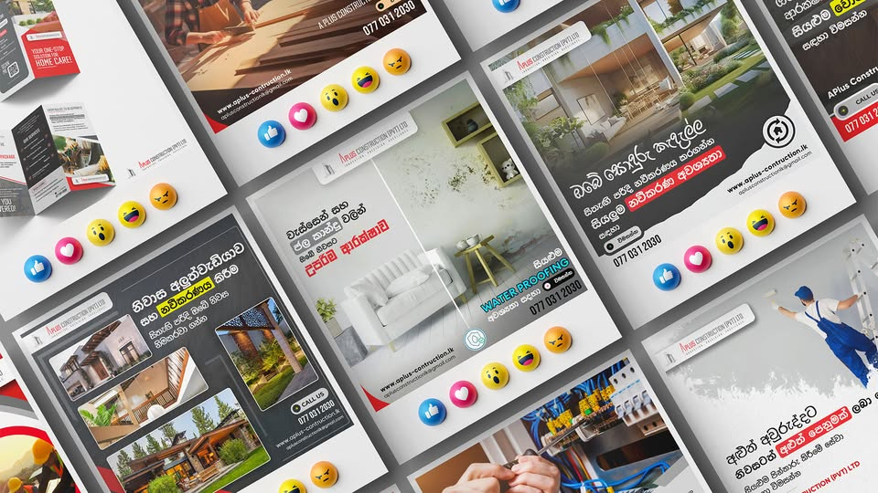  A Plus Construction  Social media campaign · Poster series |   DJI Mic Mini  Prime Camera Rent · Product promotion

  Creator Combo  Prime Camera Rent · Product promotion | 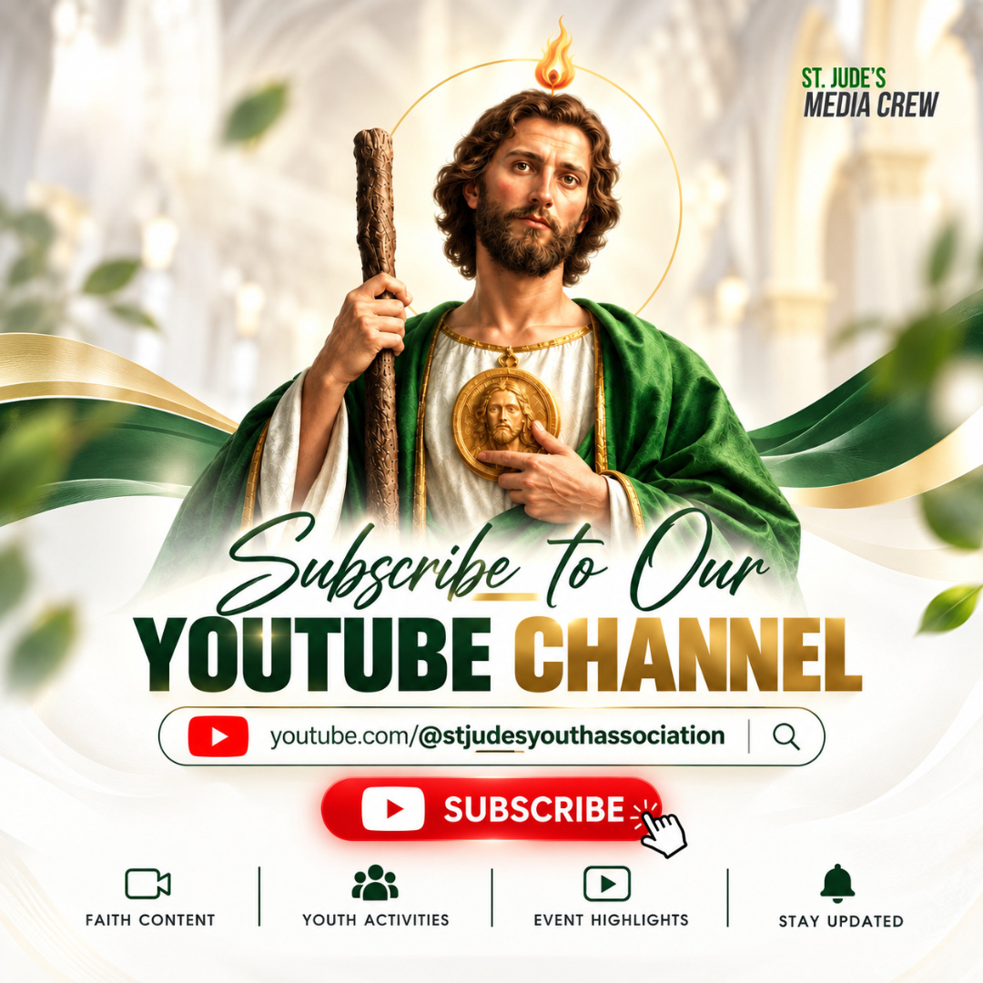  YouTube Channel  St. Jude’s Media Crew · Social campaign

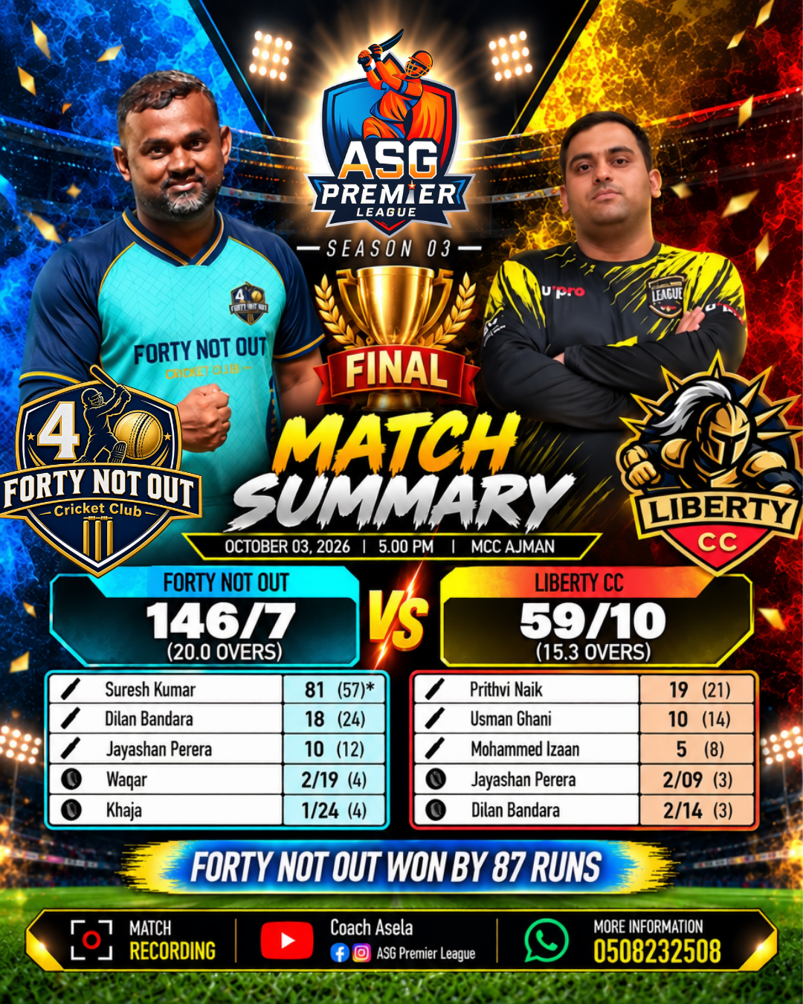  Season 03 Final  ASG Premier League · Match summary | 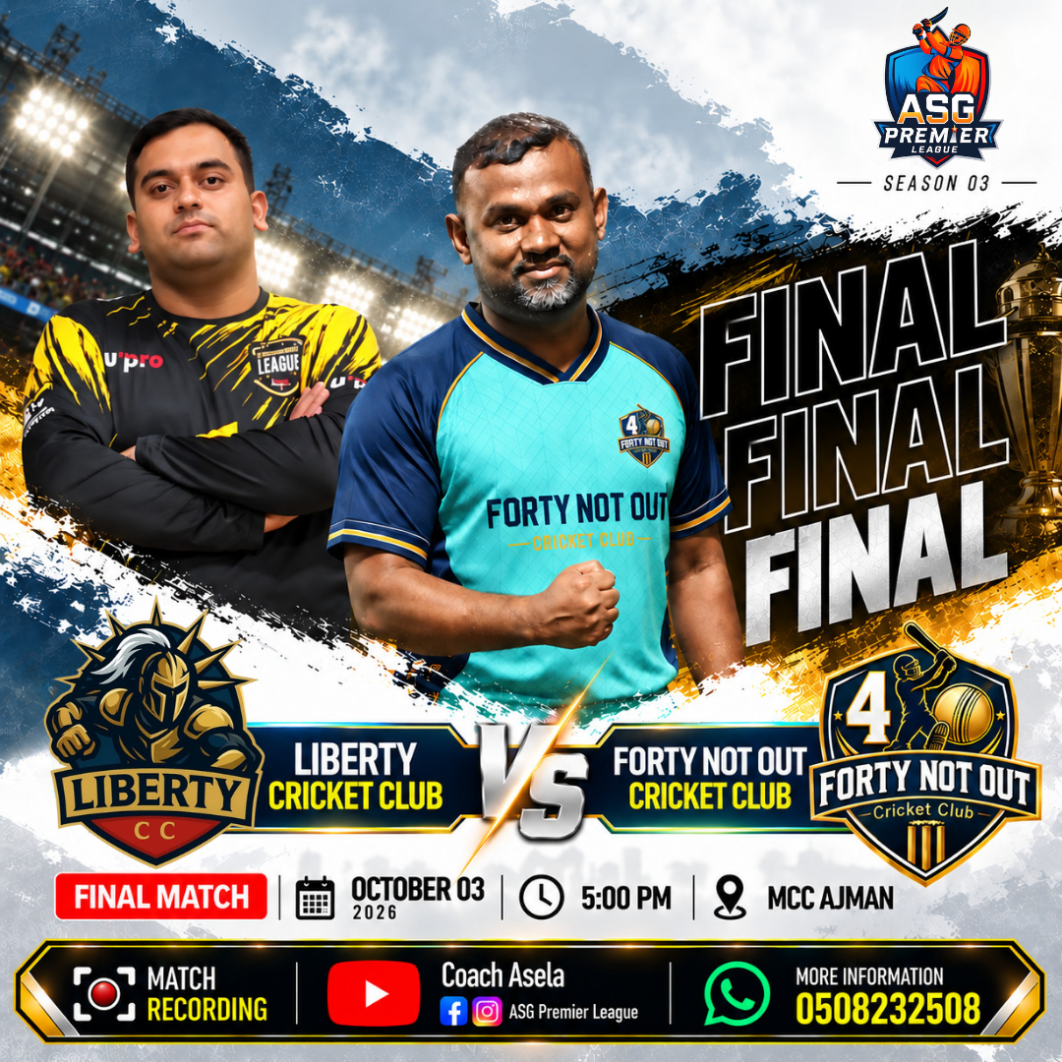  Final Match  ASG Premier League · Match artwork

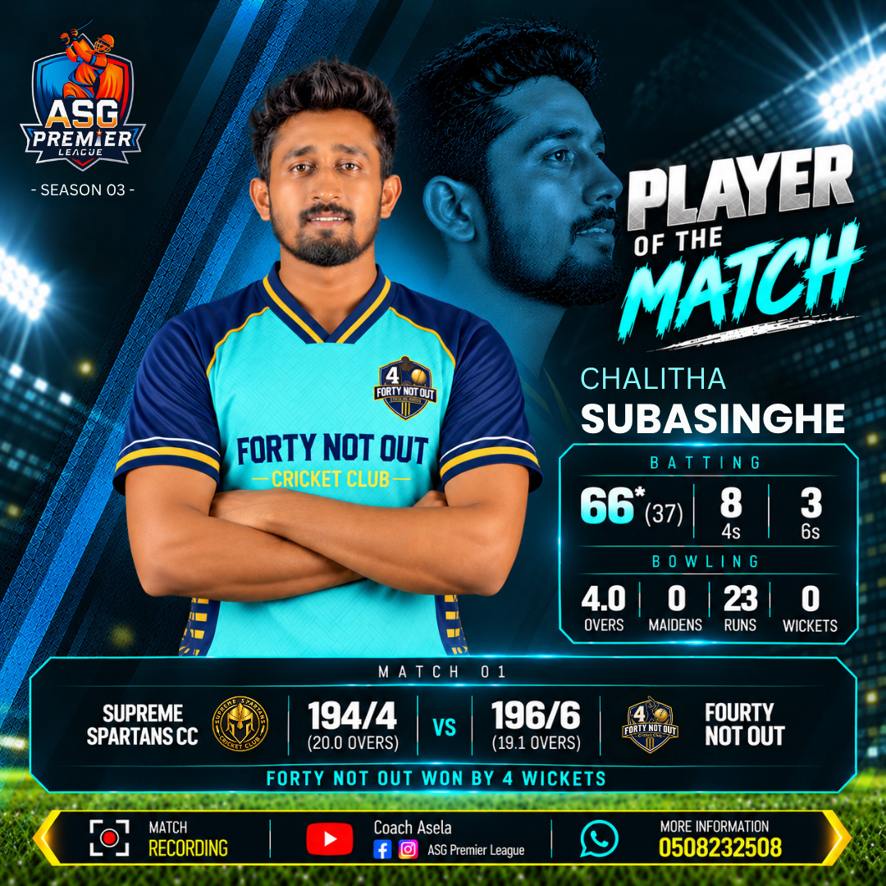  Player of the Match  ASG Premier League · Sports graphic | 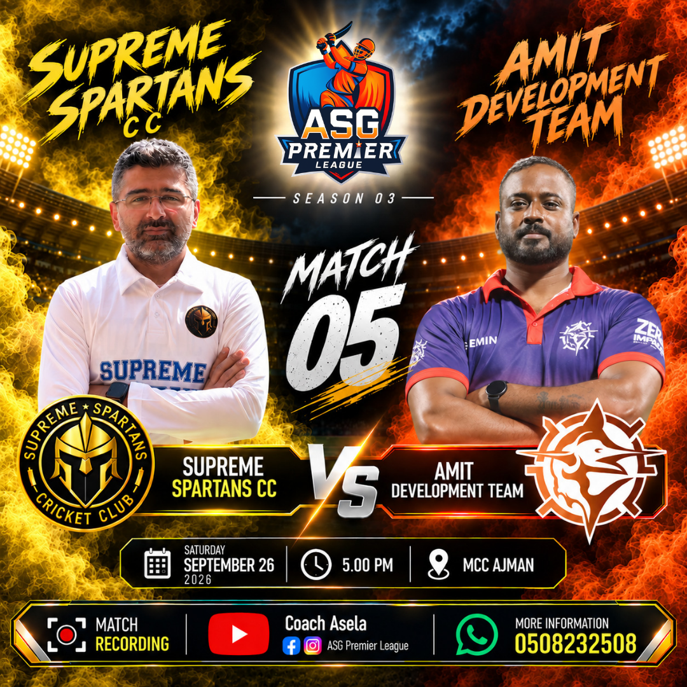  Match 05  ASG Premier League · Match artwork

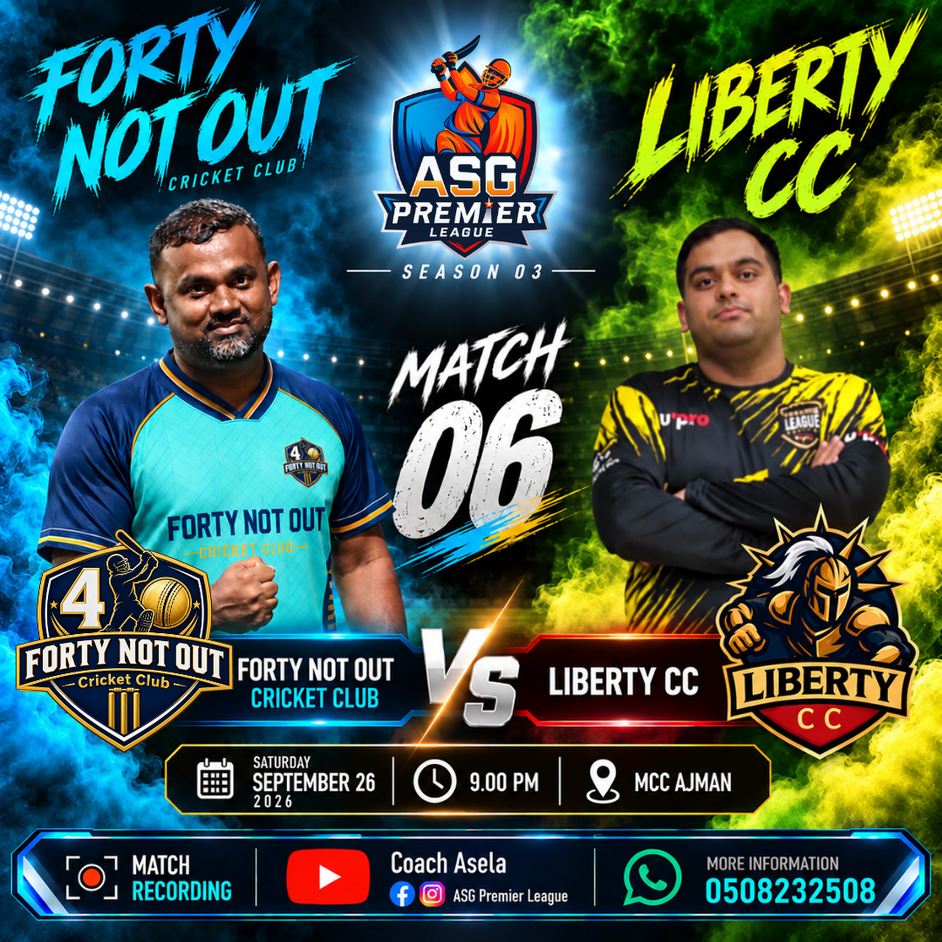  Match 06  ASG Premier League · Match artwork | 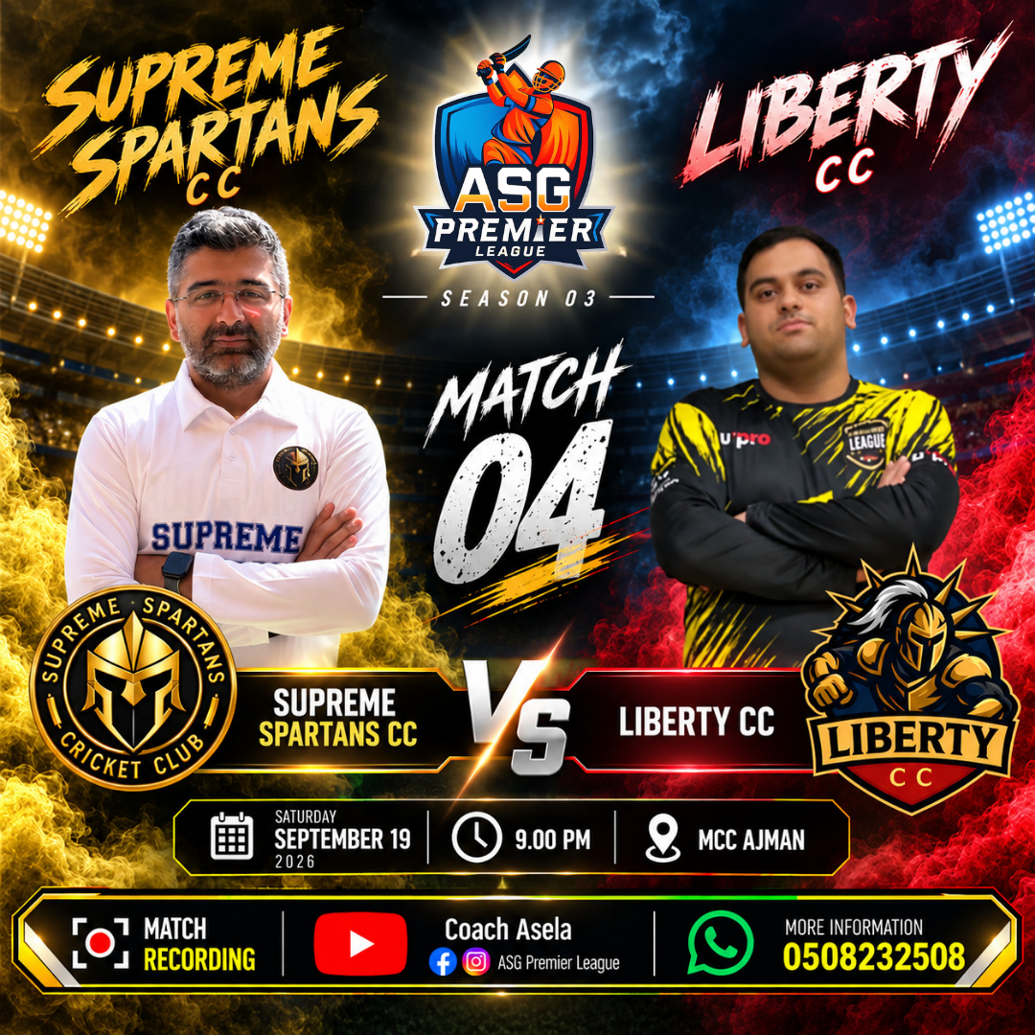  Match 04  ASG Premier League · Match artwork

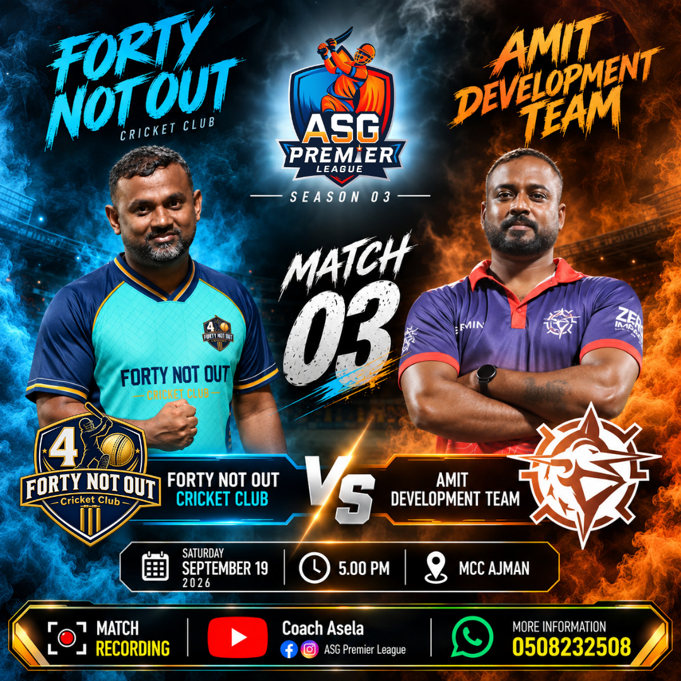  Match 03  ASG Premier League · Match artwork | 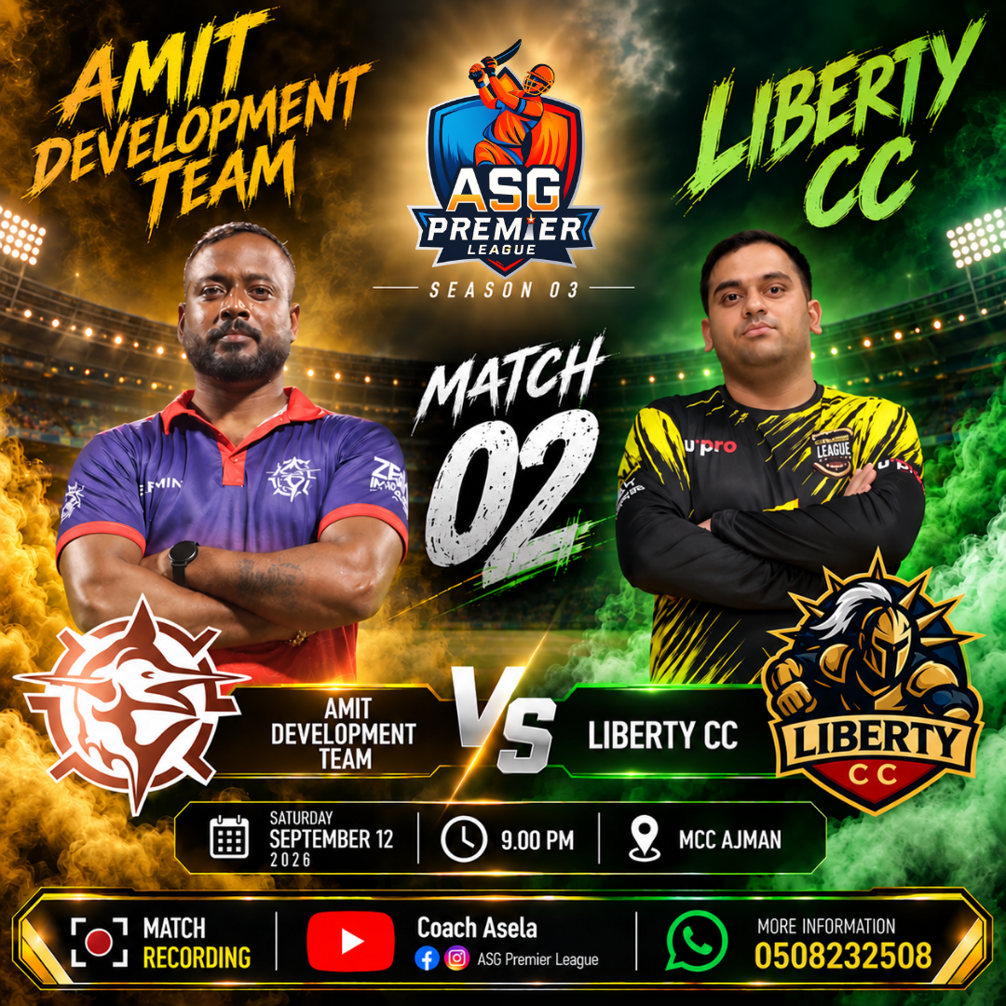  Match 02  ASG Premier League · Match artwork

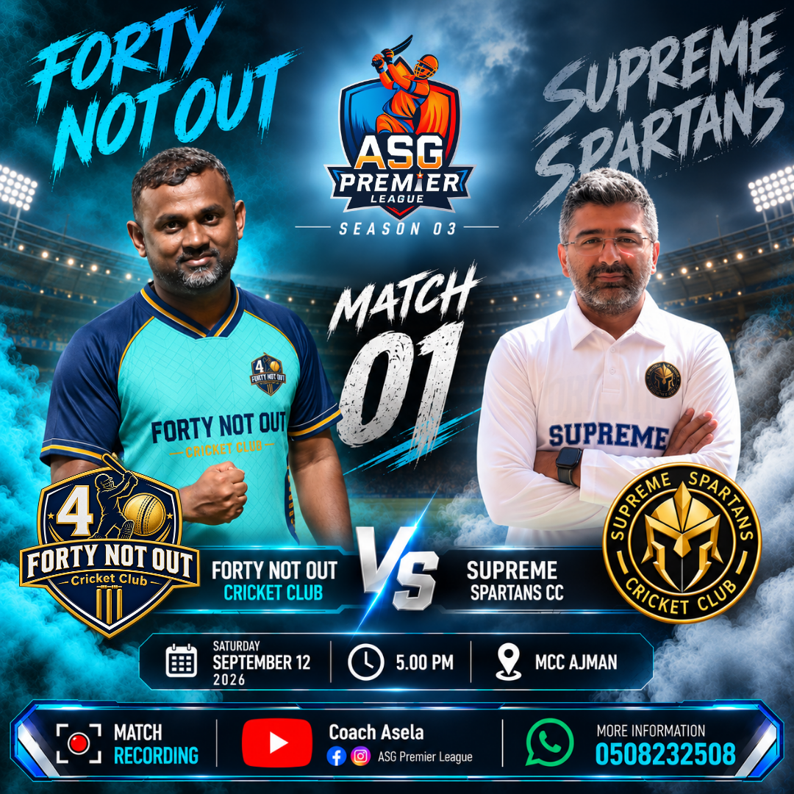  Match 01  ASG Premier League · Match artwork | 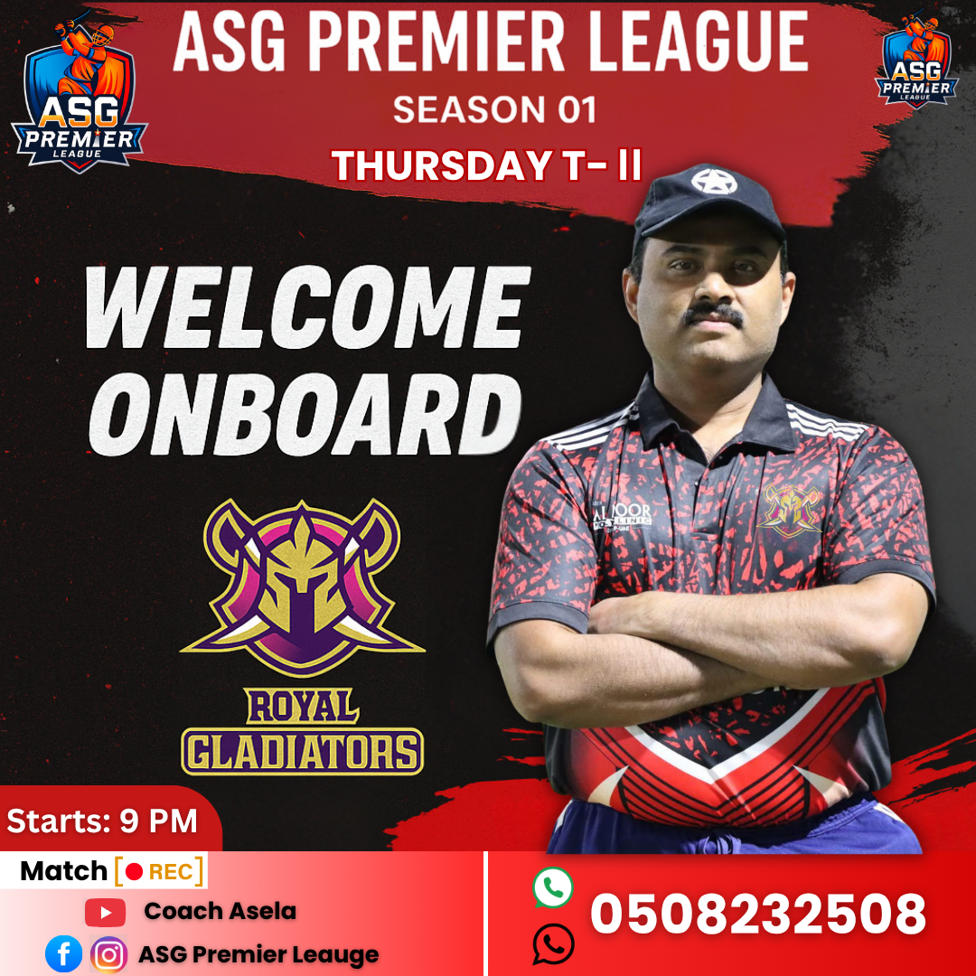  Ceylon Strikers  ASG Premier League · Team reveal

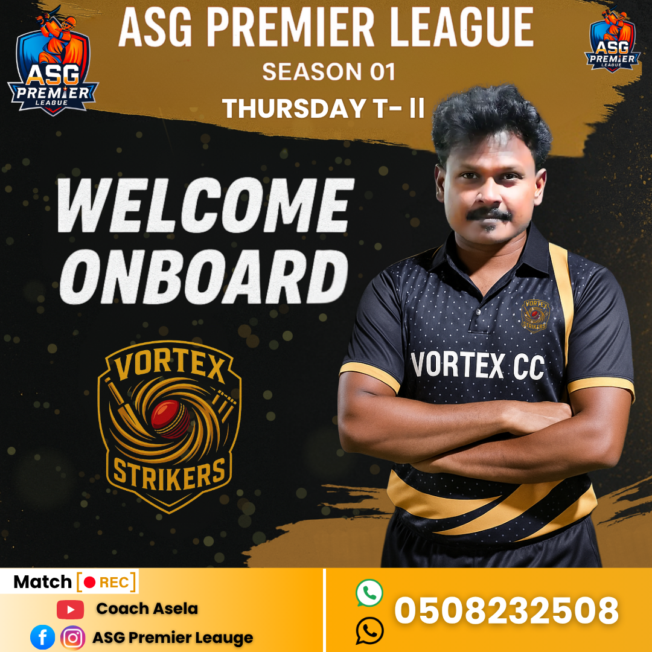  Royal Gladiators  ASG Premier League · Team reveal | 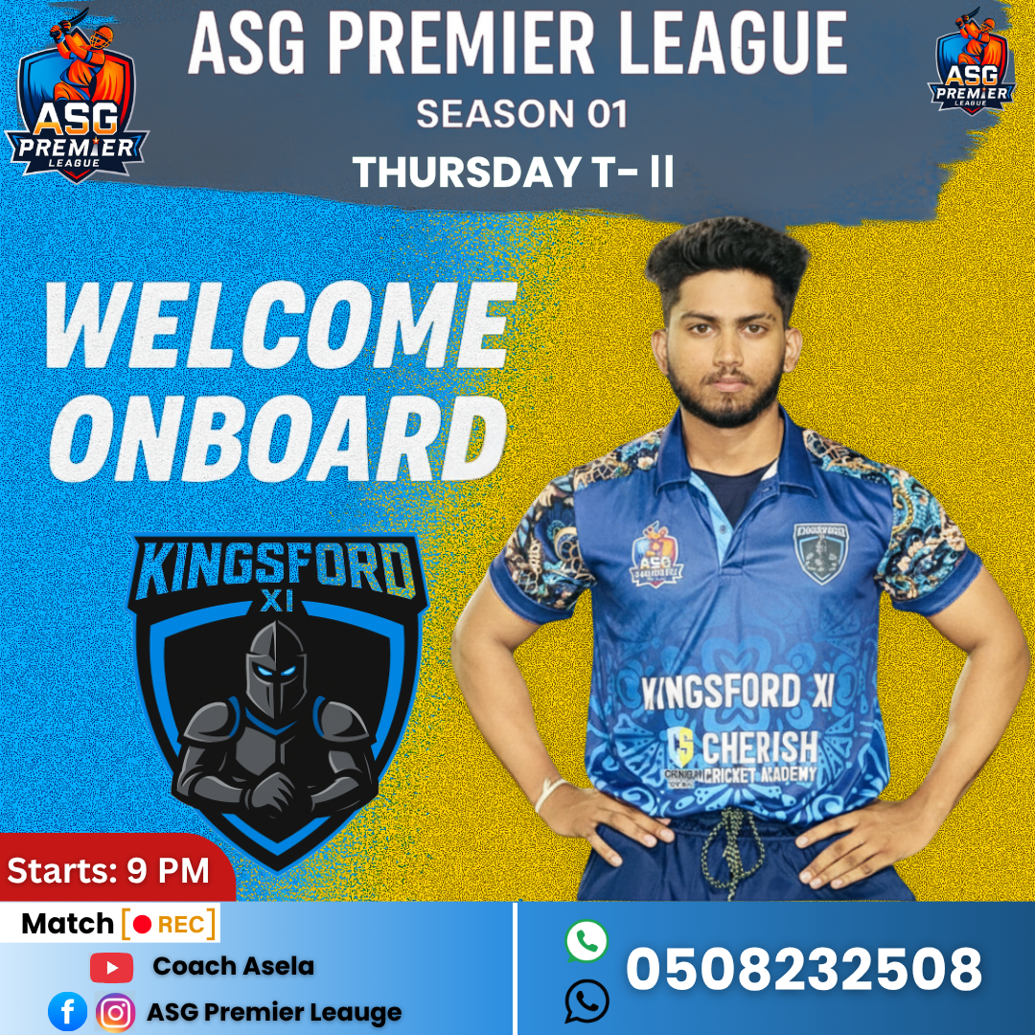  Kingsford XI  ASG Premier League · Team reveal

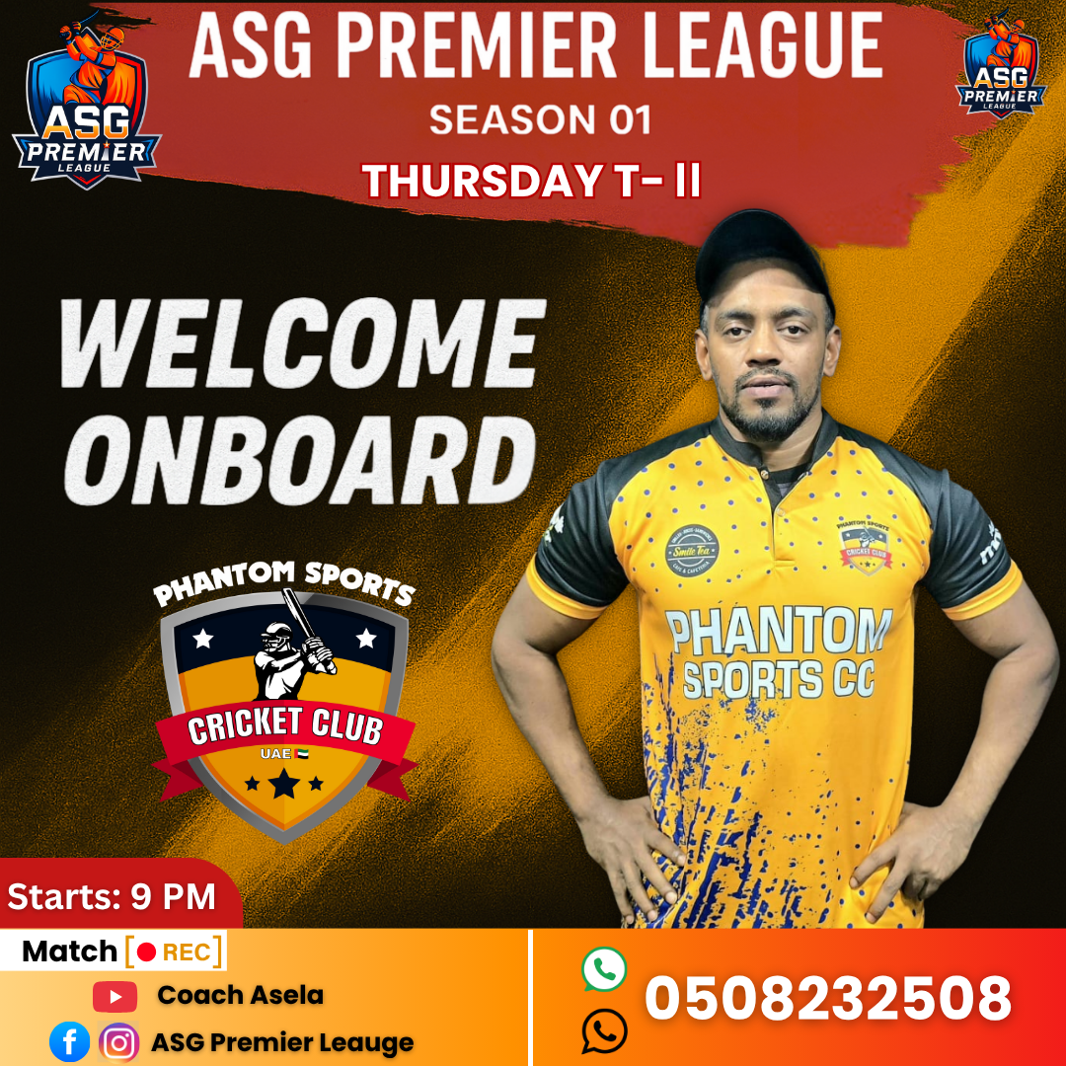  Phantom Sports CC  ASG Premier League · Team reveal | 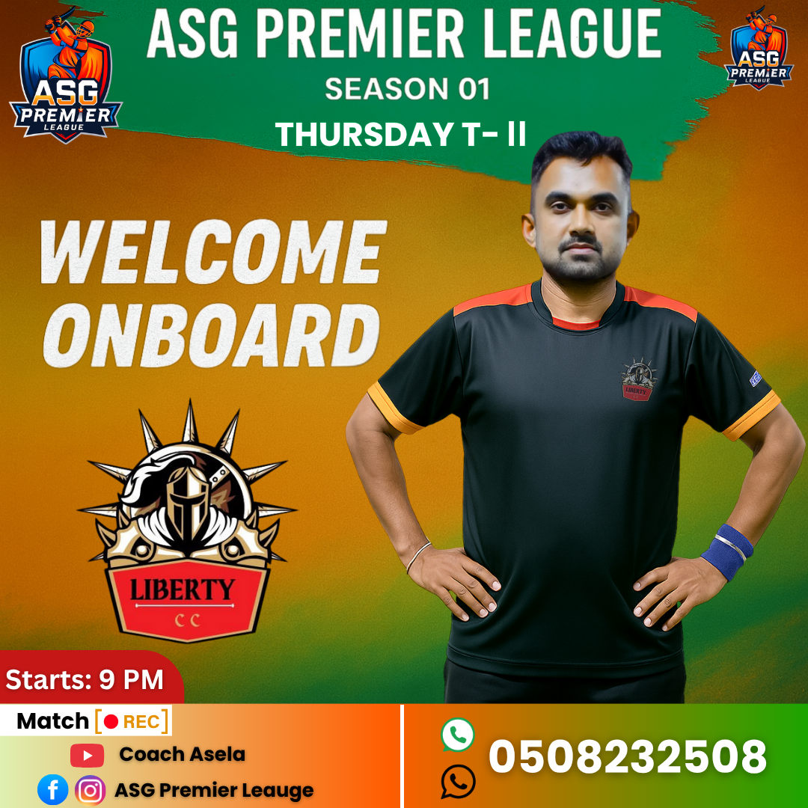  Liberty CC  ASG Premier League · Team reveal

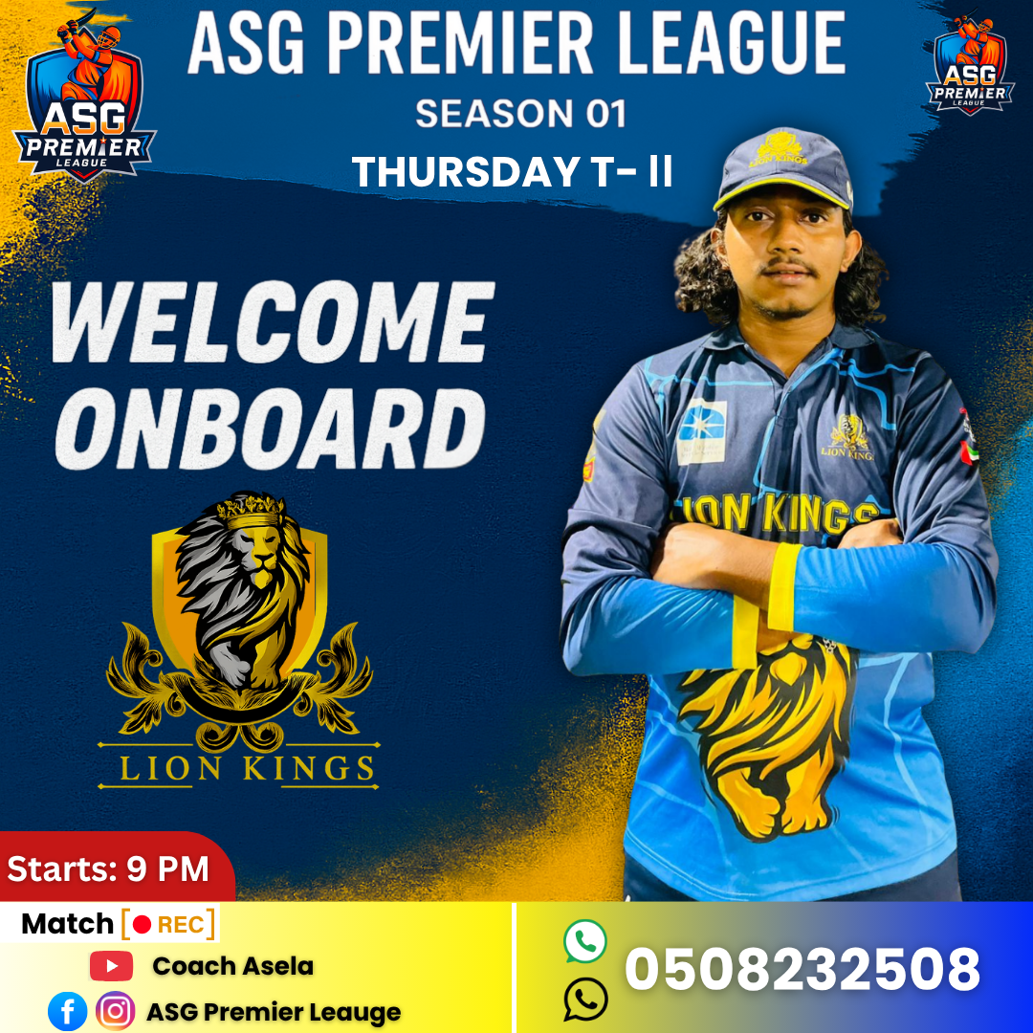  Lion Kings  ASG Premier League · Team reveal | 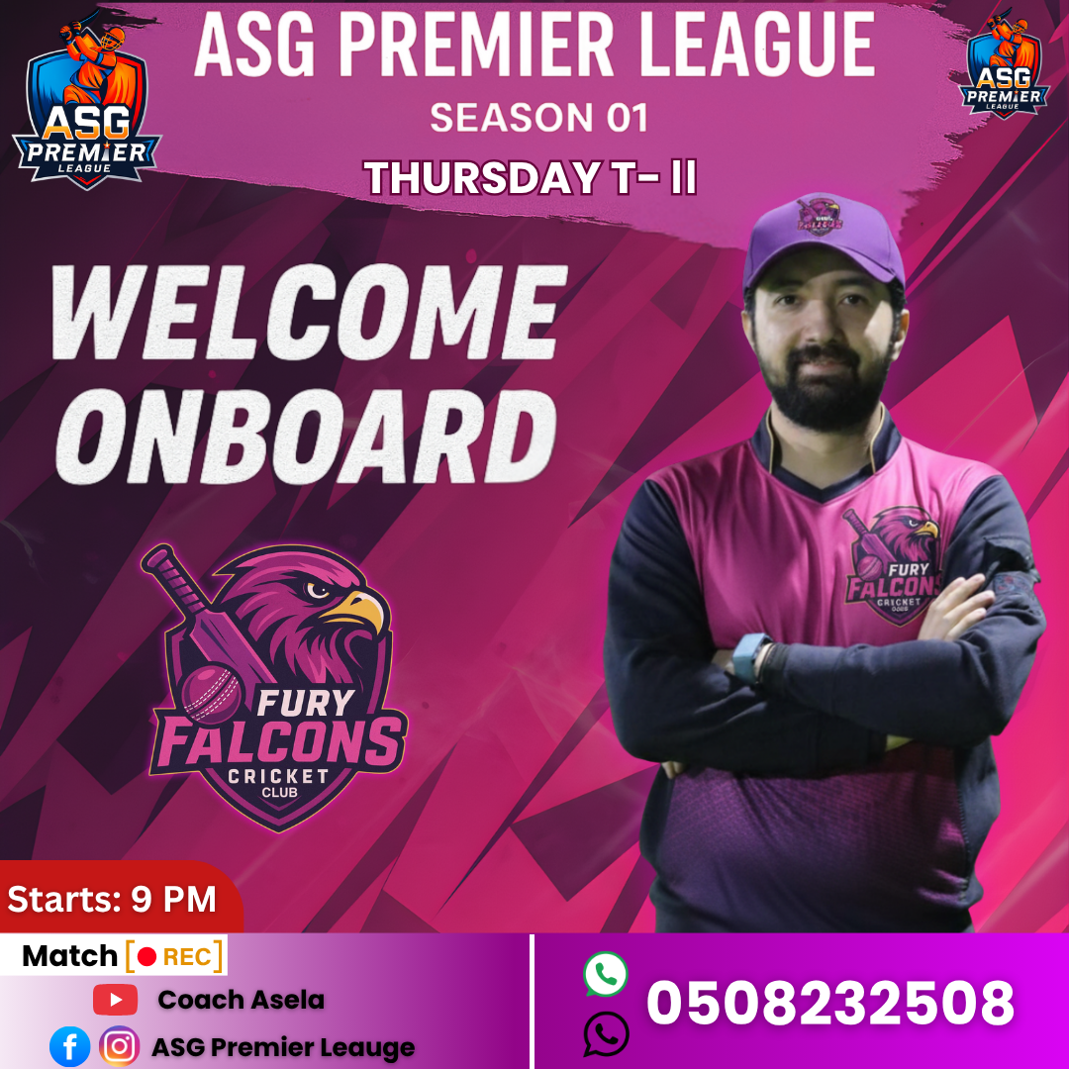  Fury Falcons  ASG Premier League · Team reveal

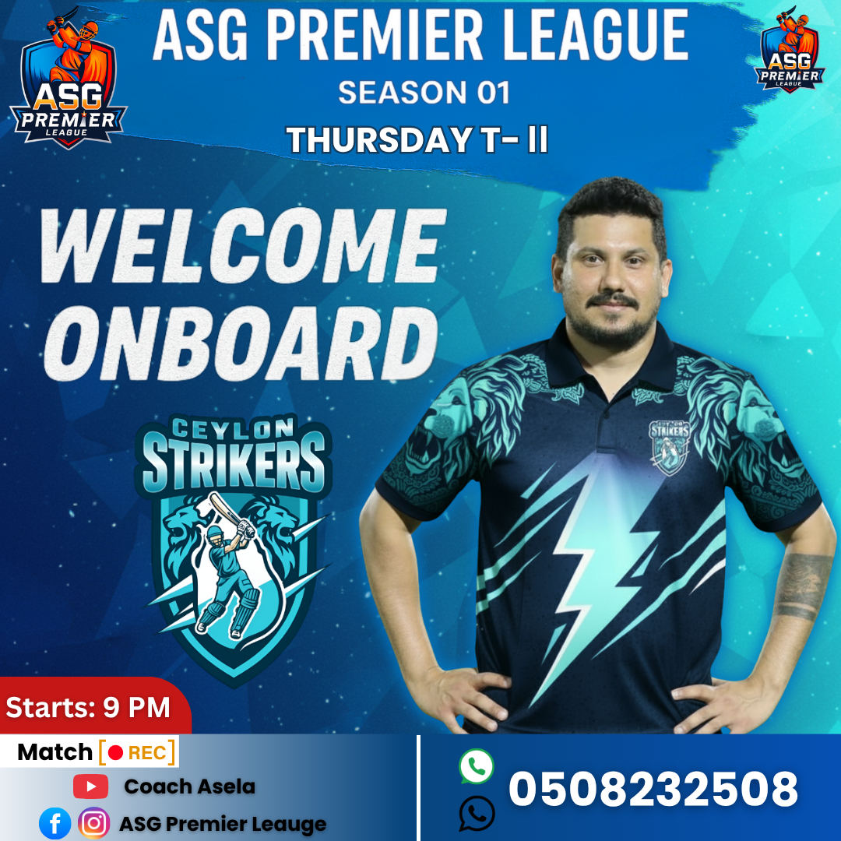  Player Welcome  ASG Premier League · Team reveal |   Garcinia Herb  Ranwan Lanka · Product campaign

  Women’s Day  Ranwan Lanka · Campaign artwork |   Product Promotion  Ranwan Lanka · Social creative

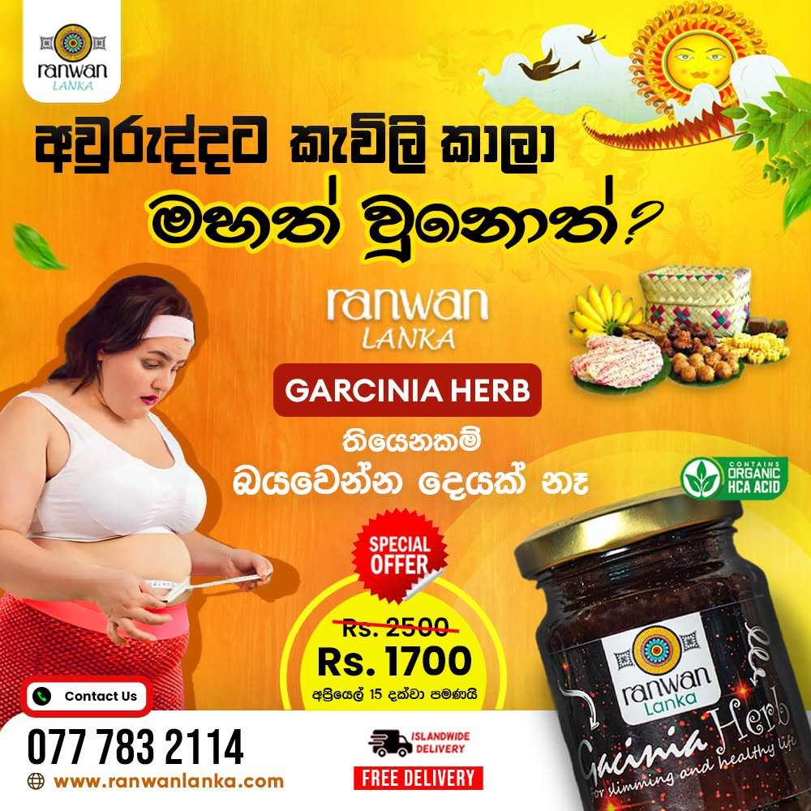  Sinhala Campaign  Ranwan Lanka · Promotional design | 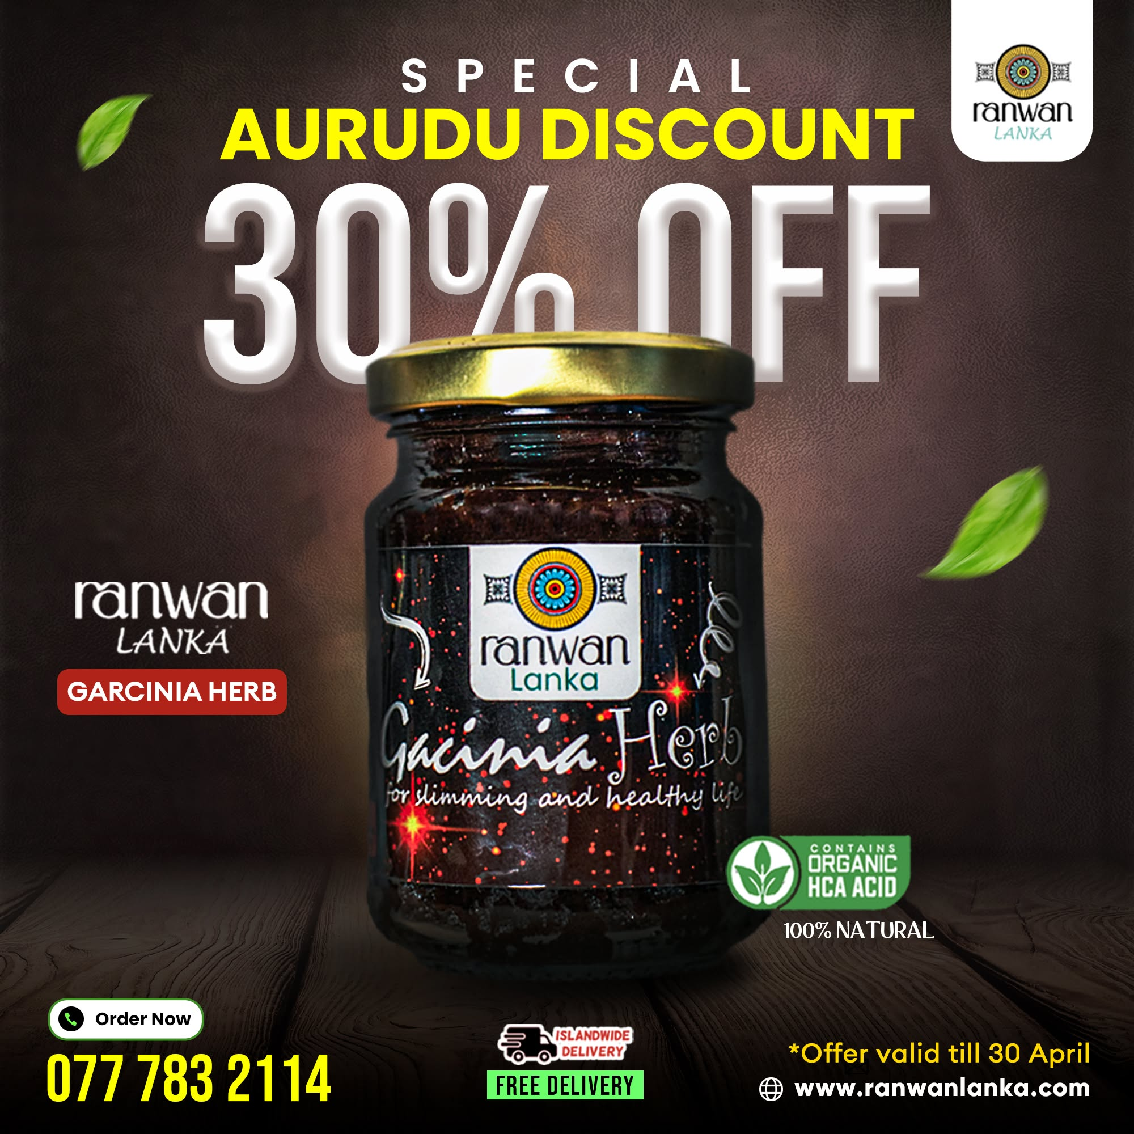  Aurudu Discount  Ranwan Lanka · Seasonal campaign

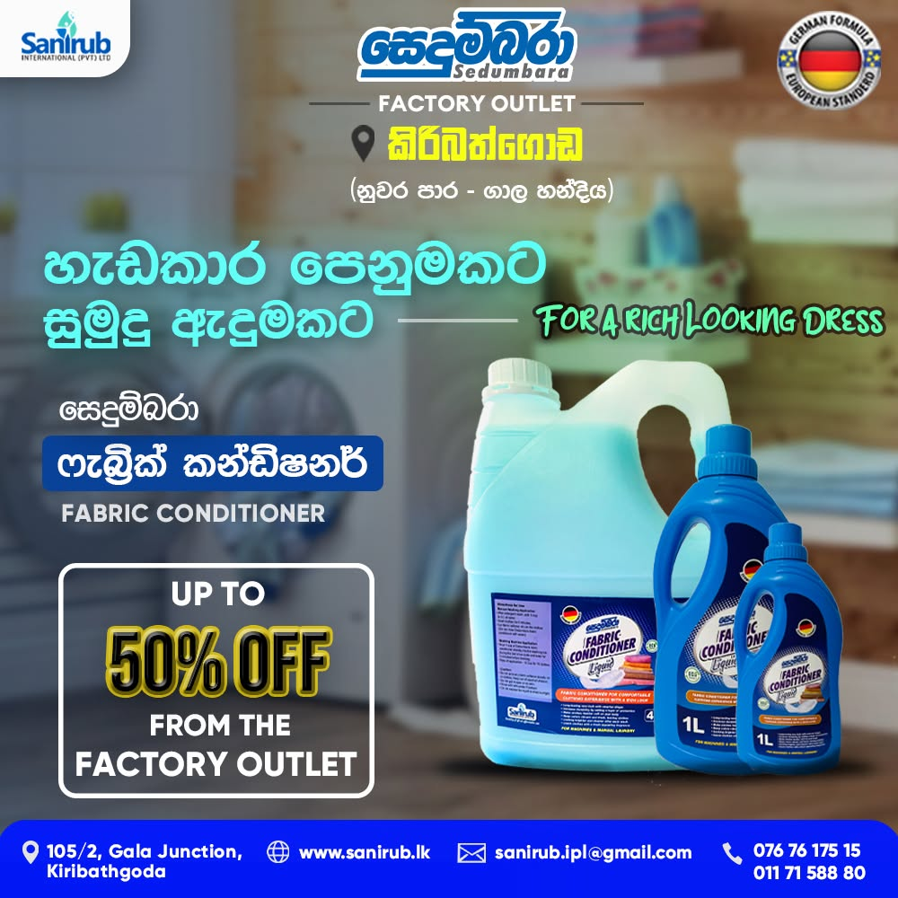  Fabric Conditioner  Sanirub · Product campaign | 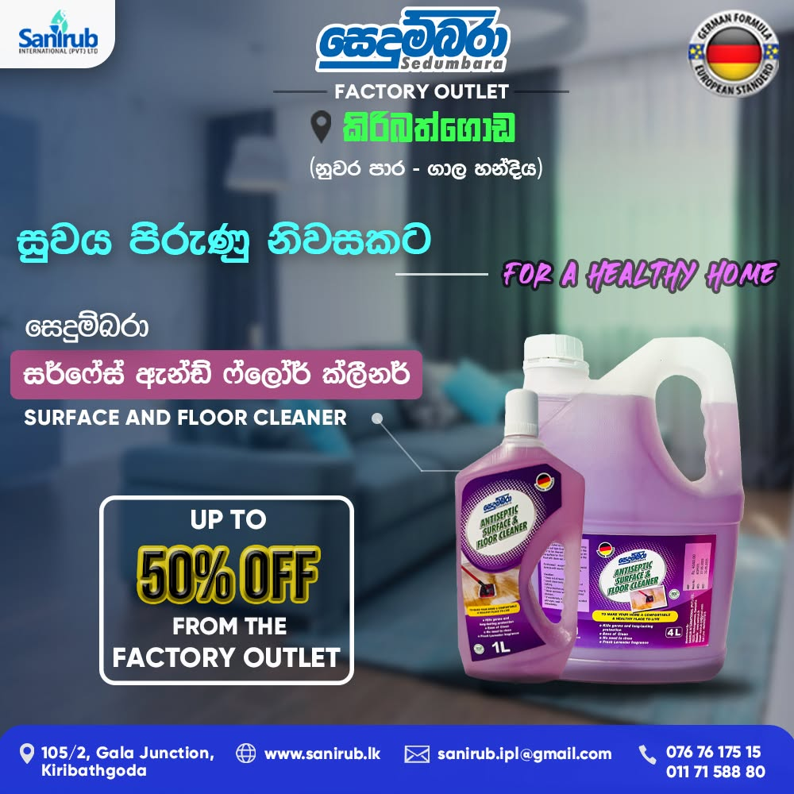  Surface Cleaner  Sanirub · Product campaign

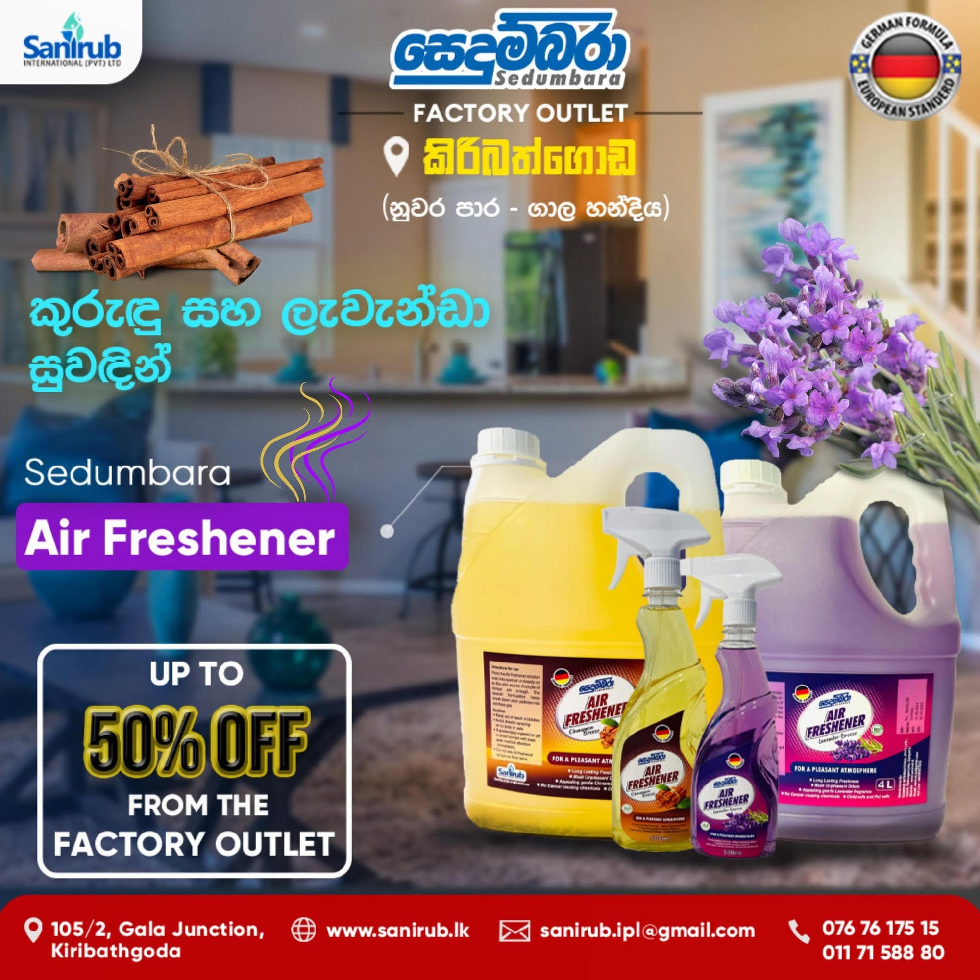  Air Freshener  Sanirub · Product campaign |   Christmas Sale  Sanirub · Seasonal campaign

