1a.You has a target of #1,000,000.00 to complete your house project. You decide to achieve this through monthly savings. Your plan is to make an initial deposit of #100,000.00 and you wish to save #50,000.00 each month. The bank has agreed to give you a monthly interest of 5%. Design an android application segment to print the total number of months when the savings will be greater than or equal to #1,000,000.00.

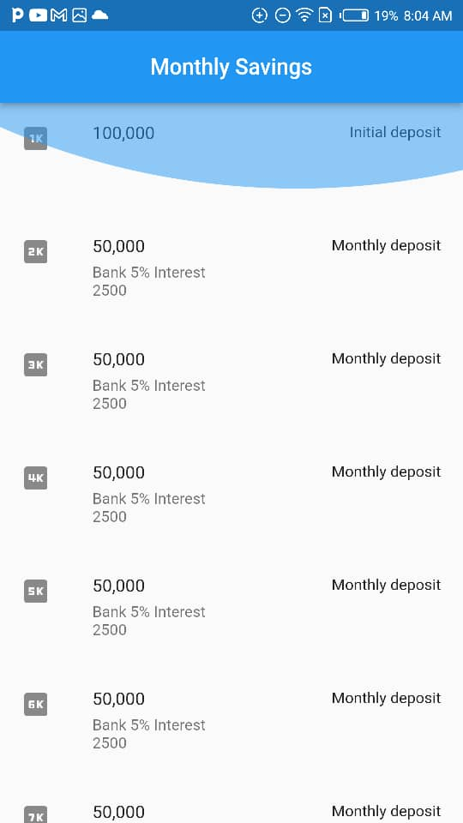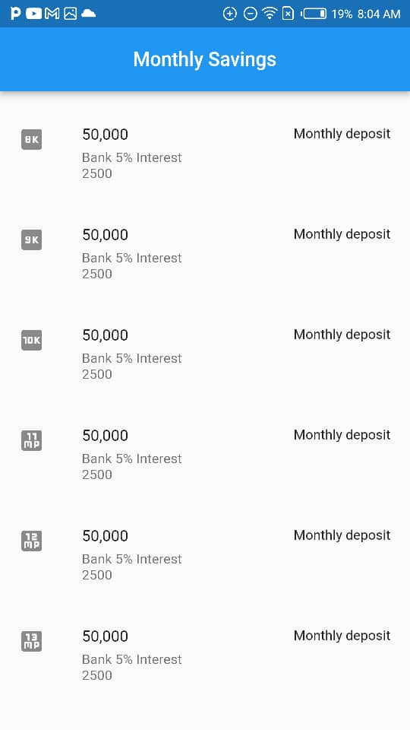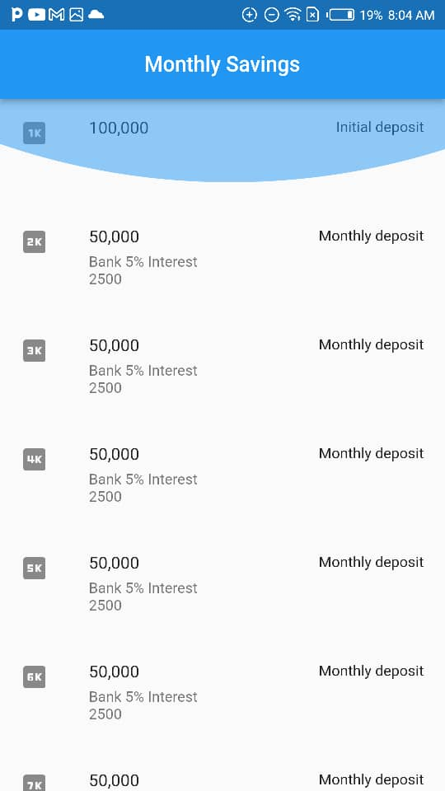**Solution**

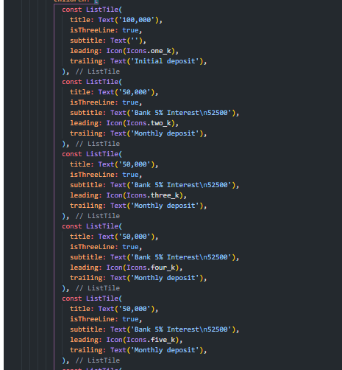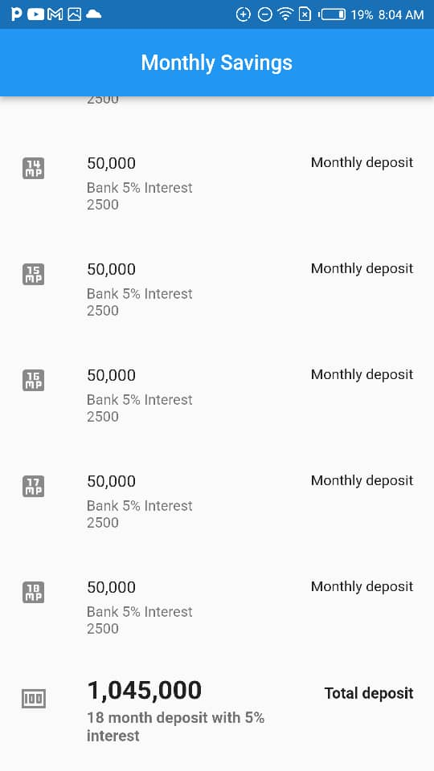

1b. Write an android application segment to find the sum of the odd number between 1 to 20.

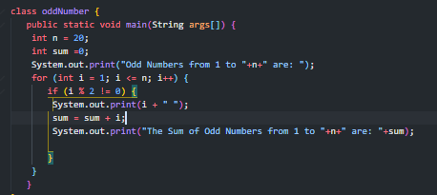

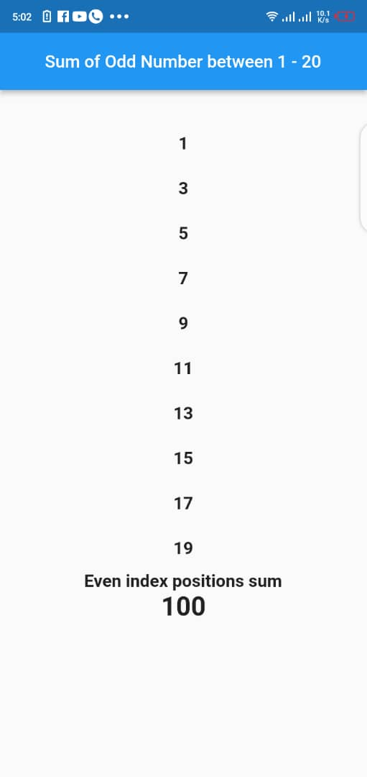

2a. the commission of a brilliant student is as follows;

1. If a student score is less than 50, no commission.
2. If a student score is greater than or equal to 50 commission is 5% of his/her school fee.
3. If a score equal to 100, commission is the total school fee plus 5% of the school fee.

Write an android application segment to compute and print commission.

(Hint: School fee = 85,000).

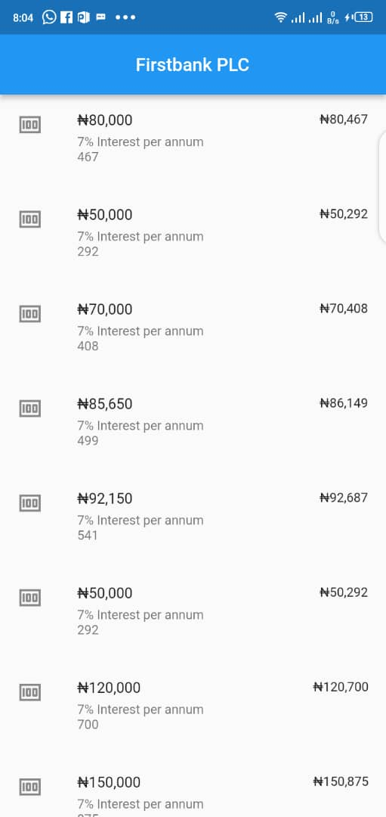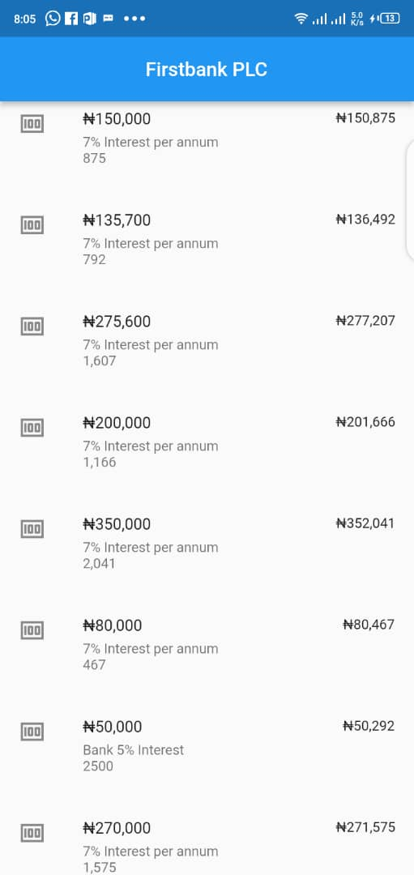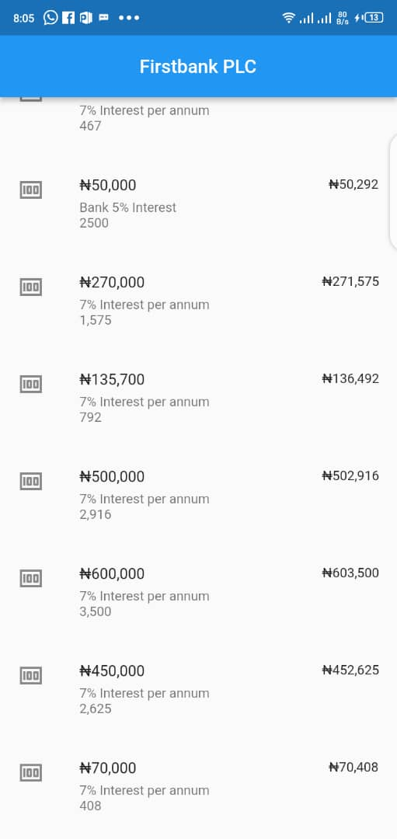**Solution**

2b. Write an android application program segment to compute the formula below;

Area = 4/3r2

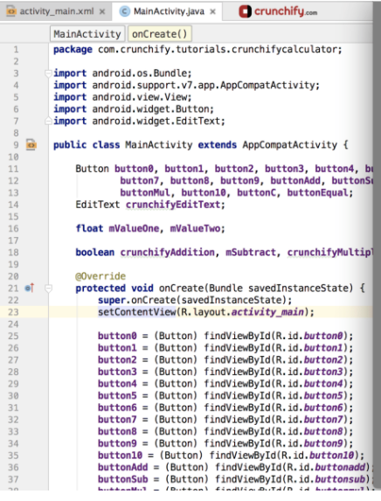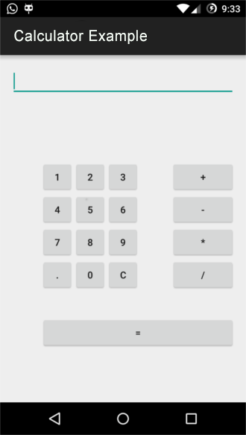

1. Write and application program segment to find the sum of two numbers.

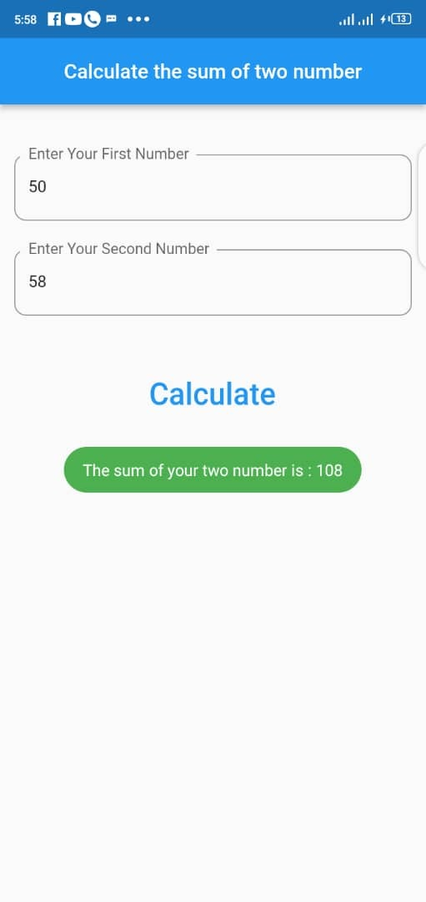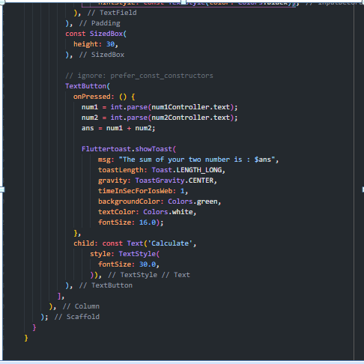

1. Write an android application program segment to find the area of a circle using formula: A=r2

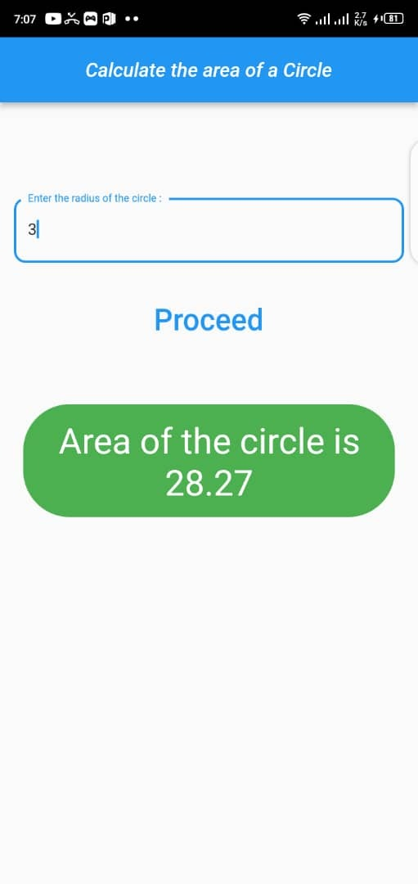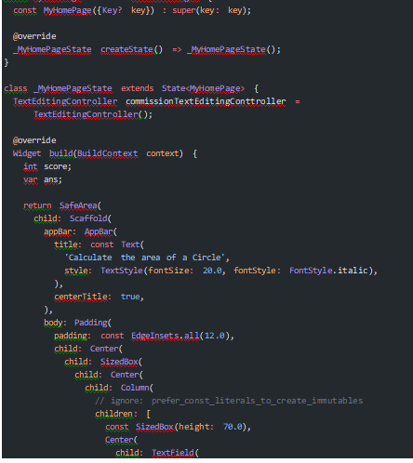

2. You are working in First Bank Plc where the computer is used to calculate the interest (I) of the customer’s current balance (B) to generate the amount (A). If the rate of the interest is 7 per annum and interest is calculated once a month. Write a mobile application program segment to achieve this task for 20 customers.

**Solution**

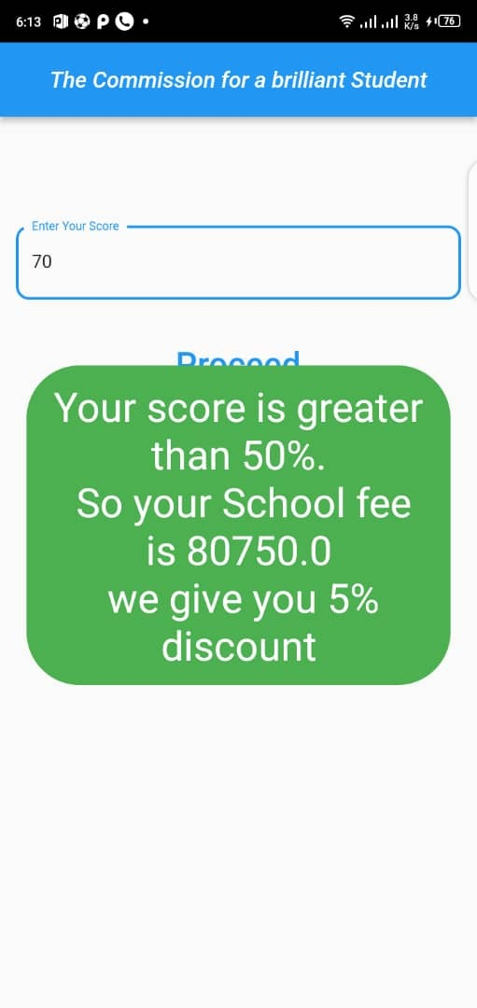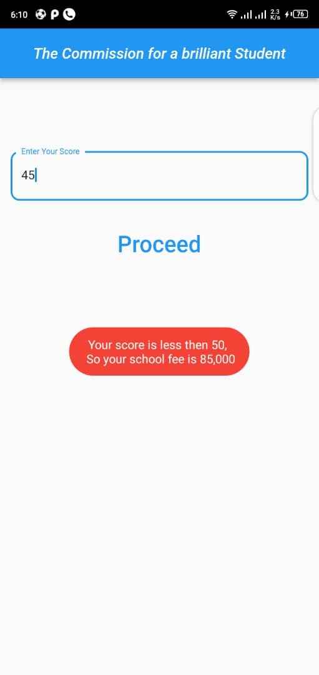

1. I. **With one example each, mention five (5) major features of an Android.**

* **Messaging**

[SMS](https://en.wikipedia.org/wiki/SMS) and [MMS](https://en.wikipedia.org/wiki/Multimedia_Messaging_Service) are available forms of [messaging](https://en.wikipedia.org/wiki/Messaging), including threaded [text messaging](https://en.wikipedia.org/wiki/Text_messaging) and Android Cloud To Device Messaging (C2DM) and now enhanced version of C2DM, Android Google Cloud Messaging (GCM) is also a part of Android Push Messaging services.

* **Auto Correction and Dictionary**

Android Operating System has an interesting feature called Auto Correction. When any word is misspelled, then Android recommends the meaningful and correct words matching the words that are available in Dictionary

* **Voice-based features**

Google search through voice has been available since initial release. Voice actions for calling, texting, navigation, etc. are supported on Android 2.2 onwards

* **Multi-touch**

Android has native support for [multi-touch](https://en.wikipedia.org/wiki/Multi-touch) which was initially made available in handsets such as the [HTC Hero](https://en.wikipedia.org/wiki/HTC_Hero). The feature was originally disabled at the kernel level (possibly to avoid infringing Apple's patents on touch-screen technology at the time).

* **Screen capture**

Android supports capturing a [screenshot](https://en.wikipedia.org/wiki/Screenshot) by pressing the power and home-screen buttons at the same time. Prior to Android 4.0, the only methods of capturing a screenshot were through manufacturer and third-party customizations (apps), or otherwise by using a PC connection (DDMS developer's tool).

Ii. What are the required tools for developing Android Application program?

* Android Studio
* ADB (Android Debug Bridge)
* AVD Manager
* Gradle
* IntelliJ IDEA