**PROJECT PROPOSAL ON MOBILE ATTENDANCE MANAGEMENT SYSTEM**

The mobile attendance has been developed to eliminate the time and effort wasted in taking attendances in schools and colleges. It also reduces the number of paper resources needs in participation information management. The system is divided into following modules:

• This is an android mobile application. It’s developed to be utilized for school/college workforce with the goal that they may take student attendance on their mobile phones.

• Attendance Storage: This information is currently put away in the staff mobile phone. Staff may likewise see it whenever on their mobile phone application.

• Attendance sheet transfer: The staff can transfer the document to a server (ordinary PC) by means of a web association where this information can be stored and maintain by the school or college.

• Attendance Check: The PC administrator may now check the attendance transfer as Student matric no, date, time and sort by date to check presentees of a specific date.

Subsequently, this student computerizes participation system and eliminates with the utilization of paperwork required for attendance making and monitoring student attendance.

The Project will have 3 different modules which are:

Student Attendance mobile Application (QR Code Generator)

Lecturer Attendance mobile Application (QR Code Scanner)

Lecturer Web Page (To have access to all the marked Attendance)

**HOW IT WORKS**

**Students Module**

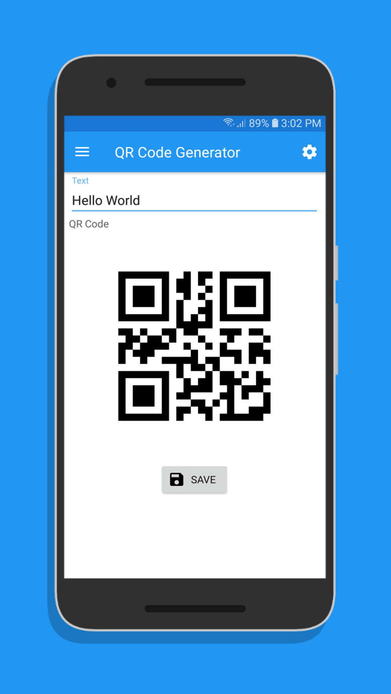

Matric Number here

**Features**:

* Once student download the application he/she can only input matric number once, Once a matric number is entered they cannot change or delete it.
* Once the lecturer is ready to mark the attendance, all student in the class will show their QR Code to for scanning.

**Lecturer Application Module**

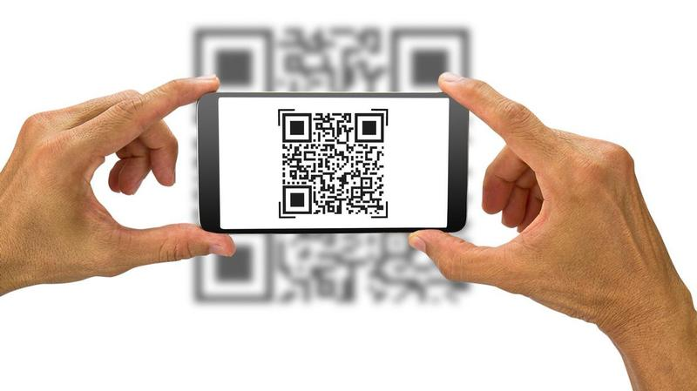

**Features**

* Lecturer will scan each student QR Code with their QR Code Scanner
* Once a student is scan the matric number, course code, date and time will be save into the data base

**Lecturer Web Module**

In this Module Lecture will be able to sort out all registered matric number and can export as PDF of Excel Format