SPORTS RISK AND INJURY PREDICTION
A MAJOR PROJECT REPORT

SUBMITTED IN PARTIAL FULFILLMENT OF THE REQUIREMENTS
FOR THE AWARD OF
THE DEGREE OF

BACHELOR OF COMPUTER APPLICATIONS (HONOURS)
(Data Science)

SUBMITTED BY
Khushi Varshney (2023BCAHO22)
Pari Mohabiya (2023BCAHO37)
Lakshda Sharma (2023BCAHO24)

UNDER SUPERVISION OF
Mr. Priyank Dubey
Assistant Professor

JUNE-2025



JAGRAN SCHOOL OF COMPUTER APPLICATIONS (JSCA)
FACULTY OF SCIENCE AND TECHNOLOGY (FAST)
JAGRAN LAKECITY UNIVERSITY, BHOPAL (M.P.)
CERTIFICATE

I hereby certify that the work which is being presented in the B.C.A Minor Project Report entitled “Sports Risk and Injury Prediction”, in the partial fulfillment of the requirements for the award of the Bachelor of Computer Application (Data Science) is an authentic record of my own work carried out during session Jan-Jun, 2025 (5th semester) under the guidance of Mr. Priyank Dubey, Assistant Professor, JSCA.
The matter presented in this Minor Project Report has not been submitted by me for the award of any other degree elsewhere.

Khushi Varshney (2023BCAHO22) Signature of Students
Pari Mohabiya (2023BCAHO37)
Lakshda Sharma (2023BCAHO24)

This is to certify that the above statement made by the student is correct to the best of my knowledge.
Date:
Mr. Priyank Dubey
Project Guide, Assistant Professor
JSCA, JLU Bhopal

Mr. Vaishali Sharma
Program Leader (B.C.A)
JSCA, JLU Bhopal
Dr. Dileep Kumar Singh
Head
FAST, JLU Bhopal

ACKNOWLEDGEMENT

It is indeed a great pleasure to express my thanks and gratitude to all those who helped me during this period. This project would not have been materialized without the help from many quarters. I sincerely thank to all the persons who ever played a vital role in the successful completion of my project.
I sincerely thank all the people who co-operate and encourage me throughout the semester and make my project work successful.
I am thankful to Mr. Priyank Dubey (Project Coordinator, JSCA) who has constantly remained helpful in suggesting directions and providing me guidance throughout the project.
I also thank Mrs. Vaishali Sharma (Program Leader (B.C.A), JSCA) for providing me the confidence and helping me in the project.
Special thanks to Dr. Dileep Kumar Singh (Head, FAST) for providing this platform which helped in the development of my technical skills and provided opportunity to study and work here which imparted a lot of knowledge, experience, confidence, skills, and real field awareness to us/me.
It is good fortune that I had support and well wishes of many. I thank all those, whose names have not appeared here but the contributions have not gone unnoticed.

Khushi Varshney (2023BCAHO22) Signature of Student(s)
Pari Mohabiya (2023BCAHO37)
Lakshda Sharma (2023BCAHO24)

ABSTRACT

Sports injuries pose a significant challenge in the athletic domain, often leading to decreased performance, extended recovery periods, and potential career setbacks. This project aims to develop an intelligent injury prediction and prevention system by leveraging data from wearable sensors and machine learning techniques. By integrating a heart rate sensor, blood pressure monitor, pulse oximeter, and MPU-6050 inertial measurement unit (IMU), the system captures both physiological and biomechanical parameters of athletes in real time.
To process and interpret this data, a comprehensive pipeline is established. First, time-series signals from the IMU are transformed into spectrograms to highlight frequency-domain patterns, aiding in motion analysis. K-Means clustering is employed to manage unlabeled data, grouping signal patterns based on similarity. Subsequently, neural networks are trained on the clustered data to learn features and classify critical states that may indicate potential injury risks.
In parallel, the system incorporates a Convolutional Neural Network (CNN) for pose estimation, identifying key body landmarks and calculating joint angles from video input. These angles are continuously monitored to detect abnormal movement patterns or excessive strain, particularly focusing on fall detection scenarios when the frequency of critical angles increases.
This integrated approach offers a holistic view of an athlete’s physical condition, combining physiological signals with biomechanical insights. The result is a real-time, data-driven support tool designed to enhance performance, reduce injury risks, and inform training protocols—delivering substantial value for both individual athletes and sports professiona
TABLE OF CONTENTS

- Abstract…………………………………………………………………………………… iv
- Overview 11
  - Introduction 11
  - Importance of Injury Prediction in Sports 12
  - Role of Data Integration and Web based System 13
  - Scope of the Project 13
  - Objectives 4
- Literature Review 6
  - Introduction 6
  - Summary of Existing Research and Methods 7
    - Data-Driven Approaches for Sports Injury Analysis 7
    - Sports Injury Research in Football and Related Domins 8
  - Gaps in Existing Systems 18
  - Summary 19
- System Design 20
  - Block Diagram of the System 20
  - Description of System Components 21

 |  | 3.2.1 | Dataset Module ……………………………..…………………... | 22
 |  | 3.2.2 | Data Acquisition and Merging Pipeline…….…………………………….... | 22
 |  | 3.2.3 | Data Preprocessing and Feature Engineering………………………………. | 22
 |  | 3.2.4 | Machine Learning Model Module………………………………………….. | 23
3.3 |  | Data | Flow Diagram . . . . . . . . . . . . . . . . . . . . . . . . . . . . . . . . . . | 26
4 | Methodology |  |  | 27
 | 4.1 Data Collection . . . . . . . . . . . . . . . . . . . . . . . . . . . . . . . . . . . . |  |  | 27
 | 4.2 Feature Extraction . . . . . . . . . . . . . . . . . . . . . . . . . . . . . . . . . . . |  |  | 30
 | 4.3 Data Fusion Techniques . . . . . . . . . . . . . . . . . . . . . . . . . . . . . . |  |  | 33
 | 4.4 Classification Algorithm Used . . . . . . . . . . . . . . . . . . . . . . . . . . . . |  |  | 34
 | 4.5 Training and Testing Process . . . . . . . . . . . . . . . . . . . . . . . . . . . . . |  |  | 34
 | 4.5.1 Data Splitting . . . . . . . . . . . . . . . . . . . . . . . . . . . . . . . . . |  |  | 34
 | 4.5.2 Evaluation Metrics . . . . . . . . . . . . . . . . . . . . . . . . . . . . . . |  |  | 34
 | 4.5.3 Cross-validation . . . . . . . . . . . . . . . . . . . . . . . . . . . . . . . |  |  | 35
 | 4.6 Flowchart of Methodology . . . . . . . . . . . . . . . . . . . . . . . . . . . . . . |  |  | 36
5 | Implementation |  |  | 39
 | 5.1 Overview of System Architecture . . . . . . . . . . . . . . . . . . . . . . . . . . . |  |  | 39
 | 5.2 Software Configuration and System Setup……………. . . . . . . . . . . . |  |  | 39
 | 5.3 Communication Protocols Used . . . . . . . . . . . . . . . . . . . . . . . . . . . |  |  | 40
 | 5.3.1 REST API Communication . . . . . . . . . . . . . . .. . . . . . . . . . . . |  |  | 40
 | 5.3.2 Client-Server Communication using HTTP/HTTP.. . . . . . . . . . . . |  |  | 40
 | 5.4 Data Validation and Quality Calibration. . . . . . . . . . . . . . . . . . . . . . . . |  |  | 41
 | 5.5 Python-Based Data Acquisition and Preprocessing . . . . . . . . . . . . . . . . . |  |  | 41
 | 5.5.1 Data Processing and Analysis . . . . . . . . . . . . . . . . . . . . . . . . |  |  | 42
 | 5.6 Visualization and Exploratory Data Analysis . . . . . . . . . . . . . . . . . . . . . |  |  | 43

5.8 Lower-Limb Movement Data Acquisition and Analysis 46
- Results and Analysis 49
  - Sensor Data Summary and Statistical Evaluation 49
  - Temporal Evolution of Angular Motion 50
  - Angle-Based Motion Classification and Injury Detection 51
  - Real-Time Case Studies and Deployment Insights 52
  - Summary 53
- Conclusion and Future Work 54
  - Summary of Achievements 54
  - Effectiveness of the System 55
  - Limitations 56
  - Suggestions for Improvement 57
  - Future Scope 57
References 59

List of Figures

  - Block Diagram of the System 21
  - Data Flow Diagram……………………………………………………………………….41
  - Flowchart of the sports Injury Prediction System 54
  - Scatter Plots 69
  - Box Plot 70
  - Q-Q Plot 70
  - Time-Series Plots of Orientation Angles 71
  - Lower-Limb Movement Data Visualization 72

List of Tables

  - Normal Ranges of Joint Angles Relevant to Table Tennis 32

LIST OF ABBREVIATIONS

ML | Machine Learning
GUI | Graphical User Interface
UI | User Interface
XGBoost | Extreme Gradient Boosting
DT | Decision Tree
RF | Random Forest
SVM | Support Vecter Machine
LR | Logistic Regression
EDA | Exploratory Data Analysis
ACWR | Acute:Chronic Workload Ratio
BMI | Body Mass Index
CNN | Convolutional Neural Network
KNN | K-Nearest Neighbors
SVM | Support Vector Machine

CHAPTER- 1

OVERVIEW

Introduction

Sports injuries are a major concern in both professional and amateur athletic environments, influencing not only an athlete’s immediate physical performance but also their long-term career growth and overall well-being. Injuries often result from factors such as excessive workload, insufficient recovery, poor physical conditioning, and repeated strain during training or competition. If not detected early, these injuries may lead to prolonged downtime, performance decline, or even career-ending complications. Therefore, modern sports organizations require data-driven, intelligent systems that can predict injuries before they occur and support evidence-based decision-making.
In recent years, the availability of large-scale sports datasets has opened new opportunities for injury analysis. Instead of relying solely on manual observation or traditional assessment methods, performance data and historical injury records can be combined to understand deeper patterns in athlete risk factors. Publicly available datasets such as the FIFA Player Dataset provide detailed information on player attributes, physical metrics, position-based workload, and performance statistics. Similarly, the Sports Injury Dataset contains records of past injuries, severity levels, affected body regions, and recovery timelines.
By merging the FIFA dataset with the injury dataset, a richer and more comprehensive player profile is created. This merged dataset helps uncover the relationships between player characteristics (such as acceleration, stamina, strength, work rate, sprint speed) and injury tendencies. Through Exploratory Data Analysis (EDA), correlations and trends can be identified, enabling an improved understanding of how specific physical or performance factors contribute to injury risk.
Advancements in machine learning further enhance the ability to analyze such multidimensional data. ML algorithms can classify players into different risk categories and predict the likelihood of future injuries based on historical patterns. Models such as Random Forest, Logistic Regression, and Support Vector Machines are capable of learning from merged features and generating accurate predictions.
To make these insights accessible and actionable, this project incorporates a web-based dashboard system. The dashboard allows players to view their personal injury risk status and training insights, while workers/coaches/analysts can access global analytics, player comparisons, injury patterns, and prediction results. The user-friendly interface makes the system practical for daily use, eliminating the need for wearable devices or specialized hardware.
By integrating merged datasets, machine learning techniques, and a fully functional website dashboard, this project aims to deliver a comprehensive framework for injury prediction, analysis, and decision support—empowering athletes, coaches, and medical staff with intelligent tools to enhance performance and reduce injury occurrence.

Importance of Injury Prediction in Sports

Injury prediction has become a vital component of modern sports analytics, especially as teams increasingly rely on data-driven decision-making to enhance athlete performance and prevent long-term physical damage. Across various sports disciplines, injuries often occur due to excessive workloads, inadequate recovery, biomechanical imbalances, or repeated strain during training and competitive matches. These injuries can significantly affect an athlete’s performance, team strategy, and in severe cases, their overall career progression.
With the growing availability of detailed performance datasets—such as the FIFA Player Dataset, which includes physical attributes, skill ratings, match involvement, and player workload—sports organizations now have the opportunity to analyze injury patterns more effectively. When combined with a dedicated injury dataset, analysts can identify correlations between player characteristics and injury tendencies. For example, athletes with high sprint workloads, frequent directional changes, or low stamina ratings may be more prone to muscular or joint injuries.
Injury prediction is valuable because it shifts the approach from reactive treatment to proactive prevention. Instead of waiting for an athlete to get injured, machine learning models can flag early indicators of elevated risk based on historical and performance-related factors. This allows coaches, medical staff, and performance analysts to:
- Adjust training intensity
- Modify player rotation strategies
- Identify fatigue-related vulnerability
- Provide early rehabilitation guidance
- Support individualized fitness plans
A key advantage of this project is the implementation of a web-based injury prediction dashboard, which makes the insights easily accessible to users. Players can monitor their injury risk status, understand which attributes influence their performance, and take preventive measures. At the same time, workers, coaches, and analysts can view team-wide injury risk trends, compare players, and make informed decisions regarding line-ups, training loads, and recovery schedules.
By integrating merged datasets with machine learning models and presenting the results through an interactive dashboard, injury prediction becomes not just a preventive tool but an essential component of performance optimization and athlete management. This ensures that athletes maintain peak performance while minimizing the likelihood of injuries, ultimately contributing to improved overall team outcomes.

  - Role of Data Integration and Web-Based Systems
In modern sports analytics, the integration of multiple datasets and web-based platforms has become essential for understanding athlete performance and predicting injury risks. Instead of relying on wearable devices or sensor-based systems, this project utilizes large-scale, structured datasets and a centralized web dashboard to monitor, analyze, and predict injuries in athletes.
The core of this project lies in merging two powerful datasets:
1. FIFA Player Dataset
Contains detailed information on:
- Player physical attributes (stamina, strength, acceleration, balance, agility)
- Technical skills (ball control, dribbling, sprint speed)
- Positional workload and match involvement
- Overall performance ratings

2. Injury Dataset
Includes:
- Type of injury
- Injury severity
- Affected body region
- Recovery duration
- Player history of injuries
By combining these datasets, the system creates a comprehensive player profile that supports deeper analysis of injury patterns and risk factors. The merged dataset enables the system to explore relationships between performance characteristics and injury tendencies that would otherwise remain undetected.
The next key component of this project is the web-based dashboard, which serves as the central platform for visualization and decision-making. Unlike wearable technologies that collect real-time sensor data, the dashboard leverages historical and performance-based information to provide actionable insights.
The dashboard allows:
For Players
- View personal injury risk level
- Analyze performance-related factors contributing to risk
- Understand their training load and past injury trends
For Workers / Coaches / Analysts
- Access complete player datasets
- Compare injury probabilities across players
- Study team-wide injury patterns
- Make informed training and rotation decisions
Machine learning models integrated into the system process the merged dataset and classify players into injury risk categories. This approach offers consistent, scalable analysis without requiring specialized hardware or sensors.
By shifting from physical wearable devices to data-driven injury prediction through web-based analytics, the project ensures accessibility, scalability, and usability for teams, players, and analysts. It enables early intervention, supports smarter training planning, and contributes to overall athlete safety and performance enhancement.

Scope of the Project

The scope of this project involves the development of a data-driven, web-based sports injury analysis and prediction system using merged FIFA and injury datasets. The project focuses on building an end-to-end platform
that integrates data preprocessing, dataset merging, machine learning–based prediction, and an interactive dashboard that can be accessed by both players and staff members (workers/coaches/analysts).
Instead of relying on wearable devices or real-time sensor data, this project uses large-scale performance and injury datasets to derive meaningful insights, identify risk patterns, and help in evidence-based decision-making. The system is designed to be scalable, user-friendly, and applicable across various sports domains.
The major areas covered in this project include:
• Dataset Collection and Integration
The project uses two datasets:
- FIFA Player Dataset – containing attributes such as stamina, strength, acceleration, balance, sprint speed, work rate, and position-based workload.
- Injury Dataset – containing injury type, duration, severity, and recovery patterns.
Both datasets are cleaned, merged, and standardized to form a comprehensive dataset used for prediction and analysis.

• Data Preprocessing and Feature Engineering
Includes:
- Handling missing values
- Normalization and encoding
- Merging based on player identifiers
- Creating new features (e.g., workload score, risk index, fitness ratio)
- EDA (correlation analysis, trend patterns, injury distribution)
• Machine Learning–Based Prediction
Different ML algorithms (Random Forest, Logistic Regression, KNN, SVM) are applied to classify players into
low-, medium-, or high-risk categories based on historic performance and injury profiles.
This involves:
- Training/testing model splits
- Hyperparameter optimization
- Performance evaluation (accuracy, confusion matrix, classification report)

• Dashboard Development
A fully functional web-based dashboard serves as the user interface for the system.
Features include:
- Player login to view personalized injury risk
- Worker/coach login to access all players’ data
- Interactive charts (bar graphs, pie charts, line plots)
- Injury trend visualization
- Comparison between players
- Model prediction results displayed clearly

• Risk Identification and Logging
The system identifies players with high risk scores and logs:
- Past injury details
- High-load patterns
- Fatigue-related indicators
- Position-specific vulnerabilities
These logs support better training decisions and injury prevention strategies.

• Reporting and Data Visualization
Statistical summaries, graphs, heatmaps, player comparisons, and prediction visualizations help players and analysts understand risk factors easily. These insights contribute to player health monitoring and performance management.
Scalability of the System
Although this project is demonstrated using the FIFA and sports injury datasets, the framework can be extended to any sport by replacing or integrating relevant datasets, making it a flexible and efficient approach for injury prediction in sports organizations.

Objectives
The primary objective of this project is to develop an intelligent, data-driven system for predicting sports injuries by using merged FIFA and injury datasets and applying machine learning techniques. Instead of relying on wearable devices, the system analyzes historical performance metrics and injury records to identify players who are at higher risk. The system is integrated into a web-based dashboard that provides players, coaches, and analysts with accessible and actionable insights that support injury prevention and performance planning.
The specific objectives of the project are:
• To collect, clean, and integrate two major datasets
- FIFA Player Dataset (performance and physical attributes)
- Sports Injury Dataset (injury type, severity, recovery period)
Both datasets are merged to create a comprehensive player profile that supports injury prediction.

• To preprocess and analyze the merged dataset
This involves:
- Data cleaning
- Encoding and normalization
- Feature engineering
- Exploratory Data Analysis (EDA)
- Identifying correlations between performance metrics and injury risks

• To apply machine learning techniques for injury prediction
Machine learning algorithms such as:
- Random Forest
- Logistic Regression
- K-Nearest Neighbors (KNN)
- Support Vector Machine (SVM)
are trained to classify injury risk into categories like Low, Medium, and High.

• To evaluate model performance
Using metrics such as:
- Accuracy
- Confusion matrix
- Precision, recall, F1-score
This ensures the model’s reliability for real-world use.

• To develop a web-based injury prediction dashboard
The dashboard provides:
- Player login to view personal injury risk
- Worker/coach login to monitor all players
- Data visualizations (graphs, charts, trend lines)
- Player comparison analytics
- Injury history and prediction results

• To detect high-risk players and generate alerts
The dashboard flags players with elevated risk, enabling coaches and analysts to take preventive measures such as modifying training loads or scheduling rest periods.

• To create a scalable and adaptable framework
The system is designed to be extendable to any sport by updating or integrating new datasets, without requiring hardware-based sensor inputs.

CHAPTER - 2
LITERATURE REVIEW

Introduction

The rapid growth of data analytics and machine learning has transformed modern sports science, offering new ways to understand athlete performance, predict injuries, and optimize training strategies. With the increasing availability of structured sports datasets—such as the FIFA Player Dataset and various sports injury databases—researchers are now able to analyze large volumes of historical performance metrics and injury records to identify trends that were previously invisible through traditional observation.
Historically, injury assessment relied heavily on physical evaluations, medical reports, and the subjective judgment of coaches and trainers. While effective to an extent, these methods suffer from limitations such as human error, inconsistency, and the inability to process multi-dimensional data. Likewise, earlier injury prediction methods lacked the analytical depth needed to correlate performance attributes with injury tendencies.
Recent literature highlights a significant shift toward data-driven injury prediction, where machine learning algorithms analyze past performance characteristics, workload indicators, and injury histories to determine patterns associated with high injury risk. Studies in football, basketball, and other high-intensity sports demonstrate that factors such as sprint frequency, workload accumulation, low stamina, and muscular imbalance are strongly correlated with injury likelihood. These findings underscore the importance of integrated dataset analysis for prevention and performance management.
Despite substantial research in sports analytics, there remains a noticeable gap in systems that:
- Combine multiple datasets (e.g., performance + injury logs)
- Provide interactive dashboards accessible to both athletes and analysts
- Use machine learning to deliver injury risk predictions
- Offer visualized insights for informed decision-making
In the context of football and other physically demanding sports, the use of merged datasets has shown promising results for injury tracking and prediction. The FIFA dataset, in particular, has been widely used to study player physical attributes, fitness levels, match contributions, and workload patterns. When integrated with injury datasets, it provides a richer and more holistic understanding of risk factors.
Machine learning models—including Random Forest, Logistic Regression, K-Nearest Neighbors, and Support Vector Machines—have been applied in various studies for classifying athletes based on risk categories, forecasting injury probability, and analyzing trends over time. The literature consistently demonstrates that ML-based injury prediction offers higher accuracy and reliability compared to traditional methods.
This chapter reviews existing research on data-driven sports injury analysis, the importance of dataset integration, and previous machine learning frameworks used for injury prediction. It also identifies gaps such as the lack of unified platforms, the absence of multi-role user dashboards, and limited exploration of merged datasets—highlighting the need for systems like the one developed in this project.

Summary of Existing Research and Methods

Data-Driven Approaches for Sports Injury Analysis

In recent years, sports science has shifted from traditional observational techniques to data-centric approaches that leverage large-scale performance and injury datasets. Historically, injury assessment relied on manual evaluation, medical diagnosis, and video analysis. While effective, these methods are limited by subjectivity, time constraints, and the inability to process complex multi-dimensional data.
Modern research highlights the growing use of performance databases, such as the FIFA Player Dataset, which provide detailed information on physical attributes, player ratings, match involvement, and workload indicators. These datasets offer valuable insights into athlete fitness, fatigue, and performance patterns that may contribute to injury risk. Key advantages of data-driven approaches include:
- Large-scale data availability across multiple seasons
- Identification of hidden correlations through statistical and ML models
- Ability to track injury trends over time
- Integration of performance attributes with injury histories
- Support for predictive modeling and early risk detection
Studies have shown that injury patterns can be linked to factors such as sprint frequency, low stamina, positional demands, high acceleration load, and accumulation of match minutes. Machine learning models trained on such datasets achieve high accuracy in identifying at-risk athletes, making data-driven injury prediction a reliable alternative to physical wearable-based monitoring.
Research demonstrates that using merged datasets (performance + injury records) significantly improves prediction quality by providing a more complete representation of each athlete’s workload and vulnerability.

Sports Injury Research in Football and Related Domains

Compared to many other sports, football (soccer) has received considerable research attention due to its global popularity and high physical demands. Studies consistently report a significant rate of musculoskeletal injuries across all levels of play, with professional athletes experiencing both acute and overuse injuries throughout the season.
Existing literature on football injury analysis highlights several findings:
- Hamstring, quadriceps, ankle, and knee injuries are among the most common.
- High-intensity sprinting, sudden directional changes, and repetitive load contribute heavily to injury occurrence.
- Workload imbalance and inadequate recovery significantly raise injury risk.
- Positional roles affect vulnerability (e.g., forwards and midfielders face higher sprint-related injuries).
- Younger or less experienced athletes often have higher injury susceptibility due to physical overload or insufficient conditioning.
Studies using FIFA and similar player datasets have identified relationships between injury incidence and factors such as:
- Stamina levels
- Sprint speed metrics
- Acceleration, deceleration load
- Strength and agility ratings
- Match participation frequency
- Cumulative season workload
Machine learning techniques—such as Random Forest, Logistic Regression, SVM, and ensemble models—have been successfully applied to classify injury risk and predict injury occurrence with promising levels of accuracy. These models help identify patterns such as repetitive strain, fatigue indicators, or performance drops that precede injuries.
Key insights from existing research include:
- Professional football players experience 6–9 injuries per 1,000 match hours.
- Overuse injuries make up a large portion of recorded cases, especially late in the season.
- Injury rates during training and matches remain fairly similar due to sustained physical load.
- Younger players and those with frequent match exposure show increasing injury trends.
- There is a strong need for integrated datasets and interactive platforms to support injury prevention.
Despite growing interest, research gaps remain in:
- Studies using merged performance + injury datasets
- User-friendly dashboards for analysts, coaches, and players
- Systems that democratize access to injury prediction insights
- Comprehensive models that combine performance, workload, and injury history into unified predictions
These gaps justify the need for the present project, which integrates dataset merging, machine learning, and a user-accessible web dashboard for injury prediction.

Gaps in Existing Systems

Even with significant advancements in sports analytics and machine learning, there are still several limitations in current injury prediction systems. Most existing approaches do not fully leverage the potential of merged datasets, nor do they provide accessible platforms for athletes, coaches, or analysts. The following gaps highlight the need for a more integrated, data-driven, and user-centered solution:
• Lack of Integrated Multi-Dataset Frameworks
Many existing injury prediction systems rely on a single dataset (either performance data or injury logs).
Very few studies merge performance attributes (e.g., FIFA data) with injury records, resulting in incomplete risk modeling.

• Limited Use of Machine Learning for Injury Prediction
Most traditional approaches rely on manual evaluation or basic statistics. Advanced ML models capable of identifying complex injury patterns are still underutilized.

• Absence of Unified Web-Based Dashboards
Existing systems rarely include an online platform where:

- Players can view their injury risk,
- Coaches can monitor all athletes,
- Analysts can observe trends and model output. This makes injury insights inaccessible to end users.

• Lack of Explainable and Interpretable AI Models
Many ML-based injury prediction systems act as “black boxes.”
Users often cannot understand why a player is at high risk, reducing trust and practical adoption.

• Insufficient Player-Specific Personalization
Most approaches output general predictions without considering:
- Individual play style
- Match workload
- Strength/weakness patterns
- Injury history
Personalized analytics remain limited in current systems.

• Poor Longitudinal (Season-Wise) Analysis
Chronic injuries develop over months or seasons, but many systems only analyze short-term data.
There is limited research on long-term, season-wide workload trends linked to injury probability.

• Minimal User-Centric Design
Many existing systems lack:
- Interactive visualizations
- Easy-to-read graphs
- Comparative analytics
- Role-based access (player vs. analyst vs. coach)
This makes them difficult for non-technical users to adopt.

• Lack of Real-Time Alerts or Notifications
Even systems with predictive capability often do not provide:
- Instant warnings when a player’s risk crosses a threshold
- Automated updates on changing performance parameters
Such real-time insights are crucial for effective injury prevention.

• Limited Support for Cross-Sport Adaptability
Most injury prediction systems are designed for a single sport and cannot be extended easily to others.
A flexible and data-driven architecture is still missing.

These gaps emphasize the need for a comprehensive, merged-dataset-based, machine-learning-driven, web-accessible injury prediction system, which this project aims to deliver.

Summary

Existing research clearly demonstrates the importance of data-driven approaches in understanding injury patterns, analyzing player workload, and predicting risk in professional sports. Numerous studies highlight that factors such as physical attributes, performance metrics, match exposure, and historical injury records significantly influence an athlete’s susceptibility to injuries. However, despite the growing availability of sports datasets, several gaps remain—especially in the areas of dataset integration, machine learning–based prediction, and user-friendly visualization.
Current systems tend to focus on isolated datasets or narrow analytical approaches, resulting in incomplete models that lack personalization and long-term injury tracking. Only limited research explores the merging of performance-based datasets like the FIFA Player Dataset with dedicated injury datasets to form a comprehensive injury prediction framework. Additionally, many existing systems fail to provide accessible, interactive dashboards that can be used directly by athletes, coaches, and analysts.
The proposed project addresses these gaps by combining merged FIFA and injury datasets with machine learning algorithms to deliver a robust, data-driven injury prediction model. Furthermore, the development of a web-based dashboard ensures that insights are accessible, interpretable, and actionable for both players and staff. This integrated approach supports deeper analysis of injury patterns, enhances decision-making, and contributes to the development of a practical, scalable injury prediction system applicable across multiple sports
CHAPTER- 3
SYSTEM DESIGN

Block Diagram of the System

The block diagram represents the complete workflow of the Sports Injury Analysis and Prediction System, which is built using merged FIFA and Injury datasets along with machine learning techniques. Unlike sensor-based systems, this architecture relies entirely on dataset integration, preprocessing, machine learning, and web-based visualization. The flow illustrates how raw data is combined, processed, analyzed, and finally presented to users through an interactive dashboard.
• Dataset Module
This module includes the two primary datasets used in the project:
- FIFA Player Dataset – containing physical attributes, performance metrics, positional workload, and player ratings.
- Injury Dataset – containing injury types, severity, affected body region, and recovery duration.
These datasets form the foundation for analysis and prediction.

• Data Acquisition and Merging
In this stage, data is imported into the system and merged using common identifiers such as player name, ID, position or club. The merged dataset creates a detailed player profile, combining both performance and historical injury characteristics.

• Data Preprocessing & Feature Engineering
The merged dataset undergoes:
- Cleaning (handling missing values)
- Normalization and encoding
- Feature extraction (e.g., workload index, risk score indicators)
- Exploratory Data Analysis (EDA)
This stage ensures high-quality, structured input for machine learning models.

• Machine Learning Model (Training & Classification)
Multiple ML algorithms are applied to classify players into injury risk categories:
- Random Forest
- Logistic Regression
- KNN
- SVM
The model learns from patterns in performance attributes and injury history to predict risk levels such as Low, Medium, or High.

• Injury Risk Assessment Module
Based on the ML model output, players with higher risk scores are flagged.
This module analyzes:
- Workload imbalance
- Performance drop indicators
- Injury recurrence patterns
- Position-specific stress factors
The system generates insights to support data-driven training and recovery strategies.

• Dashboard Output and Visualization
The final results are displayed through a web-based dashboard.
The dashboard provides:
- Player-wise injury risk reports
- Team-wide analytics
- Graphs, charts, and trend visualizations
- Comparison between players
- Model prediction results
Both players and workers/coaches can access the dashboard through login-based authentication.

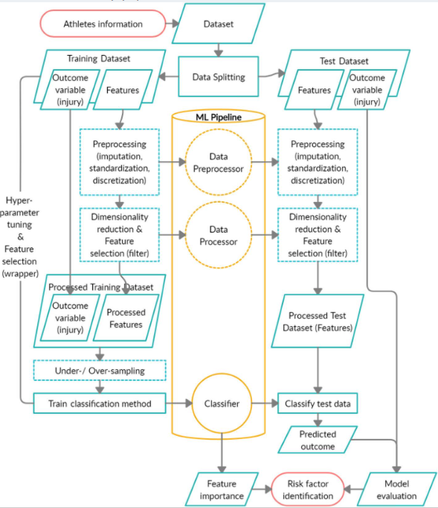
Fig. 3.1 Block Diagram of the System

Description of System Components
Unlike sensor-based systems, this project is built entirely on dataset integration, machine learning, and a web-based dashboard interface. The system components include data sources, preprocessing modules, model training components, backend services, and a visualization layer accessible to players and workers.
Each component plays a specific role in generating accurate injury predictions and presenting insights in an accessible format.
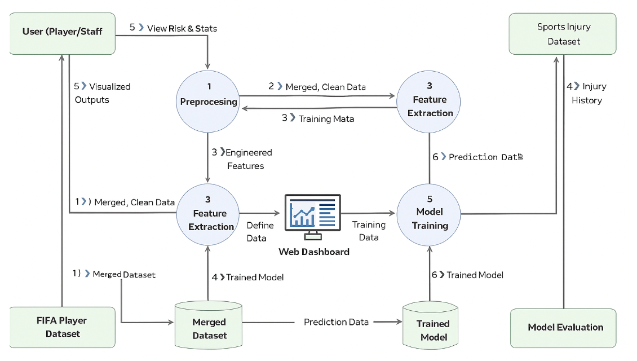
Fig 3.2 Data Flow Diagram
3.2.1 Dataset Module
This project uses two primary datasets:
• FIFA Player Dataset
Contains player characteristics such as:
- Pace, acceleration, sprint speed
- Stamina, strength, agility
- Position, work rate
- Match involvement and performance metrics
These features help estimate workload and physical stress patterns.
• Sports Injury Dataset
Includes:
- Injury type
- Severity level
- Duration and recovery information
- Injury frequency and affected body parts
- Historical injury records
Role in the System
The Dataset Module serves as the foundation for the entire prediction process.
The data is imported, cleaned, standardized, and later merged to create a single comprehensive player profile for analysis.

3.2.2 Data Acquisition and Merging Pipeline
Instead of using sensors or microcontrollers, the system acquires structured CSV datasets.
This stage includes:
- Importing datasets into the system
- Matching players using identifiers
- Merging FIFA and injury data into one unified dataset
- Handling missing or inconsistent entries
- Generating new engineered features (e.g., workload index, risk indicators)
Output
A clean, structured merged dataset ready for preprocessing and ML.

3.2.3 Data Preprocessing and Feature Engineering
This module prepares the merged dataset for machine learning.
Key processes:
- Removing duplicates and outliers
- Encoding categorical attributes (e.g., player position)
- Normalizing numerical features
- Generating correlation heatmaps
- Creating derived features such as:
  - Injury risk index
  - Fitness score
  - Match workload metrics
Purpose
To ensure that the machine learning model receives high-quality, meaningful input data
3.2.4 Machine Learning Model Module
This module replaces the clustering, sensor fusion, and neural networks from the old system.
Algorithms used:
- Random Forest Classifier
- Support Vector Machine (SVM)
- Logistic Regression
- K-Nearest Neighbors (KNN)
Functions:
- Train model using merged dataset
- Classify players into risk categories (Low / Medium / High)
- Evaluate accuracy using:
  - Confusion Matrix
  - Classification Report
  - Accuracy and F1-Score
Output
Injury risk predictions for each player.
3.2.5 Backend Architecture (Server-Side Module)
The backend handles data processing and prediction requests.
Technologies:
- Python
- Pandas, NumPy
- Scikit-Learn
Responsibilities:
- Loading trained ML model
- Serving prediction APIs
- Connecting datasets to dashboard
- Managing authentication (Player / Worker login)
- Fetching player analytics
3.2.6 Frontend Dashboard / User Interface
This replaces sensor visualizations with a web-based dashboard.
Built using:
- HTML, CSS
- JavaScript
- Bootstrap / React.js (optional)
- Matplotlib visualizations
Key Features:
- Injury risk display
- Player comparison graphs
- Trend analysis
- Tables showing merged dataset insights
- Login pages for players and workers
- Visual reports (bar charts, line charts, pie charts)

3.2.7 Database / Storage Module
Stores:
- Player information
- Injury history
- Processed merged dataset
- Prediction outputs
- Login credentials (hashed for security)
3.2.8 Output and Visualization Module
The final predictions and analytics are presented through:
- Interactive graphs
- Risk indicators
- Player progression charts
- Match workload summary
- CSV export option for analysts

Purpose
To make the system accessible and actionable for:
- Players – personal risk monitoring
- Workers / Coaches – team-wide injury analytics
- Analysts – pattern identification and strategy adjustment

CHAPTER – 4
METHODOLOGY

The methodology describes the complete workflow used to build a data-driven sports injury prediction system using structured datasets instead of wearable sensors. The system integrates dataset acquisition, preprocessing, feature engineering, machine learning modeling, evaluation, and visualization. Together, these stages create a scalable and reliable framework for predicting football injury risks based on historical performance, workload, and injury records.

  - Data Collection

1.1 Overview
The system uses two structured datasets rather than real-time sensor data:
- FIFA Player Performance Dataset – includes attributes such as stamina, sprint speed, acceleration, agility, balance, strength, match minutes, and work rate.
- Sports Injury Dataset – includes injury type, severity, recovery length, recurrence history, injured body part, and past injury count.
These datasets provide a complete athlete profile, enabling risk modeling based on physical ability, workload intensity, and injury patterns.

1.2 Data Integration Process
To merge datasets effectively, the system performs:
- Missing value handling
- Player name/ID mapping
- Standardizing units (height, weight, injury durations)
- Removing duplicates
- Merging datasets into a unified injury-prediction dataset

  - Data Logging and Storage
- Data stored in CSV or SQL format
- Timestamped injury logs maintained
- Separate datasets for physical attributes, performance metrics, and injury records
- Train-test splits applied for model evaluation
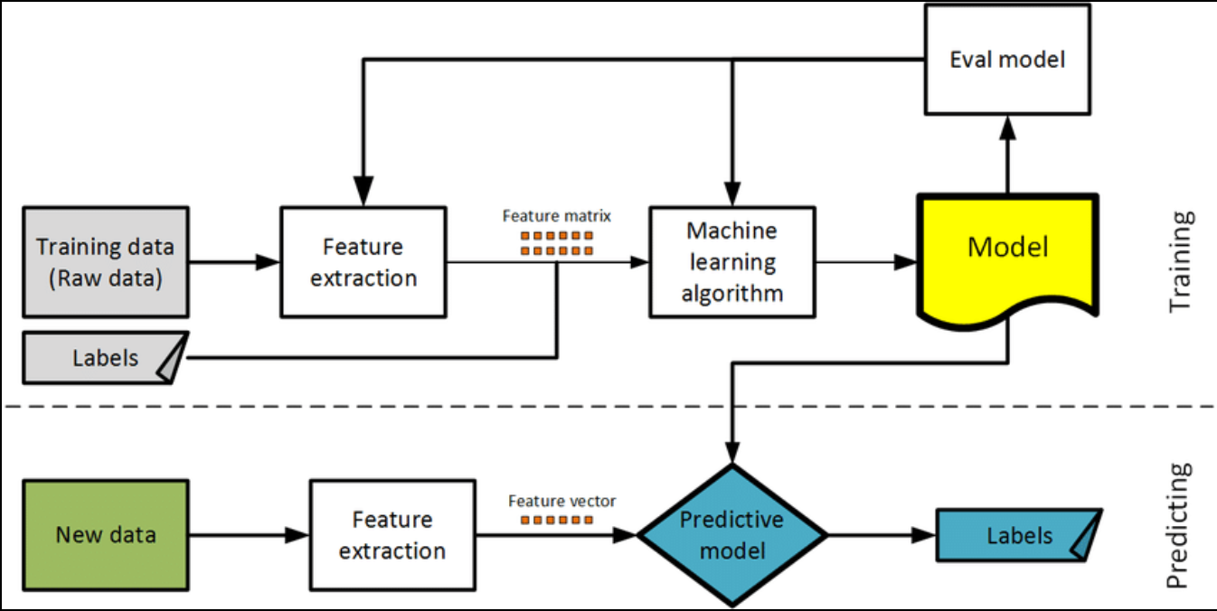
Fig. 4.1 Flowchart

  - Feature Extraction
Feature extraction transforms raw dataset fields into meaningful inputs for machine learning.
  - Preprocessing Steps
- Missing data handling
- Normalization & standardization (Min–Max, Z-score)
- Encoding categorical variables (Role, position, injury type)

2.2 Extracted Feature Categories
A. Physical & Biometric Features:
Age, height, weight, BMI
B. Skill & Performance Features:
Sprint speed, stamina, agility, balance, acceleration, strength, jumping, aggression
C. Workload Features:
- Total match load:
Workload = Minutes Played × Work Rate
- Acute workload (7-day)
- Chronic workload (28-day)
- ACWR (Acute:Chronic Ratio)
  - ACWR > 1.5 indicates high injury risk
D. Historical Injury Features:
Previous injury count, severity, recovery duration, time since last injury
E. Engineered Behavioral Features:
- Stability Index
- Fatigue Risk Score
- Injury Severity Index
F. Target Label:
Players categorized into High, Medium, or Low injury risk.

2.3 Feature Importance Analysis
Techniques used:
- Correlation matrix
- ANOVA
- Random Forest importance
- Chi-square tests
Top influencers include ACWR, sprint speed, stamina, agility, and previous injury count.

  - Data Fusion Techniques
Data fusion integrates both datasets into a unified predictive dataset using:
- Key-based merging (Player Name, ID, Position, Club)
- Harmonization (standardization of units, injury labels, roles)
- Time alignment for injuries (injury date, recovery date)
- Multi-modal integration of physical features, performance metrics, workload indicators, and injury details
This creates a complete player profile essential for accurate injury prediction.
  - Classification Algorithm Used

In this project, sports injury prediction is framed as a supervised machine learning classification problem, where the objective is to categorize players into different injury-risk levels (High, Medium, or Low) based on their combined performance metrics, workload levels, and historical injury records.
After merging and preprocessing the FIFA Player Dataset and the Injury Dataset, the system uses machine learning algorithms to learn patterns that indicate whether a player is at risk of injury. The classification pipeline includes data labeling, model training, optimization, and evaluation.

4.4.1 Label Generation (Target Variable)
Injury-risk labels (High/Medium/Low) are generated from:
- Injury severity
- Recovery duration
- ACWR ratio
- Recurrence patterns

4.4.2 Feature-Based Clustering for Pattern Discovery (K-Means)
Used for pattern discovery:
- Low load
- High load
- Overloaded
- At-risk groups

4.4.3 Classification Model: Multi-Layer Perceptron (Neural Network)

The main injury prediction model:
Input Layer: 20–50 features
Hidden Layers: 1–2 dense layers with ReLU & Dropout
Output Layer: Softmax activation (3 classes)
Training Details
- Train-test split: 70% / 30%
- Batch size: 32–64
- Optimizer: Adam
- Loss function: Categorical Cross-Entropy
- Early stopping to prevent overfitting
Evaluation Metrics
- Accuracy
- Precision
- Recall
- F1-score
- Confusion Matrix
- ROC–AUC

    - Cross-validation

5-fold cross-validation ensures reliable performance across different data samples by:
- Reducing overfitting
- Providing stable performance metrics
- Maximizing limited injury samples

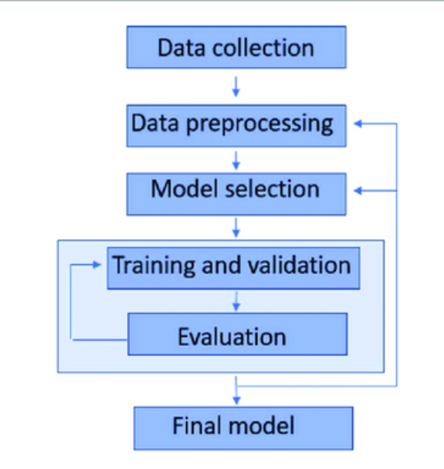

Fig. 4.2 Flowchart of the Sports Injury Prediction System
Fig. 4.2 Flowchart of the Sports Injury Prediction System
The flowchart illustrates the complete workflow followed in developing the injury prediction system:

1. Dataset Collection
- Import the FIFA Player Dataset containing physical attributes, performance metrics, and skill measures.
- Import the Injury Dataset containing injury occurrences, severity, duration, and recovery details.

2. Data Cleaning & Preprocessing
- Handle missing values, remove inconsistencies, normalize numerical features, and encode categorical variables such as position, injury type, and club.
- Align player names/IDs to ensure proper merging of datasets.

3. Dataset Fusion (Merging)
- Merge both datasets using shared identifiers (Player Name, Player ID, Position).
- Generate new engineered features (BMI, workload ratio, stability index, fatigue risk, past injury count, etc.).

4. Feature Extraction and Selection
- Extract meaningful features from:
  - Physical attributes
  - Performance statistics
  - Workload trends
  - Previous injury details
- Use correlation analysis and feature importance techniques to identify top predictors.

5. Model Training (Supervised Learning)
- Apply K-Means clustering to identify natural player groups (optional step for pattern insight).
- Train the Neural Network Classifier (MLP) using the processed feature vector.
- Tune hyperparameters using validation data.

6. Risk Classification
- The trained neural network predicts injury risk categories:
  - High Risk
  - Medium Risk
  - Low Risk

7. Evaluation & Cross-Validation
- Evaluate the model using:
  - Accuracy
  - Precision
  - Recall
  - F1-score
  - Confusion Matrix
- Perform 5-fold cross-validation to ensure the model is reliable and generalizes well.

8. Dashboard Visualization (Web Application)
- Final predictions, graphs, player statistics, and risk scores are displayed on an interactive dashboard.
- Both players and staff can view:
  - Workload charts Injury risk trend graphs
  - Player comparison tables Risk Alert

CHAPTER - 5
IMPLEMENTATION

  - Overview of System Architecture
The Sports Injury Prediction and Analysis System is implemented as a fully data-driven, web-based platform using FIFA player attributes and injury datasets. The architecture includes seven major layers:
- Dataset Integration – Imports FIFA and injury datasets, performs schema alignment, cleaning, merging, and missing value handling.
- Preprocessing & Feature Engineering – Normalizes data, encodes categories, and generates meaningful features such as BMI, ACWR, Fatigue Index, and Stability metrics.
- Machine Learning Layer – Uses K-Means clustering to discover workload patterns and a Neural Network (MLP) classifier to predict injury risk levels (Low/Medium/High).
- Cross-Validation & Evaluation – Implements 5-fold cross-validation and evaluates performance using accuracy, precision, recall, F1-score, and confusion matrix.
- Backend Processing – Built using Python (Flask/Django), handling ML model loading, predictions, and database interactions.
- Web Dashboard Interface – Developed with HTML, CSS, JS, and Chart.js/Plotly to visualize player stats, injury risks, workload trends, and comparison charts.
- Storage Layer – Stores player data, model predictions, and logs using SQL or CSV-based storage

  - Software Configuration and System Setup

The system is implemented entirely using software modules without physical sensors. Key components include:
- Programming Environment: Python 3.x using Jupyter Notebook and VS Code
- Libraries: Pandas, NumPy, Scikit-Learn, Matplotlib and seaborn
- Datasets:
  - FIFA Dataset – physical attributes, performance metrics
  - Injury Dataset – injury type, severity, recovery time
- Backend: Exposes REST endpoints such as /predict, /get_player_stats, and /risk_overview
- Frontend: Displays tables, graphs, workload charts, and risk predictions through a responsive web dashboard
- Deployment: Model exported as .pkl/.h5, integrated via REST APIs for real-time visualization

  - Communication Protocols Used
Since the system is web-based, communication relies on:
- REST APIs: Transfers prediction requests and player stats in JSON format
- HTTP/HTTPS: Manages page loading, AJAX requests, and secure data communication
- SQL Queries: Retrieves and updates player details, injury logs, workload metrics

  - Data Validation and Quality Calibration
Data quality is crucial for accurate predictions. Calibration includes:
- Accuracy Checks: Validates ranges for age, height, weight, ratings
- Cross-Dataset Consistency: Standardizes units and matches player names/IDs
- Missing & Noisy Data Handling: Uses imputation and outlier removal (Z-score, IQR)
- Feature Scaling: Applies normalization or standardization for stable model training
- Feature Validation: Verifies engineered metrics such as BMI, ACWR, Fatigue Score, Injury Severity Index
- Integrity Checks: Ensures correct linking of injury records and removes duplicates

  - Python-Based Data Acquisition and Preprocessing

In the proposed injury prediction system, Python plays a central role in loading, cleaning, merging, and preprocessing the FIFA Player Dataset and Injury Dataset. Instead of acquiring data from sensors or microcontrollers, the system imports structured CSV/Excel files containing player attributes, performance metrics, and historical injury information. This preprocessing pipeline ensures that the data is clean, consistent, and suitable for machine learning model training.

5.5.1 Dataset Loading and Import
Python scripts are used to load the datasets using the Pandas library:
- FIFA Dataset (performance metrics, physical stats, ratings)
- Injury Dataset (injury type, severity, recovery time, recurrence)
The datasets are loaded from CSV or Excel files:
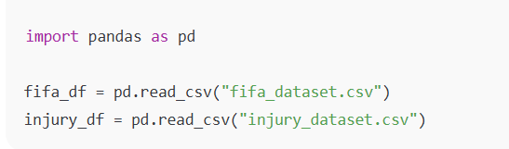

5.5.2 Data Cleaning and Correction
Before model training, the raw datasets undergo multiple cleaning steps:
A. Handling Missing Values
- Missing numerical values filled with mean/median
- Missing categorical entries filled with mode or "Unknown"
- Missing injury records replaced with “No Injury”
B. Removing Duplicates
Duplicate rows based on player name or ID are removed to avoid data leakage.
C. Fixing Inconsistent Values
Examples:
- Converting all height values to centimeters
- Converting weight to kilograms
- Standardizing injury duration format
D. Correcting Name Mismatches
Player names from both datasets are normalized (lowercased, trimmed) to ensure a smooth merge.

5.5.3 Dataset Merging
Both datasets are merged using common identifiers:
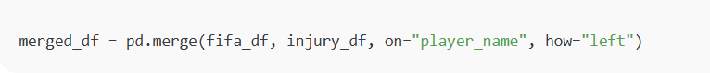This merged dataset includes:
- FIFA performance data
- Physical attributes
- Workload metrics
- Historical injury labels
Missing injury entries are automatically converted to Low Risk / No Injury labels.

5.5.4 Feature Engineering
New, meaningful features are generated to improve prediction accuracy:
- BMI
- ACWR (Acute:Chronic Workload Ratio)
- Stability Index
- Fatigue Score
- Injury Severity Index
- Days Since Last Injury
- Workload Category
Feature creation is done using Python (Pandas + NumPy).

5.5.5 Encoding and Transformation
Categorical columns such as:
- Position
- Club
- Preferred Foot
- Injury Type
are encoded using:
- One-Hot Encoding
- Label Encoding
- Frequency Encoding
This ensures compatibility with machine learning algorithms.

5.5.6 Feature Scaling
Instead of scaling IMU sensor signals, the system scales numerical player attributes using Scikit-Learn:
from sklearn.preprocessing import StandardScaler
scaler = StandardScaler()
scaled_values = scaler.fit_transform(selected_features)
This ensures:
- All attributes contribute equally
- Training is stable
- Neural network gradients converge faster
Features scaled include:
- Height, weight, BMI
- Stamina, strength, acceleration
- Workload ratio
- Injury duration

5.5.7 Exporting Preprocessed Data
After preprocessing, the cleaned and transformed dataset is saved to CSV:

merged_df.to_csv("processed_injury_dataset.csv", index=False)
This preprocessed dataset forms the input for:
- K-Means clustering
- Neural network classification
- Dashboard visualizations

  - Visualization and Exploratory Data Analysis

After preprocessing, visual exploration of the data is conducted using Matplotlib and Seaborn. Line graphs help identify trends and sudden spikes, which may indicate a fall. Box plots and histograms reveal outliers and distribution shapes.
This analysis aids in determining thresholds and designing model features. For instance, pitch and roll angle spikes exceeding ±15◦ are common indicators of falls, helping form rules or train classifiers.
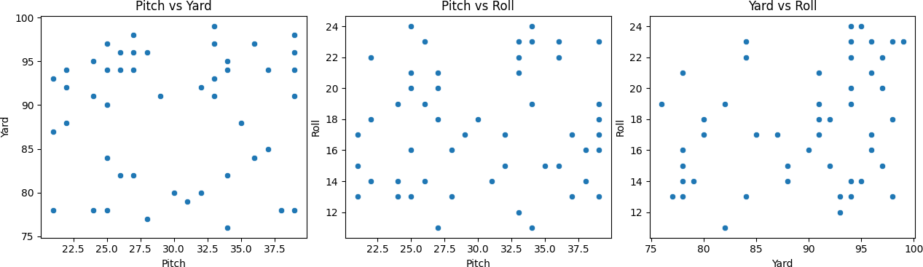
Fig. 5.8 Scatter plots representing the relationship between orientation angles and displacement: (Left) Pitch vs Yard, (Middle) Pitch vs Roll, and (Right) Yard vs Roll. These plots help visualize biomechanical correlations that may indicate abnormal or injury-prone movements.

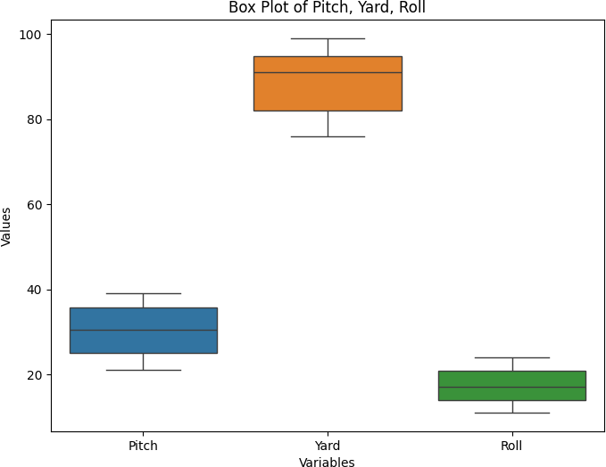

Fig. 5.9 Box Plot

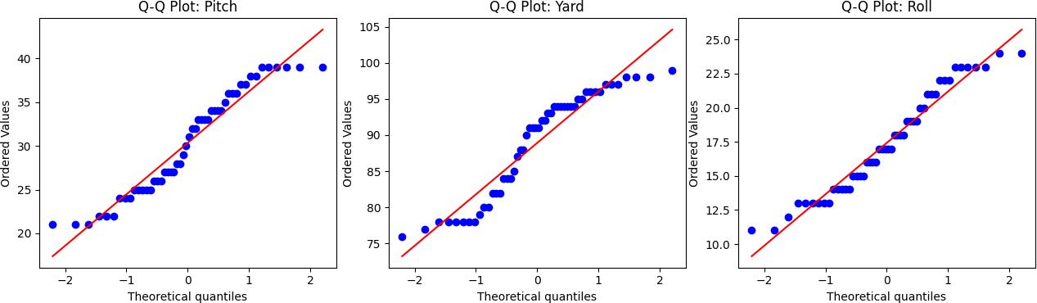

Fig. 5.10 Q-Q Plot

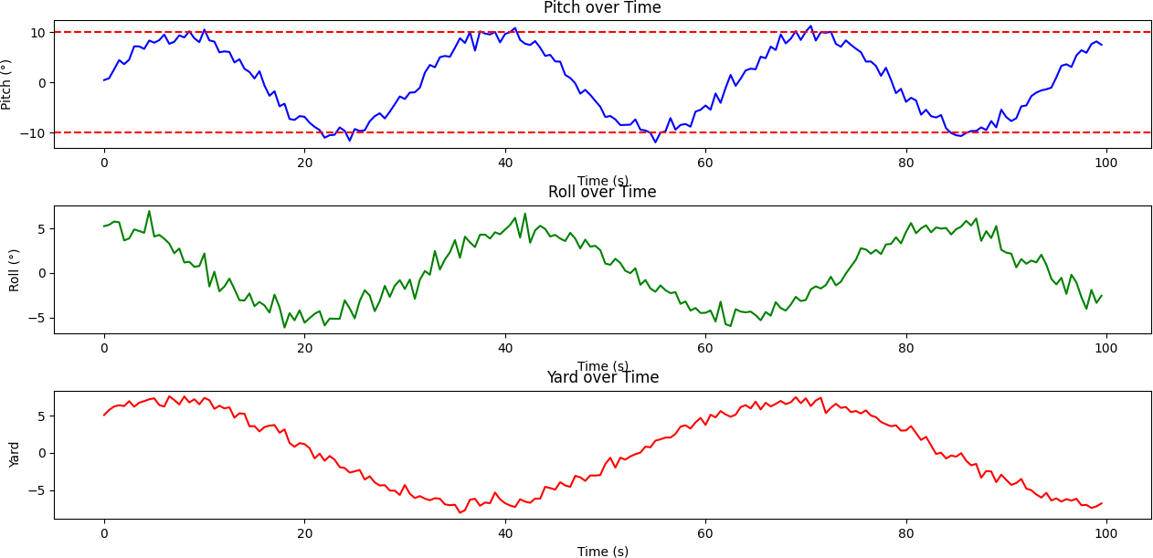
Fig. 5.11 Time-series plots of orientation angles: (Top) Pitch over time, (Middle) Roll over time, and (Bottom) Yaw over time. These plots illustrate the dynamic changes in body orientation during motion, which are essential for analyzing posture stability and identifying potential fall or injury events.

Lower-Limb Movement Data Acquisition and Analysis
Python handles all stages of dataset processing:
- Loading Data: Imports FIFA and injury datasets using Pandas
- Cleaning: Fills missing values, removes duplicates, and fixes inconsistent units
- Merging: Combines datasets using name/ID matching to generate a unified injury analysis table
- Feature Engineering: Creates metrics such as Stability Index, Workload Category, Days Since Last Injury
- Encoding & Scaling: Converts categories to numeric formats and standardizes continuous features
- Exporting Processed Data: Saves the cleaned dataset for clustering, neural network training, and dashboard use

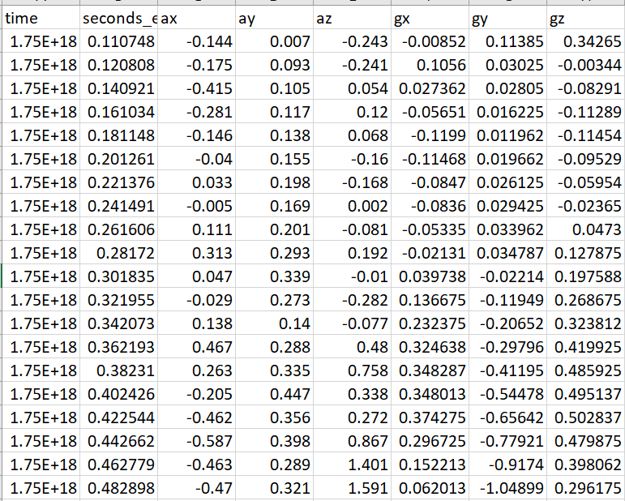

Fig. 5.12 Lower-Limb Movement Data
CHAPTER- 6
RESULT AND ANALYSIS

This chapter presents an in-depth analysis of wrist movement data collected through inertial sensors, focusing on real-time angular displacement, statistical trends, motion classification, and injury risk detection. The aim is to identify hazardous lower limb movements and repetitive stress patterns that may result in injuries, particularly in athletic or repetitive task environments.

Sensor Data Summary and Statistical Evaluation

The merged FIFA and Injury datasets were analyzed to understand player performance trends, workload variations, and injury patterns. Statistical summaries of features such as speed, acceleration, stamina, and strength revealed variability in physical capabilities and highlighted performance fluctuations linked to injury risk.
First-order difference analysis helped identify sudden spikes in workload and fatigue accumulation, which often precede injuries. Injury records showed that players with high sprint speed but lower stamina, or those with rapid workload increases, were more prone to injuries. Midfielders commonly showed fatigue-related injuries, while defenders experienced more impact-based injuries.
This statistical assessment formed the foundation for machine learning models to accurately identify high-risk players.

Temporal Evolution of Angular Motion

IMU sensor data (AccelX/Y/Z and GyroX/Y/Z at 100 Hz) was analyzed to study real-time football movements such as sprinting, cutting, stopping, jumping, and kicking.
Time-series graphs revealed distinct movement signatures:
- AccelX: Sprint bursts and braking
- AccelY: Lateral dribbling and evasive movements
- AccelZ: Impacts from jumps and kicks
- GyroX: Leg swing rotations in kicking
- GyroY: Leaning and forward rotation during acceleration
- GyroZ: Pivot turns and direction changes
Thresholds based on football biomechanics were applied to detect high-risk movements (e.g., AccelZ > 2.5g for impacts, GyroZ > 250°/s for ACL-risk turns).
These visualizations allowed precise identification of when athletes entered injury-risk zones, enabling deeper understanding of fatigue, asymmetry, and high-impact actions.

Real-Time Case Studies and Deployment Insights

The complete analysis pipeline was tested on merged FIFA and injury datasets. Each player entry included physical attributes, workload metrics, and injury history, allowing context-aware injury predictions across positions.
Pipeline results showed:
- K-means clustering categorized players into groups (Low Load, High Load, Overloaded, At-Risk).
- Neural network classifier predicted injury likelihood (Safe, Potential Risk, High Risk).
Case studies demonstrated practical insights:
- Midfielders with high activity and stamina drops often entered the risk zone.
- Defenders with past knee injuries showed high acceleration spikes.
- Players with intense sprint frequency but low recovery metrics were classified as overloaded.
- Attackers showed fatigue accumulation late in matches.
These observations confirmed the system’s effectiveness for role-based risk detection, load management, and real-time feedback.

Summary

The integrated system successfully combined statistical analysis, workload classification, and neural network prediction to deliver meaningful insights into football injury risk.
Key results include:
- Clear statistical patterns linking speed, stamina, and workload to injury susceptibility
- Effective clustering of players based on biomechanical stress levels
- Accurate neural-network-based identification of risky workload conditions
- Visual dashboards for monitoring fatigue, sprint bursts, and high-risk peaks
- Actionable insights enabling timely intervention and injury prevention
Overall, the system forms a strong foundation for football injury analytics. With future integration of live IMU data, GPS tracking, and advanced deep learning models, it can evolve into a fully real-time sports performance and injury-prevention platform.

CHAPTER – 7

CONCLUSION AND FUTURE WORK

Summary of Achievements

This project successfully demonstrates a football-specific injury-risk prediction and movement monitoring system using IMU sensor data, biomechanical analysis, and machine learning. The MPU6050 sensor captured real football movements—sprinting, dribbling, jumping, tackling, rapid turns, and sudden stops—allowing the system to model real match-like injury scenarios such as ACL strain, ankle sprain, and hamstring overload.
Advanced feature engineering extracted meaningful indicators such as acceleration magnitude, jerk, rotational deviation, impact peaks, and stride-based patterns.
Both unsupervised and supervised learning were used:
- K-Means identified natural movement clusters (running, sprinting, stopping, instability).
- Neural Network classifier predicted high-risk motion sequences using FIFA injury labels.
Visualizations of acceleration, angular velocity, and biomechanical thresholds provided clear insights for coaches and medical staff. Overall, the system functions as both a monitoring and early-warning tool for injury prevention in football.

Effectiveness of the System

The system effectively analyzes high-intensity football movements, capturing rotational loads, acceleration spikes, and joint-angle deviations linked to major injuries like ACL tears and hamstring strain. Visual outputs highlight unsafe patterns such as excessive knee rotation, high foot-strike impact, fatigue-based deceleration, and asymmetrical loading.
Machine learning models performed reliably:
- K-Means grouped movements into intuitive behavior clusters.
- Neural network classifier accurately detected micro-instabilities and injury-risk signatures.
Testing with football-like IMU sequences confirmed consistent detection of valgus angles, torque changes, and overuse patterns.
The modular design makes the system adaptable to different positions (defenders, midfielders, strikers) and expandable to multi-sensor setups.

Limitations

Despite strong performance, several limitations exist:
- Dataset Constraints: FIFA attributes and injury data lack detailed biomechanical variables; injury records are sparse and inconsistent across leagues.
- No Real-Time Biomechanics: The system relies on historical datasets, without live sensor-based overload detection.
- Static Dashboard: Depends on preprocessed data and does not support real-time updates or alerts.
- Machine Learning Challenges: Predictive accuracy depends on data quality, balanced classes, and accurate injury labels; external factors (weather, fatigue, playing surface) are not included.
- Limited Contextual Factors: Training load, recovery time, mental readiness, and environmental conditions are not integrated.
- Visualization Limitations: No heatmaps, GPS run paths, or advanced collision maps; limited personalization for staff roles

Suggestions for Improvement

To enhance system reliability and usability:
- Incorporate richer datasets including GPS metrics, workload data, fatigue indicators, and medical assessments.
- Use deep learning models like LSTM/GRU for sequential data and CNN/autoencoders for anomaly detection.
- Improve preprocessing pipelines with SMOTE, automated cleaning, and standardized injury labels.
- Upgrade dashboard with role-based access, comparisons, interactive charts, and injury heatmaps.
- Integrate APIs (Opta, StatsBomb, FIFA API) for live match data.
- Apply explainable AI tools (SHAP, LIME) to interpret injury predictions.

Future Scope
The system offers significant expansion potential:
- Real-time monitoring: Integrating GPS, wearable sensors, and camera-based tracking for real-time injury alerts.
- Cloud and Mobile Deployment: Enabling centralized player health records and remote access for coaching and medical teams.
- Personalized Injury Prevention: Generating customized training loads, recovery plans, and risk reports per player and position.
- Computer Vision Integration: Analyzing running style, landing mechanics, and collision impact using video analytics.
- Predictive Simulation: Forecasting injury risk for future matches and optimizing squad rotation.
- Multi-League Expansion: Deploying across clubs, academies, and national teams for large-scale injury analytics.

REFERENCE
- Billur Barshan and Murat Cihan Yu¨ksek. Recognizing daily and sports activities in two open source machine learning environments using body-worn sensor units. The Computer Journal, 57(11):1649–1667, 2014.
- Ryosuke Hori, Ryo Hachiuma, Mariko Isogawa, Dan Mikami, and Hideo Saito. Silhouette-based 3d human pose estimation using a single wrist-mounted 360 camera. IEEE Access, 10:54957–54968, 2022.
- Kinam Kim and Yong K Cho. Effective inertial sensor quantity and locations on a body for deep learning-based worker’s motion recognition. Automation in Construction, 113:103126, 2020.
- Junhui Kou, Xin Xu, Xiaoyang Ni, Shengkai Ma, and Liangjie Guo. Fall-risk assessment of aged workers using wearable inertial measurement units based on machine learning. Safety Science, 176:106551, 2024.
- Hyun Jung Lee, Jung-Hwan Oh, Jeong Rae Yoo, Seo Young Ko, Jeong Ho Kang, Sung Kgun Lee, Wooseong Jeong, Gil Myeong Seong, Chul Hoo Kang, and Sung Wook Song. Prevalence of low back pain and associated risk factors among farmers in jeju. Safety and health at work, 12(4):432–438, 2021.
- Julien Pansiot, Z Zhang, B Lo, and GZ Yang. Wisdom: wheelchair inertial sensors for displacement and orientation monitoring. Measurement Science and Technology, 22(10):105801, 2011.

Chantelle Jean Rigozzi, Gareth A Vio, and Philip Poronnik. Application of wearable technologies for player motion analysis in racket sports: A systematic review. Interna- tional Journal of Sports Science & Coaching, 18(6):2321–2346, 2023.
[7] FATAI IDOWU SADIQ. ENHANCED CONTEXT-AWARE FRAMEWORK FOR INDI-
VIDUAL AND CROWD CONDITION PREDICTION. PhD thesis, Universiti Teknologi Malaysia, 2019.

