SHIBU P
25MML0042

Error in the Dataset:
The dataset contain noise level and flatness of 0.520 and 0.127
Noise:
Noise in audio refers to unwanted, random signals mixed with the actual sound
Flatness:
Spectral Flatness tells us whether the audio frequency content looks like:
- Noise → flat spectrum
- Tone → uneven spectrum

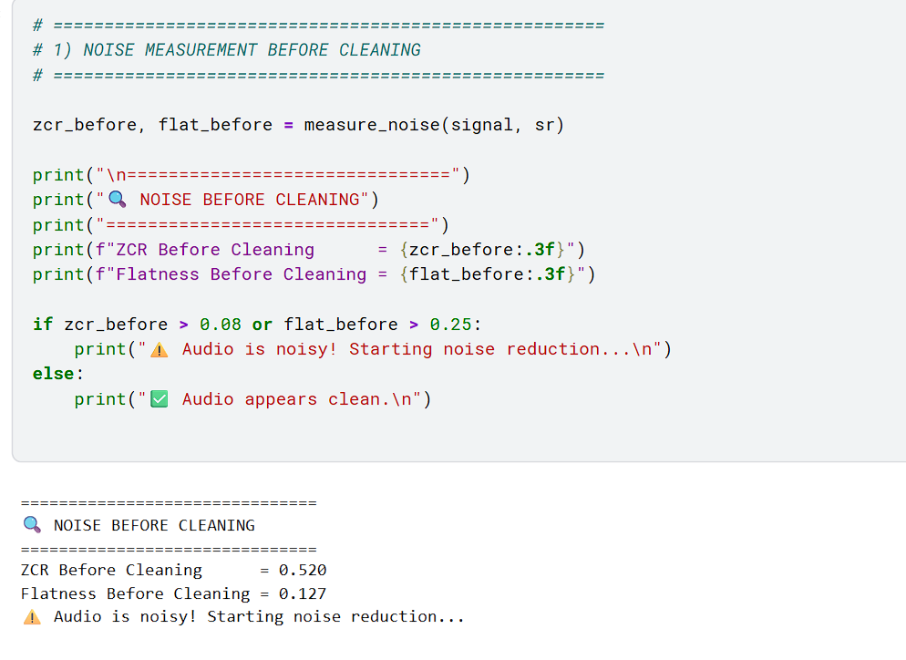

Pipeline to Reduce the Noise and Flatness:

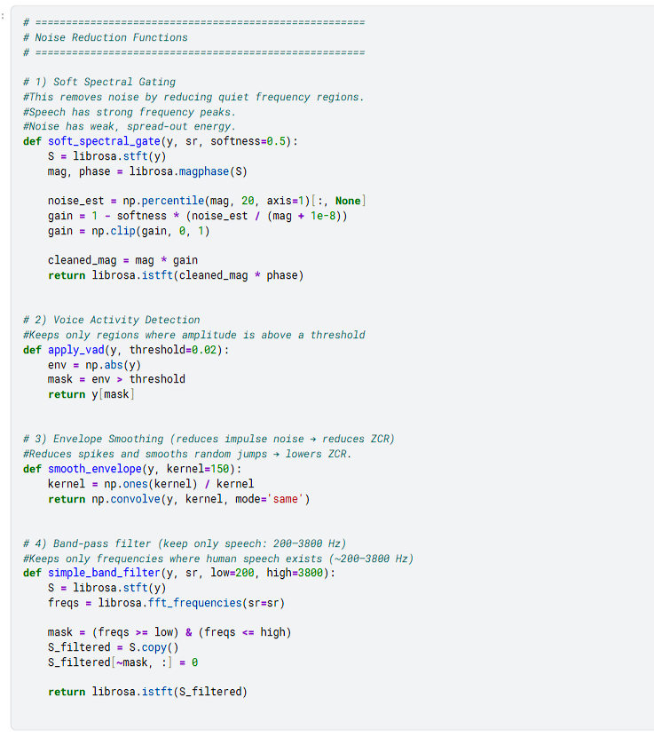

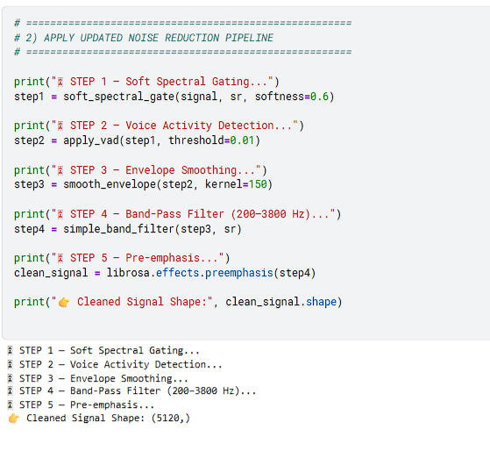

ZCR:
ZCR = How many times the audio waveform crosses the zero line.
- High ZCR → More random, noisy signal
- Low ZCR → Clearer, tonal sound (like speech or music)
Noisy audio jumps up and down quickly → high ZCR.

