表格 1. RT605-710 各軸馬達之部分電器與機械規格 。

|  |  |  |  |  |  |  |
| --- | --- | --- | --- | --- | --- | --- |
|  | $$A_{1}$$ | $$A_{2}$$ | $$A_{3}$$ | $$A_{4}$$ | $$A_{5}$$ | $$A_{6}$$ |
| 製造商 | Sanyo Denki CO.,LTD | | | | | |
| 產品系列 | SANM*O*TION R2-Series | | | | | |
| 馬達編號*1 | R2AA-06-040-F-C-P | R2AA-06-040-F-C-P | R2AA-06-020-F-C-P | R2AA-04-010-F-C-P | R2AA-04-005-F-C-P | R2AA-04-005-F-C-P |
| Rated Power  (*W*) | 400 | 400 | 200 | 100 | 50 | 50 |
| Rated Velocity  (rpm) | 3000 | 3000 | 3000 | 3000 | 3000 | 3000 |
| Max. Velocity  (rpm) | 6000 | 6000 | 6000 | 6000 | 6000 | 6000 |
| Rated Armature Current  (*A rms*) | 2.8 | 2.8 | 1.5 | 0.81 | 0.67 | 0.67 |
| Rated Torque  (*N-m*) | 1.27 | 1.27 | 0.636 | 0.318 | 0.159 | 0.159 |
| Max. Torque  (*N-m*) | 4.8 | 4.8 | 2.2 | 1.18 | 0.59 | 0.59 |
| Torque Constant  (*N-m/ A rms*) | 0.524 | 0.524 | 0.476 | 0.424 | 0.246 | 0.246 |
| Voltage Constant per Phase (*mV/rpm*) | 18.3 | 18.3 | 16.6 | 14.8 | 8.6 | 8.6 |
| Moment of Inertia  (*kg-m2*) | 4.15 | 4.15 $$×{10}^{-5}$$ | 2.190 $$×{10}^{-5}$$ | 6.270 $$×{10}^{-6}$$ | 3.760 $$×{10}^{-6}$$ | 3.760 $$×{10}^{-6}$$ |
| Phase Resistance  ($Ω$) | 1.36 | 1.36 | 2.7 | 9.3 | 6.7 | 6.7 |
| Phase Inductance  ($μH$) | 4300 | 4300 | 7100 | 7600 | 6000 | 6000 |

* *1：編號可以參閱圖 1。

表格 2. RT605-710 減速機構之相關等效傳動轉動慣量。

|  |  |  |  |  |  |  |
| --- | --- | --- | --- | --- | --- | --- |
| 減速機構相關 | | | | | | |
|  | $$J_{1}$$ | $$J_{2}$$ | $$J_{3}$$ | $$J_{4}$$ | $$J_{5}$$ | $$J_{6}$$ |
| Pulley (皮帶輪) and Miter Gear (傘齒輪) | | | | | | |
| Pulley Ratio | 1 | 1 | 1 | 1 | 1 | 1 |
| Pulley Transmission Direction | 1 | 1 | 1 | 1 | 1 | 1 |
| Pulley Inertia  (*kg-m2*) | 4.100 | 1.880 $$×{10}^{-5}$$ | 1.880 $$×{10}^{-5}$$ | 1.100 $$×{10}^{-5}$$ | 2.400 $$×{10}^{-6}$$ | 2.139  (Note *2) |
| Reducer (諧波減速機) | | | | | | |
| Reduction Ratio  (*rad./rad.*) | 80 | 100 | 80 | 81 | 80 | 50 |
| Reduction Direction*3 | 1 | 1 | -1 | -1 | -1 | -1 |
| Reducer Inertia  (*kg-m2*) | 2.850 | 1.690 $$×{10}^{-4}$$ | 4.130 $$×{10}^{-5}$$ | 4.040 $$×{10}^{-5}$$ | 3.300 $$×{10}^{-6}$$ | 3.300 $$×{10}^{-6}$$ |
| 其餘等效的轉動慣量 | | | | | | |
| Others equivalent Inertia (*kg-m2*) | 4.7319 | 9.3930 $$×{10}^{-5}$$ | 4.8830 $$×{10}^{-5}$$ | 1.1018 $$×{10}^{-5}$$ | 4.901 $$×{10}^{-6}$$ | 7.5980 $$×{10}^{-6}$$ |
| Total Transmission Inertia*4 | | | | | | |
| (*kg-m2*) | 3.7352 | 3.0413 $$×{10}^{-4}$$ | 1.1203 $$×{10}^{-4}$$ | 5.769 $$×{10}^{-5}$$ | 1.196 $$×{10}^{-5}$$ | 1.466 $$×{10}^{-5}$$ |

*2：由於機構的設計需求，第六軸有多傘齒輪機構，以進行90度的角度轉換。

*3：方向表示經過減速機之角度轉換後關節的角度方向，-1表反轉 +1 表維持原轉向。

*4：從 減速機 $轉子⟶皮帶輪⟶馬達轉子 之轉動慣量總和。$

$(i.e. total inertia=motor+pulley+reduction+others$)

# Appendix-1

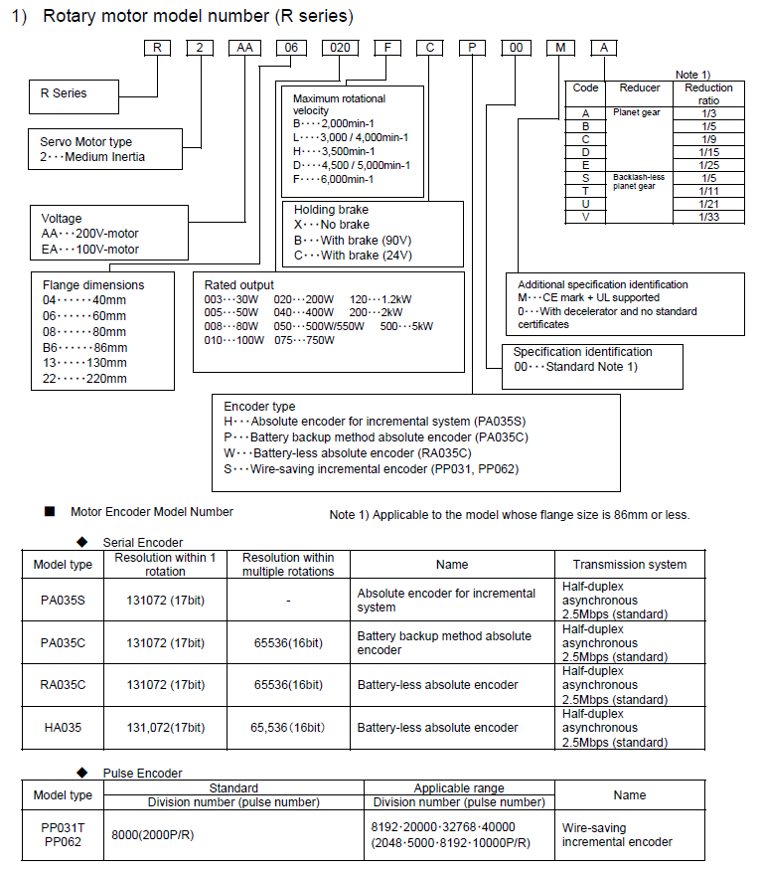

圖 1. 馬達規格編號說明*A1。

* A1：此圖為參閱技術手冊：SANMOTION_R_AD_M008957F 之 1-8頁。