**ASSIGNMENT-1**

**By**

**Shikshit Sharma**

**Roll Number : 2023A1R003**

**1st Semester**

**Department Name: CSE**



**Model Institute of Engineering & Technology (Autonomous)**

(Permanently Affiliated to the University of Jammu, Accredited by NAAC with “A” Grade)

Jammu, India

2023



1. **Program to find factorial of a number using a recursive function**

#include<stdio.h>

int fact(int);

int main()

{

    int x,n;

    printf(" Enter the Number to Find Factorial :");

    scanf("%d",&n);

    x=fact(n);

    printf(" Factorial of %d is %d",n,x);

    return 0;

}

int fact(int n)

{

    if(n==0)

        return(1);

    return(n*fact(n-1));

}

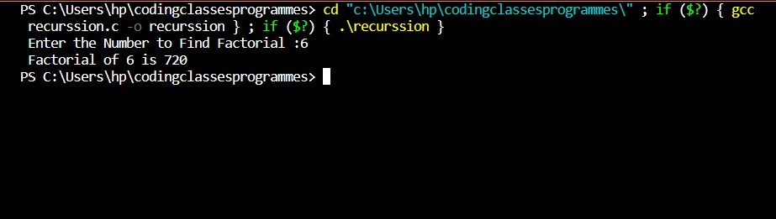**2. Write the program for printing the student marksheet using structure.**

#include <stdio.h>

struct student {

    char name[50];

    int roll;

    float marks;

} s;

int main() {

    printf("Enter information:\n");

    printf("Enter name: ");

    fgets(s.name, sizeof(s.name), stdin);

    printf("Enter roll number: ");

    scanf("%d", &s.roll);

    printf("Enter marks: ");

    scanf("%f", &s.marks);

    printf("Displaying Information:\n");

    printf("Name: ");

    printf("%s", s.name);

    printf("Roll number: %d\n", s.roll);

    printf("Marks: %.1f\n", s.marks);

    return 0;

}

