**PRACTICAL 8**

**AIM:** Mobile Forensics

* Download required files

1. MOBILedit! Forensic Software
2. Open MOBILEdit Forensic (Should be Activated/Cracked)

**Step1:** Connect your Device

* Enable Developer Option on Android Device
* Enable USB Debugging and Connect with (Desktop/Laptop) using USB Cable

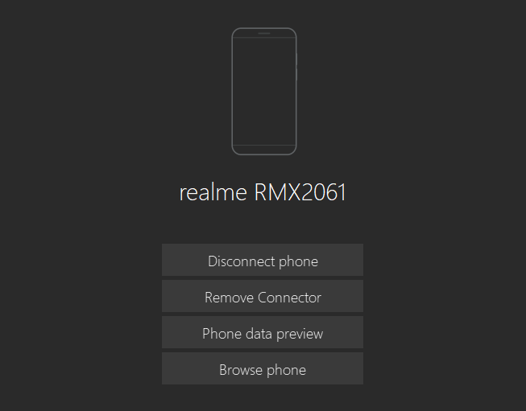

Step2: Select Import Data and choose an option like Specific Selection, Full Content, Application Analysis, or others based on your needs.

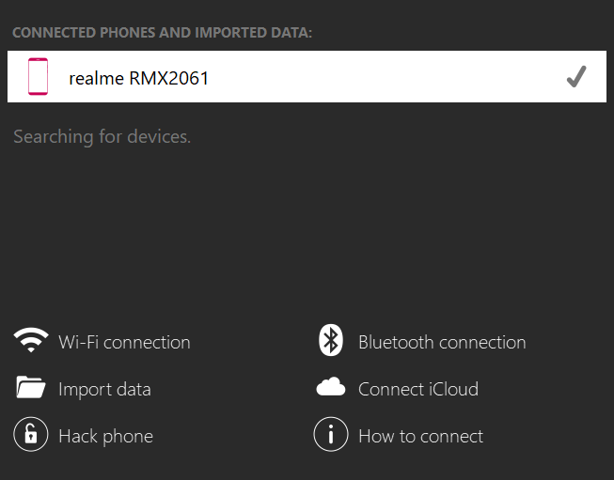 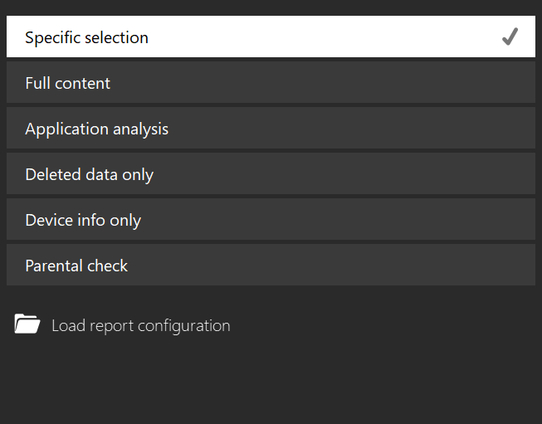

**Step 3:** Apply filters like time, contact, text, or location to refine the imported data or choose no filtering to retrieve all data.

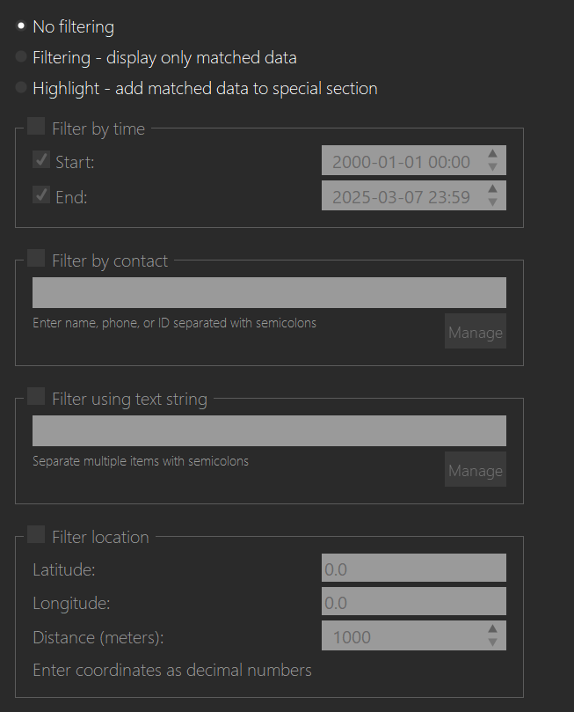

**Step 4:** Select the data categories you want to extract, like Emails, GPS locations, or Bluetooth pairings.

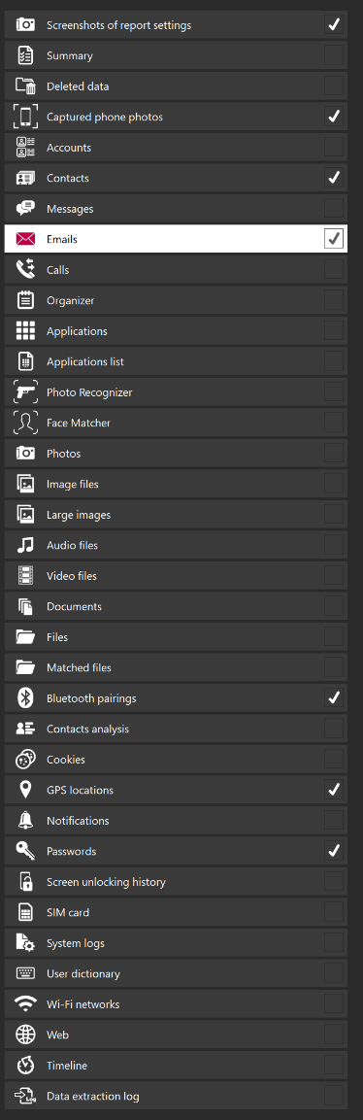

**Step 5:** Sort and filter contacts (SIM, application, vCard, or deleted) by name, creation time, or frequency, and refine using time or specific contacts.

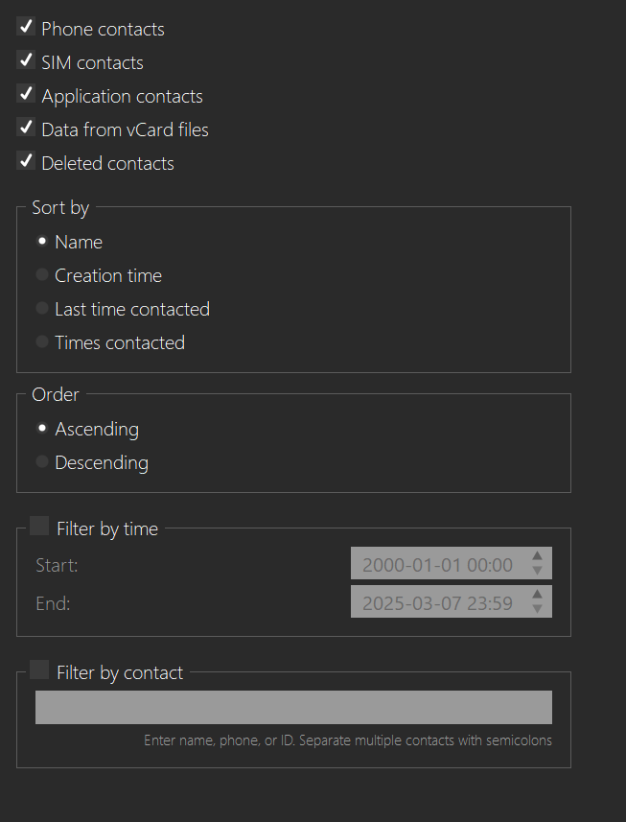

**Step 6:** Sort and filter application and deleted emails by time, contact, type, or content, and refine using specific criteria.

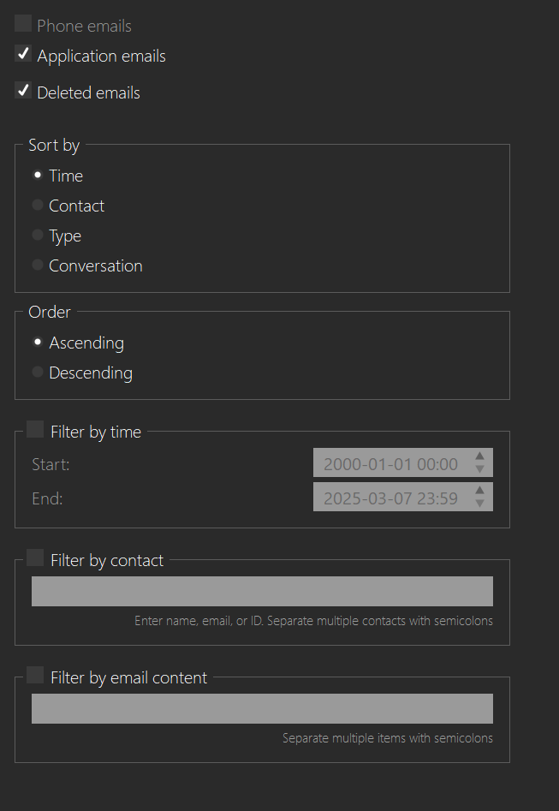

**Step 7:** Enable locations and passwords; for locations, sort by time or proximity with latitude and longitude, order ascending/descending, and filter by coordinates or distance, select passwords and long passwords.

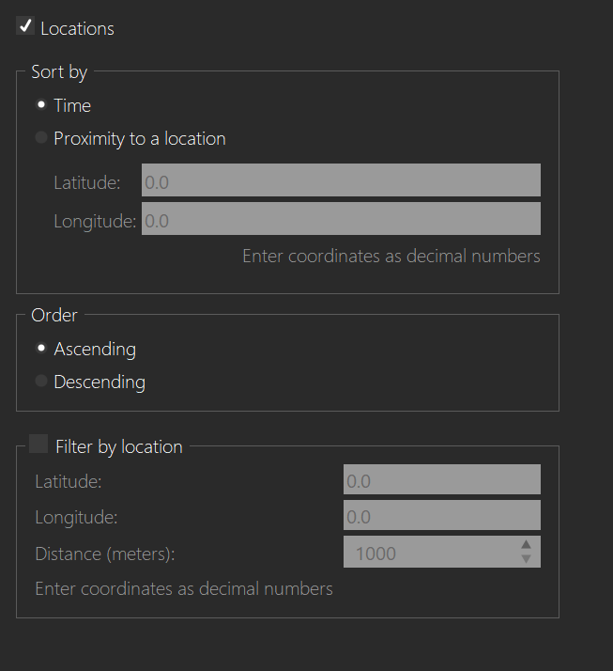 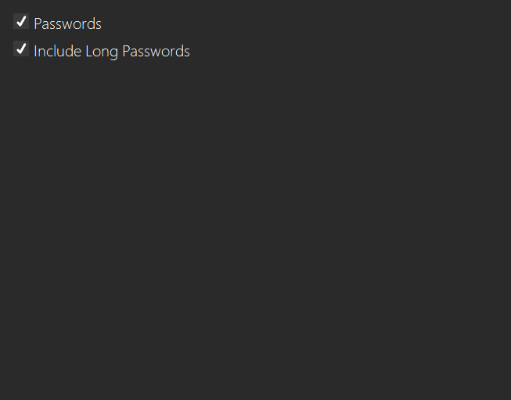

**Step 8:** Fill in the "Specify report details" form with both case and device information, including labels, evidence numbers, notes, and owner details, then click Next.

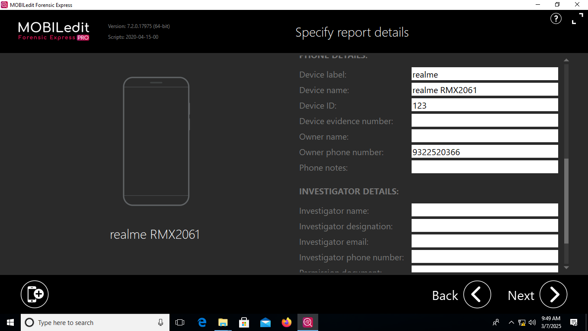 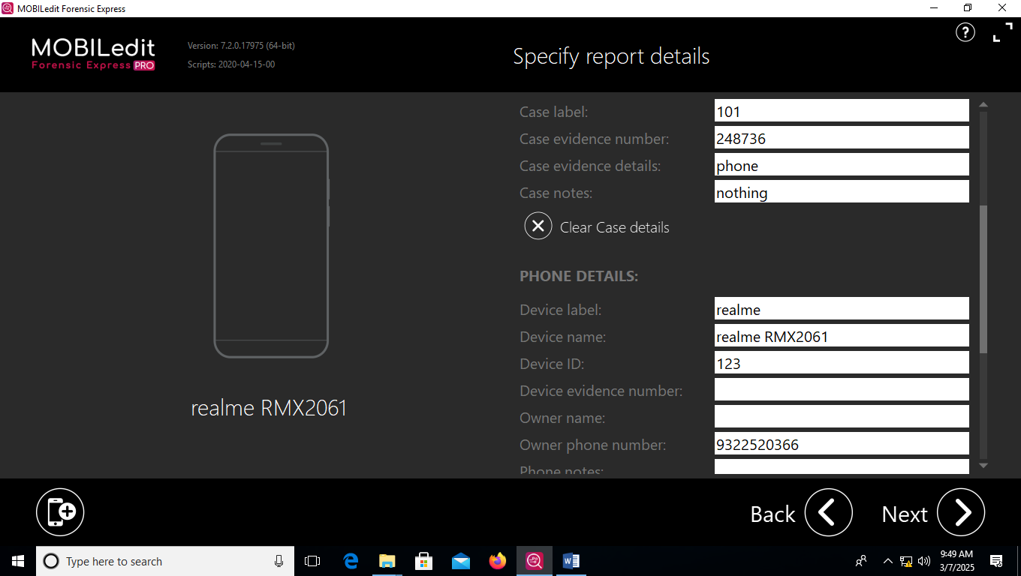

**Step 9:** Choose the desired output formats (e.g., PDF report), select report packing and paper format options, and click Next.

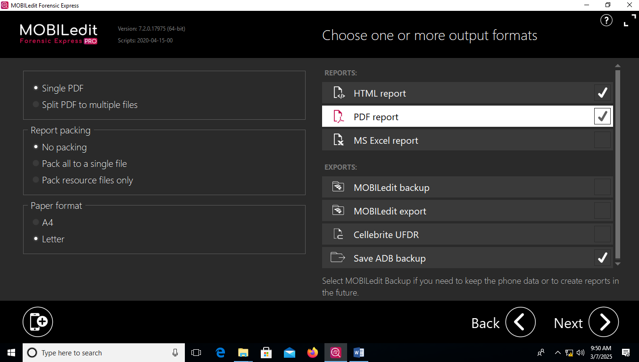

**Step 10:** Specify the export name and destination folder, then click 'Export' to save the data.

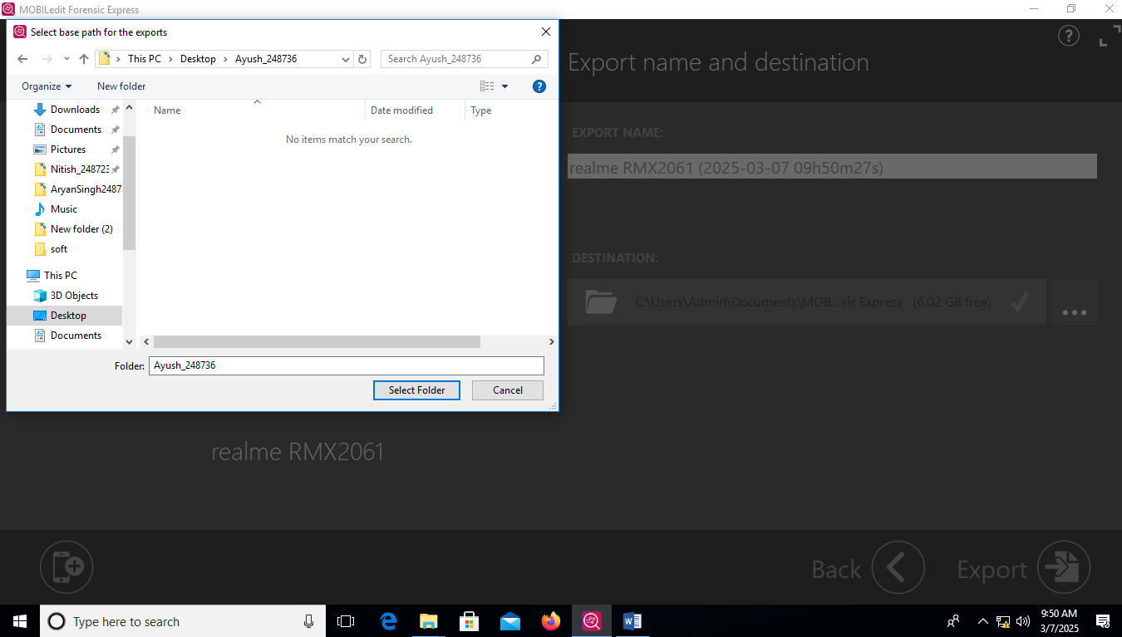 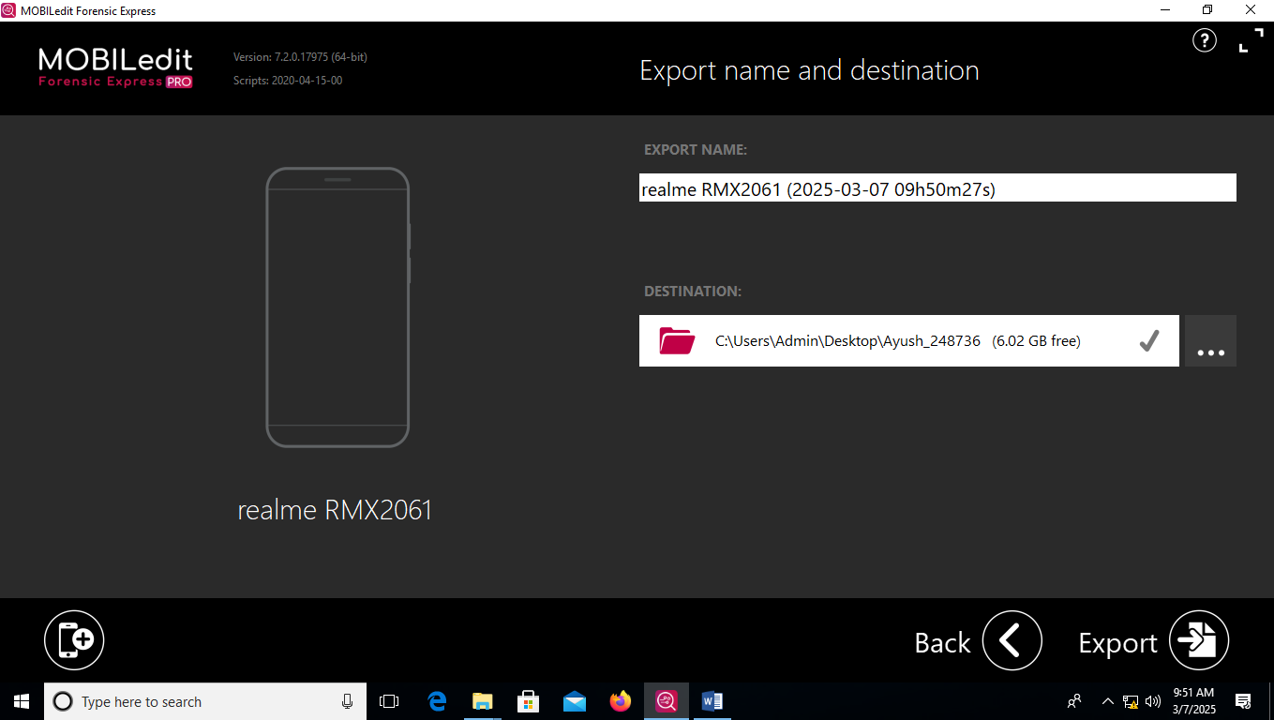

**Step 11:** Start the export process by clicking Export and observe the progress bar as the software collects data from the selected device.

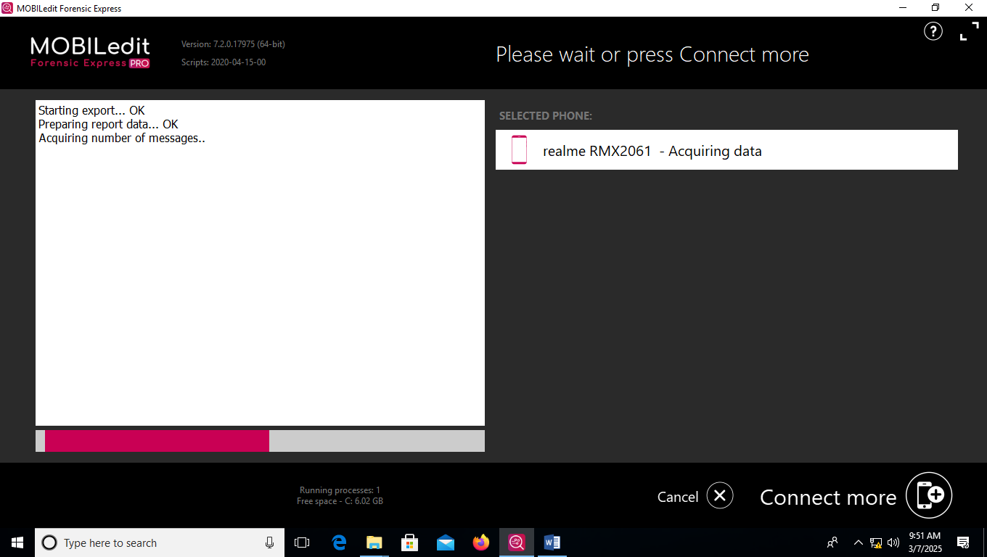 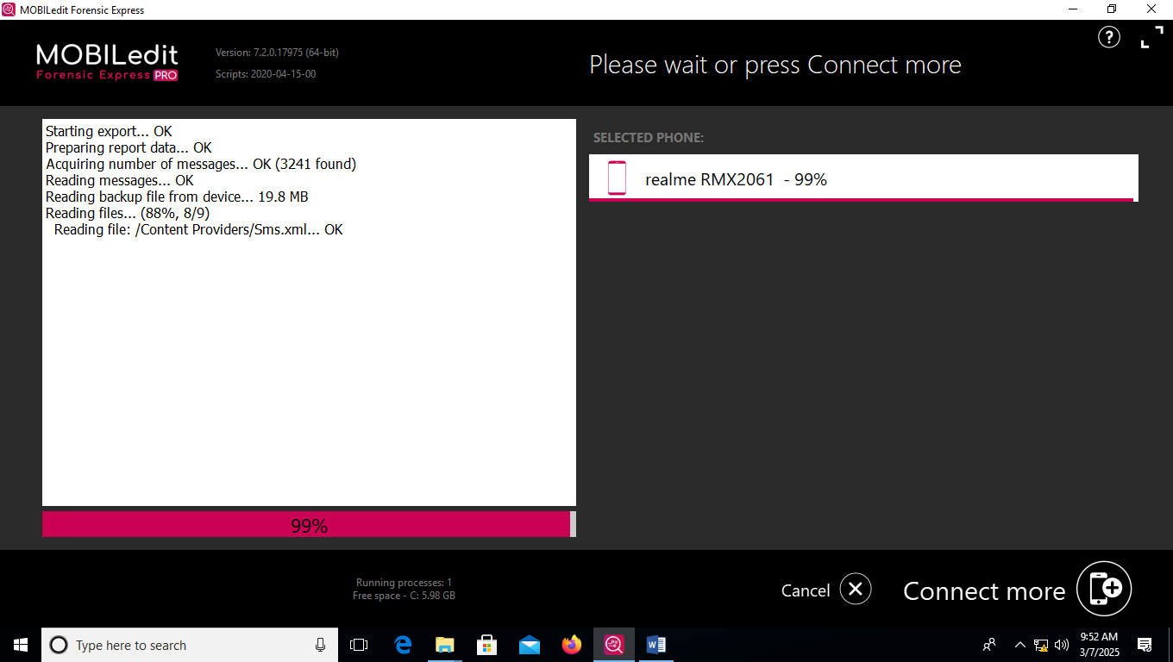

**Step 12:** Open the generated forensic report to review detailed case and device information.

