Dota Winner Prediction

Documentation

Project Timeline

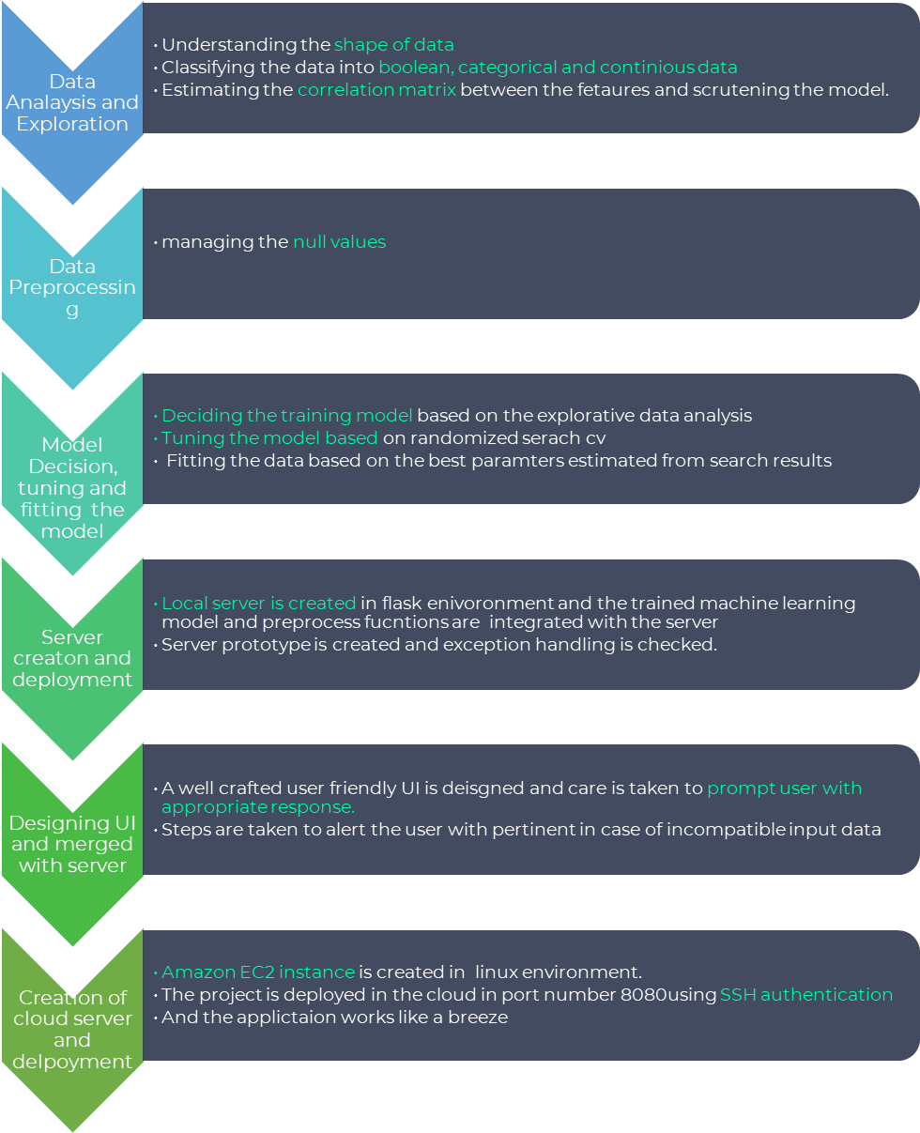

Time





Pandas Dataframe

Pre-processed Data

> Flask server which runs on port number 8080 in AWS cloud instance machine

> All routings connecting to different pages

> pretrained models are imported from the python code.

> A dedicated UI coded in HTML, CSS, Java script and twitter Boostrap

Data matrix csv

Predicted Data

output

Application Structure

> xgboost Classifier model for classifying the dota winner





UI Documentation

Public_url : <http://ec2-3-6-92-45.ap-south-1.compute.amazonaws.com:8080/>

Dashboard : A well binded single UI dashboard is implemented to route to respective the model prediction page.

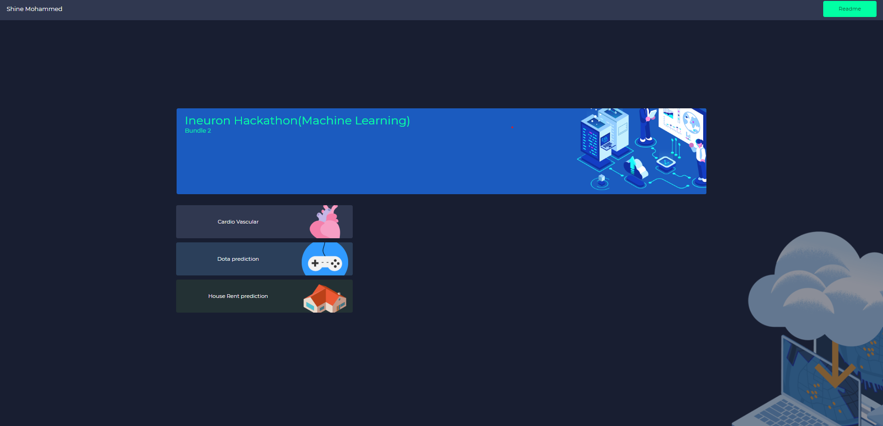

Predicted archive files : One stop place for all previously predicted data, that the download will be triggered on click.

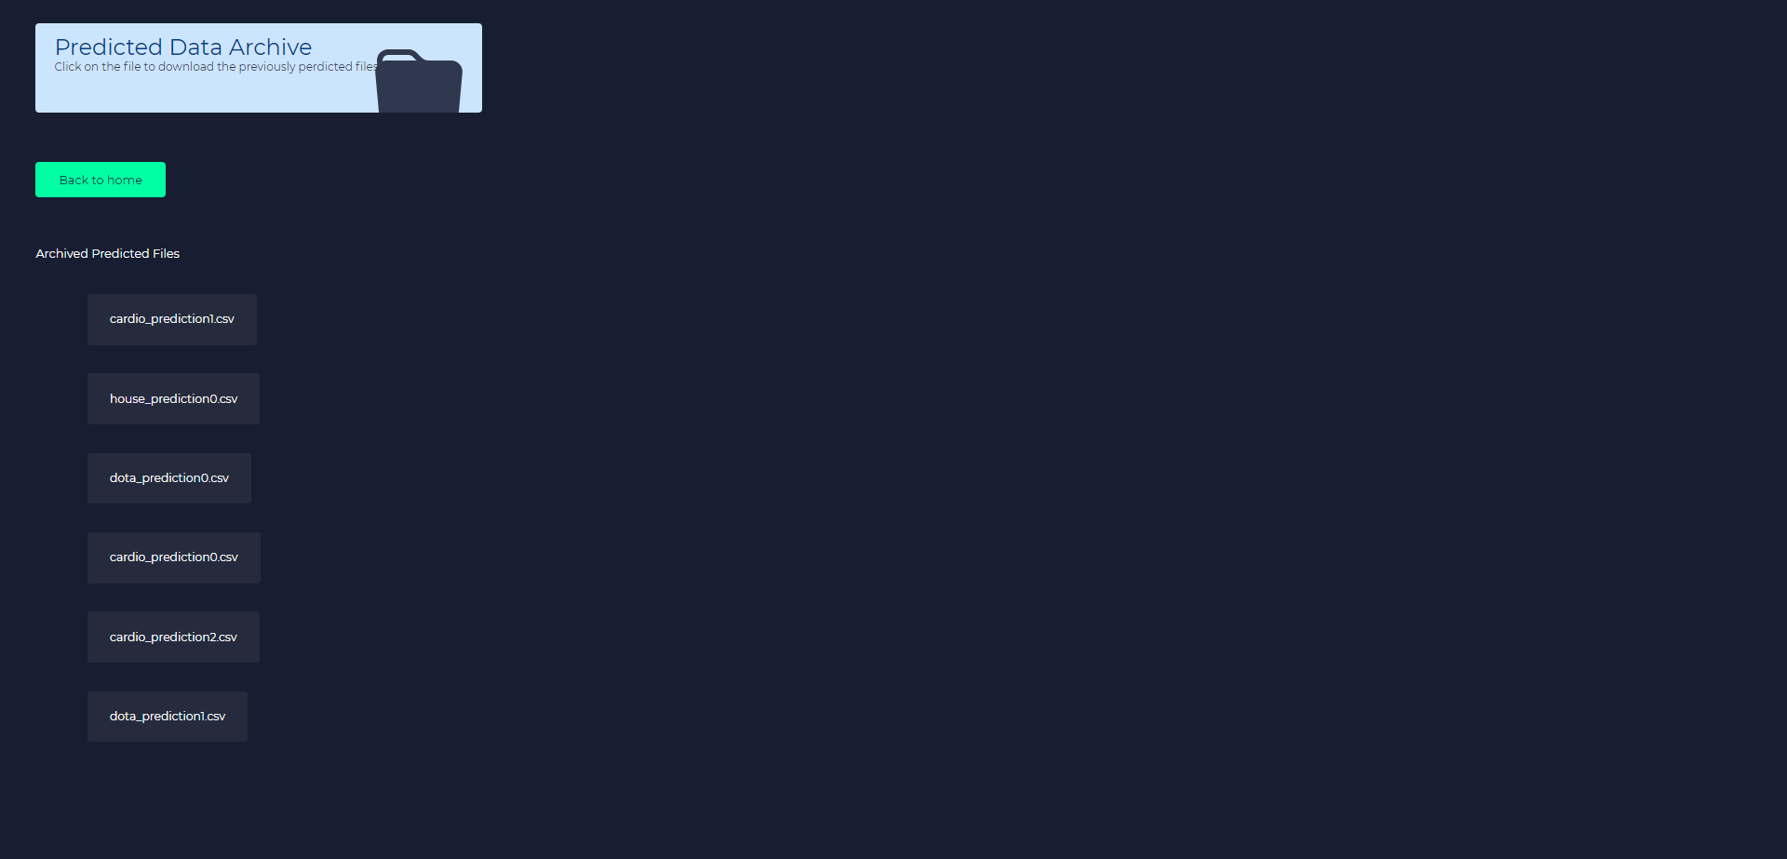

Dota prediction page: Dedicated web page u=is designed for easy prediction of data and as form values and bulk csv.

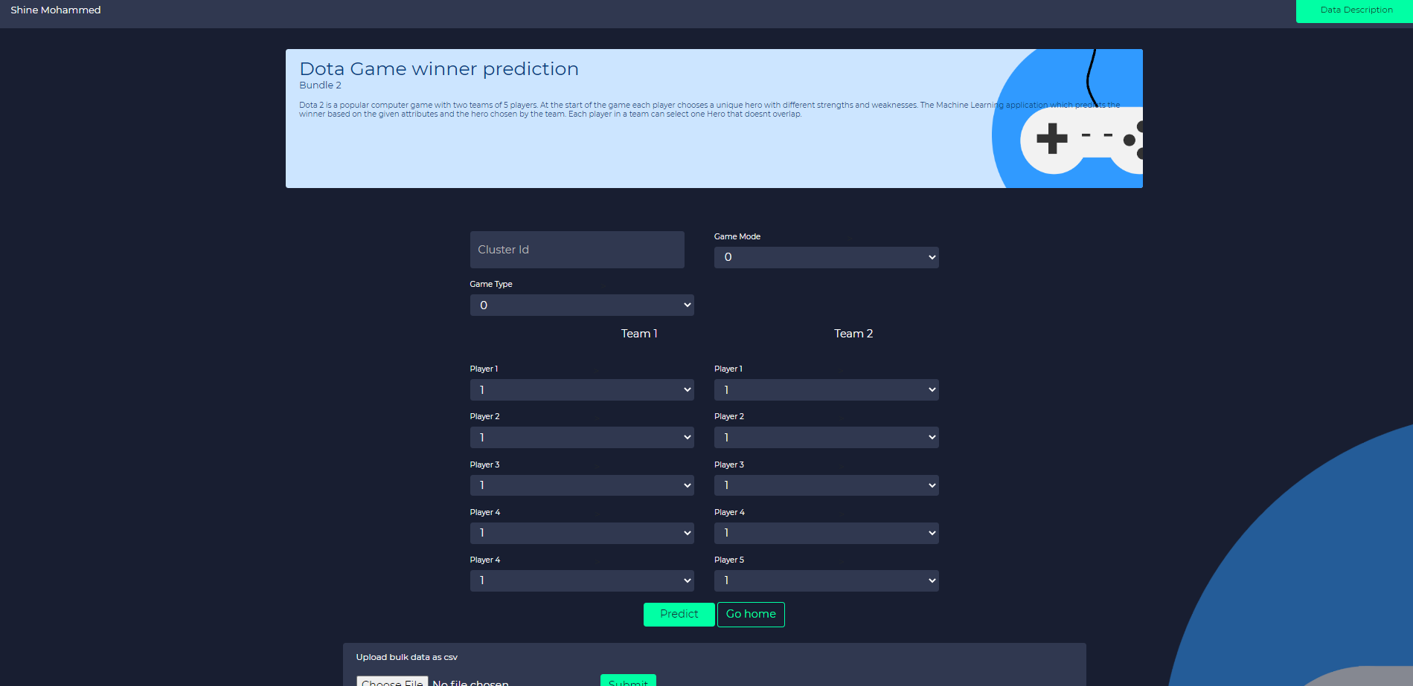

Data description page : A guideline page to show the data attributes and the sequence at which the csv file must be arranged.

