IMPLEMENTING MICROSERVICES
WITH DOCKER HUB, AMAZON ECR
AND AMAZON ECS
A practical, screenshot-led deployment and learning guide

Project scope This guide documents the workflow evidenced in the supplied 15 screenshots: EC2 access and security-group configuration, Docker setup, GitHub clone, image build/tag/push to Docker Hub, and ECS task-definition/service deployment. Amazon ECR and CI/CD are explained as the next production-oriented stages because the supplied screenshots do not show a completed ECR push or CodePipeline execution.

Prepared from the supplied Capstone Project 1 document

How to use this guide
Read the sections in order. Each screenshot is reproduced as an original image, in the same sequence in which it appears in your uploaded document. The explanation beneath each image describes what is visible, why that step matters, and what to verify before moving forward.
- Commands are shown in code blocks. Run them in the EC2 terminal unless the instruction explicitly says AWS Console, local workstation, or Docker Hub.
- Replace values written as <PLACEHOLDER> with your own resource names, AWS Region, account ID, repository URI, or application port.
- Never paste passwords, Docker Hub access tokens, AWS access keys, or other secrets into GitHub.
- A screenshot is evidence of a point-in-time state, not proof that every later stage is configured correctly. Verify the live AWS resource before relying on it.

Important accuracy notes from the supplied evidence
- The screenshots include more than one naming context: React image names, node-image/node_repo, siri3/node_repo, and ECS service names siri-service and node-image-service. These may come from separate attempts or lab sessions. This guide preserves them and explains where to standardize names for a clean repeatable run.
- Screenshot 2 shows an inbound security-group rule allowing all traffic from 0.0.0.0/0. This is not a safe production configuration. Restrict inbound rules to only required ports and trusted source IP ranges.
- The ECS screenshots show a task definition named node-image:1 and service activity. The screenshots do not prove that the service was deployed through CodePipeline.
- The final browser screenshot displays an Express welcome page at a public IP on port 3000. It demonstrates an HTTP response from an application endpoint, but does not by itself prove the React frontend and backend are both deployed as separate ECS services.

Contents
- 1. Project overview and learning objectives
- 2. Architecture and request flow
- 3. Prerequisites and naming convention
- 4. Step-by-step implementation with all 15 original screenshots
- 5. Docker Hub workflow
- 6. Amazon ECR workflow (implementation extension)
- 7. Amazon ECS task definitions and services
- 8. Validation and troubleshooting
- 9. Security, cost and cleanup
- 10. CI/CD with AWS CodePipeline (next-stage design)
- 11. GitHub repository structure and README guidance
- 12. Glossary and interview explanation

1. Project overview
The goal of this capstone is to package application components as container images and run them on Amazon Elastic Container Service (Amazon ECS). Docker is used to build a portable image from application source code. Docker Hub is used as a public image registry in the demonstrated workflow. Amazon Elastic Container Registry (Amazon ECR) is the AWS-native registry target for an AWS deployment. ECS uses a task definition to describe how a container should run and an ECS service to keep the required number of tasks running.

What is a microservice?
A microservice is an independently deployable application component that owns a focused responsibility and communicates with other components through a defined interface, commonly an HTTP API or messaging. A frontend and backend can be deployed independently, but only if the application is actually separated into independently buildable and deployable components. A single Docker image containing one application is a containerized application; it is not automatically a microservices architecture.

Project outcomes
- Connect to an Ubuntu EC2 instance and prepare a Docker build environment.
- Clone application source code from GitHub.
- Build a Docker image and inspect it locally.
- Tag and push an image to a Docker Hub repository.
- Understand the AWS ECR equivalent and how ECS pulls an image from a registry.
- Create an ECS task definition and deploy it through an ECS service.
- Verify service/task health and test the application endpoint.

2. Architecture and request flow
Layer | Responsibility | Main technology
Source control | Stores application code, Dockerfiles and deployment configuration | GitHub
Build environment | Checks out source and builds a container image | Ubuntu EC2, Git, Docker
Image registry | Stores versioned container images | Docker Hub (shown); Amazon ECR (AWS target)
Orchestration | Schedules containers and maintains desired task count | Amazon ECS
Compute | Runs the ECS tasks | EC2 launch type or AWS Fargate; confirm selected capacity provider
Networking | Controls inbound/outbound connectivity | VPC, subnets, security groups, public IP or load balancer
Observability | Captures task lifecycle, application logs and metrics | Amazon ECS, CloudWatch Logs/metrics

Conceptual flow for the AWS-native deployment:
Developer
|
v
GitHub repository
|
v
Docker build (Dockerfile + application source)
|
v
Container image
|
+--> Docker Hub (demonstrated push)
|
+--> Amazon ECR (recommended registry for ECS)
|
v
ECS task definition
|
v
ECS service / cluster
|
v
Running task(s) -> application port -> browser/client
Important distinction Docker creates and runs containers. A registry stores images. ECS schedules and maintains containers. EC2 or Fargate supplies the compute capacity. These services solve different parts of the deployment lifecycle.

3. Prerequisites and naming convention
Prerequisite | Why it is needed | Check
AWS account and Region | Creates EC2, ECR and ECS resources in a chosen Region | Confirm the console Region, shown as us-east-1 in the screenshots
Ubuntu EC2 instance | Provides a Linux host for Git and Docker commands | Instance state should be Running
SSH / EC2 Instance Connect | Provides terminal access to the instance | Connect using an approved access method
Git | Downloads the source repository | git --version
Docker Engine | Builds and tags container images | docker --version; docker info
GitHub repository | Stores source code and project documentation | Open repository URL and inspect branch
Docker Hub account | Stores the demonstrated public image | Confirm namespace and repository name
ECR repository | Stores the AWS deployment image | Create repository in the same Region as ECS or use the full registry URI
ECS cluster and task execution role | Runs tasks and allows image/log operations | Check IAM role permissions

Recommended naming convention for a clean run
AWS_REGION=us-east-1
DOCKERHUB_USER=siri3
DOCKERHUB_REPO=node_repo
IMAGE_NAME=node-image
IMAGE_TAG=v1
ECR_REPO=microservices/node-image
The screenshots show more than one image name (react-img and node-img) and service name (siri-service and node-image-service). For a fresh implementation, choose one consistent name and use it in the Docker build, tag, registry URI, ECS task definition, and documentation. Do not rename the original screenshots; the standard names above are a clean example for future commands.

4. Step-by-step implementation and original screenshot evidence
The following evidence is presented in the same order as the 15 images embedded in the original DOCX. The image content has not been cropped, annotated, recolored, or otherwise modified.

Evidence 01 — EC2 instance overview
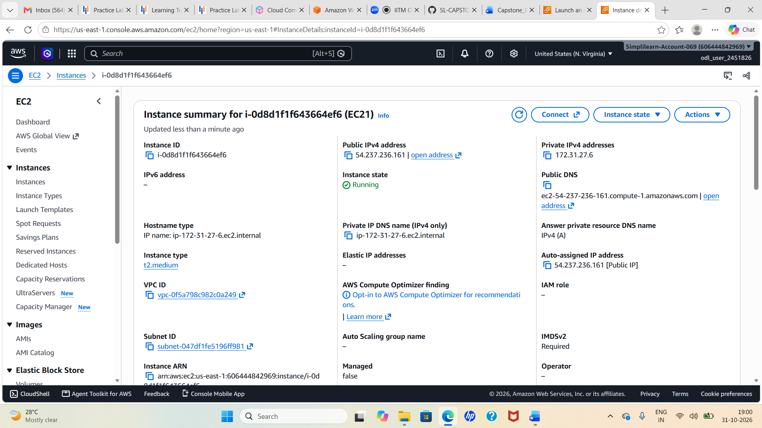
Original screenshot 01 of 15 — preserved unchanged
The AWS EC2 console shows an Ubuntu instance in the Running state, with a public IPv4 address and a private IPv4 address. The instance is the Linux compute host used for the terminal-based setup and Docker commands. The private address is used for communication inside the VPC; the public address may be used for internet-facing access when routing and security rules allow it.
What this proves An EC2 instance is available for the hands-on work. Before running commands, confirm that this is the intended instance and Region. Public IP addresses can change after stop/start unless an Elastic IP is associated.

Evidence 02 — Security-group inbound rule
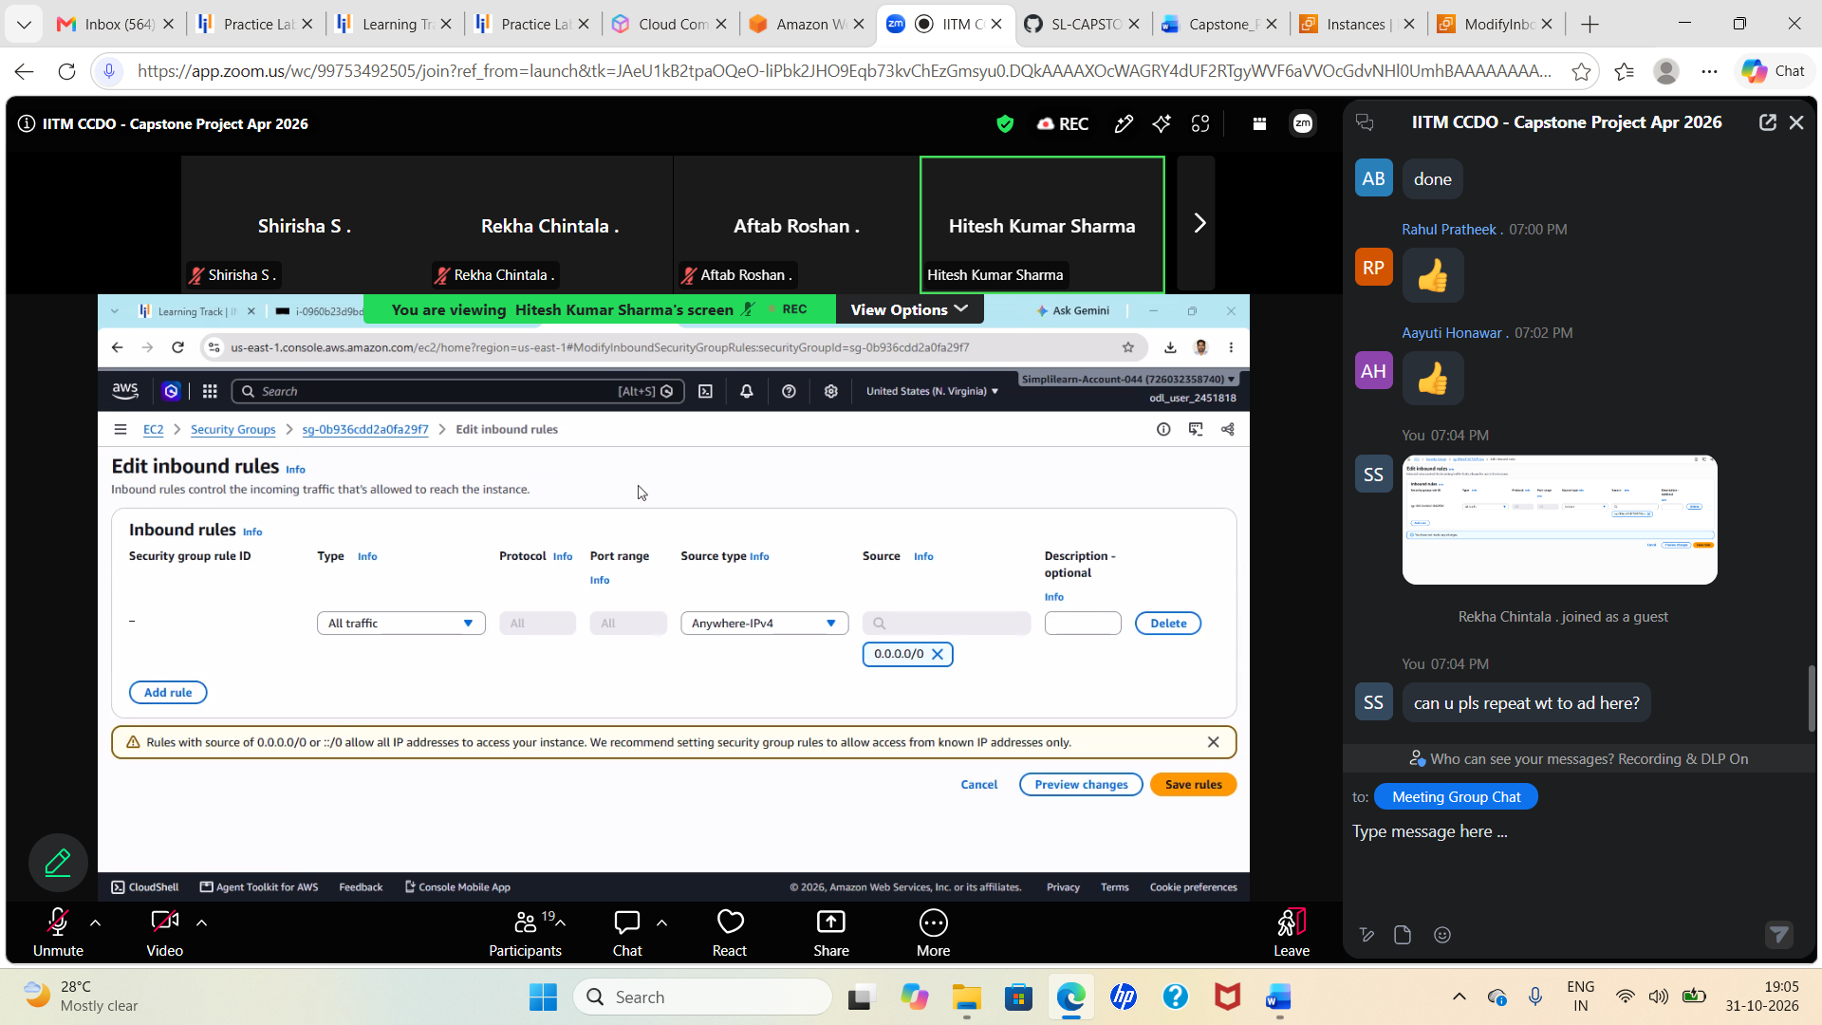
Original screenshot 02 of 15 — preserved unchanged
The screenshot shows the Edit inbound rules page and a rule allowing All traffic from Anywhere-IPv4 (0.0.0.0/0). This setting allows any IPv4 address on the internet to attempt connections to every port/protocol covered by that rule. It is useful to understand why a test might become reachable, but it is overly permissive and should not be retained.
What this proves Security groups are stateful virtual firewalls attached to network interfaces/instances. For a safer setup, allow SSH (TCP 22) only from your current trusted IP, and allow the application port (for example TCP 3000) only from a trusted test IP or preferably expose the app through an appropriately configured load balancer on TCP 80/443. Remove the all-traffic rule.

Security warning Do not publish screenshots containing account identifiers, public IP addresses, usernames, or broad security rules to a public GitHub repository without reviewing the exposure. The screenshots in this document are preserved exactly as requested; consider using a private repository or obtaining approval before making the document public.

Evidence 03 — Ubuntu package metadata and Docker repository setup
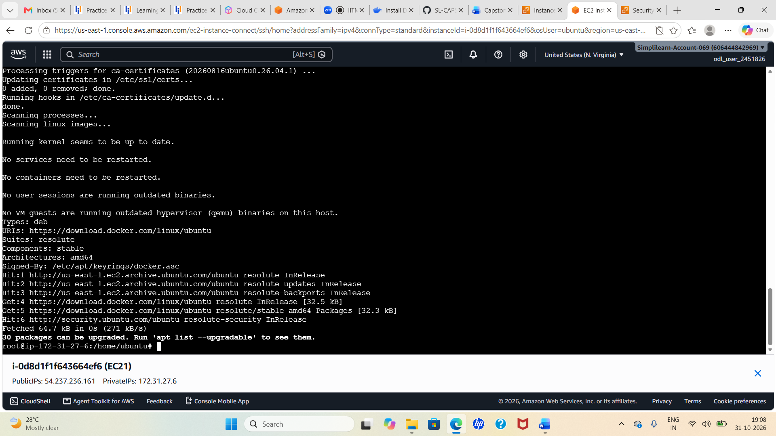
Original screenshot 03 of 15 — preserved unchanged
The terminal shows package-management activity, including repository metadata being fetched from Docker's Ubuntu package source and the Ubuntu repositories. `apt` is the Debian/Ubuntu package manager. Updating package indexes makes the operating system aware of the latest package versions available from configured repositories. The Docker repository setup makes Docker packages available through the configured package source.
What this proves This is preparation for installing Docker. A successful repository refresh is not the same as Docker being installed. Continue only after the Docker Engine installation completes and `docker --version` works.

Evidence 04 — Docker command availability check
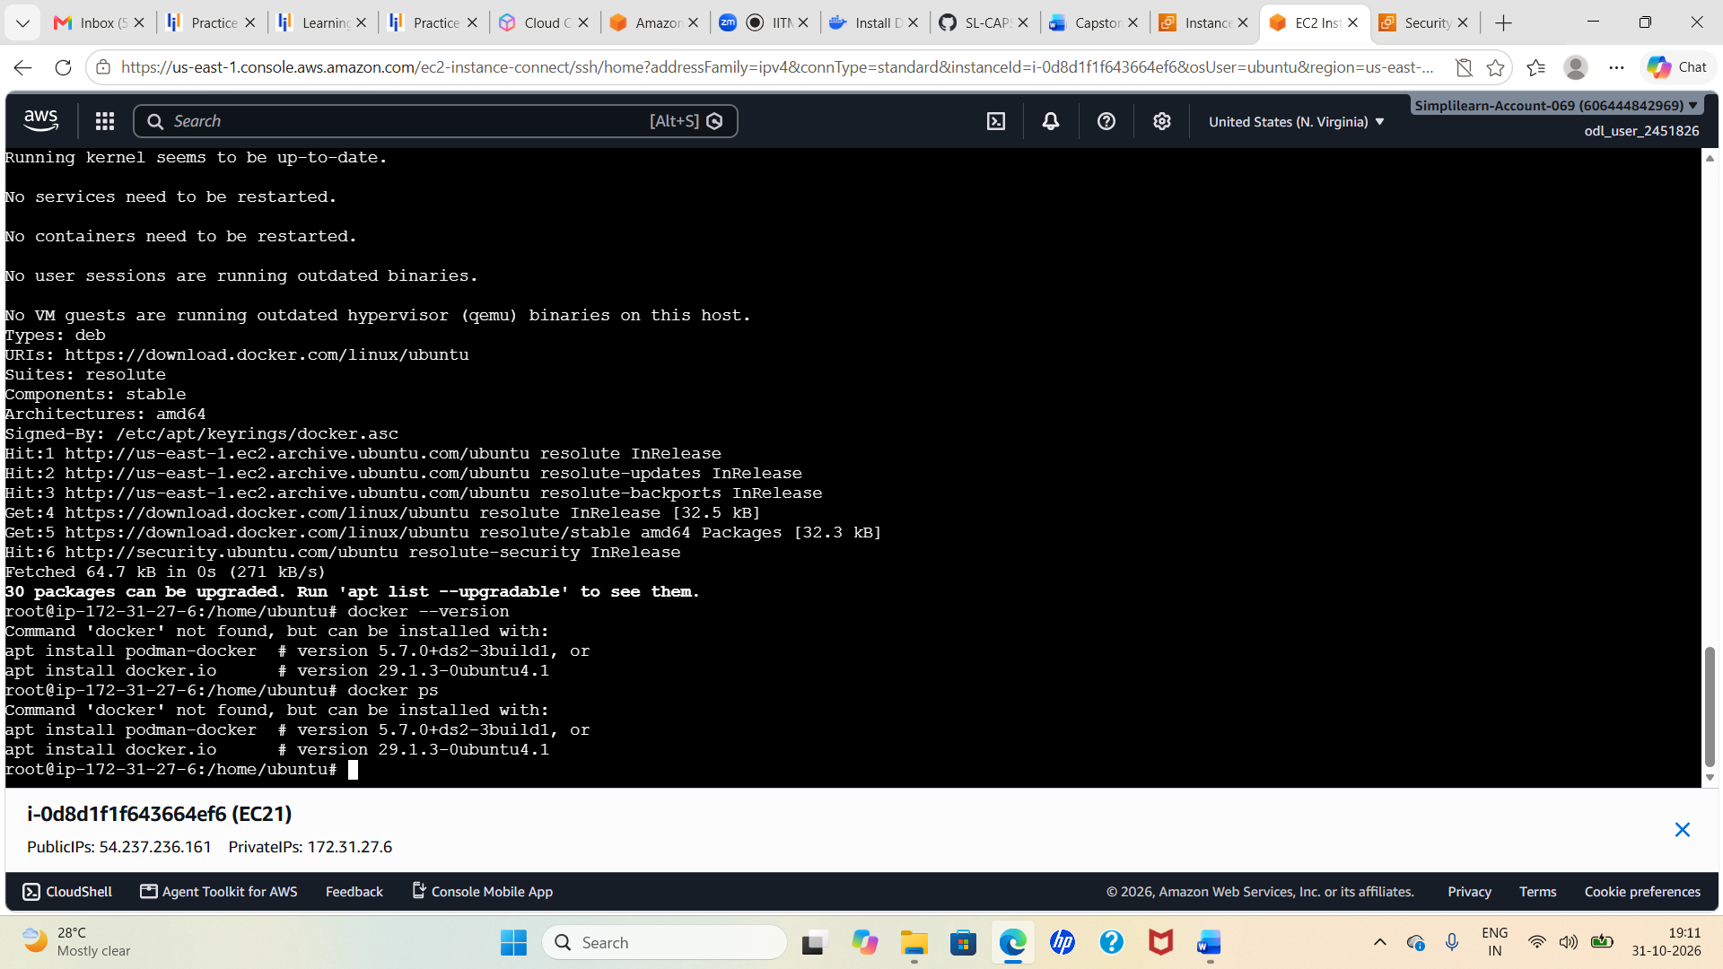
Original screenshot 04 of 15 — preserved unchanged
The terminal explicitly reports that `docker` is not found when `docker --version` and `docker ps` are attempted. This is an important troubleshooting checkpoint: the shell cannot find the Docker client executable, so Docker has not yet been installed or is not on the PATH at this point.
What this proves The screenshot itself shows the Docker commands failing because the command is unavailable. Do not proceed to `docker build` until Docker Engine is installed, the service is running, and the current user has permission to access the Docker daemon.

Install and verify Docker (complete setup instructions)
The screenshots show repository preparation and a Docker-not-found check, followed later by successful image builds. The following commands are a clear installation sequence for Ubuntu systems using Docker's official apt repository. Confirm your Ubuntu release and follow the current Docker Engine documentation if package names or repository configuration have changed.
# Refresh package metadata
sudo apt-get update
# Install packages required to add a signed apt repository
sudo apt-get install -y ca-certificates curl
# Create the keyring directory
sudo install -m 0755 -d /etc/apt/keyrings
# Download Docker's official signing key
sudo curl -fsSL https://download.docker.com/linux/ubuntu/gpg \
-o /etc/apt/keyrings/docker.asc
sudo chmod a+r /etc/apt/keyrings/docker.asc
# Add Docker's official apt repository
echo \
"deb [arch=$(dpkg --print-architecture) signed-by=/etc/apt/keyrings/docker.asc] https://download.docker.com/linux/ubuntu \
$(. /etc/os-release && echo "$VERSION_CODENAME") stable" | \
sudo tee /etc/apt/sources.list.d/docker.list > /dev/null
# Install Docker Engine, CLI, containerd and Buildx/Compose plugins
sudo apt-get update
sudo apt-get install -y docker-ce docker-ce-cli containerd.io \
docker-buildx-plugin docker-compose-plugin
# Start Docker now and automatically on reboot
sudo systemctl enable --now docker
# Verify installation and daemon status
sudo docker --version
sudo systemctl status docker --no-pager
Optional: allow the ubuntu user to run Docker without `sudo`. This takes effect after logging out and logging back in. Membership in the docker group grants root-equivalent privileges, so only do this for a trusted administrative user.
sudo usermod -aG docker ubuntu
newgrp docker
docker ps

Evidence 05 — Clone the application source from GitHub
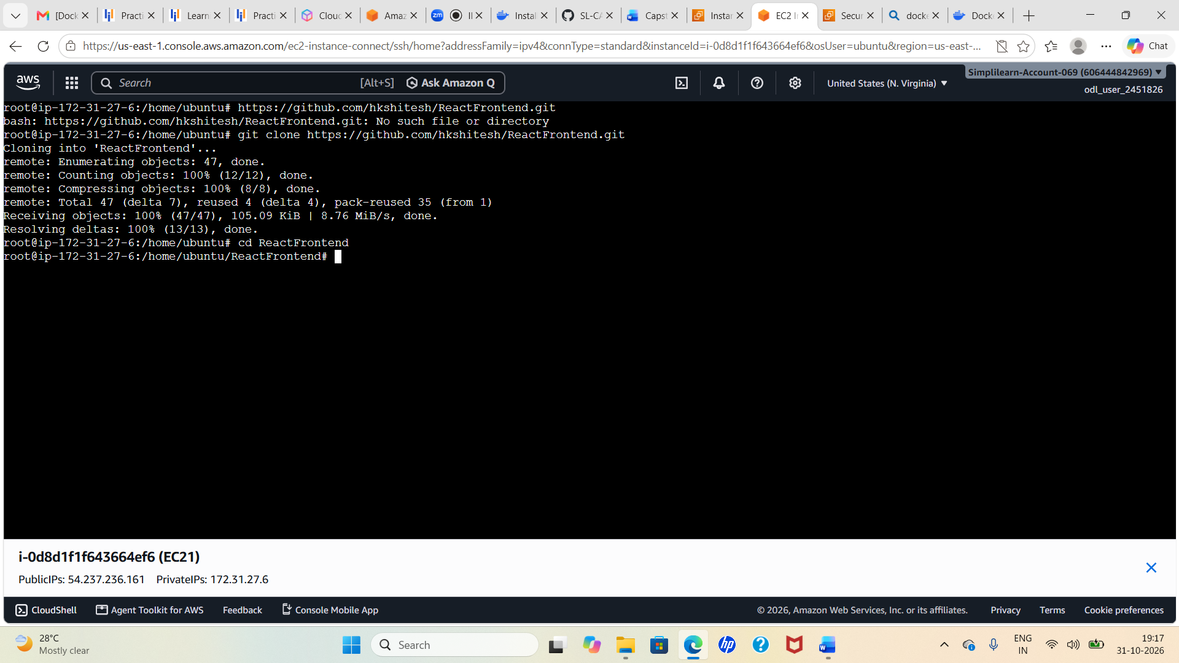
Original screenshot 05 of 15 — preserved unchanged
The terminal shows a `git clone` operation against the ReactFrontend repository, followed by a change into the cloned directory. Git clone downloads the repository history and working files from the remote Git server into a new local directory. The screenshot also shows an initial attempt to enter the URL as if it were a shell command; the correct operation is `git clone <repository-url>`.
What this proves The repository was cloned successfully and the shell moved into the ReactFrontend directory. Verify the actual project root and locate the Dockerfile before building.

Git commands explained
# Check Git is installed
git --version
# Clone the repository (use your own repository URL)
git clone https://github.com/<OWNER>/<REPOSITORY>.git
# Move into the cloned folder
cd <REPOSITORY>
# List files, including hidden files
ls -la
# Check the current branch and working-tree status
git status
A Docker build must be run from the directory containing the intended Dockerfile, unless you explicitly provide a different build-context path and Dockerfile path. The build context is the set of files Docker can access while building.

Evidence 06 — Build a Docker image from the application
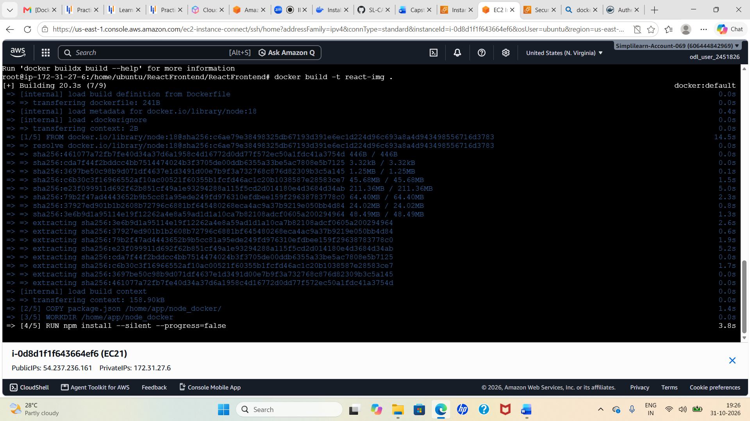
Original screenshot 06 of 15 — preserved unchanged
The terminal shows `docker build -t react-img .` and Docker BuildKit progress. The `-t` option assigns a local image name and tag; because no tag suffix is supplied, Docker uses `latest`. The dot (`.`) means the current directory is the build context. The Dockerfile defines the base image, working directory, dependency installation, copied source files and startup command.
What this proves The build output progresses through Dockerfile steps, including an npm install step. The screenshot is a build-in-progress capture; confirm a final `FINISHED`/exported image result and then inspect it with `docker images.

What happens during docker build?
- Docker reads the Dockerfile in the build context.
- It resolves the base image specified by `FROM` (for example, a Node.js image).
- It executes build instructions such as `WORKDIR`, `COPY`, and `RUN npm install`.
- It creates image layers and exports the final image to the local Docker image store.
# Example command shown in the screenshot
docker build -t react-img .
# Verify local images
docker images
# Inspect image metadata
docker image inspect react-img:latest
A Docker image is a read-only template containing the application and its runtime dependencies. A container is a running or stopped instance created from an image. Building an image does not automatically start the application.

Evidence 07 — Inspect local images and apply a registry tag
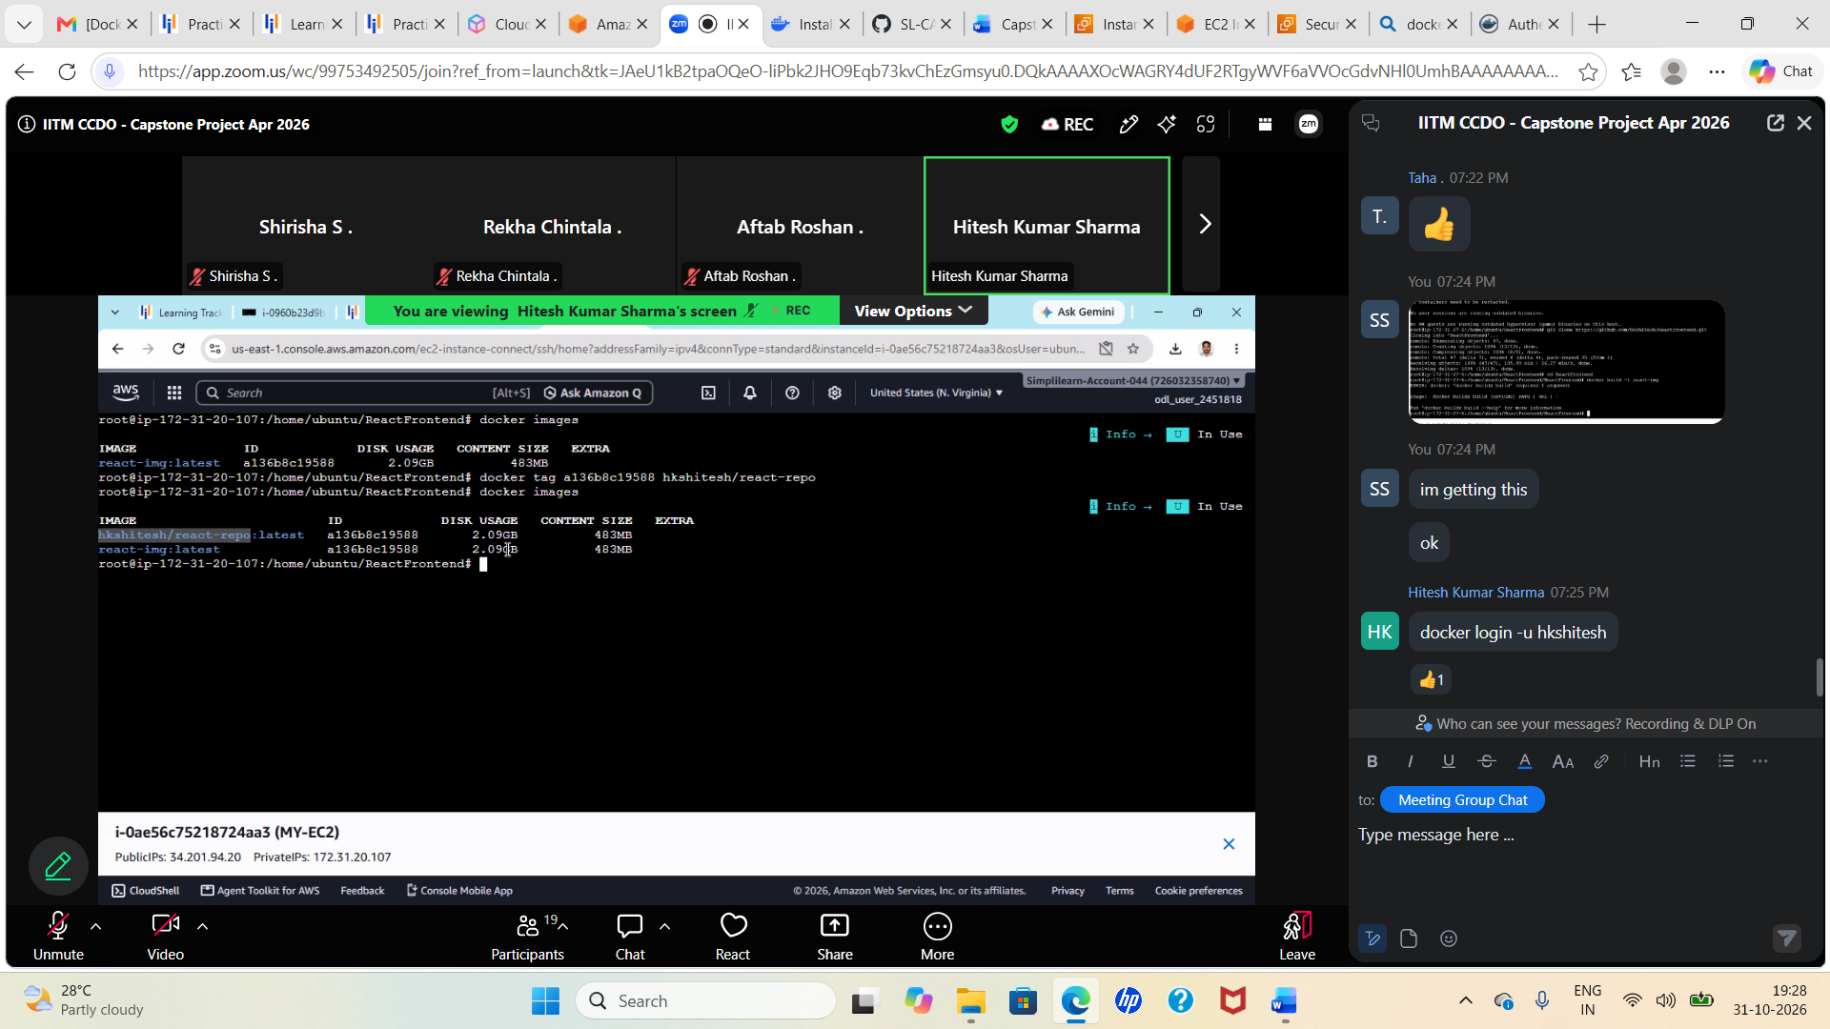
Original screenshot 07 of 15 — preserved unchanged
The screenshot shows `docker images`, a local image named `react-img:latest`, and a `docker tag` command. Tagging associates an existing image ID with another repository/name:tag reference. It does not rebuild the image or upload it. This screenshot also contains a different Docker Hub namespace from the later `siri3/node_repo` push; treat it as a separate naming example rather than assuming it is the same registry destination.
What this proves The local image is present and a registry-style tag is being assigned. For your own Docker Hub repository, use the exact namespace and repository shown in your Docker Hub account.

# Example from the screenshot's naming context (not the siri3 repository)
docker tag <IMAGE_ID> <DOCKERHUB_USER>/<REPOSITORY>:<TAG>
# For the repository shown in your Docker Hub screenshot:
docker tag node-img:latest siri3/node_repo:latest
# Confirm both tags point to the same image ID
docker images
Use the full `username/repository:tag` format for Docker Hub. The Docker Hub namespace is the account or organization name; the repository is the image repository; the tag identifies a particular version.

Evidence 08 — ECS cluster before service deployment
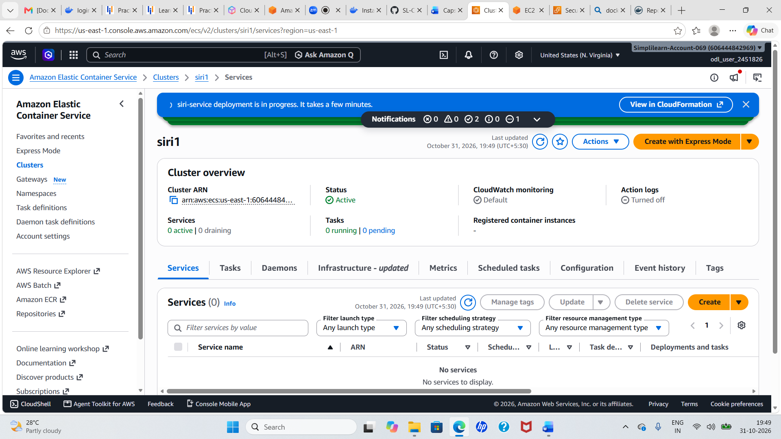
Original screenshot 08 of 15 — preserved unchanged
The ECS console shows the cluster overview with zero active services and no services listed. This is a useful baseline: a cluster is the logical grouping/management boundary for ECS workloads, but creating a cluster alone does not launch an application. A task definition and a task or service are still required.
What this proves The cluster exists, but no ECS service is running at this point in the screenshot. The cluster is not the container image and does not itself contain application code.

Evidence 09 — ECS service task status during deployment
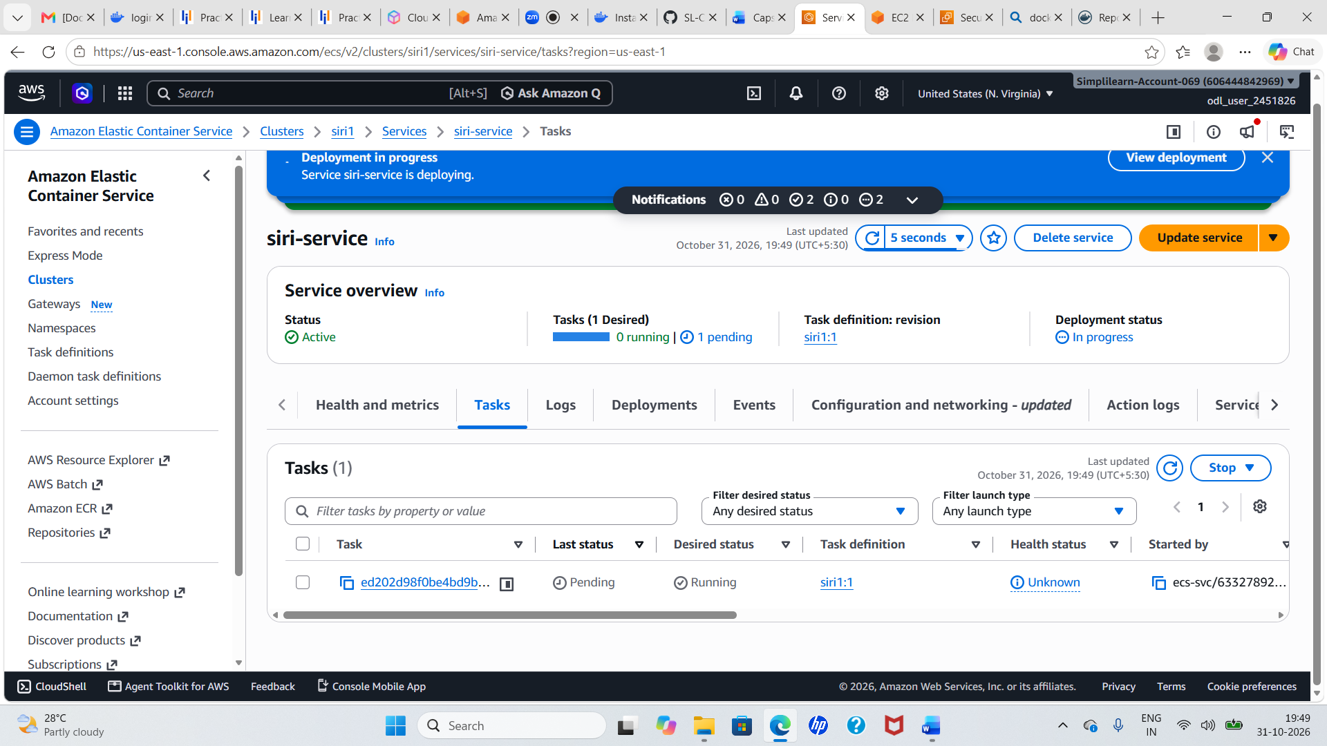
Original screenshot 09 of 15 — preserved unchanged
The ECS service details page shows a service named `siri-service`, with one desired task and a task in a Pending/Running transition while deployment is in progress. ECS services maintain a desired number of task instances and replace tasks when they fail or need redeployment.
What this proves Pending is a transitional state, not a final health confirmation. Wait for the task to reach RUNNING, then inspect service events, task stopped reasons, container health checks, and logs if it does not stabilize.

Evidence 10 — Browser response showing raw React HTML template
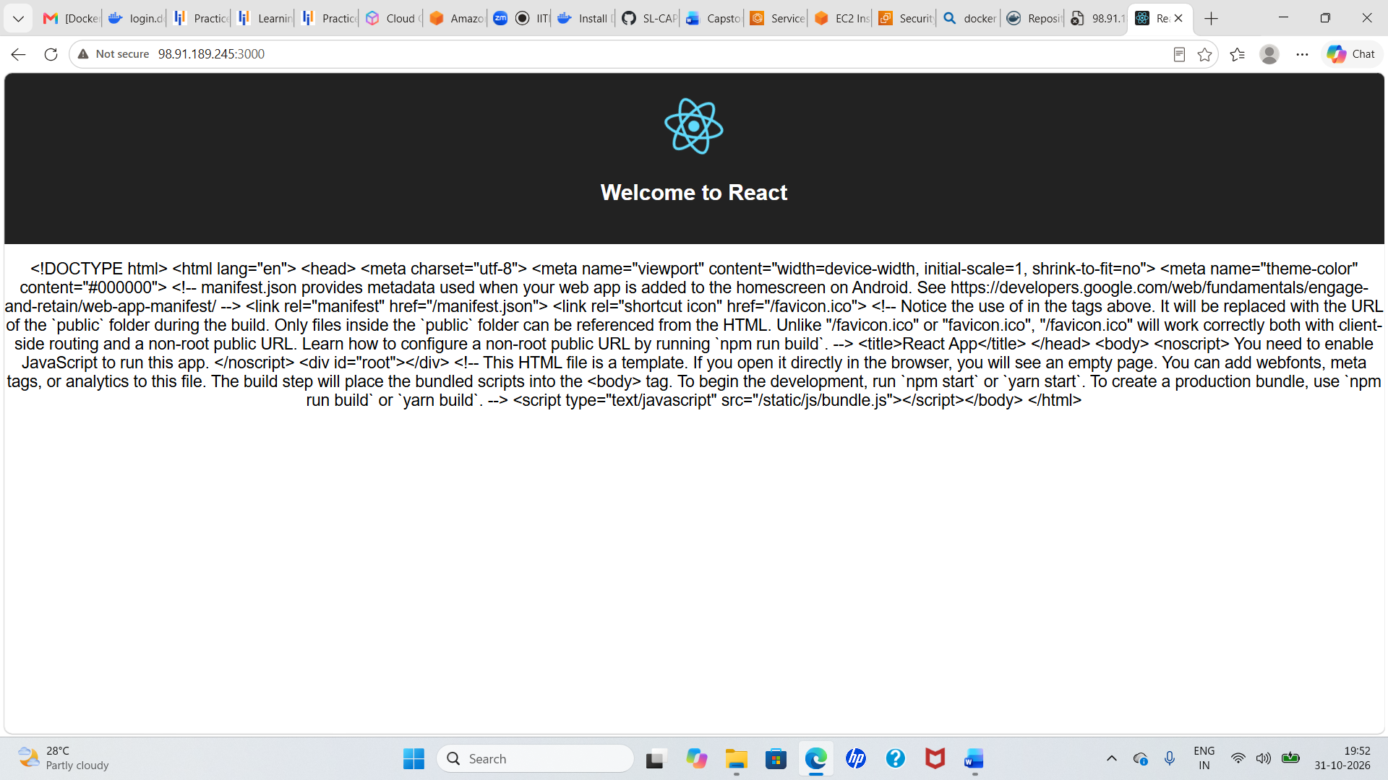
Original screenshot 10 of 15 — preserved unchanged
The browser displays HTML source/template text rather than a rendered React interface. The visible markup includes the React root element and references to bundled JavaScript. This can happen when the wrong URL/path or server configuration is used, or when the development/build assets are not served as expected. It is not evidence of a correctly rendered frontend.
What this proves Treat this as a troubleshooting observation. Test the correct application URL and port, inspect browser developer tools, and review the container logs. For a production React deployment, build static assets and serve them with a suitable web server, or use a correctly configured Node server.

Evidence 11 — Docker Hub image push
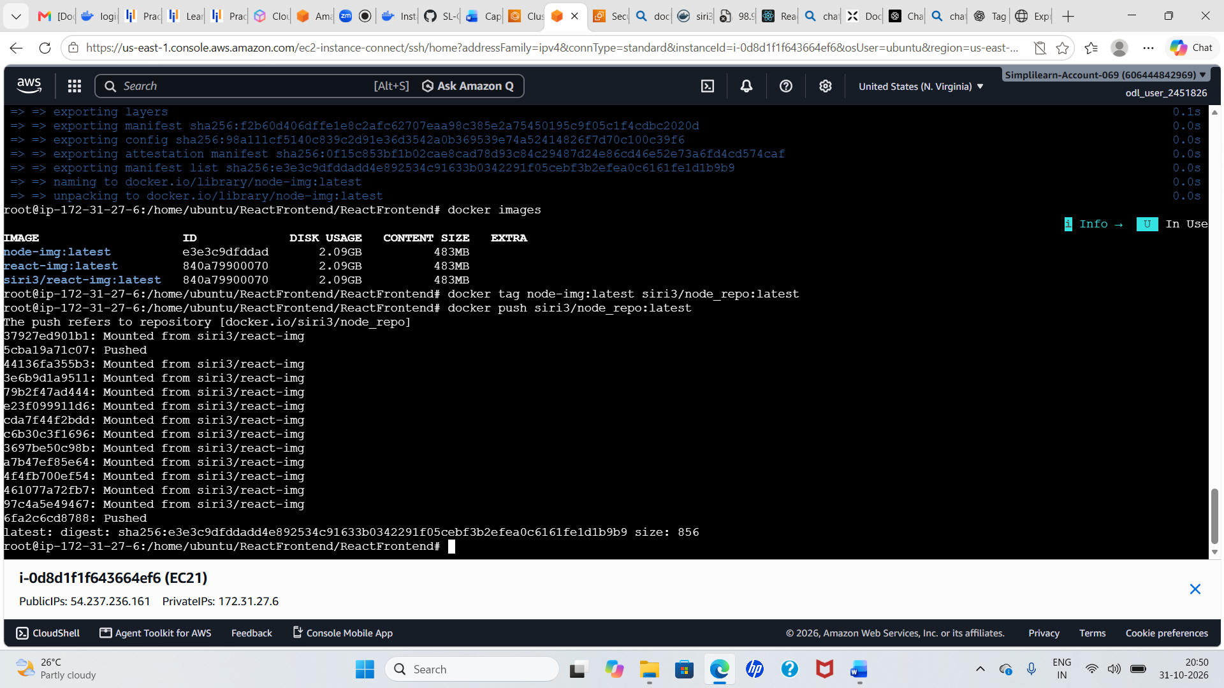
Original screenshot 11 of 15 — preserved unchanged
The terminal shows the image list, the command `docker tag node-img:latest siri3/node_repo:latest`, and `docker push siri3/node_repo:latest`. Docker uploads image layers to the Docker Hub repository. Layers that already exist remotely may be reused/mounted instead of uploaded again; the final digest identifies the pushed image manifest.
What this proves This is the clearest evidence in the supplied document that an image was pushed to the `siri3/node_repo` Docker Hub repository. The digest is a content identifier for the pushed manifest. Verify the `latest` tag in Docker Hub after the command completes.

Docker Hub commands for your repository
# Authenticate interactively; use a Docker Hub access token when required
docker login --username siri3
# Tag the local image with the Docker Hub repository path
docker tag node-img:latest siri3/node_repo:latest
# Push the tagged image
docker push siri3/node_repo:latest
# Confirm the local image/tag
docker images
If the local image is named `react-img:latest` instead of `node-img:latest`, change only the source image in the tag command. For example: `docker tag react-img:latest siri3/node_repo:latest`. Do not assume both image names exist on the same EC2 instance.

Evidence 12 — ECS task definition successfully created
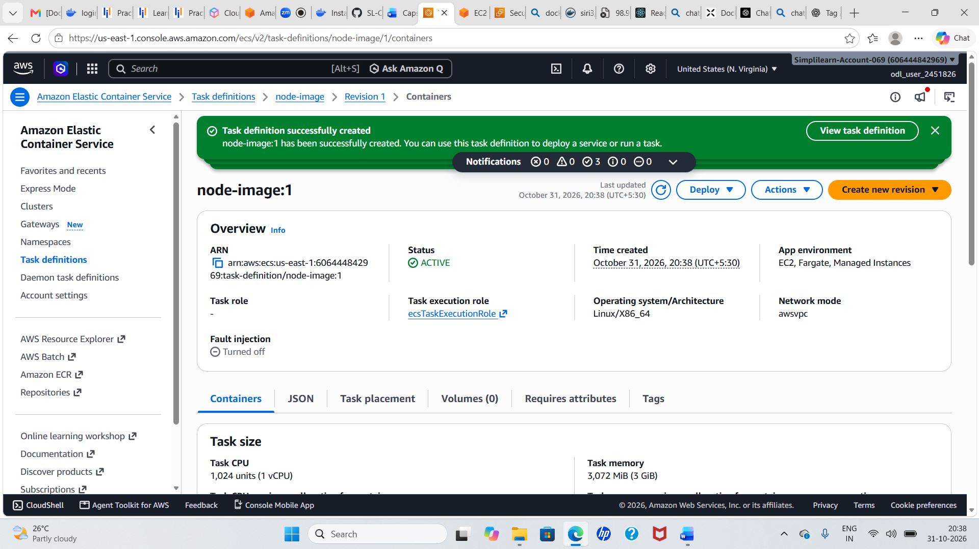
Original screenshot 12 of 15 — preserved unchanged
The ECS console confirms creation of task definition family `node-image`, revision `1`. The page shows an execution role named `ecsTaskExecutionRole`, Linux/X86_64, `awsvpc` network mode, and task sizing information. A task definition is a versioned blueprint that tells ECS which container image to run and how to configure it.
What this proves Task definition creation is a configuration milestone; it does not prove a task is running. Check the container image URI, container port mappings, environment variables, log configuration, CPU/memory, task role and execution role before deploying.

Task definition concepts
- Task definition family/revision: a named configuration with immutable numbered revisions (for example, node-image:1).
- Container image: the registry URI and tag or digest that ECS must pull.
- Task execution role: permissions used by ECS/Fargate/agent infrastructure for operations such as pulling from ECR and sending logs to CloudWatch.
- Task role: permissions granted to the application code inside the container to call AWS APIs.
- Network mode: `awsvpc` gives each task an elastic network interface and task-level security-group attachment.
- Port mapping: maps the application container port to the task networking configuration.

Evidence 13 — ECS cluster with one active service
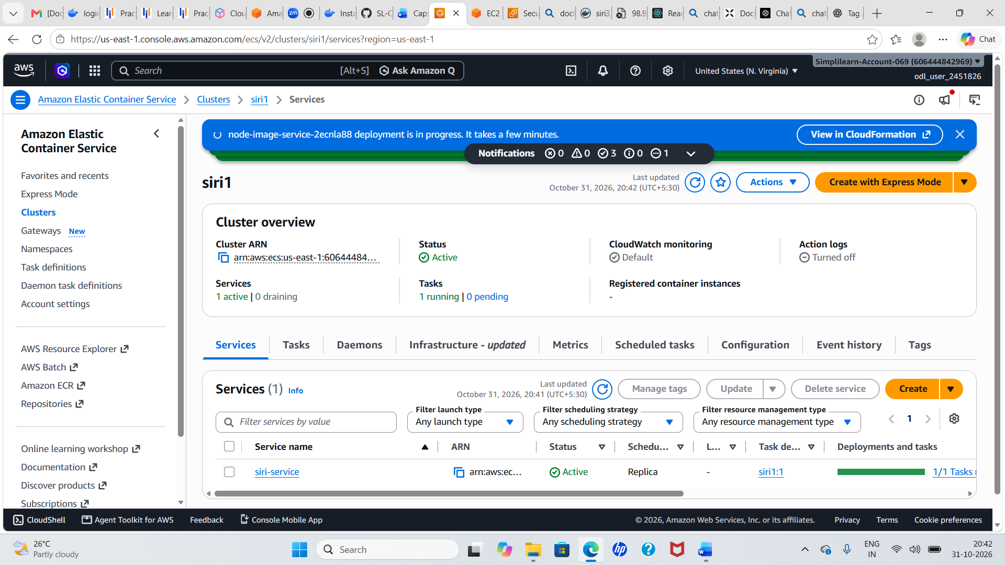
Original screenshot 13 of 15 — preserved unchanged
The cluster overview now shows one active service and one running task. The service list includes `siri-service` with a 1/1 task deployment count. This indicates the service has reached a stable-looking desired-versus-running count at the time captured.
What this proves A 1/1 count is a useful deployment signal, but it is not a complete application health test. Confirm the task health status, service events, target-group health (if a load balancer is used), and the application response.

Evidence 14 — ECS cluster showing two services and task counts
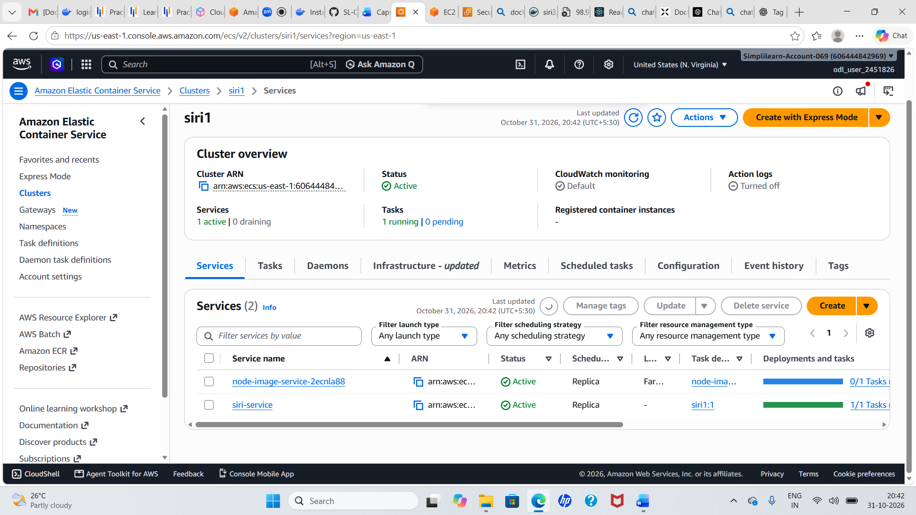
Original screenshot 14 of 15 — preserved unchanged
The cluster view shows two service entries, including `node-image-service-2ecnla88` and `siri-service`. The visible task count differs between them: one service shows 0/1 while the other shows 1/1. This illustrates why each ECS service must be checked individually. A cluster can contain multiple services with different deployment states.
What this proves Do not report every service as healthy based only on the cluster-level summary. Open each service, review its Deployments and Tasks tabs, and inspect events and stopped-task reasons for any service that remains at 0 running tasks.

Evidence 15 — Application endpoint displays the Express welcome page
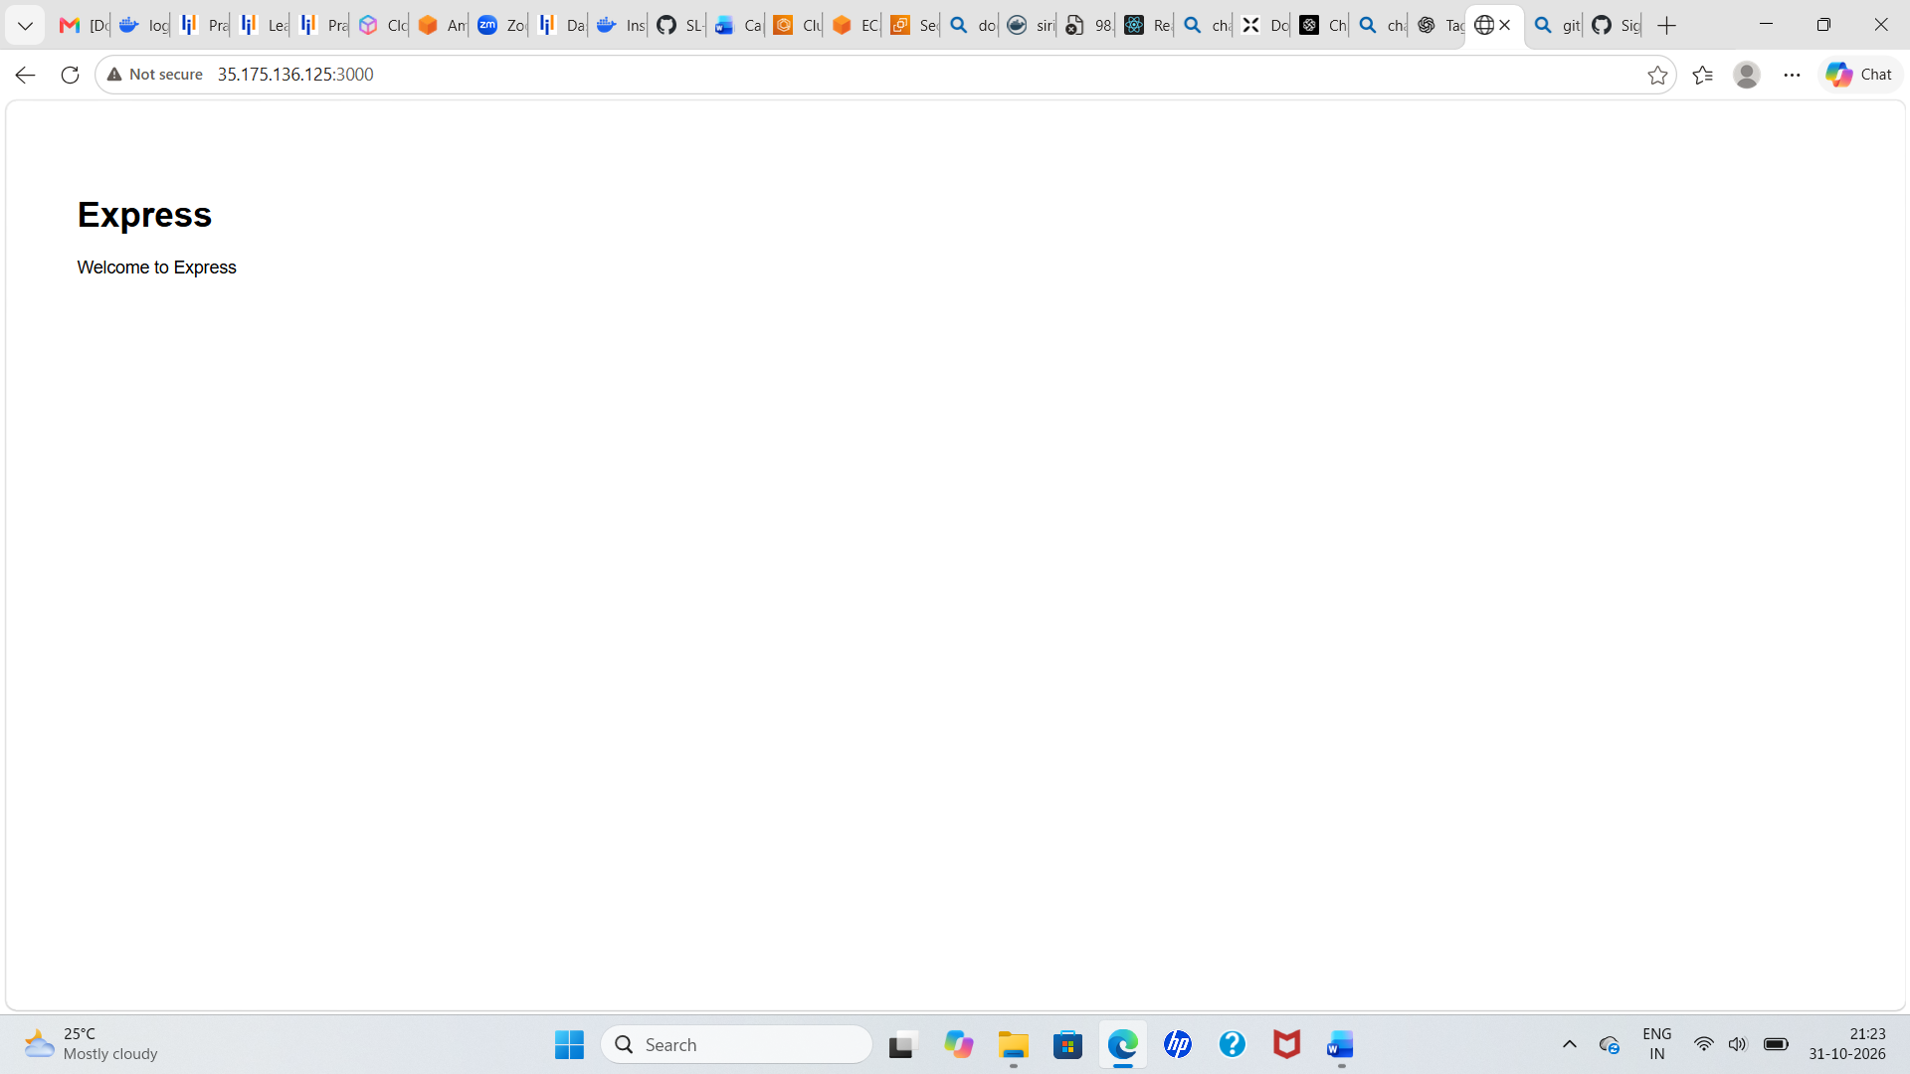
Original screenshot 15 of 15 — preserved unchanged
The browser displays an Express welcome page at a public IPv4 address using port 3000. This is evidence that an HTTP endpoint returned the Express default welcome response at the time of capture. It may be the backend/API service or a simple Express sample application; the screenshot alone does not establish the complete frontend/backend microservices integration.
What this proves Test the endpoint from a client that is allowed by the security group. For a production deployment, avoid exposing a raw EC2/task public IP directly; use a load balancer, HTTPS, health checks and restricted security-group rules.

5. Docker Hub workflow — command reference
Command | Purpose | Expected check
docker --version | Confirms Docker CLI is installed | Version string
sudo systemctl status docker | Checks Docker daemon | active (running)
git clone <URL> | Downloads source repository | New project directory
docker build -t <name>:<tag> . | Builds image from Dockerfile | Build completes successfully
docker images | Lists local images | Image name, tag and ID
docker tag <source> <target> | Adds another image reference | Both names share the same image ID
docker login --username siri3 | Authenticates to Docker Hub | Login Succeeded
docker push siri3/node_repo:latest | Uploads image layers and manifest | Digest and push completion

6. Amazon ECR — AWS-native image registry
Amazon ECR is a managed container image registry. ECS commonly pulls images from ECR because it integrates with AWS IAM and the task execution role. The supplied screenshots show Docker Hub push but do not show an ECR repository creation or a successful ECR push. The following is therefore an implementation extension to complete the ECR portion of the project title.

6.1 Create an ECR repository
In the AWS Console, open Amazon ECR in the same Region as your ECS cluster, choose Private repositories, and create a repository such as `microservices/node-image`. Keep image scanning enabled where available and choose an appropriate tag-mutability policy.
# Set your Region and AWS account ID
AWS_REGION=us-east-1
ACCOUNT_ID=$(aws sts get-caller-identity --query Account --output text)
ECR_REPO=microservices/node-image
# Create the private ECR repository (AWS CLI must be configured)
aws ecr create-repository \
--repository-name "$ECR_REPO" \
--region "$AWS_REGION" \
--image-scanning-configuration scanOnPush=true

6.2 Authenticate Docker to ECR
aws ecr get-login-password --region "$AWS_REGION" | \
docker login --username AWS --password-stdin \
"$ACCOUNT_ID.dkr.ecr.$AWS_REGION.amazonaws.com"
The AWS CLI obtains a short-lived ECR authorization password and passes it to Docker through standard input. This avoids putting the password directly in the command history. The EC2 instance needs an IAM role or AWS CLI credentials with the required ECR permissions.

6.3 Tag and push the image to ECR
ECR_URI="$ACCOUNT_ID.dkr.ecr.$AWS_REGION.amazonaws.com/$ECR_REPO"
# Tag the local image for the ECR destination
docker tag node-img:latest "$ECR_URI:v1"
# Push the image
docker push "$ECR_URI:v1"
# Verify the image exists in ECR
aws ecr describe-images \
--repository-name "$ECR_REPO" \
--region "$AWS_REGION"
If your local image is `react-img:latest`, use that as the source image in the `docker tag` command. ECS task definitions should reference the ECR image URI, preferably pinned to a version tag or immutable digest rather than an unchanging `latest` tag.

Docker Hub versus ECR
Topic | Docker Hub | Amazon ECR
Provider | Docker ecosystem registry | AWS managed registry
Image naming | username/repository:tag | account.dkr.ecr.region.amazonaws.com/repository:tag
Authentication | Docker Hub login/access token | AWS IAM + ECR authorization token
Best fit in this project | Demonstrated public image sharing | Recommended private registry for ECS deployment
Access control | Repository visibility and Docker Hub permissions | IAM policies and repository policies

7. Amazon ECS — task definition and service deployment

7.1 Understand the ECS building blocks
Component | Meaning | In this project
Cluster | Logical grouping for ECS services and tasks | Cluster named siri1 appears in console
Task definition | Versioned template describing one or more containers | node-image:1 is visible
Task | A running instance of a task definition | Task status is shown in service details
Service | Maintains a desired number of tasks and manages deployments | siri-service and node-image-service are visible
Capacity | Compute on which tasks run | Confirm EC2 or Fargate launch/capacity provider
Networking | Task ENI, subnet and security-group connectivity | Screenshot shows awsvpc network mode

7.2 Create or review the task definition
In the ECS console, open Task definitions and select the `node-image` family. Review the image URI, CPU/memory, task execution role, task role, operating system/architecture, network mode, container port and log configuration. If using ECR, the image field should point to the ECR URI, for example `<account-id>.dkr.ecr.<region>.amazonaws.com/microservices/node-image:v1`.
Port mapping check The application must listen on the same container port configured in the task definition. The final browser screenshot uses port 3000. If the Express application listens on 3000, configure the container port as 3000 and make the service/network path allow traffic to that port.

7.3 Create or update an ECS service
- Choose the target ECS cluster.
- Create a service from the correct task-definition family and revision.
- Choose the intended launch type/capacity provider (EC2 or Fargate) and compatible networking.
- Set desired task count. For a simple lab, one task is sufficient; production availability normally requires multiple tasks across Availability Zones.
- Select subnets and a security group that allows only required traffic.
- If using an Application Load Balancer, configure a target group and a health-check path that returns a successful response.
- Create the service and monitor the Events, Deployments and Tasks tabs until the desired task count is running and healthy.

7.4 Useful ECS CLI checks
# List clusters
aws ecs list-clusters --region "$AWS_REGION"
# List services in a cluster
aws ecs list-services --cluster siri1 --region "$AWS_REGION"
# Describe a service and its deployment state
aws ecs describe-services \
--cluster siri1 \
--services siri-service \
--region "$AWS_REGION"
# List tasks in the cluster
aws ecs list-tasks --cluster siri1 --region "$AWS_REGION"
# Describe a task (replace with the actual task ARN/ID)
aws ecs describe-tasks \
--cluster siri1 \
--tasks <TASK_ARN_OR_ID> \
--region "$AWS_REGION"
Use the exact cluster and service names shown in your own AWS account. The names in the screenshots are case-sensitive identifiers and may differ between lab sessions.

8. Validation checklist
- ☐ EC2 instance is in the intended Region and is Running.
- ☐ Docker CLI is installed and the Docker daemon is active.
- ☐ Git clone completed and the correct project directory contains the Dockerfile.
- ☐ Docker build completes successfully; the intended image appears in `docker images`.
- ☐ Docker Hub repository contains the expected tag and digest.
- ☐ If using ECR, `describe-images` returns the pushed tag/digest.
- ☐ ECS task definition points to the intended registry URI and correct image tag/digest.
- ☐ Task execution role can pull the image and write logs as required.
- ☐ ECS service desired count equals running healthy task count.
- ☐ Container port, task security group, subnet routing and load-balancer health checks are consistent.
- ☐ Application URL returns the expected response; frontend and backend endpoints are tested separately if they are separate services.

9. Troubleshooting guide
Symptom | Likely cause | What to check / fix
docker: command not found | Docker Engine/CLI not installed or PATH issue | Install Docker; verify `docker --version`; check package installation.
Cannot connect to Docker daemon | Service stopped or user lacks socket permission | `sudo systemctl enable --now docker`; use `sudo docker`; review docker-group security.
Docker build cannot find Dockerfile | Wrong working directory or Dockerfile name/path | Run `pwd`, `ls -la`, and build from the directory containing Dockerfile.
npm install/build fails | Network, package-lock, Node version or dependency issue | Review full BuildKit error; check Dockerfile and package files; rebuild after fixing root cause.
Docker Hub denied / unauthorized | Wrong username, token, repository name or permissions | Run `docker login`; verify `siri3/node_repo`; use a Docker Hub access token if required.
Image tag not found locally | Tag command uses a name that does not exist | Run `docker images`; use the exact source image name and tag.
ECR push denied | Missing IAM permissions or wrong Region/account URI | Check `get-caller-identity`, Region, repository URI and ECR push permissions.
ECS task stops immediately | Bad image, app crash, missing env var, wrong command/port | Inspect stopped reason, container exit code, CloudWatch logs and task definition.
ECS task remains PENDING | Insufficient capacity, subnet/IP shortage, image pull or placement issue | Review ECS service events, capacity provider, subnet IP availability and IAM/image access.
Service shows 0/1 running | Task failing health checks or failing to start | Open service Events and Tasks; inspect stopped-task reason and container logs.
Browser times out | Security group, route, listener, port mapping or app bind issue | Check inbound rule, route table, public IP/load balancer, container port and app listening address.
React HTML appears as raw text | Incorrect path/content type/server/static asset handling | Check browser URL, server configuration, built static assets and browser developer console.

10. Security, reliability and cost considerations
- Do not allow all traffic from 0.0.0.0/0. Open only required ports and restrict administrative access to trusted IP ranges.
- Prefer IAM instance profiles and ECS task execution roles over long-lived AWS access keys on EC2.
- Use private ECR repositories for internal application images; enable image scanning and lifecycle policies.
- Store application secrets in AWS Secrets Manager or Systems Manager Parameter Store and inject them securely. Do not bake secrets into Docker images.
- Use HTTPS through an Application Load Balancer and AWS Certificate Manager for production traffic.
- Send container logs to CloudWatch Logs and configure log retention, metrics and alarms.
- Use multiple Availability Zones and health checks for resilient production services.
- Right-size EC2/Fargate CPU and memory, review CloudWatch utilization and Cost Explorer, and delete unused lab resources.

11. CI/CD with AWS CodePipeline — recommended next stage
The project title/summary mentions CI/CD, but the supplied screenshots do not show a CodePipeline pipeline execution or CodeBuild build logs. Therefore, this section describes how to extend the demonstrated manual workflow into automated CI/CD; it should only be marked completed after the pipeline is actually configured and tested.
Developer pushes code to GitHub
|
v
AWS CodePipeline
|
v
AWS CodeBuild
- install dependencies
- run tests
- build Docker image
- tag image with commit/version
- push image to Amazon ECR
|
v
ECS deployment action
- update task definition image URI
- deploy new task definition revision
|
v
Amazon ECS service
- rolling deployment
- health checks
- rollback if configured
A robust pipeline should use a unique image tag such as the Git commit SHA, not only `latest`. The deployment stage should update the ECS task definition to reference the exact image that was built. Configure IAM roles with least privilege, keep secrets out of source code, and add automated tests before deployment.

12. GitHub repository structure
A clear repository makes the project understandable to reviewers and makes it easier to reproduce. Keep the guide, source code and deployment configuration organized. Do not commit AWS credentials, Docker Hub tokens, `.env` files containing secrets, private keys, or unredacted sensitive screenshots.
aws-microservices-docker-ecs/
|
|-- README.md
|-- docs/
| |-- AWS_Microservices_DockerHub_ECR_ECS_Implementation_Guide.docx
| |-- architecture.png
| |-- screenshots/
| |-- (optional: only approved, reviewed screenshots)
|
|-- frontend/
| |-- Dockerfile
| |-- package.json
| |-- src/
|
|-- backend/
| |-- Dockerfile
| |-- package.json
| |-- src/
|
|-- infrastructure/
| |-- ecs-task-definition.json
| |-- buildspec.yml
| |-- pipeline-notes.md
|
|-- .gitignore

Suggested .gitignore
.env
.env.*
!.env.example
*.pem
*.key
.aws/
node_modules/
build/
dist/
.DS_Store

12.1 Publish the guide to GitHub
After creating or cloning your project repository on your workstation, copy the final guide into the `docs/` folder and the README into the repository root. Then commit and push:
git status
git add README.md docs/AWS_Microservices_DockerHub_ECR_ECS_Implementation_Guide.docx
git commit -m "Add detailed AWS microservices deployment guide"
git push origin main
If your default branch is not `main`, use the branch name shown by `git branch --show-current`. Review the staged files before committing with `git status` and `git diff --cached --stat`.

13. Glossary
Term | Plain-English meaning
EC2 | Virtual server in AWS.
VPC | Private, logically isolated network in AWS.
Security group | Stateful virtual firewall controlling inbound and outbound traffic.
Git | Version-control tool used to track source-code changes.
Dockerfile | Instructions used to build a Docker image.
Image | Packaged application filesystem, runtime and metadata used to create containers.
Container | An isolated running process created from an image.
Registry | A service that stores and distributes container images.
Tag | A human-readable label pointing to an image version.
Digest | Content-addressed identifier for an image manifest.
Docker Hub | Hosted container registry from Docker.
ECR | AWS-managed container image registry.
ECS | AWS container orchestration service.
Cluster | Logical grouping in which ECS services and tasks are managed.
Task definition | Versioned blueprint describing containers and runtime settings.
Task | Running instance of an ECS task definition.
Service | ECS controller that maintains a desired number of tasks.
Task execution role | IAM role used by ECS infrastructure for image pulls and log delivery.
Task role | IAM role credentials available to application code in the container.
CI/CD | Automated integration, testing, packaging and deployment workflow.

14. How to explain this project in an interview
60–90 second project explanation I worked on containerizing an application and deploying it on AWS. I connected to an Ubuntu EC2 environment, cloned the application source from GitHub, prepared Docker, and built a container image using the application's Dockerfile. I inspected the local image, tagged it with the Docker Hub repository name and pushed it to Docker Hub. On the AWS side, I worked with ECS concepts including a cluster, task definition and service. The task definition specifies the container image and runtime configuration, while the ECS service maintains the desired number of running tasks. I verified the deployment state in the ECS console and tested an application endpoint in the browser. For an AWS-native production flow, I would store the versioned image in ECR and automate build and deployment using CodeBuild and CodePipeline.

Questions you should be ready to answer
- Why do we build a Docker image instead of copying source code directly to the server?
- What is the difference between an image and a container?
- What does the dot (`.`) mean in `docker build -t app .`?
- What is the difference between `docker tag` and `docker push`?
- Why use ECR when Docker Hub is available?
- What is the difference between an ECS cluster, task definition, task and service?
- What is the purpose of the ECS task execution role?
- What does desired count 1/1 mean, and why is it not sufficient by itself to prove application health?
- What is `awsvpc` network mode?
- How would you troubleshoot a task that keeps stopping?
- How would you secure the application endpoint and the EC2/ECS environment?
- How would you convert this manual workflow into CI/CD?

15. Final completion status based on the supplied screenshots
Project activity | Evidence in supplied file | Status interpretation
EC2 instance setup/access | Screenshot 1 | Visible; instance shown Running
Security-group inbound configuration | Screenshot 2 | Visible; rule is overly permissive and should be tightened
Docker repository/package preparation | Screenshots 3–4 | Visible; Docker command initially unavailable
GitHub source clone | Screenshot 5 | Visible; clone completed
Docker image build | Screenshot 6 | Build command and progress visible; verify final image on target host
Docker image listing/tagging | Screenshot 7 | Visible; naming context differs from later push
Docker Hub push to siri3/node_repo | Screenshot 11 | Visible; push digest shown
ECS cluster/service setup | Screenshots 8–9, 13–14 | Visible; service/task states differ; inspect each service
ECS task definition | Screenshot 12 | Visible; node-image:1 created
Application endpoint test | Screenshot 15 | Express welcome page visible on port 3000
ECR repository/image push | Not shown | Not evidenced in supplied screenshots; follow Section 6
AWS CodePipeline automated deployment | Not shown | Not evidenced in supplied screenshots; follow Section 11

Final note This guide deliberately separates what the screenshots demonstrate from the additional ECR and CodePipeline steps needed to complete the broader project scope. That distinction makes the document technically honest and stronger in interviews and GitHub review.

