Unless a rectangle is drawn from the upper left corner to the lower right corner, the drawing process is not displayed in other directions.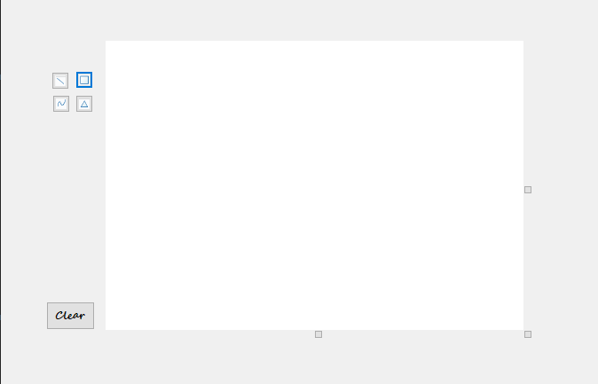

After clicking clear screen, there is no process to draw any graphics.
