MODEL QUESTION PAPER 2RLVSE06
USN | 1 | S | I |  |  |  |  |  |  |  | 

Siddaganga Institute of Technology, Tumakuru – 572 103
(An Autonomous Institute affiliated to Visvesvaraya Technological University, Belagavi, Approved by AICTE, New Delhi)

2nd Semester M.Tech (VLSI Design and Embedded Systems)
Electronics and Instrumentation Engineering Examinations 2020

VLSI Testing & Verification
Time: 03:00 Hours | Max. Marks: 100

Note | : | 1. | Answer any five questions choosing one full question from each unit.

 |  | Unit - I | Marks | BL | CO

1 | a) | Explain VLSI technology trends affecting testing. | 8 | 2 | 1
 | b) | Explain fault equivalence of 2 input AND and OR gate for stuck at 0 and  Stuck at 1 fault at the output respectively. | 6 | 3 | 1
 | c | Explain concurrent and parallel fault simulation. | 6 | 2 | 1

2 | a) | What is philosophy behind testing? Explain by taking analogy of student test. | 8 | 2 | 1
 | b) | Differentiate and explain naïve and realistic analog and digital VLSI testing using flowcharts. | 8 | 2 | 1
 | c) | What is fault dominance? Explain with an example | 4 | 2 | 1

 |  | Unit - II | Marks | BL | CO

3 | a) | Find the test to determine the S-A-1 fault at node h in the Fig.3(a) using truth table method.  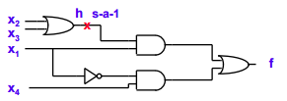  Fig.3(a) | 8 | 4 | 2
 | b) | What are bound lines and headlines? Give example. | 4 | 2 | 2
 | c) | Find suitable test vector to detect α s-a-1 in Fig.3(b) using PODEM method.  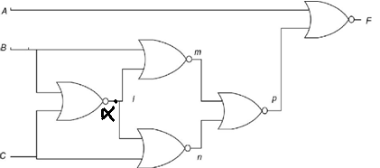  Fig.3(b) | 8 | 4 | 2

4 | a) | Determine the test to detect line b s-a-0 in Fig 4(a) using Boolean difference method .  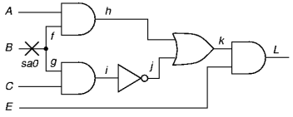  Fig 4(a) | 8 | 4 | 2
 | b) | Mention the basic steps involved in implementing D-algorithm. Find suitable test vector for SA-1 at α in Fig. 4(b) using D-algorithm.  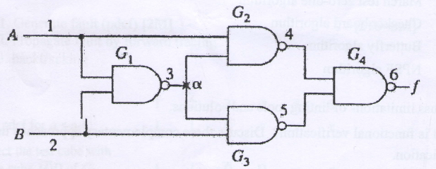  Fig. 4(b) | 8 | 4 | 2
 | c) | Write the difference between FAN and PODEM methods. | 4 | 2 | 2

 |  | Unit - III | Marks | BL | CO

5 | a) | Define terms controllability and observability. Explain non scan path technique for testable sequential circuits using multiplexer. | 10M | 2 | 3
 | b) | With suitable diagrams explain Full scan LSSD and partial scan LSSD. | 10M | 2 | 3

6 | a) | How are DFT techniques categorized? Explain any 4 Ad hoc techniques. | 10M | 2 | 3
 | b) | Explain scan path technique for testable sequential circuits with one example. | 10M | 2 | 3

 |  |  | Unit - IV |  | Marks |  | BL | CO
7 |  | a) |  | With neat block diagram, explain how a boundary scan register can be used  for Testing Chips. |  | 6 | 2 | 4
 |  | b) |  | Design a LFSR for polynomial P(x) =1+x+x⁴.Generate maximal length pseudorandom pattern assuming initial seed value for LFSR as 1111. |  | 8 | 4 | 4
 |  | c) |  | Calculate syndrome count for circuit diagram shown in Fig 7(c).  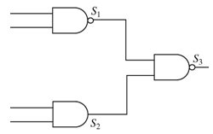  Fig 7(c) |  | 6 | 4 | 4

8 | a) | With relevant diagram, explain BIST for embedded RAM. | 8 | 2 | 4
 | b) | Explain logic diagram of BILBO with different modes of operation. | 8 | 3 | 4
 | c) | Explain BILBO based BIST architecture. | 4 | 2 | 4

 |  | Unit - V | Marks | BL | CO

9 | a) | Compare Event based simulation and cycle based simulation. | 8 | 2 | 5
 | b) | What is linting tool? Discuss limitations of linting tools and solutions. | 6 | 2 | 5
 | c) | Explain reconvergence model for verification | 6 | 2 | 5

10 | a) | Compare ASIC and FPGA verification | 6 | 2 | 5
 | b) | What is functional verification? Discuss three complementary approaches used for functional verification. | 6 | 2 | 5
 | c) | What is simulator explain different types of simulators. | 8 | 2 | 5
________

