**Report (Mates Con)**

(it is a MERN STACK social media website where you can connect with others post images,video,ask quetion,give answers,follow other, chat with others and much more.)

**Here are some of the screen shots**

1. **Home page**

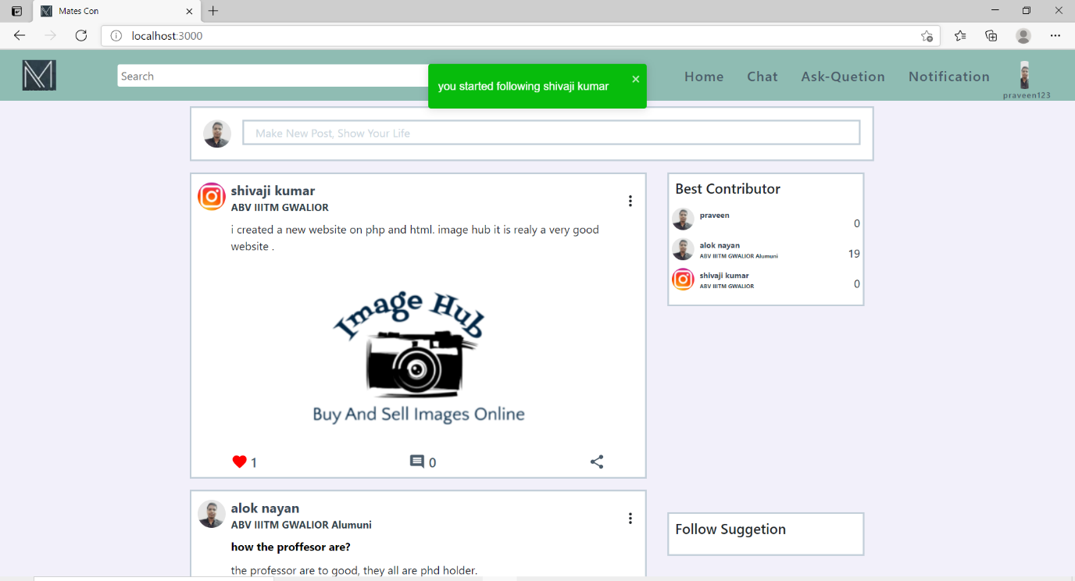

This is the home page of our website. From here you can see feed (others post and answer which are relevant for you). From here you can see the top contributors of our website and suggestion to follow.

1. **Question – answer**

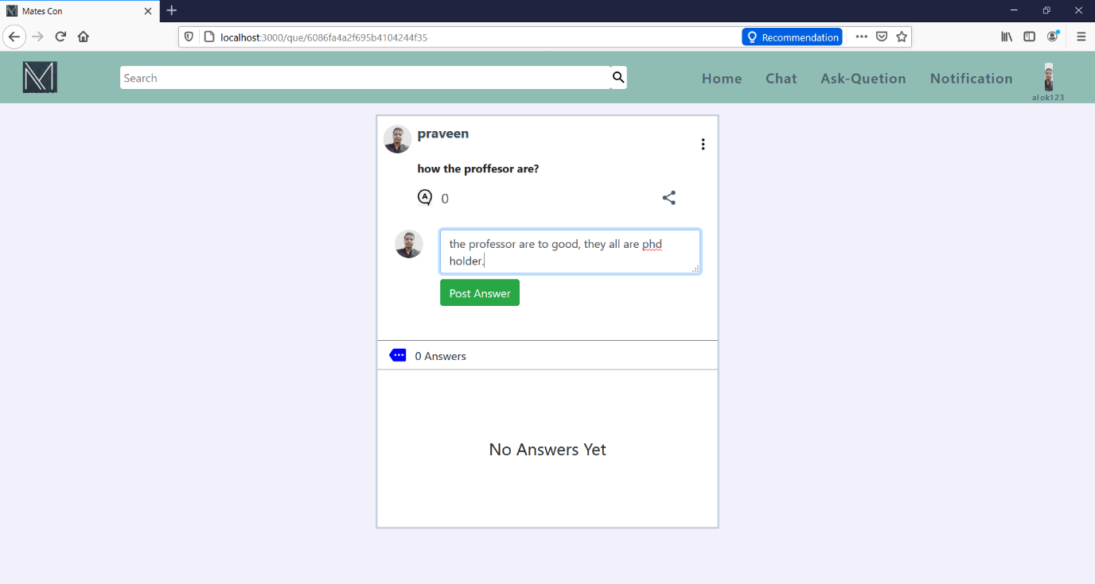

This is the palace where you can answer the que which are asked by other users and maybe you know the correct ans.

1. **Ask Question**

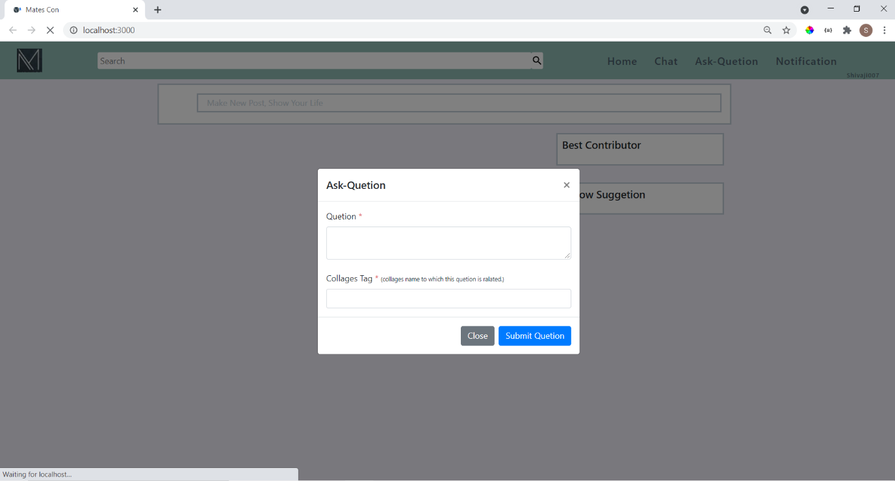

Add your question to matescon and matescon will suggest this question to them who are releated to the tag presented in your question, and try to find most appropriate answer for you.

1. **Post image**

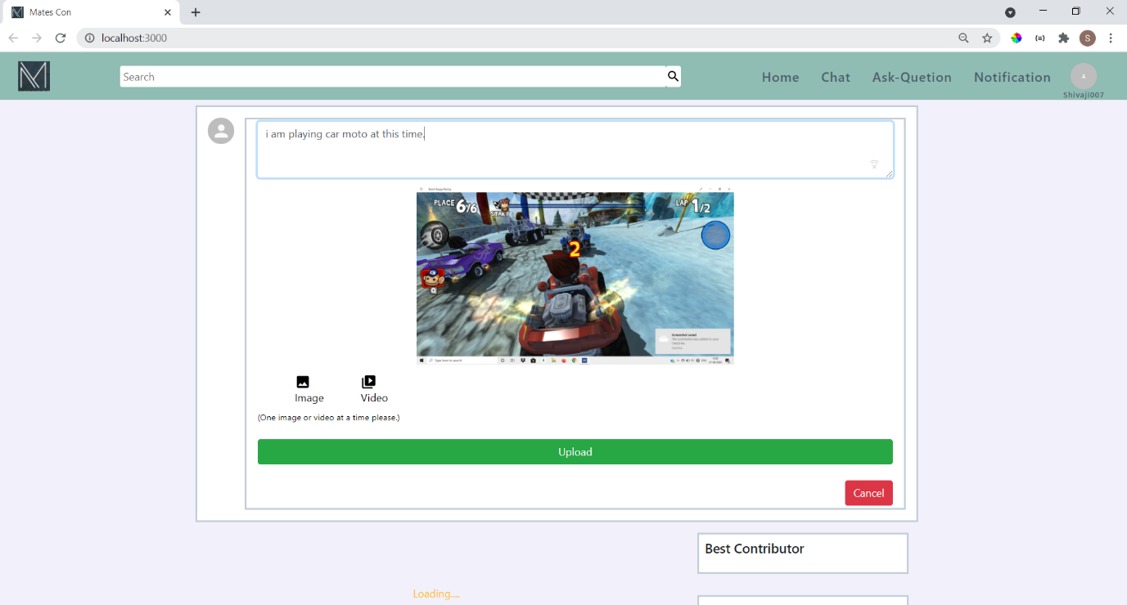

Here you can post and show your life to others.

1. **Like and comment on the post and answers**

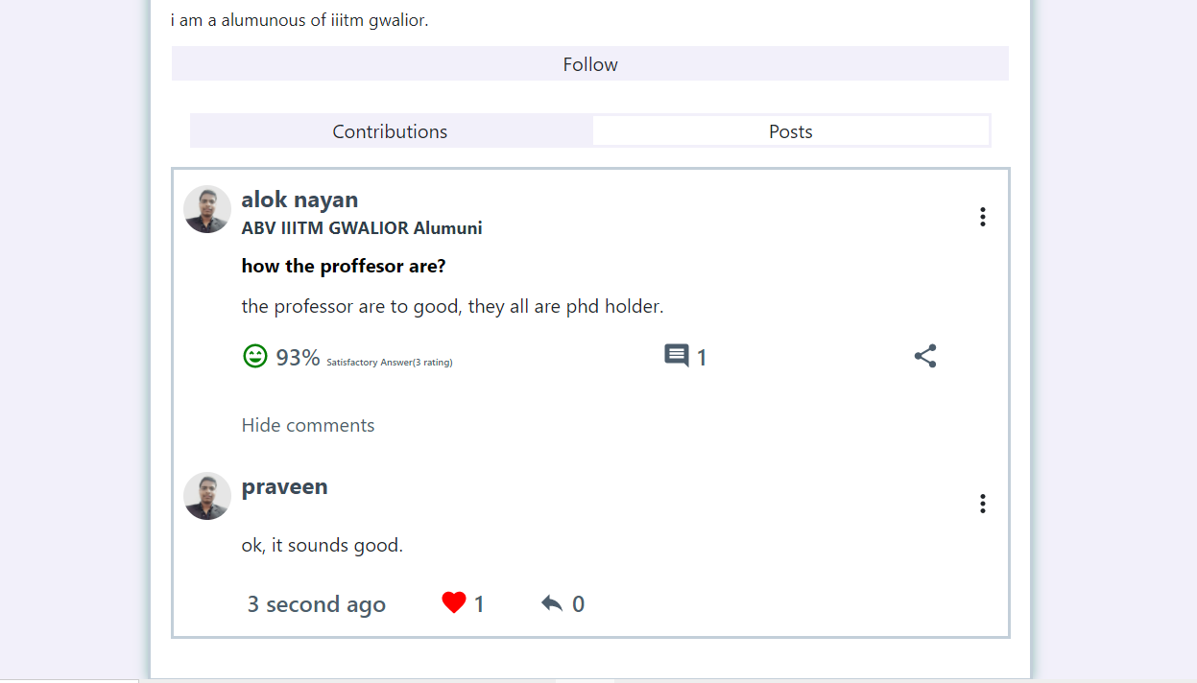

you can like or comment on the post and also rate the answer based on your satisfaction.

1. **Chat with others**

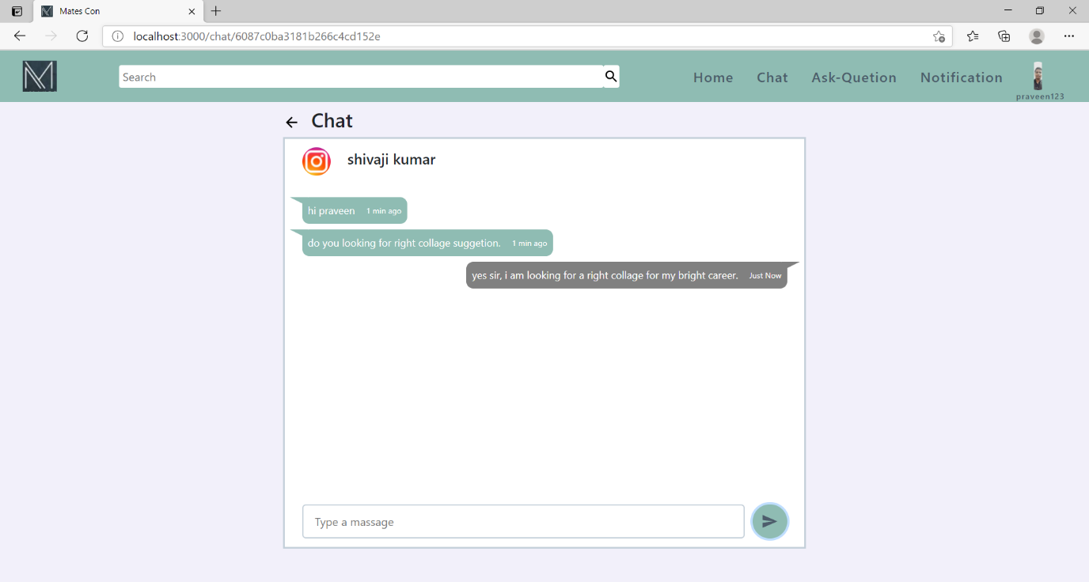

here you can chat with the fellow matescon members whom you are following.