UNIT-2

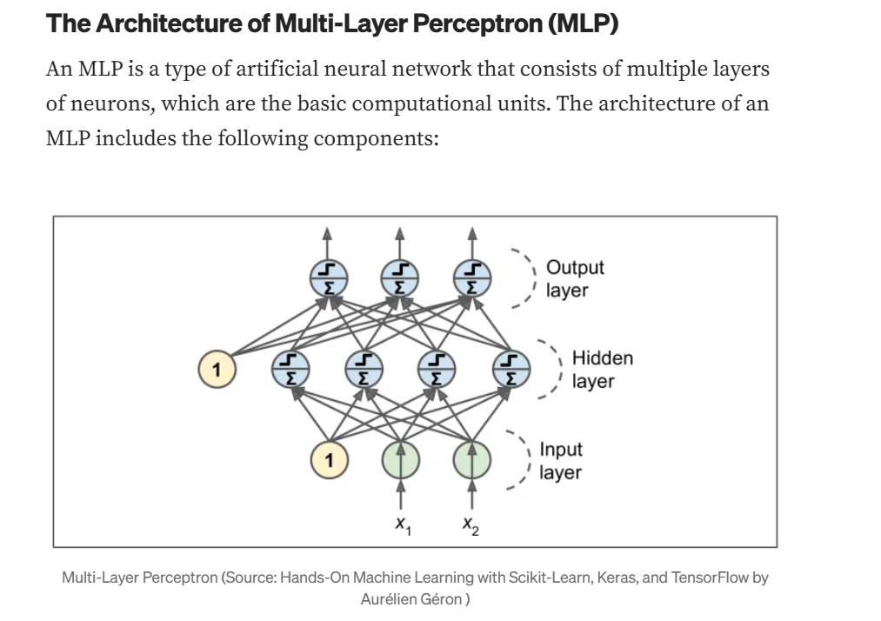16.Explain in detail the architecture of a Multi-layer Perceptron (MLP). Discuss how the forward and backward passes work, including the role of weights, biases, and activation functions. Provide an example to illustrate the entire process.

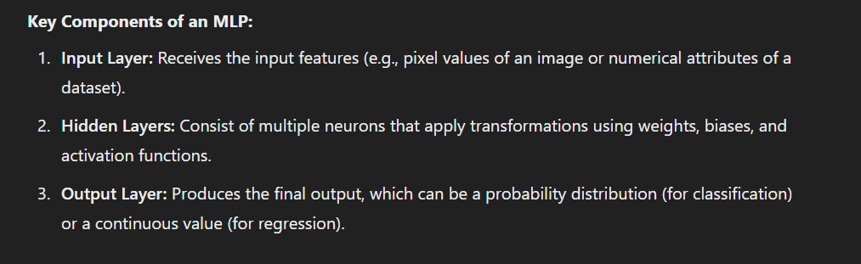

**Forward Pass in an MLP**

The forward pass is the process where input data propagates through the network layer by layer to generate the output.

**Steps in the Forward Pass:**

**1.Initialize Inputs**: Assume an input vector X=[x1,x2,...,xn]X = [x_1, x_2, ..., x_n]X=[x1​,x2​,...,xn​].

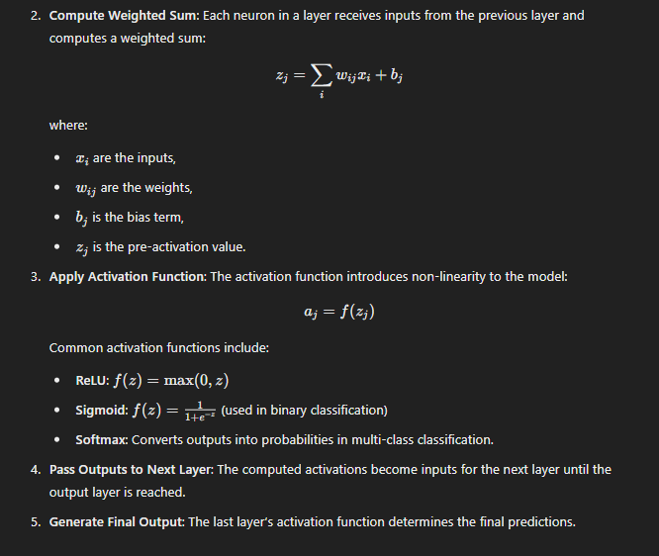

**Backward Pass (Backpropagation)**

Backpropagation is used to update the weights and biases based on the loss function to minimize prediction error.

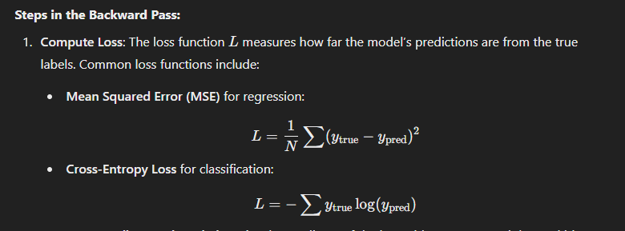’

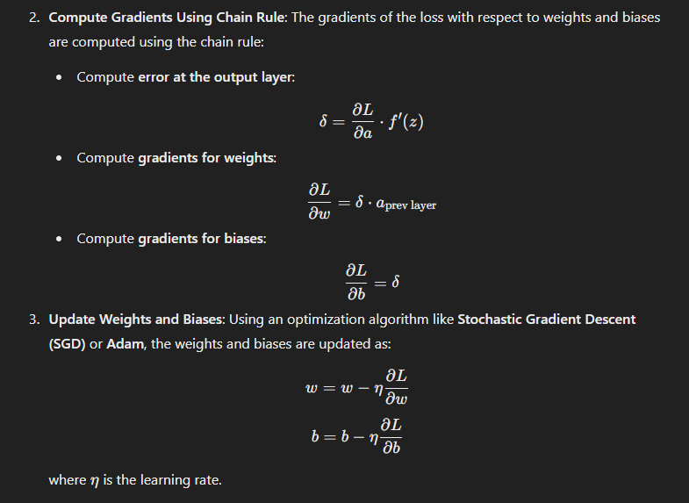

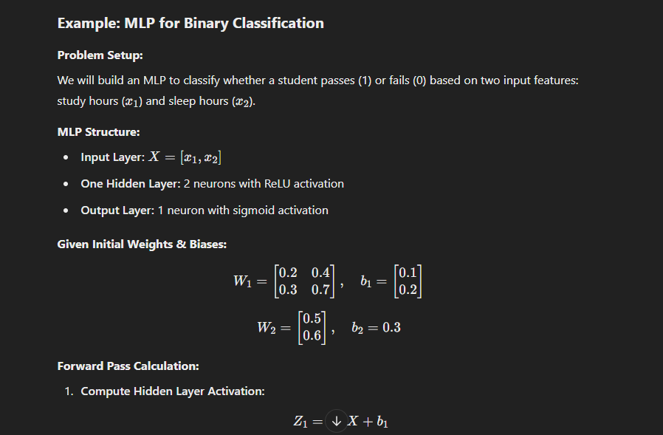

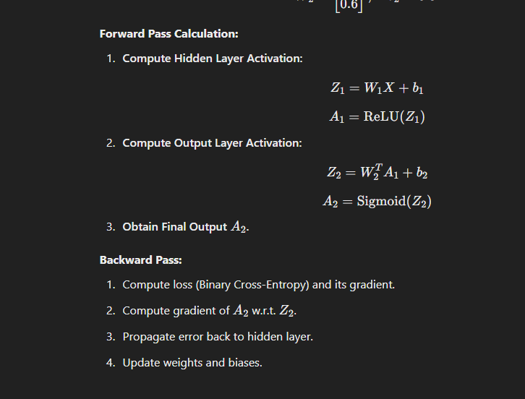``

1. Provide a comprehensive overview of Support Vector Machines (SVM). Discuss the mathematical formulation of SVMs, the concept of the hyperplane, margin maximization, and how SVMs handle non-linearly separable data. Include examples to illustrate your points.

Support Vector Machines (SVMs) are a class of supervised learning algorithms used for classification and regression tasks. SVMs are particularly powerful for **binary classification**, where they find the optimal hyperplane that best separates data points belonging to different classes.

### ****Key Features of SVMs****

✅ **Effective for high-dimensional data**  
✅ **Robust to overfitting (with proper regularization)**  
✅ **Works well with both linear and non-linear classification problems**  
✅ **Uses the kernel trick to handle non-linearly separable data**

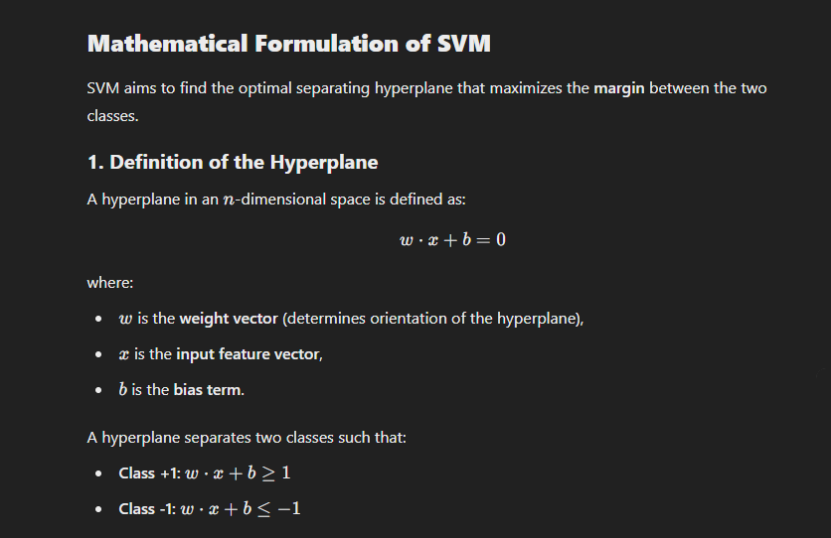

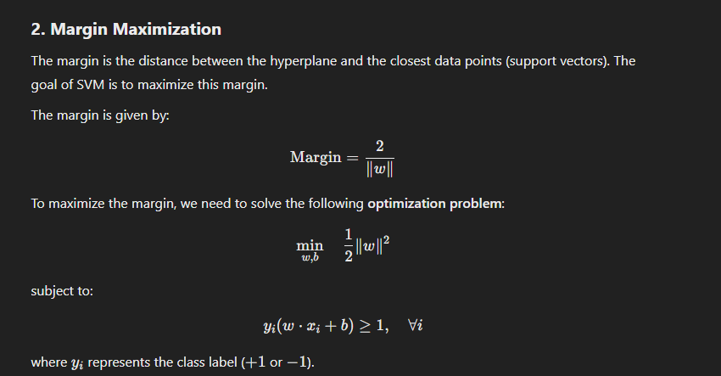

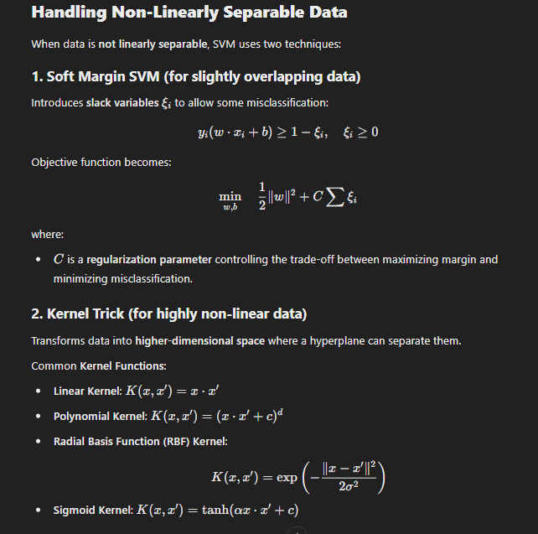Hubcb

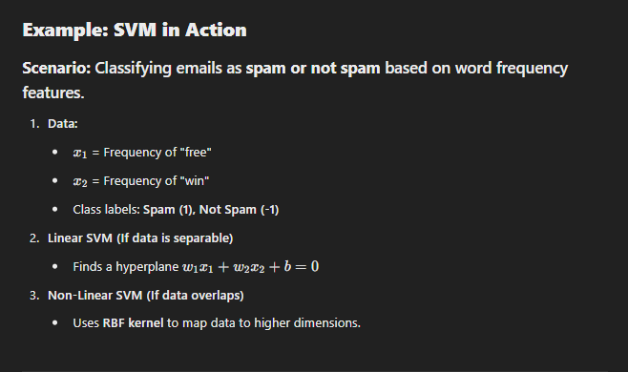

UNIT-1

1. Construct the linear Regression algorithm

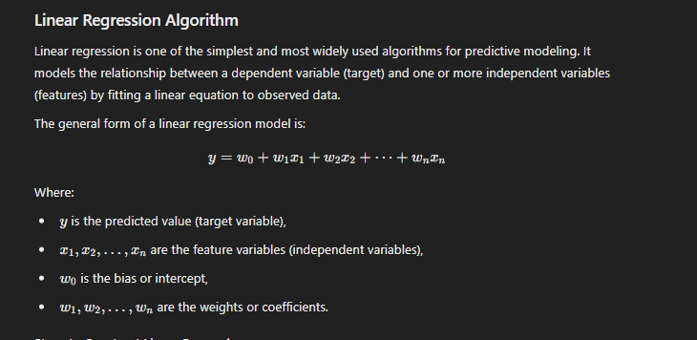

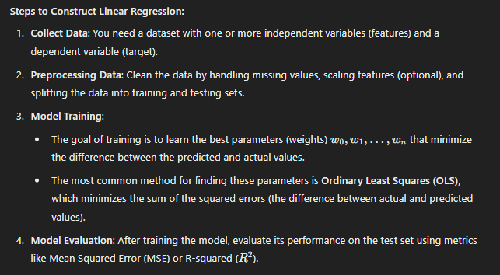

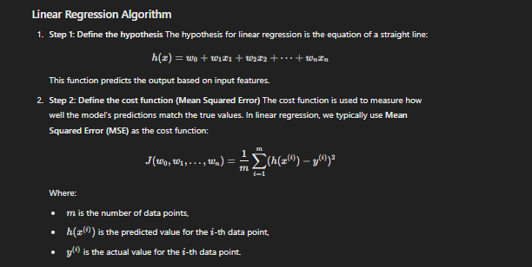

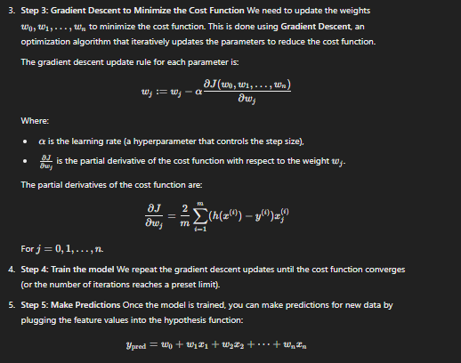

UNIT-3

Explain the role of entropy and information gain in constructing decision trees. How do these measures influence the splitting of nodes during the treebuilding process.

Decision trees are a popular supervised learning algorithm used for classification and regression. The effectiveness of a decision tree depends on how it **splits** nodes during construction. **Entropy** and **Information Gain** are two key metrics that guide this process.

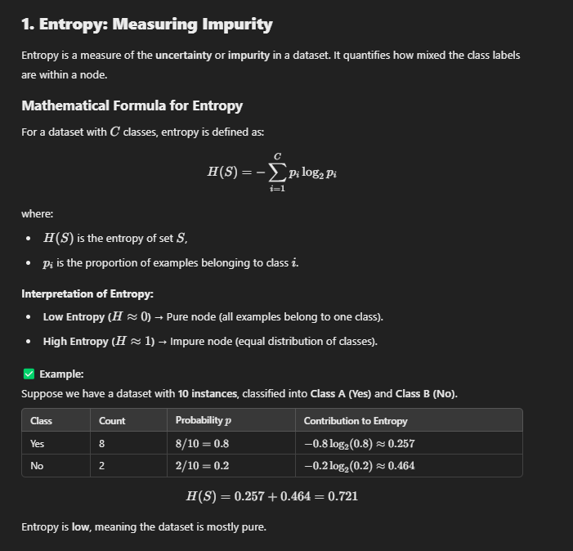

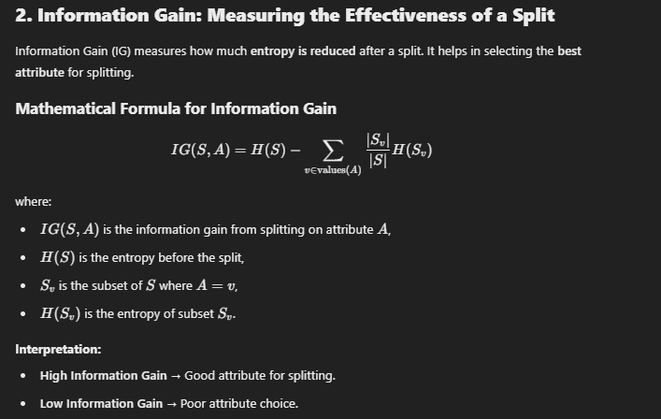

## ****How These Measures Influence Node Splitting****

1. **Calculate entropy of the current node** (before the split).
2. **For each attribute**, calculate entropy after the split.
3. **Compute information gain** for each attribute.
4. **Choose the attribute with the highest information gain** as the split.
5. **Repeat the process recursively** for each branch.