Short Ans;

**1. Define the Market (2M)**  
A **market** is a place, physical or virtual, where buyers and sellers interact to trade goods and services.  
It can include local markets, online platforms, and even international trade zones.

**2. What is the Meaning of Pricing? (2M)**  
**Pricing** is the process of setting a monetary value for a product or service offered to customers.  
It impacts sales volume, profit margins, competition, and market demand.

**3.Explain the Breakeven Point. (2M)**  
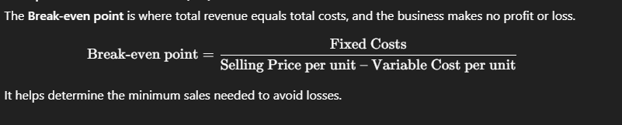

**4. What is Accounting? (2M)**  
**Accounting** is the process of systematically recording, classifying, summarizing, and interpreting financial transactions.  
It helps businesses track income, expenses, and financial health for decision-making.

**5. What is the Rule of Double Entry System? (2M)**  
The **double entry system** states that every transaction has two sides: **a debit and a credit** of equal value.  
This ensures the accounting equation always remains balanced.

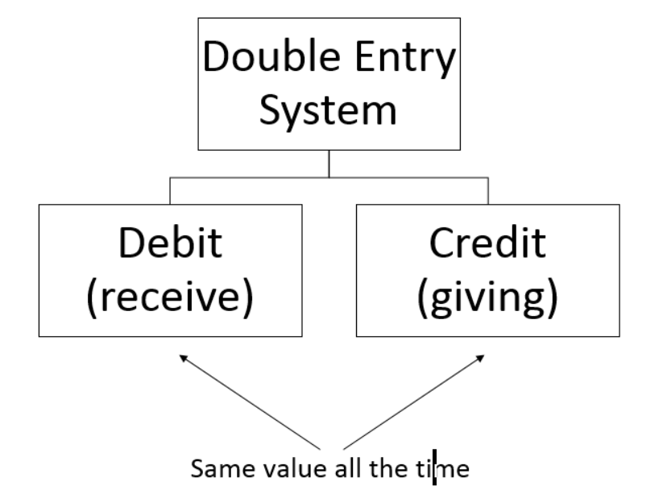

**6. Write About Any Three Accounting Concepts. (2M)**

1. **Going Concern Concept**: Business will operate in the foreseeable future.
2. **Accrual Concept**: Transactions are recorded when they occur, not when cash is exchanged.
3. **Money Measurement Concept**: Only transactions measurable in money are recorded.

These concepts form the foundation for proper accounting practices.

**7. What is the Meaning of Dual Entry System? (2M)**

The **Dual Entry System** in accounting means that **every financial transaction is recorded in two accounts** – once as a **debit** and once as a **credit**, with equal amounts. This system ensures the **accounting equation** (Assets = Liabilities + Equity) always stays balanced.

**Example**: If a business buys goods for cash, the inventory account is debited and the cash account is credited.

**8. Draw the Proforma of Ledger.**

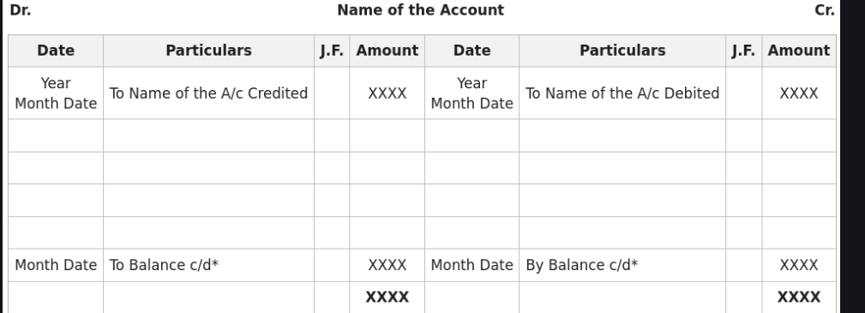

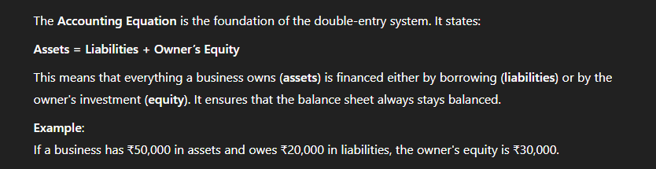**9.** **Explain Accounting Equation. (2M)**

**10. Explain the Meaning of Ratio. (2M)**  
A **ratio** in accounting and finance is a **mathematical comparison between two related financial figures**, usually expressed as a proportion, percentage, or fraction. It helps in analyzing the financial performance, efficiency, and health of a business.

**Example**:  
If a company’s net profit is ₹20,000 and its sales are ₹1,00,000, the **Net Profit Ratio** is:  
**Net Profit Ratio = (Net Profit / Sales) × 100 = (20,000 / 1,00,000) × 100 = 20%**

**11. Write the Formula for Gross Profit Ratio. (2M)**



This ratio measures how efficiently a company produces and sells goods above their cost.

**12. What is the Formula for Current Ratio? (2M)**



It checks the firm’s short-term financial strength — whether it can pay off its short-term obligations.

**13. Write the Formula of Quick Ratio. (2M)**

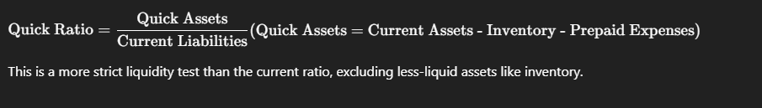This is a more strict liquidity test than the current ratio, excluding less-liquid assets like inventory.

**14. Explain Any Three Limitations of Ratios. (2M)**

1. **Historical in nature** – They are based on past data, not future potential.
2. **Ignores qualitative aspects** like brand value or customer satisfaction.
3. **Accounting differences** – Companies using different methods may show distorted ratios.

Hence, ratios need to be interpreted with caution.

**15. Write the Uses of Ratio Analysis. (2M)**

* Helps analyze **financial health** and performance.
* Assists management and investors in **decision-making**.
* Enables **trend analysis** and **comparison with competitors**.
* Assesses **liquidity, solvency, profitability, and efficiency** of a business

Unit-4

31.

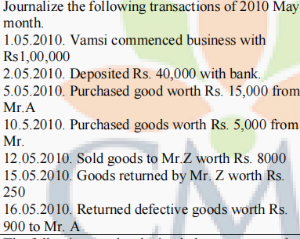

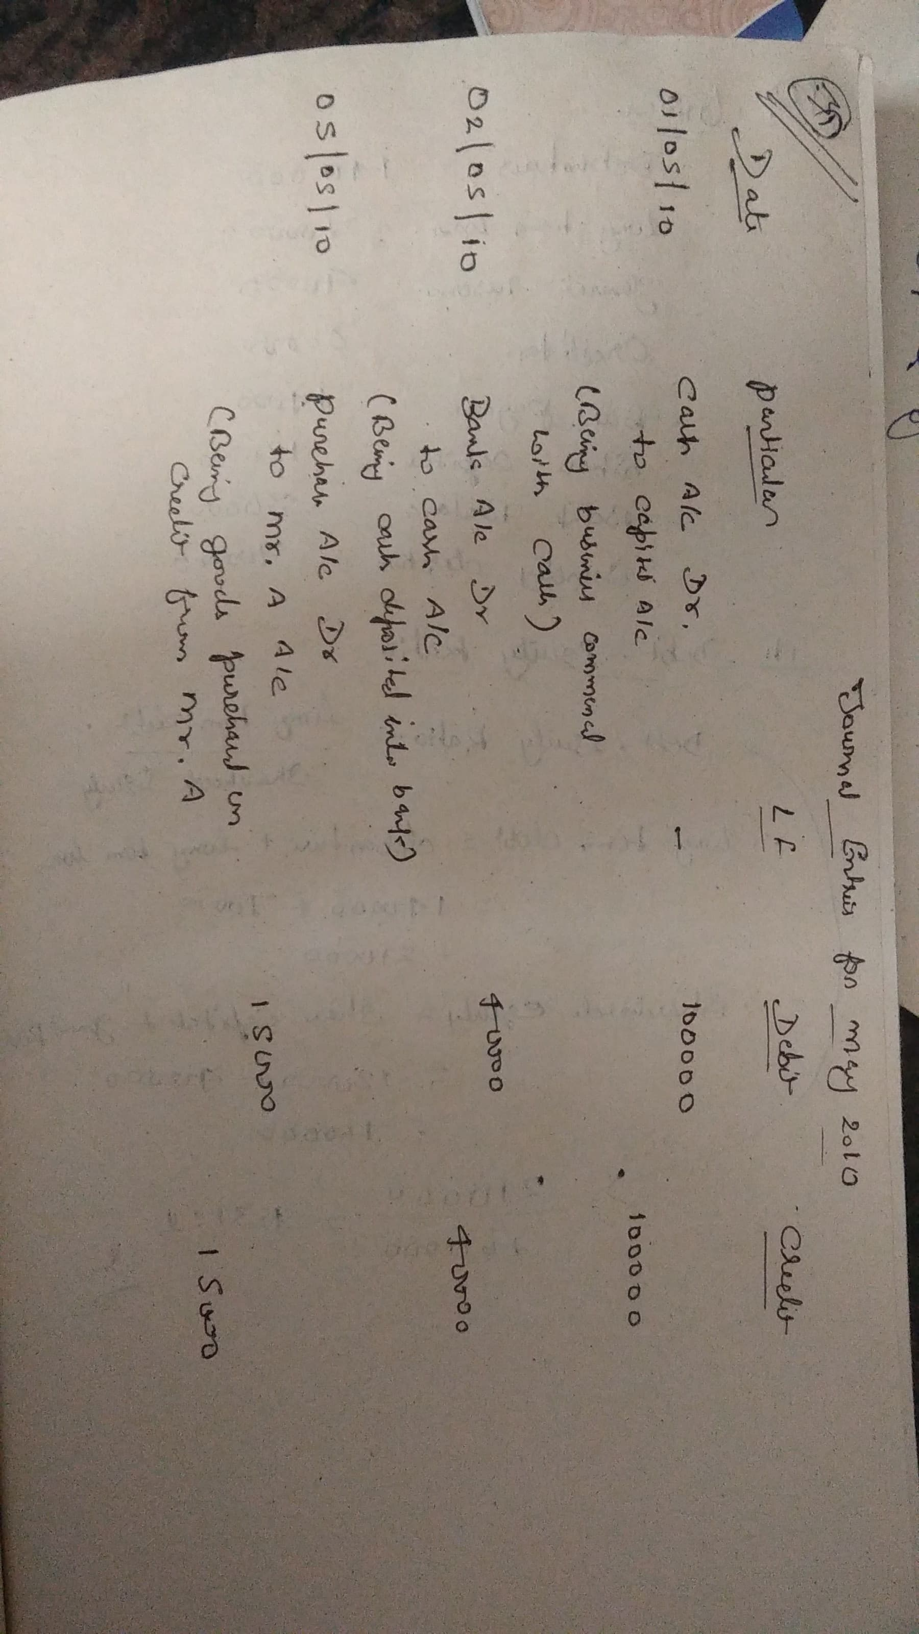

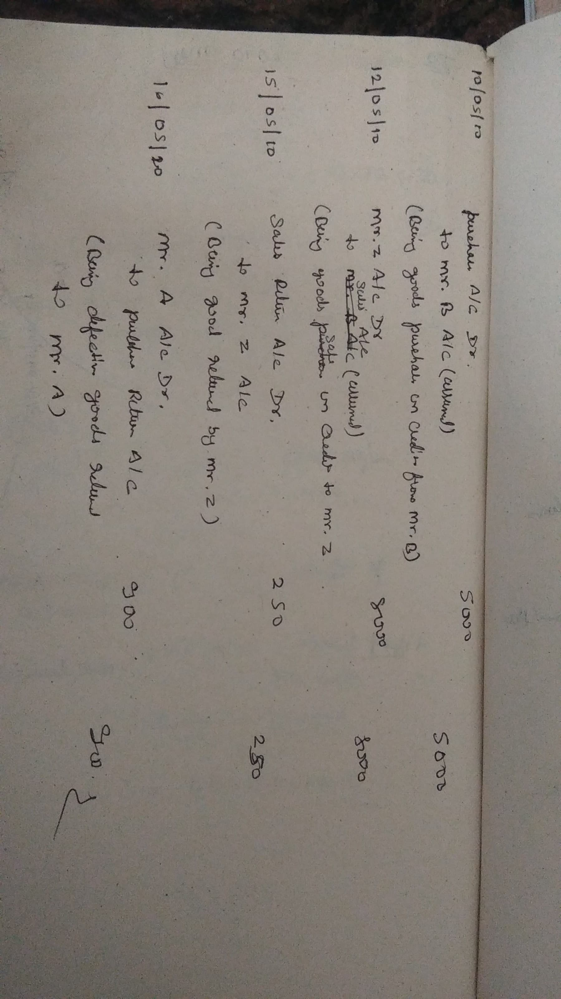

32. The following are the closing balances extracted from the books of Bhargav for the year ending 31st December 2004 with the help of which prepare Trading Account, Profit and Loss A/c and Balance Sheet. Debit balances Rs. Credit Balances Rs. Opening stock 6,050 Sales 13,720 Purchases 9,030 Purchases returns 130 Carriage 220 Capital 3,000 Drawings 450 Creditors 4,500 Investments 3,800 Discounts received 350 Debtors 2,500 Mortgage loan 4,000 8M L4 CO4 UNIT-IV Cash 1,350 Printing charges 1,200 Wages 1,100 25,700 25,700 ADJUSTMENTS (a) Closing stock was valued at Rs.16,000 (b) Wages outstanding by Rs.900 (c) Outstanding discounts receivable Rs.150 (d) Write off bad debts Rs. 500 (e) Prepaid printing charges Rs. 500.

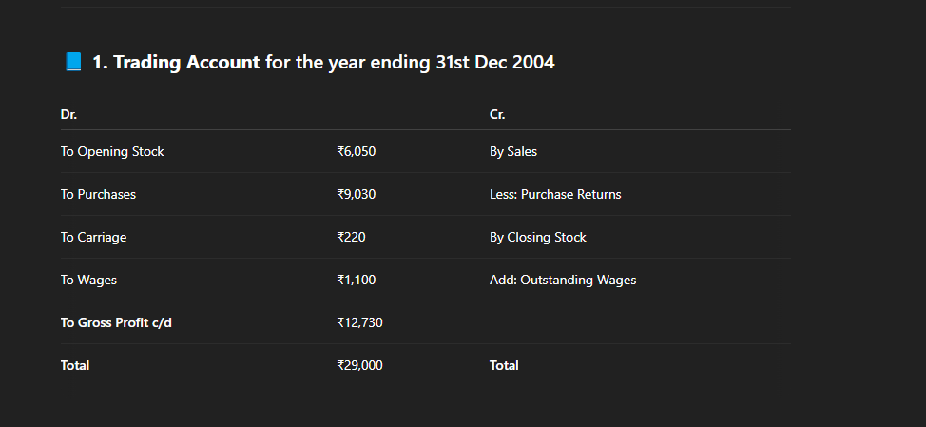

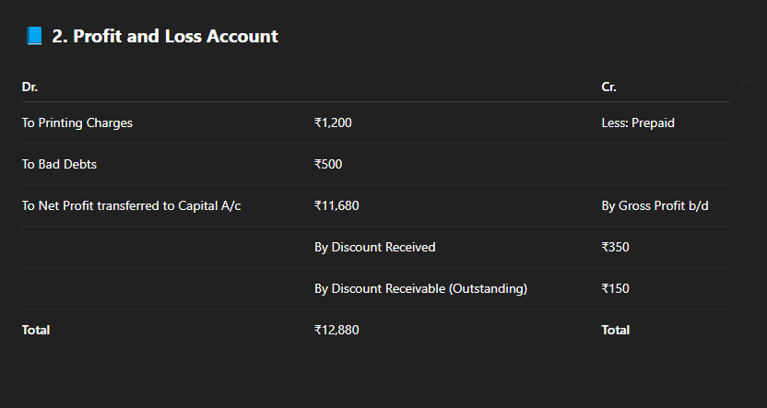

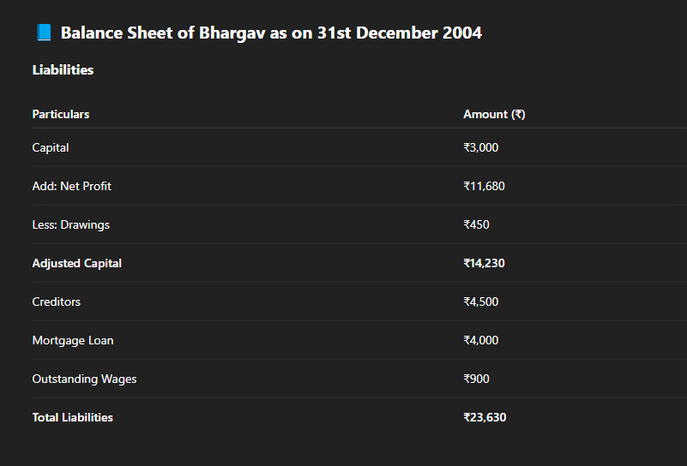

**33. Define double entry system. Explain the rules of double entry system while converting business transaction in to journal entry.**

**Definition of Double Entry System:**

The **Double Entry System** is an accounting system where every business transaction is recorded in at least two accounts — **one account is debited, and another is credited** — with **equal amounts**. This system ensures the accounting equation:

**Assets = Liabilities + Owner’s Equity**

### ****Rules of Double Entry System:****

The rules depend on the **type of account** involved in the transaction. Accounts are classified into three main types:

1.**Personal Accounts** : Accounts which are transactions with persons are called

“Personal Accounts” . Inaccounting, all natural persons and all the firms are considered

as persons.

A separate account is kept on the name of each person for recording the benefits

received from ,or givento the person in the course of dealings with him.

E.g.: Krishna‟s A/C, Gopal‟s A/C, SBI A/C, Nagarjuna Finanace Ltd.A/C, Obul Reddy &

Sons A/C ,HMT Ltd. A/C, Capital A/C, Drawings A/C etc.

• **Rule**: Debit the receiver, Credit the giver

• **Example**: If goods are sold to Ram,

* **Debit**: Ram's A/c (receiver)
* **Credit**: Sales A/c (giver of goods/services)

2.**Real Accounts**: The accounts relating to properties or assets are known as “Real

Accounts” .Every business needs assets such as machinery , furniture etc, for running its activities .A separate account is maintained for each asset owned by the business .

• **Rule**: Debit what comes in, Credit what goes out

• **Example**: If machinery is purchased for cash,

* **Debit**: Machinery A/c (machinery comes in)
* **Credit**: Cash A/c (cash goes out)

E.g.: cash A/C, furniture A/C, building A/C, machinery A/C etc.

3.**NominalAccounts**:Accounts relating to expenses, losses, incomes and gains are

known as “Nominal Accounts”. A separate account is maintained for each item of

expenses, losses, income or gain.

* **Rule**: Debit all expenses and losses, Credit all incomes and gains
* **Example**: If salary is paid,
  + **Debit**: Salary A/c (expense)
  + **Credit**: Cash A/c (cash goes out)

E.g.: Salaries A/C, stationery A/C, wages A/C, postage A/C, commission A/C, interest

A/C, purchases A/C, rent A/C, discount A/C, commission received A/C, interest received

A/C, rent received A/C,discount received A/C.

Before recording a transaction, it is necessary to find out which of the accounts is to be

debited and whichis to be credited. The following three different rules have been laid

down for the three classes ofaccounts….

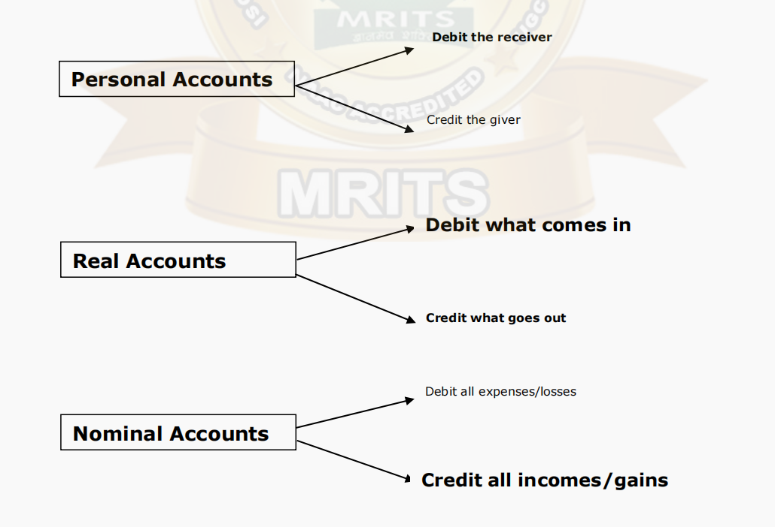

**Converting Transactions into Journal Entries:**

**Steps:**

1. **Identify the accounts involved**
2. **Classify each account (Personal, Real, Nominal)**
3. **Apply the golden rules (as above)**
4. **Decide which account to debit and which to credit**
5. **Write the journal entry with date and narration**

Summary table

| **Account Type** | **Debit Rule** | **Credit Rule** |
| --- | --- | --- |
| Personal | Receiver | Giver |
| Real | What comes in | What goes out |
| Nominal | Expenses and Losses | Incomes and Gains |

**Unit-5**

**40.**

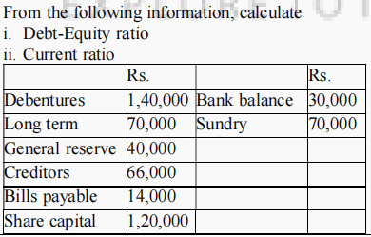

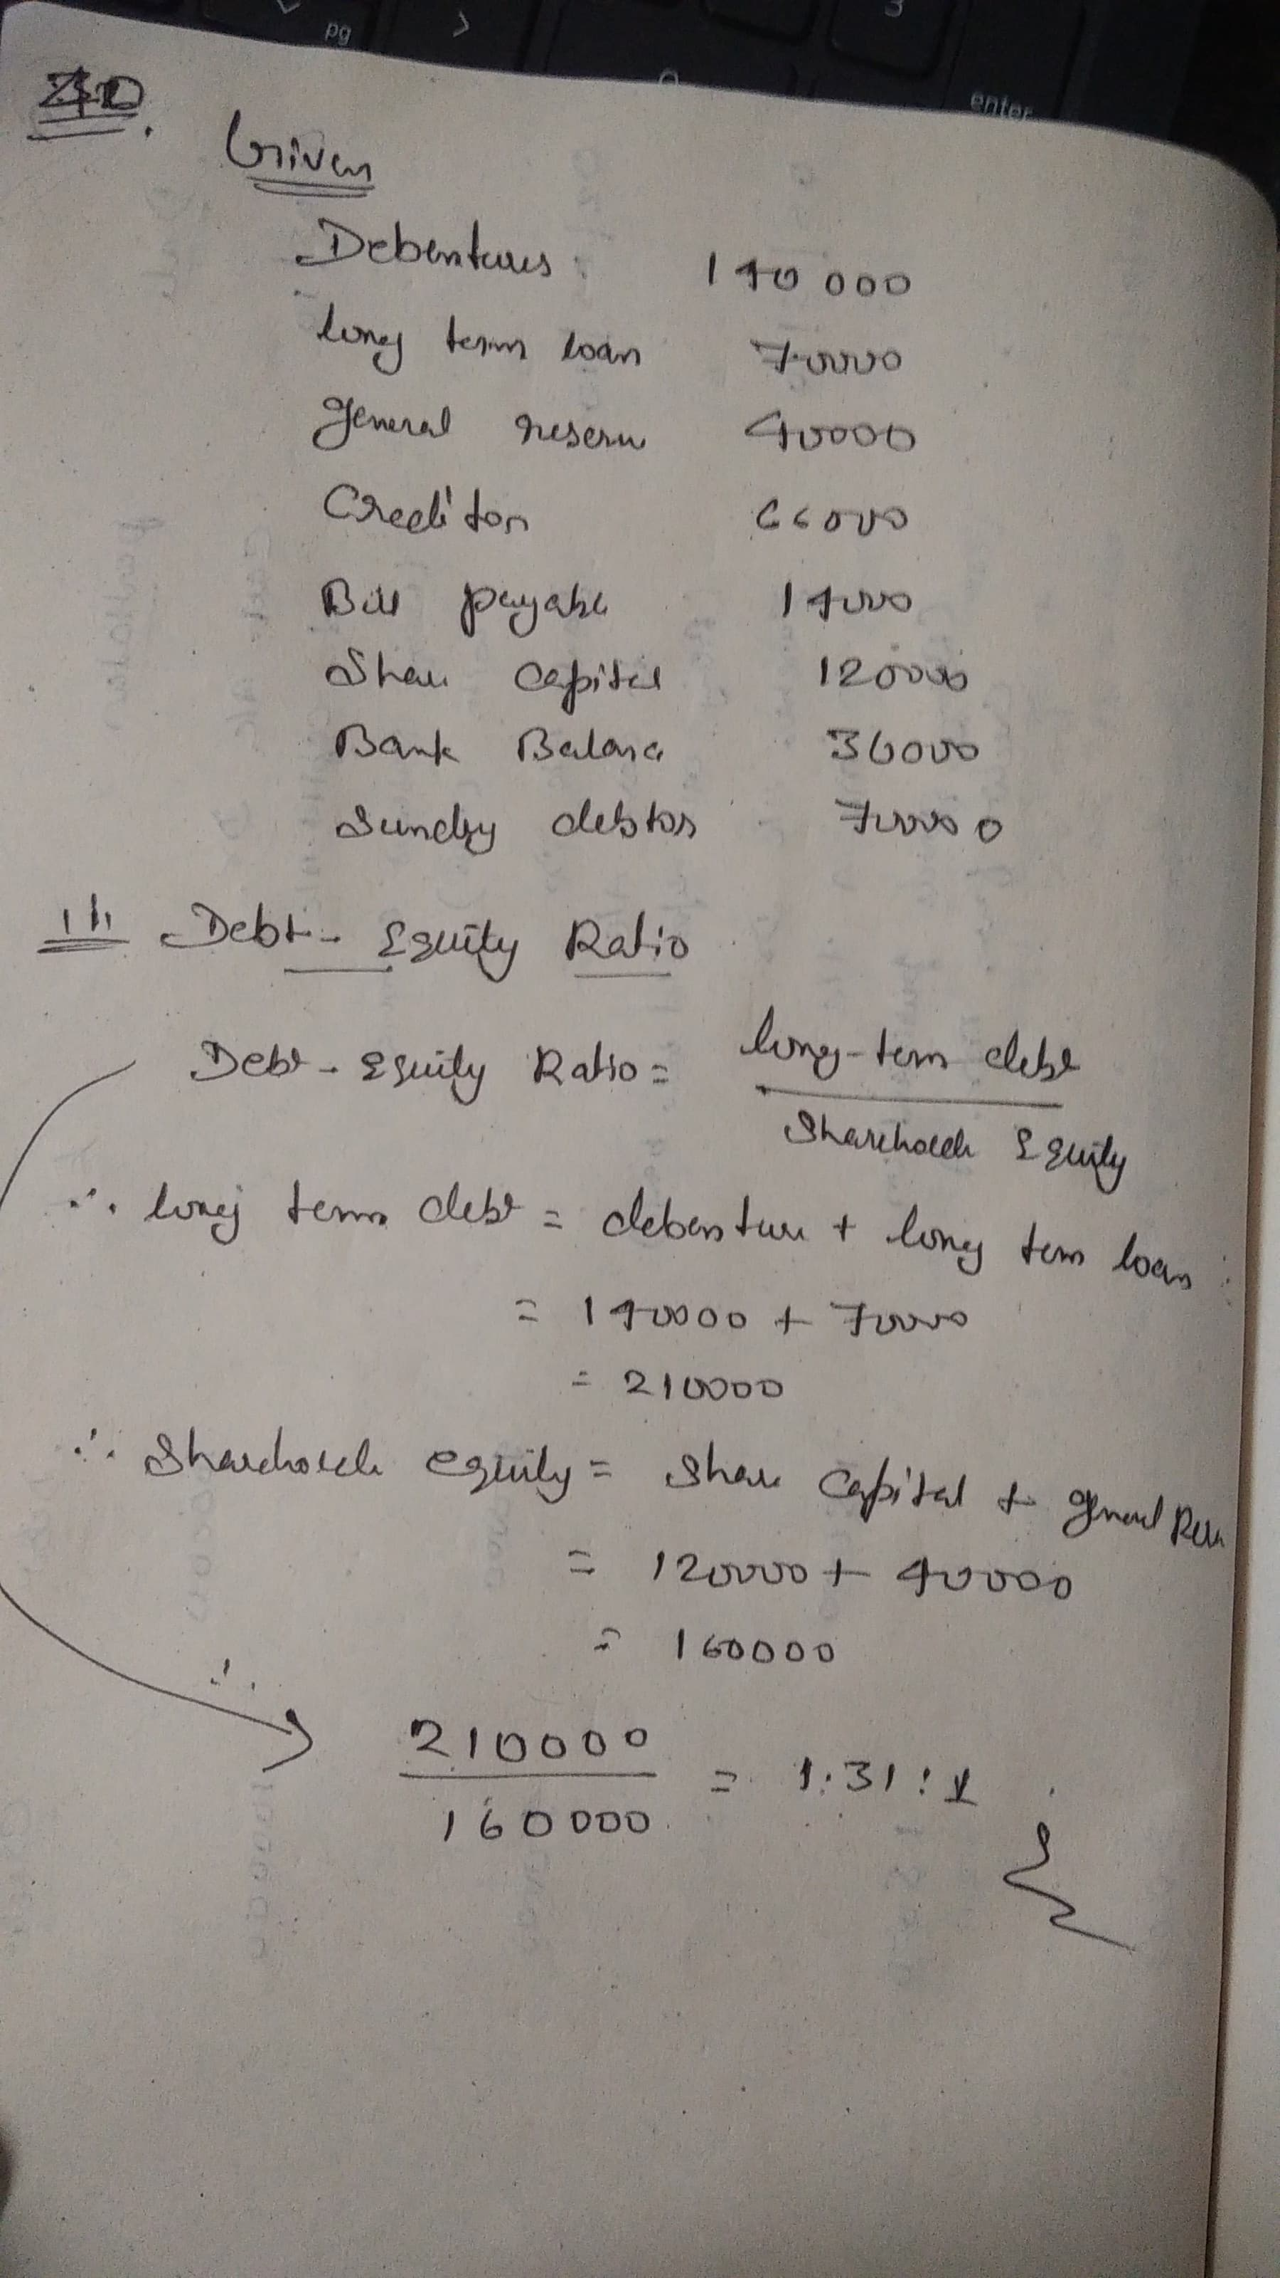

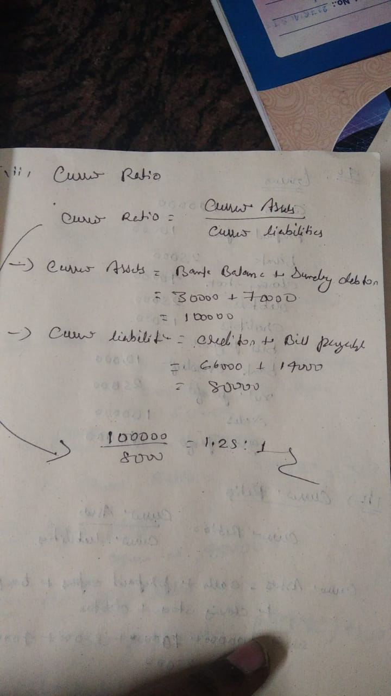

**41.**

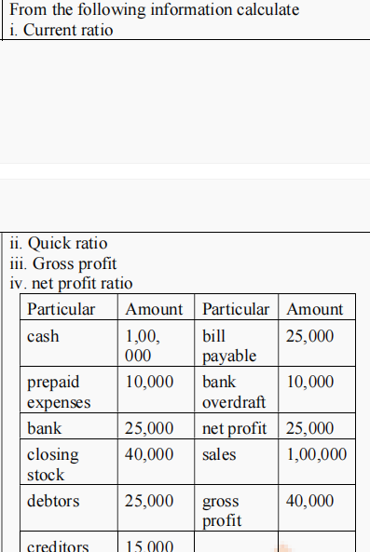

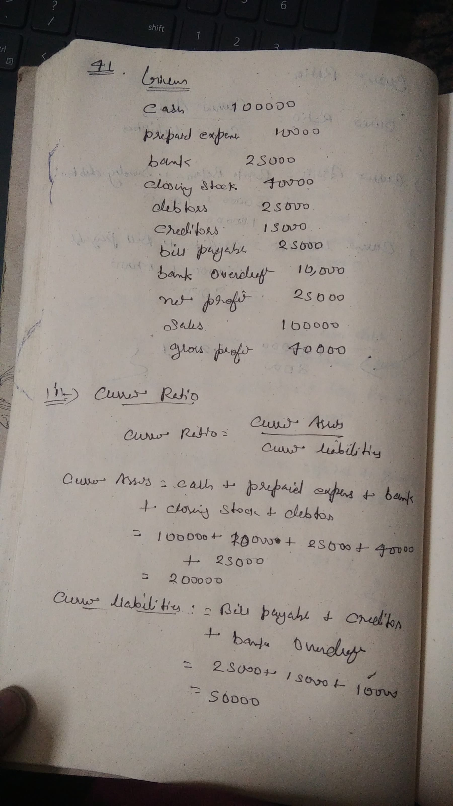

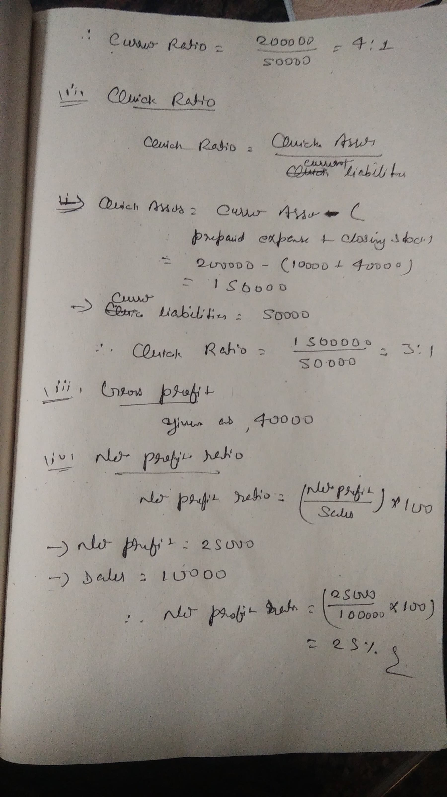

42.What are the advantages and limitations of Ratio Analysis? Does ratio analysis really measure the financial performance of a company?

## **Advantages of Ratio Analysis**

### 1. ****Performance Measurement****

* Ratios like **Net Profit Margin**, **Return on Capital Employed (ROCE)**, or **Earnings Per Share (EPS)** help assess how effectively a company is generating profit from its operations and capital.

### 2. ****Liquidity Assessment****

* Ratios such as **Current Ratio** and **Quick Ratio** indicate the firm’s ability to meet short-term obligations. This is critical for banks and creditors before extending credit.

### 3. ****Operational Efficiency****

* **Inventory Turnover**, **Debtors Turnover**, and **Asset Turnover Ratios** help judge how well resources are being utilized. A low turnover might indicate poor sales or overstocking.

### 4. ****Financial Health and Risk****

* Ratios like **Debt-Equity Ratio** or **Interest Coverage Ratio** help assess financial leverage and the risk of default.

### 5. ****Comparative Analysis****

* Stakeholders can **compare** the firm’s performance over time (trend analysis) or with peers (cross-sectional analysis) to identify best practices or red flags.

### 6. ****Management Control****

* Management uses ratios for **internal control and planning**, such as setting inventory levels or credit policies.

## **Limitations of Ratio Analysis**

### 1. ****Static View****

* Ratios are based on data from the balance sheet or income statement **at a point in time**. They do not consider dynamic market conditions or future performance.

### 2. ****Different Accounting Policies****

* If two companies use different depreciation methods, their **profitability ratios** (like ROI or ROCE) might be distorted, making comparison unreliable.

### 3. ****Manipulation Possibility (Window Dressing)****

* Companies may adjust figures near the year-end (e.g., delaying expenses, recognizing early revenues) to improve ratios artificially.

### 4. ****Doesn’t Include External Factors****

* Market trends, government policies, competition, or global events (like a recession or pandemic) are not reflected in ratios but can deeply impact performance.

### 5. ****Inconsistent Definitions****

* Different stakeholders might calculate ratios differently. For example, **"Current Assets"** might or might not include inventories based on the analysis purpose.

### 6. ****Inflation Effects****

* If assets are recorded at **historical cost**, financial statements and hence ratios may understate or overstate the company’s actual position.

### 7. ****No Causal Explanation****

* Ratios only indicate symptoms. For example, a falling profit margin doesn’t tell why — it could be due to increased cost, reduced sales, or pricing pressure.

## **Does Ratio Analysis Truly Measure Financial Performance?**

### ✔️ ****Yes — It Helps, Because:****

* Provides a **quantitative foundation** to assess performance.
* Helps **identify red flags** or strengths early.
* Acts as a useful tool for **trend and competitor analysis**.
* Forms a part of **due diligence** for investors and lenders.

### ❌ ****But Not Fully — Because:****

* It does **not reflect qualitative aspects** (e.g., employee morale, innovation, customer loyalty).
* It’s **retrospective**, not predictive.
* Can be **manipulated or distorted**.
* It cannot work in isolation — **context and interpretation are key**.