Short Ans:

1. Define Gaussian Mixture Models (GMM).

Ans

**Gaussian Mixture Models (GMMs)** are a *soft clustering technique* used in *unsupervised learning* to

determine the *probability that a given data point belongs to a cluster*.

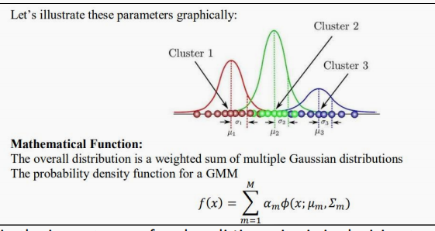

2. Explain the importance of node splitting criteria in decision trees (e.g., Gini index

or entropy).

Ans

Node splitting criteria like **Gini Index** and **Entropy** help select the best attribute to split the

data, aiming to make child nodes as pure as possible. Good splits improve the accuracy,

simplicity, and efficiency of the decision tree.

3. What are the advantages and disadvantages of using decision trees in machine

learning?

Ans

**Advantages:** Easy to understand, works for both classification and regression, needs little data

preprocessing.

**Disadvantages:** Prone to overfitting, unstable with small data changes, and can produce biased

splits.

4. How does LDA differ from PCA?

Ans

 **PCA** is **unsupervised** and focuses on **maximizing variance** to reduce dimensions

without considering class labels.

 **LDA** is **supervised** and aims to **maximize class separability**, finding a feature space

that best separates known categories.

 **PCA** finds **principal components**, while **LDA** finds **discriminant directions** that

maximize **between-class variance** and minimize **within-class variance.**

5. Apply PCA to reduce the dimensionality of a dataset with many correlated

features)

Ans

 **Steps**:

1. **Standardize** the dataset (mean = 0, variance = 1).

2. Compute the **covariance matrix**.

3. **Calculate eigenvectors and eigenvalues**.

4. **Select principal components** corresponding to the largest eigenvalues.

5. **Project** the data onto the selected components.

 **Result**:

The reduced data retains the most important features (variances) and removes redundancy.

6. What is the purpose of Linear Discriminant Analysis (LDA)?

Ans

 **Purpose**:

To **reduce dimensionality** while **preserving class discriminatory information**.

 It finds **linear combinations of features** that best separate two or more classes.

7. What are genetic algorithms used for in optimization problems?

Ans

**Use**:

 Solving **complex optimization** problems where traditional techniques fail.

 Used in **feature selection**, **hyperparameter tuning**, **scheduling**,etc.

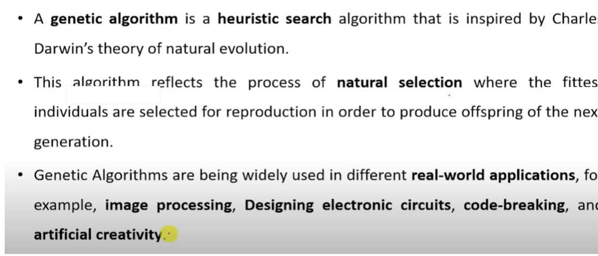

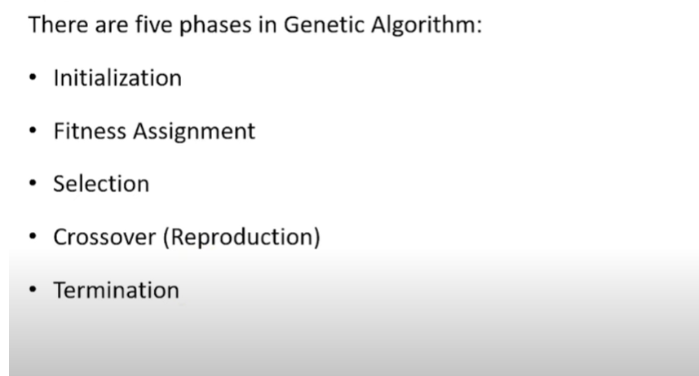

8. Explain the concept of factor analysis.

Ans

**Factor Analysis**:

 A statistical method used to describe variability among observed variables in terms

of fewer unobserved variables called **factors**.

 It identifies **latent variables** that influence observed variables, reducing

dimensionality like PCA but focused more on **explaining correlations.**

9. Explain the working of crossover and mutation in genetic algorithms.

Ans

 **Crossover**:

 Combines two parent solutions to create new offspring.

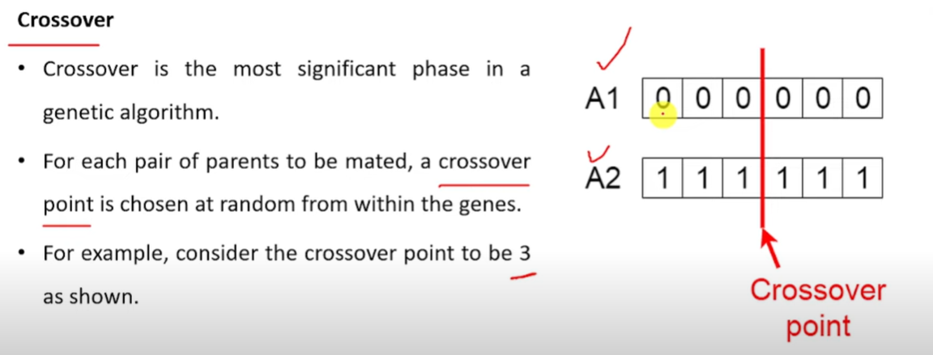’

 **Mutation**:

 Introduces random changes in offspring.

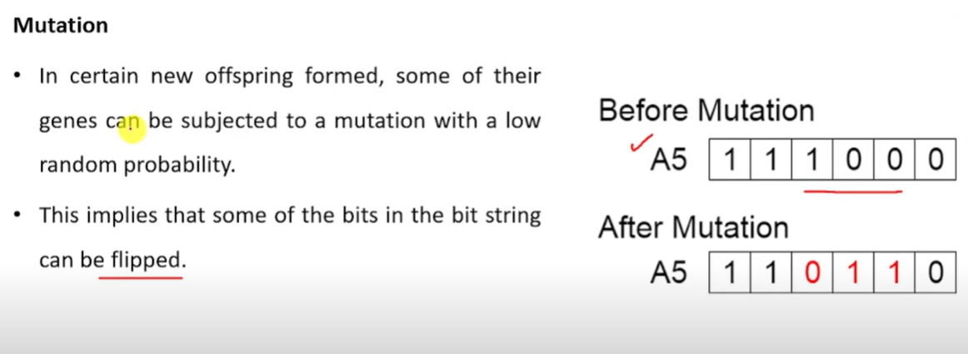

10. What is the primary goal of reinforcement learning?

Ans

The primary goal of reinforcement learning is to train an agent to make a sequence of decisions within an environment to maximize a cumulative reward.

This involves learning a policy that dictates how the agent should act in different situations to achieve the best possible outcome over time.

11. Define Markov Chain Monte Carlo (MCMC) methods.

Ans

 Markov Chain Monte Carlo (MCMC) simulations allow for parameter estimation such as means, variances, expected values, and exploration of the posterior distribution of Bayesian models

 Examples: **Metropolis-Hastings**, **Gibbs Sampling**.

12. How does reinforcement learning differ from supervised learning?

Ans

**Reinforcement Learning** learns through **trial and error**, Where as Supervised Learning

learns from labelled data. Reinforcement Learning interacts with an environment to

**maximize cumulative rewards** ,where Supervised learning minimizes errors Between

Predictions and true labels.

13. Explain the concept of a Bayesian Network?

Ans

 **Bayesian Network**:

 A **Directed Acyclic Graph (DAG)** where nodes represent random variables, and

edges represent **conditional dependencies**.

 Used for **probabilistic inference**, **diagnosis**, and **prediction**.

14. What is the purpose of a Hidden Markov Model (HMM)?

Ans

 **Purpose**:

 To **model time-series data** or sequences where the system being modeled has

**hidden states**.

 Applications: **Speech recognition**, **biological sequence analysis**, **activity recognition**.

15. Apply the Hidden Markov Models and check the result.

Ans

**Simple Example**: Suppose we model weather (hidden state) based on observations (e.g.,

umbrella usage).

 **States**: Rainy, Sunny

 **Observations**: Umbrella (Yes/No)

 **Transition probabilities**:

Rainy→Rainy: 0.7, Rainy→Sunny: 0.3

Sunny→Sunny: 0.6, Sunny→Rainy: 0.4

 **Emission probabilities**:

Rainy→Umbrella: 0.9, Rainy→No Umbrella: 0.1

Sunny→Umbrella: 0.2, Sunny→No Umbrella: 0.8

**Using the Viterbi Algorithm**, if someone is seen with an umbrella, we can predict it was

most likely "Rainy".

Unit-4 -🡪 8Marks

**Provide a comprehensive explanation of Principal Component Analysis (PCA), including its mathematical derivation, steps involved in the algorithm, and how it reduces dimensionality. Discuss its advantages, limitations, and real-world**

Ans:

**Principal Component Analysis (PCA): A Comprehensive Explanation**

Principal Component Analysis (PCA) is a widely used unsupervised linear dimensionality reduction technique. Its primary goal is to transform a dataset with a large number of correlated variables into a smaller set of uncorrelated variables called **principal components** while retaining as much of the original data's variance as possible. Essentially, PCA identifies the directions (principal components) in the data that capture the most significant variations.

### Steps involved in algorithm and Mathematical Derivation



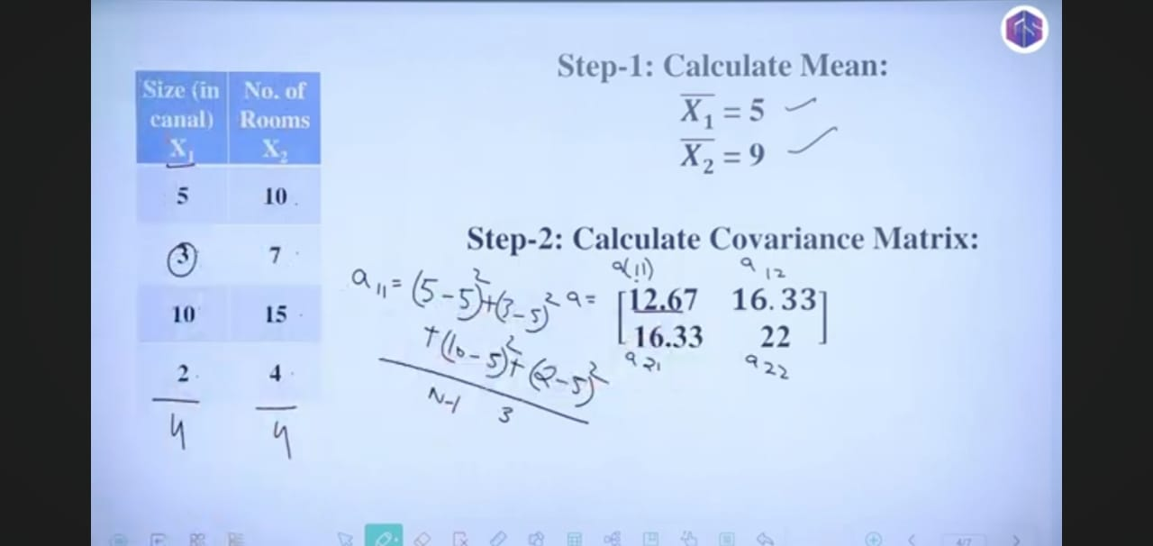

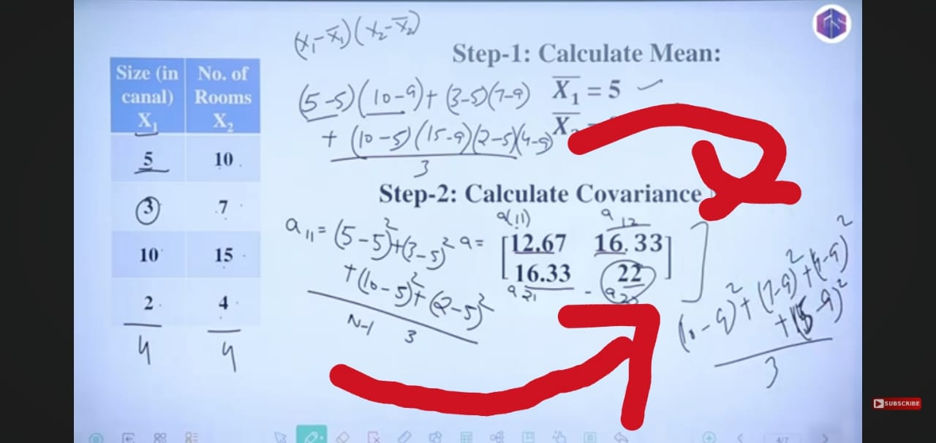

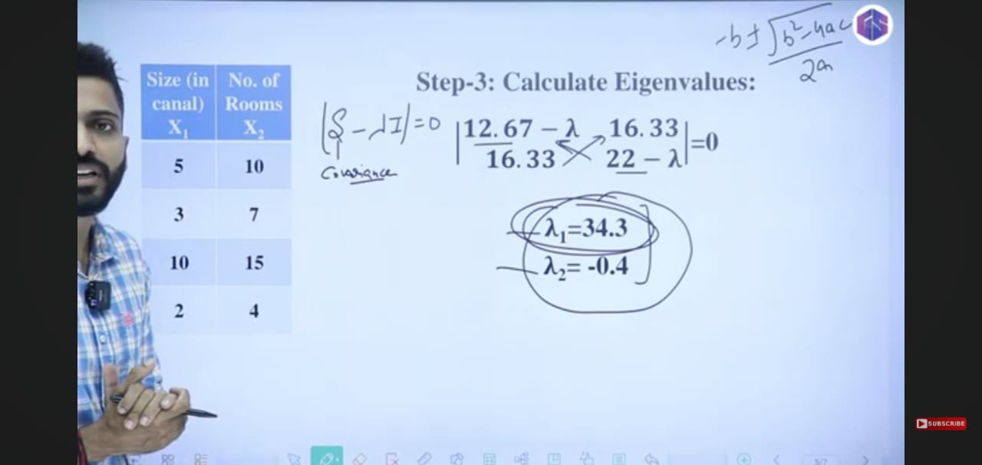

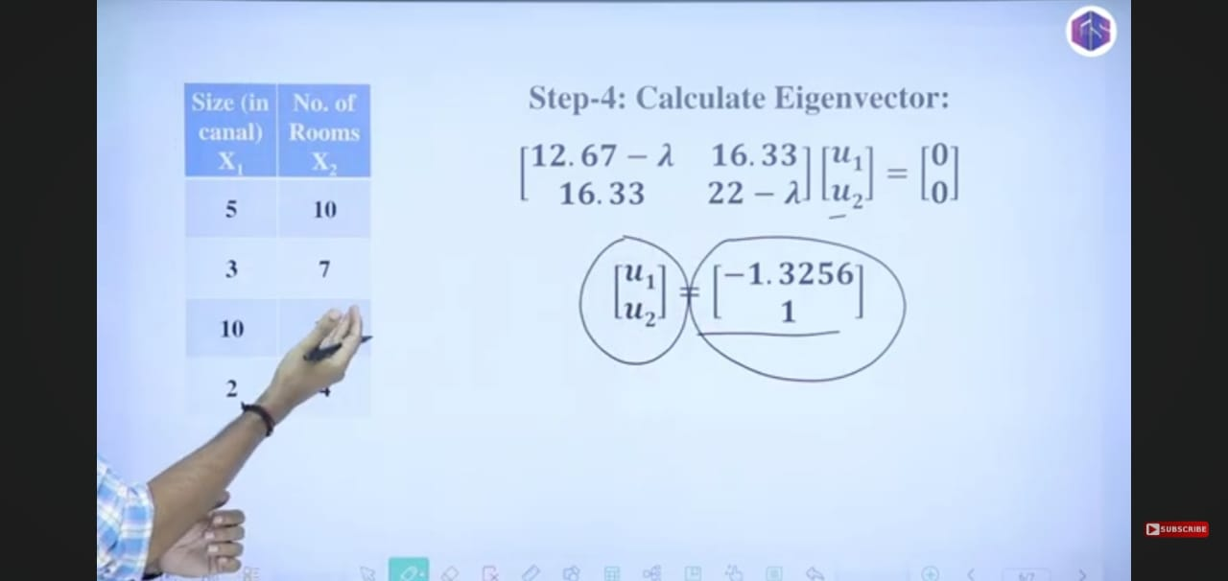

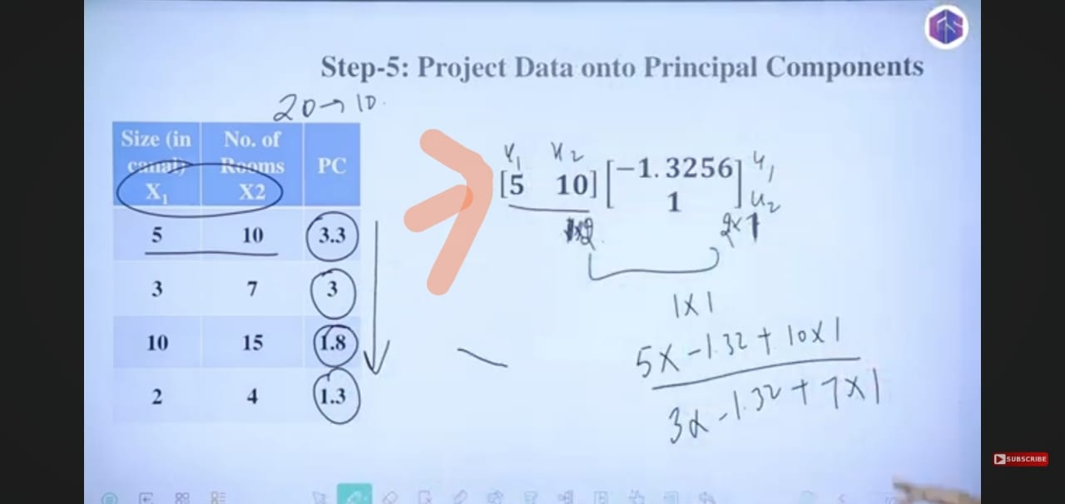

.

**How PCA Reduces Dimensionality**

### Advantages of PCA

* **Dimensionality Reduction:** Reduces the number of features, simplifying the data and potentially improving the performance of subsequent machine learning algorithms by mitigating the curse of dimensionality.
* **Noise Reduction:** By focusing on the directions of maximum variance, PCA can help filter out noise or less informative dimensions in the data.
* **Feature Extraction:** Creates new, uncorrelated features (principal components) that are linear combinations of the original features. These new features can be more meaningful or easier to interpret in some contexts.
* **Data Visualization:** Reduces high-dimensional data to two or three dimensions, allowing for easier visualization and exploration of data patterns.

### **Limitations of PCA**

* **Linearity Assumption:** PCA assumes that the principal components are linear combinations of the original features. It may not be effective for data with complex, non-linear relationships.
* **Sensitivity to Scaling:** The results of PCA can be sensitive to the scaling of the original features. It's often necessary to standardize or normalize the data before applying PCA.
* **Loss of Information:** Dimensionality reduction inherently involves some loss of information. The goal is to minimize this loss by retaining the most important variance.

### **Real-World Applications of PCA**

PCA is a versatile technique with applications in various fields:

* **Image Compression:** Reducing the dimensionality of image data while retaining essential visual information (e.g., JPEG compression uses a related technique called Discrete Cosine Transform).
* **Face Recognition:** Reducing the dimensionality of face images to extract the most important features for recognition (eigenfaces).
* **Finance:** Reducing the number of correlated financial indicators to identify underlying market trends.
* **Natural Language Processing:** Reducing the dimensionality of word embeddings or document-term matrices.
* **Data Visualization:** Projecting high-dimensional datasets into 2D or 3D for visualization and exploratory data analysis.

**2.Compare and contrast PCA and Factor Analysis for dimensionality reduction**

Ans:

**PCA vs. Factor Analysis: A Comparison**

|  |  |  |
| --- | --- | --- |
| **Feature** | **Principal Component Analysis (PCA)** | **Factor Analysis (FA)** |
| **Goal** | Reduce dimensionality while retaining maximum variance in the data. | Identify underlying latent factors that explain the correlations among observed variables. |
| **Underlying Model** | No underlying statistical model assumed. It's a mathematical transformation. | Assumes an underlying factor model where observed variables are linear combinations of latent factors and unique variances (errors). |
| **Focus** | Explaining the total variance in the observed variables. | Explaining the shared variance (covariance) among the observed variables. |
| **Components/Factors** | Principal components are linear combinations of the original variables. | Factors are latent (unobserved) constructs that are inferred from the observed variables. |
| **Variance Partitioning** | Assumes all variance is common variance (no unique variance component in the initial step). | Partitions the variance of each observed variable into common variance (explained by factors) and unique variance (specific to the variable and error). |
| **Mathematical Basis** | Eigen decomposition of the covariance or correlation matrix. | More complex statistical modeling involving factor loadings, commonalities, and unique variances, often solved using methods like Maximum Likelihood or Principal Axis Factoring. |
| **Direction of Influence** | Components are derived *from* the observed variables. | Latent factors are assumed to *cause* the variation in the observed variables (a theoretical model). |
| **Determinacy of Components/Factors** | Principal components are uniquely determined. | Factor scores are typically estimated and can have some indeterminacy (different methods can yield slightly different factor scores). |
| **Rotation** | Rotation can be applied to principal components to improve interpretability, but it's not inherent to the core PCA. | Factor rotation (orthogonal or oblique) is a common step to achieve a simpler and more interpretable factor structure. |
| **Interpretation** | Interpretation focuses on the linear combinations of original variables that capture the most variance. | Interpretation focuses on understanding the nature of the underlying latent factors and their relationships with the observed variables. |
| **Assumptions** | Sensitive to scaling of variables. Assumes linear relationships. | Assumes linear relationships, sufficient sample size, and that the correlation matrix has a factor structure. Multivariate normality is often assumed for certain extraction methods. |
| **Use Cases** | Data preprocessing, noise reduction, visualization, simplifying input for other algorithms. | Identifying underlying constructs (e.g., in psychology, marketing), theory building, and reducing dimensionality based on a theoretical model. |

## Similarities Between PCA and Factor Analysis

* **Dimensionality Reduction:** Both techniques aim to reduce the number of dimensions needed to represent the data.
* **Identify Underlying Structure:** Both try to find a more concise and interpretable structure within the data.
* **Based on Correlations/Covariances:** Both methods analyze the relationships between variables, typically through the covariance or correlation matrix.
* **Can be Steps in a Larger Analysis:** Both PCA and FA can be used as preprocessing steps before applying other statistical or machine learning techniques.
* **Software Implementation:** In practice, statistical software often offers procedures that can perform both PCA and various forms of factor analysis, sometimes leading to confusion.

## When to Use Which Technique

* **Use PCA when:**
  + Your primary goal is to reduce the dimensionality of the data while preserving as much variance as possible.
  + You don't have a strong theoretical model about underlying latent factors.
  + You want to create a new set of uncorrelated variables (components) that are linear combinations of the original variables.
  + Visualization of high-dimensional data is a key objective.
  + You need to preprocess data to improve the performance of other algorithms.
* **Use Factor Analysis when:**
  + You hypothesize the existence of underlying latent factors that explain the relationships between observed variables.
  + Your goal is to understand and interpret these underlying constructs.
  + You want to model the error or unique variance associated with each observed variable.
  + You are working in fields like psychology, sociology, or marketing where latent constructs are often theorized.

**3. Illustrate the trade-offs between preserving local structure (LLE) and global structure (Isomap) for**

**visualization tasks.**

Ans:

The trade-offs between **preserving local structure** (using **LLE**) and **preserving global structure** (using **Isomap**) for **visualization tasks** can be effectively illustrated by comparing the strengths, weaknesses, and use cases of both methods. Let's explore these trade-offs visually and conceptually:

### **1. Preserving Local Structure (LLE)**

#### **Strengths:**

* **Accurate Local Relationships**: LLE excels at maintaining **local neighborhoods**, ensuring that nearby points in high-dimensional space stay close in the lower-dimensional space.
* **Locally Linear Manifolds**: LLE is particularly effective when the data is non-linear but locally behaves like a **flat space** (i.e., the data lies on a **non-linear manifold**).
* **Non-linear Data**: LLE works well when **local non-linear patterns** in the data need to be captured.

#### **Weaknesses:**

* **Ignores Global Structure**: The technique doesn’t preserve the **overall global layout** of the data. Distances between distant points may be distorted.
* **Disconnected Global Layout**: The global representation may not accurately represent the overall structure, leading to disconnected or poorly connected clusters.

#### **Use Case:**

* **Clustering Tasks**: When focusing on **local clusters** or smaller-scale patterns, such as grouping **similar objects** in **image datasets** (e.g., facial expression data), LLE provides clear visualizations of locally related data.

#### **Illustration:**

In datasets where the **local structure** is crucial (such as local clustering or patterns), LLE will ensure that points within each cluster remain close together, but the **global relationship** between clusters may not be well-represented.

For instance, in a **2D manifold** (like a spiral or helix), LLE will keep points that are close to each other on the spiral close together, but the **overall layout** of the spiral may be lost in the lower-dimensional projection.

### **2. Preserving Global Structure (Isomap)**

#### **Strengths:**

* **Preservation of Geodesic Distances**: Isomap maintains the **global shape** and **overall relationships** between all data points. It preserves **global distances** by using geodesic distances (shortest paths on the manifold).
* **Handling Non-linear Global Structures**: Isomap is especially effective for datasets that lie on **curved or twisted manifolds**, such as the **Swiss Roll** dataset, where the data is non-linear but has a well-defined global structure.

#### **Weaknesses:**

* **Distorts Local Relationships**: While Isomap preserves the global structure, it can distort fine-grained **local relationships**. Neighboring points may not stay as close as they were in the original high-dimensional space.
* **Computational Complexity**: The method can be **computationally expensive**, especially for large datasets, as it requires computing the shortest paths between points.

#### **Use Case:**

* **Global Structure Tasks**: Isomap is suitable for tasks that require a clear understanding of the **overall shape** of the data, such as **3D object modeling**, **geographic data**, or visualizing data that lies on a complex manifold like the **Swiss Roll**.

#### **Illustration:**

Isomap is effective at preserving the **global layout** in a non-linear manifold. In the case of a **Swiss Roll**, Isomap will preserve the **overall roll-like structure** of the data, whereas LLE may fail to capture the global wrap-around effect.

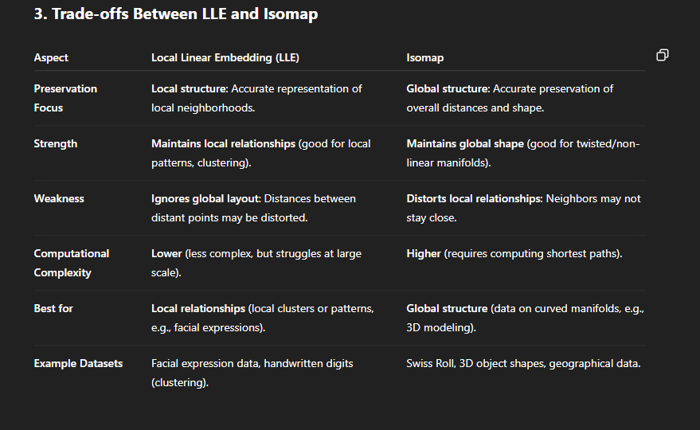

Example:

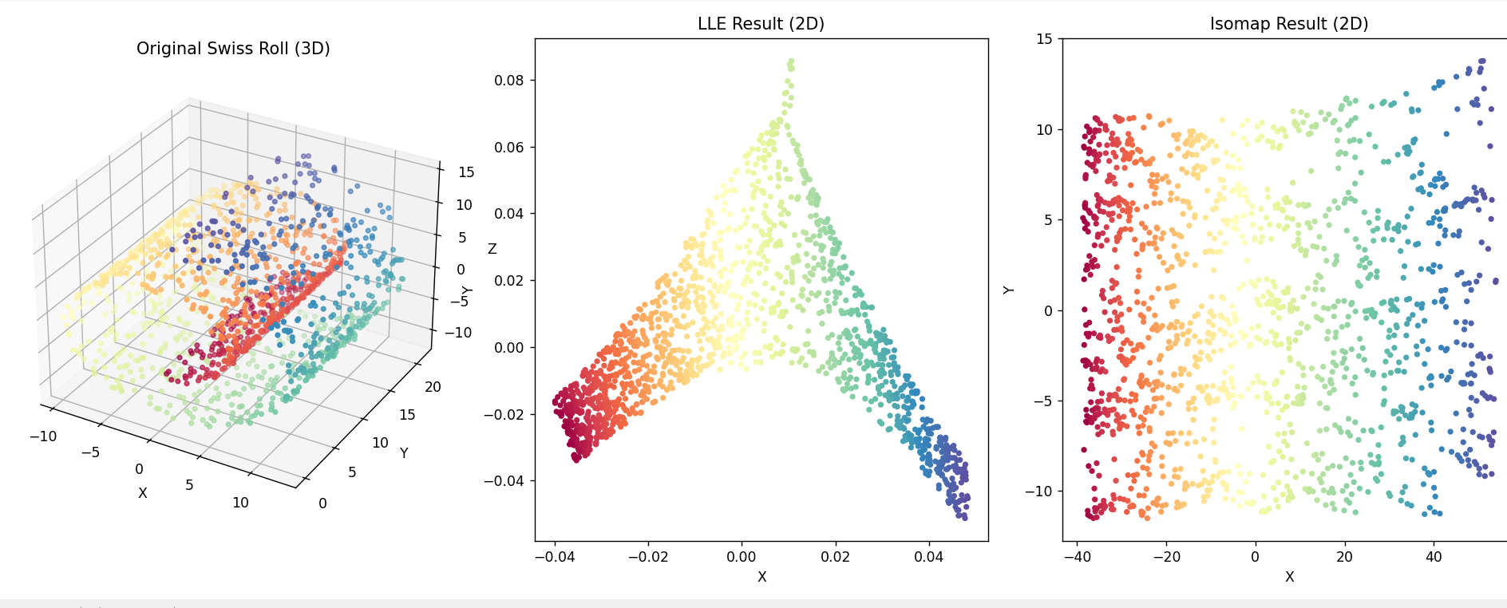

Unit-5 🡪 8marks

**44. Compare the strengths and limitations of Bayesian Networks versus Markov Random Fields in**

**representing dependencies.**

**Ans:**

## Bayesian Networks

## C:\Users\shiva kumar\AppData\Local\Packages\5319275A.WhatsAppDesktop_cv1g1gvanyjgm\TempState\D299A92004734135DE74355770B7C785\WhatsApp Image 2025-04-28 at 06.15.38_e1da4635.jpg

## C:\Users\shiva kumar\AppData\Local\Packages\5319275A.WhatsAppDesktop_cv1g1gvanyjgm\TempState\A3CE63A7A8521C37A513DB67129855A8\WhatsApp Image 2025-04-28 at 06.15.38_0729fe24.jpg

**Strengths:**

* **Directed Acyclic Graph (DAG):** BNs use directed edges to represent conditional dependencies and potential causal relationships between variables. This directionality makes them intuitive for modeling processes where a clear flow of influence exists.
* **Causal Modeling:** The directed nature allows for explicitly representing cause-and-effect relationships, which can be valuable for understanding and intervening in systems.
* **Conditional Probability Tables (CPTs):** Each node in a BN has a CPT that quantifies the probability of its states given the states of its parents. This provides a clear and direct way to define the probabilistic relationships.
* **Efficient Inference for Certain Structures:** Inference algorithms like variable elimination and belief propagation can be efficient for BNs with sparse connections and specific structures (e.g., polytrees).
* **Learning with Missing Data:** BNs can handle missing data relatively well by using the existing relationships to estimate unknown values.
* **Incorporation of Prior Knowledge:** BNs can naturally incorporate prior beliefs or expert knowledge into the model structure and parameters.
* **Generation of Data:** It is generally easier to generate data from a Bayesian network following the direction of the edges.

**Limitations:**

* **Difficulty Representing Cyclic Dependencies:** The DAG structure cannot naturally represent cyclic dependencies or feedback loops between variables.
* **Awkward Representation of Certain Undirected Dependencies:** Some dependencies are more naturally expressed as correlations without a clear direction. Representing these in a BN can lead to more complex structures and potentially less intuitive interpretations. For example, dependencies based on shared constraints or physical laws.
* **Complexity in Structure Learning:** Learning the structure (the DAG) of a BN from data can be a challenging task, especially with a large number of variables. Determining the correct directionality of edges can also be difficult.
* **Computational Intractability for Dense Networks:** Inference in BNs with many variables and dense connections can become computationally very expensive (NP-hard).
* **Limited Expressiveness for Certain Independence Structures:** BNs might not be able to compactly represent certain conditional independence relationships that MRFs can handle more naturally.

## Markov Random Fields

**Strengths:**

* **Undirected Graph:** MRFs use undirected edges to represent dependencies or correlations between variables without implying a direction of influence. This is suitable for modeling relationships where the interaction is symmetric or the direction is unknown or not important.
* **Natural Representation of Certain Dependencies:** MRFs can more naturally and compactly represent certain types of dependencies, such as those arising from spatial or temporal proximity, or shared constraints.
* **Flexibility in Potential Functions:** The relationships in MRFs are defined by potential functions over cliques of variables, which can be more flexible than the conditional probabilities in BNs for capturing complex interactions.
* **Ability to Model Cyclic Dependencies:** The undirected nature allows for the representation of cyclic dependencies.
* **Applications in Various Domains:** MRFs have been successfully applied in areas like image processing, spatial statistics, and social networks where undirected relationships are common.

**Limitations:**

* **Lack of Inherent Directionality:** The undirected nature makes it difficult to represent causal relationships or model processes with a clear flow of influence.
* **Computational Challenges with the Partition Function:** A key challenge in MRFs is the computation of the normalization constant (partition function), which often involves summing over an exponentially large number of states, making exact inference intractable for many models. Approximation techniques are often required.
* **Difficulty in Interpretation:** The potential functions in MRFs do not always have a direct probabilistic interpretation like the conditional probabilities in BNs, which can make the model less intuitive.
* **More Complex Data Generation:** Generating data from a general MRF can be more complex than from a BN due to the lack of a clear generative process defined by directed edges.
* **Learning Can Be Challenging:** Parameter learning in MRFs often involves maximizing a likelihood function that depends on the intractable partition function, requiring specialized and computationally intensive methods.

**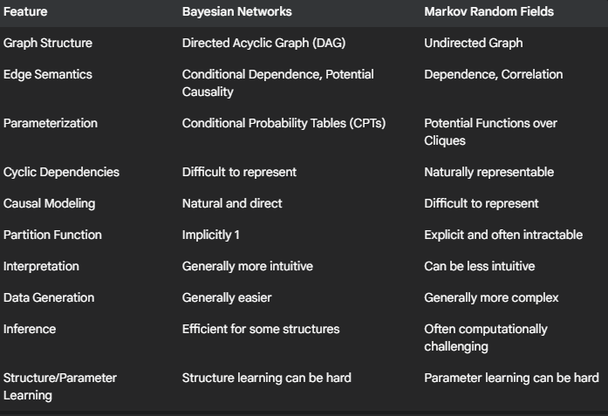**

**45**. Compare MCMC methods with deterministic optimization methods in probabilistic modeling

| **Aspect** | **MCMC Methods** | **Deterministic Optimization Methods** |
| --- | --- | --- |
| **Nature of Approach** | Stochastic (random sampling-based) | Deterministic (systematic, follows a fixed rule) |
| **Goal** | Approximate full posterior distribution | Find point estimates (e.g., MAP or MLE) |
| **Output** | A set of samples from the posterior distribution | A single solution (optimal parameters) |
| **Uncertainty Quantification** | Naturally captures uncertainty through posterior samples | Requires additional effort (e.g., Hessian, bootstrap) to assess uncertainty |
| **Computation** | Often more computationally intensive; slower convergence | Generally faster and more efficient, especially for convex problems |
| **Scalability** | Less scalable for large datasets or complex models | More scalable with gradient-based techniques (e.g., SGD) |
| **Convergence Guarantee** | Asymptotically guarantees sampling from the true posterior (given enough time) | May converge to local optima (especially for non-convex problems) |
| **Interpretability** | Produces interpretable distributions over parameters | Provides a single best estimate |
| **Robustness** | More robust to multimodal or non-convex distributions | Can get stuck in local minima without good initialization |
| **Examples** | Metropolis-Hastings, Gibbs Sampling, Hamiltonian Monte Carlo | Gradient Descent, Newton’s Method, Expectation-Maximization (EM) |
| **Use Cases** | Bayesian inference, posterior sampling, probabilistic modeling | Maximum likelihood estimation, point prediction, model fitting |

**46**. Analyse the role of Markov Random Fields in applications such as image processing

Markov Random Fields (MRFs) are powerful tools in image processing, providing a probabilistic framework for modeling the dependencies between neighboring pixels. They operate on the principle that the value of a pixel depends on the values of its neighbors, capturing local contextual information. This makes them particularly well-suited for various image analysis tasks.

Here's an analysis of their role in image processing applications:

**1. Image Restoration:**

* **Noise Reduction:** MRFs can model the expected smoothness of an image. By defining energy functions that penalize significant differences between neighboring pixels, MRFs can effectively smooth out noise while preserving important image details like edges.
* **Inpainting:** When parts of an image are missing or corrupted, MRFs can be used to infer the missing pixel values based on the information from the surrounding, intact pixels. The model considers the statistical likelihood of different pixel configurations in the neighborhood to fill in the gaps realistically.
* **Deblurring:** Similar to noise reduction, MRFs can incorporate prior knowledge about the blur process and the expected sharpness of the original image to deconvolve blurred images.

**2. Image Segmentation:**

* **Region Labeling:** MRFs can be used to assign labels (e.g., different object classes or regions) to each pixel in an image. The model considers both the individual pixel's features (like color or intensity) and the consistency of labels among neighboring pixels. This helps to create spatially coherent segmentations.
* **Boundary Detection:** By defining energy functions that favor discontinuities in pixel labels, MRFs can be used to identify the boundaries between different regions or objects in an image.

**3. Texture Analysis and Synthesis:**

* **Texture Modeling:** MRFs can capture the statistical properties of textures by defining the relationships between neighboring pixel intensities or texture features. This allows for the analysis and classification of different textures.
* **Texture Synthesis:** Once a texture is modeled using an MRF, new samples of that texture can be generated by randomly assigning pixel values while respecting the learned neighborhood dependencies.

**4. Image Compression:**

* **Contextual Prediction:** MRFs can model the statistical dependencies between pixels to predict pixel values based on their neighbors. This prediction can be used in compression algorithms to reduce redundancy in the image data.

**Key Advantages of using MRFs in Image Processing:**

* **Incorporation of Contextual Information:** MRFs excel at modeling the spatial relationships between pixels, which is crucial for many image processing tasks where local context provides important cues.
* **Principled Probabilistic Framework:** MRFs provide a solid mathematical foundation for image analysis, allowing for the use of Bayesian inference and other probabilistic techniques.
* **Flexibility in Model Design:** The energy functions in MRFs can be designed to incorporate various prior knowledge and constraints specific to the image processing task at hand.

**Challenges in using MRFs:**

* **Computational Complexity:** Inference in MRFs, especially finding the optimal labeling or configuration, can be computationally expensive, particularly for large images and complex models. Algorithms like Gibbs sampling, simulated annealing, and graph cuts are used for approximate inference.
* **Parameter Estimation:** Determining the appropriate parameters for the MRF model (e.g., the strengths of the interactions between neighbors) can be challenging and often requires learning from data.
* **Model Design:** Designing an MRF model that accurately captures the underlying dependencies in an image while remaining computationally tractable can be a complex task.
  + **4 marks**

**38 .Explain the basic principle of reinforcement learning and how it differs from supervised and**

**unsupervised learning**

Ans:

The basic principle of reinforcement learning (RL) is to train an **agent** to make optimal decisions in an **environment** by learning from the consequences of its actions. The agent interacts with the environment and receives **rewards** or **penalties** based on its behavior. The goal of the agent is to learn a **policy** (a mapping from states to actions) that maximizes the cumulative reward it receives over time. This learning process occurs through trial and error, where the agent explores different actions and learns which ones lead to the highest rewards in the long run.

Here's how reinforcement learning differs from supervised and unsupervised learning:

**Supervised Learning:**

* **Data:** Supervised learning uses labeled data, meaning the training data includes input-output pairs, where the desired output is provided for each input. The algorithm learns a mapping function from the input to the output based on this labeled data.
* **Feedback:** The feedback during training is in the form of direct corrections if the model's prediction doesn't match the provided label.
* **Goal:** The goal is to learn a function that can accurately predict the output for new, unseen inputs.
* **Analogy:** Think of learning with a teacher who tells you the correct answer for every practice question.

**Unsupervised Learning:**

* **Data:** Unsupervised learning uses unlabeled data, meaning the training data only consists of input data without any corresponding output labels. The algorithm's task is to find hidden patterns, structures, or relationships within the data.
* **Feedback:** There is no explicit feedback during training about whether a discovered pattern is "correct" or not. The algorithm learns based on the inherent structure of the data.
* **Goal:** The goal is to discover insights from the data, such as clustering similar data points, reducing the dimensionality of the data, or finding associations between data items.
* **Analogy:** Think of exploring a new dataset without any prior knowledge and trying to find groups or interesting patterns on your own.

**Reinforcement Learning:**

* **Data:** Reinforcement learning does not rely on a fixed dataset of labeled or unlabeled examples. Instead, the agent generates its own data through interaction with the environment. This data consists of states, actions, and the resulting rewards.
* **Feedback:** The feedback is in the form of a scalar reward signal that indicates how good or bad the agent's action was in a particular state. This reward might be delayed and is not a direct instruction on the correct action.
* **Goal:** The goal is to learn a policy that maximizes the expected cumulative reward over time. This involves making a sequence of decisions that lead to the best long-term outcome.
* **Analogy:** Think of learning to ride a bicycle. You try different actions (steering, pedaling), and you receive feedback through balance (reward for staying upright, penalty for falling). You learn over time which actions lead to successful riding.

**40 .Describe how Bayesian Networks can be used to model complex probabilistic relationships. Provide**

**an example of a real-world application.**

**41 .Explain how Hidden Markov Models (HMMs) can be used in speech recognition. What are the key**

**components of an HMM that enable it to handle sequential data.**

Hidden Markov Models (HMMs) are statistical models used to analyze sequential data where the underlying system transitions between a series of hidden states, and each state emits observable outputs. In speech recognition, HMMs are employed to model the temporal structure of speech sounds (phonemes) and how they combine to form words.

Here's how HMMs are used in speech recognition:

1. **Acoustic Modeling:** Each basic unit of speech, like a phoneme (e.g., /k/, /ae/, /t/ in "cat"), is modeled by a separate HMM. These HMMs learn the statistical properties of the acoustic features (like Mel-Frequency Cepstral Coefficients or MFCCs) extracted from the speech signal that are characteristic of that phoneme.
2. **State Representation:** The hidden states within each phoneme's HMM typically represent different acoustic stages or variations within the pronunciation of that phoneme. For example, a phoneme might have a beginning, middle, and end state, each with its own probability distribution over the acoustic features.
3. **Sequence Recognition:** When an unknown speech utterance is given as input (a sequence of acoustic feature vectors), the speech recognition system tries to find the most likely sequence of phoneme HMMs that could have generated this acoustic sequence. This is done using algorithms like the Viterbi algorithm.
4. **Word and Language Models:** The recognized sequence of phonemes is then mapped to words using a pronunciation dictionary. Furthermore, a language model (which captures the statistical probabilities of word sequences in a language) is often integrated to improve accuracy by favoring grammatically and semantically plausible word sequences.

**Key Components of an HMM for Sequential Data:**

An HMM is defined by the following key components that enable it to handle sequential data effectively:

1. **Set of Hidden States (S):** These are the unobservable underlying states of the system. In speech recognition, these states within a phoneme HMM represent different acoustic realizations of that sound over time. The transitions between these states follow the Markov property, meaning the next state depends only on the current state.
2. **Set of Observable Symbols (V):** These are the outputs or observations that are visible. In speech recognition, these are the acoustic feature vectors extracted from the speech signal at each time frame.
3. **Transition Probability Matrix (A):** This matrix defines the probability of transitioning from one hidden state to another at each time step. aij​=P(st+1​=j∣st​=i), where st​ is the state at time t, and i and j are hidden states. This captures the temporal dynamics of how a phoneme unfolds.
4. **Emission Probability Matrix (B):** This matrix defines the probability of observing a particular symbol (acoustic feature vector) when in a specific hidden state. bj​(ot​)=P(ot​∣st​=j), where ot​ is the observation at time t and j is a hidden state. This links the hidden states (phoneme substages) to the actual sounds produced. These probabilities are often modeled using continuous distributions like Gaussian Mixture Models (GMMs) to handle the continuous nature of speech features.
5. **Initial State Probability Distribution (π):** This vector defines the probability of starting in each of the hidden states at the beginning of a sequence. πi​=P(s1​=i). This specifies the likelihood of starting a phoneme in a particular acoustic substage

**42.Compare the roles of exploration and exploitation in reinforcement learning.**

In reinforcement learning (RL), an agent learns to make decisions by interacting with an environment and receiving rewards or penalties. A fundamental challenge in this learning process is the **exploration-exploitation dilemma**. This dilemma arises because the agent must decide between two conflicting strategies:

**Exploration:**

* **Goal:** To discover new information about the environment. This involves trying out different actions, even if they don't seem optimal based on the agent's current knowledge.
* **Benefit:** Exploration allows the agent to potentially find better actions or strategies that it wouldn't have discovered by only relying on past experiences. It helps in building a more accurate understanding of the environment's dynamics and the consequences of different actions.
* **Risk:** Exploration can lead to immediate negative rewards or suboptimal performance in the short term, as the agent tries out unfamiliar and potentially bad actions.
* **Analogy:** Trying a new restaurant that you've never been to before. It might be amazing, or it could be a bad experience, but you gain information about a new option.

**Exploitation:**

* **Goal:** To maximize the immediate reward based on the agent's current knowledge. This involves choosing the actions that the agent believes will yield the highest reward based on its past experiences.
* **Benefit:** Exploitation allows the agent to perform well in the short term by leveraging the knowledge it has already acquired. It focuses on taking advantage of known good actions to accumulate rewards.
* **Risk:** By only exploiting, the agent might get stuck in a suboptimal policy. It might fail to discover better actions or strategies that exist but haven't been explored yet. The agent's knowledge remains limited to what it has already experienced.
* **Analogy:** Going back to your favorite restaurant that you know you always enjoy. You are guaranteed a good experience based on past knowledge.

**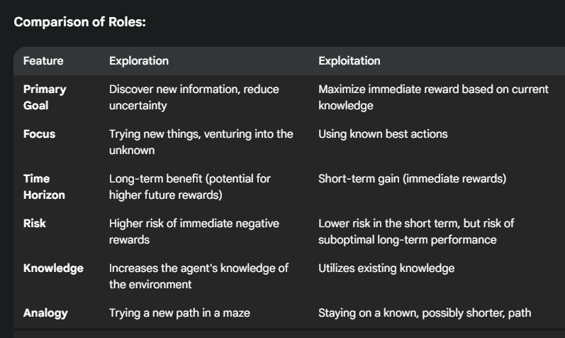**

**43.Explain the Tracking methods in graphical models**

**Ans:**

### 1. **Overview of Graphical Models**

Graphical models represent probabilistic relationships among variables. When applied to tracking, we typically use **Dynamic Bayesian Networks (DBNs)** or **Hidden Markov Models (HMMs)**, which model the temporal evolution of a system.

* **State**: Hidden variable representing the system at a time step.
* **Observation**: What we can measure or observe.
* **Transition Model**: Probability of moving from one state to another.
* **Observation Model**: Probability of observing certain measurements given a state.

### 2. **Common Tracking Methods**

#### A. **Kalman Filter**

* **Used for**: Linear systems with Gaussian noise.
* **How it works**: Predicts the next state using the current state and control inputs, then updates this prediction using new observations.
* **Graphical model**: Linear-Gaussian DBN.
* **Limitations**: Only suitable for linear, Gaussian systems.

#### B. **Extended Kalman Filter (EKF)**

* **Used for**: Non-linear systems by linearizing around the current estimate.
* **Approach**: Applies a Taylor expansion to handle non-linearity.
* **Still assumes**: Gaussian noise.

#### C. **Unscented Kalman Filter (UKF)**

* **Improves on EKF**: Uses a deterministic sampling technique (unscented transform) to better handle non-linearities without linearization.

#### D. **Particle Filter (Sequential Monte Carlo)**

* **Used for**: Non-linear, non-Gaussian systems.
* **Approach**: Represents the belief over states using a set of weighted samples (particles).
* **Steps**:
  1. Prediction – Move particles according to transition model.
  2. Update – Weight particles based on likelihood of observation.
  3. Resampling – Remove low-weight particles and replicate high-weight ones.
* **Highly flexible**, but computationally intensive.

### 3. **Graphical Representation**

In a **DBN**, each time step is a replica of the base Bayesian network, with links:

* From previous state Xt−1X\_{t-1}Xt−1​ to current state XtX\_tXt​ (transition model)
* From current state XtX\_tXt​ to current observation ZtZ\_tZt​ (observation model)

plaintext

CopyEdit

Time t-1 Time t

X\_{t-1} → X\_t

↓ ↓

Z\_{t-1} Z\_t

### 4. **Applications**

* **Computer Vision**: Tracking people, vehicles, or facial features across frames.
* **Robotics**: SLAM (Simultaneous Localization and Mapping).
* **Econometrics**: Estimating hidden variables like market trends.

### 5. **Comparison Table**

| **Method** | **System Type** | **Noise Type** | **Nonlinear Support** | **Notes** |
| --- | --- | --- | --- | --- |
| Kalman Filter | Linear | Gaussian | ❌ | Fast, but limited |
| EKF | Non-linear approx | Gaussian | ✔ (approximate) | Uses Jacobian |
| UKF | Non-linear | Gaussian | ✔ | Better non-linear handling |
| Particle Filter | Any | Any | ✔ | Flexible, computationally heavy |

**Unit-3**

**25 .Explain how the K-means algorithm handles the assignment of data points to clusters. What criteria does it use, and how does it update centroids?**

The K-means algorithm is an iterative clustering algorithm that aims to partition a dataset into K distinct, non-overlapping clusters. The way it handles the assignment of data points to clusters, the criteria it uses, and how it updates centroids are as follows:

**1. Assignment of Data Points to Clusters:**

* **Distance Calculation:** In the assignment step, each data point in the dataset is assigned to the cluster whose centroid is the "closest" to that data point. The most common metric used to measure this closeness or distance is the **Euclidean distance**. The Euclidean distance between two points x=(x1​,x2​,...,xn​) and y=(y1​,y2​,...,yn​) in n-dimensional space is calculated as:
* 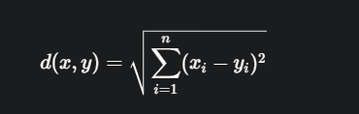
* Other distance metrics like Manhattan distance or Minkowski distance can also be used depending on the data characteristics and the desired cluster shape, but Euclidean distance is the default and most widely used.
* **Assignment Rule:** For each data point, the algorithm calculates its distance to all the current centroids. The data point is then assigned to the cluster whose centroid has the minimum distance to that data point. If a data point is equally distant from two or more centroids, the assignment can be arbitrary or based on a pre-defined rule.

**2. Criteria for Assignment:**

The primary criterion used by the K-means algorithm for assigning data points to clusters is the **minimization of the within-cluster sum of squares (WCSS)**, also known as **inertia**. WCSS measures the sum of the squared distances between each data point and its assigned cluster's centroid. The goal of the assignment step is to reduce this WCSS for the current set of centroids. By assigning each point to the nearest centroid, the algorithm locally minimizes the squared distance of that point to its cluster's center, thus contributing to the overall reduction of the WCSS.

**3. Update of Centroids:**

* **Recalculation:** After all data points have been assigned to clusters in the assignment step, the algorithm proceeds to the centroid update step. In this step, the centroids of the newly formed clusters are recalculated.
* **Mean Calculation:** The new centroid for each cluster is computed as the **mean** of all the data points that have been assigned to that cluster. If a cluster is empty (has no data points assigned to it), this situation needs to be handled, for example, by re-initializing the centroid or removing the empty cluster.
* If Cj​ is the set of data points assigned to the j-th cluster, and ∣Cj​∣ is the number of data points in that cluster, then the new centroid μj​ for the j-th cluster is calculated as
* 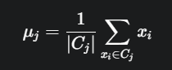
* This update step aims to find the point that minimizes the sum of squared Euclidean distances of all points within that cluster. The mean is the geometric center of the points in the cluster and satisfies this minimization property.

**26.Describe the K-means algorithm used in unsupervised learning. Explain the steps involved in the algorithm, how the number of clusters is determined, and discuss the limitations and advantages of K-means in practical applications**

**Ans:**

## 🔍 What is K-means?

**K-means** is an **unsupervised clustering algorithm** used to group similar data points into **K distinct clusters** based on feature similarity. It minimizes the **intra-cluster variance**, i.e., how close points are to their assigned centroid.

## 📌 Goal of K-means

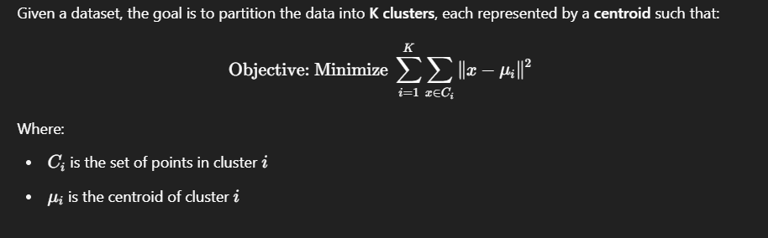

## 🚶 Steps in the K-means Algorithm

1. **Initialization**:
   * Choose the number of clusters **K**.
   * Randomly select **K initial centroids** (can also use smart methods like K-means++).
2. **Assignment Step**:
   * Assign each data point to the **nearest centroid** using a distance metric (usually **Euclidean distance**).
3. **Update Step**:
   * For each cluster, **recalculate the centroid** as the **mean of all points** assigned to that cluster.
4. **Repeat**:
   * Repeat steps 2 and 3 until:
     + Centroids no longer change significantly, or
     + A maximum number of iterations is reached.
5. **Convergence**:
   * Once convergence is reached, clusters are finalized.

## How is the Number of Clusters (K) Determined?

Choosing **K** is crucial and often **not known in advance**. Some common methods include:

### 1. **Elbow Method**:

* Plot **within-cluster sum of squares (WCSS)** vs. number of clusters.
* Choose **K** where the curve starts to "bend" like an elbow.

### 2. **Silhouette Score**:

* Measures how similar a point is to its own cluster vs. other clusters.
* Values range from -1 to 1. Higher means better clustering.

### 3. **Gap Statistic**:

* Compares total intra-cluster variation for different values of **K** with expected values under null reference distribution.

## ✅ Advantages of K-means

1. **Simple and fast**: Easy to implement and computationally efficient.
2. **Scalable**: Works well with large datasets.
3. **Unsupervised**: Does not require labeled data.
4. **Converges quickly** in practice.
5. **Adaptable**: Can be extended to online/mini-batch versions.

## ⚠️ Limitations of K-means

1. **Need to specify K**: Choosing the right number of clusters can be tricky.
2. **Sensitive to initialization**:
   * Poor initial centroids can lead to suboptimal clustering (solved partly by K-means++).
3. **Assumes spherical clusters**:
   * Works best when clusters are roughly equal-sized and well-separated.
4. **Not suitable for non-convex clusters**:
   * Struggles with complex shapes like "moons" or "spirals".
5. **Sensitive to outliers**:
   * A few extreme values can heavily skew centroids.

## 📦 Practical Applications of K-means

* **Customer segmentation** (e.g., grouping users by behavior)
* **Image compression** (using clusters of color)
* **Document classification** (clustering similar texts)
* **Market basket analysis**
* **Anomaly detection**

**27.Compare and contrast bagging, boosting, and stacking**

**Ans:**

## Bagging

**Bagging, also known as**[bootstrap](https://en.wikipedia.org/wiki/Bootstrapping_(statistics))**aggregation, is an ensemble learning technique that combines the benefits of bootstrapping and aggregation to yield a stable model and improve the prediction performance of a machine-learning model.**

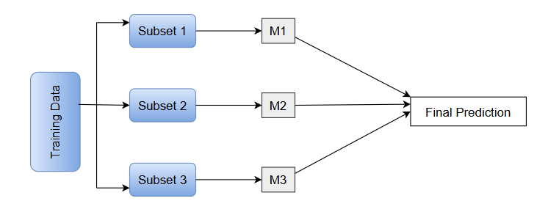

## Boosting

**In boosting, we train a sequence of models. Each model is trained on a weighted training set. We assign weights based on the errors of the previous models in the sequence.**

**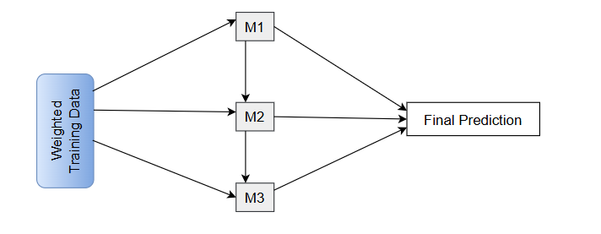**

**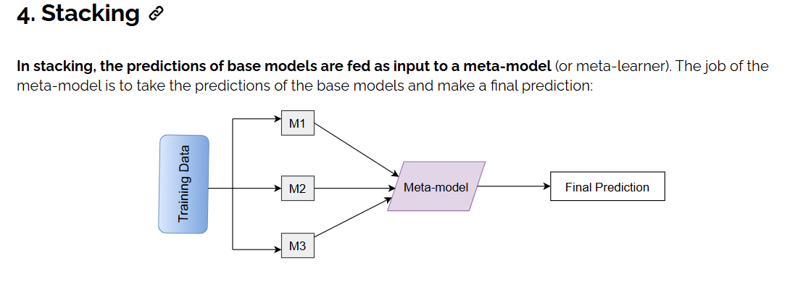**

**28. Classify the distance measures in nearest neighbour methods**

In **nearest neighbor methods** (like **K-Nearest Neighbors**, or KNN), the **distance measure** is crucial—it determines how similarity between data points is computed. The choice of distance affects classification or regression performance, especially in high-dimensional or non-Euclidean data.

**Classification of Distance Measures in Nearest Neighbor Methods**

Distance measures are broadly classified into the following categories:

