Unit-1
1.Purpose of Testing
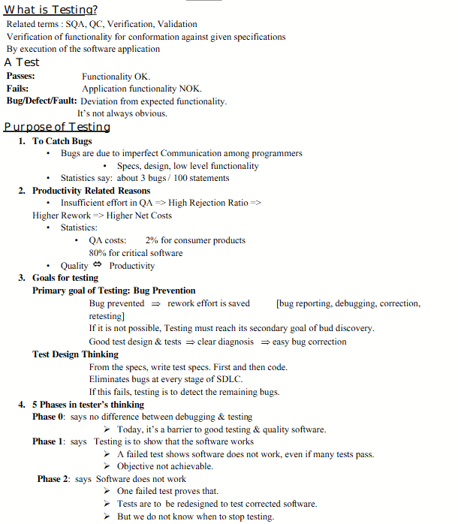
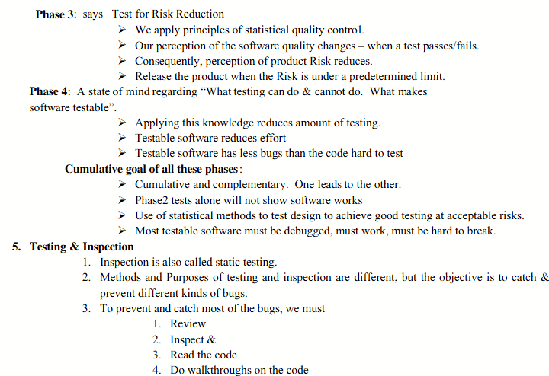

2.Dichotomics
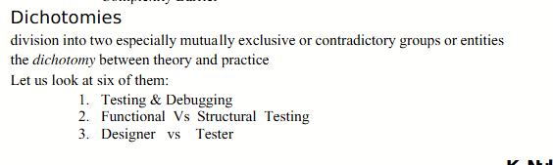
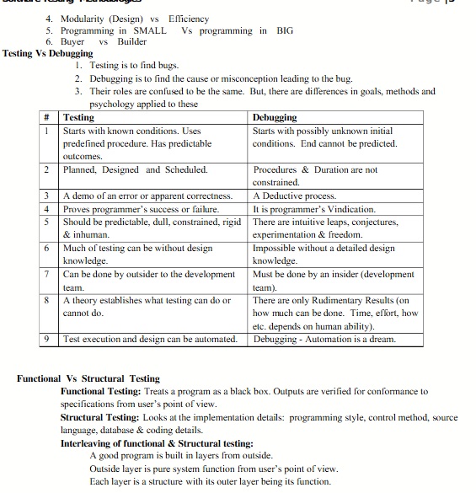

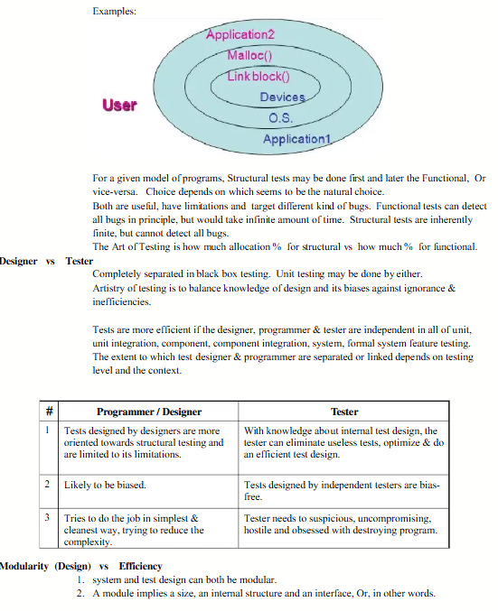

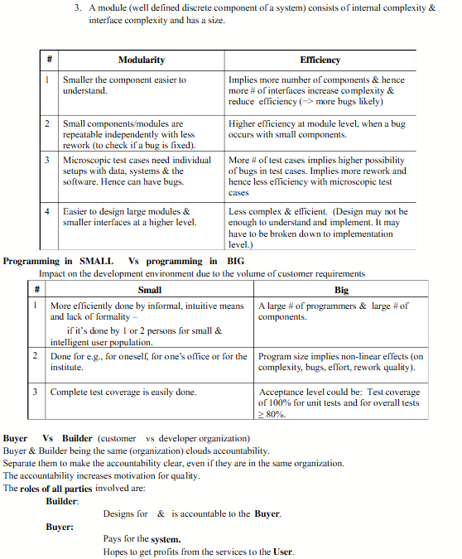

3.A Model for Testing
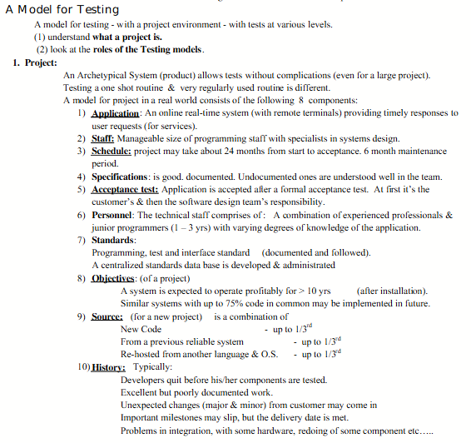
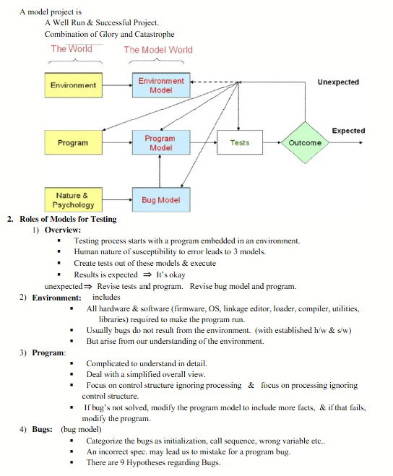

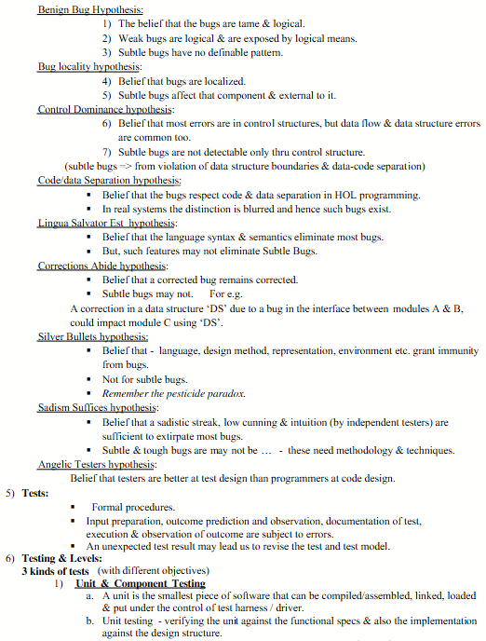

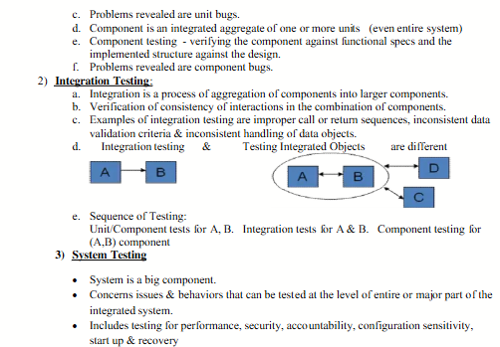

4.Consequnce of the bugs

✅ Consequences of Bugs in STM (Software Testing and Maintenance)

💡 Introduction:
A bug is a flaw, error, or fault in a software program that causes it to produce incorrect or unexpected results or to behave in unintended ways. Bugs can occur during design, development, or maintenance phases and can lead to serious consequences if not detected and resolved.

🔴 Major Consequences of Bugs:
- 1. System Crash / Failure
  - Severe bugs can cause the entire system to crash or stop functioning.
  - E.g., a bug in a banking system might cause a server crash during transactions.
- 2. Incorrect Output / Logic Errors
  - Bugs often produce wrong results without any warning.
  - May go unnoticed and cause long-term damage (e.g., in accounting software).
- 3. Security Vulnerabilities
  - Bugs can create security loopholes, allowing unauthorized access.
  - Example: Buffer overflow bugs used by hackers.
- 4. Data Loss or Corruption
  - Bugs in file handling or memory management can lead to loss or corruption of critical user data.
  - Very common in healthcare, banking, and government systems.
- 5. Increased Cost
  - Late detection of bugs during or after deployment leads to high maintenance costs.
  - Fixing a bug post-release is 10–100 times costlier than fixing during design.
- 6. Time Delays
  - Bugs during testing can cause project delays, missing deadlines, and delivery schedules.
- 7. Loss of Reputation
  - Releasing buggy software may lead to loss of customer trust and brand reputation.
  - Example: Failure in flight software or car braking system.
- 8. Legal and Compliance Issues
  - Bugs can cause the software to violate legal regulations or industry standards.
  - This may result in penalties or lawsuits.

- 9. Customer Dissatisfaction
  - Frequent bugs and crashes lead to poor user experience, reducing customer satisfaction and increasing churn rate.
- 10. Maintenance Overhead
- Bugs often require frequent updates and patches, increasing overall maintenance efforts.

📌 Summary:
Consequence | Description
System Crash | Application stops functioning
Incorrect Output | Produces wrong or unexpected results
Security Issues | Vulnerable to cyber attacks
Data Loss | Information is lost or corrupted
Increased Cost | Late bug fixes are expensive
Time Delays | Project completion is delayed
Reputation Loss | Damages company trust
Legal Problems | Non-compliance with standards
User Dissatisfaction | Poor usability and feedback
Maintenance Burden | More effort needed for patching bugs

5.The Taxonomy of Bugs

✅ Taxonomy of Bugs (Bug Classification)

💡 Introduction:
Taxonomy of bugs refers to the systematic classification of software bugs based on their nature, origin, impact, and behavior. Categorizing bugs helps in understanding, identifying, preventing, and resolving them efficiently.
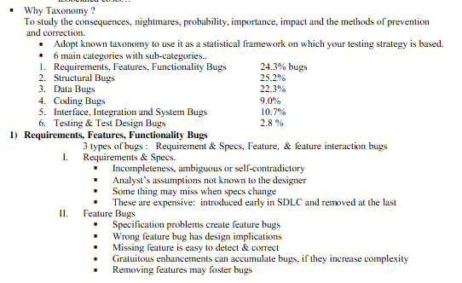
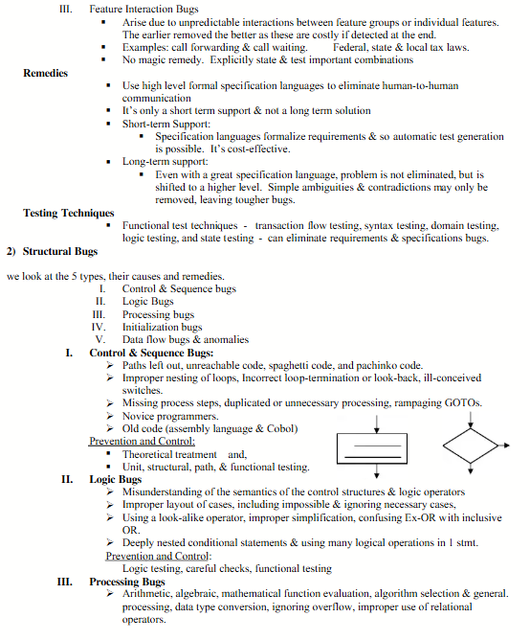

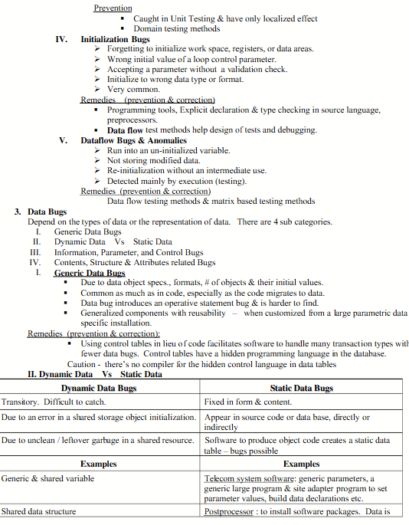

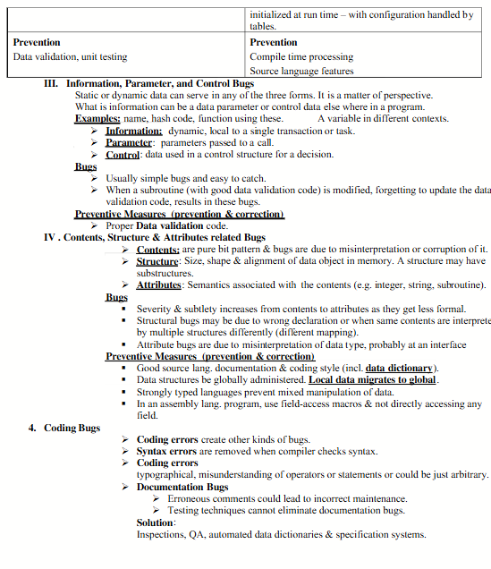

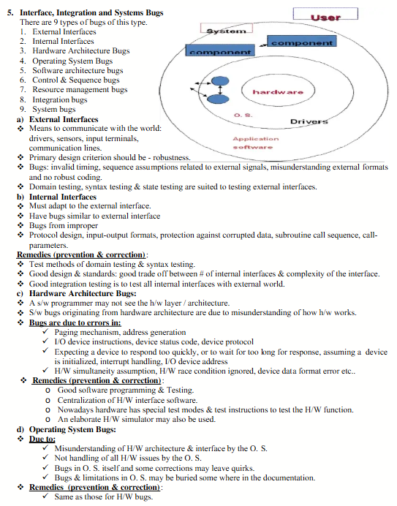

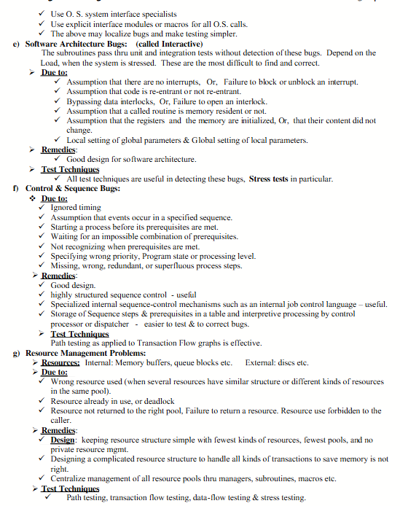

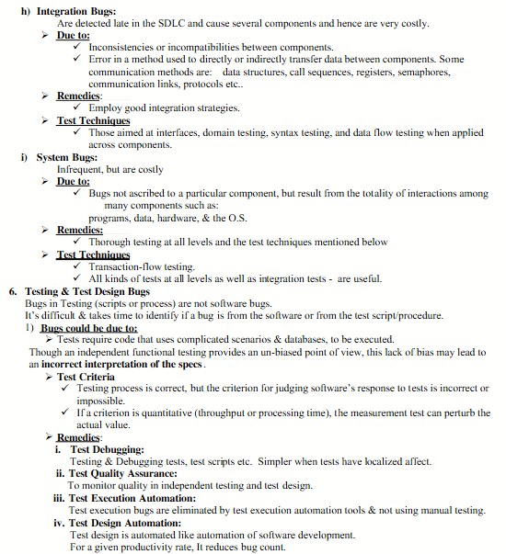

6.Concept of Path Testing
Path Testing is a white-box testing technique that involves examining all possible execution paths in a program or module to ensure that every path is tested at least once.
It helps in:
- Detecting logical errors
- Ensuring complete code coverage
- Improving program correctness

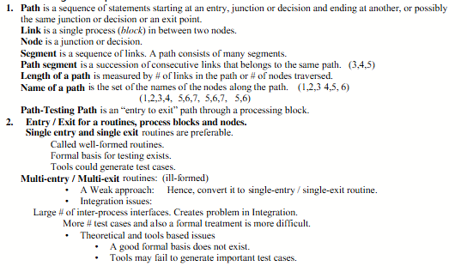
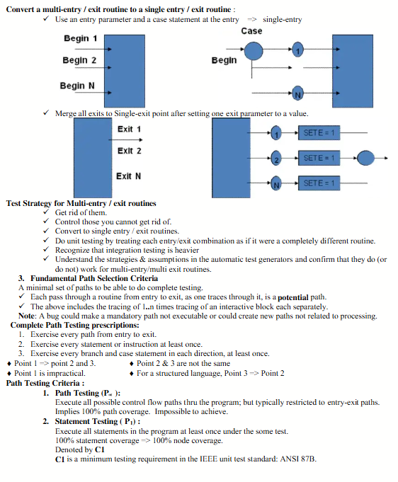

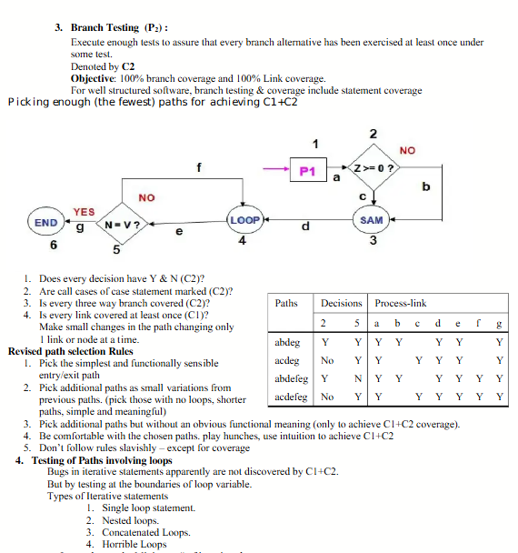

✅ 1. Simple Loop Testing
Test cases should include:
- Zero iteration (loop is skipped)
- One iteration
- Typical number of iterations
- Maximum iteration (upper limit)
- One beyond maximum (to check loop exit condition)

🔹Example:
java
CopyEdit
for (int i = 0; i < 5; i++) {
System.out.println(i);
}
Test with:
- i = 0 (Zero times)
- i = 1 (One time)
- i = 4 (Typical)
- i = 5 (Max)
- i = 6 (Beyond)

✅ 2. Nested Loop Testing
- Start with innermost loop, then progress outward.
- Fix outer loop to minimal iteration, vary inner.
- Slowly increase outer loop depth.

🔹Example:
java
CopyEdit
for (int i = 0; i < 3; i++) {
for (int j = 0; j < 2; j++) {
System.out.println(i + "," + j);
}
}
- Start with i = 0 (outer once), test inner fully.
- Then i = 1, 2, etc.

✅ 3. Concatenated Loop Testing
- When multiple loops are not nested, test each independently, then together.

🔹Example:
java
CopyEdit
for (int i = 0; i < 2; i++) {
System.out.println(i);
}
for (int j = 0; j < 3; j++) {
System.out.println(j);
}
- Test first loop, then second.
- Finally test full flow for continuity.

✅ 4. Horrible Loops
- Use flow graph or control flow analysis.
- Complex; try to refactor into structured code before testing.

7.Predicate
