UNIT-1
Finite Automata
1.Structural Representation of Finite automata
Finite automata are abstract machines with finite states, processing inputs via transitions. They are represented structurally as deterministic finite automata (DFA) or nondeterministic finite automata (NFA), each with distinct characteristics.
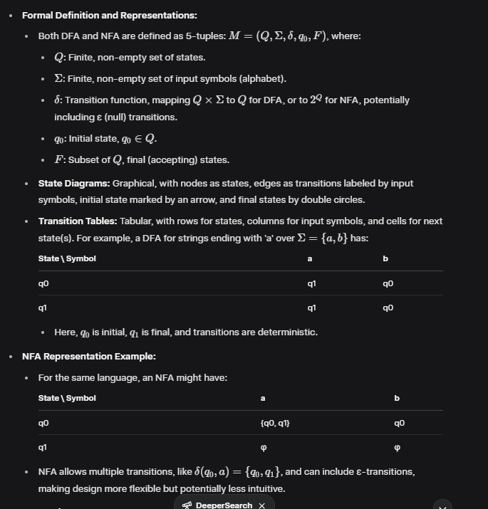

2.Automata and Complexity
Automata theory is intrinsically linked to computational complexity, exploring what can be computed and how efficiently, using models like finite automata, pushdown automata, and Turing machines.
- Automata and Computational Power:
  - Automata classify languages in the Chomsky hierarchy:
    - Finite Automata (DFA/NFA): Recognize regular languages, processed in linear time.
    - Pushdown Automata: Recognize context-free languages, requiring stack memory.
    - Turing Machines: Recognize recursively enumerable languages, with unbounded memory.
  - The hierarchy reflects increasing computational power, with finite automata at the base, handling patterns like strings ending with 'a'.
- Complexity Theory Integration:
  - Complexity theory, developed in the 1960s, studies time and memory resources. For instance, Shannon's 1956 work provided complexity measures for Turing machines, while the Myhill–Nerode theorem (1958) gives conditions for regular languages, linking state count to complexity
  - Finite automata operations, like string acceptance, are typically linear time, but NFA to DFA conversion can exponentially increase states, impacting efficiency.
- Historical Context:
  - Automata theory emerged mid-20th century, with "Automata Studies" (1956) by Shannon et al. introducing regular languages and complexity measures. Complexity theory evolved with Hartmanis and Stearns' 1964 work on recursive sequences, shaping modern understanding .

3.Central Concept of Automata Theory
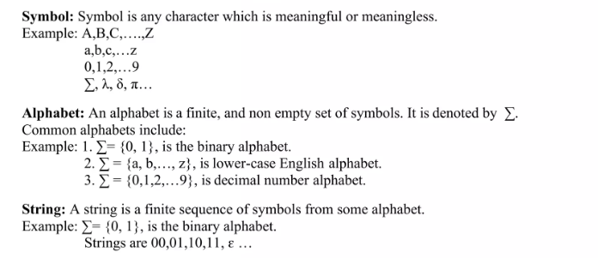
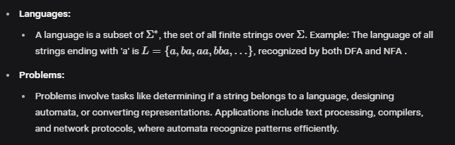

Non-Deterministic Finite Automata
4.Formal Defination of NFA
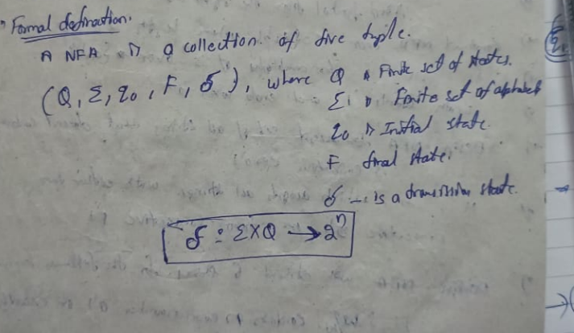
Application
- Text Search and Pattern Matching: NFAs efficiently model patterns for searching substrings or regular expressions in text, such as finding "ab" in a string, due to their ability to handle multiple transitions.
- Lexical Analysis in Compilers: NFAs are used to tokenize source code by recognizing patterns like identifiers or keywords, enabling efficient lexical scanner design.
- Regular Expression Implementation: NFAs directly represent regular expressions, allowing tools like grep or regex libraries to match complex patterns concisely.
- Network Protocol Analysis: NFAs model protocols with nondeterministic behavior, such as packet sequences, aiding in validation and simulation.
- Natural Language Processing: NFAs assist in processing ambiguous or context-sensitive language structures, like parsing partial matches in speech recognition.
- Software Verification: NFAs model system behaviors with nondeterministic paths, used in model checking to verify software correctness.

5. Non Finite Automata with Epsilon-Transitions
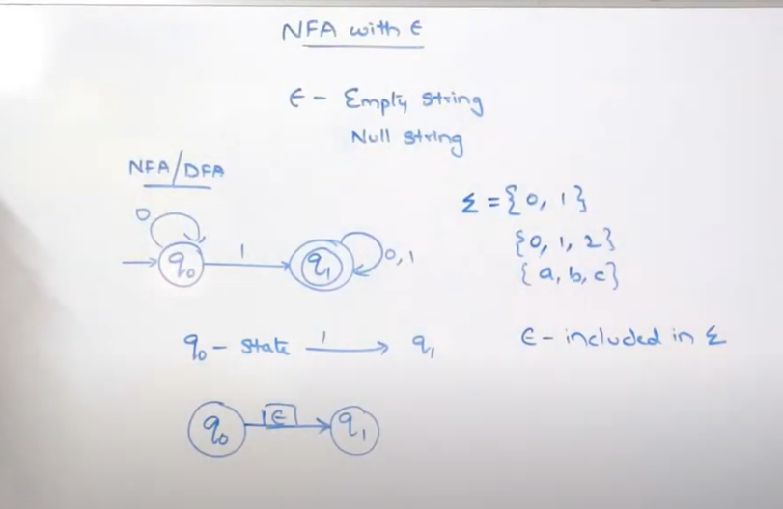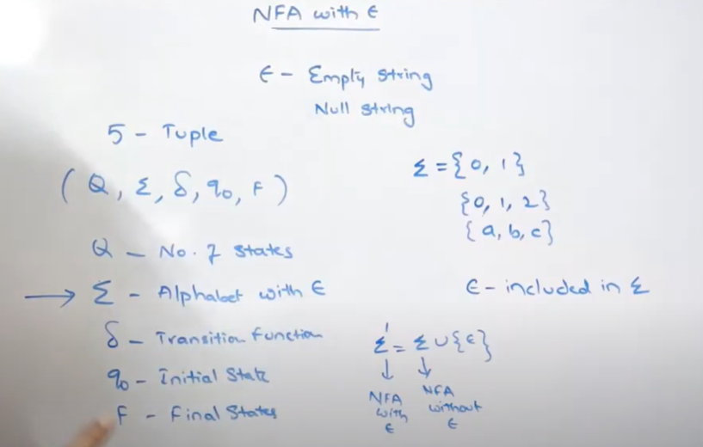
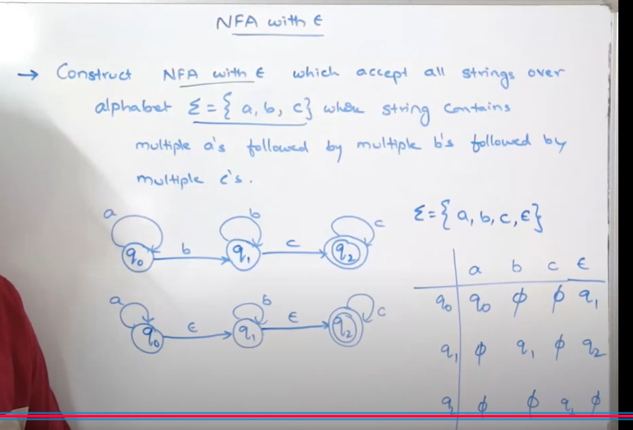

6.Deterministic Finite Automata
In DFA, for each input symbol, one can determine the state to which the machine will move. Hence, it is called Deterministic Automaton. As it has a finite number of states, the machine is called Deterministic
Finite Machine or Deterministic Finite Automaton.

Formal Definition of a DFA
A DFA can be represented by a 5-tuple (Q, ∑, δ, q0, F) where −
• Q is a finite set of states.
• ∑ is a finite set of symbols called the alphabet.
• δ is the transition function where δ: Q × ∑ → Q
• q0 is the initial state from where any input is processed (q0 ∈ Q).
• F is a set of final state/states of Q (F ⊆ Q).

Graphical Representation of a DFA
A DFA is represented by digraphs called state diagram.
• The vertices represent the states.
• The arcs labeled with an input alphabet show the transitions.
• The initial state is denoted by an empty single incoming arc.
• The final state is indicated by double circles.

7.The Language of DFA
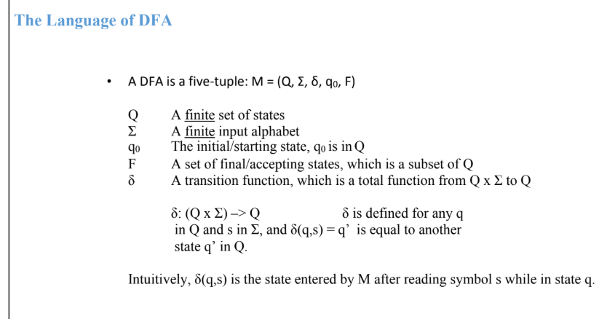
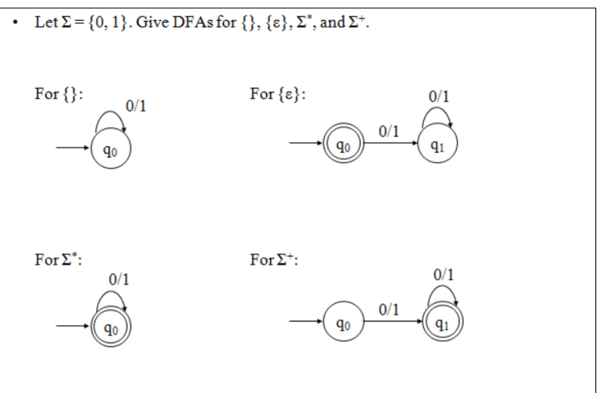

8. Conversion of NFA with €-transitions to NFA without €-transitions
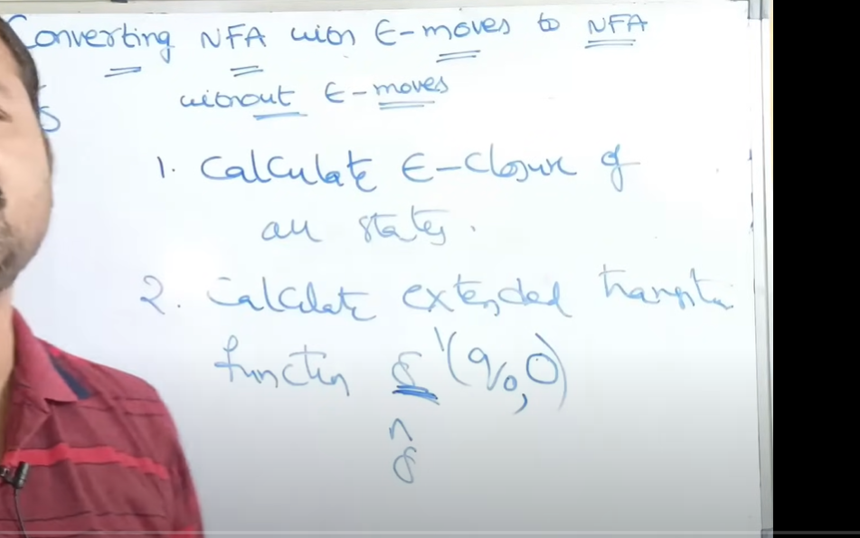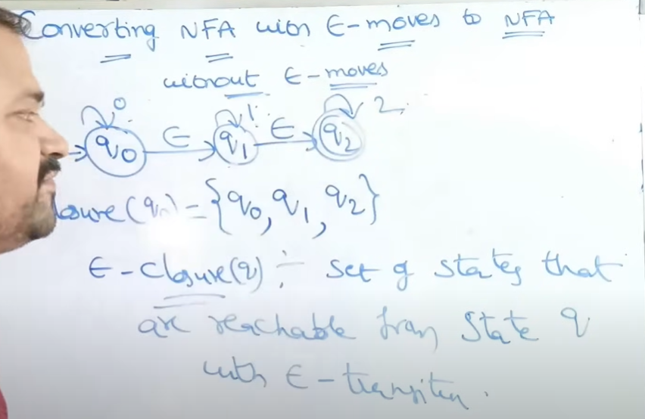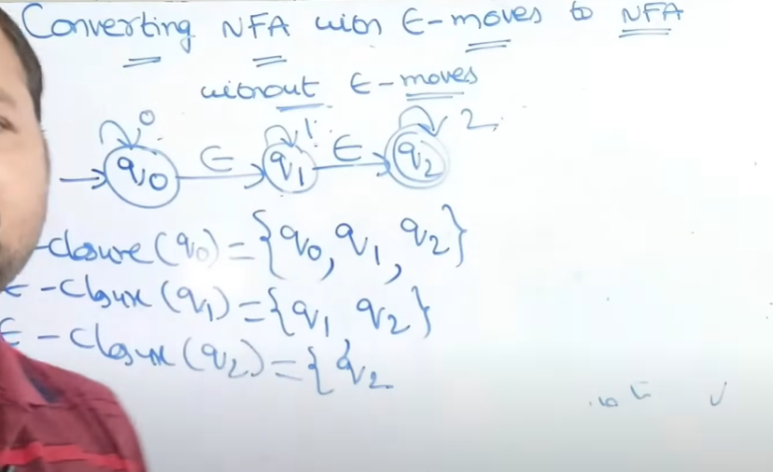
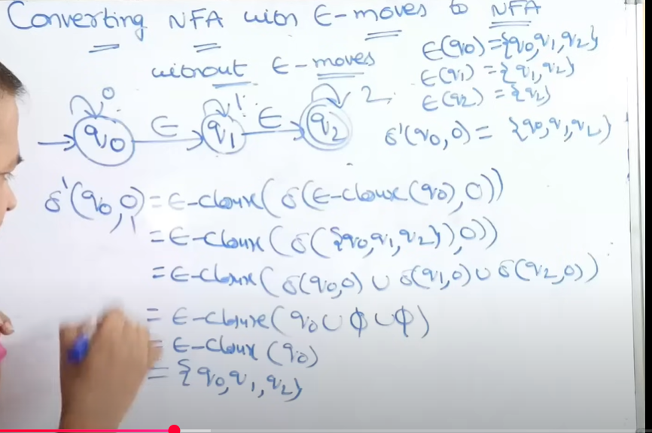
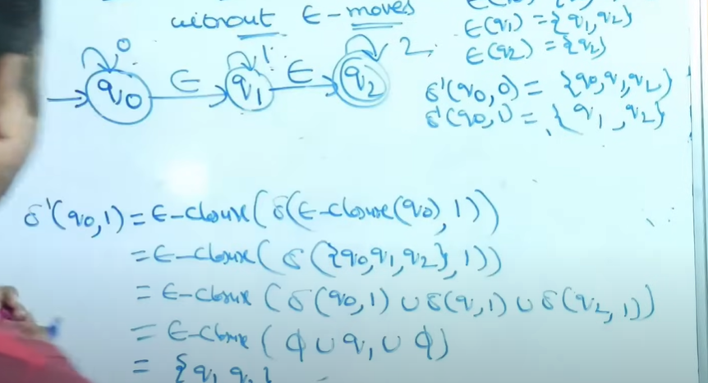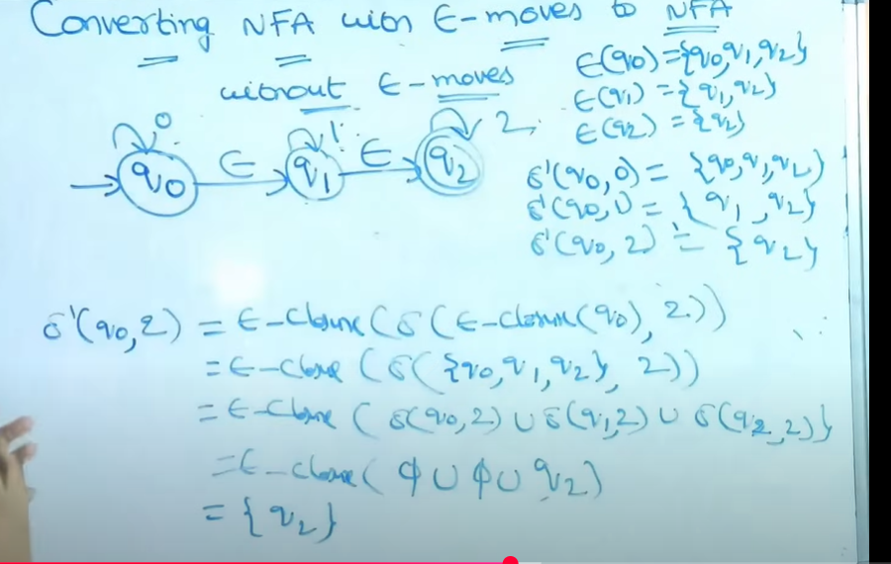
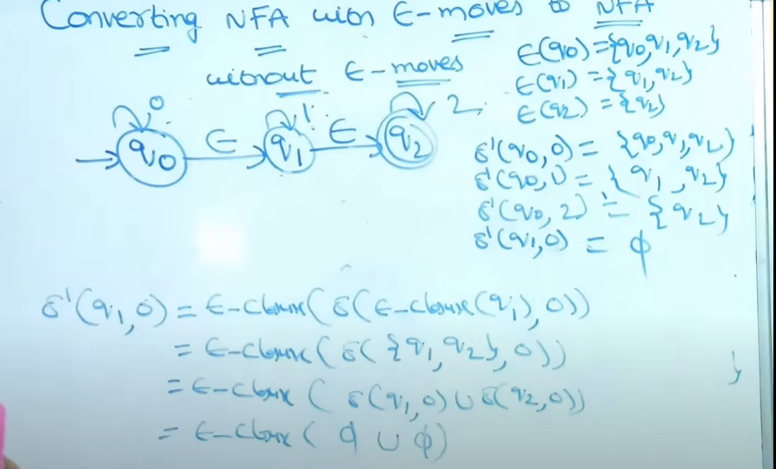
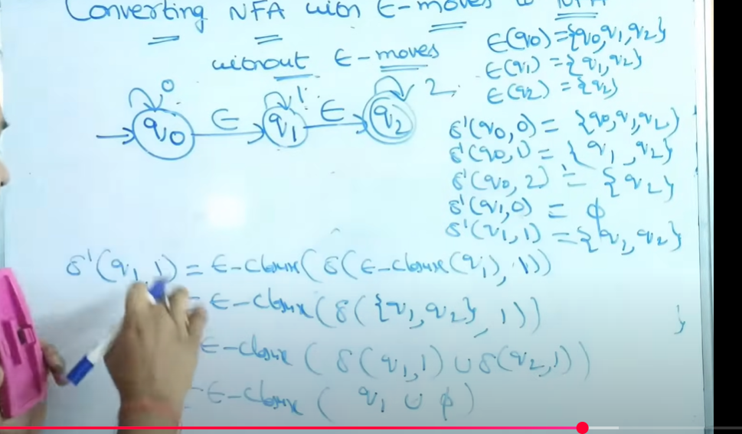
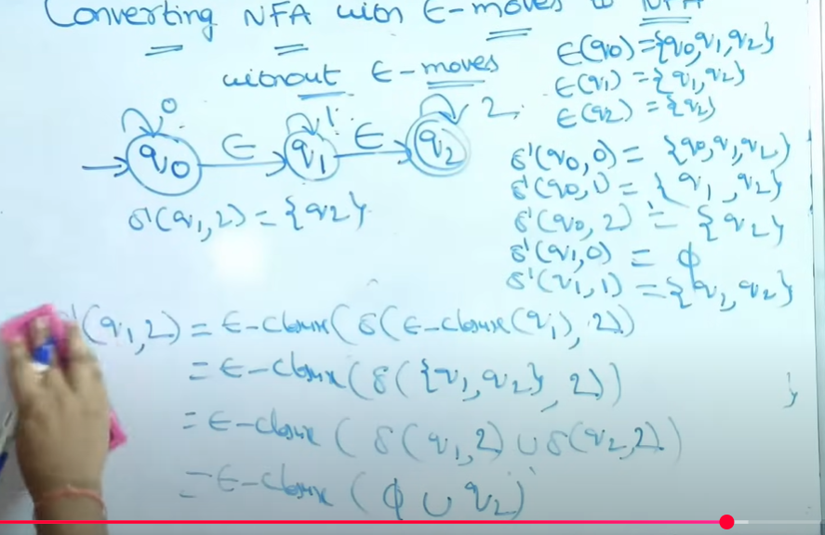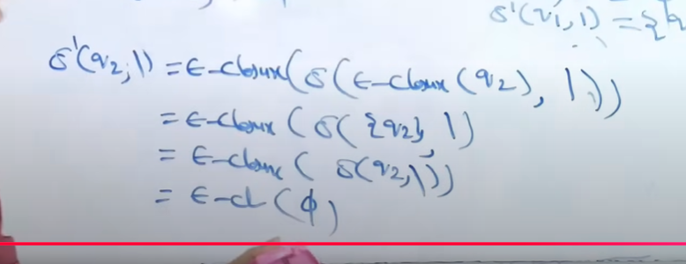
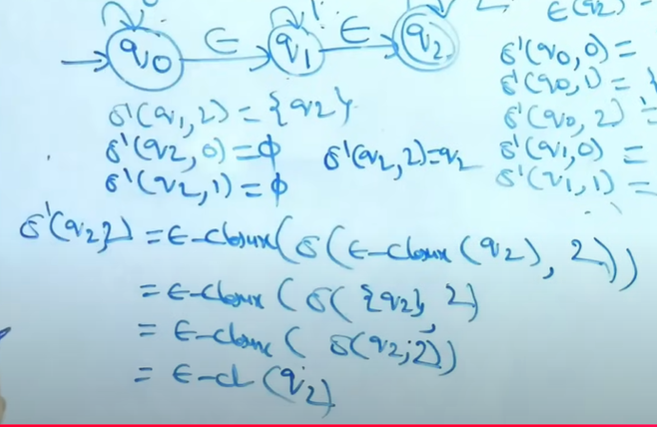
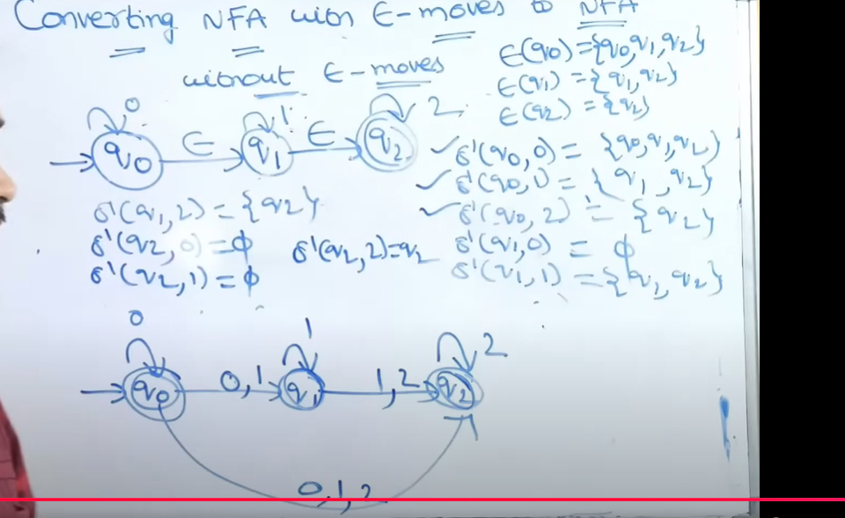

9. . Conversion of NFA to DFA
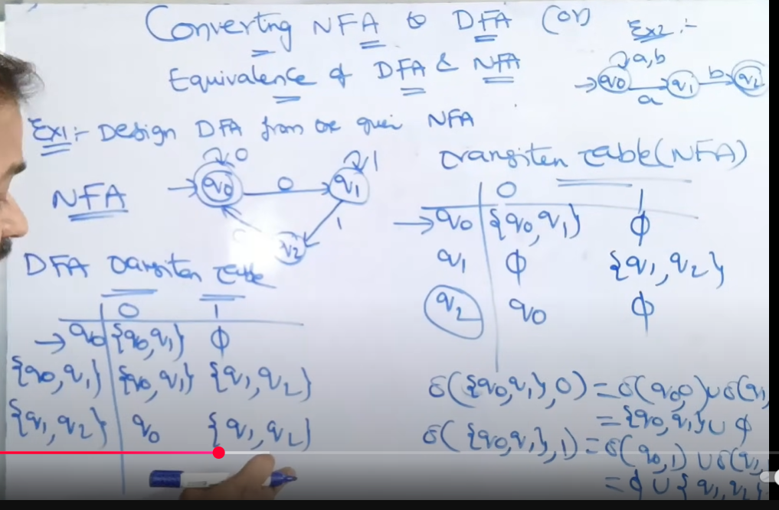

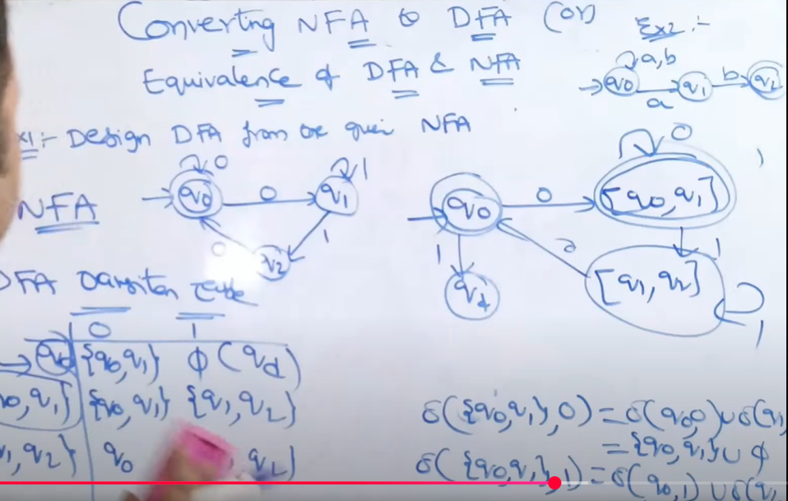

10.Moore and Melay machine
Moore and Mealy Machines are Transducers that help in producing outputs based on the input of the current state or previous state
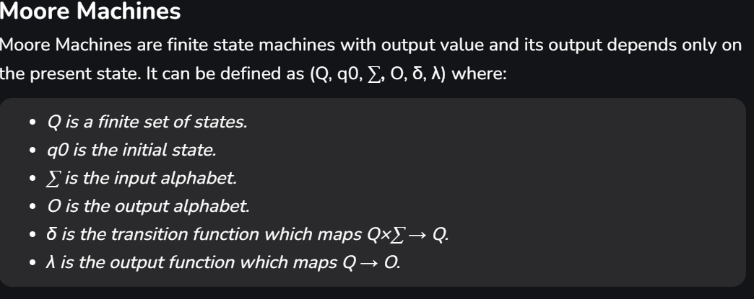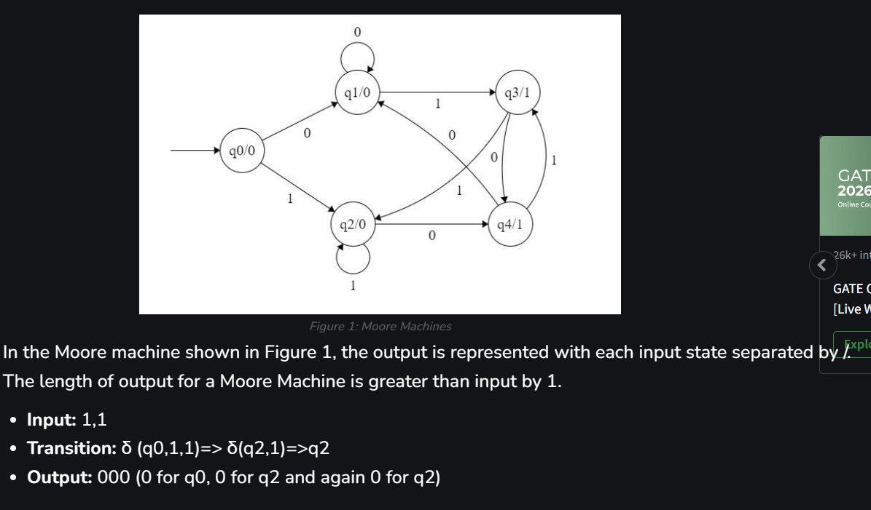

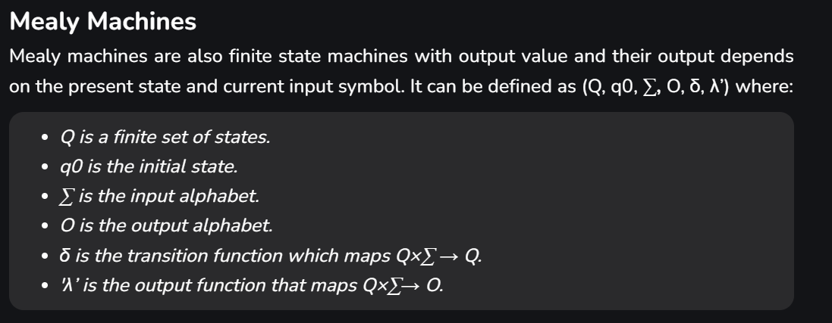
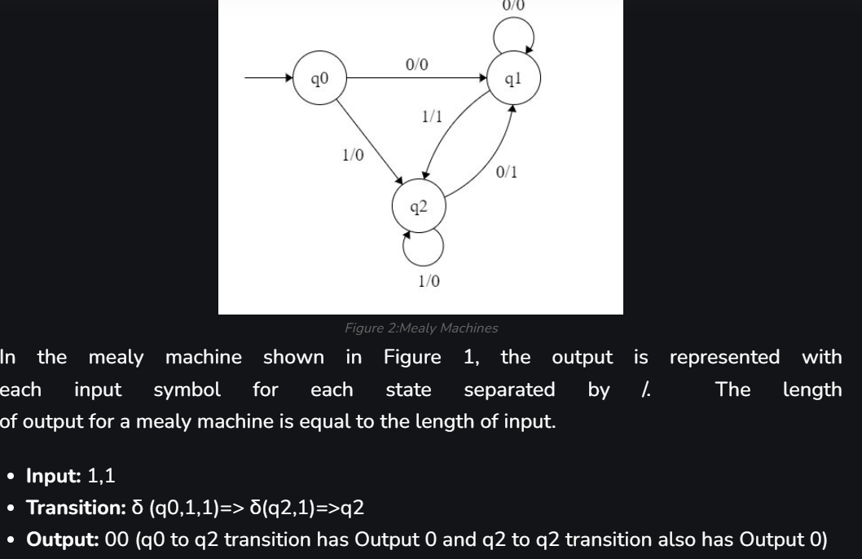

UNIT-2
Regular Expression
1.Finite Automata and Regular Expression
If L=L(A) for some DFA, then there is a regular expression R such that L=L(R)
We are going to construct regular expressions from a DFA by eliminating states.
When we eliminate a state s, all the paths that went through s no longer exist in the automaton.
If the language of the automaton is not to change, we must include, on an arc
that goes directly from q to p ,the labels of paths that went from some state q to state p , through s.
The label of this arc can now involve strings, rather than single symbols (may be an infinite number of strings).
We use a regular expression to represent all such strings.
Thus, we consider automata that have regular expressions as labels.

2.Construct finite automata to regular expression
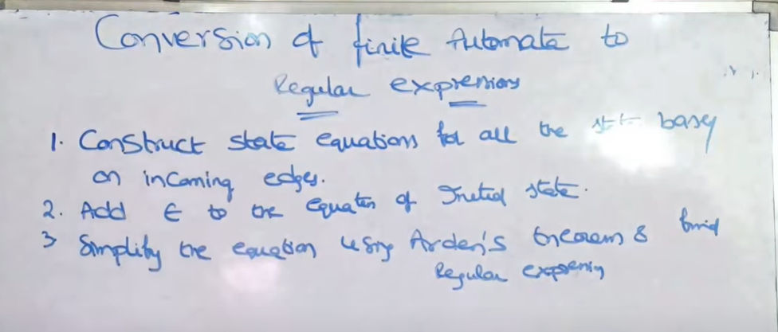
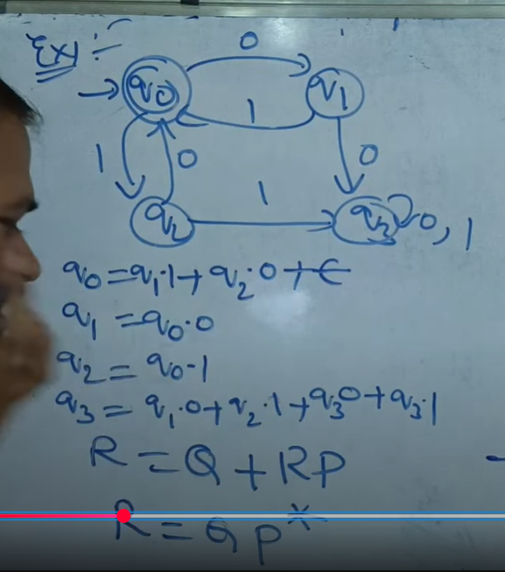
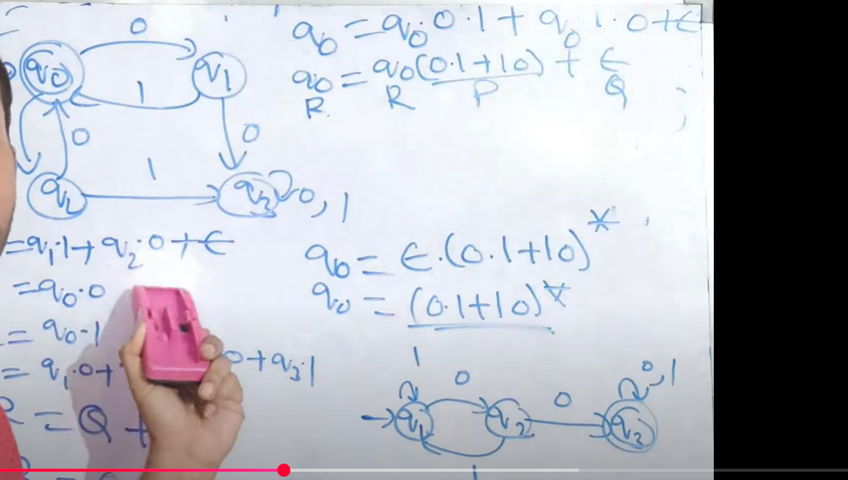

3.Application of Regular Expression
• Data Validation
• Data Scraping
• Data Wrangling
• Simple Parsing
• Syntax Highlighting Systems
• Internet Search Engines

4.Algebraic Laws for Regular Expression
Definition :Two regular expressions with variables are equivalent if whatever
languageswe substitute for the variables, the results of the two expressions are the
same language.
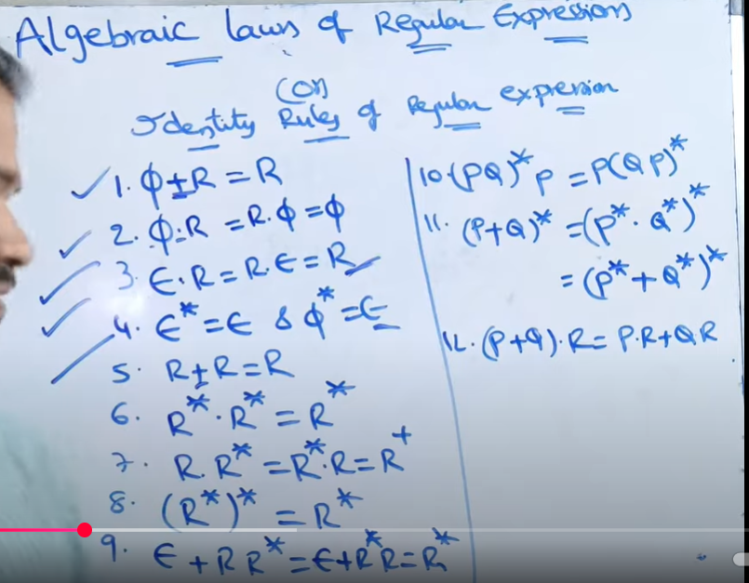

5.Pumping Lemma for Regular Expression
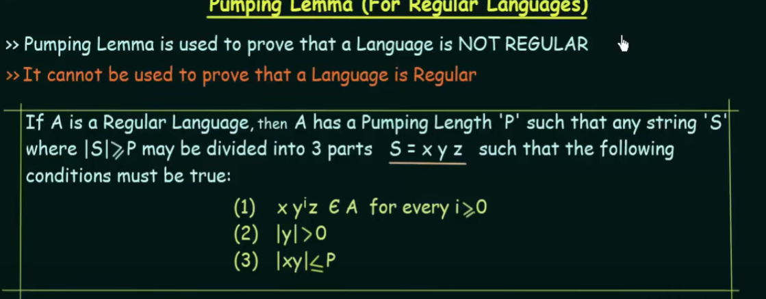
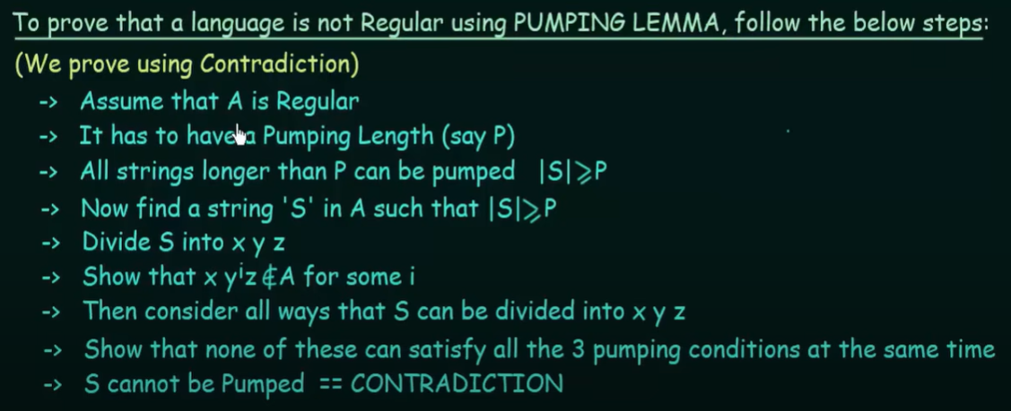
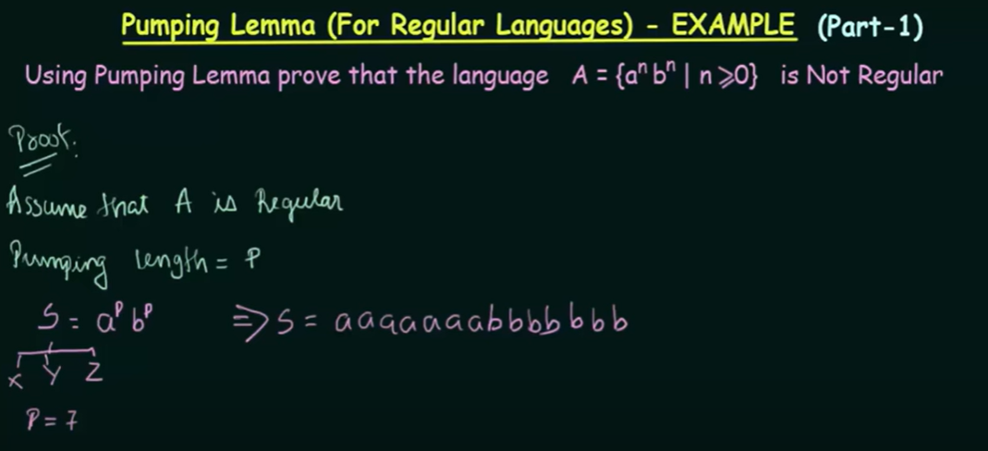
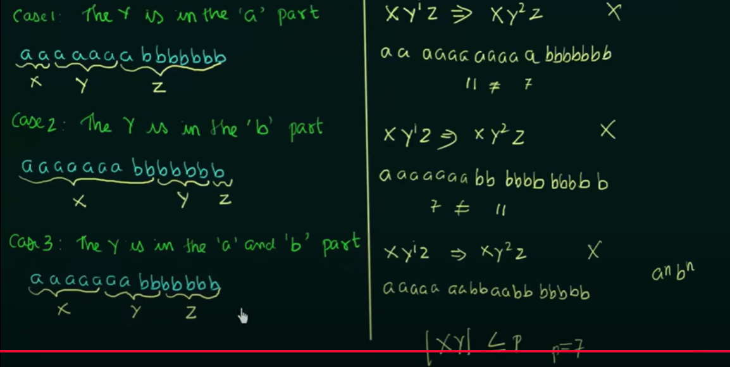

Application of Pumping Lemma
- Proving a Language is Not Regular
- Analyzing Context-Free Languages
- Designing Automata and Grammars
- Verifying Language Properties
- Testing Regular Expression Equivalence
- Algorithm Optimization

6.Closure Property of Regular Expression
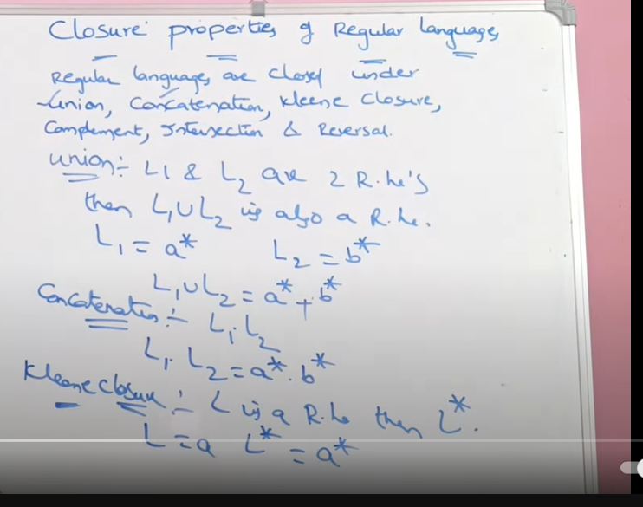
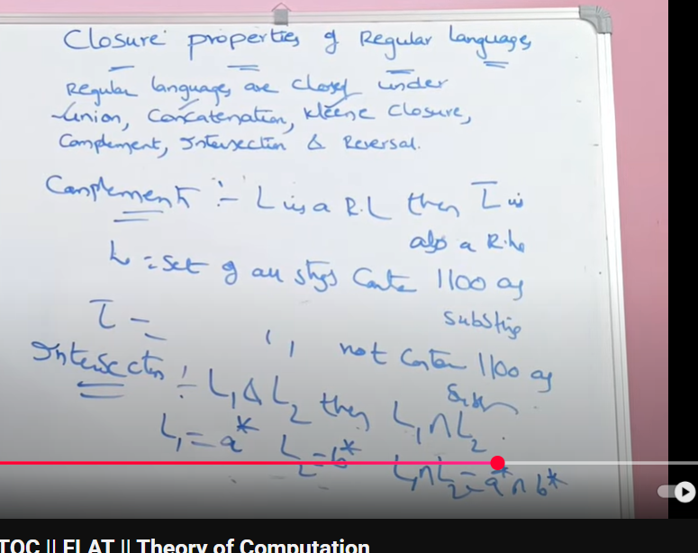
7.Decision Tree of Regular Language
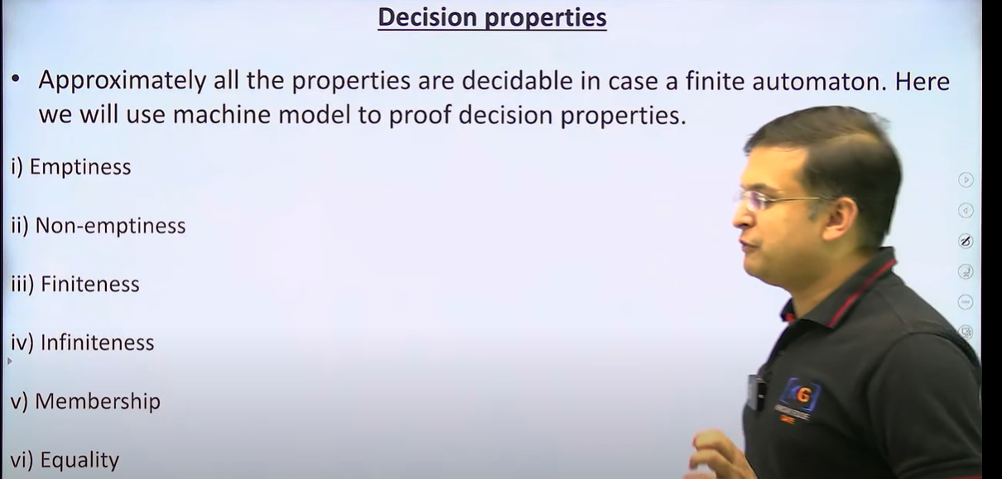
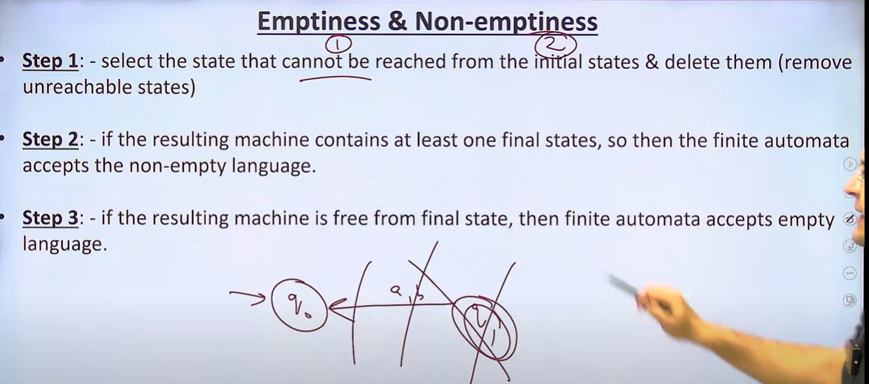
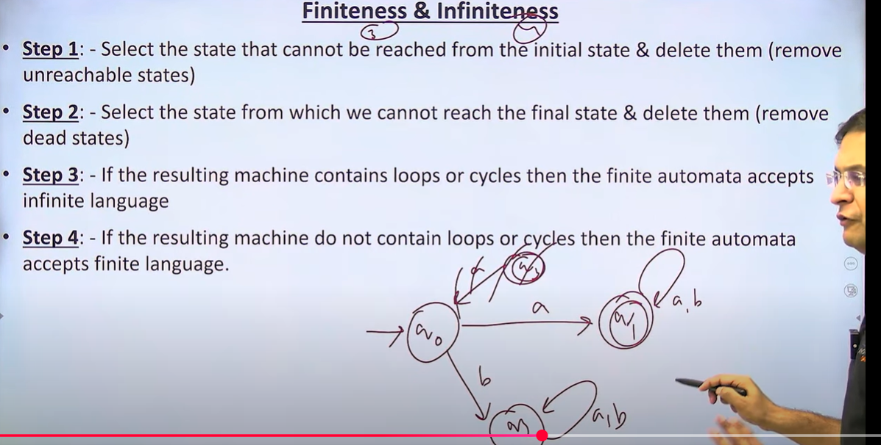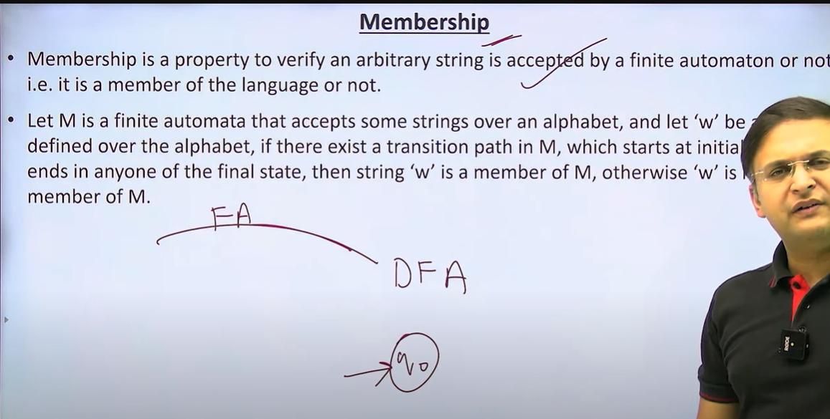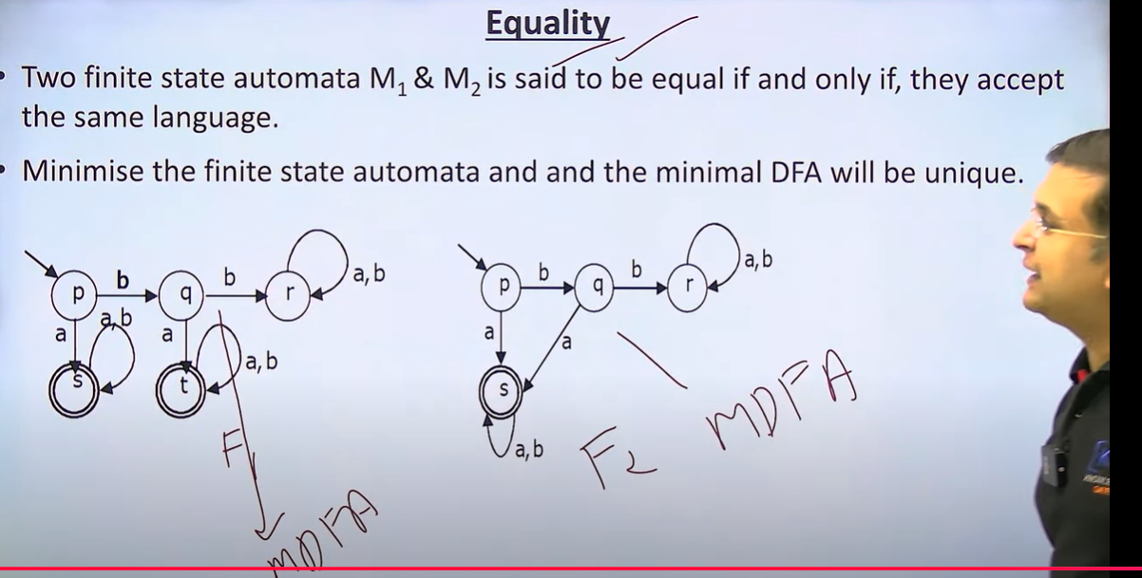

8. Equivalence and Minimization of Automata.
