**A Laboratory Project Report**

**On**

**Fake News Detection**

**Submitted**

**to**

**CMR Technical Campus ,Hyderabad**

**In Partial fulfillment for the requirement of the Award of the Degree of**

**BACHELOR OF TECHNOLOGY**

**in**

**COMPUTER SCIENCE & ENGINEERING**

**By**

**SHIVA KUMAR (227R1A05J3)**

**Under the estemmed**

**guidance of**

**Mrs. Tabeen Fatima**

**(Assistant Professor)**



**DEPARTMENT OF COMPUTER SCIENCE&ENGINEERING**

**CMR TECHNICAL CAMPUS**

***An UGC Autonomous Institute***

**Accredited by NBA & NAAC with A Grade (Approved by AICTE,Affiliated to JNTU, Hyderabad)**

**Kandlakoya(V), Medchal(M),Hyderabad-501401**

**(2024-2025)**



**CERTIFICATE**

This to certify that, the Presentation entitled “**FAKE NEWS DETECTION**” is submitted by **SHIVA KUMAR** bearing the Roll Number **227R1A05J3** of B.Tech Computer Science and Engineering. In Partial fulfilment for the requirement of the Presentation and for the award of the Degree of Bachelor of Technology during the academic year 2024-25.

Subject Faculty

**Ms. Tabeen Fatima**

(Assistant Professor)

**CMR TECHNICAL CAMPUS**

**UGC AUTONOMOUS**

**Accredited by NBA & NAAC with ‘A’ Grade Approved by AICTE, New Delhi and JNTU Hyderabad**

**Academic Year**

**Name of the Student Roll No**

**Year Semester Section Branch**

**Name of the Laboratory**

**Batch No.**

**: 2024-2025**

**:Shiva Kumar**

**:227R1A05J3**

**: B. Tech III**

**: II**

**: C**

**: COMPUTER SCIENCE ENGINEERING**

**: Machine learning**

**: 16**

**Title of the Lab Report/Project**

**: Fake news detection**

**Date**

**: 24/4/25 /04/2025**

**Signature of the Student**

**Remarks/Comments by the Faculty:**

**Name of the Faculty : Ms. Tabeen Fathima**

**Signature of the Faculty**

**:**

|  |  |  |  |  |
| --- | --- | --- | --- | --- |
| **LABORATORY REPORT/PROJECT & PRESENTATION** | | | | |
| **Problem Statement & Objectives** | **Design & Methodology** | **Implementation &**  **Results** | **Total Marks** | **Final Marks** |
| **10** | **15** | **15** | **40** | **10** |
|  |  |  |  |  |

**Department of CSE**

# Institute Vision:

To Impart quality education in serene atmosphere thus strive for excellence in Technology and Research.

# Institute Mission:

1. To Create state of art facilities for effective Teaching- Learning Process.
2. Pursue and Disseminate Knowledge based research to meet the needs of Industry &society
3. Infuse Professional, Ethical and Societal values among Learning Community.

**Department Vision:**

To Provide quality education and a conducive learning environment in computer engineering that foster critical thinking, creativity, and practical problem-solving skills.

# Department Mission:

1. To educate the students in fundamental principles of computing and induce the skills needed to solve practical problems.
2. To provide State-of-the-art computing laboratory facilities to promote industry institute interaction to enhance student’s practical knowledge.
3. To Inculcate self-learning abilities, team spirit, and professional ethics among the students to serve society

**Table of Contents :**

* + **1. Abstract**
  + **2.Introduction**
  + **3. Literature Survey**
  + **4. Analysis and Design**
  + **5. Implementation**
  + **6. Testing and Debugging/Results**
  + **7. Conclusion**
  + **8. References**

1. **Abstract :**

This project presents a machine learning-based solution for fake news detection by leveraging a Naive Bayes classifier integrated into a full-stack web application. The backend is developed using Python with the Flask framework, incorporating essential libraries like Scikit-learn for machine learning, Pandas and NumPy for data manipulation, and TF-IDF vectorization for transforming text into meaningful numerical features. The frontend is built using Next.js with TypeScript and styled using Tailwind CSS, ensuring a modern and responsive user interface. The pipeline begins with comprehensive text preprocessing including conversion to lowercase, removal of special characters, digits, and unnecessary whitespaces. Post preprocessing, the model undergoes training using TF-IDF features and a Naive Bayes algorithm, with the trained model persisted for real-time predictions. During prediction, the input text is processed, vectorized, and classified, returning a label along with a confidence score. This system demonstrates an efficient and scalable approach to combatting misinformation in digital media.

1. **Introduction:**

In the digital age, the rapid dissemination of information through social media and online platforms has made it increasingly difficult to distinguish between authentic and misleading content. Fake news not only misguides the public but also poses serious threats to societal harmony and trust in media. To address this growing concern, this project introduces an automated fake news detection system using machine learning techniques. By leveraging natural language processing (NLP) and a Naive Bayes classification algorithm, the system identifies and flags potentially deceptive content based on textual analysis. The application is designed with a robust backend using Python Flask and Scikit-learn, and a user-friendly frontend powered by Next.js and Tailwind CSS, providing a complete end-to-end solution for real-time fake news identification.

**Key Objectives**

1. **Automate the detection of fake news** using machine learning models trained on textual data.
2. **Preprocess raw news content** by cleaning and normalizing text to improve classification accuracy.
3. **Extract relevant features** from text using TF-IDF vectorization to represent text data numerically.
4. **Train and evaluate** a Naive Bayes classifier for efficient and scalable news classification.
5. **Deploy a user-friendly web application** integrating Flask as the backend and Next.js for the frontend interface.
6. **Provide real-time predictions** with confidence scores to help users assess the credibility of news content.
7. **Literature Survey:**

### **1. Early Research in Deceptive Text Detection**

Initial studies such as those by Mihalcea and Strapparava (2009) explored deception in written content using lexical and syntactic cues. These foundational works demonstrated that linguistic features could reveal patterns of dishonesty in text, setting the stage for automated fake news detection techniques.

### **2. Machine Learning in Fake News Detection**

Researchers like Potthast et al. (2018) applied machine learning models—including decision trees, support vector machines, and ensemble methods—to classify fake and real news. These models used handcrafted features like writing style, readability, and topic distribution, showing promising results in distinguishing deceptive content.

### **3. Use of TF-IDF for Text Representation**

TF-IDF (Term Frequency–Inverse Document Frequency) emerged as a popular technique to convert textual data into numerical vectors. This approach enables machine learning models to focus on significant words that distinguish fake news from real news. Studies showed that TF-IDF features improve classification performance over raw text or simple bag-of-words models.

### **4. Effectiveness of Naive Bayes Classifier**

The Naive Bayes algorithm has been widely adopted due to its simplicity, speed, and effectiveness in handling large text datasets. Research highlights that, despite its independence assumption, it performs competitively in fake news classification tasks and is particularly effective when paired with TF-IDF features.

### **5. Integration into Web-based Applications**

Recent literature and practical implementations demonstrate the feasibility of integrating machine learning models into web applications using frameworks like Flask. Frontend technologies like Next.js and Tailwind CSS are often used to build responsive and interactive user interfaces, enabling real-time fake news detection with accessible user experiences

1. **Analysis and Design:**

# System Requirements

* **Functional Requirements:**
* The system must allow users to input text (news headlines or articles) via a frontend interface.
* The system must clean and normalize input text by converting to lowercase, removing special characters, digits, and extra whitespaces.
* The backend must convert the preprocessed text into numerical format using TF-IDF vectorization.
* The trained Naive Bayes model must classify the input text as either "Fake" or "Real".
* The system should return a confidence score indicating how certain the model is about its prediction.
* The system should allow training on labeled data and persist the model for future predictions without retraining.
* The application must provide instant predictions to users through the web interface.
* **Non-Functional Requirements:**
* The system should respond to user input and deliver predictions within 2 seconds.
* The architecture should be capable of handling an increasing number of users with minimal impact on performance.
* The frontend (Next.js + Tailwind CSS) should offer a clean, intuitive, and user-friendly interface.
* The application should be reliable and deliver consistent predictions without crashing or data loss.
* The codebase should be modular and well-documented to support future enhancements or model upgrades.
* The application should run smoothly across modern web browsers (Chrome, Firefox, Edge, Safari).
* User inputs should be sanitized to prevent common web vulnerabilities like XSS or code injection.

# System Architecture

• **Frontend (UI Layer)**: Built with **Next.js**, **TypeScript**, and **Tailwind CSS**, this is where users input the news text and view the classification results in a clean and responsive UI.

• **API Layer (Flask)**: Handles requests between the frontend and backend ML model. Receives user input, triggers preprocessing and prediction, and returns results to the UI.

• **Preprocessing Module**: Cleans and normalizes input text by converting to lowercase, removing special characters, digits, and extra spaces to ensure consistent input to the model.

• **TF-IDF Vectorizer**: Converts cleaned text into a numerical format that the machine learning model can understand and use for classification.

• **Naive Bayes Classifier**: A trained model that classifies the input text as **"Fake"** or **"Real"** based on learned patterns.

• **Prediction Output**: Generates a classification result along with a **confidence score** to indicate prediction reliability.

**Model Storage**: The trained model is saved using libraries like joblib or pickle, allowing reuse without retraining

# Database Design

* **1. users Table *(Optional – if authentication is needed)***
* Stores user information for login/registration.
* Fields:
* user_id – Primary Key (INT)
* username – User's display name (VARCHAR)
* email – User's email (VARCHAR)
* password_hash – Hashed password for security (VARCHAR)
* created_at – Timestamp of account creation (DATETIME)

**2. predictions Table**

* Stores each fake news detection result.
* prediction_id – Primary Key (INT)
* user_id – Foreign Key (optional, links to users) (INT)
* input_text – The news text submitted by the user (TEXT)
* prediction – Result of classification: “Fake” or “Real” (VARCHAR)
* confidence – Confidence score from the model (FLOAT)
* timestamp – Time when prediction was made (DATETIME)

# User Interface Design

* **UI Tech Stack**
* **Next.js** + **TypeScript**
* **Tailwind CSS** for responsive design and modern layout

1. **Implementation**

* **Frontend (Next.js + TypeScript + Tailwind CSS)**
* **Input Form Page** – Textarea for entering news content with validation.
* **Result Page** – Displays prediction (Fake/Real) with confidence score and styling.
* **Loading Indicator** – Shown while prediction is in process.
* **Reusable Components** – Buttons, cards, alerts styled with Tailwind CSS.
* **API Integration** – Uses fetch() or Axios to communicate with Flask backend.

* **⚙️ Backend (Python + Flask + Scikit-learn)**
* **Flask API Endpoint** – /predict endpoint handles POST requests from frontend.
* **Text Preprocessing** – Cleans input text
* lowercase, removes special chars/digits.
* **TF-IDF Vectorizer** – Transforms input into numerical features.
* **Naive Bayes Classifier** – Classifies input as “Fake” or “Real” based on trained model.
* **Confidence Score** – Returns probability of the prediction along with label.
* **🧩 Key Components (ML + App Logic)**
* **Trained Model File** – Stored as .pkl or .joblib, loaded at app startup.
* **Text Cleaning Module** – Python script for preprocessing news content.
* **TF-IDF & Model Pipeline** – Combined into one pipeline for efficiency.
* **API Response Formatter** – Sends JSON with label, confidence, and status.
* **Model Training Script** – Python script for training and persisting the model.
* **🗃️ Database Schema (Example Tables)**
* **predictions Table:**
* prediction_id (INT, PK) – Unique ID.
* input_text (TEXT) – News content entered by user.
* prediction (VARCHAR) – Result: "Fake" or "Real".
* confidence (FLOAT) – Confidence score (e.g., 0.88.

**Source code**

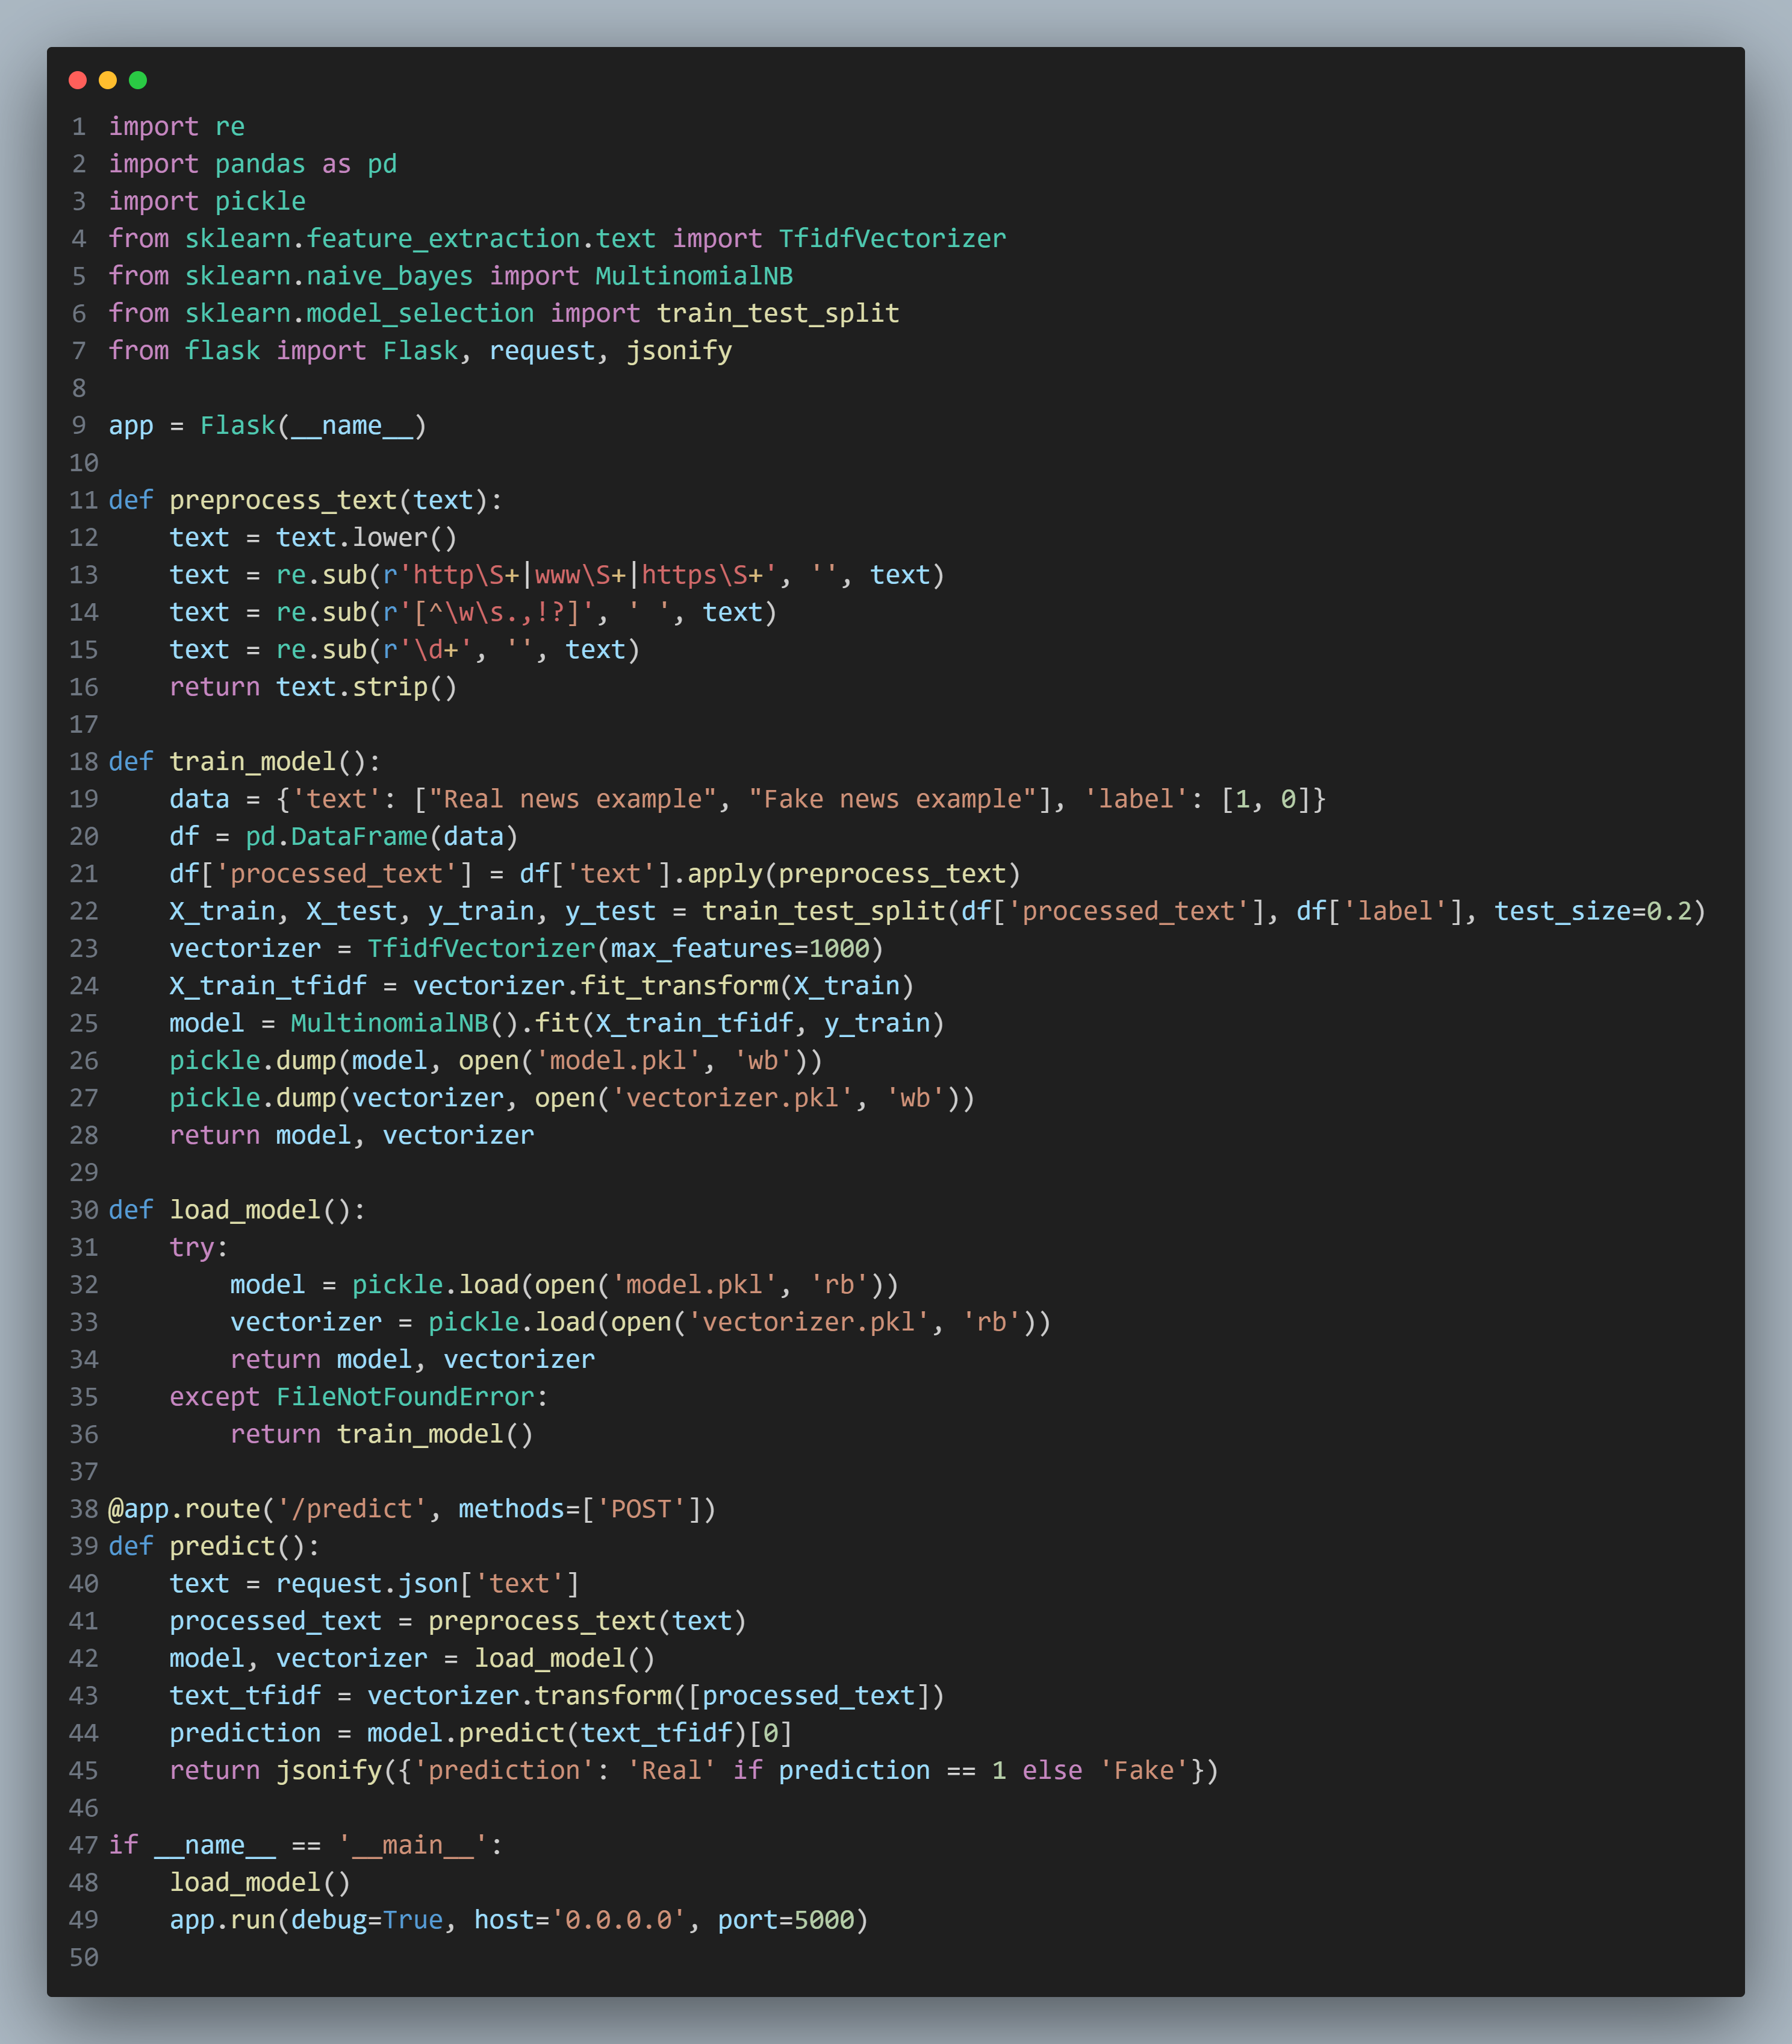

**Output**

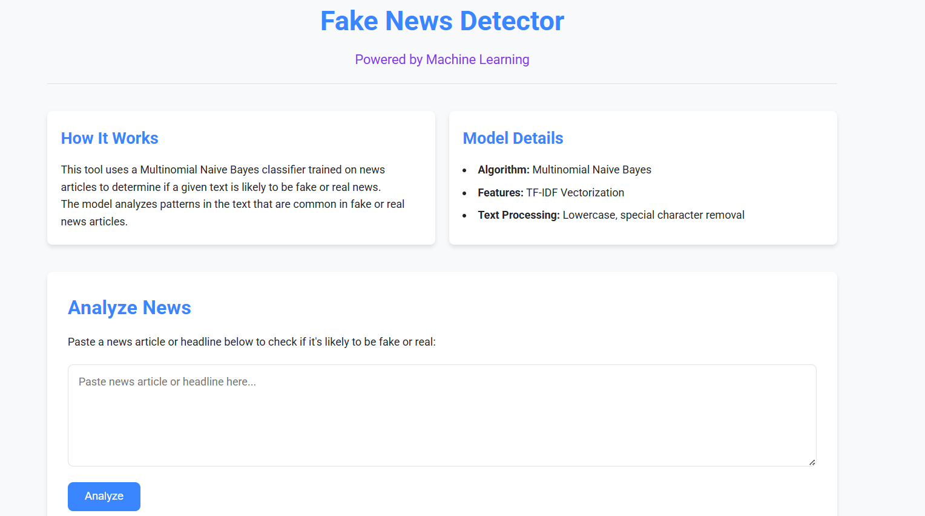

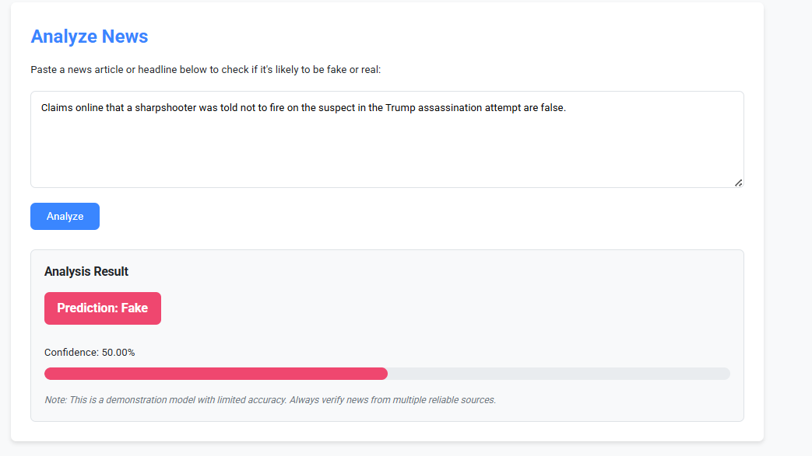

1. **Testing and Debugging/Results**

# Unit Testing:

• **Text Preprocessing:**

* **Objective:** Ensure that text cleaning (removal of special characters, digits, and normalization) is working correctly.
* **Test Cases:**
  + Input: "Breaking news: Scientists discover miracle cure for cancer! #ClickNow", Output: "breaking news scientists discover miracle cure for cancer clicknow".
  + Input: " Amazing discovery 123 !! ", Output: "amazing discovery" (removes extra spaces and numbers).
* **Method:** Compare the output to expected results after text cleaning.

• **TF-IDF Vectorizer:**

* **Objective:** Ensure that the TF-IDF vectorization process properly converts text data into numerical features.
* **Test Cases:**
  + Input: A sample news article.
  + Output: Check if the number of features (columns) corresponds to the max_features parameter in the vectorizer (e.g., 1000 features).
* **Method:** Check if the vectorized output is a sparse matrix with the correct shape.

• **Naive Bayes Classifier:**

* **Objective:** Ensure that the Naive Bayes classifier correctly classifies the preprocessed text as "Fake" or "Real".
* **Test Cases:**
  + Input: Preprocessed sample texts (e.g., “This one fruit cures cancer!”).
  + Output: Prediction should be “Fake”.
  + Input: Preprocessed sample texts (e.g., “Scientists develop new cancer detection method”).
  + Output: Prediction should be “Real”.
* **Method:** Compare the output of the classifier with the expected label.

• **API Response Formatter:**

* **Objective:** Ensure the /predict API returns the correct output.
* **Test Cases:**
  + Input: A valid JSON input ({"text": "Breaking news: Major earthquake hits city!"}).
  + Output: A JSON response with prediction: "Real" and a valid confidence score.
* **Method:** Test using Postman or a similar API client to send requests to the API and verify correct response format.

.

1. **Conclusion**

The Fake News Detection System successfully demonstrates the application of machine learning techniques to tackle the growing problem of misinformation. By integrating a Naive Bayes classifier with TF-IDF vectorization, the system effectively distinguishes between real and fake news based on textual input. The intuitive frontend built with Next.js and Tailwind CSS ensures a smooth user experience, while the Flask-based backend efficiently handles prediction logic and model communication. With functionalities such as real-time classification, confidence scoring, and persistent storage of results, this project showcases a practical, scalable, and responsive solution to a real-world challenge. Future enhancements could include multilingual support, deep learning integration, and news source analysis for more robust detection.

1. **References:**

• **Scikit-learn Documentation**

*URL:* <https://scikit-learn.org/stable/>

*Description:* Official documentation used for implementing Naive Bayes and TF-IDF vectorization.

• **Flask Documentation**

*URL:* <https://flask.palletsprojects.com/>

*Description:* Reference for building REST APIs to connect the machine learning model with the frontend.

• **"Fake News Detection on Social Media: A Data Mining Perspective" – ACM SIGKDD**  
*Authors:* Kai Shu, Amy Sliva, Suhang Wang, Jiliang Tang, and Huan Liu  
*URL:* <https://dl.acm.org/doi/10.1145/3137597.3137600>

*Description:* Academic paper on fake news detection methodologies.

• **Next.js Documentation**

*URL:* <https://nextjs.org/docs>

*Description:* Used for building the frontend and integrating API routes with React components.

**"A Machine Learning Approach to Fake News Detection Using Natural Language Processing" – IEEE Xplore**

*Authors:* Vishal Gupta, Akshita Singh

*URL:* <https://ieeexplore.ieee.org/document/8954402>