LINUX SECURITY MONITORING
USING WAZUH
SOC / Blue Team Project Documentation

Author
Shivam
Technologies Used
Wazuh SIEM (Manager & Dashboard v4.13.1) | Ubuntu / Kali GNU-Linux 2026.2
OpenSSH | Linux Auth Logs (/var/log/auth.log) | Wazuh Agent
DQL / Lucene Query Language | MITRE ATT&CK Framework
Category: Security Operations Center (SOC) | Blue Team | Threat Detection

2. Project Overview

2.1 Introduction
Linux systems are among the most widely deployed server operating systems in enterprise environments, making them a frequent target for brute-force attacks, unauthorized access attempts, and privilege escalation. Linux Security Monitoring involves continuously collecting, correlating, and analyzing system and authentication logs to detect malicious activity in real time. This project implements a centralized log monitoring and threat detection pipeline using Wazuh, an open-source SIEM/XDR platform, to monitor SSH authentication activity on a Linux endpoint.

2.2 Purpose
The purpose of this project is to simulate a real-world SOC monitoring workflow — deploying an endpoint agent, generating authentic attack traffic (SSH brute-force / invalid-user login attempts), and using the Wazuh dashboard to detect, investigate, and validate the resulting security alerts.

2.3 Objectives
- Deploy and register a Wazuh Agent on a Linux endpoint (Kali GNU/Linux).
- Enable and verify centralized SSH / PAM authentication log collection.
- Simulate SSH authentication failures and non-existent-user login attempts.
- Detect and triage alerts using the Wazuh Threat Hunting module.
- Correlate alerts to MITRE ATT&CK techniques (Brute Force, Password Guessing).
- Cross-verify Wazuh alerts against raw Linux authentication logs.
- Document findings in a SOC-analyst-style investigation report.

3. Technologies Used
Technology | Role in the Project
Wazuh (Manager + Dashboard) | Open-source SIEM/XDR platform used to collect, correlate, and visualize security events and generate alerts.
Ubuntu / Kali Linux | Monitored endpoint (agent host) generating authentication and system logs.
SSH (OpenSSH) | Remote access service targeted for authentication monitoring and brute-force simulation.
Linux Authentication Logs | /var/log/auth.log — source of truth for PAM and sshd authentication events, used to validate alerts.
Wazuh Dashboard (Kibana-based) | Web UI used for agent management, threat hunting, event search, and alert visualization.

4. Lab Architecture
The lab follows a standard centralized SIEM architecture consisting of three logical tiers:
┌────────────────────────────┐
Ubuntu / Kali Endpoint (Wazuh Agent)
└────────────────────────────┘
│ (encrypted agent-manager protocol, port 1514/1515)
▼
┌────────────────────────────┐
Wazuh Manager (node01 — rule engine)
└────────────────────────────┘
│ (indexed alerts, port 9200)
▼
┌────────────────────────────┐
Wazuh Dashboard (visualization & threat hunting UI)
└────────────────────────────┘

4.1 Log Flow
- The Wazuh Agent installed on the Linux endpoint continuously reads /var/log/auth.log and other system log sources.
- Raw log lines are forwarded securely to the Wazuh Manager, which decodes them and evaluates them against its detection rule set.
- Events matching a rule are converted into alerts, enriched with rule level, MITRE ATT&CK mapping, and metadata, then indexed for search.
- The Wazuh Dashboard queries the indexed alerts to power the Threat Hunting module, enabling SOC analysts to search, filter, and visualize activity in near real time.

5. Implementation

5.1 Wazuh Agent Installation
The Wazuh Agent package was installed on the Kali Linux endpoint and configured to point to the Wazuh Manager's IP address. The sshd service was explicitly started on the endpoint (systemctl start ssh) to enable inbound SSH connections for monitoring and testing.

5.2 Agent Registration
After installation, the agent was registered with the Wazuh Manager and grouped under the default agent group. Registration was verified from the Endpoints Summary page, which confirmed the agent ("shivam") as Active, running agent version v4.13.1 on cluster node node01 (see Figure 1).

5.3 Log Collection
The Wazuh Agent's logcollector module was configured to monitor /var/log/auth.log, which captures all PAM and sshd authentication events on the endpoint, including successful logins, failed passwords, and invalid-user attempts.

5.4 Authentication Monitoring
Wazuh's built-in sshd and PAM decoders/rules automatically classify authentication events, distinguishing between successful logins, authentication failures, and brute-force patterns (multiple failures from the same source in a short window).

5.5 Dashboard Verification
The Threat Hunting module was used to confirm that alerts generated on the endpoint were being received and indexed correctly by filtering on manager.name: wazuh-server and reviewing the resulting event count (see Figure 2).

6. Investigation

6.1 Attack Simulation
To generate realistic authentication activity, repeated SSH login attempts were made against the endpoint using a non-existent username (fakeuser) from a remote session. This simulates a common real-world reconnaissance / brute-force pattern used by attackers scanning for valid accounts.

6.2 Authentication Failure Analysis
Raw log evidence was cross-checked directly on the endpoint using tail -20 /var/log/auth.log, confirming multiple "Invalid user fakeuser", "Failed password for invalid user fakeuser", and "authentication failure" entries generated by sshd-session and pam_unix (see Figure 5).

6.3 SSH Login Monitoring
The Events view was filtered using agent.name:"shivam" to isolate all activity from the monitored endpoint, producing a timestamped histogram of event volume and a searchable table of rule.description, rule.level, and rule.id values (see Figure 4).

6.4 Threat Hunting
The Threat Hunting → Dashboard tab was used to pivot on rule.groups:sshd, isolating only SSH-related alerts. This surfaced 8 alerts, all classified as authentication failures, with MITRE ATT&CK mapping to Password Guessing, SSH, and Brute Force techniques (see Figure 7).

6.5 Alert Investigation
Drilling into the Events table for the sshd rule group revealed two distinct alert types: rule 5710 ("Attempt to login using a non-existent user", level 5) fired repeatedly, and rule 5712 ("sshd: brute force trying to get access to the system. Non existent user", level 10) fired once the repetition threshold was crossed — confirming Wazuh's frequency-based brute-force correlation logic (see Figure 6).

6.6 Correlation with Raw Logs
Every alert observed in the dashboard was traced back to a corresponding raw log line in /var/log/auth.log, validating that the Wazuh detection pipeline was accurately parsing and classifying endpoint activity with no false positives introduced during simulation.

7. Linux Commands Used
Command | Purpose
sudo tail -20 /var/log/auth.log | View the last 20 lines of the authentication log to inspect recent SSH/PAM login events.
cat /var/log/auth.log | Display the full contents of the authentication log for manual review.
grep "Failed password" /var/log/auth.log | Filter the log for failed SSH login attempts.
awk '{print $1,$2,$3}' /var/log/auth.log | Extract and format specific fields (e.g., timestamps) from log entries.
journalctl -u ssh -f | Follow live systemd journal logs for the SSH service in real time.
journalctl -u wazuh-agent | Review Wazuh Agent service logs for troubleshooting connectivity/registration.
systemctl start ssh | Start the SSH daemon on the endpoint to enable remote access.
systemctl status wazuh-agent | Check whether the Wazuh Agent service is active and running.

8. Dashboard Analysis

8.1 Agent Deployment & Registration
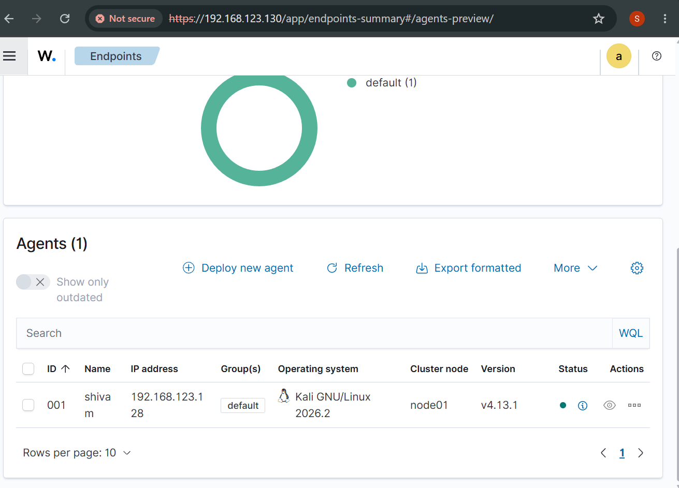
Figure 1: Wazuh Endpoints Summary — Agent Registration
This screenshot confirms the successful deployment and registration of the Wazuh Agent "shivam" (ID 001) running Kali GNU/Linux 2026.2 on cluster node node01, agent version v4.13.1, with an Active (green) status. From a SOC perspective, verifying agent health is the first step of any investigation — an inactive or disconnected agent means blind spots in visibility.

8.2 Threat Hunting — Overview
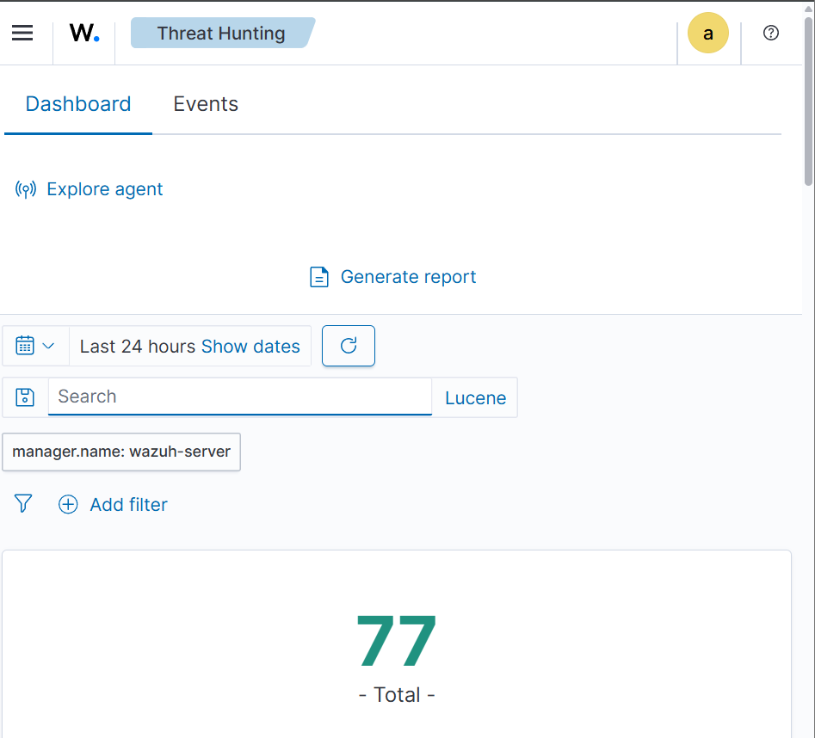
Figure 2: Threat Hunting Dashboard — 24-Hour Event Overview
The Threat Hunting dashboard, filtered to manager.name: wazuh-server over the last 24 hours, shows 77 total indexed events. This high-level view is typically the analyst's starting point each shift, giving a quick pulse-check on overall alert volume before drilling into specifics.

8.3 Authentication Monitoring Overview
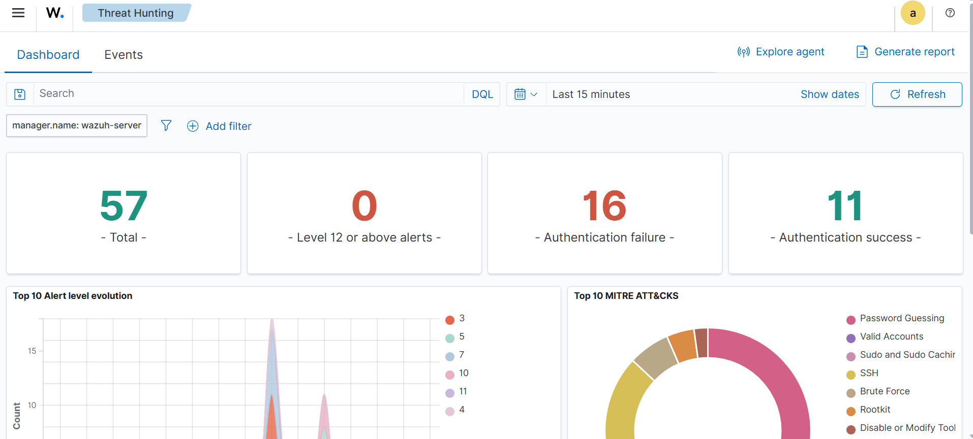
Figure 3: Authentication Monitoring Overview — KPIs and MITRE ATT&CK Mapping
This view (last 15 minutes) breaks down 57 total alerts into 16 authentication failures and 11 authentication successes, with zero critical (level 12+) alerts. The Top 10 MITRE ATT&CK donut chart shows the activity is dominated by Password Guessing and SSH-related techniques, giving the analyst immediate context on attacker TTPs without reading individual events.

8.4 Event Timeline & Alert Distribution
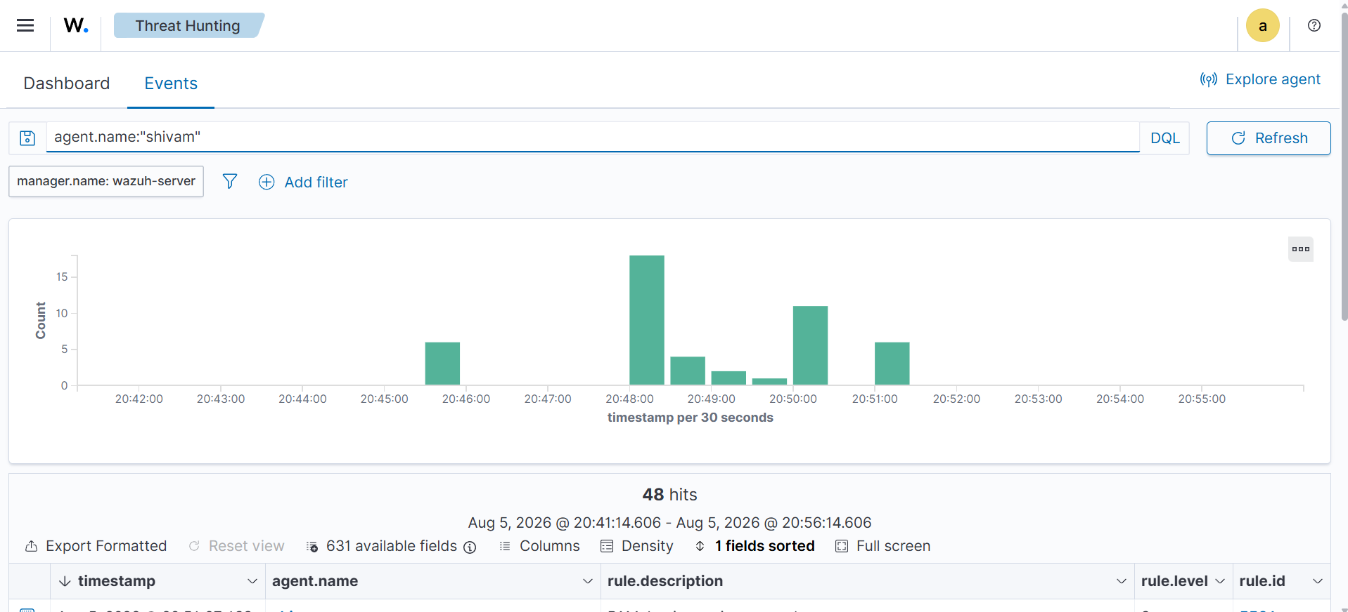
Figure 4: Events Table Filtered by Endpoint (agent.name:"shivam")
Filtering the Events view to a specific agent isolates 48 hits, with a per-30-second histogram showing clear activity spikes between 20:48–20:51. This timeline view is essential for establishing an attack window and correlating volume spikes with specific rule triggers, seen here alongside rule.description and rule.level columns.

8.5 Raw Authentication Log Validation
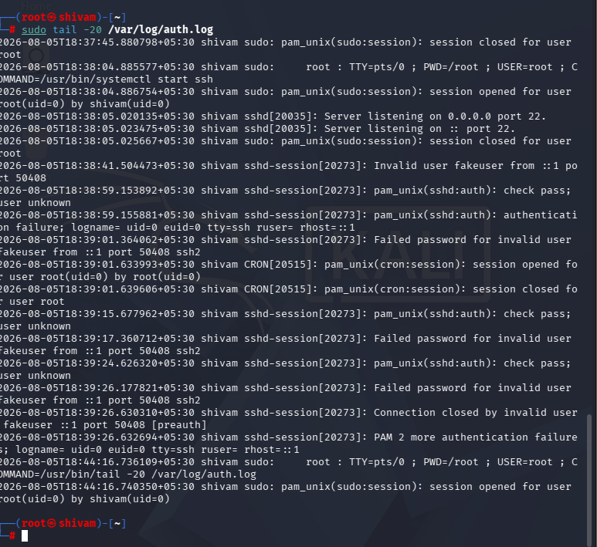
Figure 5: Terminal Output — /var/log/auth.log (Ground Truth Validation)
Direct inspection of the raw auth.log on the endpoint confirms repeated "Invalid user fakeuser" and "Failed password for invalid user fakeuser" entries from sshd-session and pam_unix, alongside legitimate sudo/cron activity. SOC analysts validate dashboard alerts against raw source logs to rule out false positives and confirm detection accuracy.

8.6 SSH Authentication Alert Details
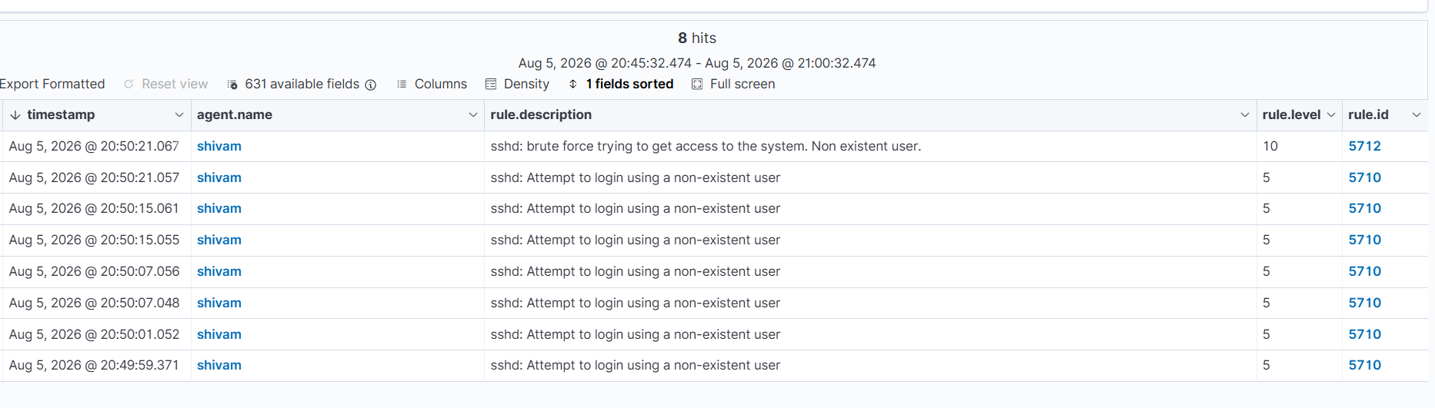
Figure 6: Events Table — SSH Brute-Force and Invalid-User Alerts
This table shows 8 individual alert hits: seven instances of rule 5710 ("Attempt to login using a non-existent user", level 5) followed by a single rule 5712 ("sshd: brute force trying to get access to the system. Non existent user", level 10). The level-10 alert demonstrates Wazuh's threshold-based correlation, escalating repeated low-severity events into a single high-confidence brute-force alert.

8.7 SSH Authentication Failure Analysis (Threat Hunting Pivot)
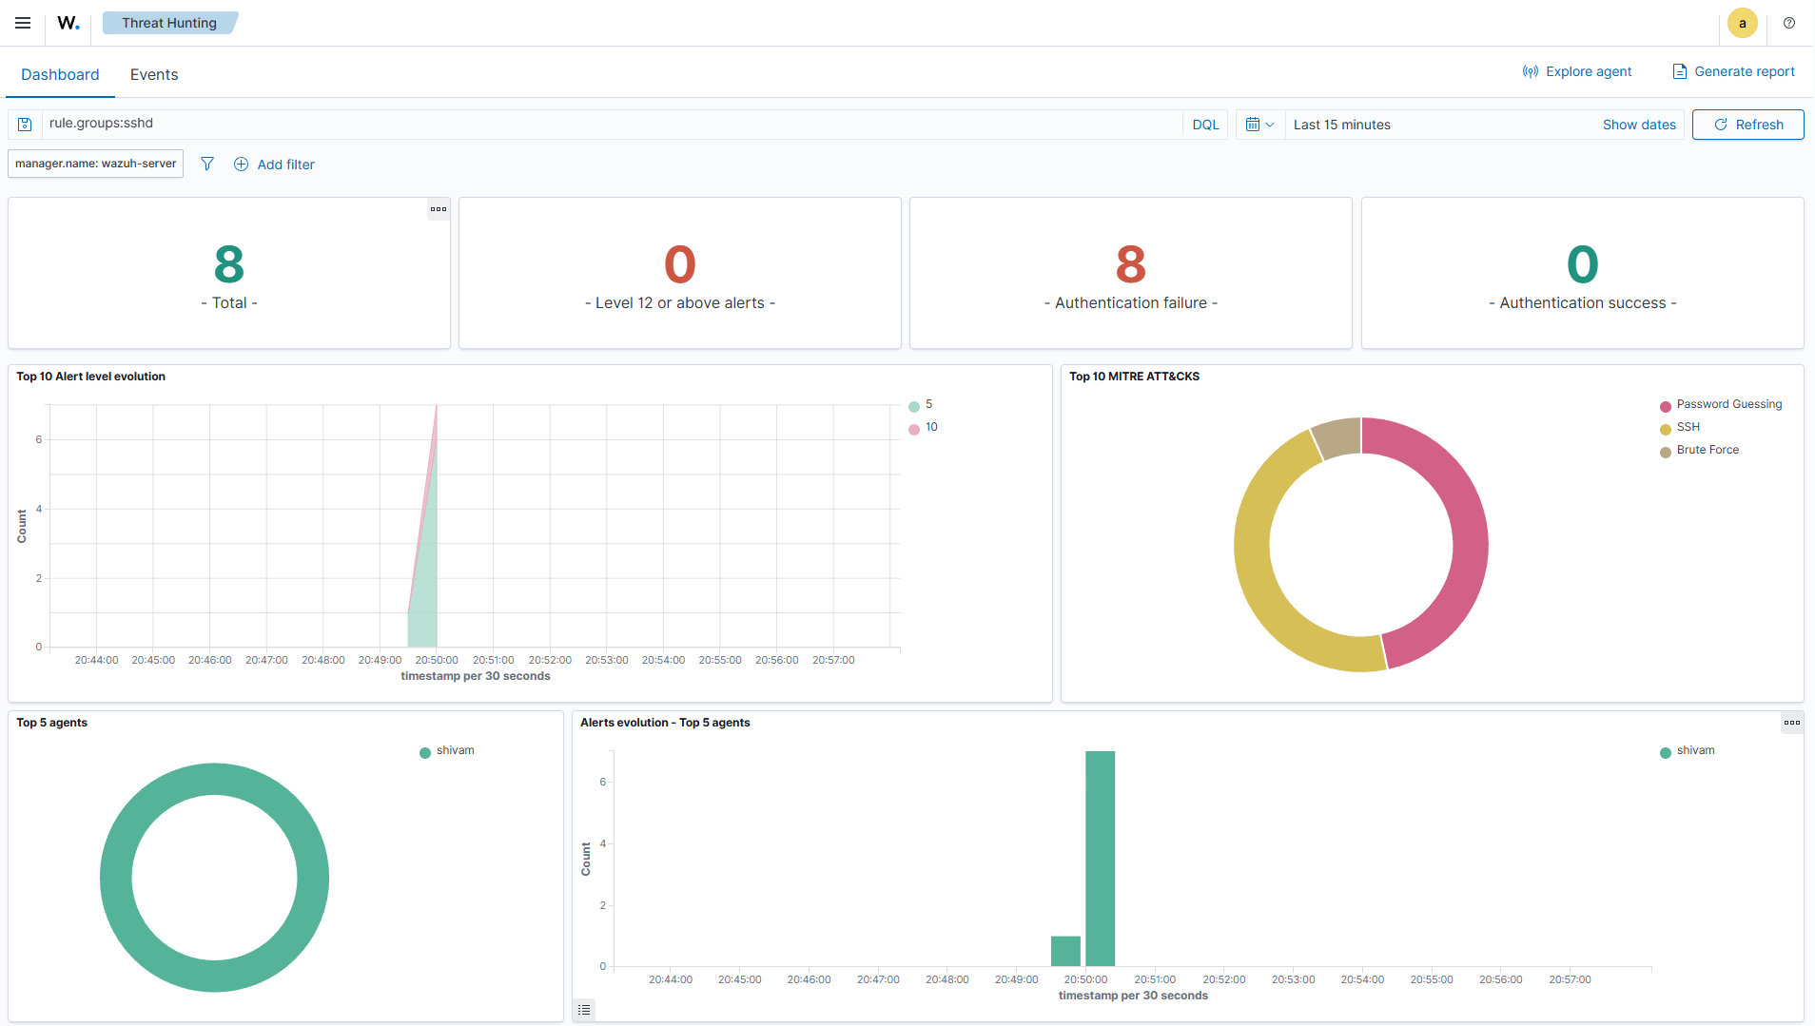
Figure 7: Threat Hunting Dashboard — Filtered on rule.groups:sshd
Pivoting the Threat Hunting dashboard on rule.groups:sshd isolates 8 SSH-specific alerts — all authentication failures, zero successes — with MITRE ATT&CK mapping to Password Guessing, SSH, and Brute Force. The "Top 5 Agents" panel confirms all activity originated from a single endpoint (shivam), consistent with a targeted brute-force simulation rather than a distributed attack.

9. Key Findings
- The Wazuh Agent was successfully deployed and reported healthy (Active) status throughout the monitoring period, confirming reliable log forwarding to the manager.
- A simulated SSH brute-force attempt using a non-existent user (fakeuser) generated 8 correlated SSH alerts, escalating from repeated level-5 "non-existent user" events into a single level-10 brute-force alert.
- 100% of dashboard alerts were traceable to corresponding raw entries in /var/log/auth.log, confirming detection accuracy with no observed false positives.
- MITRE ATT&CK mapping correctly classified the activity under Password Guessing and Brute Force techniques, demonstrating Wazuh's out-of-the-box threat-intelligence enrichment.
- All anomalous SSH activity originated from a single endpoint/agent (shivam), indicating a contained, non-distributed attack pattern suitable for straightforward triage and response.
- Zero critical (level 12+) alerts were recorded, indicating the simulated activity, while suspicious, did not escalate to a confirmed compromise during the monitoring window.

10. Skills Demonstrated
Category | Skills
Monitoring & Deployment | Linux Security Monitoring, Wazuh Agent Deployment & Registration
Detection | Authentication Monitoring, SSH Log Analysis, Threat Hunting
Investigation | Alert Investigation, Linux Log Analysis, Root-Cause Correlation
Operations | Blue Team Operations, SOC Workflow, MITRE ATT&CK Mapping

11. Conclusion
This project demonstrated an end-to-end Linux security monitoring workflow using Wazuh — from agent deployment and log collection through attack simulation, alert investigation, and raw-log validation. The exercise reinforced core SOC analyst competencies: verifying endpoint health, using threat hunting tools to pivot across data (by agent, rule group, and time), correlating dashboard alerts against MITRE ATT&CK techniques, and validating detections against ground-truth log data. The resulting detection pipeline successfully identified an SSH brute-force / invalid-user attack pattern with zero false positives, illustrating the practical value of centralized log monitoring in defending Linux infrastructure.

