Credit Card Weekly Status Dashboard using Power BI

Author: Shivani Bhatt
1. Project Objective
The objective of this project is to design and develop interactive Power BI dashboards to analyze credit card customer behavior and transaction performance.
The solution includes:
- Customer Analysis Dashboard
- Transaction Analysis Dashboard
- Extra Insights Dashboard
These dashboards provide weekly insights, customer segmentation, and revenue analysis to support business decision-making.

2. Data Source
The project uses two CSV datasets:
- CreditCard.csv → Transaction & revenue data
- Customer.csv → Customer demographics

3. Step-by-Step Implementation
Step 1: Import Data into Power BI
- Open Power BI Desktop
- Click Get Data → .CSV
- Load:
  - Credit Card dataset
  - Customer dataset
- Click Load
Step 2: Data Cleaning & Preparation
- Checked for null values
- Verified column data types
- Standardized date format
- Ensured numerical fields (Revenue, Amount) are correct

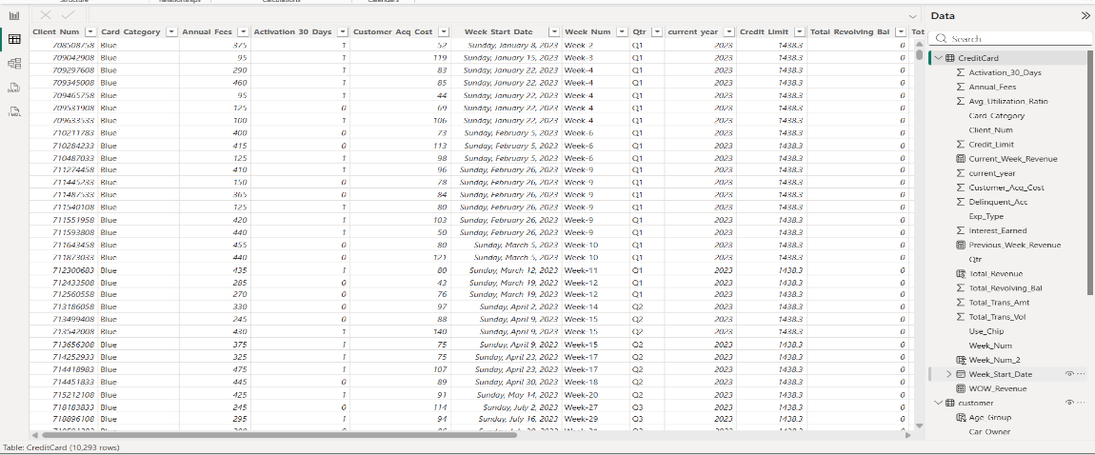
Figure: 1

Step 3: Data Modeling
- Created relationship:
  - Customer[Client_Num] → CreditCard[Client_Num]
- Ensured proper one-to-many relationship

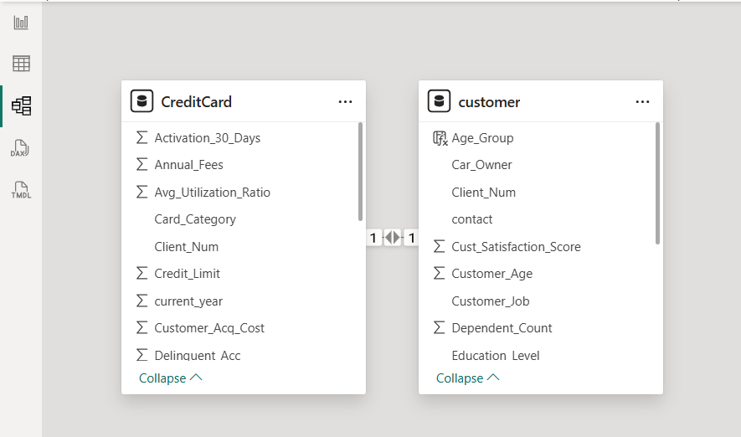
Figure:2
Step 4: Create Calculated Columns

- Dax Formula for Calculated Columns of Credit Card

1. Total_Revenue
Total_Revenue = CreditCard[Annual_Fees] + CreditCard[Total_Trans_Amt] + CreditCard[Interest_Earned]

Figure: 3

2. Week_Num_2
Week_Num_2 = WEEKNUM(CreditCard[Week_Start_Date])

Figure: 4

- Dax Formula for Calculated Measures of Credit Card

1. Current_Week_Revenue
Current_Week_Revenue = CALCULATE(
SUM(CreditCard[Total_Revenue]),
FILTER(ALL(CreditCard),
CreditCard[Week_Num_2] = MAX(CreditCard[Week_Num_2])
))

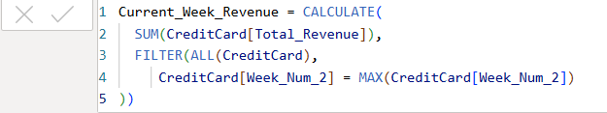
Figure: 5
2. Previous_Week_Revenue
Previous_Week_Revenue = CALCULATE(
SUM(CreditCard[Total_Revenue]),
FILTER(ALL(CreditCard),
CreditCard[Week_Num_2] = MAX(CreditCard[Week_Num_2])-1))

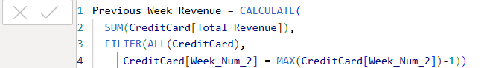
Figure: 6

3. WOW_Revenue
WOW_Revenue = DIVIDE(([Current_Week_Revenue] - [Previous_Week_Revenue]), [Previous_Week_Revenue])

Figure: 7

- Dax Formula for Calculated Columns of Customer

1. Age_Group
Age_Group = SWITCH(
TRUE(),
customer[Customer_Age] >= 20 && customer[Customer_Age] <= 30, "20-30",
customer[Customer_Age] >= 30 && customer[Customer_Age] <= 40, "30-40",
customer[Customer_Age] >= 40 && customer[Customer_Age] <= 50, "40-50",
customer[Customer_Age] >= 50 && customer[Customer_Age] <= 60, "50-60",
customer[Customer_Age] >= 60, "60+"
)

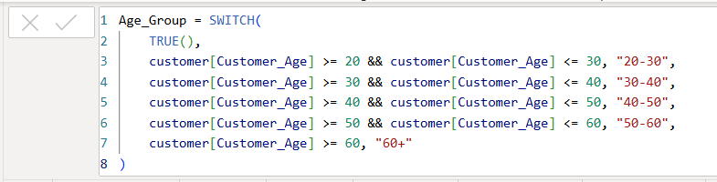
Figure: 8
2. Income_Group
Income_Group = SWITCH(
TRUE(),
customer[Income] < 30000, "Low",
customer[Income] >= 30000 && customer[Income] < 70000, "Medium",
"High"
)

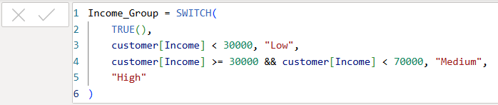
Figure: 9
- Dashboard

Dashboard 1: Credit Card Customer Report

KPIs Used
- Revenue → 57M
- Total Interest → 8M
- Income → 588M
- CSS → 3.19
Why KPIs Used
- Provide quick summary
- Help stakeholders understand performance instantly

Charts & Their Purpose
1. Revenue by Week (Line Chart)
- Shows revenue trend over time
- Helps identify peaks & drops

2. Delinquent Account Table
- Shows count of delinquent vs non-delinquent
- Helps risk analysis

3. Gender Distribution (Treemap)
- Shows revenue split (Male vs Female)
- Useful for customer targeting

4. Age Group Analysis
- Shows revenue by age segment
- Helps in segmentation

5. Customer Job Table
- Shows revenue by profession
- Helps business targeting

6. Income Group Chart
- Shows revenue across income levels
- Important for strategy

7. Marital Status Chart
- Helps understand behavioral segmentation

8. Top 5 States
- Identifies high-performing regions

9. Education Level
- Helps demographic analysis

Filters / Slicers
- Quarter (QTR)
- Week Start Date
- Card Category

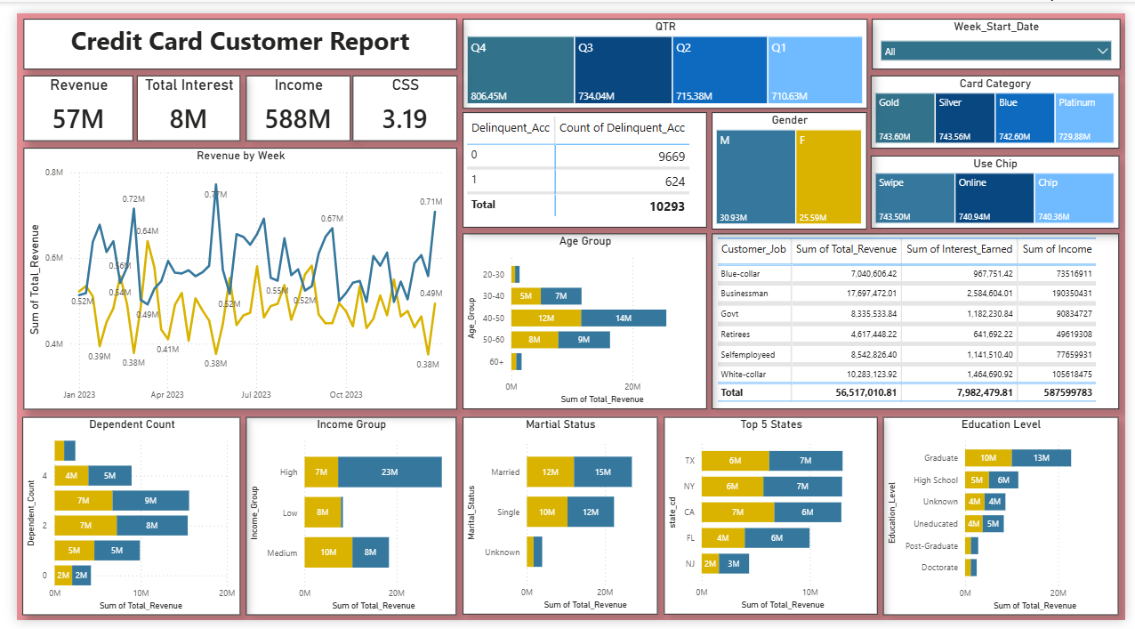
Figure: 10

5. Dashboard 2: Credit Card Transaction Report

KPIs
- Revenue → 57M
- Total Interest → 8M
- Transaction Amount → 46M
- Transaction Volume → 667K

Charts & Purpose
1. Card Category Table
- Shows revenue, transaction amount & volume
- Helps compare card performance

2. Revenue by Category (Area Chart)
- Shows contribution of each card type
- Helps identify dominant card

3. QTR Revenue & Volume Chart
- Combined bar + line
- Shows trend & comparison

4. Revenue by Expenditure Type
- Shows spending behavior (Fuel, Bills, Grocery)

5. Revenue by Education
- Shows impact of education on spending

6. Revenue by Customer Job
- Helps segment customers by profession

Filters
- Income Group
- Quarter

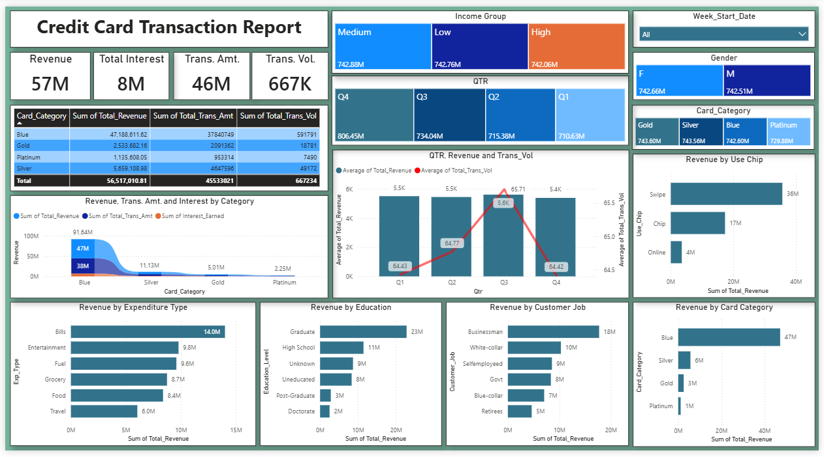
Figure: 11

- Dashboard 3: Extra Insights Report

Purpose
This dashboard is used for:
- Advanced analysis
- Weekly performance tracking
- Supporting decision-making

Key Elements
1. Weekly Revenue Table
- Includes:
  - Current Week Revenue
  - Previous Week Revenue
  - WoW Growth
2. Delinquency Analysis
- Tracks risk patterns
3. Activation Analysis
- Shows active vs inactive customers
4. Transaction Trend
- Line chart for transaction amount
5. Credit Limit Analysis
- Shows distribution of credit usage

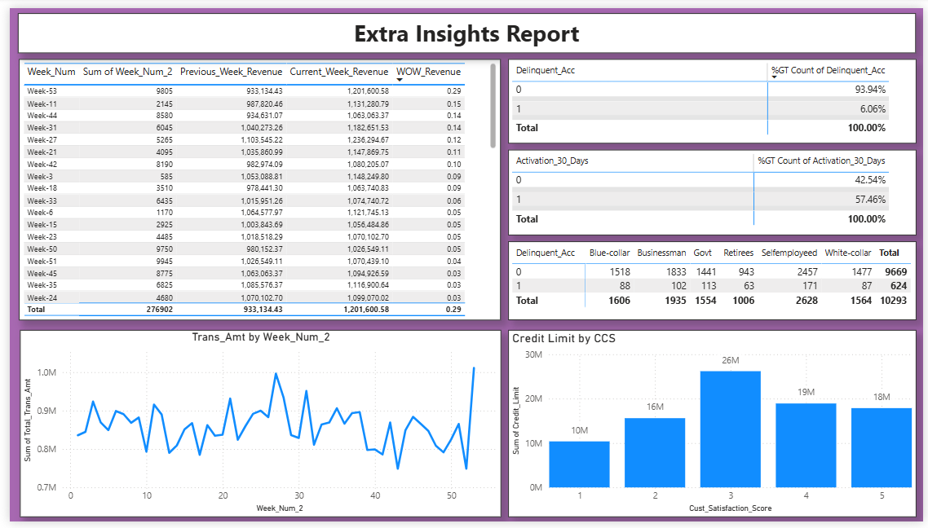
Figure: 12

7. Canvas Settings & Design
Canvas Size
- Width: 1425 px
- Height: 780 px
Color Themes Used
Customer Dashboard
- Light Pink background (#E68F96)
Transaction Dashboard
- Green theme (#6DB095)
Extra Insights
- Purple theme (#A666B0)

Why Different Colors
- Helps differentiate dashboards
- Improves readability
- Enhances user experience

8. Key Insights
- Revenue shows weekly growth trend
- Delinquent customers are very low (~6%)
- High activation rate (~57%)
- Male customers contribute more revenue
- Blue & Silver cards dominate transactions
- Certain states contribute highest revenue

9. Challenges
- Creating WoW calculations
- Designing clean dashboard layout
- Managing relationships
- Handling time-based analysis

10. Conclusion
The project successfully demonstrates:
- End-to-end Power BI development
- Advanced DAX usage
- Business intelligence reporting
The dashboards provide:
- Clear insights
- Better decision-making
- Strong data storytelling

------------------------------------------------Completed Successfully-----------------------------------------------

