Tata Forage - Data Visualization Internship

Dashboard Documentation

Task – 3

Author: Shivani Bhatt

1. Introduction

This project analyzes online retail data to generate insights on revenue, customers, and regional performance using Power BI dashboard.

2. Data Source
Dataset: Online Retail Dataset.xlsx
Fields used:
Country, CustomerID, Quantity, UnitPrice, InvoiceDate

3. Data Loading Process
1. Open Power BI
2. Click Get Data → Excel
3. Select Online Retail Dataset.xlsx
4. Click Transform Data

4. Data Transformation
Transformation is necessary to remove incorrect values and ensure accurate insights.
Steps:
- Removed negative values from Quantity and UnitPrice
- Ensured clean dataset
- Click Close & Apply
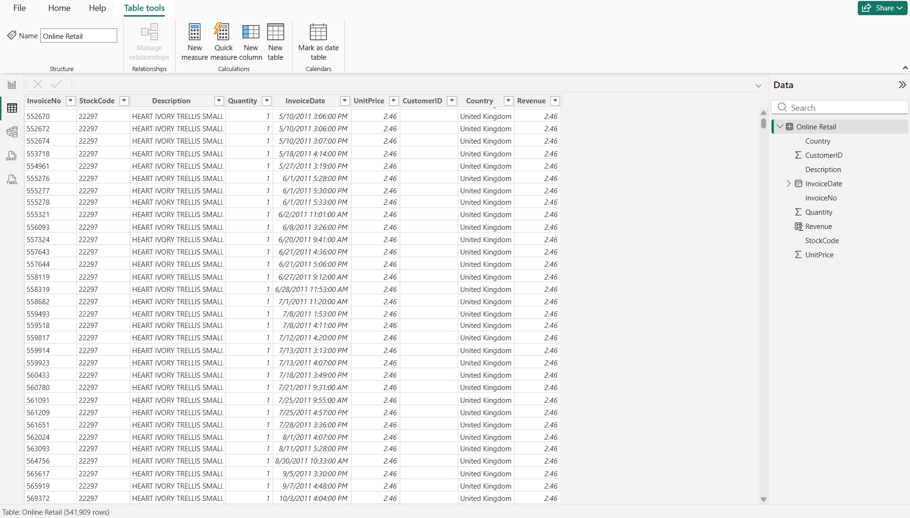
Figure – 1

5. Calculated Columns
Revenue = Quantity * UnitPrice
Purpose: Calculates total revenue per transaction for analysis.

6. Calculated Measures
Total Revenue = SUM(Revenue)
Purpose: Aggregates revenue for visualization.

7. Dashboard Design
Title: TATA VISUALIZATION DASHBOARD

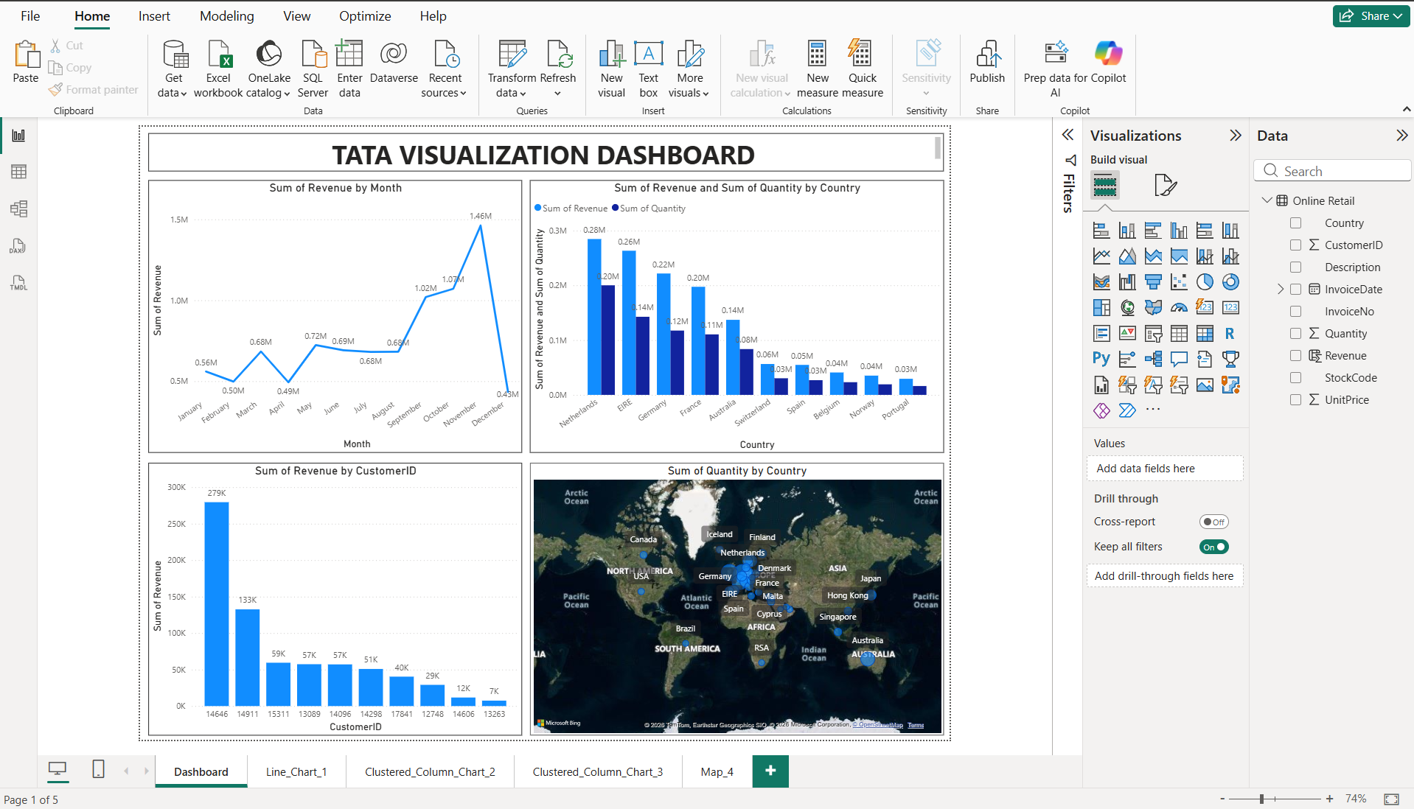
Figure – 2

Charts
- Line Chart (Line_Chart_1)
Title - Revenue by Month
Axis: Month
Values: Revenue
Purpose: Show revenue trends over time
Use: Helps identify seasonality and growth patterns

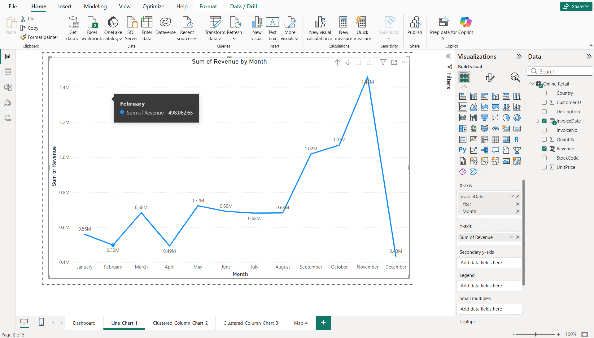
Figure – 3
- Clustered Column Chart (Clustered_Column_Chart_2)
Title - Revenue & Quantity by Country
Axis: Country
Values: Revenue, Quantity
Purpose: Compare revenue and quantity across countries
Use: Helps identify high-performing countries

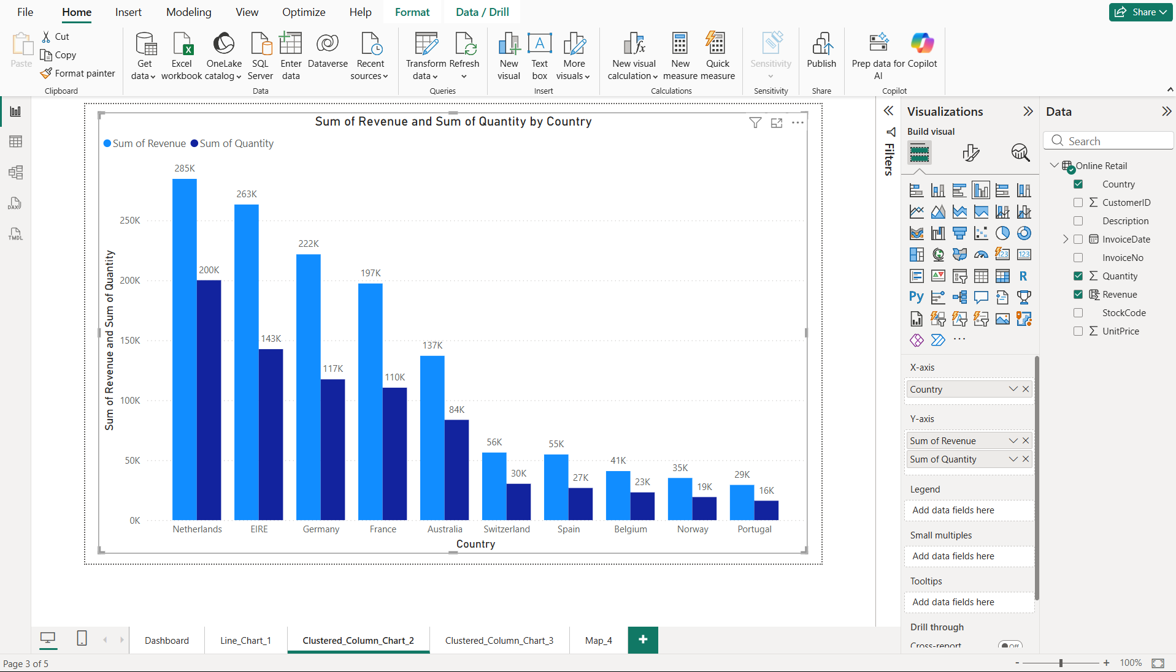
Figure – 4

- Clustered Column Chart (Clustered_Column_Chart_3)
Title - Revenue by Customer
Axis: CustomerID
Values: Revenue
Purpose: Show top customers by revenue
Use: Helps identify key customers

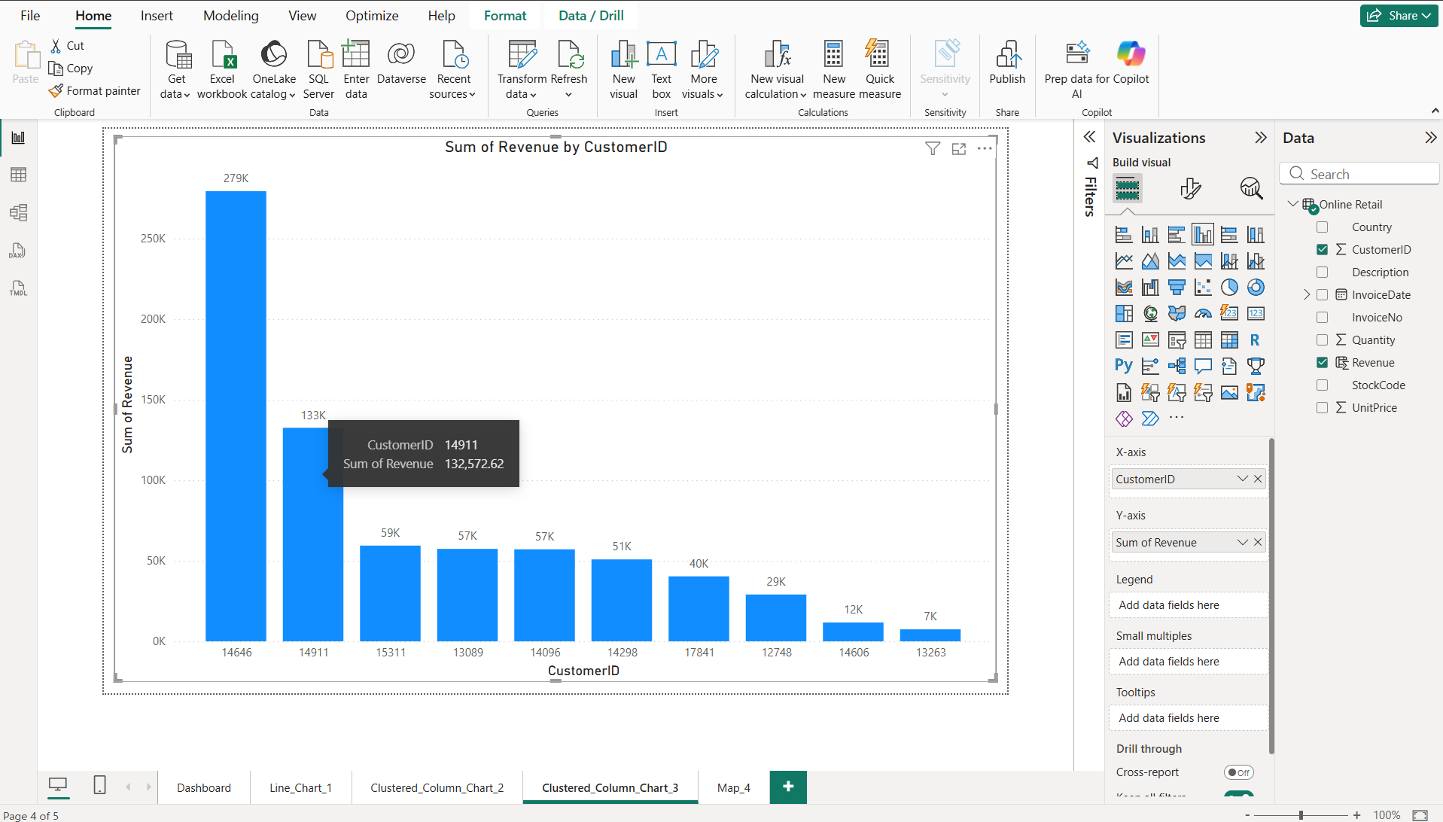
Figure – 4

- Map Chart (Map_Chart_4)
Title - Quantity by Country
Location: Country
Values: Quantity
Purpose: Show geographical revenue distribution
Use: Helps identify regional performance

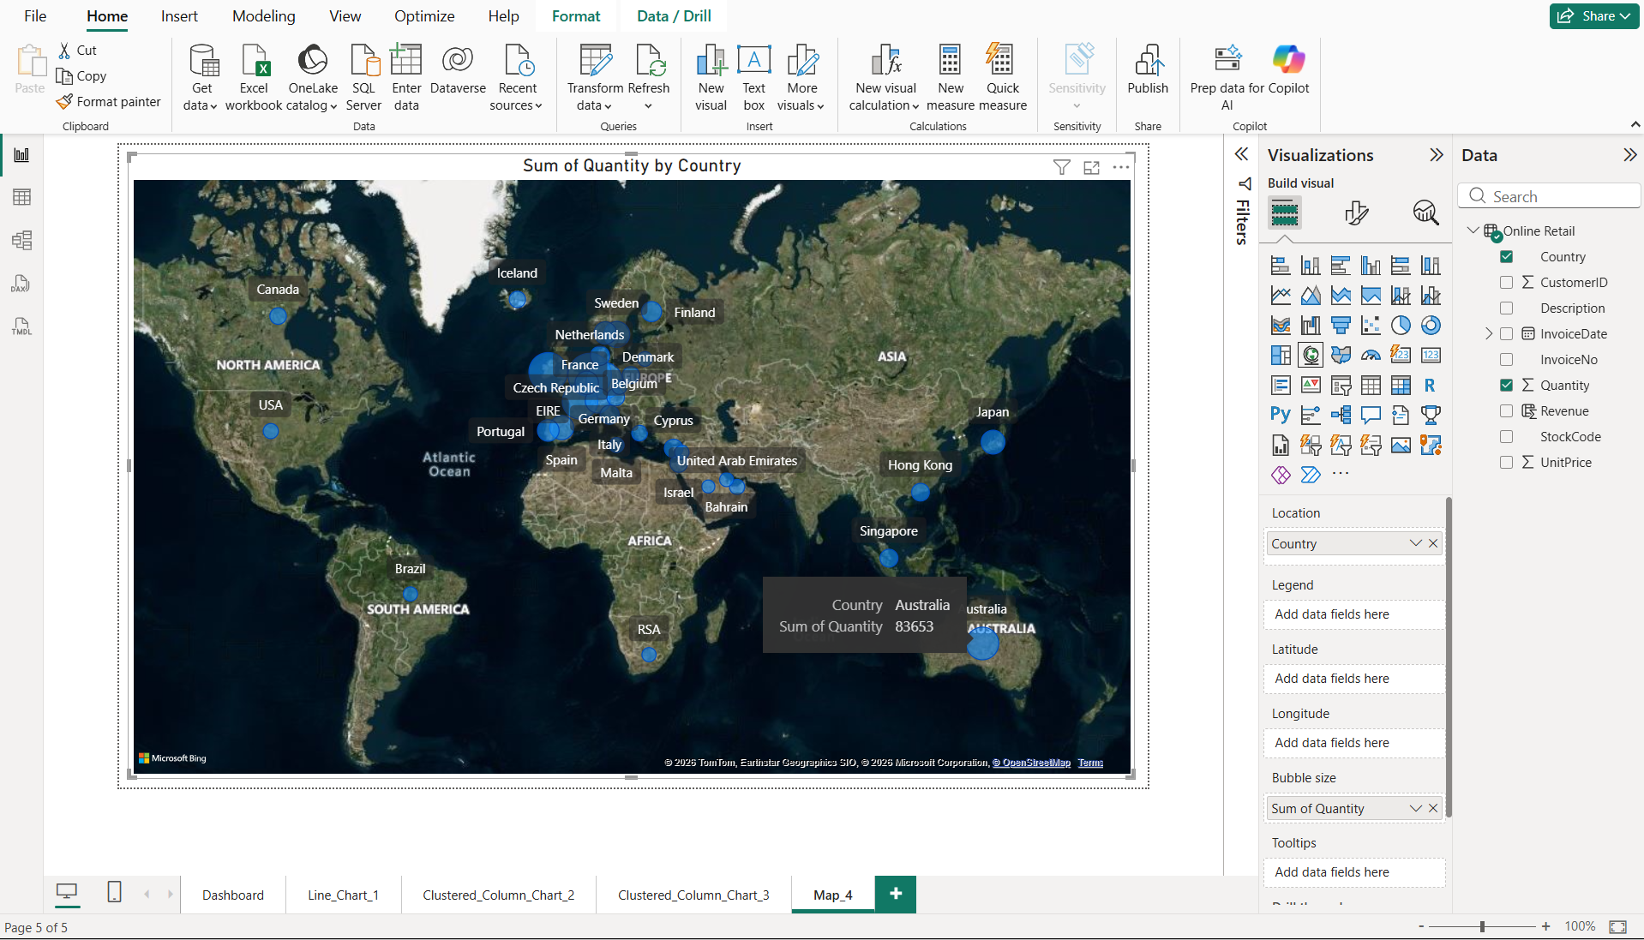
Figure - 5

8. Dashboard and Canvas Settings
Dashboard Canvas:
- Type: Custom | Height: 900 px | Width: 1188 px
- Background: White (#FFFFFF)
- Each chart size: Height 400, Width 607
Charts Pages Canvas:
- Type: Custom | Height: 600 px | Width: 960 px
- Background: White (#FFFFFF)
9. Conclusion
This project demonstrates data cleaning, DAX calculations, and visualization to derive business insights.

