Game Design Document

Fill up the following document

1. Write the title of your project.

Alien attack

1. What is the goal of the game?

Protect the earh from the ufo’s

1. Write a brief story of your game.

Ufos attack on a planet and the astronaut saves the planet by shooting the cannonballs on them from the ground and as the cannonball touches the ufo’s they get destroyed and score increases by 5 points

1. Which are the playing characters of this game?

* Playing characters are the ones who respond to the user based on the input from the user.
* Cars, monkeys, dinos, wizards, etc., are the playing characters in the game.

|  |  |  |
| --- | --- | --- |
| Number | Character Name | What can this character do? |
| 1 | cannon | Shoot balls |
| 2 | Ufo’s | They attack on a planet |
| 3 |  |  |
| 4 |  |  |
| 5 |  |  |
| 6 |  |  |
| 7 |  |  |
| 8 |  |  |

1. Which are the Non-Playing Characters of this game?

* Non-Playing characters are the ones that don't have an action or behavior when the user interacts with the game.
* Hurdles, stones, bananas, coins, etc., are non-playing characters in the game.

|  |  |  |
| --- | --- | --- |
| Number | Character Name | What can this character do? |
| 1 | Ufo’s | Stationary object |
| 2 |  |  |
| 3 |  |  |
| 4 |  |  |
| 5 |  |  |
| 6 |  |  |
| 7 |  |  |
| 8 |  |  |

Draw your imagination of this game. What does this game look like?

* Draw the game either on your computer or on paper.
* Add images of the game scenes to show each of the playing and non-playing characters at least once. 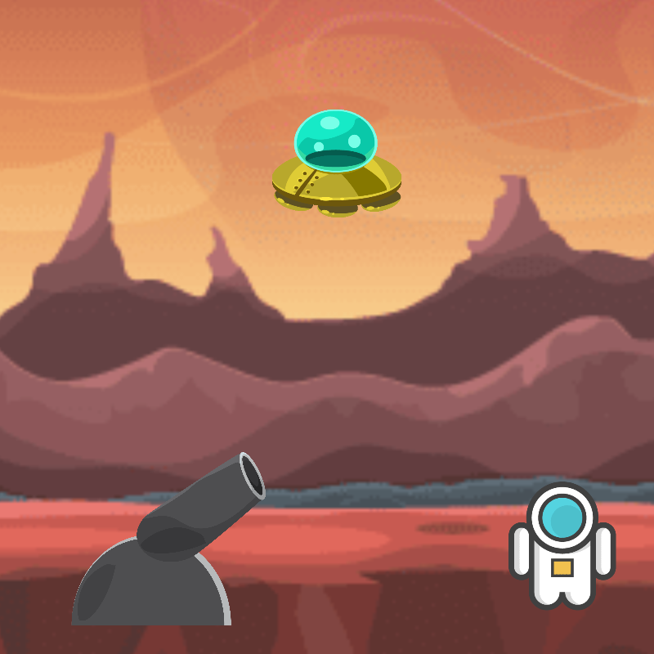

How do you plan to make your game engaging?

Increase the velocity of the ufo’s when the score reaches 50