ASSIGNMENT 1
AI ASSISTED CODING 2303A52488
Shivasai.ch

Task 1: AI-Generated Logic Without Modularization (Fibonacci Sequence Without Functions)

- Scenario
You are asked to write a quick numerical sequence generator for a learning platform prototype.

- Task Description
Use GitHub Copilot to generate a Python program that: ➢ Prints the Fibonacci sequence up to n terms
  - Accepts user input for n
  - Implements the logic directly in the main code
  - Does not use any user-defined functions

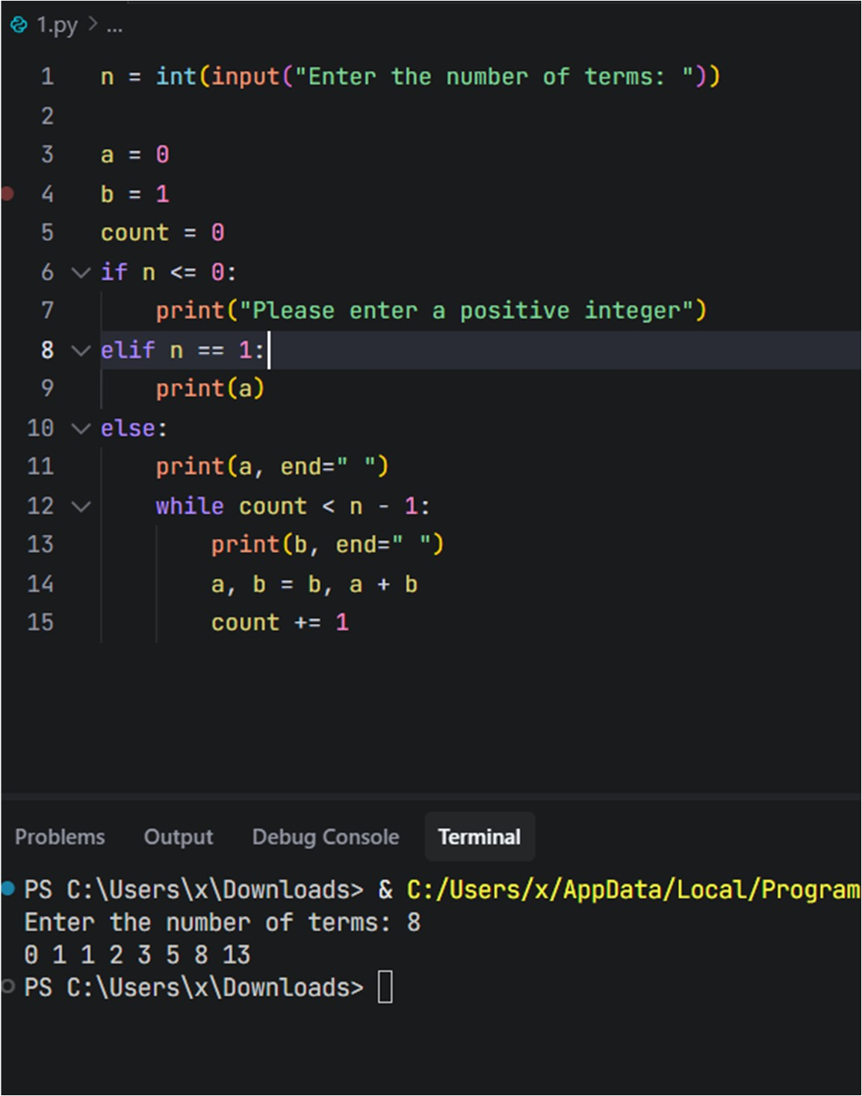

Task 2: AI Code Optimization & Cleanup (Improving Efficiency)

- Scenario
The prototype will be shared with other developers and needs optimization.

- Task Description
  - Examine the Copilot-generated code from Task 1 and improve it by:
  - Removing redundant variables
  - Simplifying loop logic ➢ Avoiding unnecessary computations ➢ Use Copilot prompts such as:
    - “Optimize this Fibonacci code”
    - “Simplify variable usage”

IMPROVED CODE

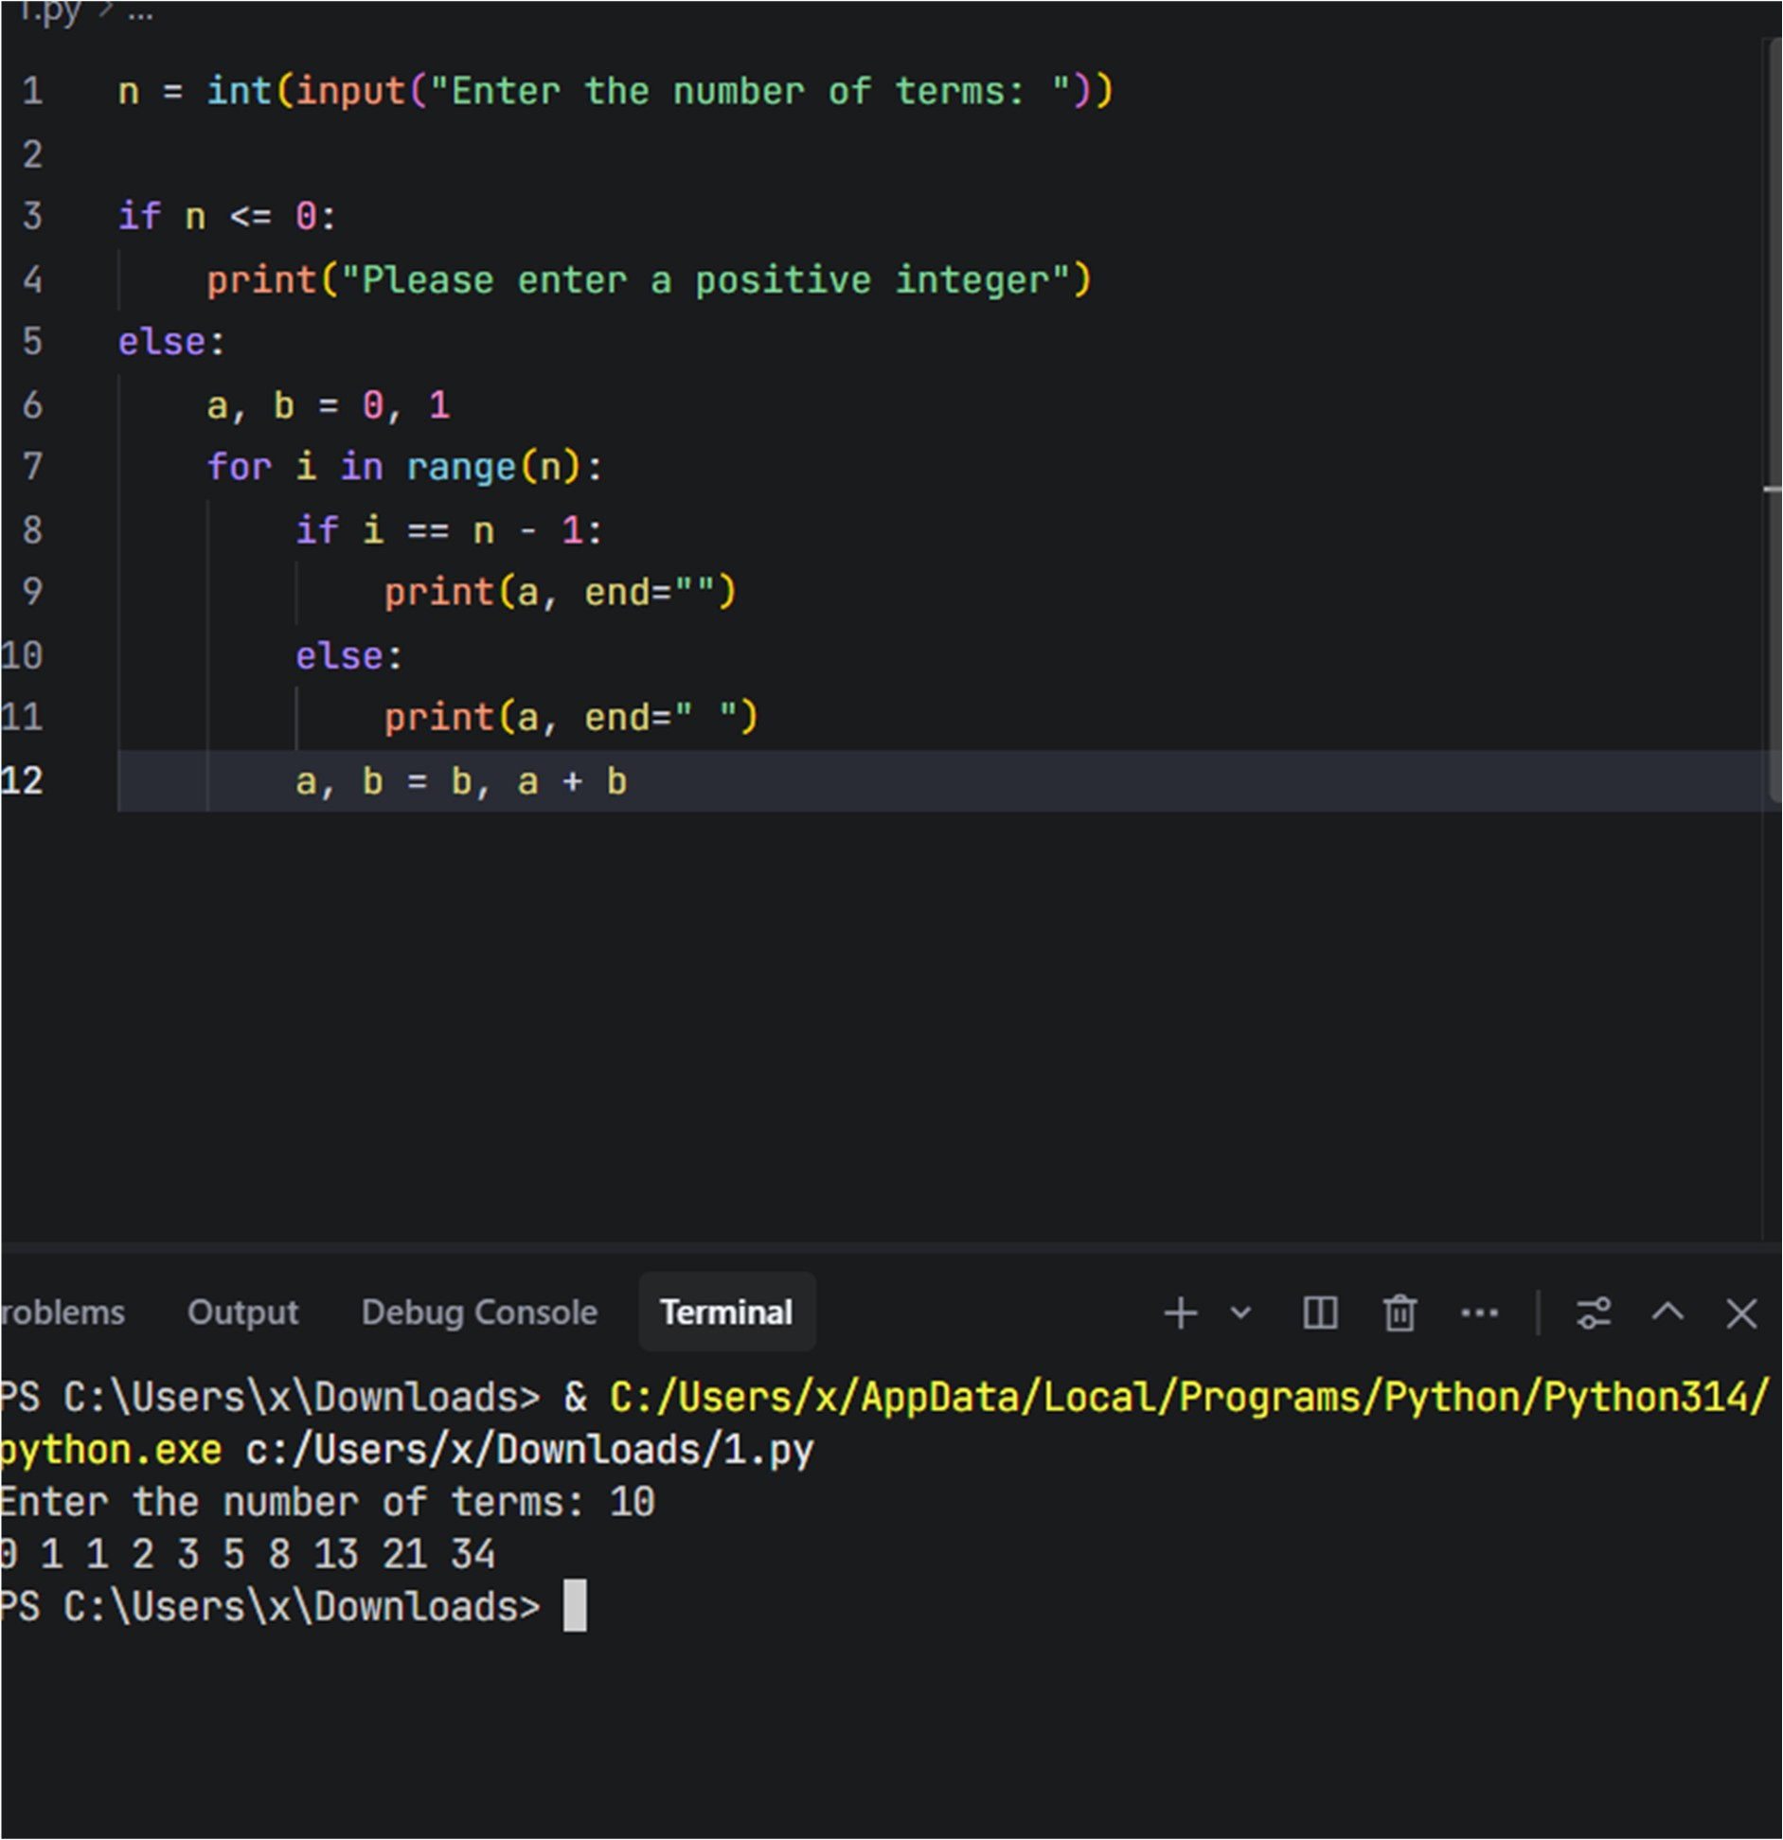

EXPLANATION
This version keeps everything in the main code (no functions) but:

- Removes the extra count variable
- Uses a for loop directly over the number of terms
- Avoids a separate n == 1 branch
- Uses a single print location for all terms
What was inefficient / less clean in the original

- Redundant loop counter

- count was tracking iterations, but Python already gives you loop counters with range .
- Managing count manually ( count = 0 , count += 1 ) adds noise.
- Unnecessary branching for n == 1

- Special-case branch elif n == 1: printed a alone.
- Then for larger n, the code printed a once before the loop and b inside the loop.
- Logic is split across multiple places, which reduces readability.
- Two separate print patterns

- First term ( a ) is printed before the loop.
- Remaining terms ( b ) are printed inside the loop.
- This makes it harder to reason about “what exactly is printed each iteration”.
- Less direct mapping to “print n Fibonacci numbers”

- The condition while count < n - 1 is slightly less intuitive than “repeat n times”.

Task 3: Modular Design Using AI Assistance (Fibonacci Using Functions)

- Scenario
The Fibonacci logic is now required in multiple modules of an application.

- Task Description
Use GitHub Copilot to generate a function-based Python program that:
  - Uses a user-defined function to generate Fibonacci numbers
  - Returns or prints the sequence up to n
  - Includes meaningful comments (AI-assisted)

- Expected Output
  - Correct function-based Fibonacci implementation
  - Screenshots documenting Copilot’s function generation

Sample test cases with outputs
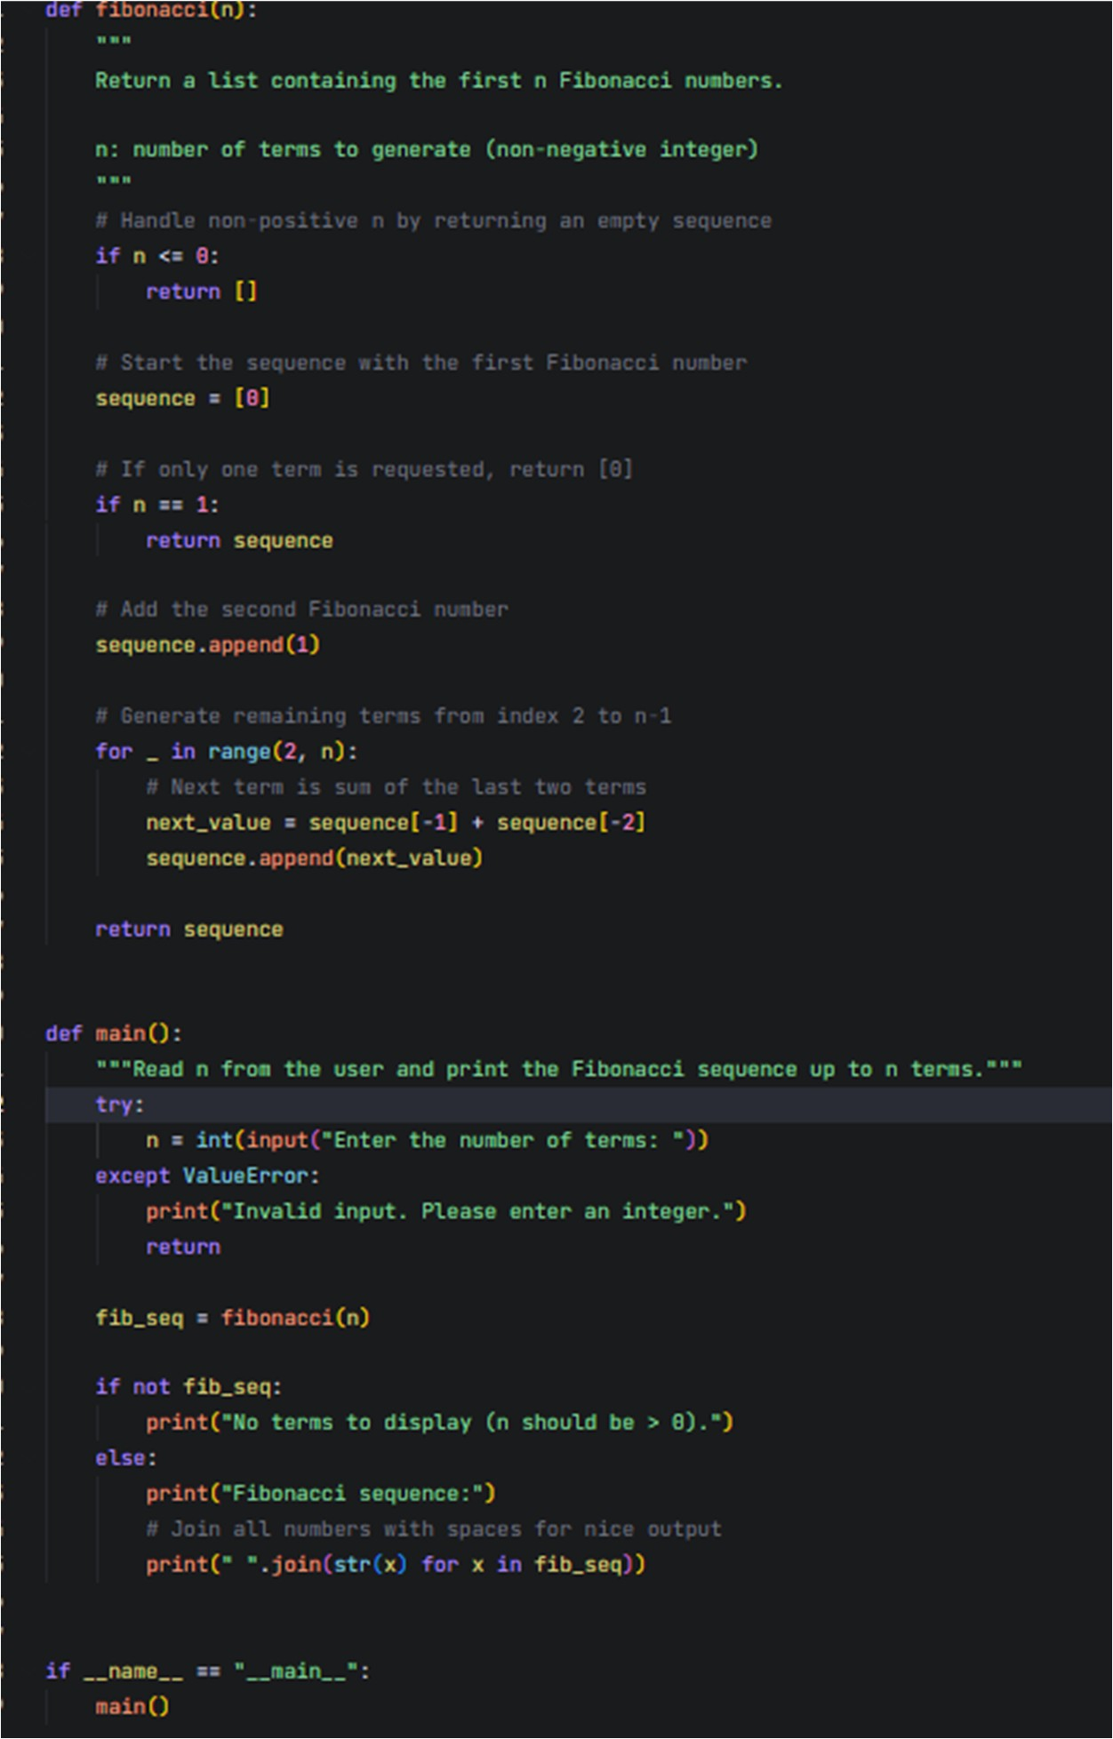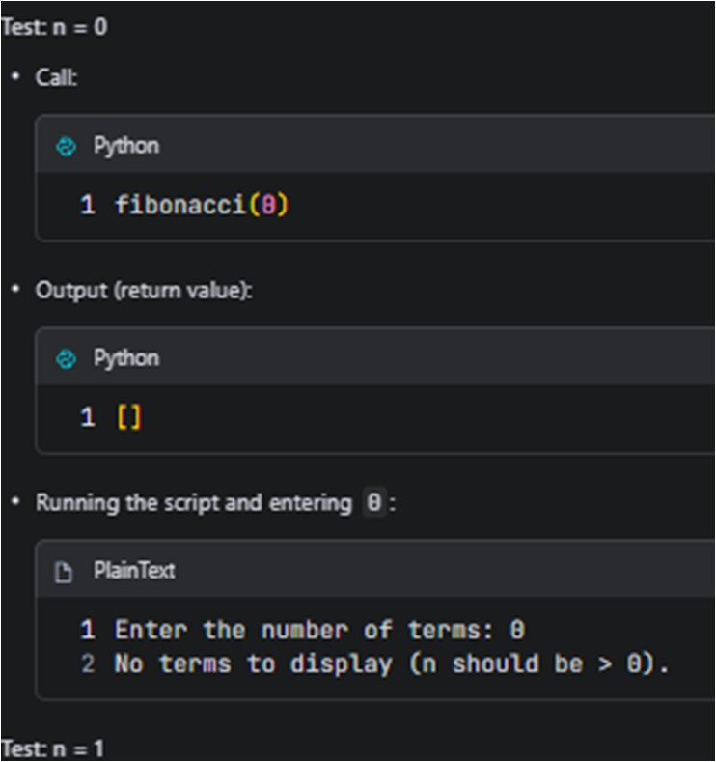

Task 4: Comparative Analysis – Procedural vs Modular Fibonacci Code

- Scenario
You are participating in a code review session.

- Task Description
Compare the Copilot-generated Fibonacci programs:
  - Without functions (Task 1) ➢ With functions (Task 3) ➢ Analyze them in terms of:
    - Code clarity
    - Reusability
    - Debugging ease
    - Suitability for larger systems

Comparison Overview

- Procedural version (Task 1) : all logic in main , no functions
- Modular version (Task 3) : fibonacci(n) function + main() wrapper

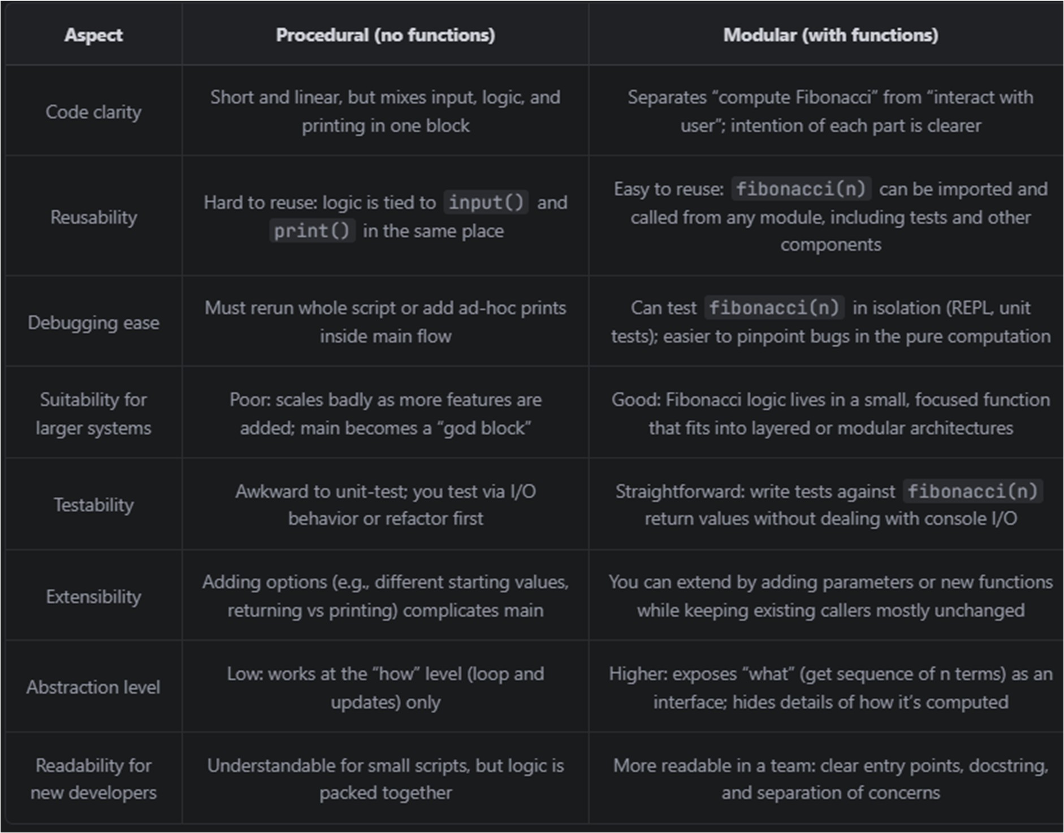

Short Analytical Report

- Code clarity

- The procedural version is fine for very small, one-off scripts: everything is visible in one place. - However, it mixes three concerns: reading input, computing Fibonacci, and printing results. As soon as you add more features (validation, logging, different output formats), this block gets harder to read.
- The modular version clearly separates concerns:
- fibonacci(n) is about the sequence calculation.
- main() is about user interaction and display.
- This makes it easier for a reviewer to answer “where is the Fibonacci logic?” and “where is the I/O?”.
- Reusability

- In the procedural version, the only way to “reuse” the logic is to copy and paste the loop, or to call the script as a separate process. Both are fragile.
- The modular version provides a reusable unit: fibonacci(n) can be imported by other modules ( from fib import fibonacci ) and used in GUI apps, APIs, other scripts, or tests.
- Debugging ease

- Debugging the procedural code often means sprinkling extra prints into the main block or stepping through the entire input/print flow in a debugger.
- With the function-based design, you can:
- Call fibonacci(5) directly in a REPL and inspect the list.
- Add unit tests for edge cases ( n = 0 , n = 1 , large n ) without touching I/O.
- When a bug appears, you can quickly determine whether it lives in the pure logic ( fibonacci ) or in the user interaction ( main ). - Suitability for larger systems

- Larger applications benefit from modularity: clear APIs, small functions, and layers (UI, business logic, data).
- The procedural version doesn’t scale well because as more requirements are added, the main block grows and becomes tightly coupled to everything else.
- The modular version maps naturally into a larger architecture:
- fibonacci(n) is part of a “domain” or “core” module.
- Different front-ends (CLI, web, GUI) can all reuse the same core function.

Task 5: AI-Generated Iterative vs Recursive Fibonacci Approaches (Different Algorithmic Approaches for Fibonacci Series)

- Scenario
Your mentor wants to assess AI’s understanding of different algorithmic paradigms.

- Task Description
Prompt GitHub Copilot to generate:
An iterative Fibonacci implementation
A recursive Fibonacci implementation

ITERATIVE def fib_iterative(n): if n < 0:
raise ValueError("n must be non-negative")

a, b = 0, 1 for _ in range(n): a, b = b, a + b
return a

RECURSIVE
def fib_recursive(n): if n < 0:
raise ValueError("n must be non-negative")

if n == 0: return 0 if n == 1: return 1

return fib_recursive(n - 1) + fib_recursive(n - 2)

Execution flow

- Iterative

- Initialize a = 0 , b = 1 .
- Loop n times:
- Set (a, b) to the next Fibonacci pair (b, a + b) .
- After the loop, a holds fib(n) .
- Control flow is straightforward: one loop, no call stack growth.
- Recursive

- For each call fib_recursive(n) :
- If n is 0 or 1, return the base value directly.
- Otherwise, call itself twice: - fib_recursive(n - 1)
- fib_recursive(n - 2)
- Sum the two results.
- The call tree branches until all paths hit n == 0 or n == 1 .

Complexity and performance comparison

- Time complexity

- Iterative:
- Each loop iteration does O(1) work.
- Loop runs n times.
- Time complexity: O(n) .
- Naive recursive:
- Each call branches into two more calls (except at base cases).
- Number of calls grows roughly like 2^n .
- Time complexity: O(2^n) (exponential).
- Space complexity

- Iterative:
- Uses a constant number of variables ( a , b , loop index).
- Space complexity: O(1) auxiliary space.
- Naive recursive:
- Each call waits on the result of two child calls.
- Maximum recursion depth is n (for the longest path down to 0/1).
- Space complexity: O(n) due to call stack.
- Performance for large n

- Iterative:
- Scales well up to very large n (e.g., hundreds of thousands) until integers or time become the bottleneck.
- Work grows linearly; practical for most uses.
- Naive recursive:
- Becomes unusable quickly:
- For n ~ 30–40 , it is already noticeably slow.
- For n > 40–45 , runtime explodes because of exponential growth in calls.

when recursion should be avoided

- You need to handle large n .
- You are in a performance‑sensitive path (e.g., called many times in a loop or server endpoint). - The recursive formulation introduces overlapping subproblems (like Fibonacci), causing repeated work and exponential behavior.
- Your runtime has a strict recursion depth limit that the algorithm might hit.

