INTERNSHIP ASSIGNMENT / WEEK 03

ADVANCED LOGISTICS
ANALYTICS
Exploratory Data Analysis, KPI Benchmarking and Visualization in Python
A REPRODUCIBLE HYPOTHETICAL DELIVERY STUDY

SIMULATED SHIPMENTS  960 | OVERALL ON-TIME RATE  93.44% | AVERAGE COST / SHIPMENT  ₹161.67

PREPARED BY Bedi Shivam Jagjeet
SUBMISSION DATE 11 October 2026
STUDY PERIOD (SIMULATED) 01 May – 31 July 2026
TOOLS Python · pandas · NumPy · Matplotlib

DATA INTEGRITY NOTE The dataset, costs, traffic and weather values used throughout this report are entirely synthetic. Findings illustrate analytical methods, not measured business performance.

01 Executive summary
This study demonstrates how Python-based exploratory data analysis can translate shipment-level operational records into readable performance metrics. A seeded simulator generated 960 fictional completed deliveries distributed across six zones and 92 days. The dataset records elapsed delivery time, promised service time, shipment weight, parcel count, distance, traffic category, weather and modeled transportation cost.
In the scenario, mean delivery time was 4.23 hours (median 3.99 hours), and 93.44% of shipments met their promised hours. Mean modeled transportation cost was ₹161.67 per shipment. Delivery distance and transportation cost showed a high positive Pearson correlation (r = 0.941). All figures are reproducible but intentionally shaped by the generating assumptions.

Project objectives
- Describe central tendency, variability and the shape of delivery-time and cost distributions.
- Compare service reliability across geographic zones, traffic categories, weather and commitment tiers.
- Visualize daily volumes, operational bottlenecks and cost relationships using charts chosen to fit each question.
- Turn patterns into testable operational hypotheses while separating simulation insights from actual evidence.

Questions addressed
Business question | Method / output
Is demand volume stable across days? | Daily time series, seven-day rolling mean
Where does on-time performance differ? | Grouped rates by zone and service level
Which conditions coincide with lateness? | Traffic box plot; weather and SLA comparisons
What is associated with modeled cost? | Distance–cost scatter, zone means and correlations

Principal takeaways
High-traffic scenarios reached only 80.00% on-time delivery versus 98.92% for low traffic. The Industrial zone had the slowest deliveries, lowest on-time performance and highest mean cost. Priority service lagged Standard on the on-time KPI (83.69% vs 97.49%) because its simulated promise is tighter. These findings suggest where to test dispatch buffers and route policies—not that any specific intervention has already worked.

02 Dataset and analytical design

Simulation scope and granularity
The analytic grain is one fictional completed shipment (one CSV row). The generator samples dispatch dates across 92 calendar days, assigns zones and service commitments, and synthesizes shipment attributes and operating conditions. A fixed random seed of 2026 makes the demonstration reproducible. The generated file contains 960 records and no personally identifiable information.
Variable | Type / units | Analytical purpose
dispatch_date | Date | Daily shipment trend, weekday analysis
zone / service_level | Categorical | Grouped reliability comparisons
traffic_level / weather | Categorical | Operating-condition comparisons
distance_km | Numeric / km | Trip-length and cost analysis
shipment_weight_kg | Numeric / kg | Shipment intensity and cost
parcel_count | Integer / parcels | Fulfillment intensity
promised_hours | Numeric / hours | Service-level target
actual_delivery_hours | Numeric / hours | Completion-time distribution
transport_cost_inr | Numeric / INR | Modeled cost driver analysis

Data generation mechanism
A gamma-shaped distribution produces positive right-skewed distances, log-normal sampling produces shipment weights, and categorical draws represent traffic, rain, zone and service level. Actual delivery time is modeled to increase with distance, traffic, rain, parcel handling and shipment weight; priority service includes a small execution-time offset. Transportation cost is intentionally modeled as a function of distance, load, traffic, service tier and random variation.
This design creates interpretable patterns for teaching EDA. Because the simulator encodes some relationships by construction, correlation strengths are expected and cannot be interpreted as independent validation of the relationships.

03 Analytical workflow and statistical profile
Pipeline: generate → validate → derive features → aggregate → summarize → visualize → interpret → recommend. The analysis script validates required columns, positive finite numerics and unique shipment IDs before deriving on-time status, positive late hours and the signed SLA margin (actual minus promised hours). Dates are parsed using pandas and groups are aggregated with groupby/resample.

Core KPI definitions
KPI | Formula / interpretation
On-time rate | 100 × shipments(actual ≤ promised) / completed shipments
SLA margin | Actual hours − promised hours; positive is late
Mean modeled cost | Sum of modeled shipment costs / completed shipments
90th-percentile completion | Time at or below which 90% of observed trips finish
Pearson correlation r | Linear association in [−1,+1]; not evidence of causation

Descriptive summary (all 960 fictional shipments)
Measure | Mean | Median | Standard deviation | Other
Delivery hours | 4.23 | 3.99 | 1.74 | P90: 6.63 h
Transport cost (₹) | 161.67 | 154.52 | 52.24 | Total: ₹155,207.39
Distance (km) | 12.08 | 10.65 | 6.81 | Range: 1.00–30.00
Shipment weight (kg) | 3.40 | 2.76 | 2.37 | Range: 0.20–15.01
Parcel count | 2.37 | 2 | 1.18 | Range: 1–7

Central tendency: the mean summarizes total elapsed hours and costs per shipment, while the median is robust to tail values; the rounded delivery-time mode is approximately four hours. Spread: standard deviation and the 90th percentile highlight variability and potential late-delivery risk. No inferential significance test or causal model is attempted.

Basic quality verification
The packaged demonstration contains one row per unique shipment ID, no null values in required fields, and positive finite numeric measures. This prevalidated Week 3 dataset is not evidence that real logistics records are already clean; data repair was the emphasis of Week 2.

04 Shipment volume and operational load
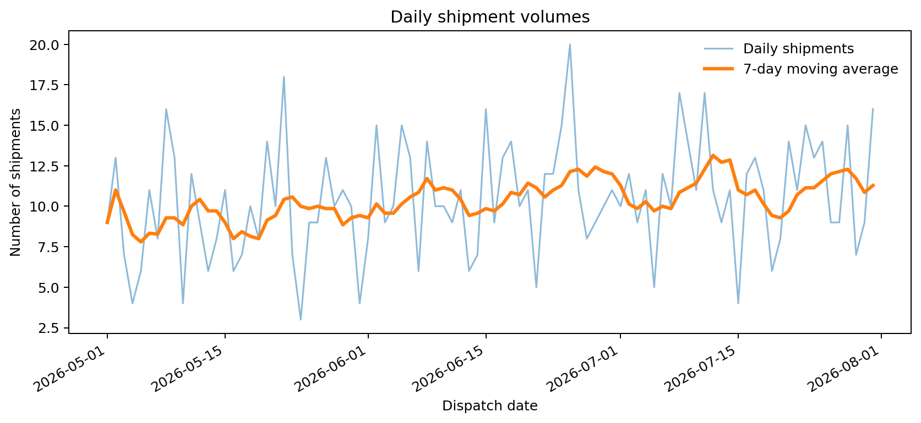
Figure 1 · Daily dispatch volume and seven-day moving average.

Why a time-series line chart?
A line chart preserves the order of calendar dates and reveals short peaks and dips that a single mean conceals. A seven-day rolling average smooths daily noise and makes short-run capacity planning easier to interpret.

Observed fictional-data insights
The 960 shipments were distributed across 92 observed calendar days. Average volume was 10.43 per day and the peak was 20 shipments. The varying dispatch load is compatible with the date-weighting built into the simulator, rather than proof of genuine market seasonality.
Decision use: if a company observed similar variability in actual operations, planners could compare daily demand with loading-bay, driver and vehicle capacity; a time-series forecast could then help staff anticipated peaks. This chart does not estimate required fleet size because capacity and shift data are absent.

05 Delivery-time distribution and tail risk
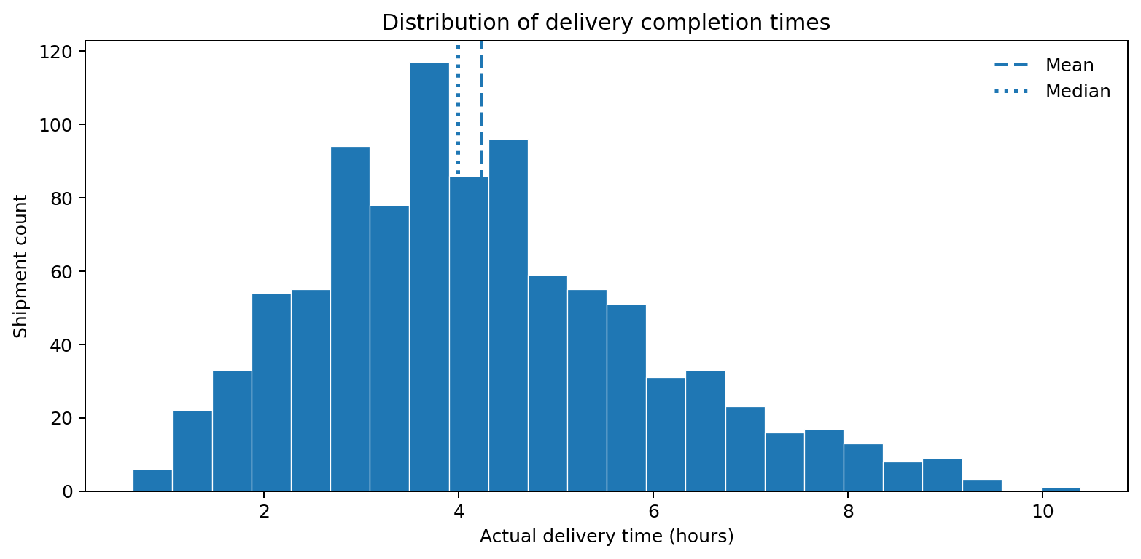
Figure 2 · Histogram of completion hours, including mean and median markers.

Why a histogram?
A histogram shows the frequency and spread of elapsed delivery times. Mean and median markers make skewness and extreme longer deliveries easier to interpret; the chart also helps distinguish a typical delivery from the upper tail.

Results and interpretation
The mean completion time was 4.23 hours and the median was 3.99 hours; 90% of shipments completed within 6.63 hours. The right tail reflects longer-distance trips and deliberately modeled operating friction. Exactly 63 shipments exceeded their own (distance- and service-sensitive) promised hours.
Recommendation: examine the longest-time decile alongside distance, congestion and service level before flagging dispatch inefficiency. An absolute delivery-duration threshold alone would unfairly compare long and short jobs; time relative to the SLA provides a complementary measure.

06 Geographic-zone performance
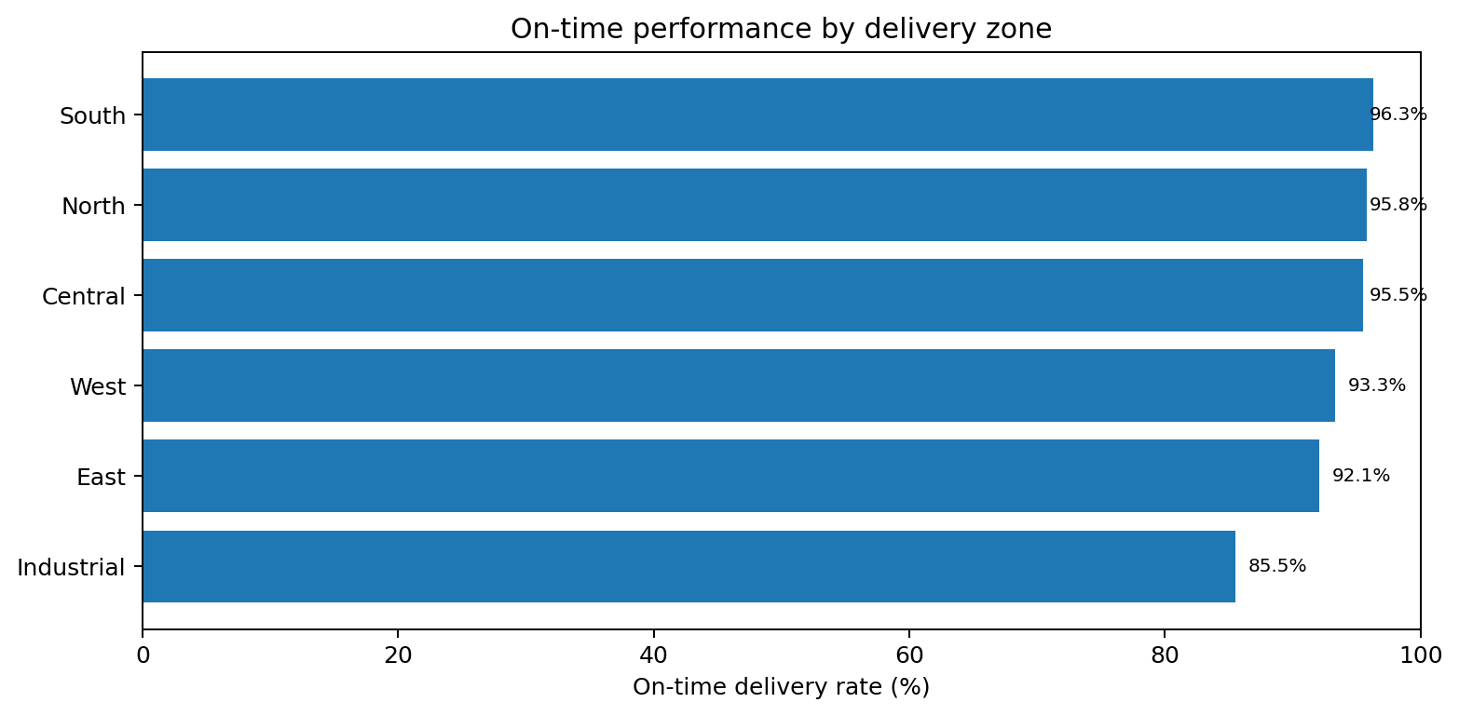
Figure 3 · Percentage of deliveries meeting their promised time, by zone.

Why a horizontal bar chart?
Bars support direct category-to-category comparison without suggesting an ordered continuous geography. Horizontal labeling remains readable for longer zone names; showing the percentage denominator makes the benchmark explicit.

Zone scorecard
Zone | Shipments | On-time rate | Mean time (h) | Mean cost (₹)
Central | 177 | 95.48% | 3.53 | 136.13
East | 164 | 92.07% | 4.26 | 165.53
Industrial | 124 | 85.48% | 5.22 | 181.97
North | 168 | 95.83% | 3.95 | 156.24
South | 163 | 96.32% | 4.23 | 165.20
West | 164 | 93.29% | 4.49 | 172.10

The Industrial zone is a candidate for diagnostic review, but it also has the longest average modeled distance (15.09 km) and a distinct simulation penalty. A fair real-world comparison would adjust for stop density, route distance, service promise and freight type.

07 Congestion and service reliability
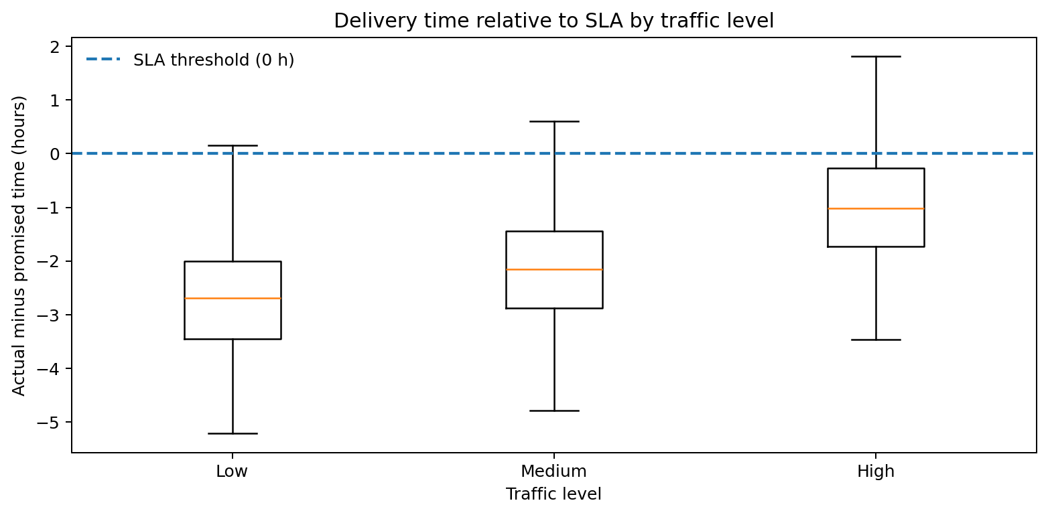
Figure 4 · Signed SLA margin by traffic group; the dashed zero line separates early from late.

Why a box plot?
A box plot compares medians and central ranges across traffic categories. It surfaces the variability of SLA margin rather than reducing each group to one average. Outlying points are hidden for readability in this rendering but are preserved in the dataset and descriptive outputs.

Group-level comparison
Traffic | Shipments | On-time | Mean SLA margin
Low | 277 | 98.92% | −2.69 h
Medium | 443 | 97.29% | −2.13 h
High | 240 | 80.00% | −0.96 h

In the simulator, high congestion is associated with higher late-delivery risk: 80.00% on time versus 98.92% under low traffic. Rainy shipments are also less punctual than clear-weather ones (83.50% versus 96.05%).
Decision use: test congestion-aware departure slots, slack buffers and early warning for weather-affected routes. A business should validate these with time-of-day, road-network and local weather data; weather and congestion alone are not randomized causes.

08 Transportation cost and trip distance
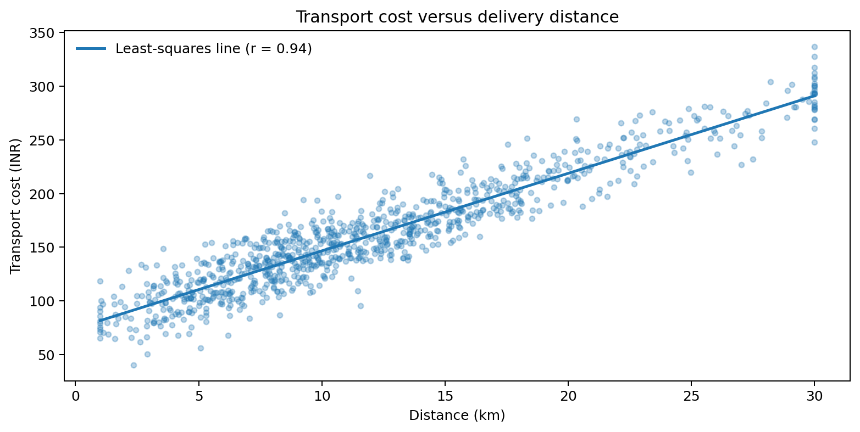
Figure 5 · Distance versus cost with an illustrative least-squares fit.

Why a scatter plot?
Each point is one shipment, so the plot exposes the form of association, dispersion around a trend, and possible costly exceptions. The fitted line is a descriptive visual summary rather than a production prediction model.

Cost interpretation
The Pearson distance–cost correlation is r = +0.941; mean modeled cost is ₹161.67 per shipment. These values reflect the simulator’s explicit per-kilometer cost term, with smaller contributions from weight, number of parcels, congestion, service tier and noise.
A strong association supports distance segmentation for diagnostic dashboards, but not a claim of savings. Actual cost optimization would need route-level fixed charges, dispatch consolidation, fuel use, driver hours, tolls and operating constraints.

09 Cost efficiency by delivery zone
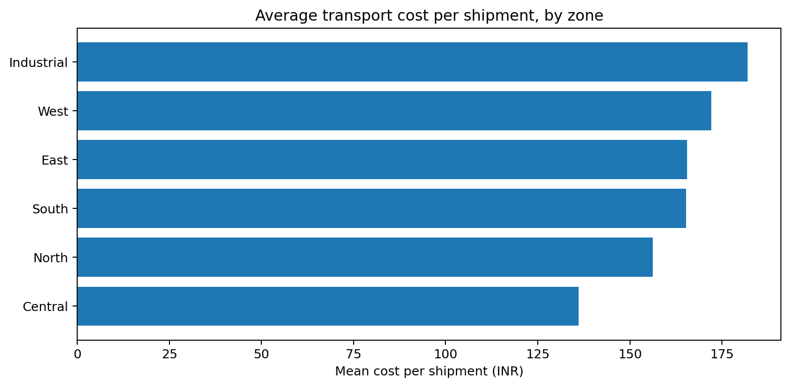
Figure 6 · Mean modeled transport cost per shipment in each zone.

Why compare averages, not only total spend?
Total spend mixes shipment frequency and cost intensity. Average cost per shipment is better suited to first-pass efficiency comparisons across uneven zone volumes. It is still not distance-normalized, so an expensive long-distance zone need not be poorly managed.

Practical reading
Industrial has the highest mean modeled transportation cost (₹181.97), followed by West (₹172.10); Central has the lowest (₹136.13). However, Industrial handles 124 shipments and Central 177, so total cost ranking differs from per-shipment cost ranking. This distinction avoids interpreting business volume as inefficiency.
Follow-up: produce cost-per-kilometer and cost-per-delivered-parcel views after checking load, return-trip allocation, fleet fixed costs and route density. Assess whether the Industrial zone requires a different promise or resource plan rather than assuming its cost can be reduced to the network average.

10 Correlations and analytical caution
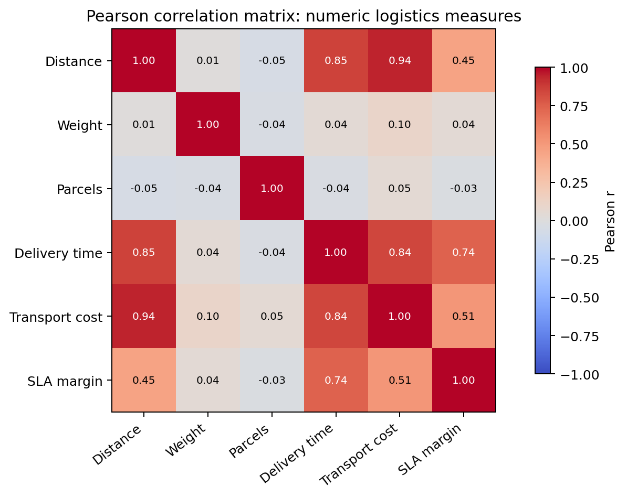
Figure 7 · Pearson r across six numeric shipment measures.

Why a heatmap?
A correlation heatmap displays many pairwise linear relationships in one compact grid. Cell annotations allow precise reading, while the symmetric matrix makes clusters of related measures visible. pandas computes these pairwise coefficients using its Pearson correlation method.

Interpretation
Distance and time correlate at r = +0.855; distance and modeled cost at r = +0.941. The positive associations are unsurprising because both time and cost explicitly depend on simulated distance. These are descriptive, sample-specific relationships, not causal or universal logistics estimates.
Correlations with a derived variable such as SLA margin are partly mechanical: the margin contains actual hours by definition. Do not treat it as an independent predictor in a model intended to predict the same delivery-time outcome. Route difficulty and service selection could also confound apparently simple associations.

11 Commitment-tier performance
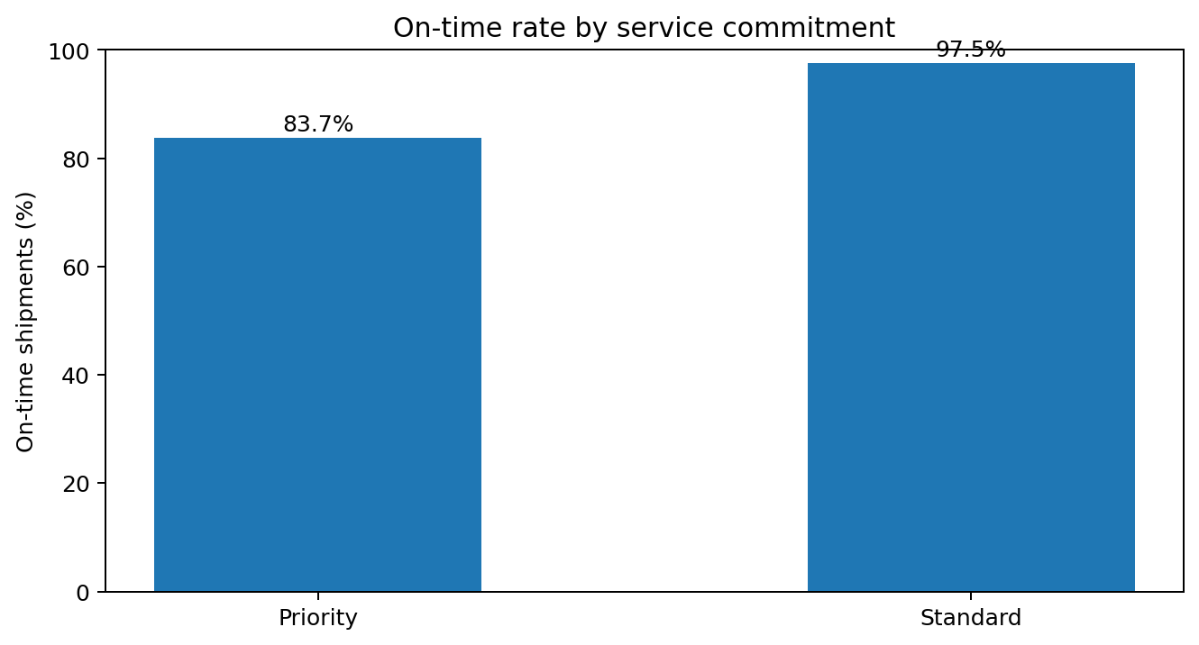
Figure 8 · On-time rates for priority and standard service commitments.

Why show service tiers separately?
The service promise changes the success threshold. A fast absolute delivery time is not necessarily on time for an aggressive priority SLA. Comparing service tiers highlights the difference between elapsed duration and contractual reliability.
The synthetic Priority category delivered 83.69% on time (282 shipments), while Standard achieved 97.49% (678 shipments). Priority and Standard mean modeled transport costs were close—₹162.40 and ₹161.37, respectively—but these values do not account for product mix or delivery-distance differences.

Proposed operational tests
- Audit promise calibration: estimate SLA compliance by zone, distance band and traffic level before changing customer-facing commitments.
- Trial traffic-aware dispatch windows in the highest-risk operating cells and compare results with a matched control period.
- Review Industrial-zone routing separately and report adjusted reliability, not only headline on-time percentages.

12 Python approach and reproducibility
The GitHub-ready package includes `generate_data.py` and `analyze_logistics.py`, as well as the exact simulated CSV, all eight PNG figures, summary tables, a data dictionary, and basic automated tests. The code below illustrates key operations from the included scripts.

Load data and calculate SLA indicators
df = pd.read_csv("data/raw/simulated_shipments.csv")
df["dispatch_date"] = pd.to_datetime(df["dispatch_date"])
df["on_time"] = df["actual_delivery_hours"] <= df["promised_hours"]
df["sla_margin_hours"] = (
df["actual_delivery_hours"] - df["promised_hours"]
)

Compare KPIs and numeric relationships
zone = df.groupby("zone").agg(
shipments=("shipment_id", "count"),
on_time_rate=("on_time", "mean"),
mean_cost=("transport_cost_inr", "mean")
)
r = df[["distance_km", "transport_cost_inr"]].corr(
method="pearson"
)

Generate figures and check pipeline
python scripts/generate_data.py --n 960 --seed 2026
python scripts/analyze_logistics.py --input data/raw/simulated_shipments.csv
python -m unittest discover -s tests -v
All code in this report is illustrative of the complete scripts. Run commands above from the project root after installing `requirements.txt`. The analysis automatically saves reusable CSV and JSON tables and PNG charts to `outputs/`.

13 Recommendations, limitations and conclusion

Prioritized recommendations
Priority | Suggested decision support | Evidence needed in operations
1 • High | Traffic-aware delivery slot buffers | Actual congestion, promised windows, driver shifts
2 • High | Industrial route performance audit | Road distances, stop density, route assignment
3 • Medium | Review priority SLA calibration | Service mix, segment-level customer commitments
4 • Medium | Cost per km and parcel dashboards | Carrier invoices, shared costs, vehicle capacity

Study limitations
- No real-world records were collected. All patterns are generated using built-in formulas and assumptions.
- The dataset assumes all fictional shipments have completed; cancellations, claims and failed deliveries are not modeled.
- No road-network geometry, fleet/driver assignment, vehicle capacity, route sequencing or delivery-window start times are available.
- Pearson correlations are linear associations; neither significance testing nor controls for confounders are used.
- Costs in INR are illustrative model outputs and should not be interpreted as realized rupee expenditures.

Conclusion
The Week 3 exercise demonstrates a coherent analytic path from shipment-level records to descriptive summaries, visual KPIs and operational questions. Results suggest that congestion, service-promise design and longer trips are useful segmentation dimensions within this fictional scenario. Next steps for an applied study are to obtain permissioned actual logistics data, verify its quality, enrich with GPS/traffic and capacity information, validate measurement assumptions and run controlled improvement pilots.

References and supporting documentation
1. pandas Development Team. DataFrame.corr API documentation. https://pandas.pydata.org/docs/reference/api/pandas.DataFrame.corr.html
2. Matplotlib Project. Plot types and statistical plot examples. https://matplotlib.org/stable/plot_types/index
3. NumPy Developers. Random Generator documentation. https://numpy.org/doc/stable/reference/random/generator.html
4. Project source files: README.md, data_dictionary.md, scripts/, data/raw/, outputs/. Reproduce all values with seed 2026.

