LOGISTICS ANALYTICS / WEEK 02
Data Collection, Cleaning
and Preprocessing
An auditable Python pipeline for transaction-level logistics demand data
REPORT DETAILS
Prepared by | Bedi Shivam Jagjeet
Course / activity | Data Science Internship — Week 2
Project theme | Last-mile demand planning and logistics decision support
Dataset reference | UCI Machine Learning Repository — Online Retail II
Demonstration | 81 synthetic rows; reproducible Python outputs
Date | 11 October 2026

DELIVERABLES INCLUDED
- Structured methodology and documented decisions
- Executed quality audit and before/after row counts
- Python code illustrations and complete runnable source file
- Chronological feature scaling without data leakage

Scope note
This report uses a publicly documented retail transaction dataset as a reference and an independently generated sample for execution. No real shipment timestamps, GPS coordinates, or delivery outcomes are asserted.

01 Executive summary & research basis
Logistics forecasting and route planning depend on clean, consistent input data. This Week 2 study continues the Week 1 last-mile logistics project by designing and running an end-to-end preparation pipeline. It standardizes a retail transaction extract, isolates cancellations and invalid records, flags suspicious quantities, reconstructs daily demand, and prepares lagged model features.

1.1 Data source and collection simulation
Reference: Online Retail II, published through the UCI Machine Learning Repository (Daqing Chen, 2012). UCI documents 1,067,371 transaction-line instances from a UK-based online retailer between 1 December 2009 and 9 December 2011, and indicates the dataset contains missing values [1]. This is a sales/fulfillment-demand proxy, not a delivery tracking database.
ATTRIBUTE | MEANING FOR ANALYSIS
Invoice / InvoiceNo | Transaction identifier; C-prefixed records indicate cancellation
StockCode | Product identifier; retained as text
Description | Item description; nonessential for total volume
Quantity | Units per transaction line; sign matters
InvoiceDate | Timestamp used for daily-demand aggregation
Price / UnitPrice | Unit price in GBP; supports monetary measures
Customer ID / CustomerID | Optional customer identifier; not artificially imputed
Country | Customer region, not a precise delivery coordinate

1.2 What was actually executed
A reproducible 81-row synthetic CSV was constructed with UCI-like field names. It intentionally contains blank customer IDs, one blank description, inconsistent country text, missing critical fields, exact duplicates, cancellations, negative and zero quantities, a negative price, a zero-price sample item, and a high-quantity wholesale-style order. The downloadable Python script processes the CSV and saves machine-readable audit outputs.

1.3 Questions addressed
- Which fields can safely be repaired, and which records must be quarantined?
- How can true bulk orders be distinguished from anomalies requiring investigation?
- How should daily demand be prepared for forecasting without time leakage?

02 Data quality assessment
The first inspection checks schema consistency, data types, nulls, duplicate lines, invalid business values and unusual quantities. The pipeline preserves the original source file and writes separate audit outputs rather than silently destroying questionable records.

2.1 Quality issues and resolutions
ISSUE | DETECTION | ACTION / RATIONALE
Column-name differences | Invoice vs InvoiceNo; Price vs UnitPrice | Map aliases to a common schema to prevent broken joins and code failures.
Missing critical fields | Null Invoice, StockCode, Date, Quantity or Price | Quarantine: inventing quantity, price or timestamps would bias demand.
Missing optional fields | Null Customer ID, Description or Country | Retain ID as missing; label unknown description/region with flags.
Exact duplicated rows | Equal standardized 8-field transaction lines | Keep one in synthetic demo; require source IDs for safe production deduplication.
Returns & cancellations | C-prefix or negative quantity | Separate for independent returns analysis; do not mix into gross demand.
Invalid numeric values | Quantity = 0 or Price < 0 | Quarantine and investigate; retain Price = 0 but flag possible promotional item.
Inconsistent categories | Case and whitespace differences | Trim strings; use title case for Country.
Extreme quantities | Above Q3 + 1.5 × IQR | Flag, never blindly delete wholesale demand.

2.2 Exact sample audit (executed results)
MEASURE | COUNT | INTERPRETATION
Raw lines | 81 | Synthetic input records
Duplicate copies | 2 | Separated for review
Returns / cancellations | 3 | Written to dedicated file
Invalid lines | 6 | Missing critical or invalid business value
Clean transaction lines | 70 | Eligible for positive-demand analysis
Quantity outlier flags | 1 | Retained in clean records; requires review

03 Preprocessing methodology & design choices
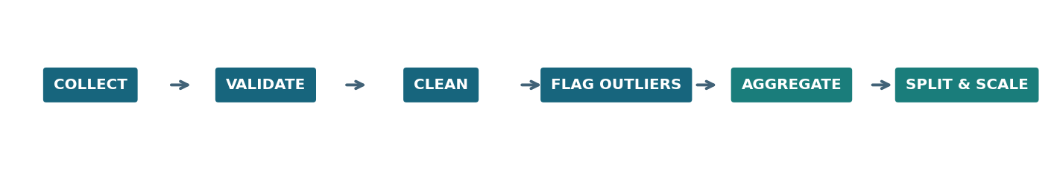
Figure 1. Processing stages implemented in the supplied Python program.

3.1 Clean by business meaning, not just statistical rules
Cancellations and returns are valid events but are excluded from the positive-demand table. Their records remain in a separate dataset for return-rate analytics. Invalid dates, unparseable quantities and negative prices are quarantined rather than assigned made-up values. Missing customer IDs remain null to avoid creating fictitious customers or distorting customer segmentation.

3.2 Outlier detection
For positive quantity values, IQR = Q3 − Q1 and upper threshold = Q3 + 1.5 × IQR. Quantities above that threshold receive a Boolean review flag; original volumes are preserved. In this sample the upper threshold is 25 units and exactly one unusually large line is flagged (450 units). High-volume orders may be legitimate wholesale demand [1], so automatic removal could understate warehouse workload.

3.3 Normalization and leakage prevention
Scaling is useful when machine-learning features have very different numeric ranges, but it should never overwrite operational units. This pipeline retains raw demand and scales only lag-based model inputs: demand from yesterday, demand from the corresponding day last week, and the mean of the previous seven days. A RobustScaler uses training-set medians and interquartile ranges, reducing outlier influence [2].
The first 80% of feature-ready days form the training set and the last 20% form the test set. The scaler is fit on training rows only and reused for the test rows. Current-day demand is a prediction target, not a predictor. Using a chronological split prevents future information from entering historical predictions.

3.4 Daily aggregation and missing calendar dates
Daily unit demand equals the sum of valid positive quantities grouped by transaction date. Missing calendar days are inserted with zero only under the assumption that the source extraction covers every calendar day; for an incomplete source extract, missing periods must be marked as unknown instead of zero.

04 Python implementation — code illustrations
The full executable program is included as week2_preprocess.py. The excerpts below highlight the substantive preprocessing operations; they are illustrations of the tested implementation rather than independent notebook cells.

4.1 Load and standardize dates and numeric columns
df['quantity'] = pd.to_numeric(df['quantity'], errors='coerce')
df['unit_price'] = pd.to_numeric(df['unit_price'], errors='coerce')
df['invoice_date'] = pd.to_datetime(
df['invoice_date'], errors='coerce', format='mixed'
)
# Invalid values become NaN / NaT and can be isolated for review.
The program also maps legacy UCI headers (Invoice, Price, Customer ID) and alternative headers (InvoiceNo, UnitPrice, CustomerID) to a single internal schema. The use of coercion allows bad text values to be detected rather than generating a fatal parsing error [3].

4.2 Remove duplicate copies and separate returns
dupe_mask = df.duplicated(subset=FULL_ROW_FIELDS, keep='first')
duplicates = df[dupe_mask].copy()
df = df[~dupe_mask].copy()
cancelled = df['invoice'].fillna('').str.upper().str.startswith('C')
returned = df['quantity'] < 0
return_rows = df[cancelled | returned].copy()
Exact duplicate removal is safe for this constructed example; in real order-line data, repeated-looking invoice lines may be legitimate, so source transaction line IDs should be reviewed before permanent deletion [4].

4.3 Preserve suspicious outliers
q1, q3 = clean['quantity'].quantile([0.25, 0.75])
upper_fence = q3 + 1.5 * (q3 - q1)
clean['quantity_outlier_flag'] = clean['quantity'] > upper_fence
# Do not automatically drop flagged rows.

4.4 Create honest operational measures
clean['line_value_gbp'] = clean['quantity'] * clean['unit_price']
clean['order_date'] = clean['invoice_date'].dt.normalize()
daily = clean.groupby('order_date').agg(
units_sold=('quantity', 'sum'),
order_lines=('invoice', 'size')
).sort_index()

05 Normalization, saved artifacts & validation

5.1 Lagged features and train-only scaling
features['lag_1_units'] = features['units_sold'].shift(1)
features['lag_7_units'] = features['units_sold'].shift(7)
features['prior_7day_mean_units'] = (
features['units_sold'].shift(1).rolling(7).mean()
)
train = features.iloc[:int(len(features) * 0.8)].copy()
test = features.iloc[int(len(features) * 0.8):].copy()
scaler = RobustScaler()
train[feature_names] = scaler.fit_transform(train[feature_names])
test[feature_names] = scaler.transform(test[feature_names])
Here, feature_names includes only the three historical-demand columns. The downloadable script writes prefixed scaled columns so that the original unscaled features and units remain available for verification. The 80/20 ratio applies after constructing lag features.

5.2 Generated files
OUTPUT FILE | PURPOSE
clean_transactions.csv | Validated positive-demand transaction lines with audit flags
duplicates_review.csv | Repeated normalized records separated for manual checking
returns_cancellations.csv | Cancelled and negative-quantity lines
rejected_review.csv | Missing essential data and invalid numeric fields
daily_demand.csv | Calendar-aligned daily units, line counts and gross line value
model_train.csv / model_test.csv | Chronologically partitioned records with scaled historical features
quality_report.json | Reproducible row counts, missingness, IQR flag totals and scaler statistics

5.3 Quality gates before model development
- All output records have a parseable invoice date and nonmissing item and invoice IDs.
- Every clean record has positive quantity and nonnegative price; zero-price lines carry an explicit flag.
- Row-level disposition reconciles: 81 input = 2 duplicates + 3 return/cancel + 6 invalid + 70 accepted.
- A train/test split follows time order; learned scaler statistics come only from the training period.
- Raw files and rejected records remain recoverable for further verification.

06 Findings, interpretation & reflection
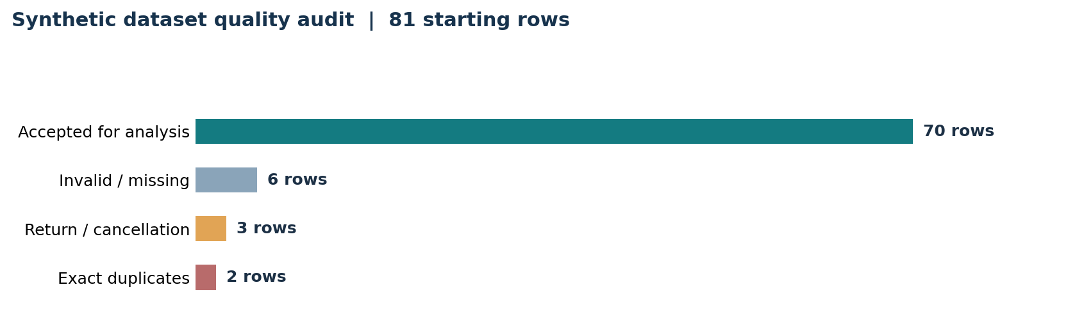
Figure 2. Demonstration output generated from synthetic orders; not observed company performance.

6.1 Observed demonstration outcomes
The script processed 81 generated rows and retained 70 for gross positive-demand analysis, while storing all 11 removed rows in explicit review datasets. The accepted rows contain two missing customer IDs (left null), one unknown country, one substituted description label, one zero-price item and one retained quantity outlier. A 35-day daily series yielded 28 feature-ready days after seven-day lagging, divided into 22 training and 6 test days.

6.2 Impact on logistics decisions
A duplicate invoice line can inflate inventory replenishment recommendations. A cancelled order counted as shipped demand can exaggerate route capacity requirements. Invalid timestamps can shift demand into the wrong planning period; dropped wholesale outliers can hide genuine peak workload. Treating such issues separately improves the interpretability of future forecasts and allows managers to review exceptional orders before allocating staff and vehicles.

6.3 Limitations and next-stage work
The UCI reference dataset records sales transactions, not verified pickup and delivery events. It cannot on its own support claims about travel distance, delivery punctuality or route savings. The synthetic sample also cannot demonstrate generalizable predictive accuracy. In Week 3, the prepared daily series can support exploratory visualizations, train/holdout demand forecasts, and segment-level demand comparisons. Routing analysis requires a separate permitted operational dataset containing depot/stop coordinates, capacities, appointment windows and travel times.

6.4 Conclusion
Preprocessing is a business-control layer, not simply a Pandas cleanup exercise. The report demonstrates defensible handling of missing fields, duplicate records, cancellations, invalid values, anomalies, time aggregation and training-only normalization. By keeping audit files and original operational quantities, the pipeline creates a transparent, reusable foundation for logistics analytics.

07 Reproducibility & references

7.1 How to run the example
# From the folder containing week2_preprocess.py
python -m pip install -r requirements.txt
python week2_preprocess.py --input data/raw/sample_orders.csv --output outputs
# Optional: after downloading the public Excel file from UCI
python week2_preprocess.py --input data/raw/online_retail_II.xlsx --output outputs_uci
Requirements: Python 3.10 or newer recommended; pandas, NumPy, scikit-learn and openpyxl. The Excel importer reads all worksheets and standardizes both historical and mirror column-name conventions. The source dataset must be downloaded separately by the reader; this submission intentionally contains only generated sample data.

7.2 Data governance and assumptions
- Synthetic records are invented solely for an educational pipeline demonstration, not an extract from a real logistics company.
- Use anonymized or permissioned operational data before training models on customers or addresses.
- Retain raw evidence and audit events; review duplicate-removal rules, suspicious prices and wholesale orders before deploying.
- Do not compare demand forecasts or logistics service KPIs with actual delivery outcomes unless those outcomes were separately collected.

7.3 References
[1] Chen, D. (2012). Online Retail II. UCI Machine Learning Repository. DOI: 10.24432/C5CG6D. https://archive.ics.uci.edu/dataset/502/online+retail+ii
[2] Scikit-learn developers. RobustScaler documentation. https://scikit-learn.org/stable/modules/generated/sklearn.preprocessing.RobustScaler.html
[3] Pandas developers. pandas.to_datetime documentation. https://pandas.pydata.org/docs/reference/api/pandas.to_datetime.html
[4] Pandas developers. DataFrame.drop_duplicates documentation. https://pandas.pydata.org/docs/reference/api/pandas.DataFrame.drop_duplicates.html
[5] Pandas developers. pandas.to_numeric documentation. https://pandas.pydata.org/docs/reference/api/pandas.to_numeric.html

End of report • Week 2 Data Preparation

