Title: **Tabs Course Format with ATS (Activity Tracking System)**

Status: Stable (feedback welcome)

Type: **Course Format**

Moodle version required: **2.5**

Git Repository – Tabs Course Format: <https://github.com/fernandooliveira/moodlefn-tabs25>

Support and Feedback: [www.moodlefn.knet.ca](http://www.moodlefn.knet.ca)

* Recommendation: The following plugins were created to work alongside the Tabs Course Format:
  + My Progress block: <https://github.com/fernandooliveira/moodlefn-myprogress25/raw/master/MoodleFN_My_Progress_25.pdf>
  + Marking Manager:

Contents of this document:

1

1. Installation Instructions
2. Overview of Tabs Course Format
3. Overview of Activity Tracking System
4. **Installation Instructions:**

**Tabs Course Format :**

1. Click on the following link to download the latest files for this plug-in:

<https://github.com/fernandooliveira/moodlefn-tabs/zipball/master/>

1. Unzip the downloaded file and rename top directory to **fntabs**
2. Upload the **fntabs** directory to **yourmoodlesite/course/format/**

**B. Overview of Tabs Course Format:**

**Screenshots:**

This course has 10 weeks:

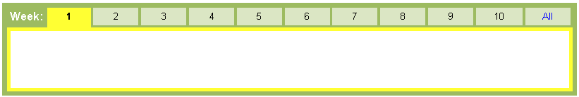

This course has 32 weeks. The “Max tabs shown” value is set to 12 (notice the previous/next links):

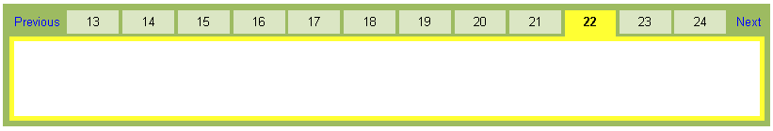

**Configuring the Tabs:**

To change tab preferences, turn editing on and then click on the gear icon located in the tab section:

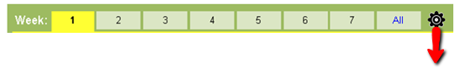

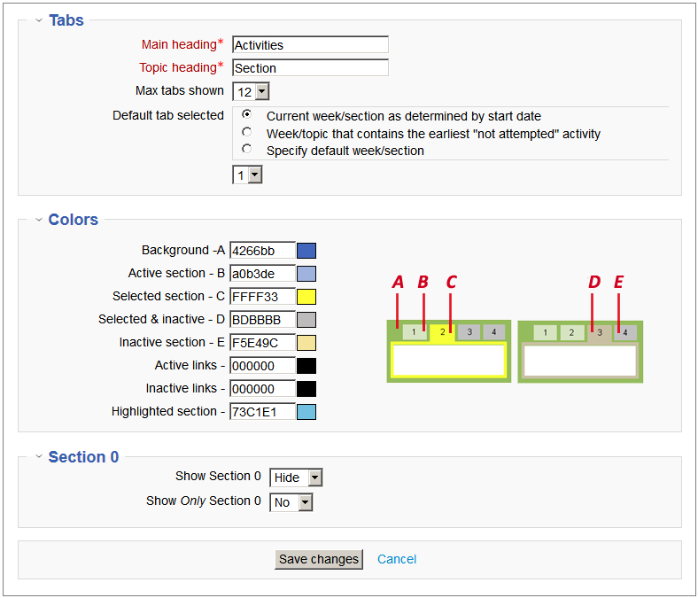

1. **Overview of Activity Tracking System**
2. The ATS uses one of five icons to indicate the status of a given activity, as shown below.
3. When the mouse is rolled over an unselected week, a “tooltip” bubble provides a summary of the activities in that week/section.
4. Each tab has a green or red bar which indicates if all activities in a week/topic is complete or incomplete

**Student View:**

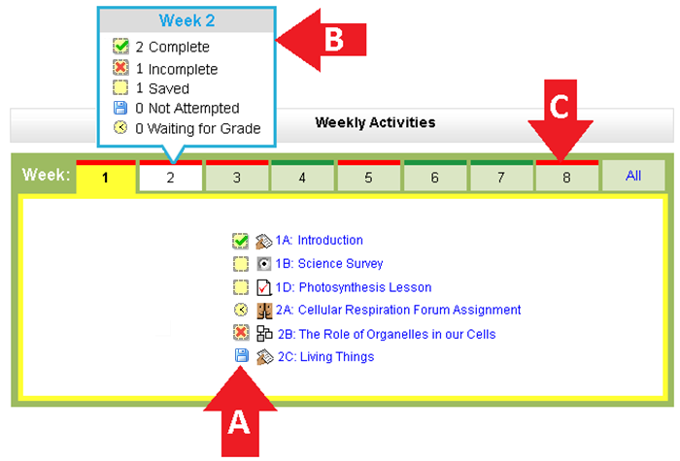

**\*Teacher View:**

Note that the status icons, tab tooltips and tab status bars can only be seen by students. When a teacher is viewing the course, a checkmark is used to indicate that an activity has completion tracking enabled.

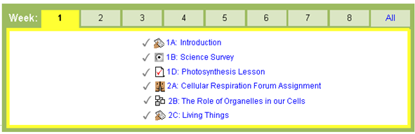

**Note 1:** The ATS relies on the Activity Completion feature that was released as part of Moodle 2.0 (more information about this feature can be found at <http://docs.moodle.org/20/en/Activity_completion>). Activities that do not have the “completion tracking” turned on will not be included in the ATS.

**Note 2:** If an activity has a “Require Grade” condition in the Activity Completion setting, then that activity will show as “complete” when it receives **any** grade.

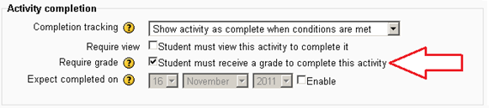

However, if the same activity also has the “[grade to pass](http://docs.moodle.org/20/en/Grade_items)” option enabled in the gradebook, the activity will show as “Incomplete” until it receives a grade that is equal or greater than the “grade to pass” value.

