**Exercise:**

1. Create a trigger that fill hiredate column with the current date, If the newly inserted record in employee has null hireDate field.

**QUERY:**

Create Trigger Emp_date

before insert on emp

For Each Row

Declare

temp date;

Begin

select sysdate into temp from dual;

IF (:new.hireDate is null) Then

:new.hireDate := temp;

End IF;

End;

select * from emp;

insert into emp values (7901,'MIKE','CLERK',7698,null,1100,0,30);

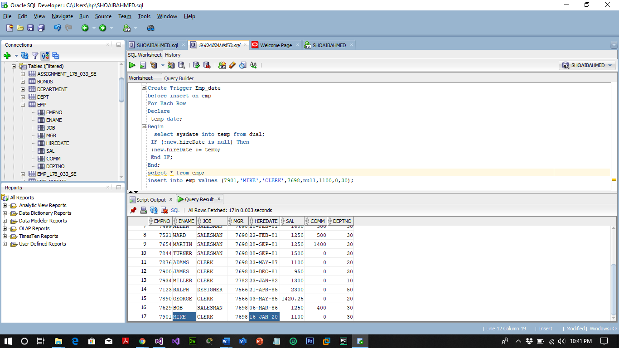

1. Create a trigger that will fill the commission attribute in Employee table always 3% of the salary attribute.

**QUERY:**

Create Trigger commision32

before insert on emp

For Each Row

Begin

:new.comm := :new.sal * 0.03;

End;

/

insert into emp values (7802,'JOHNC','CLERK',7698,null,1100,0,30);

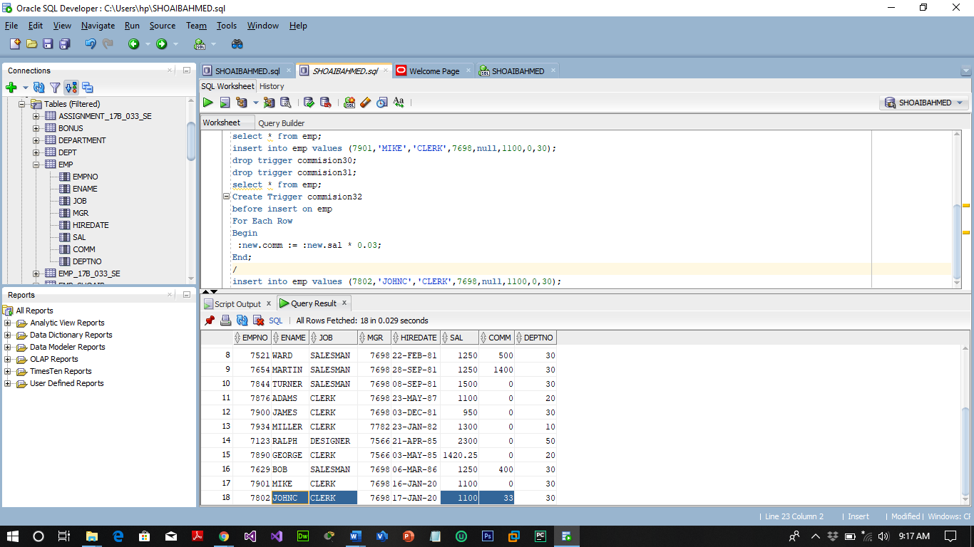

1. Study INSTEAD OF Triggers and explain it with examples.

**INSTEAD OF Trigger**

"INSTEAD OF trigger" is the special type of trigger. It is used only in DML triggers. It is used when any DML event is going to occur on the complex view.

Consider an example in which a view is made from 3 base tables. When any DML event is issued over this view, that will become invalid because the data is taken from 3 different tables. So in this INSTEAD OF trigger is used. The INSTEAD OF trigger is used to modify the base tables directly instead of modifying the view for the given event.

Suppose, an application needs to insert new brands into the production.brands table. However, the new brands should be stored in another table called production.brand_approvals for approval before inserting into the production.brands table.

To accomplish this, you create a view called production.vw_brands for the application to insert new brands. If brands are inserted into the view, an INSTEAD OF trigger will be fired to insert brands into the production.brand_approvals table.