**EXERCISES**

Consider the schema of the previous lab session that represents information about *employees*, *grades*, *training* and *projects* in an organization and answer the following questions.

1. Create a sequence to generate the primary key column EMPNO of EMPLOYEE table in the lab session 06. The sequence should start with 1, increment by 1 and have maximum value of 10000.

**QUERY:**

create SEQUENCE employee2 INCREMENT by 1 START WITH 1 MAXVALUE 10000;

INSERT INTO employee122 (EMPNO1, NAME1,DESIGNATION,QUALIFICATION,JOIN_DATE) VALUES(employee2.NEXTVAL, 'SHOAIB AHMMED',1, 'BE', TO_DATE('27-DEC-1980', 'DD-MON-YYYY'));

INSERT INTO employee122 (EMPNO1, NAME1,DESIGNATION,QUALIFICATION,JOIN_DATE) VALUES(employee2.NEXTVAL, 'SHOAIB AHMMED',2, 'BE', TO_DATE('27-DEC-1980', 'DD-MON-YYYY'));

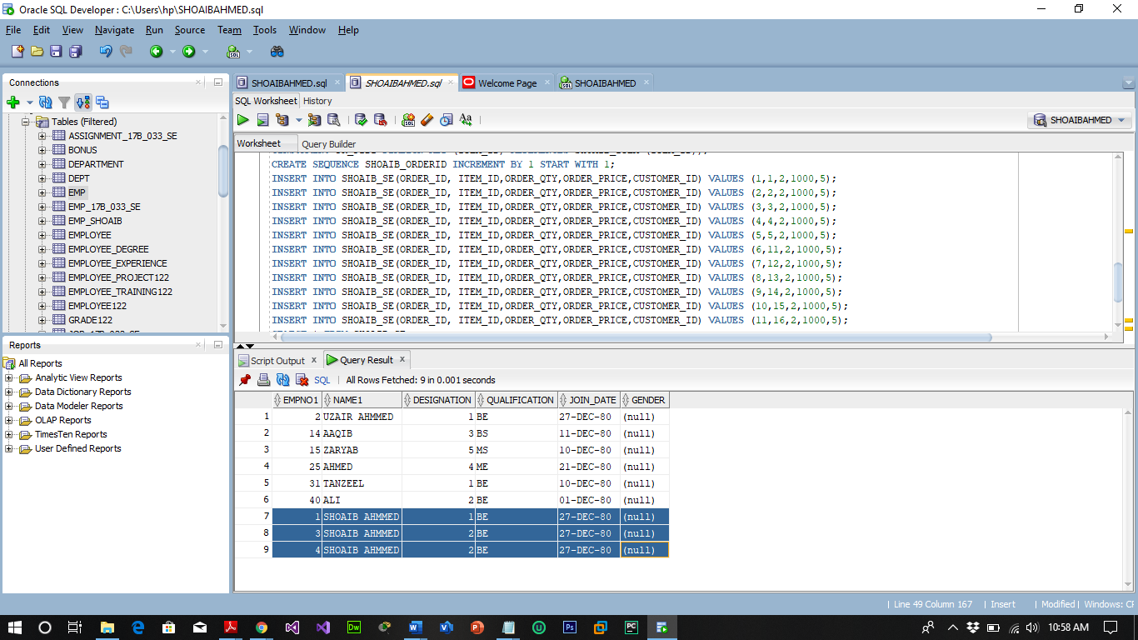

1. Create **B-Tree** indexes on
2. **Name** column of EMP table

**Create index Employee3 On EMPLOYEE122(NAME1);**

1. **Designation** column of EMP table

**Create index Employee_des On EMPLOYEE122(designation);**

1. First 10 characters of **Title** in TRAINING table

**Create index Training_title On training122(substr(TITLE1,1,10));**

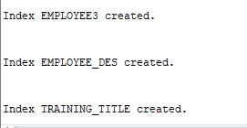

1. Create **bitmapped** indexes on
2. **Gender** column of EMP table

**Create Bitmap index Employee_Gender On EMPLOYEE122(gender);**

1. **Performance** column of EMP_PROJECT table

**Create Bitmap index Employee_Project_Performance On EMPLOYEE_Project122(Performance1);**

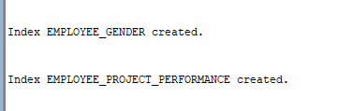

**CHECKING INDEXES:**

SELECT INDEX_NAME, TABLE_NAME, TABLE_OWNER, UNIQUENESS FROM USER_INDEXES;

