1. Create a stored procedure to get the project ID and print the project title, client name, duration (in days) and status.

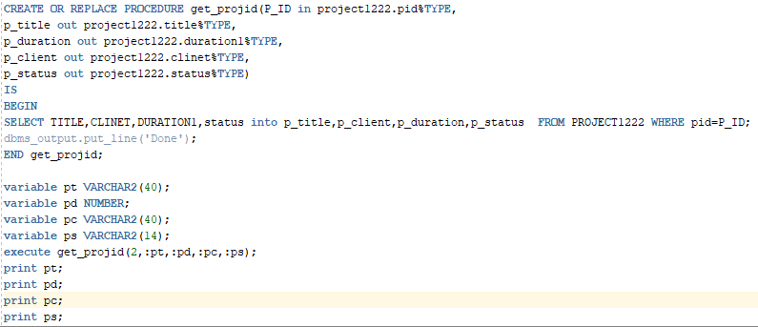

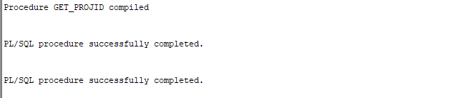

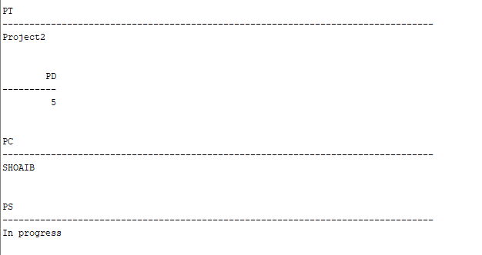

1. Create a stored procedure that takes the employee number and designation. Change the designation of the employee to the new value passed and then print the new grade as follows: -

New Grade: xxx

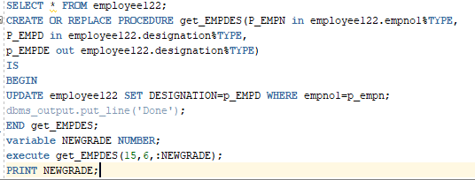

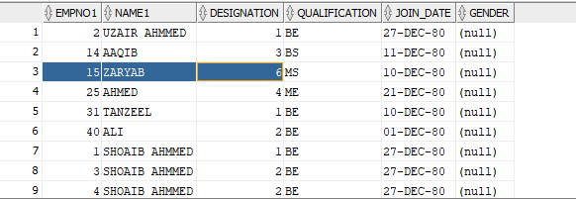

1. Create a stored procedure that has two arguments TID and duration. The first argument takes training code for a training program from the calling environment and the second argument should return the duration of training in weeks to the calling environment. Then print the duration in the calling environment.

