**EXERCISES**

1. Write down the result of the function calls in the first column to the second column.

|  |  |
| --- | --- |
| **Function Call** | **Result** |
| SUBSTR(CONCAT(‘HIGH’, ‘SALARY’), 4, 6) | **HSA** |
| CONCAT(SUBSTR(‘INFORMATION’, 3, 4), ‘TECH’) | **FOTECH** |
| INSTR(CONCAT(‘GET’, ‘ING’), ‘TIN’) | **3** |
| ROUND(69.476, 1) | **69.5** |
| TRUNC(’13-MAR-90’, ‘MONTH’) | **01-MAR-90** |
| TRUNC(’13-MAR-90’, ‘YEAR’) | **01-JAN-90** |
| MOD(90, LENGTH(‘SEVENTY’)) | **6** |
| MONTHS_BETWEEN(’14-AUG-96’, ’23-MAR-95’) | **17** |

1. Write down SQL queries to perform following functions:-
2. To show the current date. Label the column *Current* *Date*.

SELECT SYSDATE AS "CURRENT DATE" FROM DUAL;

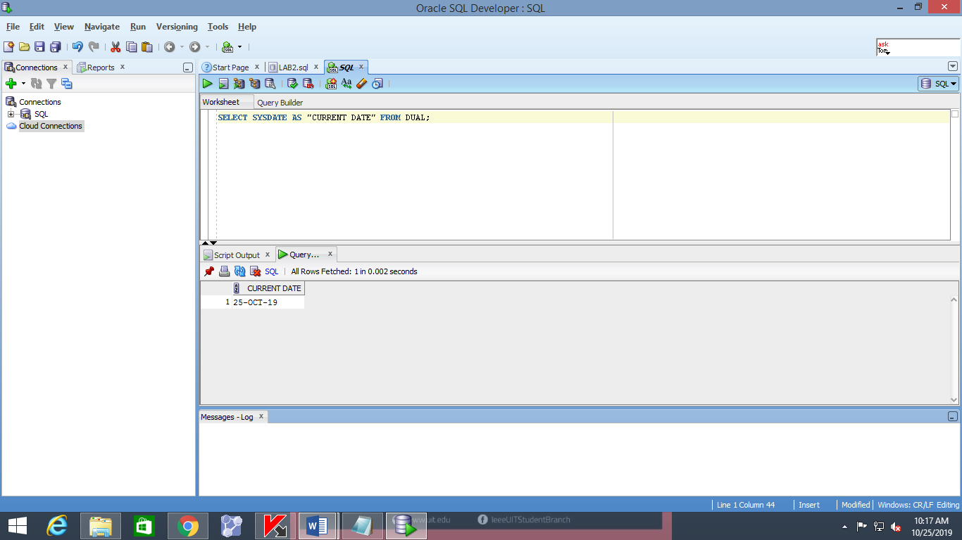

1. To display the employee number, name, salary, salary increase by 15% expressed as a whole number (labeled as *New Salary*), the difference between old salary and new salary (labeled as *Increment*).

SELECT ENAME, EMPNO, SAL, TRUNC(SAL+SAL*0.15) AS "NEW SALARY”, TRUNC(SAL+SAL*0.15-SAL) AS "INCREAMENT" FROM EMP;

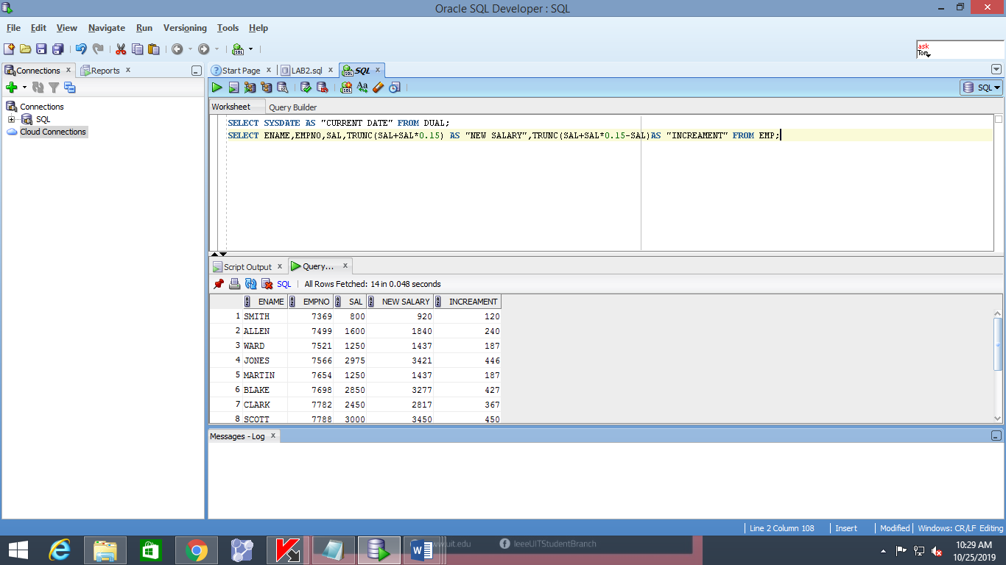

1. To display the employee name and calculate the number of months between today and the date the employee was hired (Labeled as *Months_Worked*). Order the results by the number of months employed and round the number of months up to the closest whole number.

SELECT ENAME, HIREDATE, TRUNC(MONTHS_BETWEEN(SYSDATE, HIREDATE)) AS "MONTH WORKED", ROUND( MONTHS_BETWEEN(SYSDATE, HIREDATE)) AS "CLOSET WHOLE NO" FROM EMP ORDER BY "MONTH WORKED" ASC;

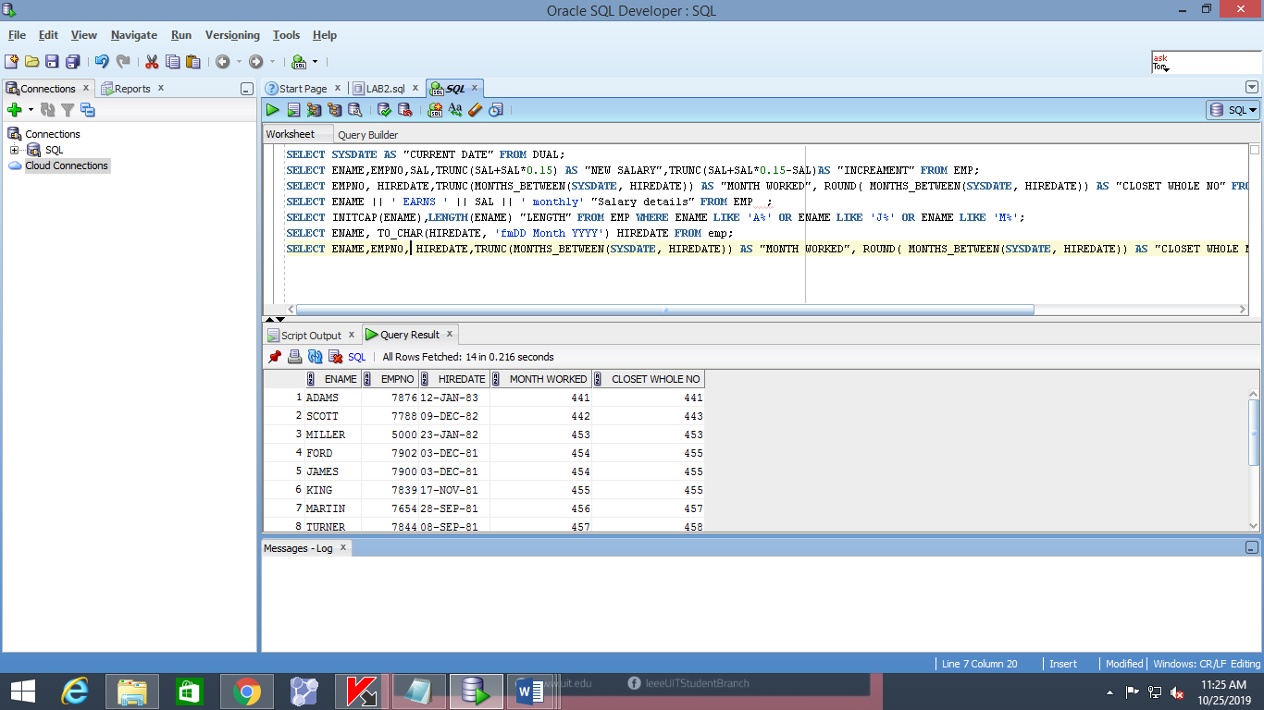

1. Write a query that produces the following for each employee:

*<employee name>* earns *<salary>* monthly

SELECT ENAME || ' EARNS ' || SAL || ' monthly' "Salary details" FROM EMP;

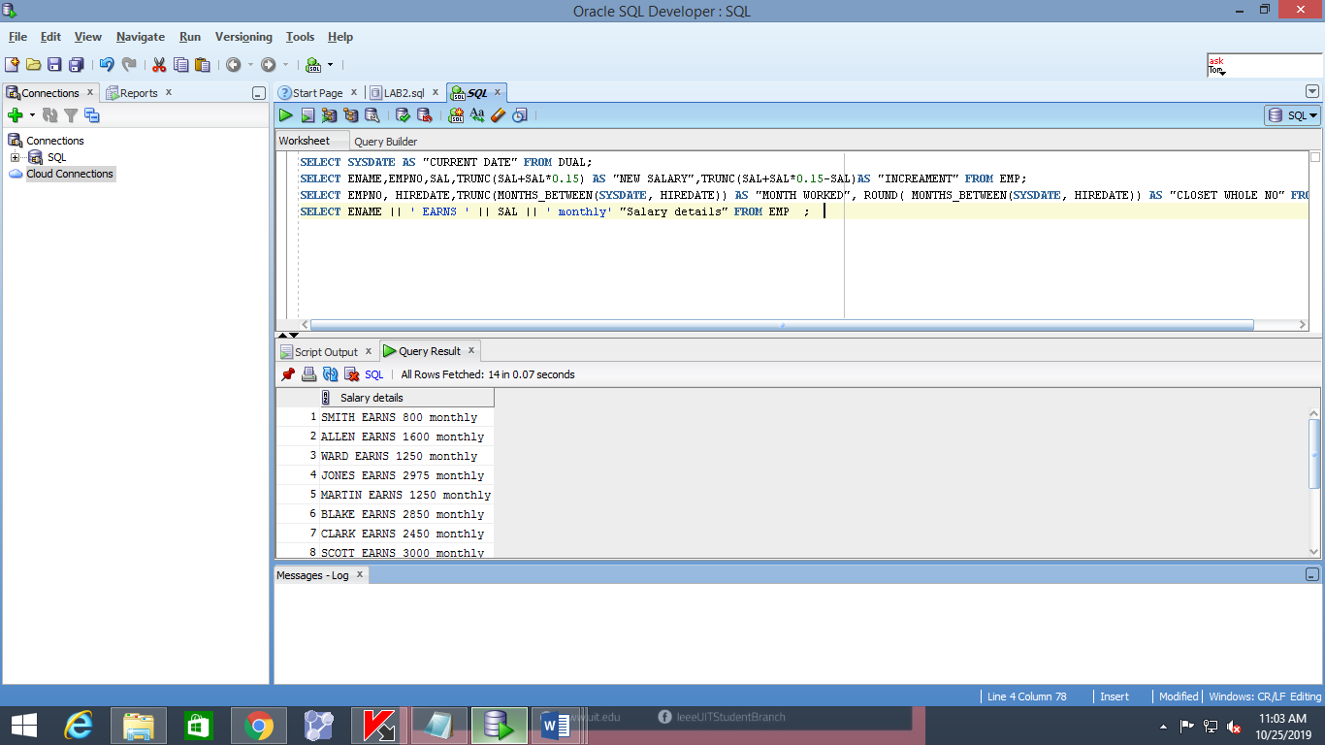

1. To display the employee’s name (labeled *name*) with the first letter capitalized and all other letters lowercase and the length of their name (labeled *length*), for all employees whose name starts with J, A or M.

SELECT INITCAP(ENAME), LENGTH(ENAME) "LENGTH" FROM EMP WHERE ENAME LIKE 'A%' OR ENAME LIKE 'J%' OR ENAME LIKE 'M%';

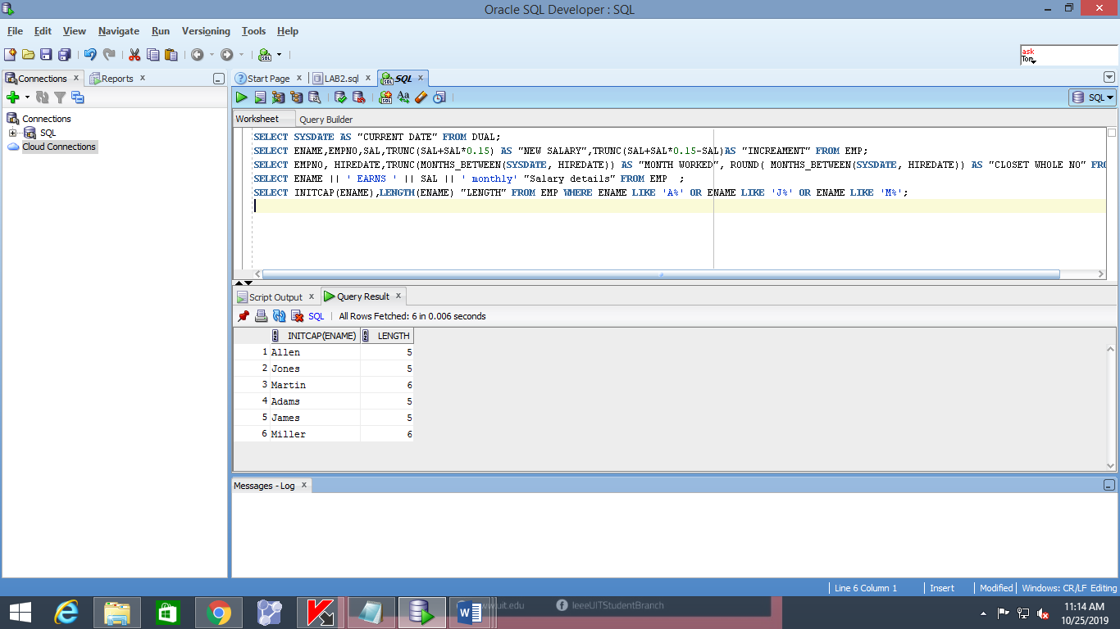

1. To list the name, hiredate, and day of the week (labeled *DAY*) on which job was started. Order the result by day of week starting with Monday.

SELECT ENAME, TO_CHAR (HIREDATE, 'fmDD Month YYYY')"DATE", TO_CHAR (HIREDATE, 'DAY') "DAY" FROM EMP ORDER BY TO_CHAR(HIREDATE-1,'D');

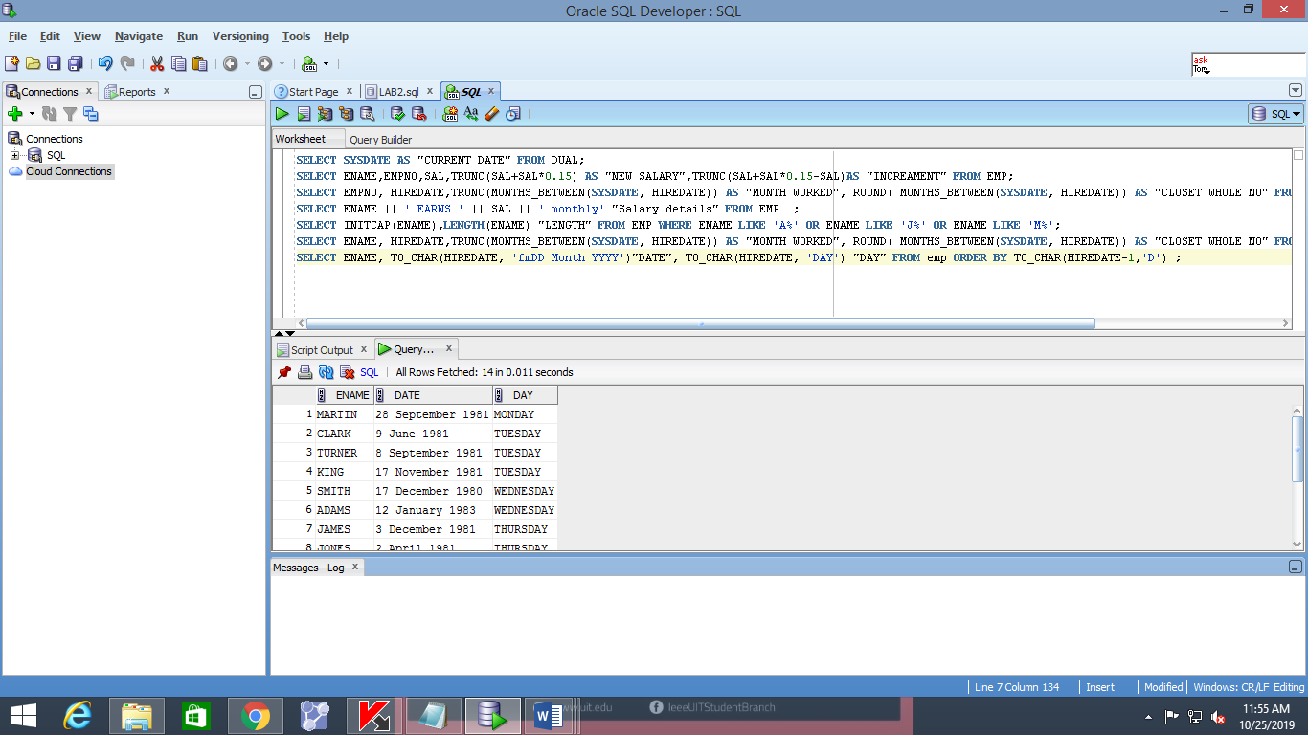

1. To display the job-wise count of employees in each department as follows: -

**DEPTNO JOB NUM_EMP**

SELECT D. DEPTNO, D. DNAME, COUNT ('E. EMPNO') "NUMBER OF EMPLOYEES"FROM DEPT D, EMP EWHERE D. DEPTNO = E. DEPTNO GROUP BY D. DEPTNO, D. DNAME;

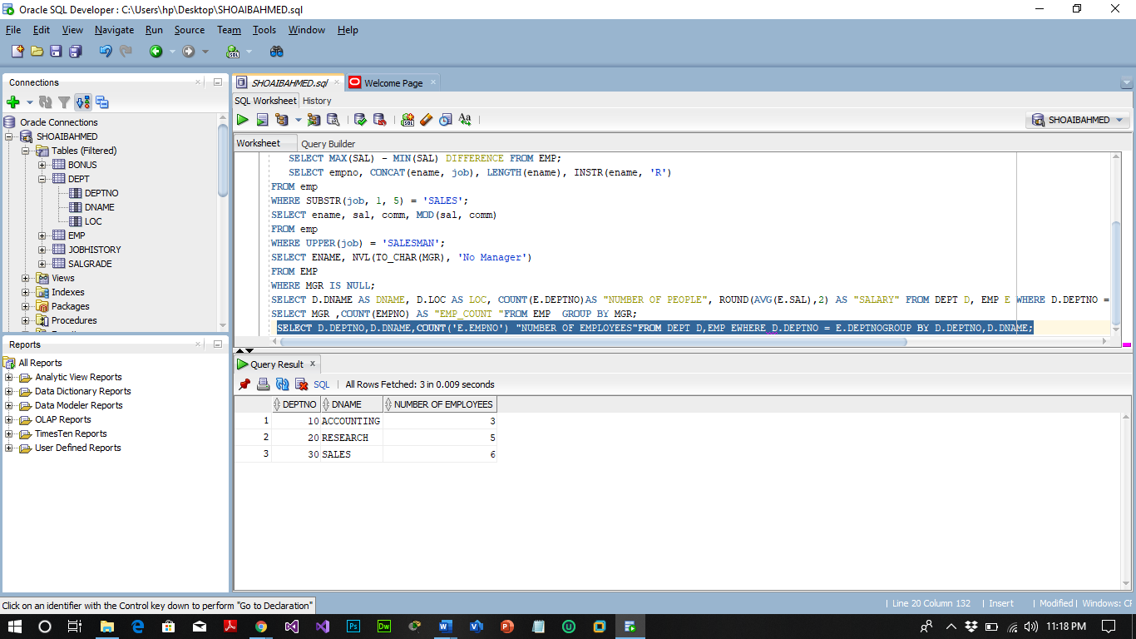

1. To display the department name, location name, number of employees and the average salary for all employees in that department. Label the columns DNAME, LOC, NUMBER OF PEOPLE and SALARY, respectively. Round the average salary to two decimal places.

SELECT D. DNAME AS DNAME, D.LOC AS LOC, COUNT (E. DEPTNO) AS "NUMBER OF PEOPLE", ROUND(AVG(E.SAL),2) AS "SALARY" FROM DEPT D, EMP E WHERE D. DEPTNO = E. DEPTNO GROUP BY D. DNAME, D.LOC, E. DEPTNO;

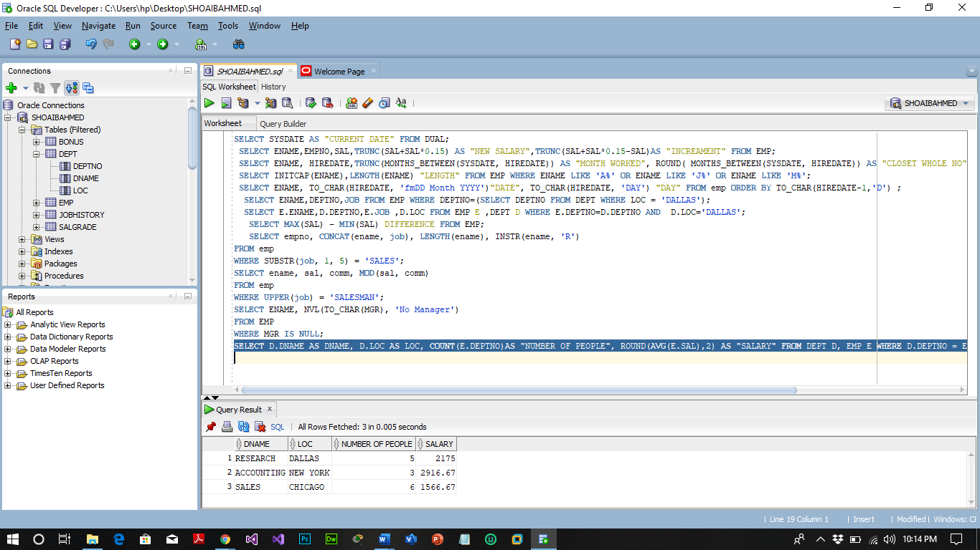

1. To display the employee name, department number and job title for all employees whose department location is *Dallas*.

1. SELECT ENAME, DEPTNO, JOB FROM EMP WHERE DEPTNO= (SELECT DEPTNO FROM DEPT WHERE LOC = 'DALLAS');
2. SELECT E. ENAME, D. DEPTNO, E.JOB, D.LOC FROM EMP E, DEPT D WHERE E. DEPTNO=D.DEPTNO AND D.LOC='DALLAS';

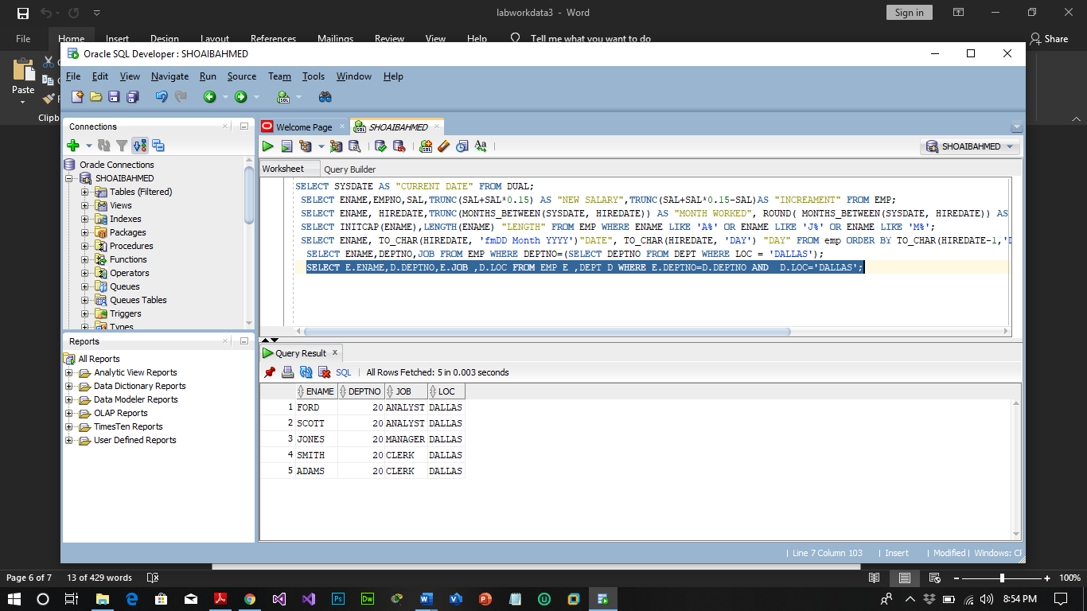

1. To display the difference between the highest and lowest salaries (Labeled as

*DIFFERENCE*)

SELECT MAX(SAL) - MIN(SAL) DIFFERENCE FROM EMP;

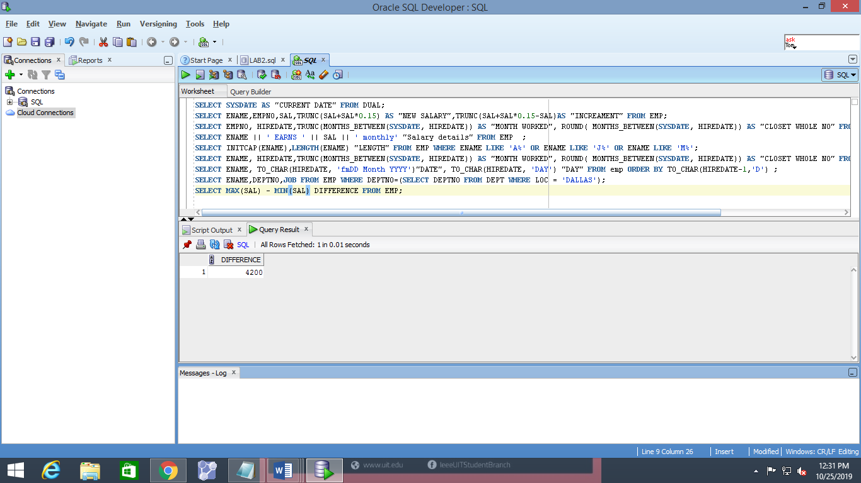

1. To show the manager name, MANAGER, and the number of employees, NUM, working under him.

SELECT MGR, COUNT(EMPNO) AS "EMP_COUNT "FROM EMP GROUP BY MGR;

