1. Develop a script file **EMPLOYEE.SQL** to create tables for the above schema. Implement all necessary *integrity constraints* including primary and foreign keys. (NOTE: All ***check*** constraints should be at table level)

**SCRIPT**

create table employee122

(

empno1 number(4),

name1 varchar (20),

designation varchar (40),

qualification varchar (20),

join_date date,

constraint pk_pripit primary key (empno1));

create table project1222

(

pid varchar(4),

title varchar (20),

clinet varchar (40),

duration1 number,

status varchar(14),

constraint pk_prpit primary key (pid),

CONSTRAINT ck_propit check (((lower(status)='new') or (upper(status)='new')or (initcap(status)='new')) or ((lower(status)='in progress') or (upper(status)='in progress')or (initcap(status)='in progress')) or ((lower(status)='complete') or (upper(status)='complete')or (initcap(status)='complete'))));

create table employee_project122

(

empno1 number(4),

pid varchar(5),

performance1 varchar(14),

CONSTRAINT ck_pro1t check (((lower(performance1)='excellent') or (upper(performance1)='excellent')or (initcap(performance1)='excellent')) or ((lower(performance1)='good') or (upper(performance1)='good')or (initcap(performance1)='good')) or ((lower(performance1)='fair') or (upper(performance1)='fair')or (initcap(performance1)='fair'))or ((lower(performance1)='bad') or (upper(performance1)='bad')or (initcap(performance1)='bad'))or ((lower(performance1)='poor') or (upper(performance1)='poor')or (initcap(performance1)='poor'))),

constraint fk_emp12t foreign key (empno1) references employee122(empno1),

constraint fk_pid3t foreign key (pid) references project1222(pid) );

create table grade122

(

grade number,

designation1 varchar (40),

totalposts number,

postavailable number,

constraint ck_postit check (postavailable<=totalposts));

create table training122

(

tcode varchar(4),

title1 varchar (20),

startdate date,

enddate date,

constraint pk_tcit primary key (tcode));

create table employee_training122

(

empno1 number(4),

tcode varchar(4),

attendance number (3),

constraint ck_attit check (attendance <=100 and attendance >=0),

constraint fk_emp1t foreign key (empno1) references employee122(empno1),

constraint fk_tc1it foreign key (tcode) references training122(tcode) );

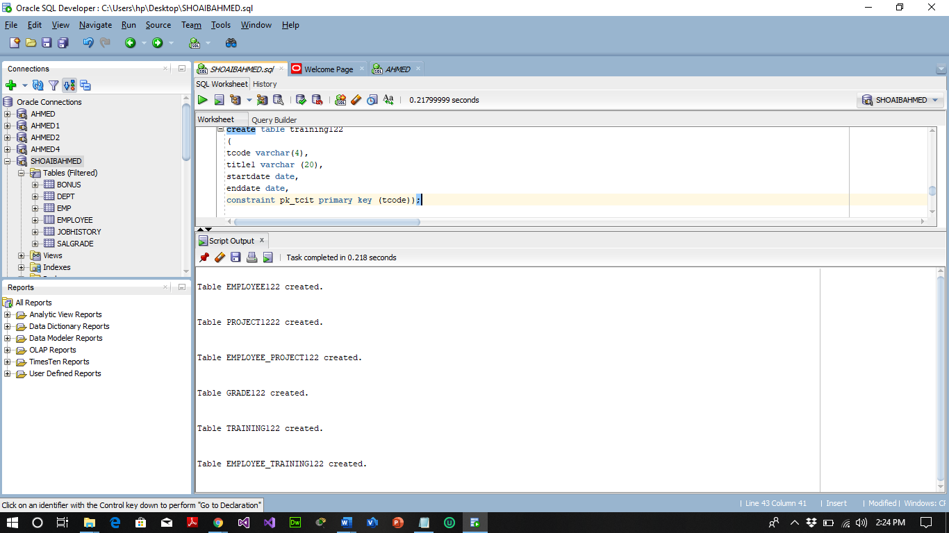

1. Write SQL statements to add

* *Gender* column to **EMP** table. The only possible values are *Male* and *Female*.

**ALTER TABLE EMPLOYEE122**

**ADD (**

**gender varchar(20),**

**constraint ck_gender check (((lower(gender)='male') or (upper(gender)='male')or (initcap(gender)='male')) or ((lower(gender)='female') or (upper(gender)='female')or (initcap(gender)='female')) ));**

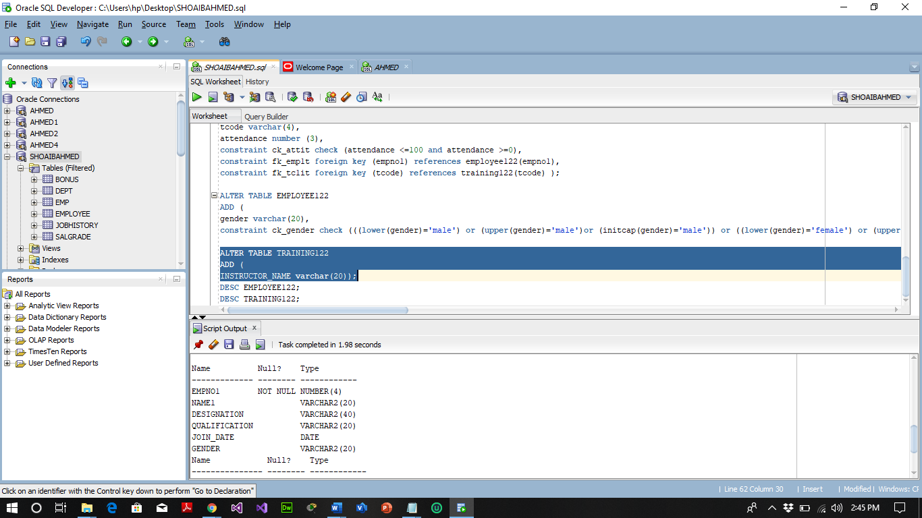

* *Instructor Name* column to **TRAINING** table.

**ALTER TABLE TRAINING122**

**ADD (**

**INSTRUCTOR_NAME varchar (20));**

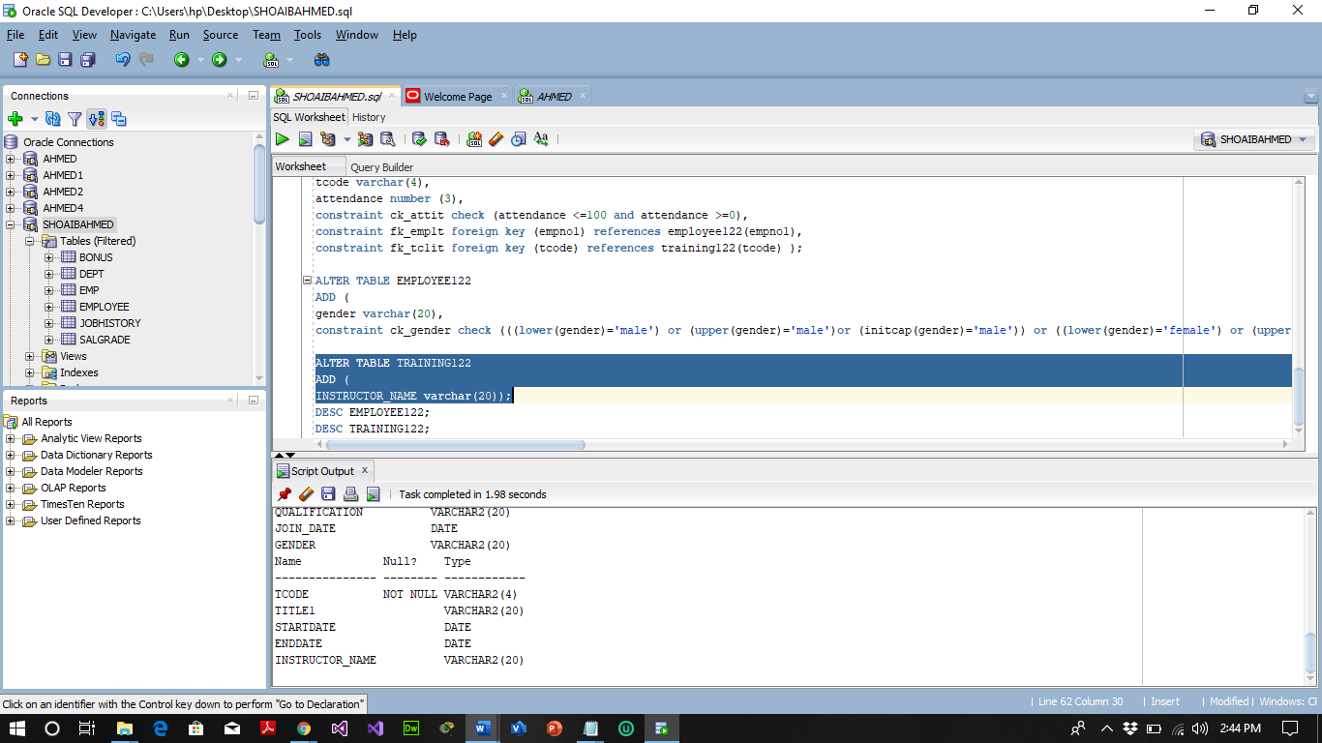

* *Salary* column to **GRADE** table.

**ALTER TABLE GRADE122**

**ADD (**

**SALARY varchar (20));**

**DESC GRADE122;**

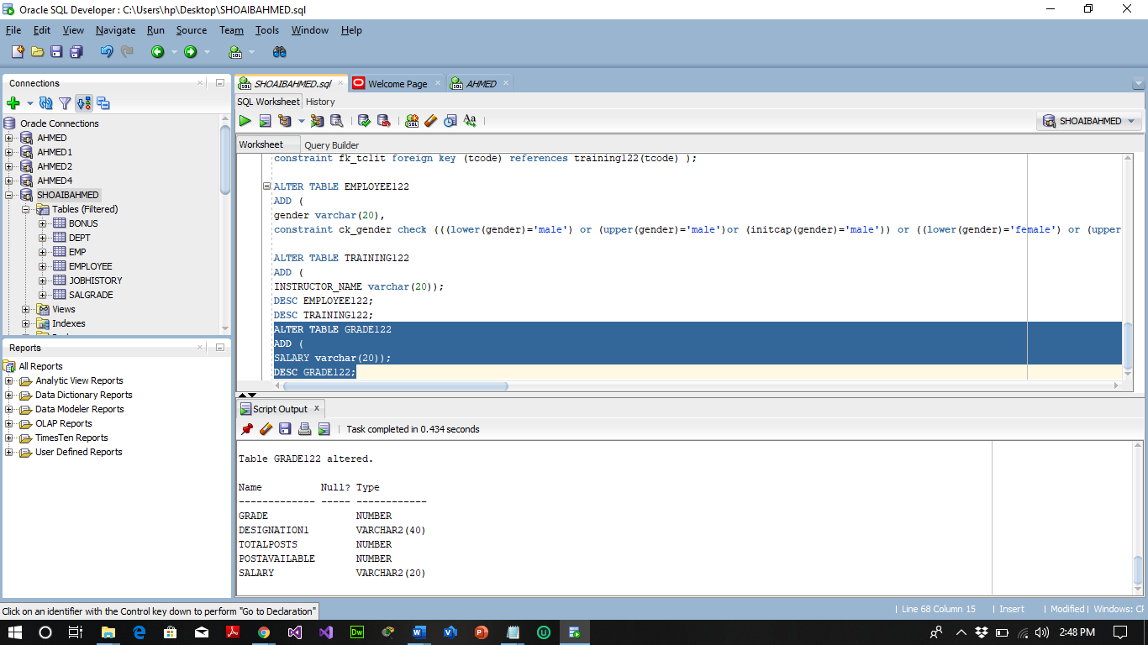

1. What is *database schema*? What are the different objects included in it?

***Associated with each database user is a schema. A schema is a collection of schema objects. Examples of schema objects include tables, views, sequences, synonyms, indexes, clusters, database links, procedures, and packages.***

1. Copy employee table to another table?

**CREATE TABLE EMP_SHOAIB AS SELECT * FROM EMPLOYEE122 WHERE (1=2);**

**DESC EMP_SHOAIB;**

