**TASKS**

1. Define Transaction. How it is terminated? Describe the different operations included in a transaction.

“Transaction is a set of operations which are all logically related.”

**OR**

“Transaction is a single logical unit of work formed by a set of operations.”

After entering the committed state or aborted state, the transaction finally enters into a **terminated state** where its life cycle finally comes to an end.

## ****Operations in Transaction-****

The main operations in a transaction are-

1. Read Operation
2. Write Operation

## ****1. Read Operation-****

* Read operation reads the data from the database and then stores it in the buffer in main memory.

## ****2. Write Operation-****

* Write operation writes the updated data value back to the database from the buffer.

1. Write a transaction to insert following rows in EMP table.

|  |  |  |  |  |  |  |  |
| --- | --- | --- | --- | --- | --- | --- | --- |
| **EMPNO** | **ENAME** | **JOB** | **MGR** | **HIREDATE** | **SAL** | **COMM** | **DEPTNO** |
| 7123 | RALPH | DESIGNER | 7566 | 21-APR-85 | 2300 |  | 50 |
| 7890 | GEORGE | CLERK | 7566 | 03-MAY-85 | 1235 |  | 50 |
| 7629 | BOB | SALESMAN | 7698 | 06-MAR-86 | 1800 | 1000 | 30 |

INSERT INTO DEPT (deptno, dname,loc) VALUES (50, 'DESIGNER', 'WASHINGTONDC');

INSERT INTO DEPT (deptno, dname,loc) VALUES (60, 'CLERK', 'MISSISIPPI');

INSERT INTO EMP VALUES

(7123, 'RALPH', 'DESIGNER', 7566,

TO_DATE('21-APR-85', 'DD-MON-YY'), 2300, NULL, 50);

INSERT INTO EMP VALUES

(7890, 'GEORGE', 'CLERK', 7566,

TO_DATE('03-MAY-85', 'DD-MON-YY'), 1235, NULL, 60);

INSERT INTO EMP VALUES

(7629, 'BOB', 'SALES', 7698,

TO_DATE('06-MAR-86', 'DD-MON-YY'), 1250, 1000, 30);

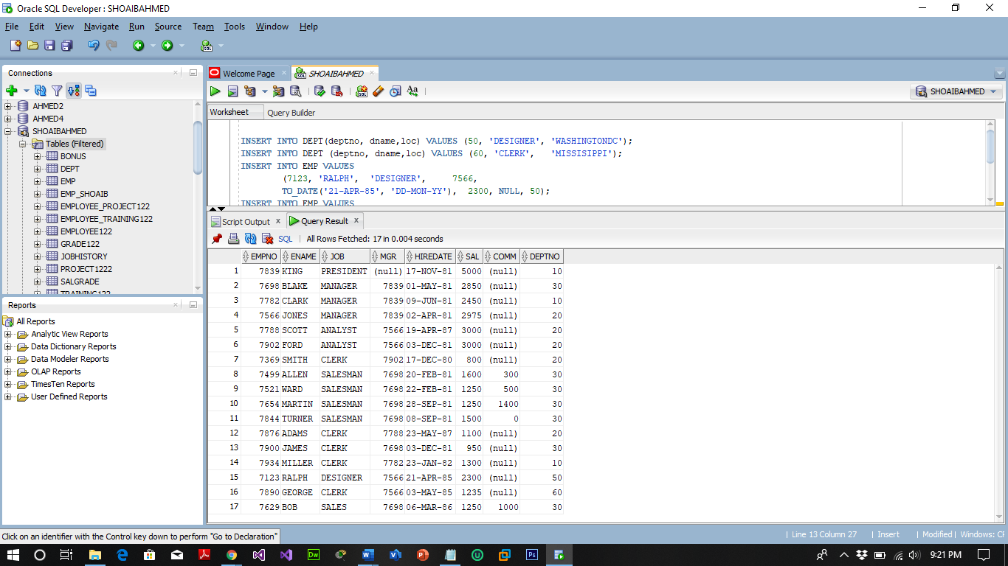

1. Write down SQL statements to perform following functions:-
2. Increase the salary by 250 of all clerks with a salary less than 900

UPDATE EMP SET SAL=SAL+250 WHERE JOB='CLERK' AND SAL<900;

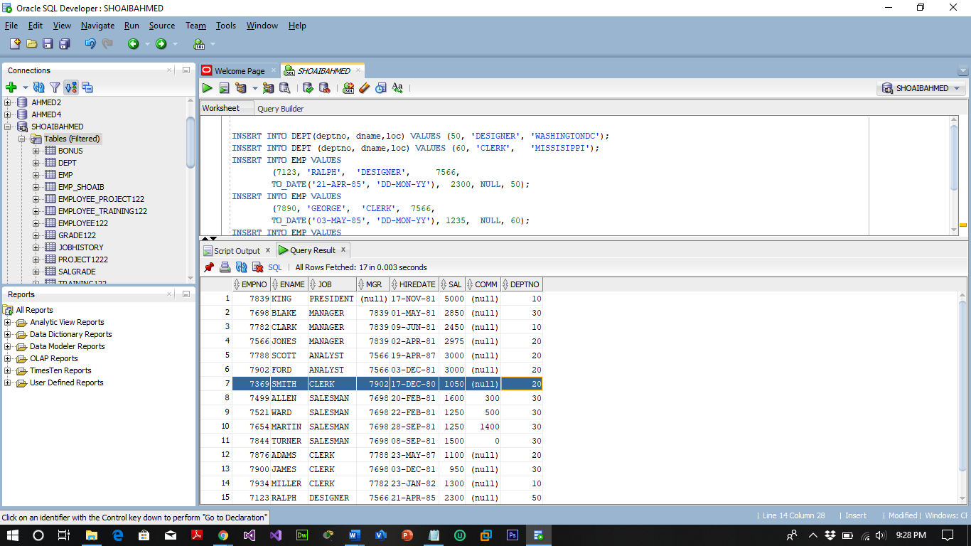

1. Transfer the employee with number 7890 to department 20 and increase his salary by 15%.

UPDATE EMP SET DEPTNO =20, SAL=SAL+SAL*0.15 WHERE EMPNO =7890;

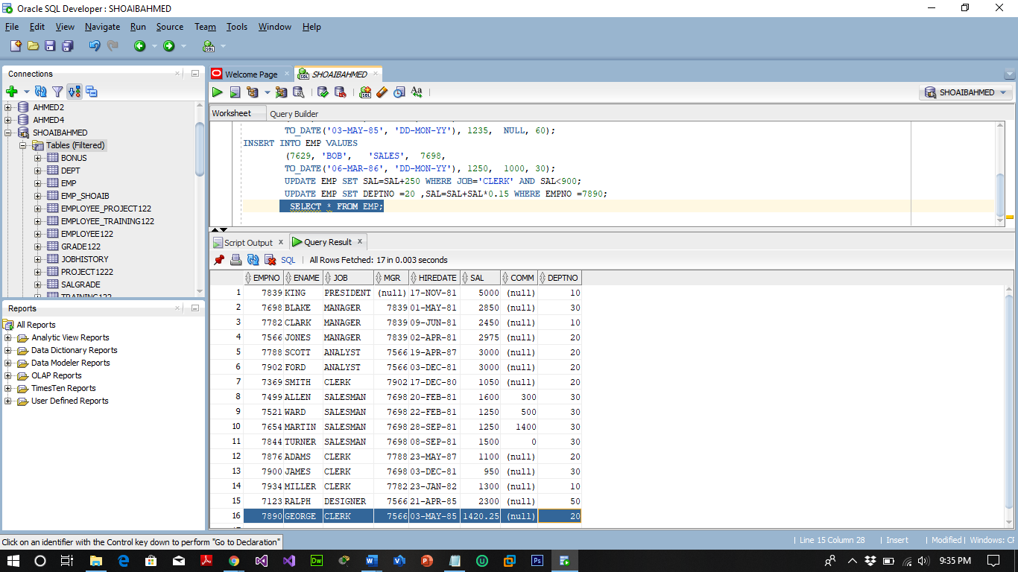

1. Increase the salary of employee with number 7369 by 10% of the salary of employee with number 7499.

UPDATE EMP SET SAL=SAL + (SELECT SAL*0.1 FROM EMP WHERE EMPNO=7499) WHERE EMPNO=7369;

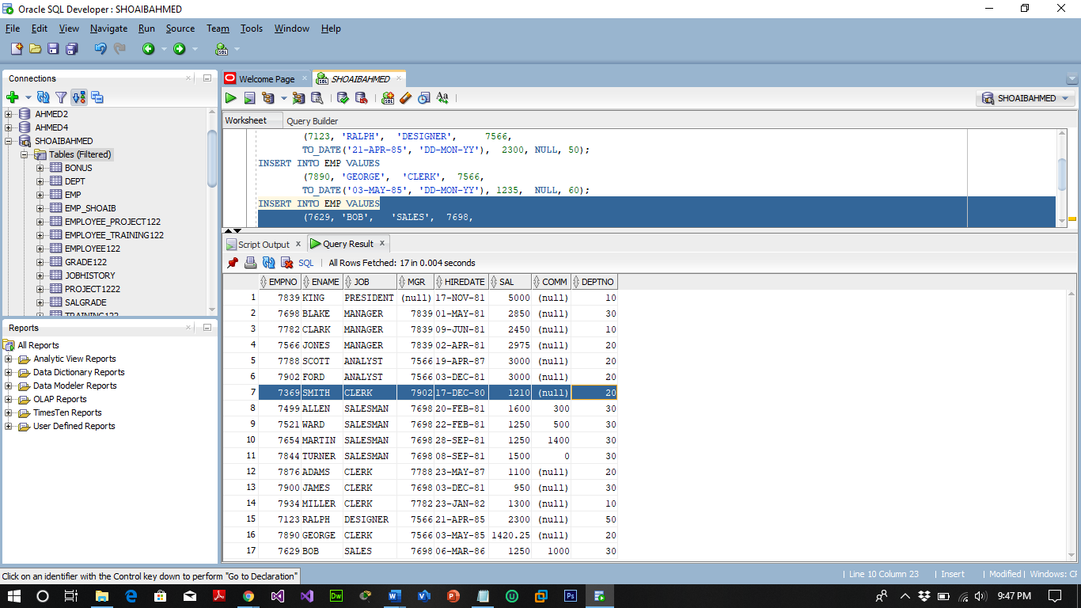

1. Assign to employee 7876 the same manager as the employee 7900.

UPDATE EMP SET MGR =(SELECT MGR FROM EMP WHERE EMPNO=7900) WHERE EMPNO =7876;

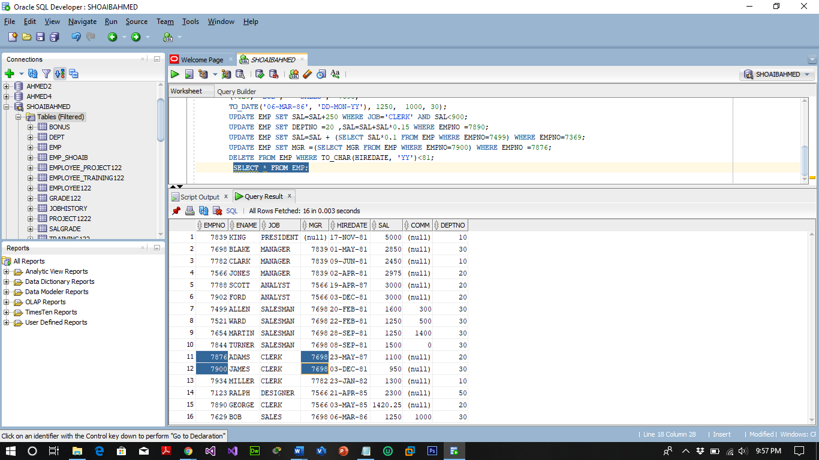

1. Remove all employees who were hired before 1981.

DELETE FROM EMP WHERE TO_CHAR(HIREDATE, 'YY')<81;

