**EXERCISE**

1. Why are subqueries needed in accessing data from the database?

**Because it is used to return data that will be used in the main query as a condition to further restrict the data to be retrieved.**

1. Write down the restrictions on using set operators in SQL.

**There are restrictions on the tables that can be combined using the set operations, the most important one being that the two tables have to be union-compatible; that is, they have the same structure. This implies that the two tables must contain the same number of columns, and that their corresponding columns contain the same data types and lengths.**

1. Write down SQL queries to perform following functions: -

* 1. To display the employee number and name for all employees who earn more than the average salary. Sort the results in descending order of salary.

SELECT EMPNO,ENAME, SAL AS "AS >AVG SALARY" FROM EMP WHERE SAL>(SELECT AVG(SAL) FROM EMP)ORDER BY SAL DESC;

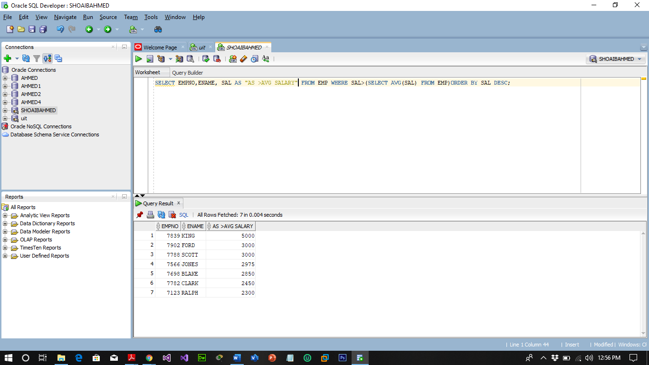

* 1. To display the employee name and salary of all employees who report to *king*.

SELECT ENAME AS "MGR KING",SAL,MGR FROM EMP WHERE MGR IN (SELECT MGR FROM EMP WHERE MGR=7839);

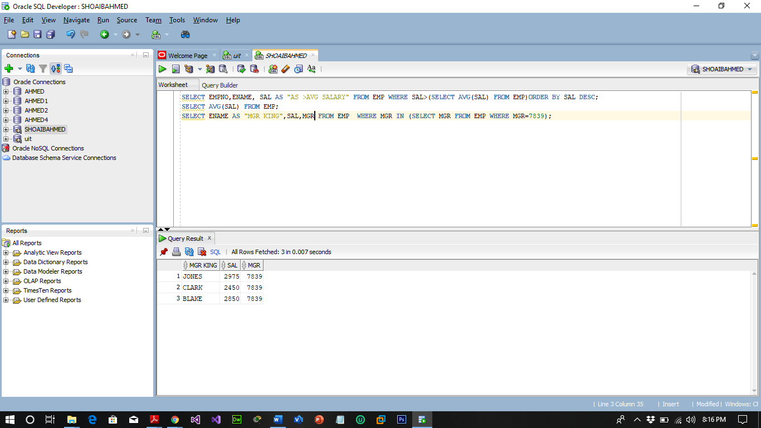

* 1. To display the department number, name and job for all employees in the *Sales* department.

SELECT ENAME,JOB,DEPTNO FROM EMP WHERE JOB IN (SELECT JOB FROM EMP WHERE JOB='SALESMAN') ORDER BY ENAME ASC;

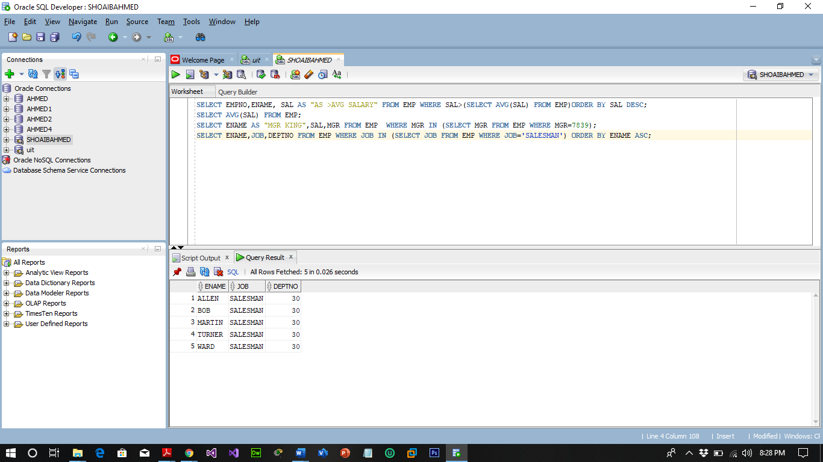

* 1. To display the name, hiredate and salary for all employees who have both the same salary and commission as *scott*.

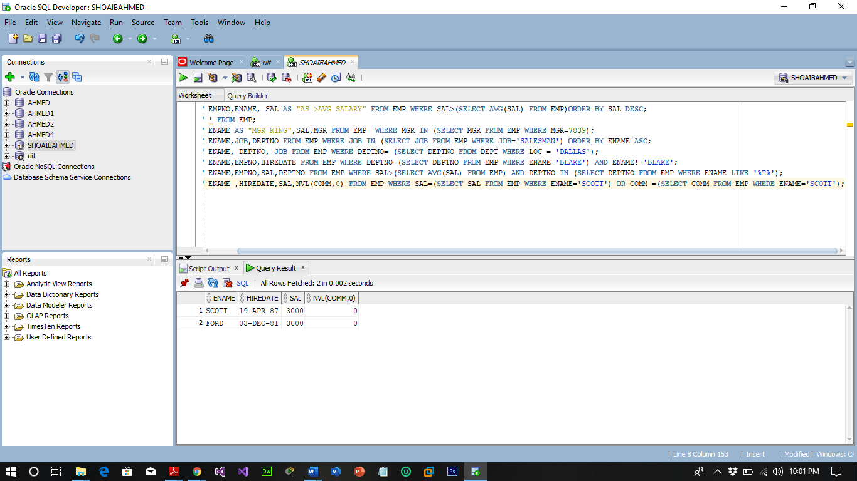

* 1. To display the employee name, department number and job title for all employees whose location is *Dallas*.

SELECT ENAME, DEPTNO, JOB FROM EMP WHERE DEPTNO= (SELECT DEPTNO FROM DEPT WHERE LOC = 'DALLAS');

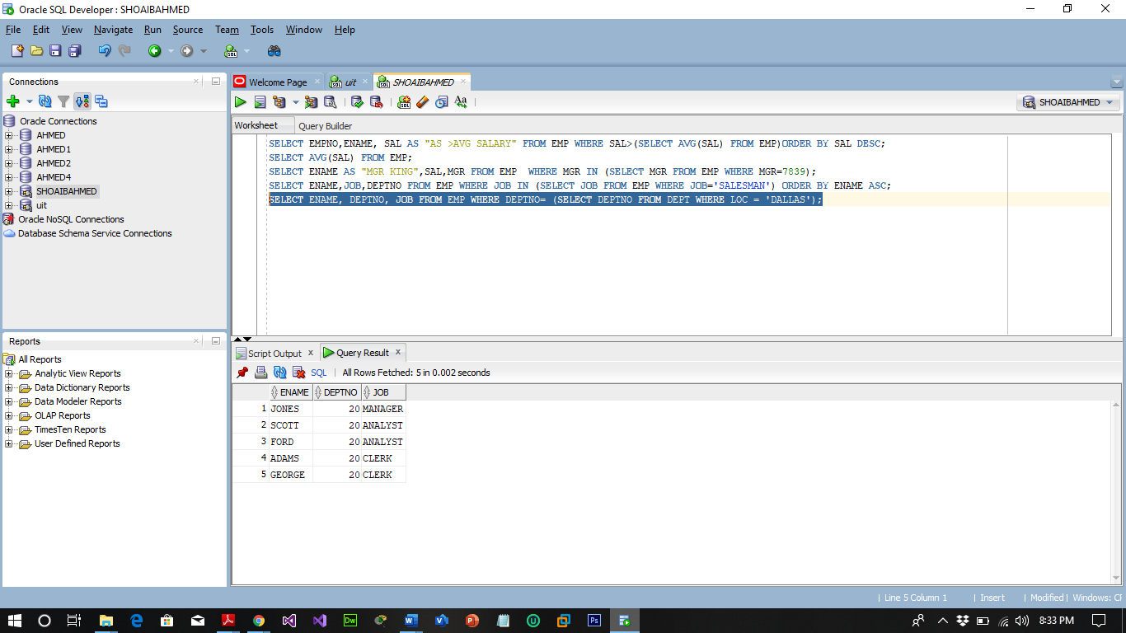

* 1. Write a query to display the employee name and hiredate for all employees in the same department as Blake. Exclude Blake.

SELECT ENAME,EMPNO,HIREDATE FROM EMP WHERE DEPTNO=(SELECT DEPTNO FROM EMP WHERE ENAME='BLAKE') AND ENAME!='BLAKE';

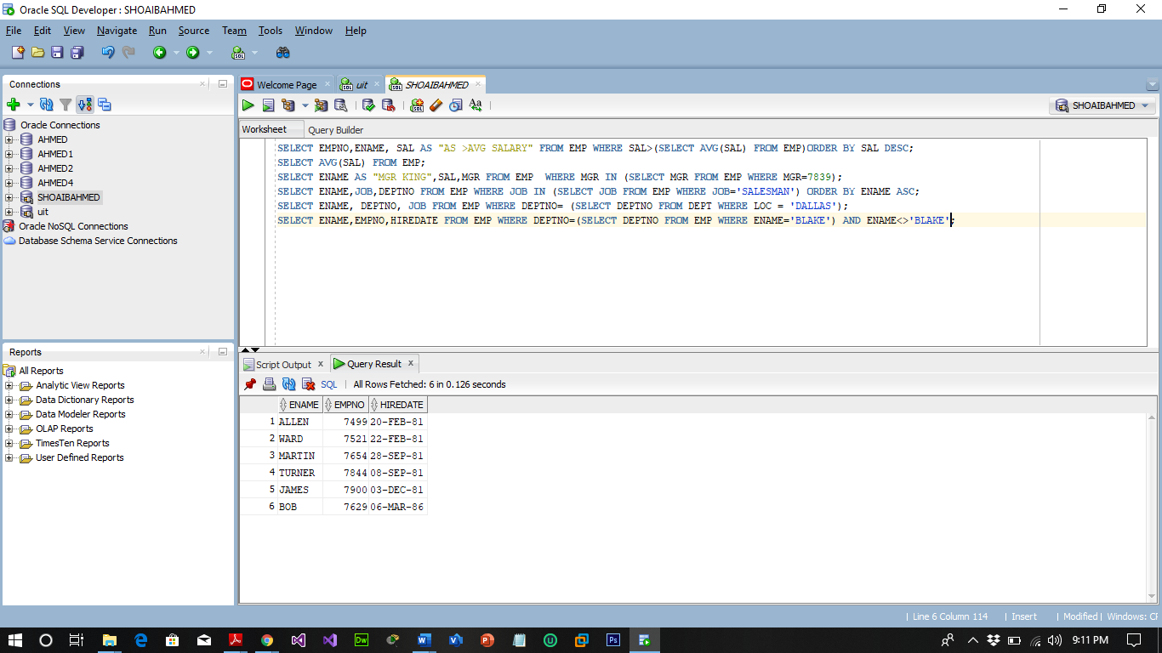

* 1. Display the employee number, name and salary for all employees who earn more than the average salary and who work in department with any employee with a T in their name.

SELECT ENAME, EMPNO, SAL, DEPTNO FROM EMP WHERE SAL>(SELECT AVG(SAL) FROM EMP) AND DEPTNO IN (SELECT DEPTNO FROM EMP WHERE ENAME LIKE '%T%');

