Task 01

Why are subqueries needed in accessing data from the database?

**Subqueries** (aka **inner queries** or **nested queries**) are useful tools when you’re performing multiple steps. It’s feels Inception-like, since you’re querying into queries.

For example:

We want to write a query to find out who earns a salary greater than Jones’ salary. We need two queries: one query to find what Jones earns and a second query to find who earns more than that amount. It can be easily done with the help of subqueries.

Task 02

Write down the restrictions on using set operators in SQL.

* Set operations are not permitted on columns of type BLOB, CLOB, BFILE, and VARRAY, nor are set operations permitted on nested table columns.
* Since UNION, INTERSECT, and MINUS operators involve sort operations, they are not allowed on LONG columns. However, UNION ALL is allowed on LONG columns.
* Set operations are not allowed on SELECT statements containing TABLE collection expressions.
* SELECT statements involved in set operations can't use the FOR UPDATE clause.
* The number and size of columns in the SELECT list of component queries are limited by the block size of the database. The total bytes of the columns SELECTed can't exceed one database block.

Task 03

1.

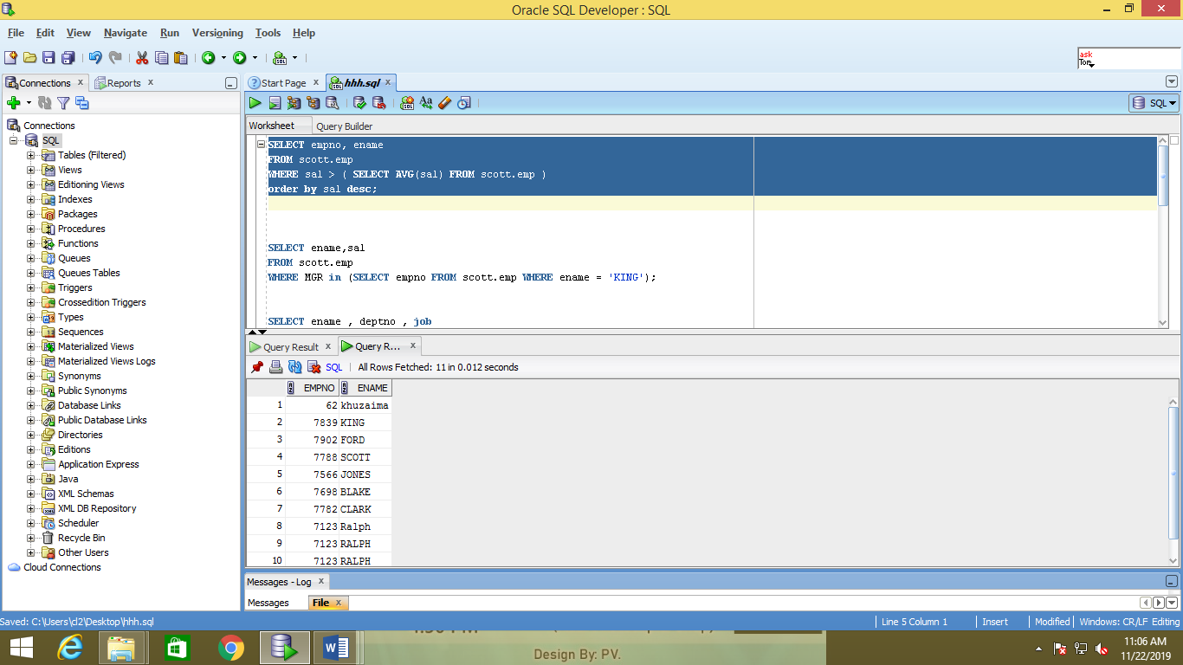

2.

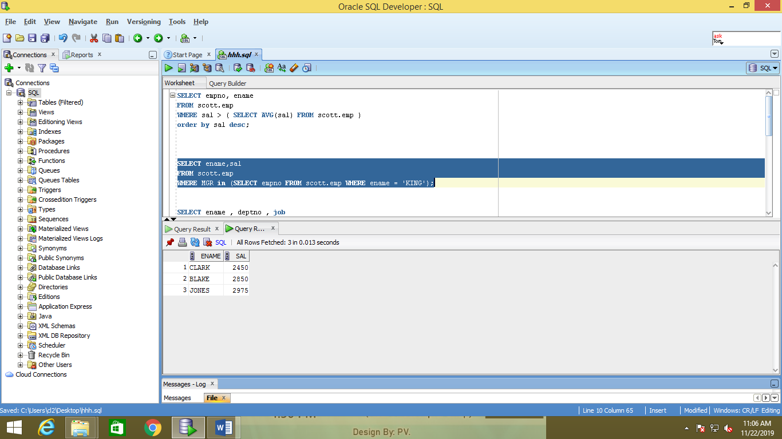

3.

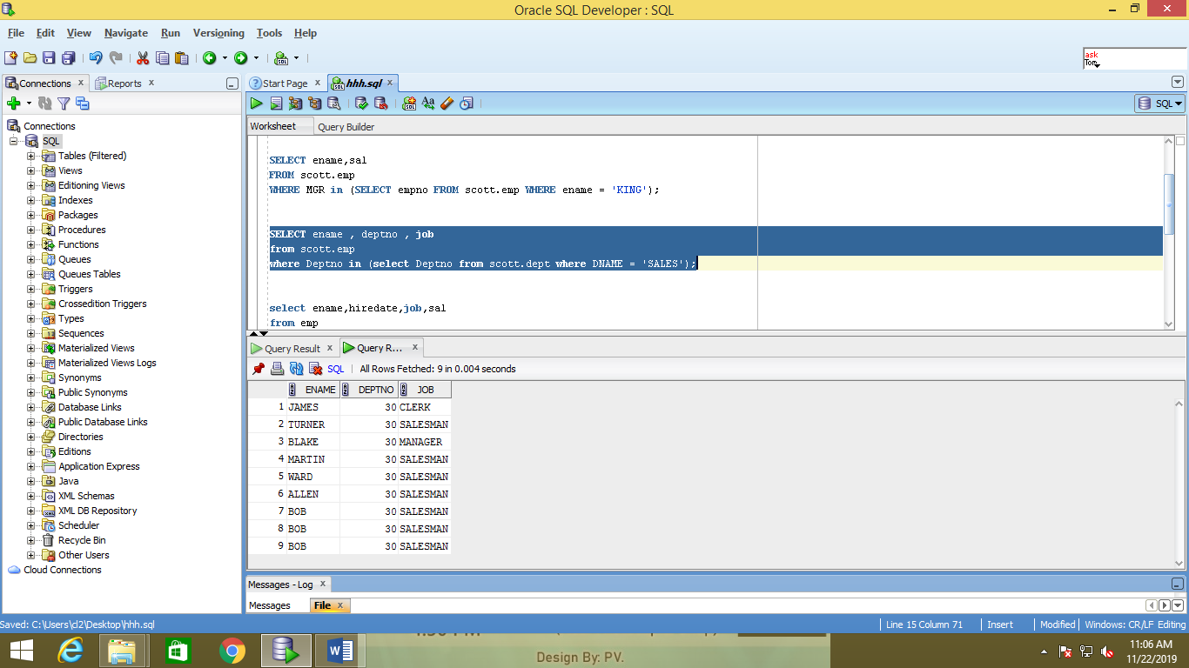

4.

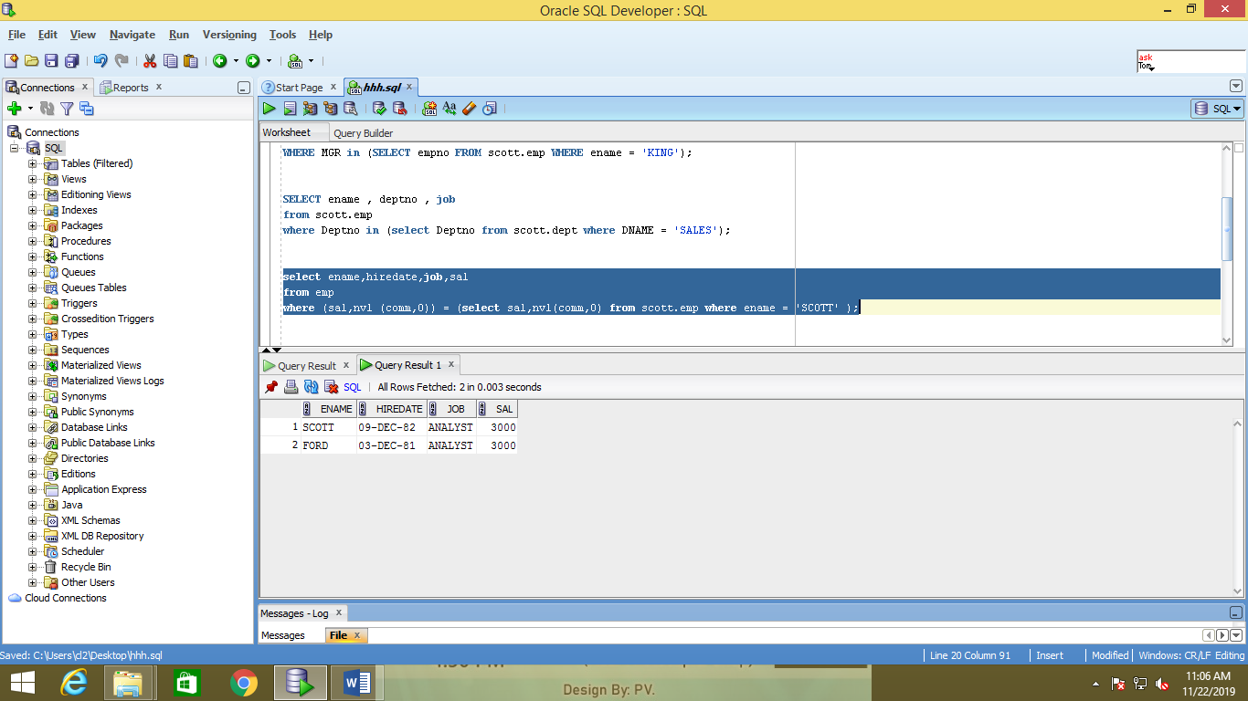

5.

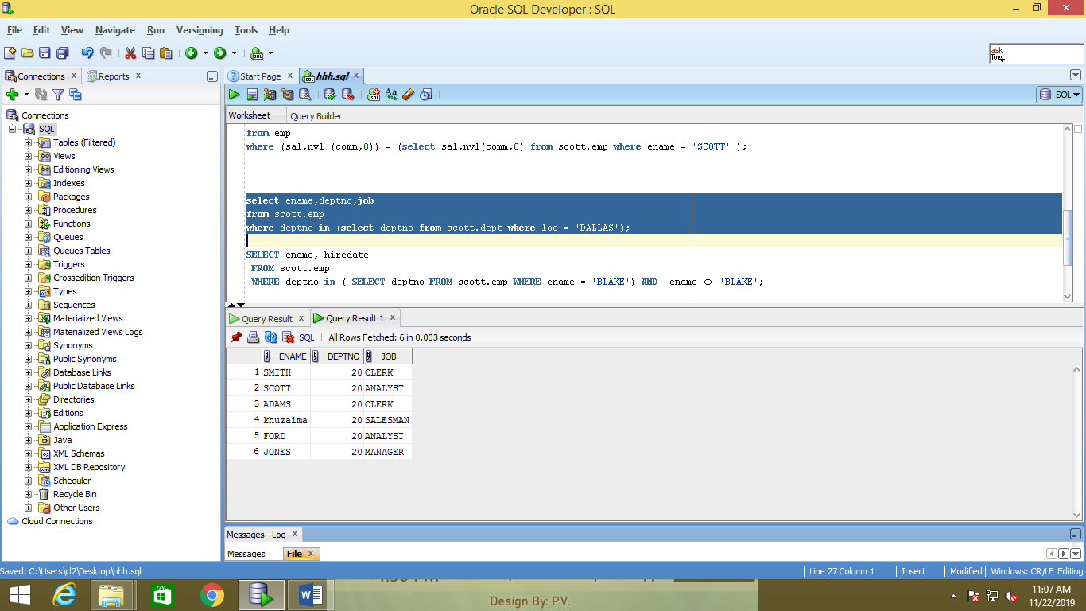

6.

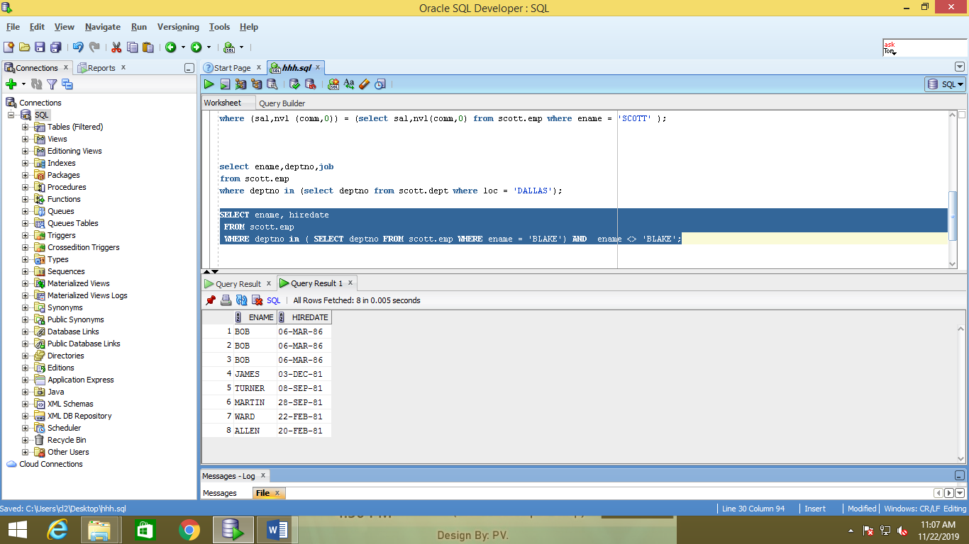

7.

