1. Write the SQL Code that will create the table of above structure (table name should be like TABLENAME_17B-XXX-CE)

**QUERIES:**

CREATE TABLE JOB_17B_033_SE(

JOB_CODE NUMBER(3,0),

JOB_DESCRIPTION VARCHAR2(25),

JOB_CHG_HR NUMBER(4,2),

JOB_LAST_UPDATE DATE,

CONSTRAINT PK_JOBC PRIMARY KEY (JOB_CODE)

);

CREATE TABLE EMP_17B_033_SE(

EMP_NUM NUMBER(4) NOT NULL,

EMP_LNAME VARCHAR2(15),

EMP_FNAME VARCHAR2(15),

EMP_INITIAL VARCHAR2(1),

JOB_CODE NUMBER(3,0),

EMP_HIREDATE DATE,

EMP_YEAR NUMBER(2,0),

CONSTRAINT PK_EMPNUM1 PRIMARY KEY (EMP_NUM),

CONSTRAINT FK_JOBCODE1 FOREIGN KEY (JOB_CODE) REFERENCES JOB_17B_033_SE (JOB_CODE)

) ;

CREATE TABLE PROJECT_17B_033_SE(

PROJ_NUM NUMBER(2,0),

PROJ_NAME VARCHAR2(25),

PROJ_VALUE NUMBER (14,2),

PROJ_BALANCE NUMBER(14,2),

EMP_NUM NUMBER(4) NOT NULL,

CONSTRAINT PK_PROJNUM1 PRIMARY KEY (PROJ_NUM),

CONSTRAINT FK_EMPNO1 FOREIGN KEY (EMP_NUM) REFERENCES EMP_17B_033_SE (EMP_NUM)

);

CREATE TABLE ASSIGNMENT_17B_033_SE(

ASSIGN_NUM NUMBER(4) NOT NULL,

ASSIGN_DATE DATE,

PRO_NUM NUMBER(2,0),

EMP_NUM NUMBER(4) NOT NULL,

ASSIGN_JOB NUMBER(3),

ASSIGN_CHG_HR NUMBER(3,2),

ASSIGN_HOURS NUMBER(2,1),

ASSIGN_CHARGE NUMBER(5,2),

CONSTRAINT PK_ASSIGNNUM1 PRIMARY KEY (ASSIGN_NUM),

CONSTRAINT FK_JOBCODE11 FOREIGN KEY (ASSIGN_JOB) REFERENCES JOB_17B_033_SE (JOB_CODE),

CONSTRAINT FK_EMPNO2 FOREIGN KEY (EMP_NUM) REFERENCES EMP_17B_033_SE (EMP_NUM),

CONSTRAINT FK_PRONUM14 FOREIGN KEY (PRO_NUM) REFERENCES PROJECT_17B_033_SE (PROJ_NUM)

) ;

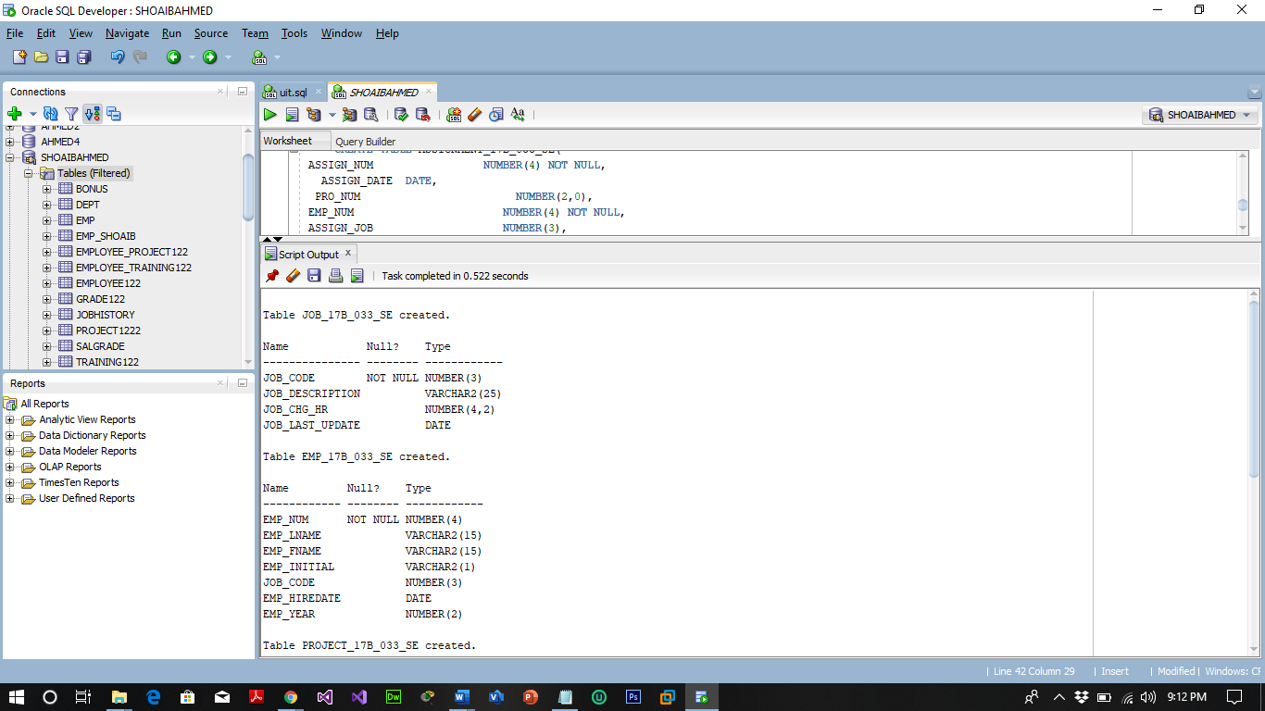 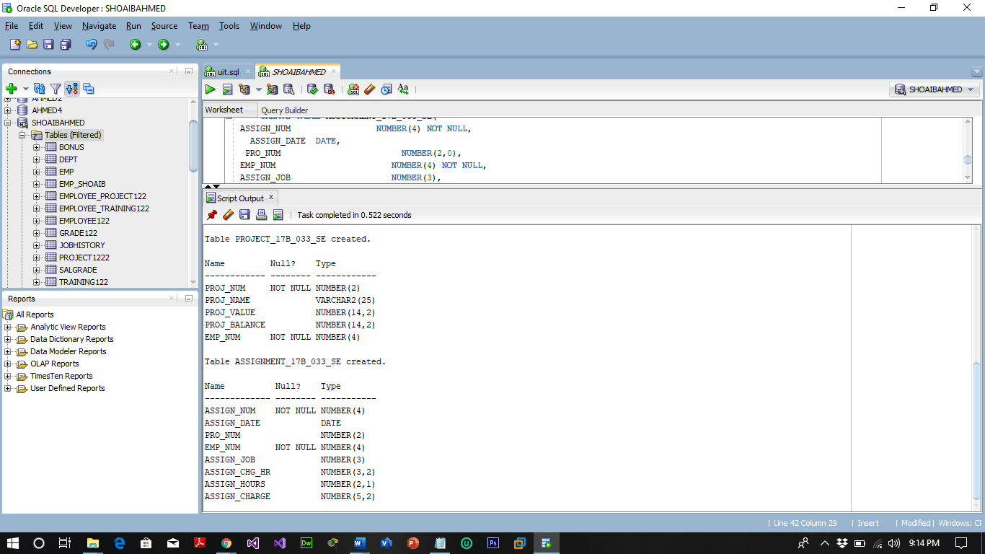

1. Perform INSERT Command in the above tables of database **ConstructCo** (please find the data on page 3-4)

**JOB TABLE:**

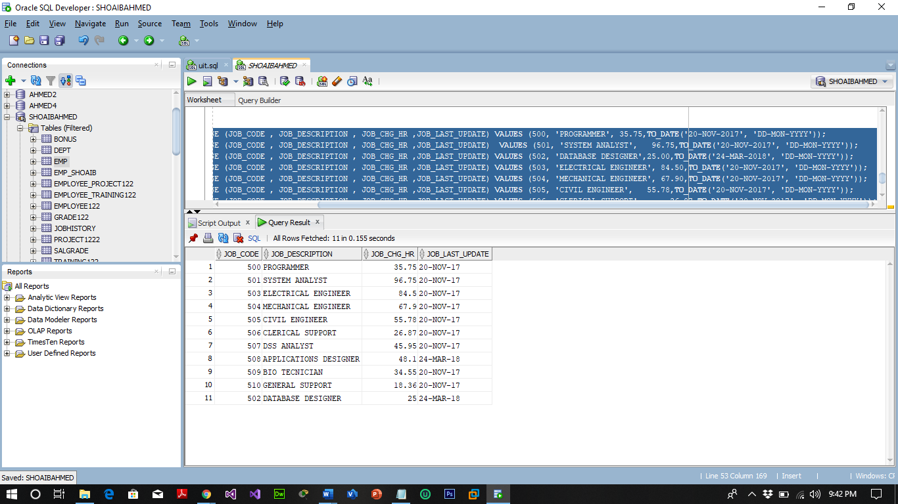

**EMP TABLE:**

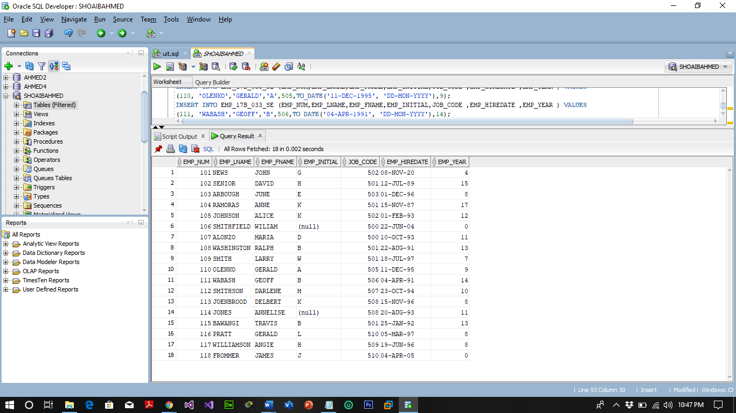

**PROJECT TABLE:**

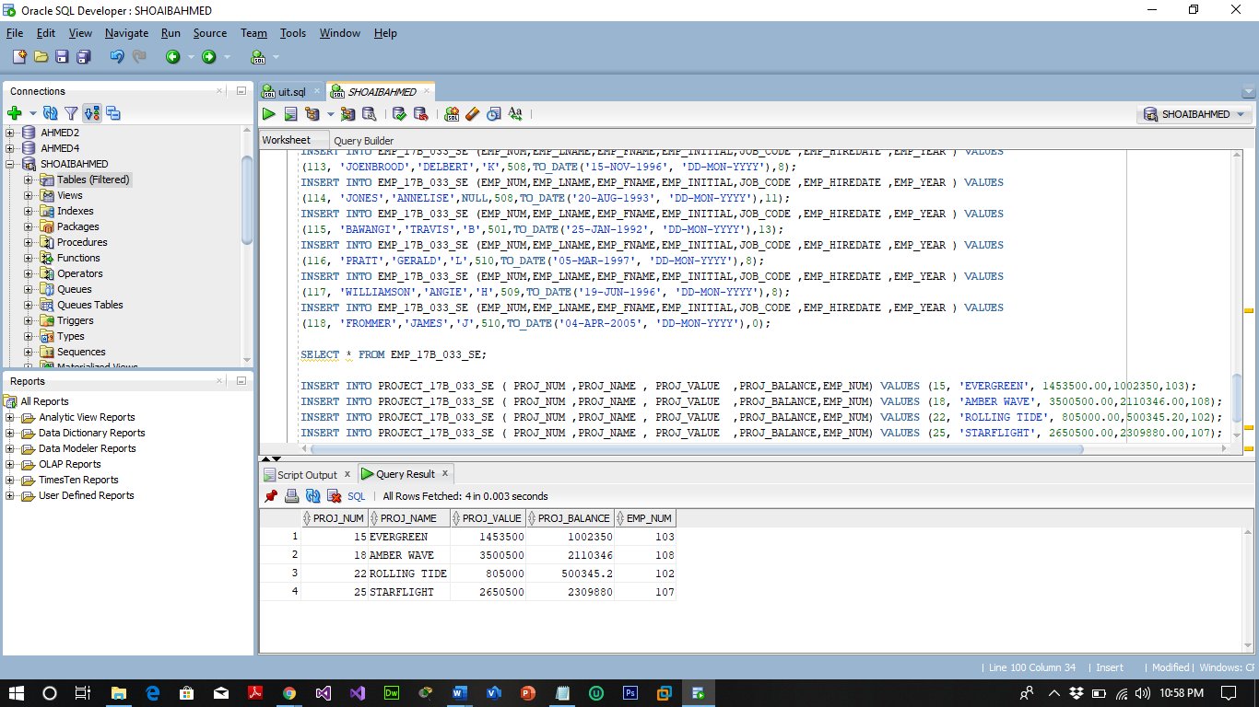

**ASSIGNMENT TABLE:**

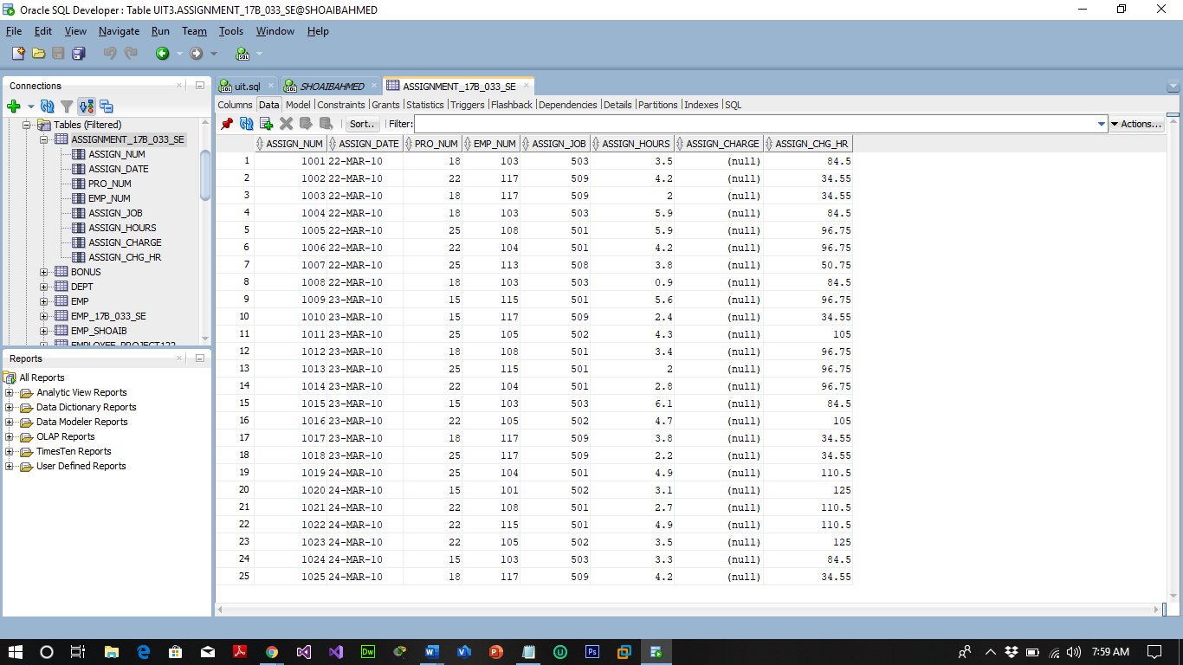

1. Write the SQL code to calculate the ASSIGN_CHARGE values in the ASSIGNMENT table in the ConstructCo database. Note that ASSIGN_CHARGE is a derived attribute that is calculated by multiplying ASSIGN_CHG_HR by ASSIGN_HOURS.

**QUERY:**

UPDATE ASSIGNMENT_17B_033_SE SET ASSIGN_CHARGE=ASSIGN_CHG_HR*ASSIGN_HOURS;

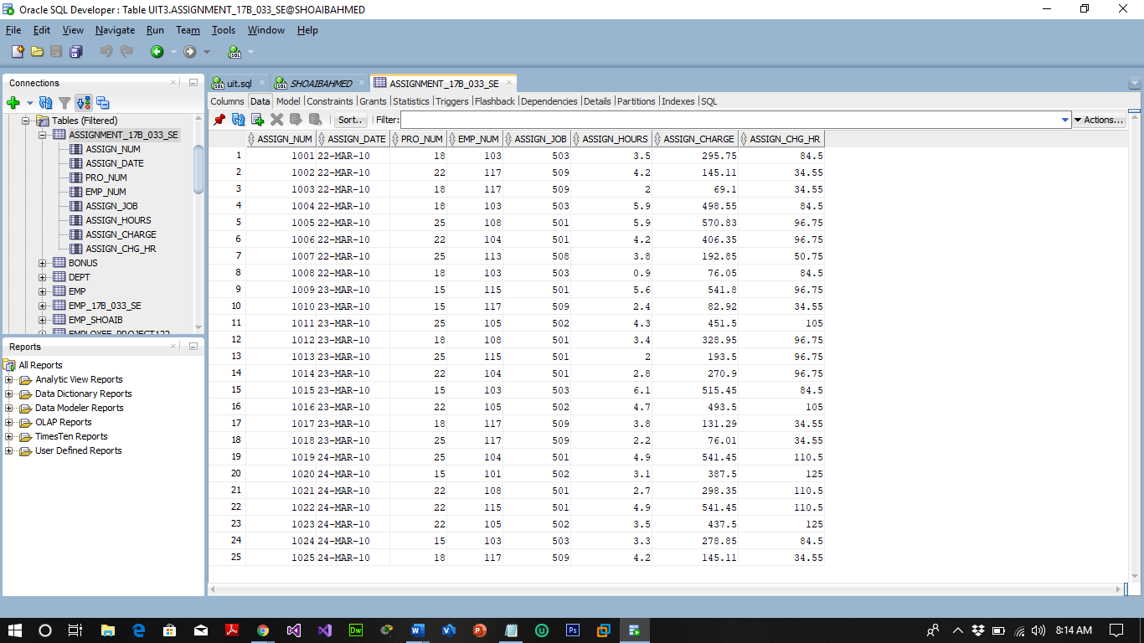

1. Using the EMPLOYEE, JOB, and PROJECT tables in the ConstructCo database, write the SQL code that will produce the results shown as in below figure.

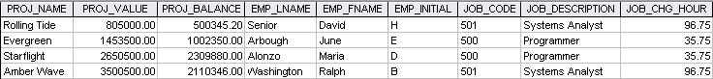

**QUERIES:**

UPDATE EMP_17B_033_SE SET JOB_CODE=500 WHERE EMP_INITIAL='E';

SELECT P.PROJ_NAME,P.PROJ_VALUE,P.PROJ_BALANCE,E.EMP_LNAME,E.EMP_FNAME,E.EMP_INITIAL,J.JOB_CODE,J.JOB_DESCRIPTION ,J.JOB_CHG_HR FROM PROJECT_17B_033_SE P , EMP_17B_033_SE E , JOB_17B_033_SE J WHERE E.JOB_CODE=J.JOB_CODE AND P.EMP_NUM=E.EMP_NUM AND (J.JOB_CODE=500 OR J.JOB_CODE=501);

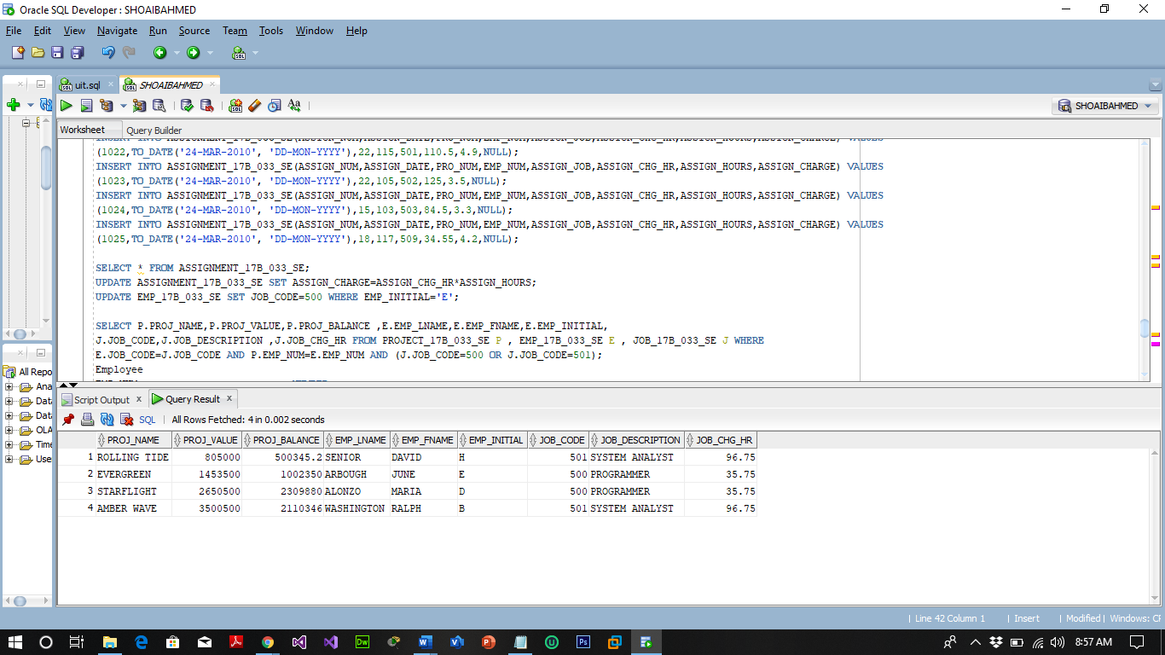

1. Write the SQL code that will produce result (FNAME, LNAME INITIAL, DESCRIPTION, CHG_HOUR, PROJ_NAME, PROJ_VALUE) with the list of all employee including those who do not have assign in any project.

**QUERY:**

SELECT E.EMP_LNAME,E.EMP_FNAME,E.EMP_INITIAL,J.JOB_DESCRIPTION ,J.JOB_CHG_HR,P.PROJ_NAME,P.PROJ_VALUE FROM EMP_17B_033_SE E , JOB_17B_033_SE J , PROJECT_17B_033_SE P WHERE

E.JOB_CODE=J.JOB_CODE AND E.EMP_NUM=P.EMP_NUM(+);

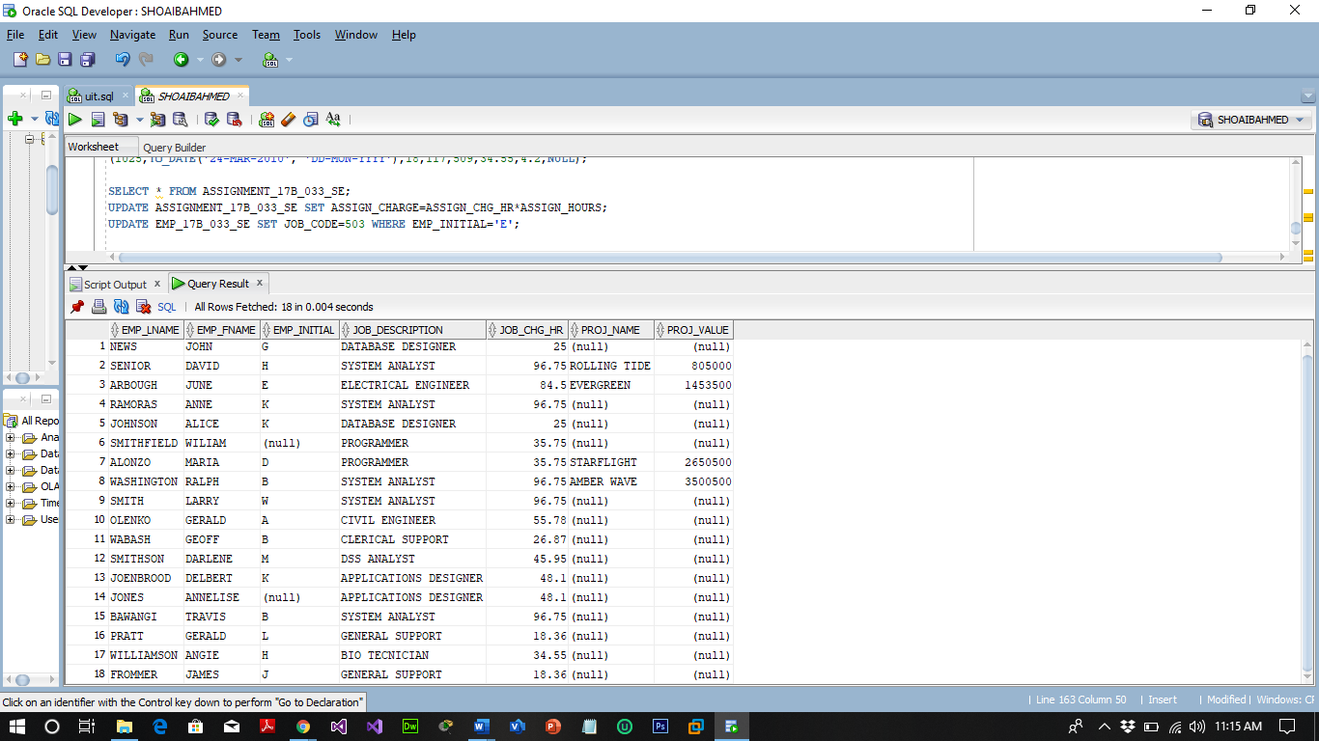

1. Using the data in the ASSIGNMENT table, write the SQL code that will yield the total number of hours worked for each employee

**QUERY:**

SELECT E.EMP_NUM,E.EMP_LNAME,SUM(J.ASSIGN_HOURS) FROM EMP_17B_033_SE E , ASSIGNMENT_17B_033_SE J WHERE J.EMP_NUM=E.EMP_NUM GROUP BY E.EMP_NUM,E.EMP_LNAME ORDER BY E.EMP_NUM ASC ;

