**Task 1:**

CREATE VIEW lab_9_task1_57 AS SELECT d.designation,count(e.empno) as Num_Emp FROM UIT1.employee_57 e, UIT1.grade_57 d WHERE d.d_id=e.designation GROUP BY d.designation;

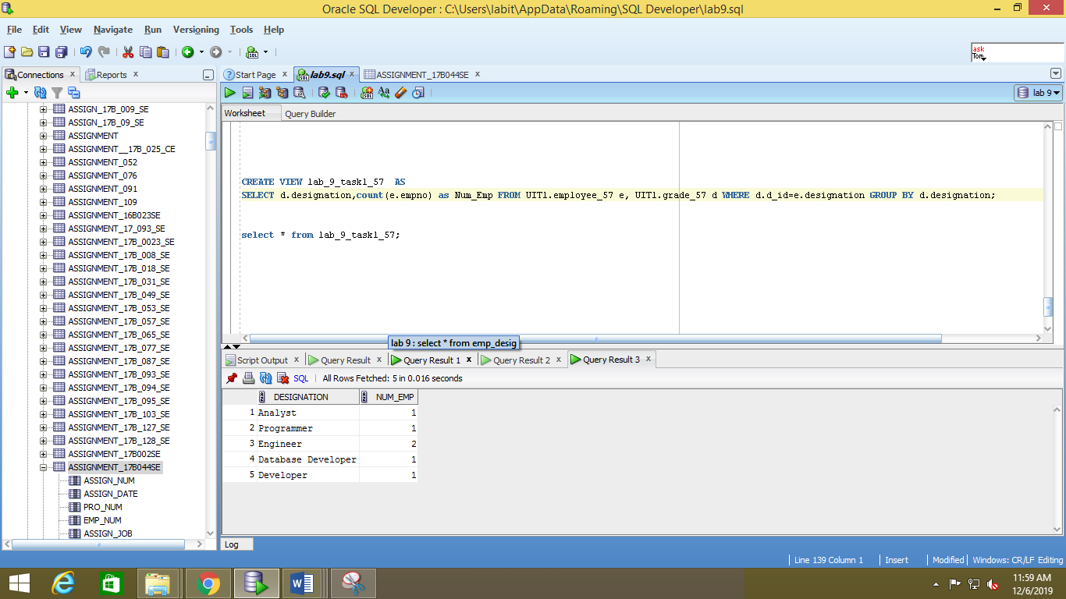

**Task 2:**

CREATE VIEW lab_9_task2_57 AS

SELECT e.empname,e.empno, count(e.empno) as Num_Projects FROM UIT1.employee_57 e,UIT1.emp_project_57 ep WHERE e.empno=ep.empno AND ep.performance='Excellent' GROUP BY e.empname,e.empno;

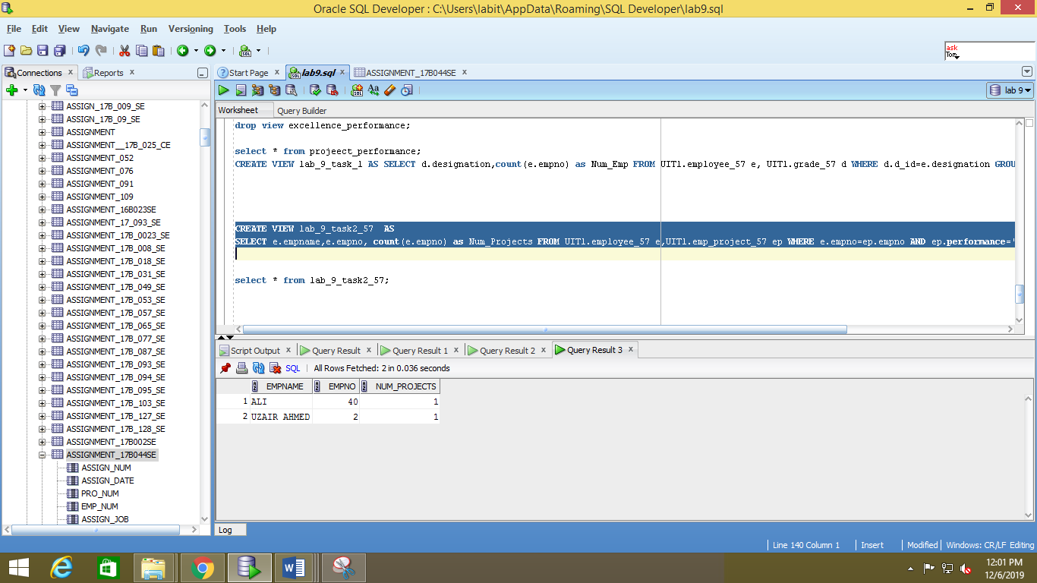

**TASK 3:**

CREATE VIEW lab_9_task_3 AS

SELECT e.empname,e.empno,p.title from UIT1.employee_57 e, UIT1.emp_project_57 ep,UIT2.project_57_ p WHERE e.empno = ep.empno and ep.pid=p.pid;

