

**American International University- Bangladesh**

**CSC 3215: Web Technologies**

**CO2 and CO4 Evaluation**

**Finished Project Report**

**Fall 2020-2021**

**Project Title: Tour Management system**

**Section: E**

|  |  |
| --- | --- |
| Student Name | Student Id |
| Tanvir,Md Shofiul Alam | **18-36283-1** |
|  |  |
|  |  |
|  |  |

Project Description:

The proposed system is a web based application and maintains a centralized repository of all related information. The system allows one to easily access the relevant information and make necessary travel arrangements.Users can decide about places they want to visit and make bookings online for travel and accommodation. STUDY OF THE SYSTEM: To provide flexibility to the users, the interfaces have been developed that are accessible through a browser. The GUI’S at the top level have been categorized as 1. Administrative user interface 2. The operational or generic user interface

The ‘administrative user interface’ concentrates on the consistent information that is practically, part of the organizational activities and which needs proper authentication for the data collection. These interfaces help the administrators with all the transactional states like Data insertion, Data deletion and Date updation along with the extensive data search capabilities.

The ‘operational or generic user interface’ helps the end users of the system in transactions through the existing data and required services. The operational user interface also helps the ordinary users in managing their own information in a customized manner as per the included flexibilities.

**Project Folder Structure:**

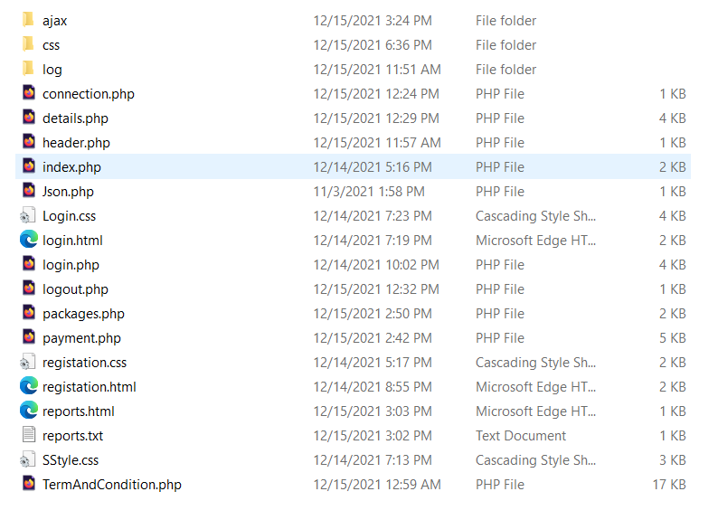

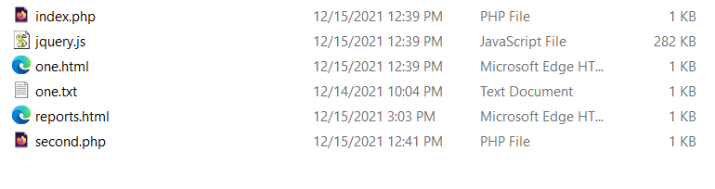

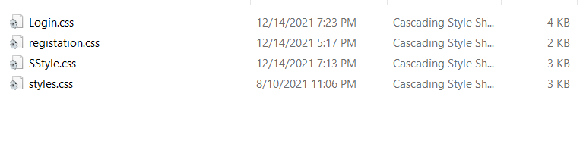

**Core Modules of the Project:**

*Here, add THREE of your CORE modules’ source code with appropriate filename as heading. (Use either* consolas or courier new *font for source code)*

*For example:*

***login.php***

*<!DOCTYPE html>*

*<html lang="en">*

*<head>*

*<meta charset="UTF-8">*

*<meta http-equiv="X-UA-Compatible" content="IE=edge">*

*<meta name="viewport" content="width=device-width, initial-scale=1.0">*

*<title>Login </title>*

*<link rel="stylesheet" href="https://maxcdn.bootstrapcdn.com/bootstrap/4.0.0/css/bootstrap.min.css" integrity="sha384-Gn5384xqQ1aoWXA+058RXPxPg6fy4IWvTNh0E263XmFcJlSAwiGgFAW/dAiS6JXm" crossorigin="anonymous">*

*<link rel="stylesheet" href="SStyle.css">*

*</head>*

*<body>*

*<nav class="navbar navbar-expand-sm navbar-dark bg-dark ">*

*<a href="#" class="navbar-brand"> Travel Agency website </a>*

*<ul class="navbar-nav ml-auto">*

*<li class="nav-item"><a href="index.php" class="nav-link "> Home </a></li>*

*<li class="nav-item"><a href="login.php" class="nav-link "> Login </a></li>*

*<li class="nav-item"><a href="registration.html" class="nav-link "> Registration </a></li>*

*</ul>*

*</nav>*

*<section class="form_holder d-flex justify-content-center align-items-center">*

*<form class="login_form p-5" action="control/loginCheck.php" onsubmit="return validation()" method="POST">*

*<h2>Please Log In</h2>*

*<div class="form-group">*

*<label for="username">Name</label>*

*<input type="text" class="form-control" id="txtMail" type="text" name="username" value="<?php if (isset($_COOKIE["username"]) ) echo $_COOKIE["username"]; ?>" placeholder="Username">*

*<span id="user"></span>*

*</div>*

*<div class="form-group">*

*<label for="password">Password</label>*

*<input type="password" class="form-control" id="Ipassword" type="password" name="password" value="<?php if (isset($_COOKIE["password"]) ) echo $_COOKIE["password"];?>" placeholder="Password">*

*<span id="userPass"></span>*

*</div>*

*<!-- <div class="form-check">*

*<input type="checkbox" class="form-check-input" name="checkbox" id="exampleCheck1 ">*

*<label class="form-check-label" name="checkbox" for="exampleCheck1">Check me out</label></br>*

*</div> -->*

*<button type="submit" class="btn btn-success mt-1" name="submit">Submit</button>*

*<div>*

*<ul id="forgotPassword">*

*<li id="fPassword"><a id="fpref" href="#">ForgotPassword? </a> </li>*

*<li id="sUp"><a id="suref" href="registration.php">Sing UP</li>*

*</ul>*

*</div>*

*</form>*

*</section>*

*<script src="https://code.jquery.com/jquery-3.2.1.slim.min.js" integrity="sha384-KJ3o2DKtIkvYIK3UENzmM7KCkRr/rE9/Qpg6aAZGJwFDMVNA/GpGFF93hXpG5KkN" crossorigin="anonymous"></script>*

*<script src="https://cdnjs.cloudflare.com/ajax/libs/popper.js/1.12.9/umd/popper.min.js" integrity="sha384-ApNbgh9B+Y1QKtv3Rn7W3mgPxhU9K/ScQsAP7hUibX39j7fakFPskvXusvfa0b4Q" crossorigin="anonymous"></script>*

*<script src="https://maxcdn.bootstrapcdn.com/bootstrap/4.0.0/js/bootstrap.min.js" integrity="sha384-JZR6Spejh4U02d8jOt6vLEHfe/JQGiRRSQQxSfFWpi1MquVdAyjUar5+76PVCmYl" crossorigin="anonymous"></script>*

*</body>*

*</html>*

**Packages.php**

<?php

session_start();

if (isset($_SESSION['loggedin']) || isset($_COOKIE['loggedin'])) {

} include 'header.php';

?>

<br>

<br>

<div class="main-package">

<head>

<meta name="viewport" content="width=device-width, initial-scale=1.0">

<style>

* {

box-sizing: border-box;

}

.columns {

float: left;

width: 33.3%;

padding: 8px;

}

.price {

list-style-type: none;

border: 1px solid green;

margin: 0;

padding: 0;

-webkit-transition: 0.3s;

transition: 0.3s;

}

.price:hover {

box-shadow: 0 8px 12px 0 rgba(0,1,0,0)

}

.price .header {

background-color: green;

color: white;

font-size: 25px;

}

.price li {

border-bottom: 1px solid #eee;

padding: 20px;

text-align: center;

}

.price .grey {

background-color: green;

font-size: 20px;

}

.button {

background-color: #04AA6D;

border: none;

color: white;

padding: 10px 25px;

text-align: center;

text-decoration: black;

font-size: 18px;

}

Payment.php

<?php

session_start();

?>

<?php if (isset($_SESSION['result'])) {

if ($_SESSION['result'] == 1) {

echo '<script> alert("Successful") </script>';

} else {

echo '<script> alert("Failed") </script>';

}

unset($_SESSION['result']);

}

?>

<!DOCTYPE html>

<html lang="en">

<head>

<meta charset="UTF-8">

<meta http-equiv="X-UA-Compatible" content="IE=edge">

<meta name="viewport" content="width=device-width, initial-scale=1.0">

<title>Payment</title>

<link rel="stylesheet" href="https://maxcdn.bootstrapcdn.com/bootstrap/4.0.0/css/bootstrap.min.css" integrity="sha384-Gn5384xqQ1aoWXA+058RXPxPg6fy4IWvTNh0E263XmFcJlSAwiGgFAW/dAiS6JXm" crossorigin="anonymous">

<link rel="stylesheet" href="SStyle.css">

</head>

<body>

<nav class="navbar navbar-expand-sm navbar-dark bg-dark ">

<a href="#" class="navbar-brand"> Tour Management system </a>

<ul class="navbar-nav ml-auto">

<!-- <li class="nav-item"><a href="profile.php" class="nav-link "> PROFILE </a></li> -->

<li class="nav-item"><a href="logout.php" class="nav-link "> LOGOUT </a></li>

</ul>

</nav>

<section class="Post_holder1 d-flex justify-content-center align-items-center">

<form class="Post_form p-4" action="control/postCheck.php" method="POST">

<form action="post.php" method="POST" class="post-form">

<table>

<h1 style="margin-bottom: 25px"><label for="">Payment</label></h1>

</table>

<table><tr><td>

<label for="">Online Payment Method :</label><div class="d-flex flex-colunm "

<div class="form-check">

<input class="form-check-input" type="radio" name="method" id="exampleRadios1" value="BDTK" checked><label class="form-check-label" for="exampleRadios1">

Bkash

</label>

</div>

<div class="form-check">

<input class="form-check-input" type="radio" name="method" id="exampleRadios1" value="BDTK" checked>

<label class="form-check-label" for="exampleRadios1">

nagad

</label>

</div>

<div class="form-check">

<input class="form-check-input" type="radio" name="method" id="exampleRadios1" value="Others" checked>

<label class="form-check-label" for="exampleRadios1">

Others

</label>

</div></div></td></tr></table></br>

<table></table></br>

<table><tr><td><label for="">Pay by card:</label>

<select name="prefIns">

<label for="">

<option value="MTB">MTB</option>

</label>

<label for="">

<option value="MTB">MTB</option>

</label>

<label for="">

<option value="DBBL">DBBL</option>

</label>

<label for="">

<option value="OTHERS">OTHERS</option></select>

</td></tr></table></br><table>

<tr><td><label for="">Total amount: </label>

<input type="amount" id="Preferable amount " name="total amount">

</td></tr></table></br><table><tr></tr>

</table></br><table><tr>

<th><button type="submit" style="transform:translate(300%,-40%)" name="submit">Pay</button></th>

</tr>

<tr>

<th>

<span>

</span>

</th>

</tr>

</table>

</form>

<script src="https://code.jquery.com/jquery-3.2.1.slim.min.js" integrity="sha384-KJ3o2DKtIkvYIK3UENzmM7KCkRr/rE9/Qpg6aAZGJwFDMVNA/GpGFF93hXpG5KkN" crossorigin="anonymous"></script>

<script src="https://cdnjs.cloudflare.com/ajax/libs/popper.js/1.12.9/umd/popper.min.js" integrity="sha384-ApNbgh9B+Y1QKtv3Rn7W3mgPxhU9K/ScQsAP7hUibX39j7fakFPskvXusvfa0b4Q" crossorigin="anonymous"></script>

<script src="https://maxcdn.bootstrapcdn.com/bootstrap/4.0.0/js/bootstrap.min.js" integrity="sha384-JZR6Spejh4U02d8jOt6vLEHfe/JQGiRRSQQxSfFWpi1MquVdAyjUar5+76PVCmYl" crossorigin="anonymous"></script>

</body>

</html>

|  |  |  |  |  |  |
| --- | --- | --- | --- | --- | --- |
| **CO2 and CO4 Evaluation: Project Report Evaluation** | | | | | |
| **Completeness**  **(5)** | **Validation**  **(5)** | **Feature Implementation**  **(5)** | **Concept Understanding**  **(5)** | **Promptness (5)** | **Total (25)** |
|  |  |  |  |  |  |
|  | | | | | |