**Fingerprint mobile Voting system**

*Assignment 2- software require system*

*Date:20.06.2021*

MD:SHOFIUL ALAM TANVIR

ID: 18-36283-1

Department: CSE

Course: Software Engineering [B]

Instructor: Assoc. Prof. Raihan Uddin Ahmed

# Software System

Fingerprint mobile voting system

# Features

Features are listed below. **High**, **Medium** and **Low** are used to indicate the importance of each feature.

|  |  |  |  |
| --- | --- | --- | --- |
| **Feature ID** | **Description** | **Priority** | **Requester** |
| **FE01** | Web based and accessible from devices (with internet connection) mobile and tablet PCs. | High | voter |
| **FE02** | Accessible only to authenticated and authorized users. | High | Authentication handler |
| **FE03** | voter can request to vote | High | voter |
| **FE04** | looking after the system | High |  |
| **FE04** | voter management and auditing user activities | High |  |
| **FE05** | Report generation based on voter total votes. | Medium |  |
|  |  |  |  |
|  |  |  |  |
|  |  |  |  |
|  |  |  |  |
|  |  |  |  |
|  |  |  |  |
|  |  |  |  |

# Use case diagram

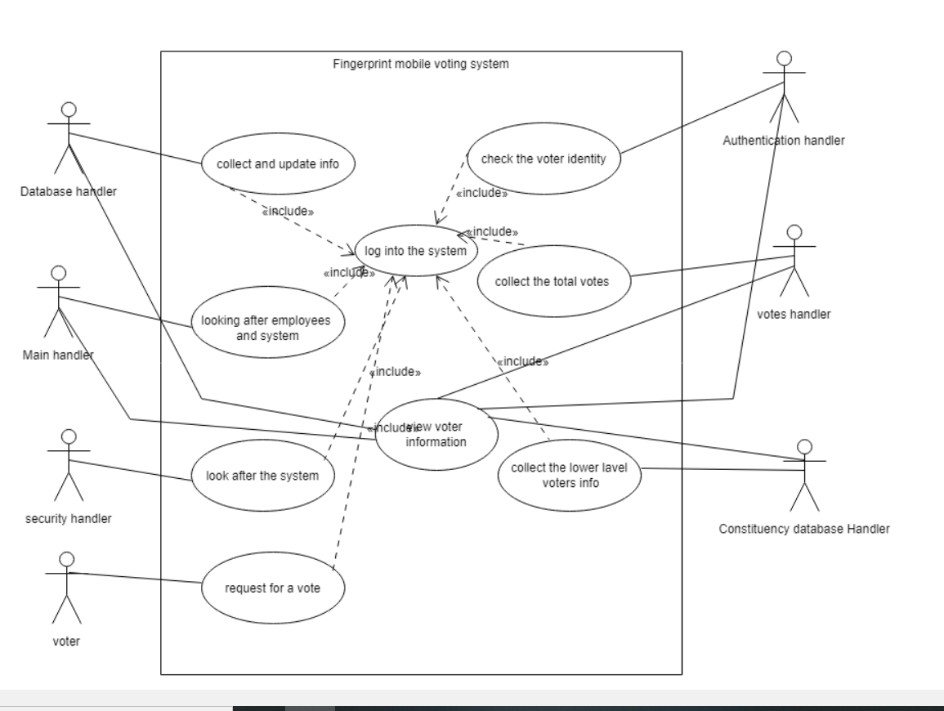

**Use Cases**

### These are the overall use cases for the end user.

|  |  |
| --- | --- |
| **FE01 - Authentication and authorization by Handler** | |
| **FE01_UC01** –voter authentication | |
| **Brief Description** | The voter first request to vote. Then voter needs to input voter ID number. After Id number matched voter give his fingerprint. After fingerprint matched. Voter able to vote. |
| **Pre-condition/s** | 1. Internet Access 2. Fingerprint based phone |
| **Priority** | High |
| **Actor/s** | General voter |
| **Main Success Scenario** | 1. voter opens up the application 2. The system displays a login form 3. User enters his/her ID number 4. The system matches user credentials against its data store. 5. The system then redirects user to the next page for fingerprint. 6. voter can see the candidates and vote. |
| **Alternative Scenario** | 1. ID number can not verify. 2. Fingerprint not matched. |
| **Notes/Questions** | Must read terms and condition for voting. |

|  |  |
| --- | --- |
| **FE02 – votes count** | |
| **FE02_UC01** – Total votes count by votes handler | |
| **Brief Description** | After voting votes handler will count the total votes and report it to the database handler. |
| **Pre-condition/s** | 1.handler must have the access to count the votes and report it.  2.Those who votes by mail handler must report it separately. |
| **Priority** | High |
| **Actor/s** | Votes Handler, Database handler |
| **Main Success Scenario** | 1. The system displays a form with all the necessary fields required to collect voter votes. These will be which candidates got which number of votes. 2. The system will automatically calculate the votes. 3. The ‘must be filled’ fields are marked with a red asterisk. |
| **Alternative scenario** | 1.The system unable to count the votes. |
| **Notes/Questions** | The system can not allow voter whose identification not matched. |

|  |  |
| --- | --- |
| **FE03_UC01** - View voter list and candidates vote. | |
| **Brief Description** | The system will display voter and candidates information. |
| **Priority** | High |
| **Actor/s** | DATABASE MAIN AND CONSTITUENCY HANDLER |
| **Main Success Scenario** | 1. The user can generate a list of voter and candidates.   2. The voter and candidates list will be displayed in a single organized page |
| **Alternative Scenario** | 1.The system is unable to extract voter information from the database and generates error message |
| **Notes/Questions** | The types of views must be mentioned |

**Non Functional Requirements**

# 1.Security:The system must be secured so none can manipulates the votes count.Alternative votes count must accurate so that any voter can not vote twice.

# 2.Performance efficiency:The system must be smooth ,there will be many user so system can give better performance