GDS Exchange APIs

Developer Toolkit:

Postman Instructions

Version 23.11_16-19-16:
- Exchange Eligibility 23.11.16
- Exchange Search 23.11.19
- Exchange Ticketing 23.11.16

Dec 2023

Contents
Import Postman Collection Files 3
Populate the Collection Credentials 3

Import Postman Collection Files
Follow this link to the online help for assistance using Postman and importing the Postman collection files:
https://support.travelport.com/webhelp/JSONAPIs/Airv11/Content/GeneralProject/UsingPostman.htm

Populate the Collection Credentials
Take the following steps to populate the required credentials for the Postman suite.
- To enter authorization credentials, expand the dropdown for OAuth:
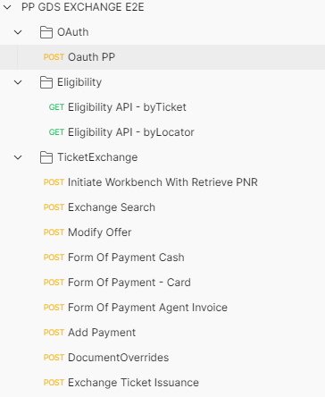
- Click the Body tab and enter the following credentials provided to you upon provisioning with Travelport:
- Username
- Password
- client_id
- client_secret

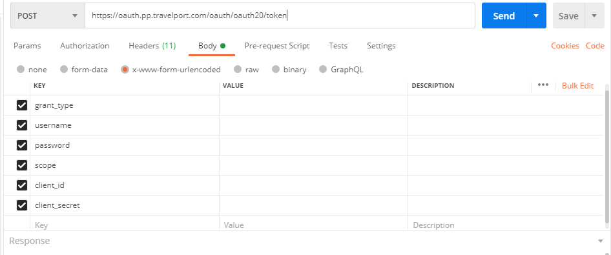
- Expand the dropdown for each API.
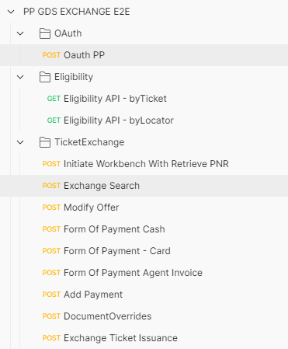

- In Headers, verify the accessgroup, Authorization, E2ETrackingID details. In Params verify the PNR Locator query parameter. Click Send.
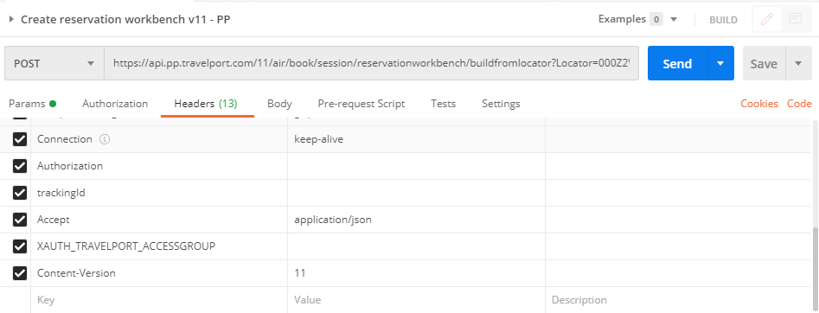
These steps populate the following:
- The reservation identifier from the Initiate Workbench from the Retrieve PNR Response is passed as the search ID in the Exchange Search request body.
- For Modify Offer, the CatalogOfferings identifier from the Search response is added to the request body and the reservation Identifier is passed in the URL.
- The reservation identifier is passed in the URL for the Add FOP, Add Payment, Document Override and Ticket Issuance steps.

NOTE: Ensure these header values are sent in all services:
- AccessGroup
- Authorization
- E2ETrackingID/ traceid
- bearer token

