1-PF Eligiable setting

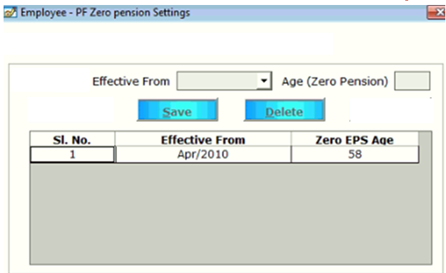

2-retriment setting

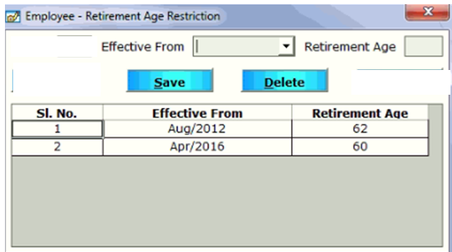

Salary structure master

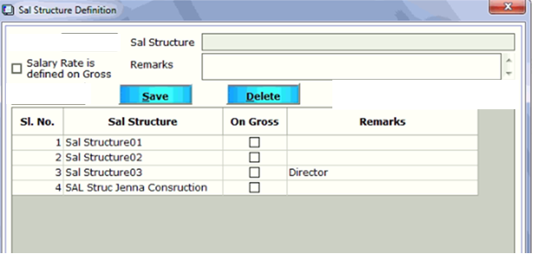

Bank Master

|  |  |
| --- | --- |
| Bank Master |  |
| Bank Name | TextBox |
| Bank Short Name | TextBox |
| Account No | TextBox |
| Address | TextArea |
| Branch Name | Textbox |
| IFSC Code | TextBox |
| Pin No | TextBox |
| Phone No | Textbox |