1-Attendance master

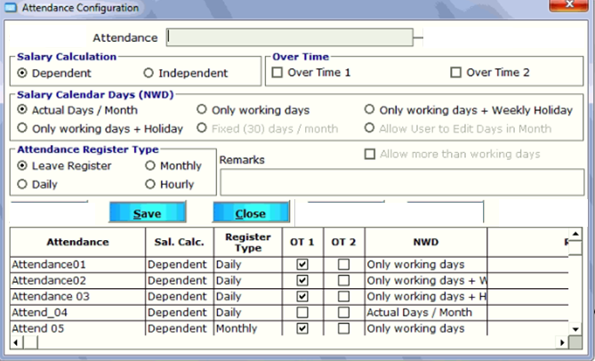

2-Occupation Master

|  |  |  |
| --- | --- | --- |
| Occupation Master |  |  |
|  |  |  |
| Label | Input Control |  |
| Name | TextBox |  |
| Short Name | TextBox |  |
|  |  |  |
| Save | Reset |  |

3-division master

|  |  |  |
| --- | --- | --- |
| Division Master |  |  |
|  |  |  |
| Label | Input Control |  |
| Name | TextBox |  |
| Short Name | TextBox |  |
|  |  |  |
| Save | Reset |  |