Project Report
On
E-Municipal Portal
(Newasa Nagar Parishad)
Submitted By
Shraddha Pramod Chavan
Indira College of Commerce and Science, Pune
M.Sc. (Computer Science) - Part I
Academic Year: 2025-2026

Project Certificate
(To be obtained from the Project Guide / Department Head)
This is to certify that the Project entitled "E-Municipal Portal" has been satisfactorily completed by Shraddha Pramod Chavan as a partial fulfillment of the requirements for M.Sc. (Computer Science) Part I, Semester II of Savitribai Phule Pune University, during the academic year 2025-2026.
_____________________________ _____________________________
Project Guide Head of Department
Date: ______________
Place: Pune

TABLE OF CONTENTS
CHAPTER 1: INTRODUCTION
1.1 Existing System and Need for System
1.2 Scope of Work
1.3 Operating Environment – Hardware and Software
CHAPTER 2: PROPOSED SYSTEM
2.1 Proposed System
2.2 Objectives of System
2.3 User Requirements
CHAPTER 3: ANALYSIS & DESIGN
3.1 UML Diagrams
3.1.1 Class Diagram
3.1.2 Object Diagram
3.1.3 Use Case Diagram
3.1.4 Sequence Diagram
3.1.5 Collaboration Diagram
3.1.6 State Diagram
3.1.7 Activity Diagram
3.1.8 Component Diagram
3.1.9 Deployment Diagram
3.2 Entity Relationship Diagram (ERD)
3.3 Data Dictionary
3.4 Table Design
3.5 Code Design
3.6 Menu Tree
CHAPTER 4: USER MANUAL
4.1 Operations Manual / Menu Explanation
4.2 Input Screens
4.3 Project Code
CHAPTER 5: LIMITATIONS AND ENHANCEMENT
5.1 Drawbacks and Limitations
5.2 Proposed Enhancements
5.3 Conclusions
5.4 Bibliography

CHAPTER 1 : INTRODUCTION
1.1 Existing System and Need for System
In the Existing System:
All civic records including birth registrations, property taxes, water connection data, and public complaints are maintained physically in paper ledgers at the Nagar Parishad office. To avail any municipal service, citizens must physically visit the office, wait in long queues, and submit handwritten forms, making even simple tasks highly time-consuming.
There is no centralized database to track complaints or service requests. Employees spend the majority of their shift sorting through stacks of paper applications. Interdepartmental communication requires physical file movement leading to loss or delays. Report generation for administrative review is tedious and relies on manual compilation.
Getting proper status reports is a tedious job. Data from one department has to be manually conveyed to another. There is no web-based interface allowing citizens to manage their services from home. These challenges necessitate a digitized, centralized E-Municipal Portal.
1.2 Scope of Work
For this project, work is divided in modules according to responsibilities:
• Citizen Operations Team
• Employee & Complaint Processing Team
• Admin & Department Management Team
• Architecture & Infrastructure Team
As the developer, I am responsible for:
• Analyzing the Nagar Parishad's operational workflow and citizen needs.
• Deciding the business logic for role-based access, complaint assignment, billing, and document upload workflows.
• Writing source code for the React-based web interface.
• Writing generalized C# classes for secure authentication and database operations.
• Writing ASP.NET Core RESTful Web APIs for all data processing using JWT security.

1.3 Operating Environment – Hardware and Software
Hardware Requirements:
Component | Minimum Specification
Processor | Intel Core i3 / AMD Ryzen 3 at 2.0 GHz or higher
RAM | 4 GB (8 GB Recommended)
Hard Disk | 250 GB
Network | Active Broadband Internet Connection

Software Requirements:
Component | Technology Used
Operating System | Windows 10 / 11 or Linux
Frontend Framework | React JS (Vite) with Tailwind CSS
Backend Framework | ASP.NET Core 8 Web API (C#)
Database | PostgreSQL 16
ORM | Entity Framework Core (Code-First)
Authentication | JWT – JSON Web Tokens (SHA-256 password hashing)
Web Browser | Google Chrome / Microsoft Edge / Firefox
Development IDE | Visual Studio Code, pgAdmin 4

CHAPTER 2 : PROPOSED SYSTEM
2.1 Proposed System
In the proposed E-Municipal Portal system, we have the following modules:
Authentication Module:
This module secures the portal using JWT-based authentication with SHA-256 password hashing. It handles three user roles — Citizen, Employee, and Admin — each with access restricted to their respective features only.
Citizen Services Module:
Allows citizens to browse available municipal services such as Birth Certificates, Property Tax, Water Connection, and Housing Schemes. Citizens can apply online by uploading required documents (Aadhar/PAN). Each application tracks its lifecycle: Pending → Approved → Completed.
Complaint Management Module:
Citizens can file civic complaints (road damage, water leakage, streetlights) with supporting photo proof. The Admin assigns complaints to the appropriate department employees who update the status upon resolution.
Billing Module:
Maintains records of all utility bills and service fees. Citizens can view their pending bills and simulate payment using Credit Card, Debit Card, or Net Banking. A payment receipt is generated automatically upon successful payment.
Department and Employee Module:
Manages the organizational hierarchy. Departments can be created, updated, or deleted. Employees are registered under specific departments with designations and salary information.
2.2 Objectives of System
The objectives of the E-Municipal Portal can be summarized as:
• Reduce time, cost, and resources required to conduct daily municipal operations.
• Provide 24/7 web-based access to all municipal services, eliminating the need for physical office visits by citizens.
• Establish complete transparency through digital tracking of complaints and application statuses.
• Streamline interdepartmental communication by routing tasks digitally to the right employees.
• Provide administrators with a real-time unified dashboard for complete management oversight.
• Generate bills, receipts, and reports in digital format to eliminate paper-based inefficiency.
2.3 User Requirements
The E-Municipal Portal is designed for three types of users:
Admin:
Admin has the maximum privileges. The Admin can create and manage departments, register new employees, oversee all citizen applications and complaints, assign complaints to specific employees, manage the service catalogue, and monitor portal-wide activity statistics.
Employee:
Employee operates under a specific department. They log in to view their assigned complaints and service requests. They can view citizen-uploaded documents, change request statuses, and upload resolution proof images to formally close assigned tasks.
Citizen:
Citizen is the primary end user. They can register, securely log in, apply for government services with document uploads, pay utility bills, file civic complaints with photo evidence, and track the real-time status of all their submissions.

CHAPTER 3 : ANALYSIS & DESIGN
3.1 UML Diagrams
3.1.1 Class Diagram
Key classes: Citizen, Employee, Admin, Department, Service, ServiceRequest, Complaint, Bill

3.1.2 Object Diagram

3.1.3 Use Case Diagram
Actors: Citizen, Employee, Admin
Use Cases: Login, Apply for Service, File Complaint, Pay Bill, Assign Complaint, Update Status, Manage Departments, Manage Employees, View Reports

3.1.4 Sequence Diagram

3.1.5 Collaboration Diagram

3.1.6 State Diagram
Complaint lifecycle: Open → Assigned → In Progress → Resolved
3.1.7 Activity Diagram

3.1.8 Component Diagram
Components: Frontend (React), Backend (ASP.NET Core), and Database (PostgreSQL)
3.1.9 Deployment Diagram
Nodes: Client Browser, Web Server (Kestrel), and Database Server

3.2 Entity Relationship Diagram (ERD)
Key Relationships:
• Citizen (1) → (Many) Complaints
• Citizen (1) → (Many) ServiceRequests
• Citizen (1) → (Many) Bills
• Department (1) → (Many) Employees
• Employee (1) → (Many) Assigned Complaints
• Service (1) → (Many) ServiceRequests

3.3 Data Dictionary
Database: EPortalDb Table: Citizens
Column Name | Data Type | Constraints | Description
IDNo | INTEGER | PRIMARY KEY, AUTO INCREMENT | Unique Citizen ID
Name | VARCHAR(100) | NOT NULL | Full name of citizen
Email | VARCHAR(100) | NOT NULL, UNIQUE | Login email address
PasswordHash | TEXT | NOT NULL | SHA-256 hashed password
Phno | VARCHAR(15) | NULLABLE | Contact phone number
Gender | VARCHAR(10) | NULLABLE | Male / Female / Other
Bday | VARCHAR(20) | NULLABLE | Date of birth
House_no | VARCHAR(50) | NULLABLE | House number
Street_no_name | VARCHAR(100) | NULLABLE | Street or locality name

Database: EPortalDb Table: Employees
Column Name | Data Type | Constraints | Description
EID | INTEGER | PRIMARY KEY, AUTO INCREMENT | Unique Employee ID
EName | VARCHAR(100) | NOT NULL | Full name of employee
Email | VARCHAR(100) | NOT NULL, UNIQUE | Login email address
PasswordHash | TEXT | NOT NULL | SHA-256 hashed password
Phno | VARCHAR(15) | NULLABLE | Contact phone number
EAdd | TEXT | NULLABLE | Residential address
Salary | DECIMAL(10,2) | NOT NULL | Monthly salary in INR
DNo | INTEGER | FOREIGN KEY → Departments | Assigned department

Database: EPortalDb Table: Departments
Column Name | Data Type | Constraints | Description
DNo | INTEGER | PRIMARY KEY, AUTO INCREMENT | Unique Department ID
DName | VARCHAR(100) | NOT NULL, UNIQUE | Department name (e.g., Water Supply)

Database: EPortalDb Table: Services
Column Name | Data Type | Constraints | Description
SID | INTEGER | PRIMARY KEY, AUTO INCREMENT | Unique Service ID
SName | VARCHAR(100) | NOT NULL | Service name
Rate | DECIMAL(10,2) | NOT NULL | Application fee (INR)
DNo | INTEGER | FOREIGN KEY → Departments | Department handling service
RequiredDocs | TEXT | NULLABLE | Comma-separated required docs

Database: EPortalDb Table: ServiceRequests
Column Name | Data Type | Constraints | Description
Id | INTEGER | PRIMARY KEY, AUTO INCREMENT | Unique Request ID
Status | VARCHAR | NOT NULL | Pending/Approved/Rejected/Completed
DocumentUrls | TEXT | NULLABLE | Paths to uploaded documents
CreatedAt | TIMESTAMP | NOT NULL | Application submission date
IDNo | INTEGER | FOREIGN KEY → Citizens | Citizen applicant
SID | INTEGER | FOREIGN KEY → Services | Service applied for
Bill_ID | INTEGER | FOREIGN KEY → Bills (NULLABLE) | Linked bill if applicable

Database: EPortalDb Table: Complaints
Column Name | Data Type | Constraints | Description
CID | INTEGER | PRIMARY KEY, AUTO INCREMENT | Unique Complaint ID
Title | VARCHAR | NOT NULL | Short title of complaint
Description | TEXT | NULLABLE | Detailed description of issue
C_date | TIMESTAMP | NOT NULL | Date complaint was submitted
C_status | VARCHAR | NOT NULL | Open / In Progress / Resolved
ImagePath | TEXT | NULLABLE | Path to uploaded photo proof
IDNo | INTEGER | FOREIGN KEY → Citizens | Citizen who filed complaint
DNo | INTEGER | FOREIGN KEY → Departments | Department responsible
EID | INTEGER | FOREIGN KEY → Employees | Assigned employee

Database: EPortalDb Table: Bills
Column Name | Data Type | Constraints | Description
Bill_ID | INTEGER | PRIMARY KEY, AUTO INCREMENT | Unique Bill ID
P_date | TIMESTAMP | NOT NULL | Bill generation date
Total_amt | DECIMAL(10,2) | NOT NULL | Total amount due (INR)
PaymentMethod | VARCHAR(50) | NULLABLE | Credit/Debit/Net Banking
IsPaid | BOOLEAN | NOT NULL, DEFAULT FALSE | Payment status flag
IDNo | INTEGER | FOREIGN KEY → Citizens | Citizen bill owner
ConsumerNumber | VARCHAR | NULLABLE | Utility consumer number
BillType | VARCHAR | NULLABLE | Water/Property Tax/etc.
DueDate | DATE | NULLABLE | Payment deadline date

3.4 Table Design
All tables are designed using Entity Framework Core Code-First Migrations with PostgreSQL 16. Primary keys are auto-incremented integers. Foreign key relationships are enforced at the database level ensuring referential integrity. Passwords are stored as SHA-256 cryptographic hashes — plain text passwords are never stored. Document files are saved to the server file system and their paths are stored in the database.
3.5 Code Design
Authentication Controller Class
public class AuthController : ControllerBase
{
// POST /api/auth/login
public async Task<IActionResult> Login([FromBody] LoginDto dto)
{
// Validate email & hashed password, return JWT token
}
// POST /api/auth/register
public async Task<IActionResult> RegisterCitizen([FromBody] CitizenRegisterDto dto)
{
// Hash password, create Citizen record in DB
}
// POST /api/auth/register-employee [Admin only]
public async Task<IActionResult> RegisterEmployee([FromBody] EmployeeRegisterDto dto)
{
// Hash password, create Employee record in DB
}
}
Services Controller Class
public class ServicesController : ControllerBase
{
// GET /api/services
public async Task<IActionResult> GetAll()
{ /* Returns all available municipal services */ }
// POST /api/services [Admin only]
public async Task<IActionResult> Create([FromBody] ServiceCreateDto dto)
{ /* Admin creates a new service entry */ }
// POST /api/services/{id}/apply [Citizen only]
public async Task<IActionResult> Apply(int id, [FromForm] ...)
{ /* Citizen applies with document uploads */ }
}
Complaint Controller Class
public class ComplaintsController : ControllerBase
{
// GET /api/complaints
public async Task<IActionResult> GetAll()
{ /* Returns complaints filtered by role */ }
// POST /api/complaints [Citizen only]
public async Task<IActionResult> Create([FromForm] ...)
{ /* Citizen files complaint with photo upload */ }
// PUT /api/complaints/{id}/assign [Admin only]
public async Task<IActionResult> Assign(int id, [FromBody] ComplaintAssignDto dto)
{ /* Admin assigns complaint to department employee */ }
// PUT /api/complaints/{id}/status [Employee only]
public async Task<IActionResult> UpdateStatus(int id, [FromForm] ...)
{ /* Employee marks complaint resolved + proof image */ }
}

3.6 Menu Tree
E-Municipal Portal
├── Home Page
│ ├── News Ticker
│ ├── Services Dropdown
│ ├── City Information
│ ├── Government Yojanas
│ └── Contact Section
├── Login Page
├── Register Page
├── Citizen Panel
│ ├── Dashboard
│ ├── Apply for Service
│ ├── My Applications
│ ├── My Bills
│ ├── My Complaints
│ └── Feedback
├── Employee Panel
│ ├── Dashboard
│ └── My Assigned Complaints
└── Admin Panel
├── Dashboard (Statistics)
├── Manage Employees
├── Manage Departments
├── Manage Services
└── Complaints Management

CHAPTER 4 : USER MANUAL
4.1 Operations Manual / Menu Explanation
Main Menu:
The Home Page navbar contains: Home | Services | City Info | Contact | Login
Services Dropdown Menu (from Home Page header):
• Birth Certificate
• Caste Certificate
• Water Connection
• Property Tax
• Death Certificate
• Building Permission
→ Clicking any service redirects to Login page (with service name context displayed)
Citizen Panel Sidebar Menu:
Dashboard | Apply for Service | My Applications | My Bills | My Complaints | Feedback
Employee Panel Sidebar Menu:
Dashboard | My Assigned Complaints
Admin Panel Sidebar Menu:
Dashboard | Manage Employees | Manage Departments | Manage Services | Complaints
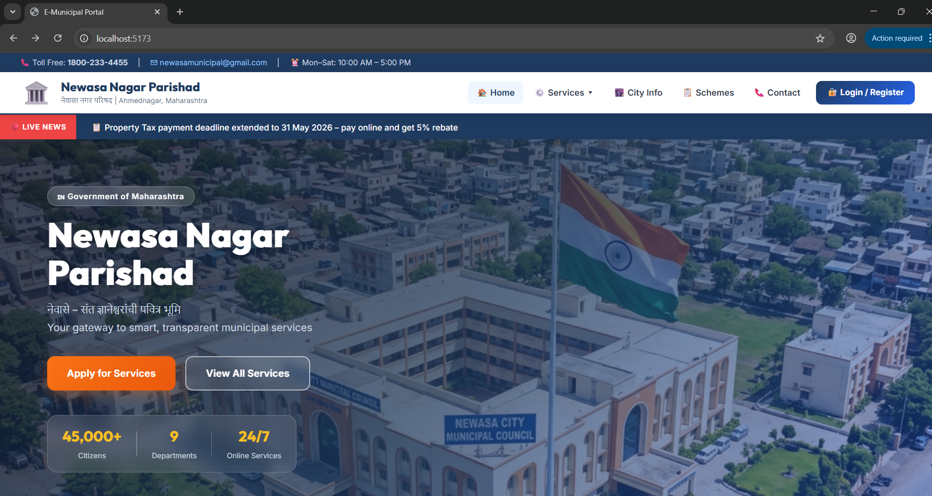

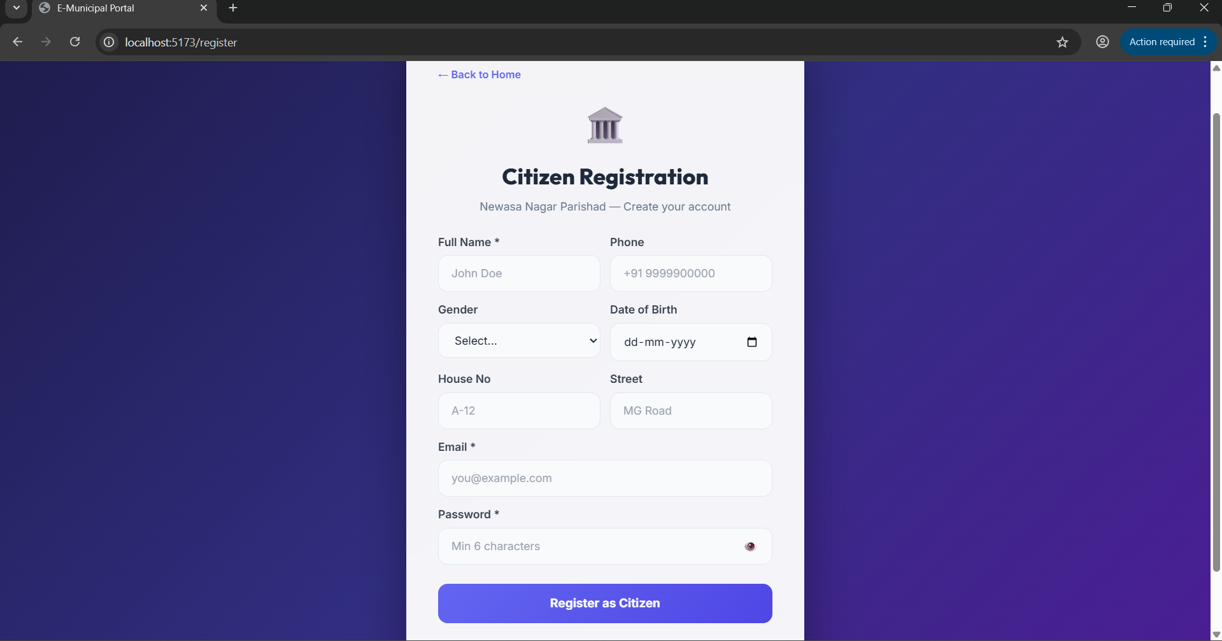

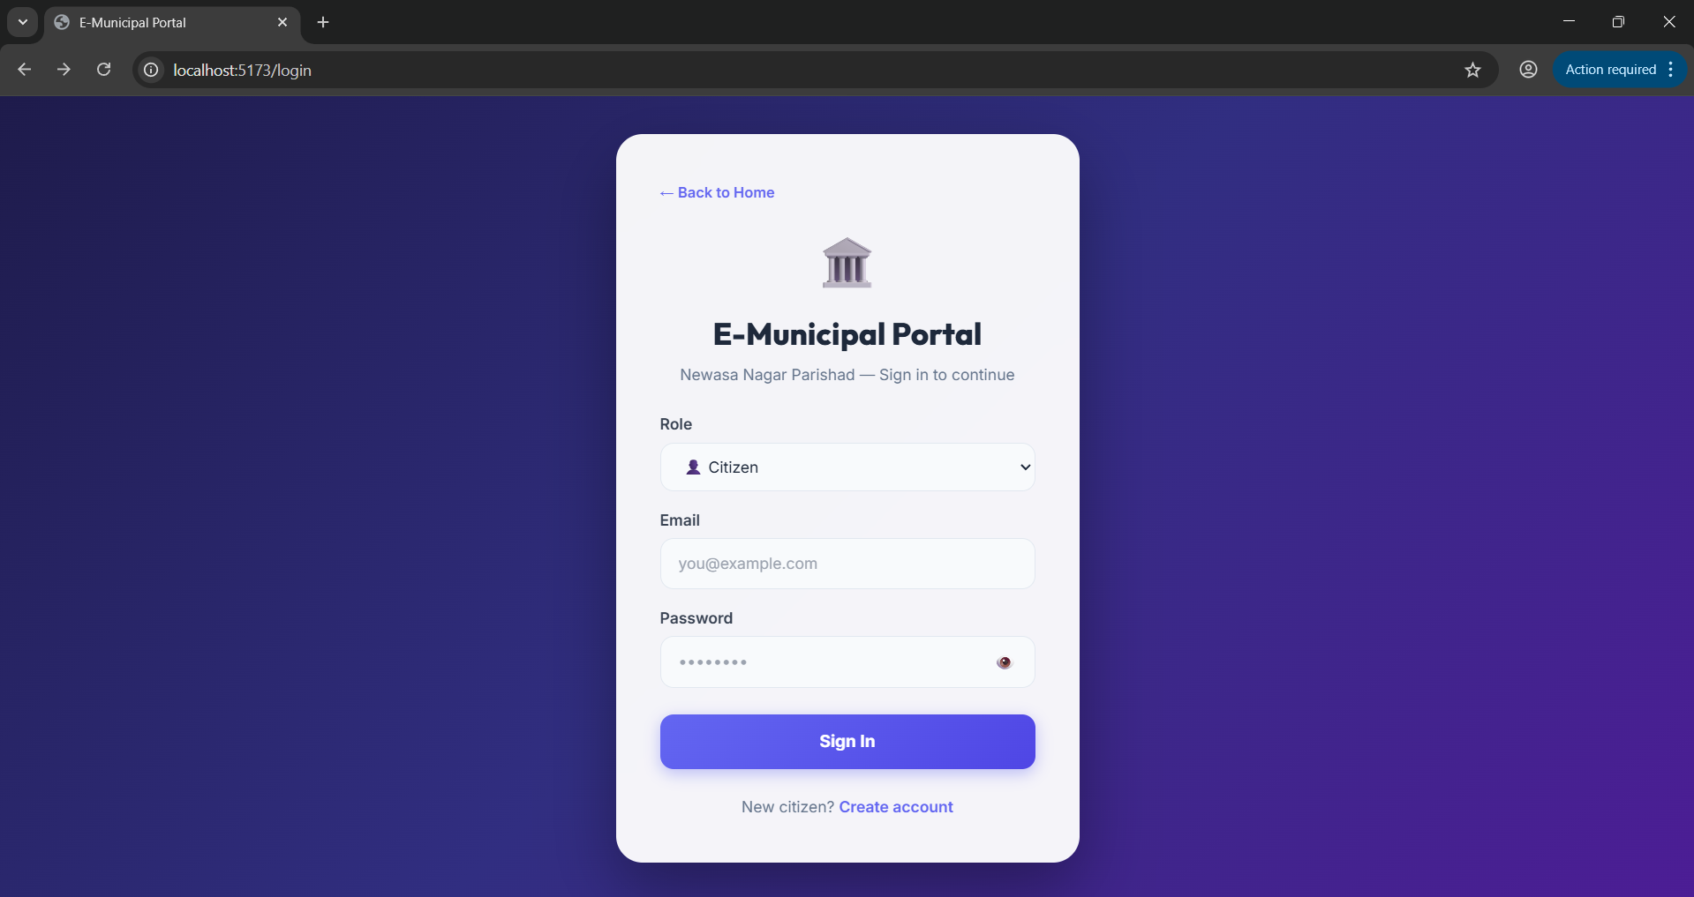

4.2 Input Screens
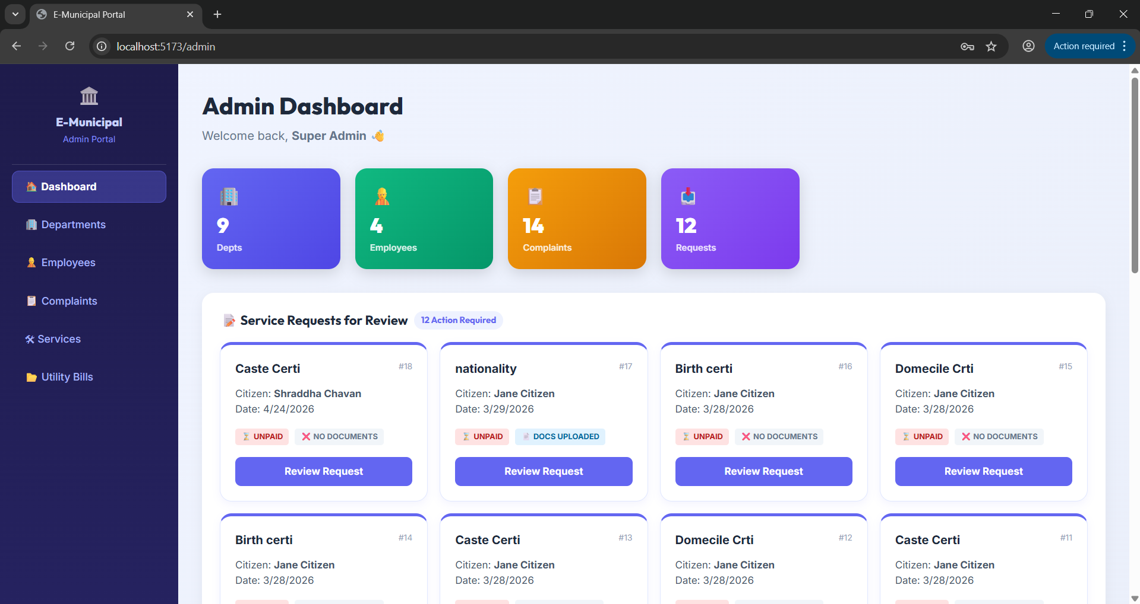

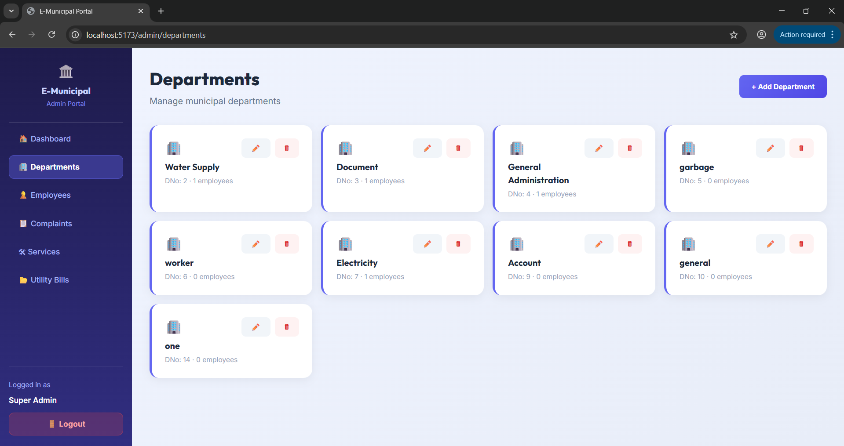

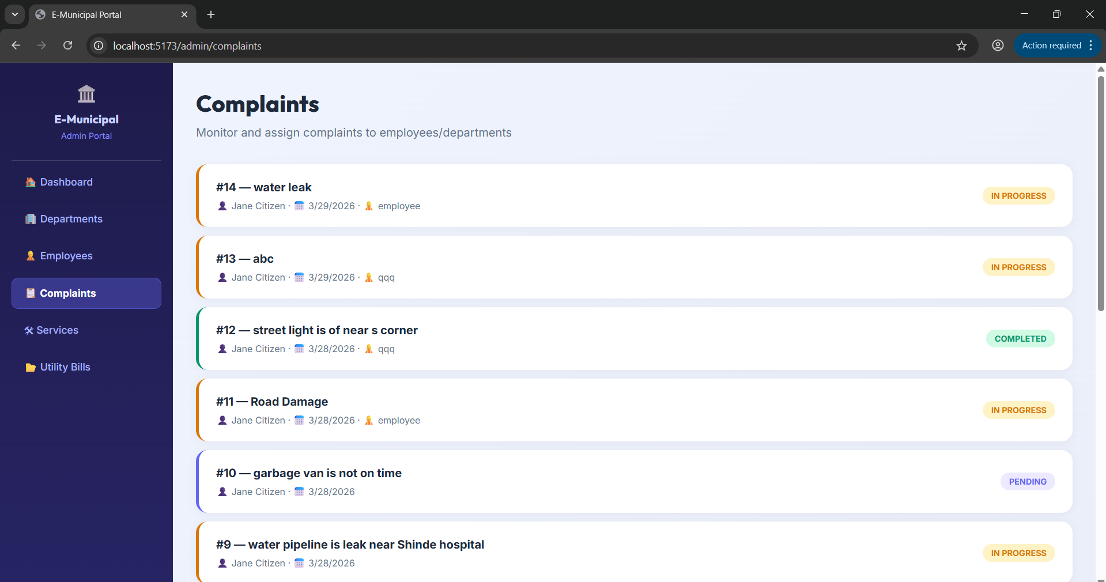

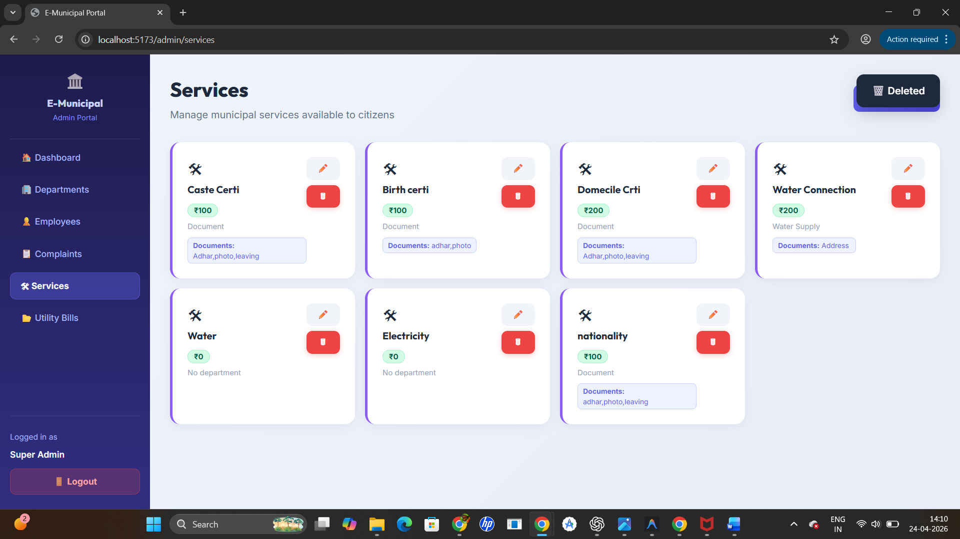

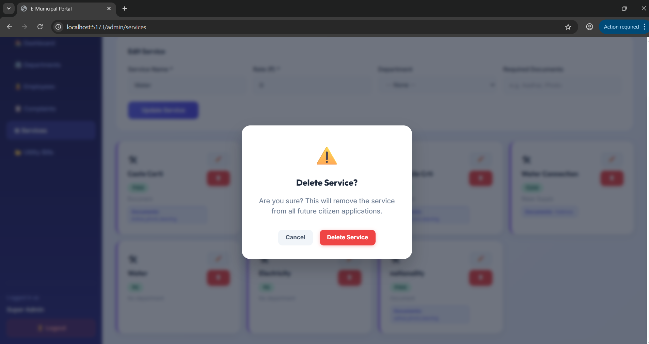

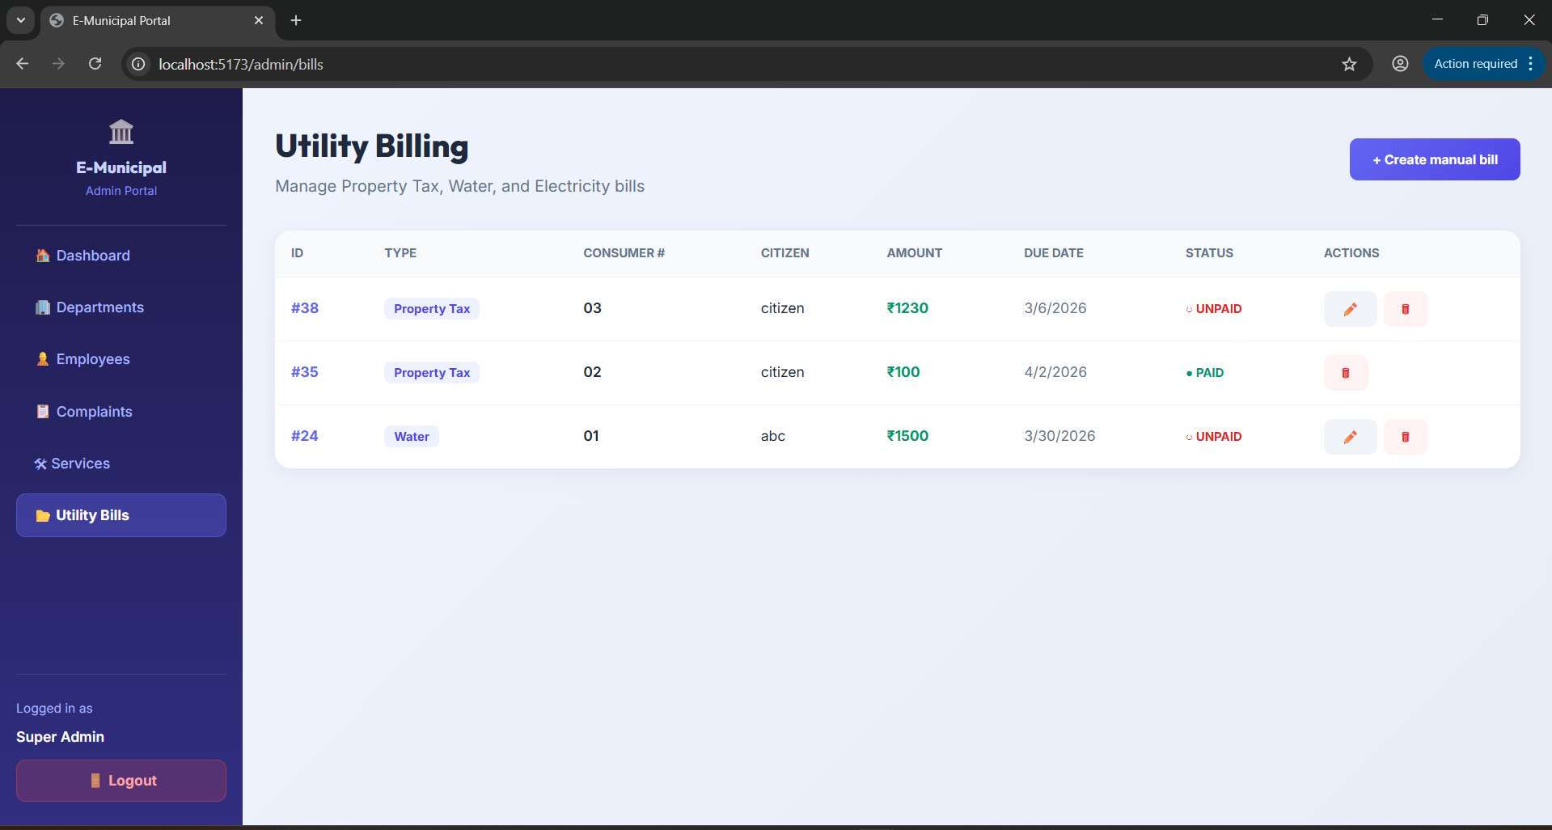

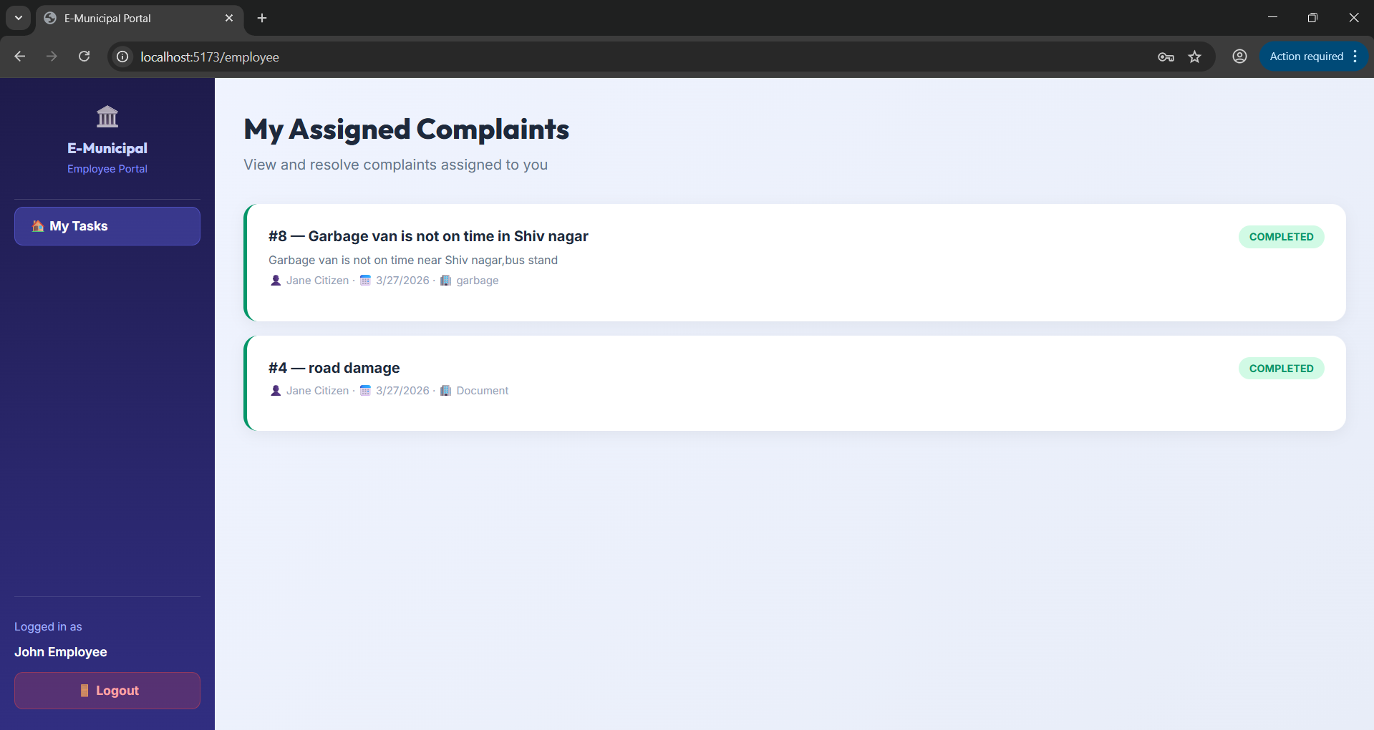

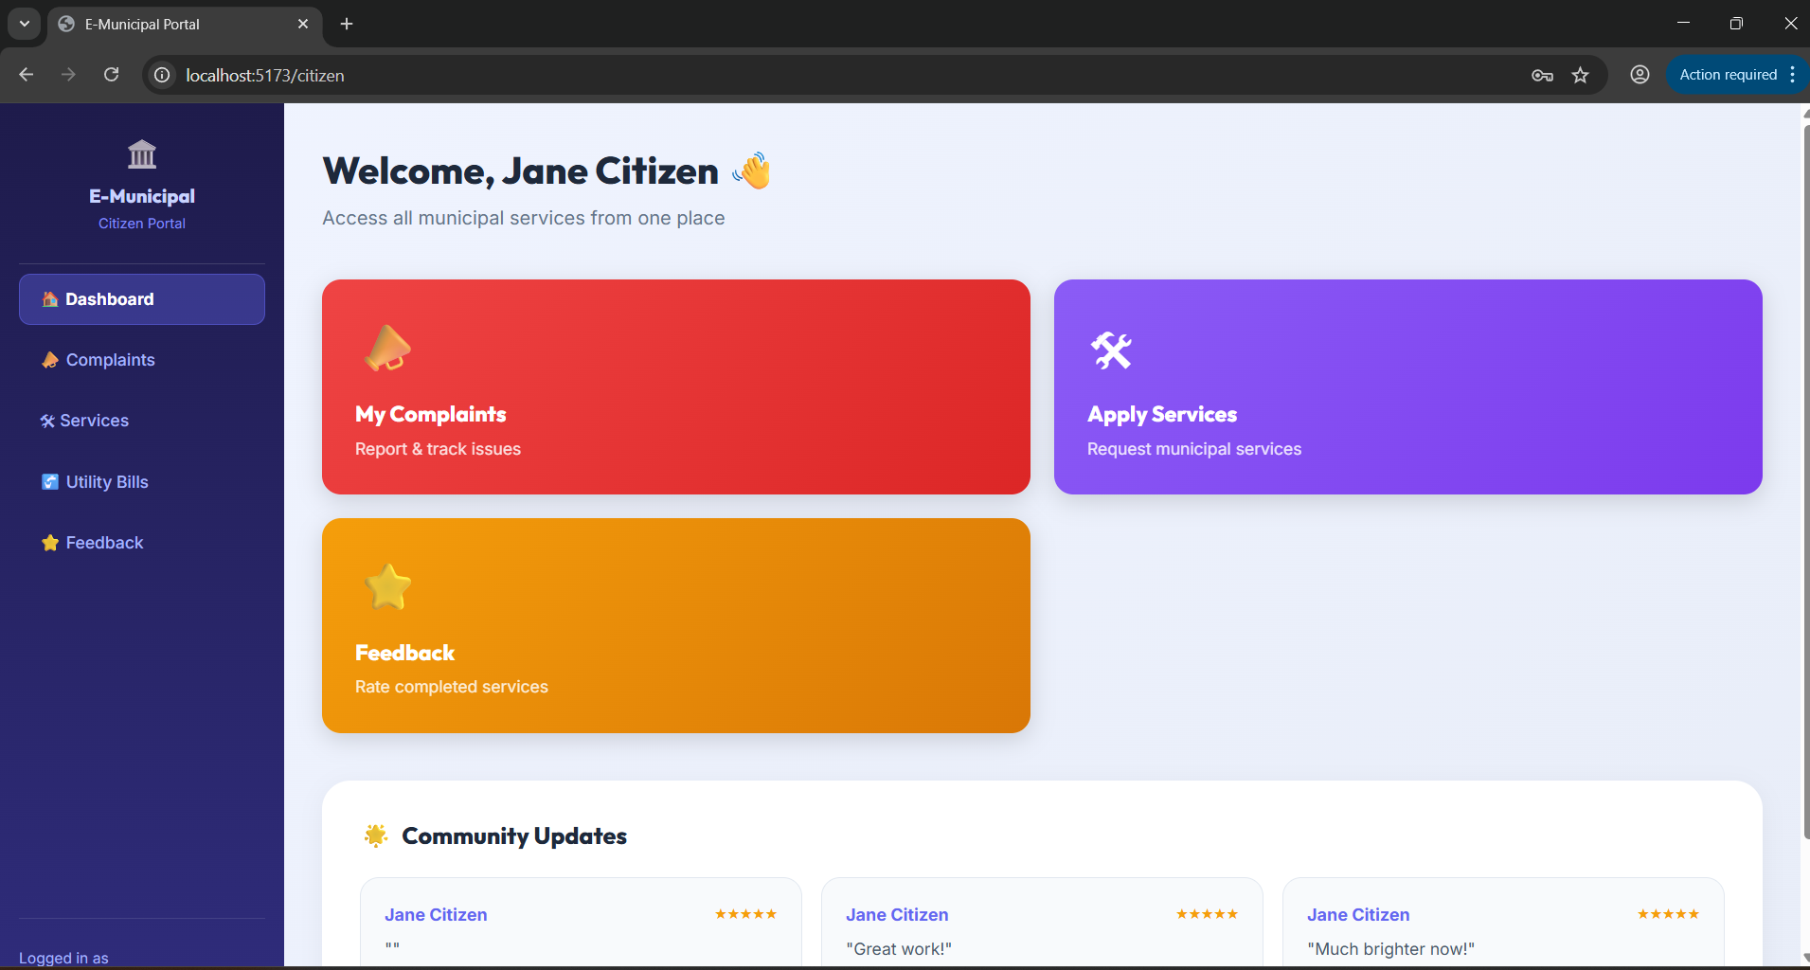
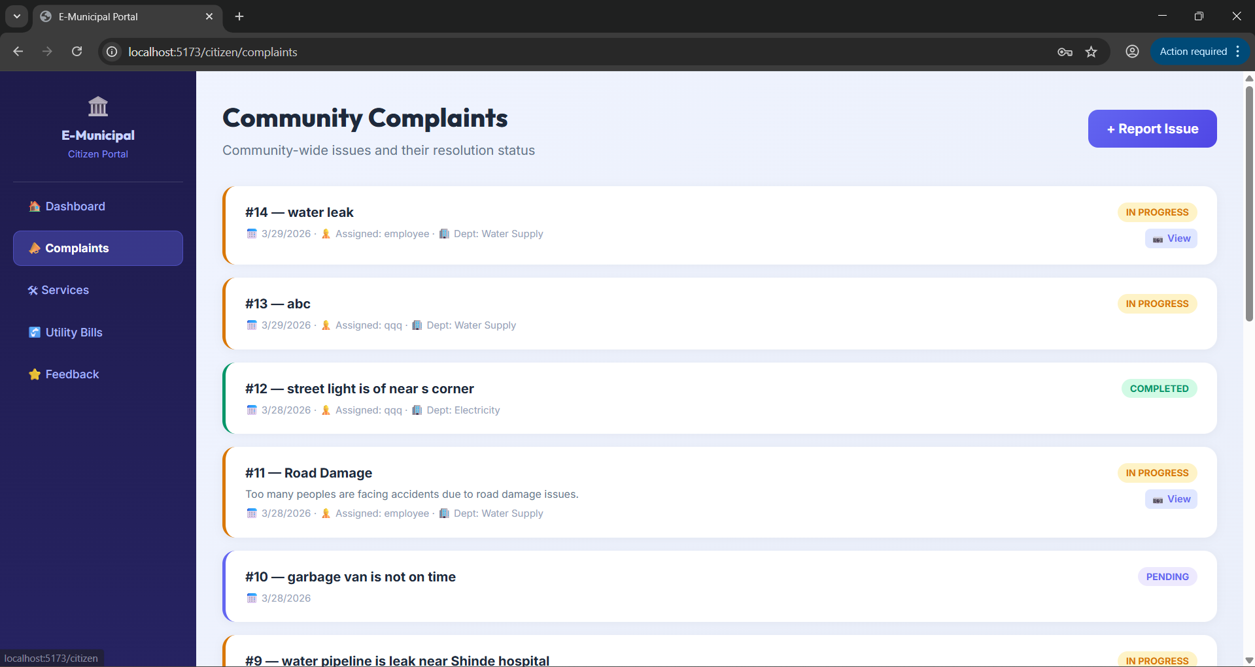

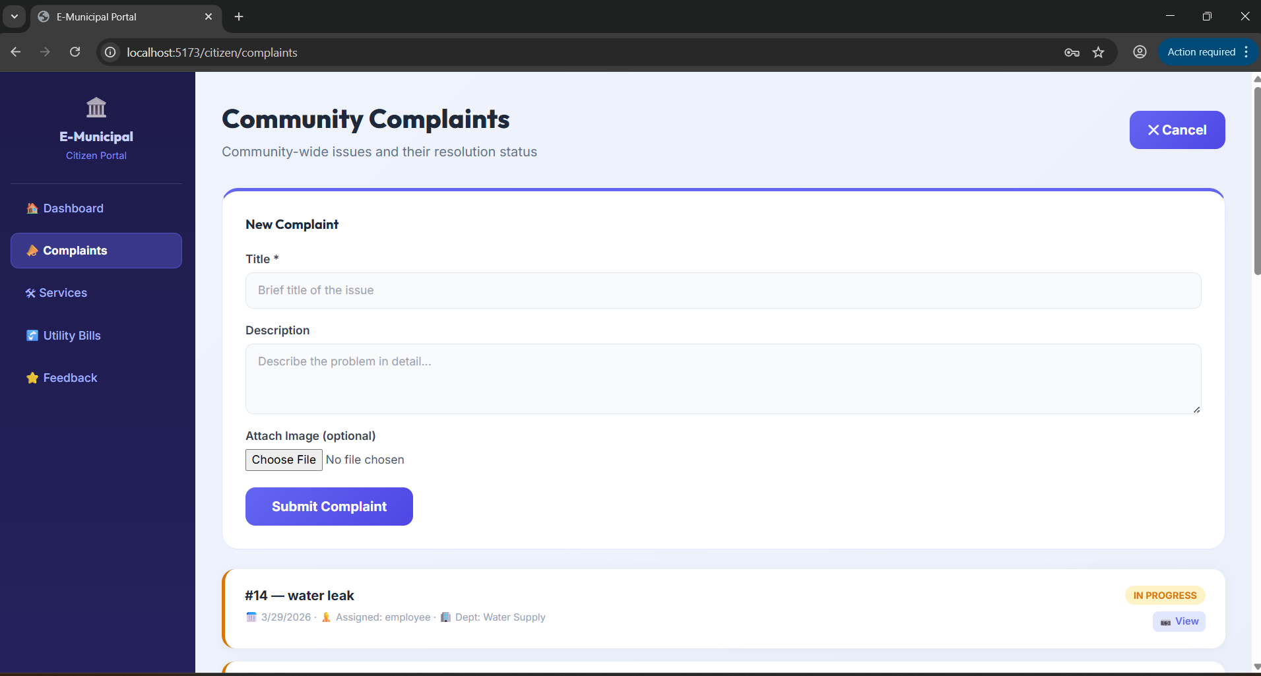

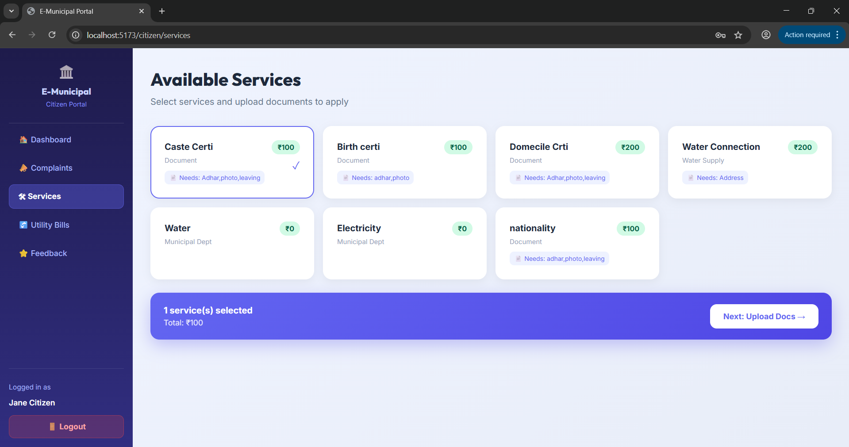

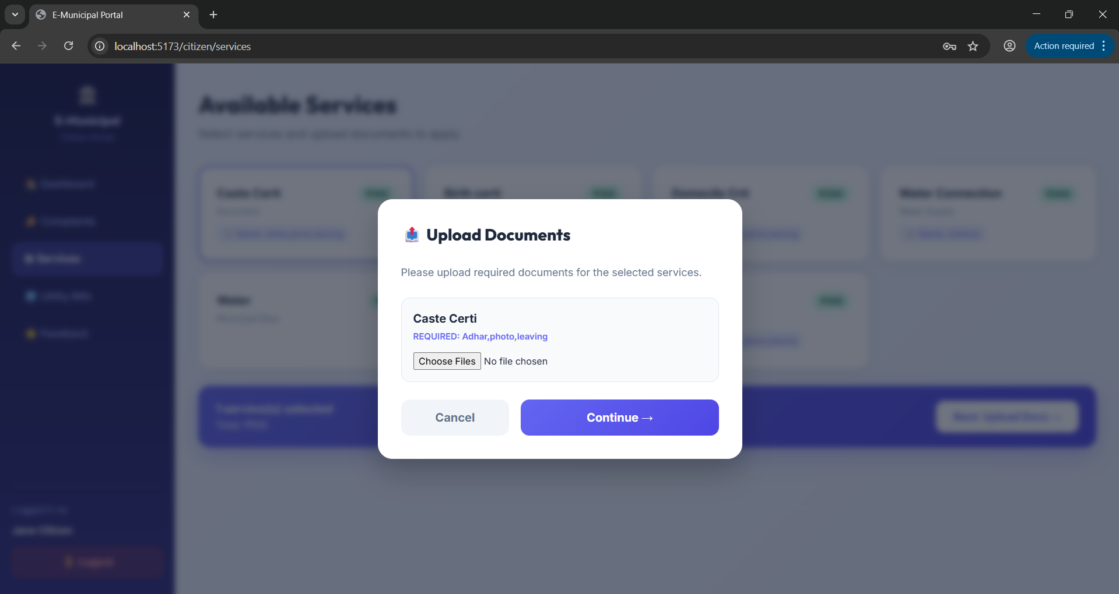

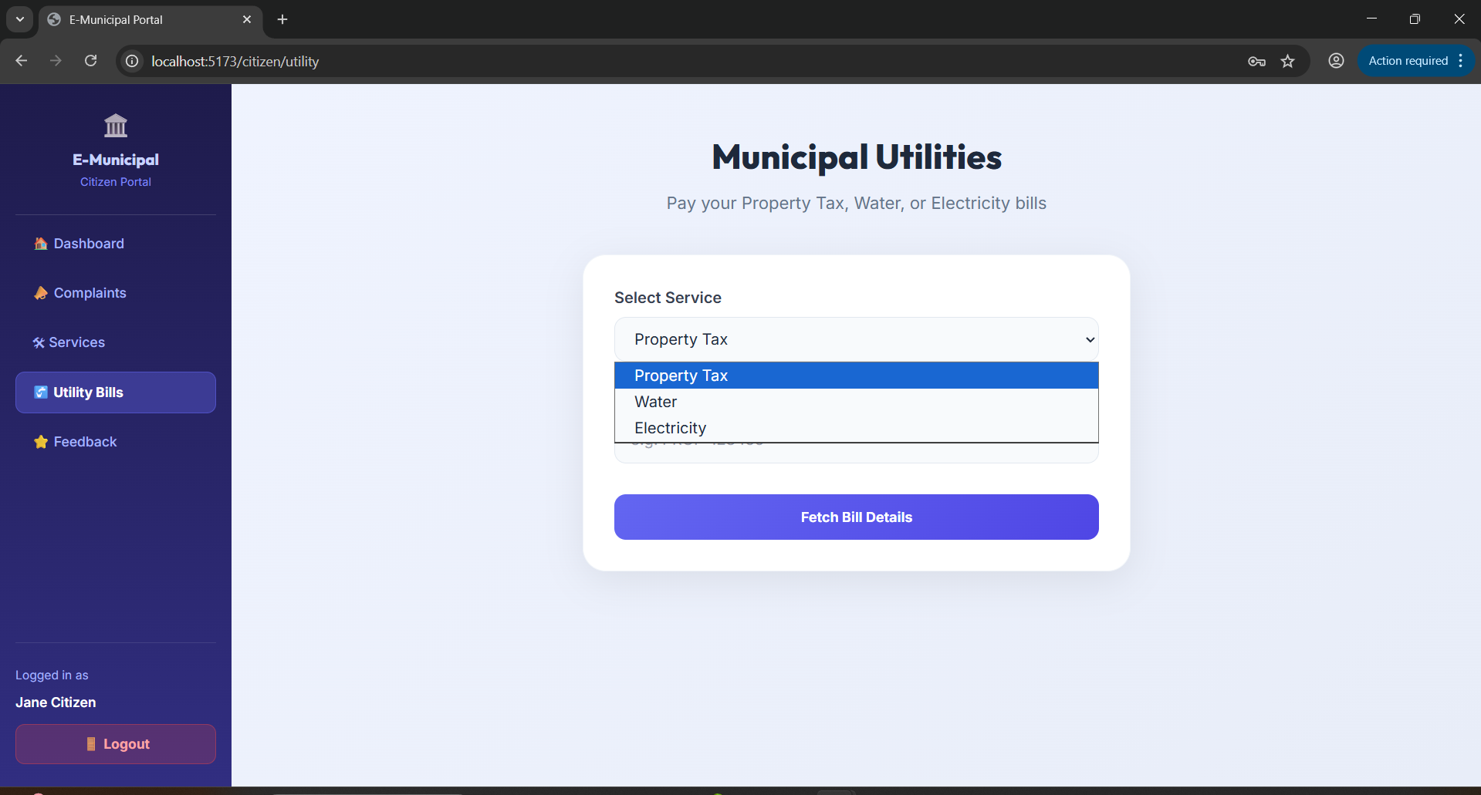

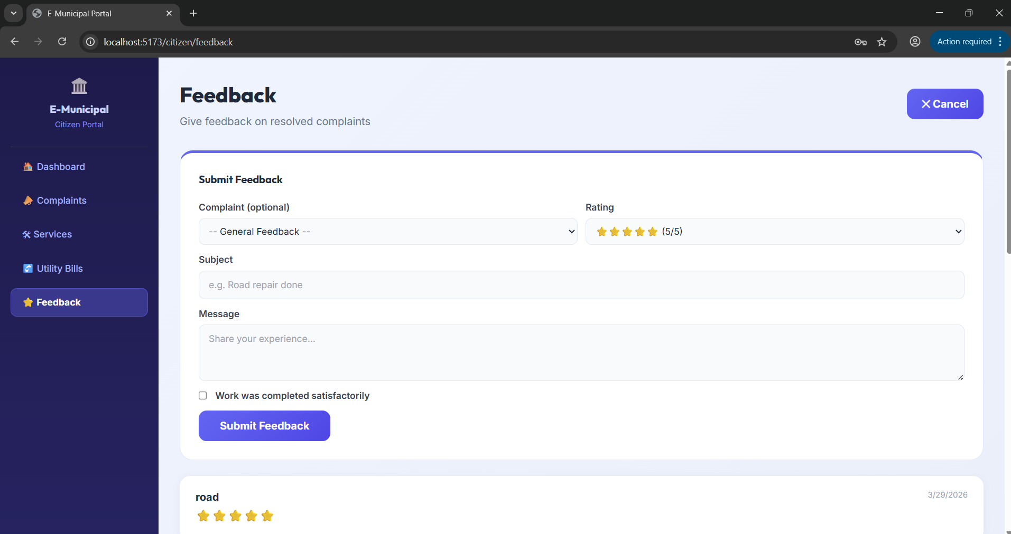

4.3 Project Code
JWT Token Generation (C#)
private string GenerateJwtToken(int userId, string name, string email, string role)
{
var claims = new[]
{
new Claim(ClaimTypes.NameIdentifier, userId.ToString()),
new Claim(ClaimTypes.Name, name),
new Claim(ClaimTypes.Email, email),
new Claim(ClaimTypes.Role, role)
};
var key = new SymmetricSecurityKey(Encoding.UTF8.GetBytes(_configuration["JwtSettings:Secret"]));
var cred = new SigningCredentials(key, SecurityAlgorithms.HmacSha256);
var token = new JwtSecurityToken(
issuer: _configuration["JwtSettings:Issuer"],
audience: _configuration["JwtSettings:Audience"],
claims: claims,
expires: DateTime.UtcNow.AddDays(7),
signingCredentials: cred
);
return new JwtSecurityTokenHandler().WriteToken(token);
}
React Login Form (JavaScript / JSX)
const handleSubmit = async (e) => {
e.preventDefault();
setLoading(true);
try {
const data = await login(form.email, form.password, form.role);
if (data.role === "Admin") navigate("/admin");
else if (data.role === "Employee") navigate("/employee");
else navigate("/citizen");
} catch (err) {
setError(err?.response?.data || "Invalid credentials.");
} finally {
setLoading(false);
}
};
AuthContext – Global Login State (React)
const login = async (email, password, role) => {
const res = await api.post("/auth/login", { email, password, role });
const data = res.data;
localStorage.setItem("token", data.token);
localStorage.setItem("user", JSON.stringify({ role: data.role, name: data.name }));
setUser({ role: data.role, name: data.name, userId: data.userId });
return data;
};
Complaint Filing with Image Upload (C#)
[HttpPost]
public async Task<IActionResult> Create([FromForm] ComplaintCreateDto dto)
{
string? imagePath = null;
if (dto.Image != null && dto.Image.Length > 0)
{
var fileName = Guid.NewGuid() + Path.GetExtension(dto.Image.FileName);
var savePath = Path.Combine("uploads", "complaints", fileName);
using var stream = System.IO.File.Create(savePath);
await dto.Image.CopyToAsync(stream);
imagePath = savePath;
}
// Save complaint to database...
}

CHAPTER 5 : LIMITATIONS AND ENHANCEMENT
5.1 Drawbacks and Limitations
• The system currently requires an active internet connection at all times; offline access is not supported.
• Document verification is performed manually by employees, which can create processing bottlenecks when application volumes are high.
• The payment gateway is currently simulated. A real payment processor (RazorPay, Paytm, or bank gateway) must be integrated before production use.
• The portal currently supports only the English language. Marathi language support is not yet implemented, which limits accessibility for rural citizens.
• File upload is limited to specific formats and sizes. Large document uploads may slow down network performance on lower bandwidth connections.
5.2 Proposed Enhancements
• Multilingual Support: Implement a full Marathi interface to improve accessibility for all citizens of Newasa.
• SMS / Email Notification Gateway: Integrate Twilio or MSG91 to automatically notify citizens via SMS when their application status changes.
• AI Chatbot: Deploy a smart assistant to answer common citizen queries about required documents, fees, or application procedures without human intervention.
• OCR Document Verification: Integrate Optical Character Recognition to automatically extract and validate Aadhar/PAN details from uploaded scans, reducing manual effort.
• Mobile Application: Develop a dedicated Android and iOS application for native mobile access to the portal.
• Real Payment Gateway: Integrate Razorpay or Paytm for live financial transactions.
5.3 Conclusions
This project gave me an excellent opportunity to understand the complete flow of a government E-Governance portal and the challenges involved in developing and deploying such a system for real municipal needs. We had the unique opportunity to engineer not just a simple CRUD application, but a multi-role, secure, full-stack web portal serving Citizens, Municipal Employees, and Administrators under one unified platform.
The E-Municipal Portal successfully eliminates the core pain points of the current manual system — unnecessary office visits, paper-based records, and departmental silos — by providing a fast, transparent, and scalable digital solution built on React JS and ASP.NET Core 8.
It gives us immense pleasure and satisfaction to complete a project in a field of real societal impact, using our technical skills to deliver a result that goes beyond academic expectations and contributes meaningfully towards smart e-governance for the citizens of Newasa.
5.4 Bibliography
1. React Official Documentation — react.dev
2. ASP.NET Core 8 Web API Documentation — learn.microsoft.com
3. Entity Framework Core in Action — Jon P Smith (Manning Publications)
4. PostgreSQL 16 Official Manual — postgresql.org/docs
5. Tailwind CSS Documentation — tailwindcss.com
6. JSON Web Tokens Introduction — jwt.io
7. E-Governance Initiatives in Maharashtra — NASSCOM Report 2023
8. Schildt, H. (2021). C# Complete Reference. McGraw-Hill Education.
9. Moroney, L. (2020). Full-Stack Web Development with ASP.NET Core. Apress.
10. National e-Governance Plan (NeGP) — Government of India, meity.gov.in

