

**Department of Information Technology**

**Academic Year: 2024-25 Name of Student:Shravani Sawant**

**Semester: V Student ID:22104008**

**Class / Branch: TEIT/Div C Date of Performance:29/07/2024**

**Subject: DevOps Lab Date of Submission: 29/07/2024**

**Name of Instructor: Sujata Oak**

**Experiment No. 3**

**Aim: To understand and perform version control system / source code management using Git.**

**PART 1: Branching and Merging**

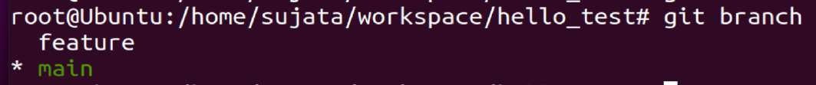





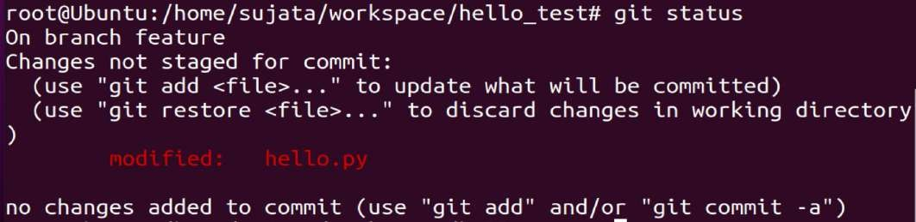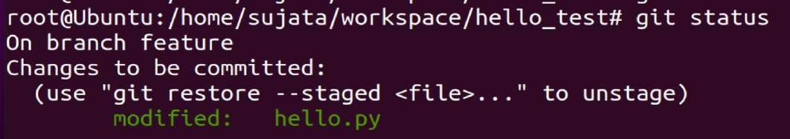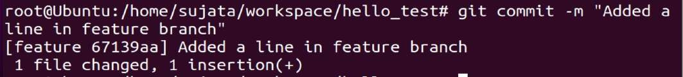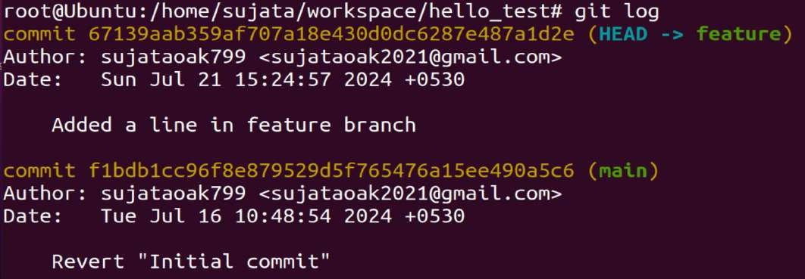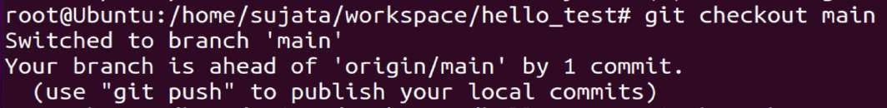



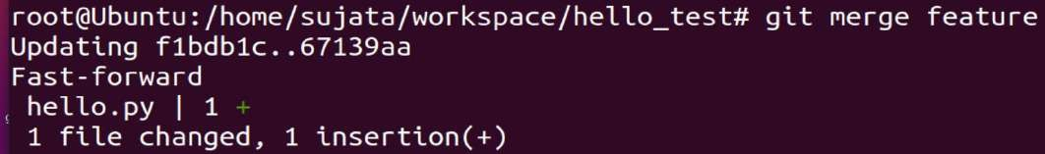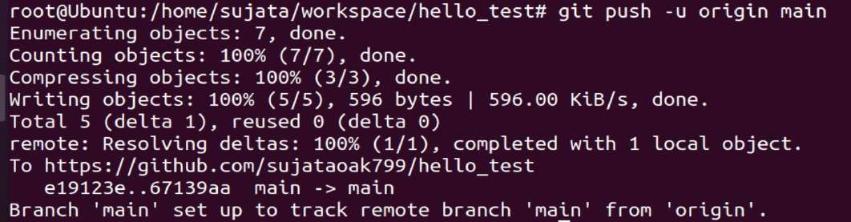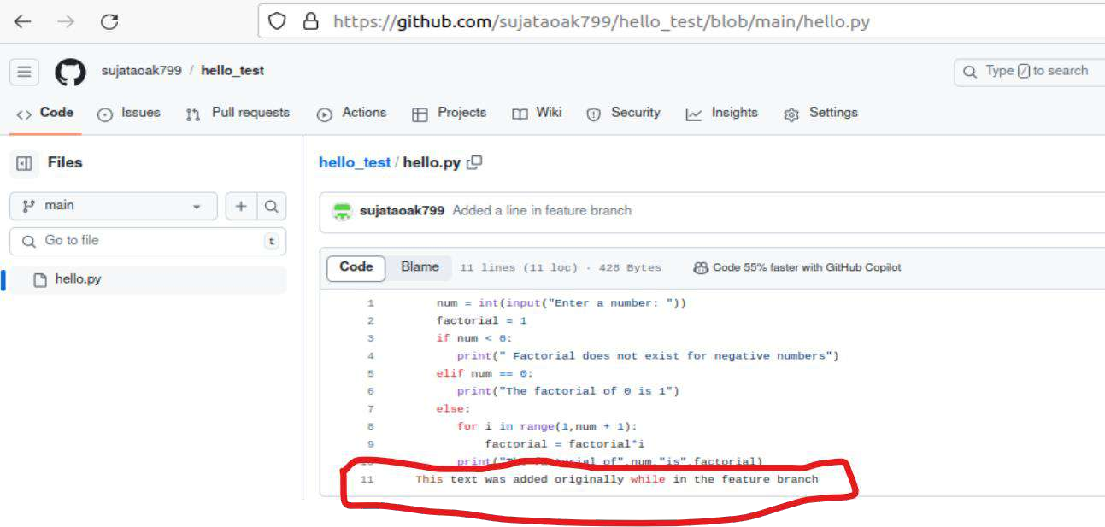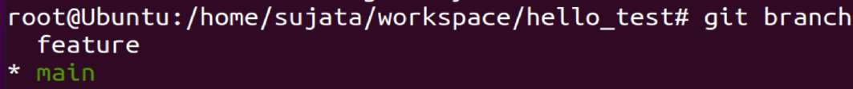



**OUTPUT:**

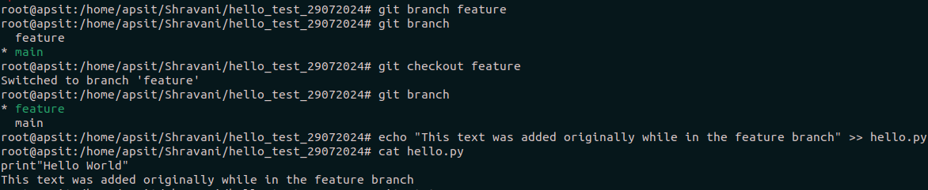

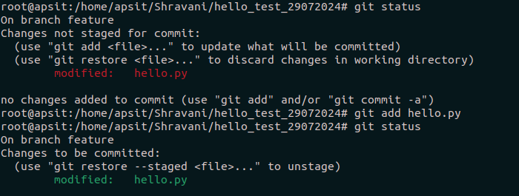

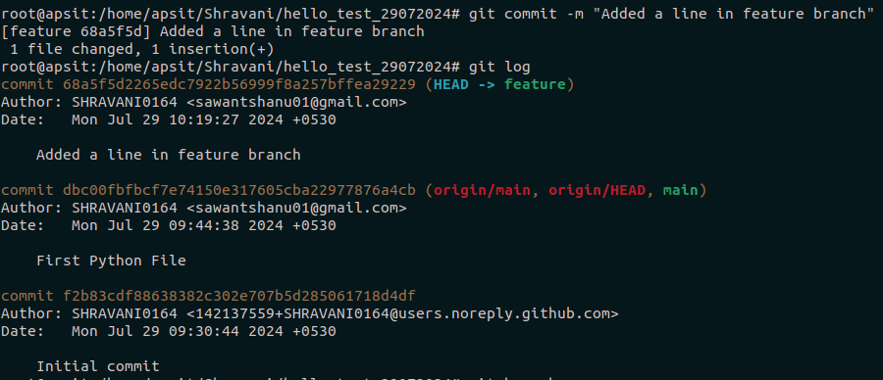

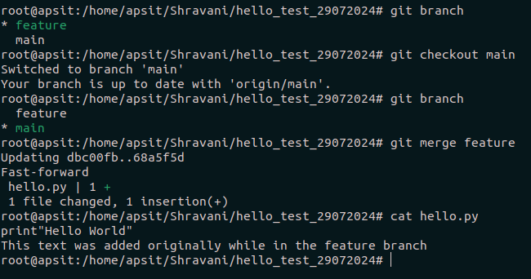

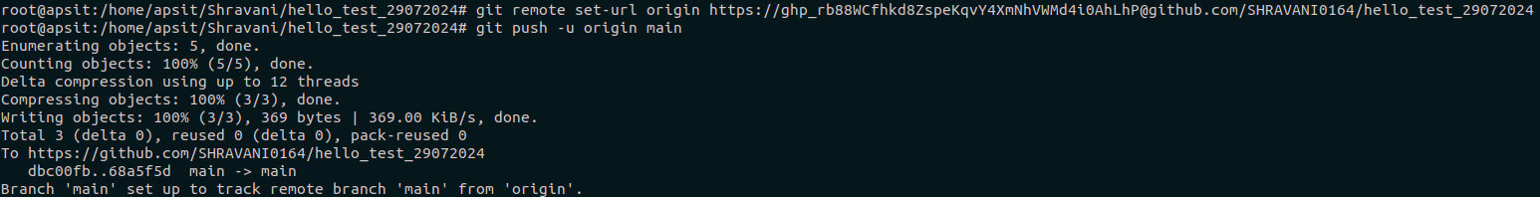

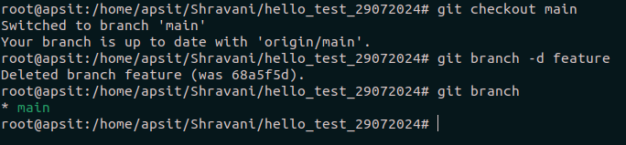

**Conclusion:**

In this experiment, we understood the use case of Version Control System in branching and merging, its benefits in real time scenario which provides a application of branching the changes when people are in working in a collaborating environment. Different commands were used for the same such as checkout, branch and merge for displaying the changes between the initial and latter texts.