

Department of Information Technology

Academic Year: 2024-25 Name of Student:Shravani Sawant
Semester: V Student ID:22104008
Class / Branch: SEIT/Div C Date of Performance:29/07/2024
Subject: DevOps Lab Date of Submission:29/07/2024
Name of Instructor: Prof.Sujata Oak

Experiment No. 2
Aim: To perform installation of Git and work on local and remote Git repositories.

GIT is a Version Control System (VCS) (aka Revision Control System (RCS), Source Code Manager (SCM)). A VCS serves as a Repository (or repo) of program codes, including all the historical revisions. It records changes to files at so-called commits in a log so that you can recall any file at any commit point.
To issue a command, start a "Terminal" (for Ubuntu/Mac) or "Git Bash" (for Windows):
$ git <command> <arguments>
The commonly-used commands are:
- init, clone, config: for starting a Git-managed project.
- add, mv, rm: for staging file changes.
- commit, rebase, reset, tag:
- status, log, diff, grep, show: show status
- checkout, branch, merge, push, fetch, pull

Getting Started with Local Repo
There are 2 ways to start a Git-managed project:
- Starting your own project;
- Cloning an existing project from a GIT host.

Git uses two stages to commit file changes:
- "git add <file>" to stage file changes into the staging area, and
- "git commit" to commit ALL the file changes in the staging area to the local repo.
You need to setup Git on your local machine, as follows:
Step1: Download & Install:
- For Ubuntu, issue command "sudo apt-get install git".
Step 2.
- Create a repository on local machine
mkdir Sumit
- Initiate that directory to make it a git repository (.git file must be added inside that folder after initiation)
Git init Sumit
Step 3: Customize and configure your Git Account:
// Set up your username and email (to be used in labeling your commits)
$ git config --global user.name "your-name"
$ git config --global user.email "your-email@youremail.com"
You can issue "git config --list" to list the settings:
$ git config --list
user.email=xxxxxx@xxxxxx.com
user.name=xxxxxx
Step 4: Create and Add one file in that folder and write some content inside it
gedit sumit.txt
git add sumit.txt
Step 5: To start first commit
git commit -m “my first commit”
Step 6: To push local repository on git account
git push origin master or git push origin main
OUTPUT:
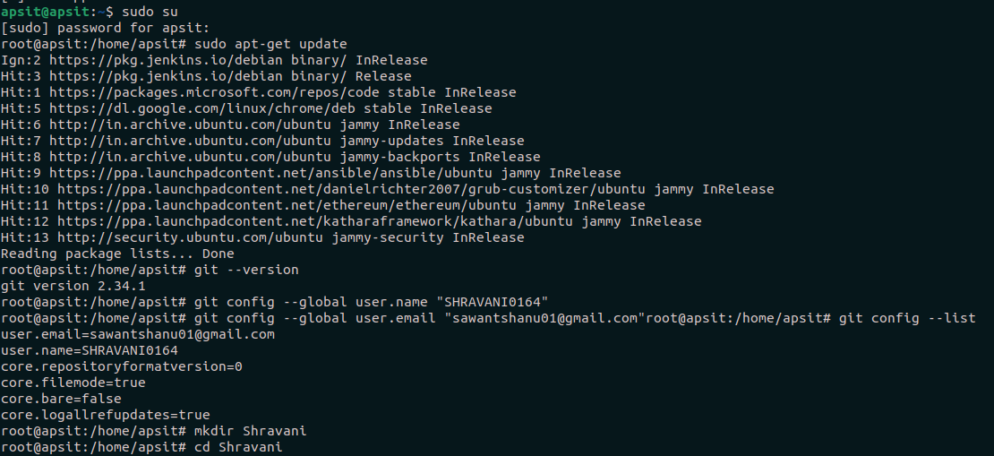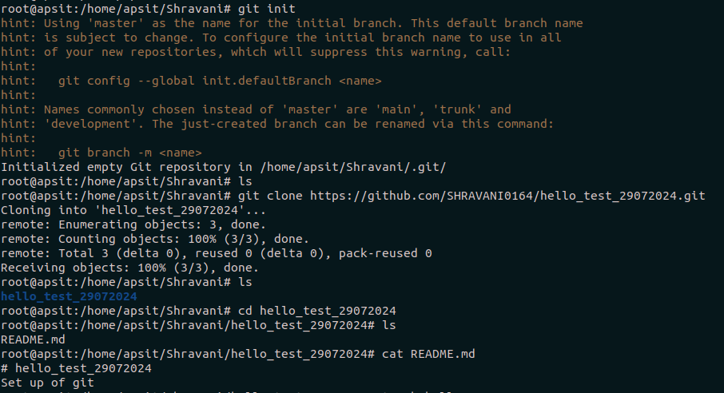
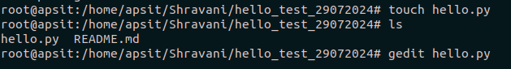
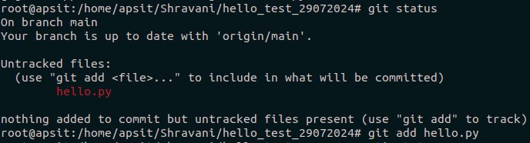
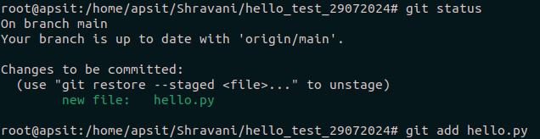
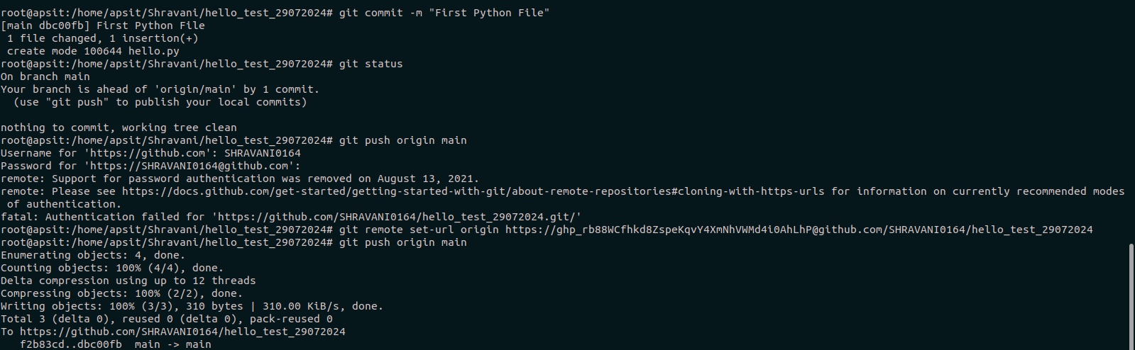

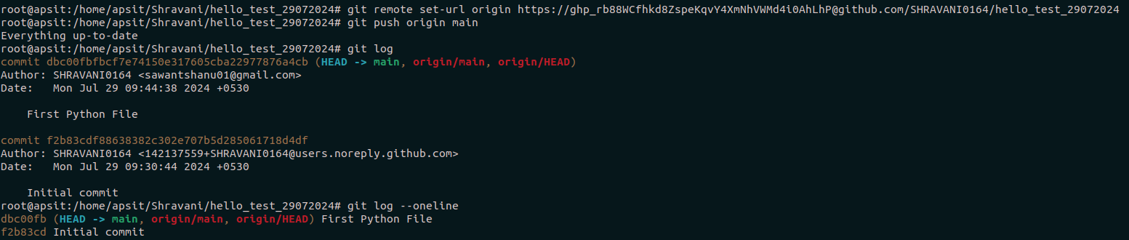

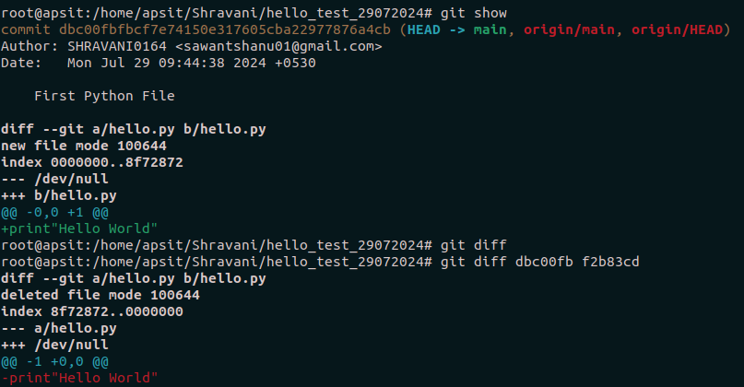

Conclusion:
In this experiment, we have successfully installed git and created a local repository using different git commands.

