1)Run cell C only that to do from :
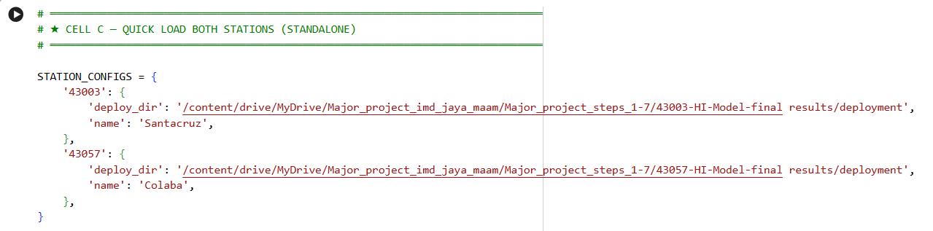
Mounted at /content/drive
📂 Found 43003 (Santacruz) artifacts at: /content/drive/MyDrive/Major_project_imd_jaya_maam/Major_project_steps_1-7/43003-HI-Model-final results/deployment
📂 Found 43057 (Colaba) artifacts at: /content/drive/MyDrive/Major_project_imd_jaya_maam/Major_project_steps_1-7/43057-HI-Model-final results/deployment
✅ SAINT architecture + builder defined

────────────────────────────────────────
Loading 43003 (Santacruz)...
✅ Scaler loaded
/usr/local/lib/python3.12/dist-packages/keras/src/saving/saving_lib.py:797: UserWarning: Skipping variable loading for optimizer 'adamw', because it has 2 variables whereas the saved optimizer has 154 variables.
saveable.load_own_variables(weights_store.get(inner_path))
✅ SAINT rebuilt + weights loaded
✅ XGBoost loaded
✅ RF loaded
✅ Meta-learner loaded
✅ Santacruz (43003) — all models ready!

────────────────────────────────────────
Loading 43057 (Colaba)...
✅ Scaler loaded
/usr/local/lib/python3.12/dist-packages/keras/src/saving/saving_lib.py:797: UserWarning: Skipping variable loading for optimizer 'adamw', because it has 2 variables whereas the saved optimizer has 206 variables.
saveable.load_own_variables(weights_store.get(inner_path))
⚠️ d_token=32 failed, trying d_token=64...
✅ SAINT rebuilt + weights loaded
✅ XGBoost loaded
✅ RF loaded
✅ Meta-learner loaded
✅ Colaba (43057) — all models ready!

══════════════════════════════════════════════════
✅ BOTH stations loaded successfully!
43003 (Santacruz) — ready
43057 (Colaba) — ready
══════════════════════════════════════════════════

🧪 Self-test predictions:

43003 (Santacruz):
/usr/local/lib/python3.12/dist-packages/keras/src/ops/nn.py:947: UserWarning: You are using a softmax over axis 3 of a tensor of shape (11, 4, 1, 1). This axis has size 1. The softmax operation will always return the value 1, which is likely not what you intended. Did you mean to use a sigmoid instead?
warnings.warn(
Hot+Humid DBT=38.5°C RH=85% → HI=79.1°C → Very High
Mild DBT=28.0°C RH=60% → HI=29.4°C → Low Risk
Extreme DBT=42.0°C RH=75% → HI=88.4°C → Very High
Cool+Dry DBT=25.0°C RH=50% → HI=24.9°C → Low Risk

43057 (Colaba):
/usr/local/lib/python3.12/dist-packages/keras/src/ops/nn.py:947: UserWarning: You are using a softmax over axis 3 of a tensor of shape (11, 8, 1, 1). This axis has size 1. The softmax operation will always return the value 1, which is likely not what you intended. Did you mean to use a sigmoid instead?
warnings.warn(
Hot+Humid DBT=38.5°C RH=85% → HI=79.1°C → Very High
Mild DBT=28.0°C RH=60% → HI=29.4°C → Low Risk
Extreme DBT=42.0°C RH=75% → HI=88.4°C → Very High
Cool+Dry DBT=25.0°C RH=50% → HI=24.9°C → Low Risk

═════════════════════════════════════════════════════════════════
🚀 SAINT-XGB-Stack API — BOTH STATIONS
═════════════════════════════════════════════════════════════════
🌐 Public URL: NgrokTunnel: "https://feisty-shadow-circling.ngrok-free.dev" -> "http://localhost:5000"

Stations: 43003 (Santacruz) + 43057 (Colaba)

POST NgrokTunnel: "https://feisty-shadow-circling.ngrok-free.dev" -> "http://localhost:5000"/predict/hi
Santacruz: {"station":"43003", "DBT":38.5, "RH":85}
Colaba: {"station":"43057", "DBT":38.5, "RH":85}

⚡ Paste URL into React dashboard!
═════════════════════════════════════════════════════════════════

2) start on VS code:
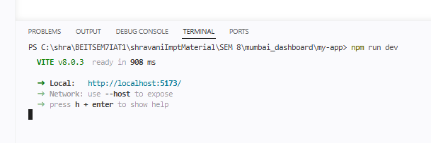

2) Once dashboard started on http://localhost:5173/ Paste the ngrox public URL on dashboard configure field:
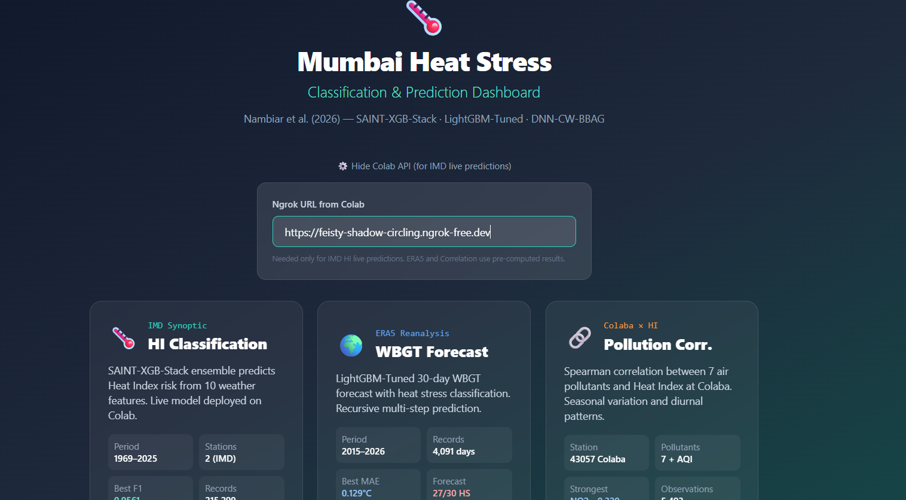
3) Now connected
U can click HI class and choose station and predict

